LITTLE DEMON ACADEMIA
CHAPTER 6: BIG GOOP
BY CHALDEACHANGE
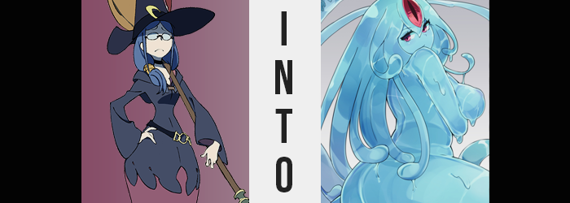

Cthulu-chan’s plan had been going off without a hitch so far, but that didn’t mean that there weren’t still risks involved. Luna Nova Academy was full of inexperienced witches that were rife for the corrupting of course, but that didn’t mean that there weren’t threats. Were they threats that could stop the outer being’s advance? Absolutely not. But they were threats in the sense that could make things far more complicated than they might have been otherwise.

These potential threats could only be the faculty of the academy. They were all trained, powerful witches that might be able to intervene in Akko’s plans to some extent if they were given the freedom to do so. And that was why she had taken care of them before attacking any of the students. Indeed, this encounter is one that takes place before Cthulu-chan made contact with Sucy Manbavaran, shortly after Akko first arrived in Luna Nova after being transformed.

Class had concluded for the day, and after having a meeting after school as they always did, all of the teachers had parted ways to take care of their own, personal business. Whether it was organizing lesson plans for the next day, or grading papers and projects – whatever needed to be done, really.

Ursula Callistis, on the other hand, had no intention of doing any of these things despite needing to. Akko had mysteriously not returned to class after the break, and whenever Akko disappeared it wasn’t typically for a good reason. The Japanese girl was more or less Ursula’s personal responsibility at this point, so she couldn’t exactly have her getting into any trouble. And if she had? Well, she would simply sigh and help her out of the problem.
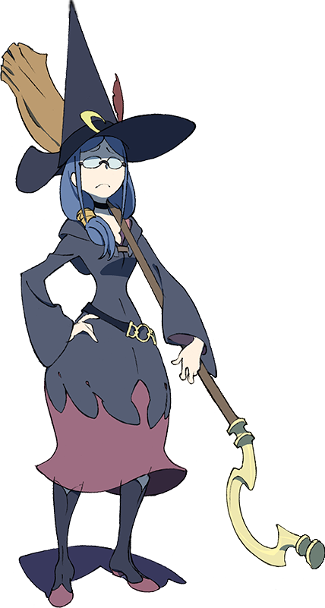
“Hm? None of them are home? Not even Akko?” The door to the dorm room shared by Atsuko, Sucy, and Lotte had been left open – yet none of the girls were there nor in the hallway outside. It was against the rules to leave your door open, and knowing Lotte she would have made sure to close it if she had been by. “Ew, wait a moment? What is that?”

Ursula had done a pass of the room after closing the door behind her with the intention of leaving right after, and yet upon doing so she had noticed something. Something a little gross. There was a pale blue goop behind the door, previously obscured by how it was open. Had some sort of creature left it there? Was Akko keeping a pet against academy policy? That certainly sounded like something she would do.

But the goop itself was a trap, one the woman had fallen for hook, line, and sinker as she crouched down and scooped some up with the tip of her index finger. Ursula even gave it a sniff. “It had no scent, so it isn’t a creature’s waste, I suppose.” And maybe that was for the best that it wasn’t? In the time it took her free hand to reach in to grab a tissue to wipe it off, however…

“Where… did it go?” She was certain she had just taken her eyes off the slime for but a single moment, and yet when she looked back? The goop upon her finger was gone. Had it slid off? No… Her body had absorbed it.

A wicked chill ran up her spine not long after. “What on…?” It was accompanied by a churning feeling in her stomach. Had touching that slime made her ill somehow? She certainly hoped not. And yet she could hardly have imagined the fate for her that had been set in motion by the actions of the very girl she had come searching for.

Signs that something was awry had already begun to show themselves, largely beneath the lenses of her glasses where dim, red light began to glow from the depths of her eyes. It was a phenomenon that was both eerie and supernatural, but it was only a small piece of what had begun to transpire. For example? The length of the woman’s hair increased dramatically in the meantime, not just pulling down until it reached past her hips, but likewise fanning out as additional volume saw it thicken and push loose the tie that bound it in the back.

“Um… Wait a moment…?” The additional weight of this hair was not something that could possibly go unnoticed, and before long Ursula had scooped up a handful behind her and brought it forward. “H-How is this possible? Did someone cast a spell on me, and I didn’t notice?” There were certainly spells out there that could affect one’s hair length, but being an experienced witch she absolutely should have noticed any magic being cast upon her.

Still, the crimson light of her eyes grew stronger.

The churning of her stomach grew stronger as well, and yet it almost bordered a different phenomenon entirely. Hunger. Were these hunger pains that Ursula was feeling? It likely should have been a more pressing concern, but the woman was instead far more entranced by the length of her hair. Well, at least until a much more demanding sensation forced her to refocus her line of sight… upon her bosom. “Uhm? UHHH!?”

Ursula’s level of alarm wasn’t at all unwarranted, not as the neckline of her gown was forced out and down by the size and shapes of her breasts, which had both surged outward in tandem with one another to a sizing that dwarfed the tits she’d once considered to be reasonably sized. As fabric ripped down the center and flesh came bursting out though, this couldn’t exactly be the adjective used to describe them any longer.

“My chest!?” Were they D-cups? E-cups? BIGGER? The woman didn’t have the foggiest idea. She could just see flesh and inflated nipples alike bouncing free upon her torso, completely bare and so big that she couldn’t hide them with a single arm. “This is impossible. This is… something is wrong here!?” But what was wrong exactly? She just didn’t know!

It wasn’t the only portion of her body to find itself busting out of her teacher’s gown either. Fabric felt tighter around the woman’s tummy and waist as her torso broadened, some of this new weight peeking out from tiny tears that formed around its diameter while farther below the sides of her skirt pushed out thanks to widened hips. “Oh!?”

While the professor really wanted to cry out, she had muted herself on purpose. If her screams attracted a student and they walked in on her while she looked so obscene, then that could only have caused further issues. And so she suffered in silence from that point on, even as her ass bloated with such vigor that her plain panties were wedged right up her crack and the black of her skirt blew out, or as her thighs thickened with a jiggle so immense that the sides of her skirt did the same.

And when all was said and done? Ursula’s proportions had thickened to an extent that she almost resembled what a fifteen-year-old boy would assume a MILF actually looks like, with all of her sexual features enhanced to the point of implausibility. If a spell existed to alter a woman’s proportions in such a way, then it wasn’t one any good witch would ever possibly learn.

“Why? Why did this happen? I can hardly even move with my clothes this way…” Electing to whisper to herself, the woman was desperately pushing upon portions of her body to try and somehow stuff them back down to a more reasonable size. It didn’t work of course, and she became anxious about how she could even fetch help looking this way. “I… I… I suppose I could… I…?”

Before she even realized what was occurring, it became far harder for Ursula to spit out a full sentence than she had just moments prior. At first it was because that hunger that had plagued her with an increasing intensity had grown to a point that she could no longer ignore it, and so she couldn’t think about anything other than consuming. Yet after barely managing to pull her thoughts back on track?

It had simply become strangely difficult to think.

Almost like someone had filled her mind with a molasses that she was trudging through just to get a single thought across. “I.. Mm…? What? Hungry?” With her mental state smothered like this, her hunger took front and center in the woman’s priorities. It was an instinctual need, and one that became subdued after a moment’s time – in conjuncture with the tightness of her outfit become much more of a non-issue.

Ursula swayed back and forth, flesh jiggling in a very unnatural manner that wholly escaped her notice with her mind as it was now. Stick and wet, not only could you make out her bones and organs through skin that was now translucent, but her clothes had been absorbed by them and were disintegrating as the material was turned into nourishment for her own body.

“Hungry…? Hungry? Heehee! Hunger!” That hunger became all she could think about even as her body began to sag and slump. The bones in her body melted within her flesh just as her clothes had until she was entirely see-through, and yet while this body began to drip and slosh about, these was something holding it all together in a sexy, humanoid shape. Some of this liquid pooled at her feet below her, and before long the same phenomenon plagued her hair until it melded together and resembled a series of goopy tentacles.

And then, all at once? The fleshy color of her ‘body’ diluted into a blue. The very same blue of the goop she had touched upon entering the room in the first place. Not that the woman could remember such a thing, not with her ability to remember tied to her ability to think. She fell to her knees with a splashing sound, and the impact brought her hulking, slimy tits and firm, slimy ass to ripple while a moan escaped her lips.

Her vision became blurry briefly, for a third eye appeared above the other two. Roughly three times the size of her regular pair, it opened vertically among the center of her hair. More than an eye, perhaps it was something like a core?

If it was, she was in no position to state as much to anyone.

Her sticky body thicc and glopping, the slime woman that had once been known by the name of Ursula Callistis giggled to herself as she hugged her huge tits keenly. She was incapable of communicating through the human language, and in fact? She was hardly capable of conscious thought. Her awareness was limited to what her instincts now allowed, and she didn’t even recall her own name. A desire to absorb any fluids she might find, whether or not she had to wring them from a human’s body.

She instinctively knew that her body was her best chance at getting a human to lower their guard, that her curves would be seen as appealing to them. This would in turn make her more approachable if she elected to use an option other than attacking them from the shadows. “Heeheehee…” Her lips, or the slime that was shaped to resemble them, spread wide as she let out another giggle and soon slid into a nearby air vent, likely seeking some form of prey.

From nearby though, Akko had been watching discreetly from the upper bunk of the bed. This had been her first attempt at transforming someone, and… “Uh, maybe I should turn down her bloodlust just a tad? Or turn it off. Maybe I’ll just make her a cute and sexy slime…”

It’d be a huge problem if a slime just killed a ton of people before she could corrupt the entire school.

