COSTUMES OF WAR
OCTOBER 2021 REQUEST STORY
BY CHALDEACHANGE
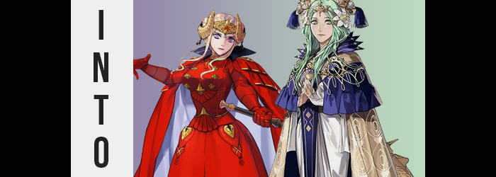

Halloween had arrived, which meant that there were plenty of people looking for good costume ideas. For most, this meant looking at the standard offerings. Butlers, policemen, sexy nurses – there wasn’t much care when it came to being creative once you hit adulthood for many. But those that still carried interest in things like stories, anime, and video games, there was a plethora of character ideas right for such an event.

Ori was one of those stuck on a costume idea. “Should I pick something from… No. What about Fire Emblem? Actually, that might be a good idea! I bet an Edelgard costume wouldn’t be all that difficult!” She’d definitely need a lot of red cloth, but depending on which arc she took her from, it was more doable than some of the more complicated anime characters out there.

Plus she wasn’t sure about dressing as Futaba Sakura for the third year in a row. Maybe.

OH? YOU WANT TO GO AS EDELGARD? WELL THAT CAN BE ARRANGED!

At the sound of an unfamiliar voice calling out from her computer screen, Ori jumped up from her chair with a shock. “Wh-Wh-Who’s there!?” She definitely hadn’t opened up and popup ads or anything, and an ad wouldn’t talk like that anyways! Was she haunted? Was it a ghost!?

HOW RUDE! AND HERE I, HISA, WAS PLANNING ON DOING YOU A FAVOR! WELL, THE WHEEL IS ACTUALLY IN MOTION ANYWAYS SO I CAN’T EXACTLY CANCEL!

“H-Hisa!?” That didn’t clear anything up! Actually, maybe it did sound a little familiar? Like she’d read that name somewhere before, but hadn’t exactly heard anyone say it aloud. Of course Ori had more questions for someone or something that was speaking to her through her computer, but before she could?

Her surroundings had changed. She was no longer standing in her bedroom, but instead was in what looked to be an inn room with a box on the white bed in front of her – marked with her name. “Wh-What!? How!?” People didn’t just teleport! That wasn’t even a thing! But she supposed it was possible she was dreaming, right? And if this was a dream, maybe there was something cool in that box?

She stepped forward and opened it, and within? There was an elegant raiment. An elaborate dress with a symbol in the accessories she immediately recognized. “Isn’t this the emblem of the Church of Seiros? Wait… This is Rhea’s outfit, isn’t it? But I wanted to be Edelgard!” But in just a few minutes, she wouldn’t want to even think about Edelgard von Hresvelg.

Nonetheless, Ori had already made the mistake of touching the box in the first place. That had been enough for Hisa’s magic to jump into its intended victim. Not that Hisa liked to consider her targets to be ‘victims’. They were more like ‘lucky recipients’ in her eyes. Whether Ori would feel lucky at the end of this, though, was something that had yet to be determined.

If she noticed anything first, it was that the clothes she was already wearing? Well, they were gone. “H-HEY!?” She had been stripped down to her bare bottom without so much as a tug, almost like it had been done with magic. Then again, she’d literally just been teleported somewhere else in the world. Having her clothes clothingknapped probably wasn’t the hill of bizarreness worth dying on at the time.

“Why am I naked!? You’re not trying to force me to put this costume on, are you!?” She couldn’t fathom why she’d have her clothing taken of all things, but it certainly served as a fair enough distraction as some prominent, yet difficult to notice warning signs bled into her appearance. Among these earlier signs was certainly a change in her eye color, which while one being a dark brown had ever-so-quickly brightened to a pale green that certainly stood out with the dark brown of her hair.

And it would have remained that way as well, if not for the fact that the very same green sprouted up midst the strands of her hair as if they were blades of fresh grass growing from a bed of fresh soil. They multiplied so quickly that it was hard to note the process happening to any single stand at a time, and before long her entire head was lit up with a hair color that certainly gave off the impression that it was dyed. However, Ori’s natural hair color had become something that couldn’t logically be natural in this world.

“She wouldn’t stop talking before, and yet now she won’t reply to anything I say? Is this really happening…?” The young woman was both distressed and annoyed about the whole situation and that was without yet noting that things were more serious than she already believed. Her green hair was lengthening like vines now, covering her ears in a way that concealed the fact that they were pulling into points as the hair wriggled down to her chest over her shoulders.

It wasn’t until a few strands tickled a nipple that the woman finally looked down. “AH!? Is… Is this a wig!?” Her first instinct had been to take a handful and tug it, which ultimately led to a sharp pain in her scalp. “Nope… Not a wig.” Alarming as the hair itself was though, casting her gaze back to her chest a moment she had to wonder: did her nipples look bigger? No, not just her nipples. Her entire chest was jutting out further than it typically did, which honestly wasn’t all that much to begin with.

“Uh… Bigg…er? Is my chest swelling!?” Ori could scarcely believe her eyes, so much so that both of her hands groped them as if to reaffirm what she was already witnessing. Not only had they grown, but they were growing even farther within her grasp, nipples poking sharply up against her palms in the process. Their weight forced her posture to lean forward ever so slightly. Not wanting to look like some sort of pervert (because she didn’t know if Hisa was watching), she eventually let go of them once they hit their maximum, E-cup sizing. “Th-This is seriously impossible!”

Her tits were so big and heavy, and they didn’t at all match her current frame! But on the other hand? They were only one piece of the puzzle that would be her continued problems. For just as she’d been forced to lean forward with the growth of her breasts, she soon found her balance being tested in the opposite direction as fresh weight behind her tugged her backwards.

“Uh…?” Ori looked over her shoulder frantically, doing her best to look past the green hair that fell back there. Considering her view wasn’t a proper one, she also reached a hand right behind her to take hold of the area she was fairly certain was changing: her ass. She didn’t have to do much more than grasp a full cheek to realize she was right. “My butt too!?”

Now, the woman’s chest had grown a lot. Yet by contrast, her ass grew even bigger. It didn’t take long for her hand to be wholly incapable of wrapping around it properly at all, the weight of each cheek so significant that her hips were forced wide so that everything below created what could likely be seen as the perfect heart shape. “It’s… so big…”

So big that every movement of her legs saw them rise and fall with hearty bounces, and so big that the eventually excess trailed into her thighs, which made good use of the excess space left by her widened hips. Skin slightly paler than normal, these inflated thighs met in the middle so that even when standing idly still, they pressed up against one another – and they were decorated by a thin bush of green pubes just above her changed pussy.

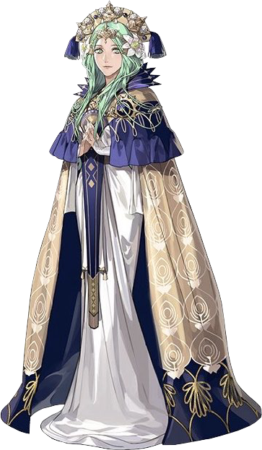
With Ori’s widened gait and big bosom, her 5’4” height only made them look all the more dramatic. It was something of a relief, then, that she soon felt her spine and limbs stretching. “Now I’m getting tall!? God, I bet I look just like…” Okay, so it hadn’t been much of a relief at all, and as she spoke she realized her voice was deepening the taller she became – until it sounded almost identical to the voice of one Cherami Leigh.

When all was said and done, she stood at 5’7”. It was only three inches taller, but it made her ample figure appear just the slightest bit more realistic. At the very least her thighs appeared more thicc rather than fat. She couldn’t help but run hands up and down her body slowly, all while her face reconstructed to be longer and much more naturally beautiful, like that of a porcelain doll given life. “Did I become her? But why? It makes little sense that… Hm? And why am I speaking in such a manner? So… proper. Mother, I should pray—Pray? Since when was I religious?” And mother?

The tall, full-figured woman couldn’t help but move her body about now that her transformation had completed. Despite being wary when her clothes had disappeared in the beginning, she was glad that they hadn’t been worn else they would have caused a great deal of discomfort during her physical shift. But how was such a thing possible? She hadn’t been given Edelgard’s costume. She’d been given Rhea’s – and then she’d become her.

“Hisa… Wait! Is that not the name of Axel’s creation? But I thought she was little more than a fictional character!” Not only did she look identical to Rhea, but she’d inherited the archbishop’s mannerisms and stiff manner of speech as well. When it came to her personality, her likes and dislikes were just as similar. That included her disdain towards the woman known as Edelgard.

“…But what am I supposed to do now, exactly?”

Only one room over, Axel had found himself within the confines of the hotel just the same. While Ori had been dropped into a bedroom with a queen-sized bed, he’d been dropped into the living room with a box with his name on it sitting on the middle cushion. Unlike Ori, he already knew what was possible. Anything was thanks to Hisa. But he didn’t understand why he was here. She hadn’t given him any notice – he’d just been looking at fanart of Rhea when she’d warped him there.

“This is obviously a trap, but…” Hisa had all of the talent of a murder game mastermind without any of the tact. If something looked like a trap, it was definitely a trap. “This is… This is Edelgard’s, isn’t it?” Crimson clothes with a golden headpiece shaped like golden horns on top. Was this the hint? But Hisa typically did things she assumed would make him happy, so why turn him into Edelgard over Rhea?

Regardless, he could tell that the box had been laced with her magic. It was already too late. And there went his clothes.

Surprisingly calm about, the young man closed his eyes. Experienced in dealing with her abilities, he could more or less sense what would be changing just seconds before it happened, and in this case? It was his eyes. When they closed they were a greenish blue that was more than standard. But when he opened them once more? They had become a striking violet that would likely only be possible via colored lenses in the world of logic and reason.

Once opened, the lashes around those eyes equally lengthened, and the shapes of his eyes took gently curves than they’d possessed before. Based on the flow of energy, he was confident that his face was changing even without touching it or looking for a mirror – and he was right. His nose shrunk and smoothed, and his slightly chubby face was drained of any excess weight so that his cheeks appeared thin and proper. Even his lips swelled, granting them a fuller glow that suggested what he had already assumed: he was being transformed into a woman.

“Next, hair.” He sighed, noting the energy had changed its location and was now settled beneath his scalp. Another good prediction, seeing as his typically short hairdo not only grew out rapidly, but the darker color lightened until it was white with a mauve undertone. It certainly wasn’t dyed, but if his assumption was correct than it wasn’t typically natural either. It was the result of something terrible that the woman he was becoming had endured.

YOU’RE NO FUN YOU KNOW, MASTER? CAN’T YOU AT LEAST ACT SURPRISED?

And there she was. His self-proclaimed servant and ‘daughter’. “I could, but then I’d be given you exactly what you want, right? Besides, how many times can you turn someone into a woman before it becomes unsurprising?” All that got was a huff from the nekomata, wherever she was hiding. He knew he was right though, and he knew that she knew he was right.

The transformation continued (not that he assumed she’d stop it), and he felt the height and weight of his figure begin to diminish. Being a thicker man, it was always a strange feeling to feel and watch your gut get sucked in, particularly when it happened fairly promptly. Yet in the blink of an eye he soon possessed a tight, firm belly that likewise pulled in at the waistline to give his sides a feminine curve.

On the other hand, with height dipping down towards 5’2” from being over 5’10” before, hips were the one area that initially swelled. They popped out several inches, the suddenness of it prompting hands to hug them with fingers that were smaller and well-manicured, but also came across as rather rough with all of the callouses erupting across fingertips from presumably wielding an axe.

Axel’s complexion was already fairly pale, but it paled even further as changes to his skin settled in. Flesh was overall softer to the touch, and yet fissures and skin indentations soon spread up his arms and around his torso and legs. A plethora of scars earned not only from combat, but from enduring human experimentation – the cause of the white hair as well. These scars lingered untouched for just a second, but his muscles soon tensed and expanded, leaving him looking rather built-in strength despite his short stature and effeminate visage.

His body, on the whole, was left looking entirely firm. “And now, I suppose— Oh. Well there’s my voice, I suppose. I sound entirely like… like… Gods, I’m not allowed to say her name?” He sounded exactly like Tara Platt, but for a character to mention their voice actress was something that went against Hisa’s rules.

Getting back on topic, he’d been about to make mention of his curves – or the surprising lack of them thus far, at least. He had a short and toned body now, but the character he was clearly becoming had some softness to her figure. Among these areas was the chest, of course, and so he didn’t even bat an eyelash once he felt nipples bloat and the new abs beneath them earn a layer of soft tissue that eventually jiggled into a ripe pair of D-cup breasts.

The other area? Naturally it would be around his legs and hips. He clenched his own ass cheeks a moment and let go, their weight jiggling more than he recalled the second he unclenched. Curiosity did get the better of him, so he peered over his shoulder – and yup! There was tight, pale ass there that would probably be nice to squeeze if not for how muscular it was beneath the layer of fat. This same layer graced his thighs, filling in the thigh gap somewhat, while…

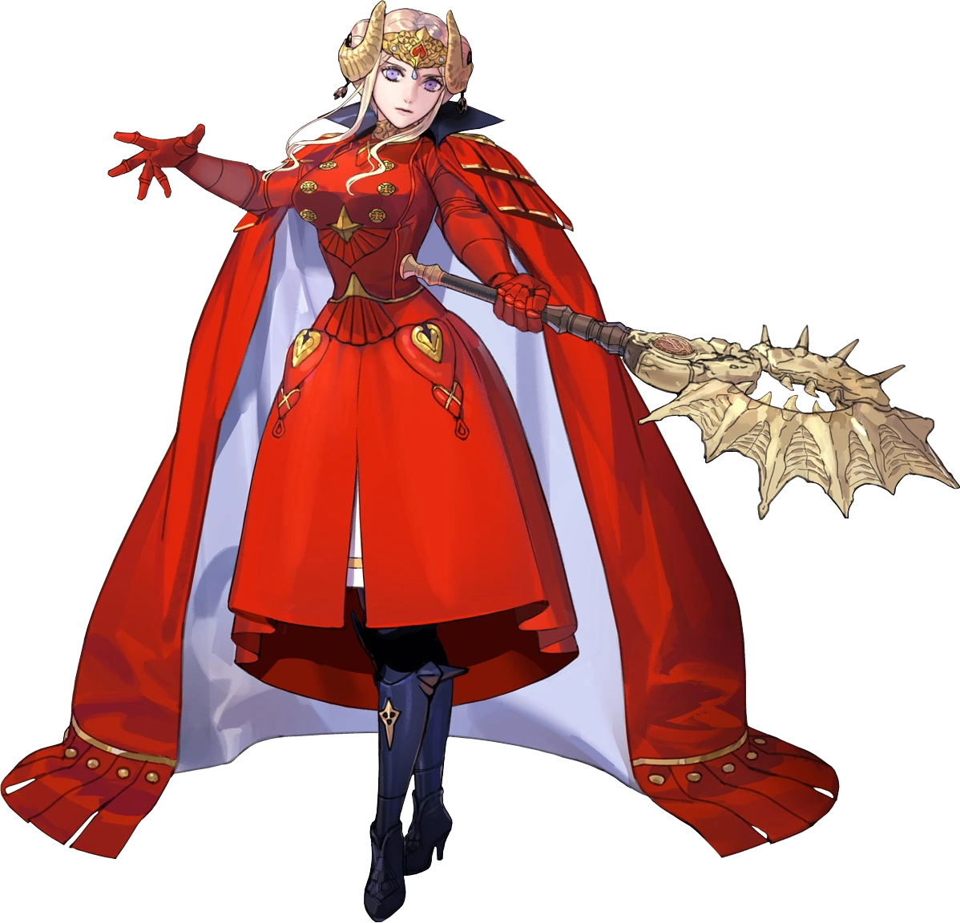
She sighed. “And there it goes.” Like a hose being reeled in, her dick had flopped around wildly a moment before being pulled into her groin, flesh redesigned into the lips of a sensitive pussy graced shaved entirely just above. If she sounded a little too serious about it, it was because her mental state had been subtly altered. She was simply behaving as the woman she had become would.

“Great, just great. How nice of her to allow me to keep my memories for a change. My demeanor, on the other hand…” Edelgard von Hresvelg held her head in her hand as she shook it slowly from side to side. In terms of body and mind she had become Edelgard wholly, right down to the scars that stained her body from all of the suffering she had endured at the hands of Those Who Slither In The Dark. But her mind? She could recall being Axel. “Let me guess… My name is Edelgard!”

Thinking she was alone, she yelled this with the intention of referring to herself as ‘Axel’, only to blurt ‘Edelgard’ out instead. That cat brat had put measures into place so that she couldn’t tell anyone who she really was. But the yelling had summoned the attention of another, and a green-haired head suddenly popped out from behind the door to the bedroom. “Edelgard!?”

“Rhea!?” On sight, the duo felt no shortage of disdain towards the other. Their memories didn’t align with the real deals, but their attitudes about one another had persisted. Even so, the same thought had occurred to the both of them – that the woman in front of them was actually someone else. They certainly didn’t bother to cover up their naked bodies, both of them too prideful to show even a moment of weakness.

OH, RIGHT! I GUESS THAT WOULD BE A PROBLEM… SO EDELGARD IS AXEL, AND RHEA IS ORI! YOU’LL BE STAYING IN THIS HOTEL UNTIL HALLOWEEN, AND IF YOU GO TRICK OR TREATING TOGETHER I’LL CHANGE YOU BACK AFTER… IF YOU WANT TO!

“Hisa!” Edelgard barked at the disembodied voice, and the source appeared before the pair of them, floating upside down. It was a young, nekomata girl. “Why did you change us into our opposing favorites!?” She had a point. It would have made more sense to turn Ori into Edelgard, and Axel into Rhea. The girl’s response? She just stuck out her tongue at them.

“Well, if you’re such big fans of the character the other became, then you have like three weeks to overcome their attitudes and get closer, right? Think about how close you two can get in that time!” Both Rhea and Edelgard went bright red as she said that, but before either of them could throttle her, she began to fade away. “Oh, by the way! I left alternate outfits for you two in the bedroom! Unless you want to stare at each other naked for the rest of the month? There’s also only one bed, so don’t forget to share!”

Left alone again, the two naked women just eyed one another with caution. The awkward silence that came over them lingered for a good ten minutes before they’d start talking out their situation.

It was going to be a long October.

