WITNESS PROTECTION
BIWEEKLY STORY #72
BY CHALDEACHANGE
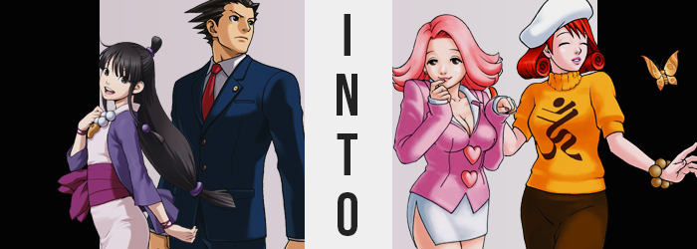

“Augh! This is stupid! Why did Nick and I get dragged out here anyways!?”

The frustration of Maya Fey might as well have been palpable, what with how tired this entire situation had made her. As the assistant of Phoenix Wright, she had been watching TV filing paperwork in their office when some strange looking cops had suddenly ushered them out and into a room in the inn across the road. An inn that was filled with unsavory memories for the both of them seeing as it had been so intrinsically tied to the death of Mia Fey, Maya’s sister and Wright’s senior.

They hadn’t really been given much of an explanation, which was part of the reason she was so pissed off! ‘Don’t leave the building, you’re under our protection for the time being’. But under their protection for what? Nick had held the same questions, but his attempt to leave had ended with him being forced back into the room they’d been given – so he’d opted just to take a nap for the time being.

“I don’t know how he can sleep at a time like this!” The spirit medium decried his behavior, but she wasn’t really better as she watched children’s programming on the television in the spacious suite’s conjoined living room. It was just easier to calm her nerves when she was doing something that took her mind off of it! Or that’s what she’d say, but Maya had really wanted to catch this Steel Samurai rerun. It was her favorite episode!

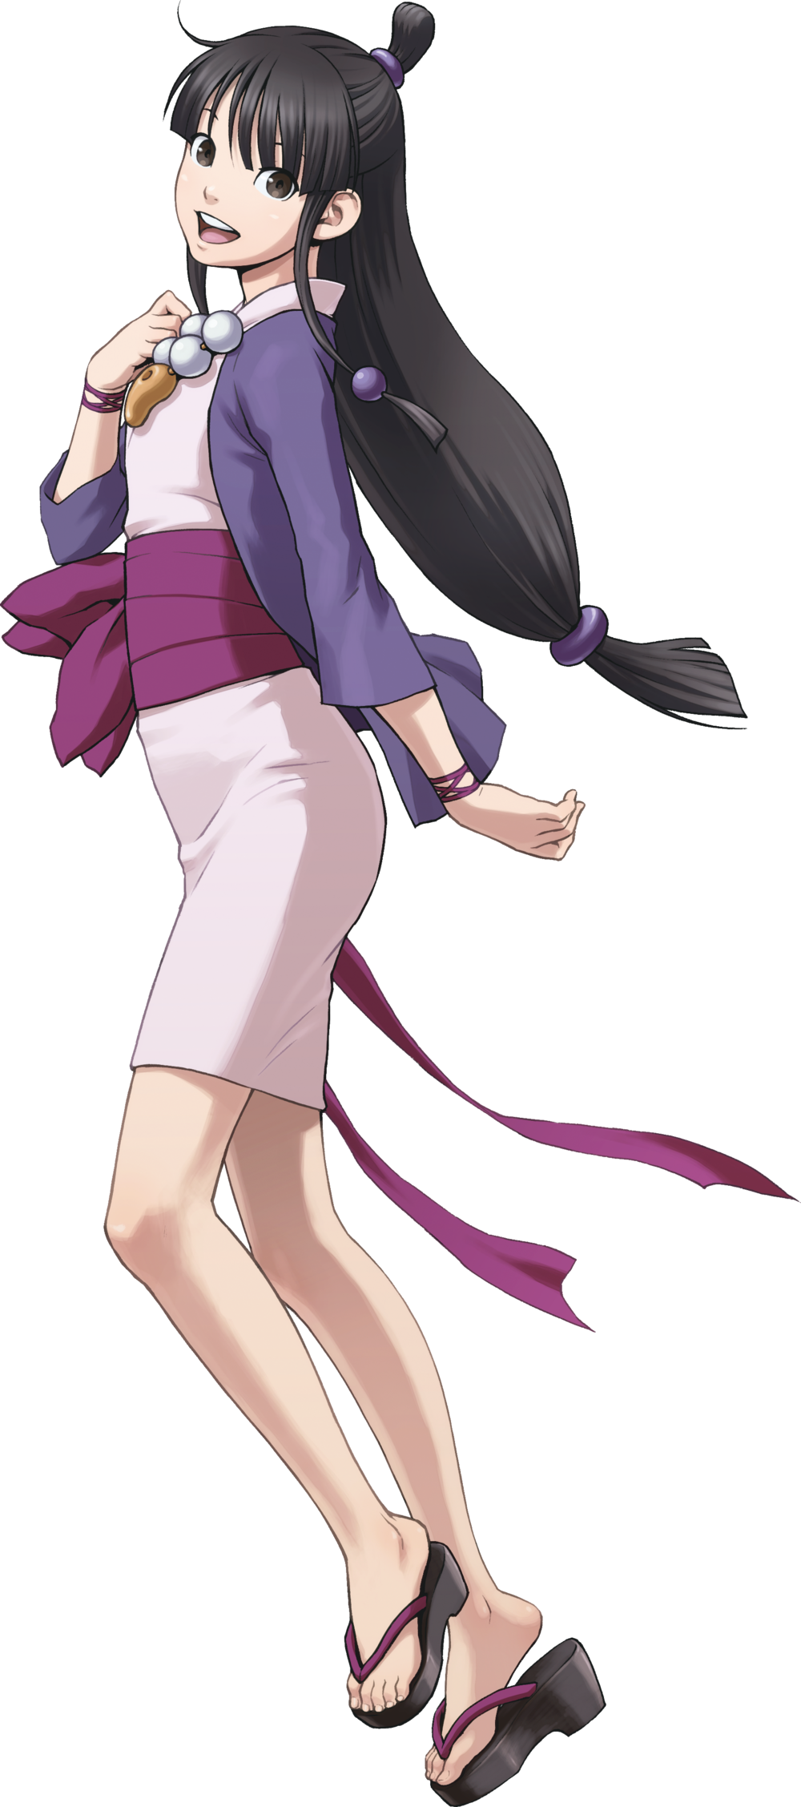
The more that she watched, though, the less interested in it she was. She couldn’t place her finger on it really. Even when it came to her least favorite episode of the show, she could always at least get into it. But this all seemed just a little boring. Too childish, maybe?

“Man, maybe this situation is taking more of a toll on me than I thought…” She eventually turned off the television and jumped up onto her feet again, wandering over to the window so that she could peer out of it. The Wright& Co. Law Office was just across the street, so why couldn’t they stay there for whatever this was!? No one was even there she could see it from there!

Why would I want to go there, though? After what that man did to my boss!

“…?” Maya wordlessly tilted her head to the side. Where had that come from? Her boss? Like at the café? No, she hadn’t worked there in forever! And why had Nick flashed into her mind while thinking about that man? He was pretty handsome, though! “Wh-What!? Gross! Nick isn’t… I don’t think of him like that!” Even worse than that was a sound that suddenly shot out from her mouth. Something in her subconscious had been attempting to repress it, but in the end…

“TEEHEE!”

A hand immediately flew up to cover her mouth. “Wh-What the heck was that!? I don’t usually giggle like that! I don’t usually giggle at all!” Maya’s eyes had gone completely wide, which made it easy to see a strange inconsistency in her appearance. Those eyes were usually a steely silver, and yet the moment she’d giggled? A brown had emerged instead.

“Ugh, maybe I’m just too worked up? That was really strange though… I need a big, strong man to make me feel bett— WH-WH-WHAT!? NO I DO NOT!” She’d never felt this way about men before – well, a woman would be fine too! – so what was going on here!?

Panic had understandably set in, and with it came a physical discomfort that the spirit medium initially mistook as a side effect of feeling so anxious. It was a tightness that she felt, really, almost like her clothes were far too tight in a sense. She wasn’t paying it enough attention to realize that this was exactly what was happening though.

Because, slowly but surely, Maya Fey was growing. Her arms were growing a little longer so that her sleeves pulled up to her elbows, and her torso stretched so that her kimono’s base rest slightly more towards the peaks of her thighs. “Eh!? Do my clothes not fit…? Actually, this is what I always wear, right?” Eventually the teen caught onto it, but before she could properly address the issue, she was overwhelmed by a strange sense of complacency that brought her to question whether what she thought to be true was even actually true.

Yet as she struggled with this complacency, the situation only worsened. In total she’d only gained a single inch of height but seeing as her outfit was fitted to her usual frame there had been just a little bit of wardrobe malfunction from that alone. This was because the tiny growth spurt only amounted to what could be seen as a prologue for the greater shifting in body type, taking Maya from a girl in her teens to, well…

The sides of the girl’s kimono skirt were stretching out to the sides, and on closer investigation it wasn’t too hard to see why that was. In fact, the sides of her skirt were digging into thighs that progressively appeared plumper and plumper, meat swollen in a way that was certainly tantalizing in a way that would earn her attention from onlookers.

This appealing look of them certainly was helped by the girth of her hips, which in the meantime stretched wider – but even with this width she couldn’t help the fact that her thickened thighs rubbed together even standing idly. Her kimono’s skirt ripped a little at the sides from the pull of it all, and those rips only worsened thanks to the fact that her ass was exhibiting similar symptoms.

“Nn! These clothes are so – TEEHEE! – tight – TEEHEE!” Maya was powerless to stop herself from giggling despite the emergency taking place here. But on the other hand, her mind was leaning more towards the idea that this was somehow ‘normal’ instead. Even though it absolutely wasn’t normal for a girl’s ass to explode into an engorged peach shape, sucking panties up into her immense crack and pulling up her skirt’s back so that the base of that crack could be seen.

It was a phenomenon that travelled upwards, and beneath her kimono that handles of her stomach tucked in to give her a very dramatic hourglass figure – at least one that didn’t possess the upper segment. But forced to unwrap itself, her kimono’s top soon revealed that this upper segment was growing in splendidly. Perky breasts that had previously been little more than A-cups had grown with such enthusiasm that they’d pushed the kimono open, revealing pink flesh that jiggled almost cartoonishly and topped with dark pink nipples which sported areola twice their normal size. Without even thinking, Maya pinched her elbows to the side and gave her new babies a jiggle.

As if it were completely natural for her to do so.

“Oh my! I really don’t know how… Hm! Is my voice prettier? I sound so… so sexy!” The woman (as her body now clearly presented her as a woman in her twenties) was hung up on her voice just as quickly as she heard it. Not because she found it strange, but because she was elated by it. Oh, how the purr of her voice paired with the bounce of her breasts could easily seduce anyone – WAIT! That’s not the kind of person I am! TEEHEE! Of course it is, you silly billy!

Maya wasn’t thinking much of her clothes now, though subconsciously the thought of ‘these are hideous’ did strike her briefly. Rather, she was puckering her lips because they felt a little unusual to her. It was because they had engorged themselves and were almost triple the girl’s usual thickness, yet what instead crossed her mind was ‘am I not wearing lipstick?’.

This change was just the smaller stroke of a great deal of brushwork that saw the medium’s face altered completely. It didn’t take long for the maturity her figure suggested to show, what with lengthened lashes and duller eyes. But Maya’s face stretched a great deal horizontally too, and her brows narrowed to a pencil thinness with an unfamiliar color seeping into them. A bright pink. At the sides of her head, holes appeared in the lobes of her ears that suggested she regularly wore piercings.

Without a single doubt, Maya brought a finger to her lip to poke at it – a habit that wasn’t actually hers. Yet each time she poked that lower lip, the bitten nail at her fingertip grew longer until it, and ever nail on her hands, was an inch past the tips and perfectly manicured. “Teehee! I’m so silly! I feel like I’m forgetting something important!”

She really couldn’t place her finger on what though. It really felt like a dumb blonde moment to her, but her hair both wasn’t blonde before, and it wasn’t turning blonde now either. Rather, a cotton candy pink had made its way into her mane and was softening its look so that it became far fluffier than it should have been. It was clear that plenty of hair care products were used in it between the look and smell of it, especially as it fanned out to the sides both in the front and the back. Her forehead was left totally exposed, and in the back not only had it shortened to fan out just above her shoulders, but the tie up top had come undone too.
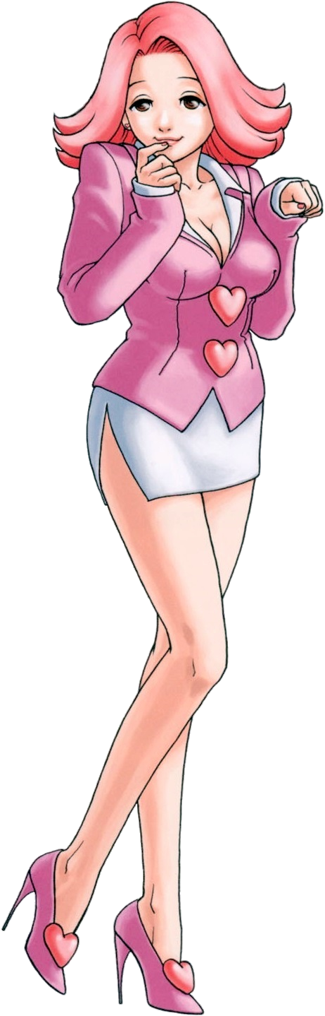
One Miss April May was both confused and not at the same time. Why was she staying in an inn room all of a sudden? Why was she dressed in these unraveled hippie clothes? Just as quickly as questions came, answers followed after. “Teehee! Oh right! Those nice offers told me we’d be here for witness protection! Something totally bad happened, right? And my clothes are supposed to be a disguise!”

Manicured fingers took her unraveled, pink kimono and tried to close it tightly across her frame… to no avail. “But oh my! Of course! My juicy tits and fat thighs are too big!” It sounded indecent, but April had mastered a method of spewing dialogue to make herself sound hot and appealing. It was so easy to get men around her finger that way! In fact, with her panties clinging on perhaps it was fine just to stay dressed like this for the time being?

“My, what time is it!? At least until she awakens, maybe I can catch my favorite soaps! Teehee!”

“Ugh, I feel like I was hit by a bus… What a weird day today has been…” Phoenix Wright did eventually rise from his slumber some hours after Maya had undergone her unusual transformation. With the bedroom door shut, all he could hear was the soft hum of voices from a television talking in the living room. It was a far cry from the usual loud and boisterous sounds that bellowed from her inexplicable choice in children’s television for a girl in her late teens, but the defense lawyer didn’t really think all that much about it.

He wasn’t dressed in his full suit when he stood from the bed of course. He’d taken off the jacket and his tie before laying down, and he’d slept in the rest because he hadn’t had a chance to pack anything before those strange officers had whisked Maya and himself away. Try as he might he hadn’t been able to get any answers out of them, so he was thinking maybe he’d try again since they were stationed outside of their suite’s door.

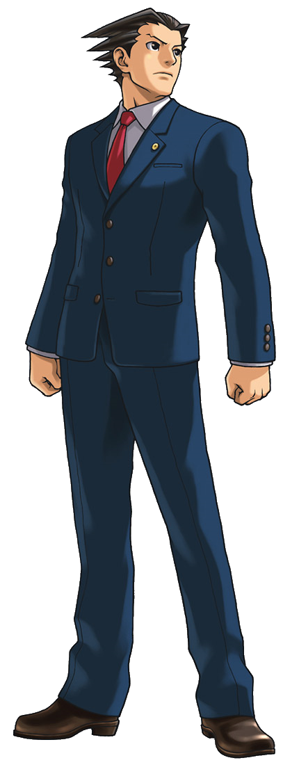
But first? He really had to pee. There was a conjoined bathroom to the bedroom, and so he went about his business without much issue. While washing his hands after the fact, though? “Huh…?” A strand of bright red had caught his eye. It was a strand of his own hair. No, not just a single one. At first, he’d thought that maybe this was the case, but before long? His entire spikey head was done up in a crimson that looked terribly clown-like in shade alone.

“Uh… What the heck?” The signature Phoenix Wright look of confusion was plastered upon his face. It wasn’t as if he’d suddenly just been conscripted into some sort of Red-Headed League or anything of the kind, and last he checked hair didn’t just change color. While squinting at the reflection in question though, he was soon made hyperaware of something else – it wasn’t simply the color of his hair, but the style was changing as well.

Frantically, the man rubbed at his eyes thinking that perhaps he was seeing things (and as he rubbed at them, the jagged design of his eyebrows mysteriously rounded into normalcy) but that didn’t change the reality of it. “My hair is flattening? H-HUH!?” That just didn’t make sense! He used so much gel that those spikes never came undone without water!

But there they were, flattening atop his head without any water whatsoever. Even putting the lack of spikiness aside, didn’t they also somehow look a little longer? It took a moment of squinting even harder than before for him to acknowledge that yes indeed, this seemed to be the case. Both at the sides and in the back the red locks were growing longer, and before long they touched his shoulders… only to find themselves rolled up until thick curls that just appeared to grow thicker and thicker.

“This is definitely the type of style a woman would wear! And I can’t help but feel like I’ve seen this hair before…?” Mr. Wright really wasn’t sure how to react to all this, and so he was lifting up on his curls and dropping them gingerly while attempting to reason his way through the situation. Was Maya still in the living room? Should he ask her for help?

Like hell I’m asking a Fey for help!

“H-Huh!?” The lawyer was immediately taken aback by a voice in the back of his head that cried out vehemently in protest. Between Mia, Maya, and Pearl, he was so indebted to the Fey family but… What was this rage he was feeling well up at even the thought of them? It made absolutely no sense! “GAAAAH!? WHAT… WHAT NOW!?”

Things were happening at a quickened pace now, and unlike Maya, a portion of Phoenix’s transformation was accompanied by a great deal of pain. It was his face – it felt like it was on fire, like it was melting! His reflection ended up being something of a horror show simultaneously, skin sagging and tightening at random while a sharp jolt readjusted the fit of his jaw. In the end it had collapsed entirely so that it was very petite, and the features?

They undeniably belonged to a woman and not a man. With his hands on the sink’s counter to keep him stable, he was shocked to find himself staring at plump, cherry lips, and thin cheekbones. The chiseled shape of his jaw was gone completely, and while he was fairly certain that the color of his eyes had changed? He wasn’t afforded much of an opportunity to observe, because his eyes were pulled tight until they were almost entirely closed. He was squinting involuntarily, almost like his life depended on it.

“This face… I’ve seen it before… And it’s not mine.” Of course it wasn’t. It clearly wasn’t the face of Phoenix Wright! But the venom in the tone of voice that had pointed it out sounded much more personal. It was almost like there was another voice calling out from within, and that voice also acknowledged this face as a travesty. “But how did this happen? My hair, my face, my…”

He could have pointed it out, but it would have been frivolous to do so. After all, the man was clearly facing a new problem: his height was diminishing. Even though he was only in his dress shirt and pants, the change in fit was pretty significant. The bottoms of his pants ended up pooling around his feet, while his dress shirt emptied not only because he’d gotten short, but because he was thinner to boot! His muscles had thinned so that he was leaner, and his waistline had tucked in.

The term ‘effeminate’ could surely be thrown around regarding his body type at this point. Wright’s pants were only fastened to his hips still because his hips had swung wider with a substantially uncomfortable POP, which in turn had also forced the man’s knees to buckle inwards. “Ah!?” Fortunately he’d still been holding onto the counter so that he didn’t fall, but what had been with that feminine moan of a cry!?

In fact, the hands gripping the counter were looking quite different as well. Thick fingers had diminished so that they were pencil thin, and clean cut nails stuck out where carelessly maintained growths had once persisted otherwise. To match, his feet hardly fit in his socks now, sporting softened heels and daintier digits.

“I’m turning into a woman…? No… I am a woman? But of course I am, right? My surgery didn’t involve changing my sex! W-Wait, surgery!?” The lawyer felt as if he were just blurting things out, but every time he did a memory accompanied the words as if to confirm them. And these memories? They struck a chord with the part of him that was still himself. His identity was becoming— “AHN!”

Before that realization could be expressed, thighs rubbed together as a wave of pleasure struck her. Phoenix’s cock and balls had eroded, and in their place a woman’s pussy decorated with a tiny, red bush had been sculpted instead. With her new sex, those thighs that were rubbing soon blossomed with a new femininity of their own, filling out the peaks of her dress pants so that they could hardly contain these fatter thighs.

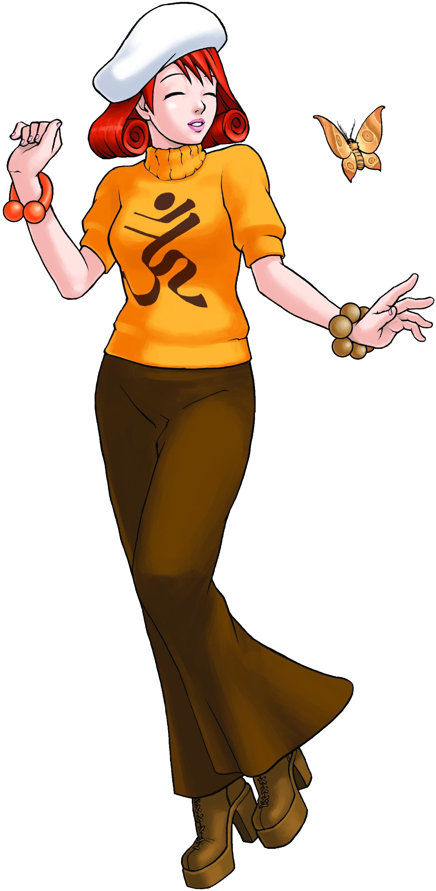
Similarly, her rear filled out to push out the back. Boxers tightened around cheeks that swelled to a delightful size; tight, firm, and appealing as could be. It was only fitting that she earned a perky rump, for beneath the confined of her loose-fitting dress shirt additional fruit grew to compliment the peach-like shape of her bottom.

Considering she was a woman biologically now, there was only one thing – or one set of things – that could grow there now. Tits, ripe and perky. They began with nipples both elongated and thickening, removing boyish nipples in favor of those several coin sizes larger. Fat filled her mammaries beneath these erect nips, and gradually a flat chest erupted into a pleasing showing of mini-melons. D-cups surely, but her oversized shirt absolutely didn’t do them any favors.

Unlike April May’s ultimate reaction to being cooped up, Mimi Miney was a little less indifferent. “What the hell was the point of all this!? Cooped up in some crappy hotel with a woman I don’t even know, dressed in a man’s clothing…!” What was all of this ‘witness protection’ shtick even for? What had she done that made it so she required protection!? And right after she’d gotten out of prison to boot!

Actually, on that note? How had she gotten out of prison anyways? The charges for murder were pretty severe, and she should have been left there for most of her remaining life. Yet… Oh, had she been scooped out of prison for this program? It only made sense, right? That had to be it! So perhaps this situation wasn’t that bad after all! It didn’t really explain the clothes, but…

“Miss Miney? Are you finally awake?” The sound of another voice immediately prompted Mimi to put on a kinder façade more reminiscent of her sister. After playing that part for so long it had become something of a coping mechanism without her even realizing. But standing in the doorway dressed in practically nothing was April May, her cheeks rather pink. “Teehee! I was curious! I know we’re both girls, but perhaps you’d like to fuck? We are sharing the same bed after all~!”

This chick was forward! Mimi immediately went red herself and seeing as she was dressed only in a pair of boxers and a white dress shirt that had the top few buttons open, she wasn’t really in any position to judge April for her outfit. She supposed she did feel a little into the idea though (a side effect of the transformation she didn’t know had happened). “Oh, how bold of you!”

“But just so you know, I’m a little rough!”

“TEEHEE! ME TOO, ACTUALLY!”

