**“All right everyone! Cam’s all good to go in three so give these babies ya best look alright? And a one…and a two…and a…oi *Suzi*! Get a lil smile going would ya? You’re looking a lil too gloomy!”** A mute wave of chortles and giggles would erupt from the surrounding gaggle of girls clad in cheerleader’s uniform lathered in somber tones and moody colors observing the shoot with attentive eyes, a thrumming mass comprised of feathery gray stripes, lace black outfits, magenta blue accessorization and a shared deathly pallor surrounding a similarly dressed photographer and her three subjects, awaiting the frazzled girl in the center to fidget awkwardly in place, flanked by a cohort who had avoided the judge’s wrath with acceptable poses and facial expressions of their own. Casting sidelong glances upon their uncertain partner who seemed confused as to what she was messing up, evidently plagued by more than just flustered embarrassment as seen in the slight frown that crosses her otherwise adorable face. A sight that paints a grin over the visage of the one overseeing it all from her lofty vantage point up on the stadium stands.

For there was a time when the petite little goth had been more assertive, headstrong and annoying. Someone who could barely be compared to the quiet waif taking on a pose oozing femininity; with a dainty shoulder thrust forward, slender arms crooked at the elbow and thrust down between crooked, girlish legs sporting just the right amount of flab in cushioned thighs and firm calves., finishing it off with an expression of whimsy aloofness. The perfect expression that capitalizes on the innate cuteness of her pinchable face and the mystique layered on by dark eyeliner and a frazzled mop of hair that curls all around. Giving her the appearance of a lackadaisical mischief maker despite the well kept locks that composed said mess attesting otherwise.

As for ***who*** that someone was…***he*** had been the one to prance about the world in ***Juliana’s*** stead before her metaphorical birth. A rogue with no respect for authority, a charmless oaf who thought brawn to be the only factor women should be looking for in a man and the latest scumbag to feel the wrath of picking on the wrong group of magically charged girls with outdated insults he had thought to be witty and scathing…serving only to stir anger and dissent rather than the heartbreak and sorrow he had hoped to instill when third year star quarterback ***Troy Richter*** had decided to pick on a group of new inductees to the school’s goth-themed cheer squad. An odd sort not even the queen bees and school bikes dared mess with for reasons the oaf would soon discover for himself when the head honcho in-charge of ***Death Cheer*** had come to confront him a day after the delivery of his vulgar vocals in the confines of the stadium….*only to promptly transform Troy without giving him a second to argue or put up a defense*.

By the time hard earned muscles had all but faded away under a deluge of magical energy coaxing forth tender mass and scrawny bones wrapped up in porcelain smooth skin while organs new bubbles forth within plentiful space offered by burgeoned hips and a heftier rump, the damage had been done. And Troy was left a fully functional girl dressed, not in baggy trousers and a lanky singlet but the Death Cheer’s standard uniform. An appropriate choice of attire to match the brooding makeup and hairstyle that had replaced Troy’s ginger curls and chiseled facial features. Leaving her helpless to resist her fate especially once she had realized the witchy circle had done more to her than just take away her physical strength. Planting some sort of ‘seal’ within her very being that prevented her from behaving the braindead boor she had been until a few seconds ago, similarly replaced with a meek, mousey persona to match her timid appearance.

Even worse however; was the effect the spell had over the rest of the world. For everyone else, including formerly disappointed parents who couldn’t have been more proud of the new little girl they remembered raising, had been made to forget about Troy as he once was. Leaving all the room in the world for memories of a ***Juliana Richter*** to take their place, a goth loving first year student with an aspiration for cheerleading and dance, hence her decision to join up with the Death Cheer as one of it’s newest members…a fabricated yet all too real experience roiling within the confused girl whose mind was being overwhelmed by the memories of two separate lives. Mental turmoil the likes of which she could not resist, especially when her new ‘squadmates’ had begun to encroach upon her, ready to introduce her to a world she had never thought to experience in such a way…

And after a few weeks of cheer practice, group hangouts and general life on the other side of the fence. It was safe to say that Juliana was warming up nice and cozy to her sudden change of circumstances. True, mannerisms and ‘muscle memory’ had been seeded at the moment of her change. But under the watchful eye of someone as seasoned as ***Minerva’s***, one could notice several subtleties that made Juliana stand out in comparison to her behavior since being forced out of the wrinkled cocoon that was Troy Richter. Of note being the lack of hesitation when it came to everything she did; from being the last to leave the locker rooms to following the others out on time. Losing the awkward gait in which she maneuvered all over the place with once her mind had properly settled in to her body’s undeniable state and the way in which she spoke being the most damning of them all, dropping the uncertain quake at the back of her voice while speaking in a demure tone far divorced from her crude speech pattern back in the day being rife with vulgarity and modern slang.

In fact, Minerva was beginning to grow suspicious as to the validity of Juliana’s claims to the contrary of what her behavior was suggesting. That, after close to a month of living life as a cute little girl, she had begun to grow accustomed…no, happy with it. A first from the many like-minded fools she and her sisters had punished over the past three years before turning them back to normal come the end of a month spent trapped in their temporary new lives. Having someone live it as if it were their own however…a surprise but not unwelcome result that had the Death Cheer leader’s mind alight with thoughts of what to do next.

And as an image file blips into existence on the screen of the laptop she was using to edit the newly taken shots with, the smile on the gothic witch’s face gives way to a pleasant grin as she ponders the idea of letting Juliana ‘simmer’ for just a little bit more before bringing her newfound addiction to light when the time came to lift the spell at the end of the month, wondering what to do with her should she really wish for the spell to be made permanent despite all the humility and initial disgust she had to trek through before discovering the benefits of being a well-educated maiden with a love for the aesthetic she once labeled them as ***Freaks*** for liking so openly. All while excited eyes linger on the still image of Juliana while she decorates the frame with the team name, accompanying images and overlaying filters to perfectly convey the mood set by her lovable team…

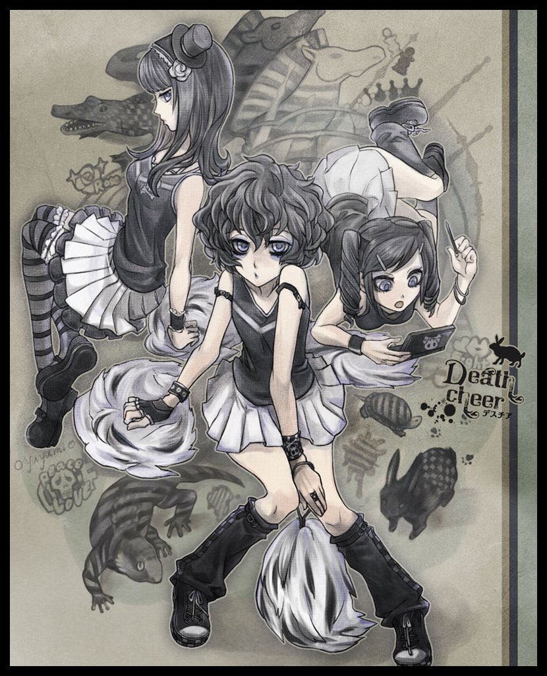

THE END

Image by Oyuyamio : <https://www.pixiv.net/en/users/61253>