MATURING DEVOTION
BIWEEKLY STORY #116
BY CHALDEACHANGE
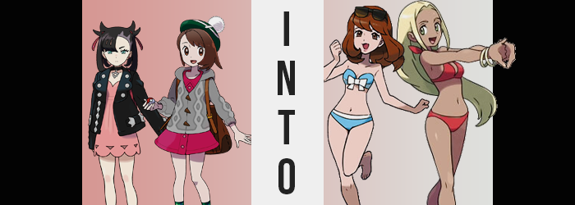

“Oi, Gloria! Ain’t ya getting a little cold?”

“Cold? We’re at the beach!”

The concern from Marnie that was aimed at her girlfriend, Gloria, wasn’t exactly unfounded. The brunette was shrugging it off because they were at the beach but she was omitting one fact in particular. It wasn’t the middle of the day. The sun wasn’t out but the moon was. They were out in the dead of night with the resort they were staying at serving as their backdrop.

It had been Gloria’s idea. Going out to the beach in the middle of the night? Well, yeah. But more than that. This entire trip to Hulbury had been the Champion’s doing. A year had past now since Gloria had become the Champion of Galar and in that time she had spent a lot of time traveling while Marnie had been doing her best to inherit the positive of Spikemuth’s Gym Leader.

The two were fifteen now and had been dating for a few months. With summer upon Galar, Gloria had seen it as a good chance for the two of them to go on a ‘vacation’ – even if it would have been better had they had gone to a different region. They had already been at the resort for a full day and it was going well! But being full of energy as always, Gloria had been restless and wanted to go for a walk.

“That ain’t… Huh? A shootin’ star! Don’t see too many of ‘em!” Marnie had wanted to refute Gloria’s nonsensical argument when a star streaked across the ocean before them. “You should make a wish!” Marnie’s wish had been a simple one. To be able to spend more time with Gloria. They were both always so busy even though they were still basically kids.

Gloria was much more dramatic about making her wish though. “Sure!” She wrapped her fingers together and closed her eyes. Her wish was similar to Marnie’s but a little different. She wanted to spend forever with Marnie if she could and she wanted to grow up faster to do so! Maybe it was a little childish, but the bond those two girls shared? They both treasured it immensely.

Little did either of them know they were wishing upon a Jirachi.

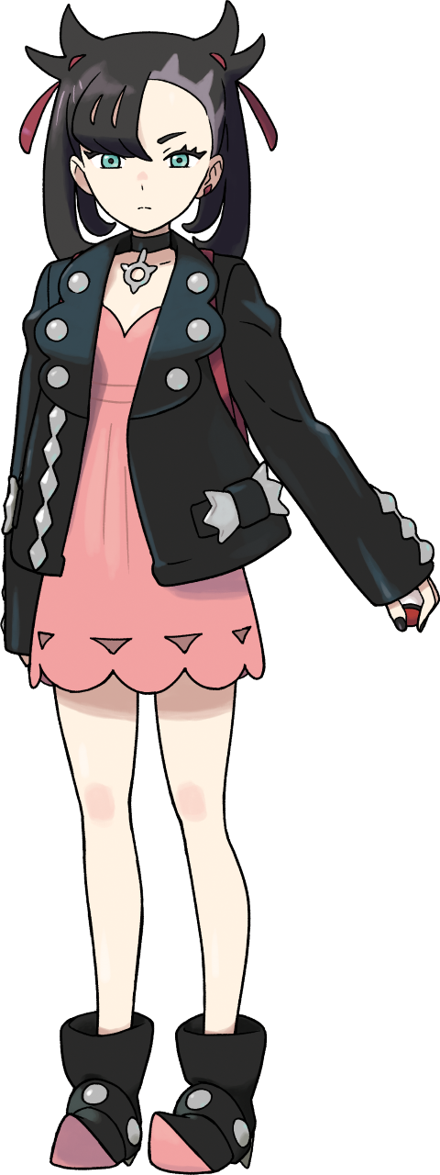
“E-EH!?” For a brief moment the ‘star’ that Marnie had been wishing upon had burned a bright blue. Something that was strange, but certainly not as strange as finding herself now back in the resort room she’d been sharing with Gloria. “Wait! How the heck’d I…? This ain’t even our room, is it!?” She’d assumed at first that it was. It looked exactly the same. A difference was soon noted though. The luggage in the room wasn’t theirs.

There was an open bag on the bed with some unusual things inside. Rubber toys? Marnie didn’t really know what they were, but they weren’t hers. Little did she know that this was all part of her wish fulfillment. Well, their wish fulfillment. Jirachi had heard their desires and altered reality to do so. Marnie was in their room, but their circumstances were different.

She just hadn’t ‘adjusted’ to them yet.

“Suddenly bein’ sent back to the hotel room though… Did a suuuuper cute Pokémon do that!?” The girl practically wanted to gag at the words that had just left her mouth. She’d been too stunned mid-sentence to stop herself from saying the rest, and while she had meant to communicate a wondering about a Pokémon’s involvement in her circumstances, never in a million years would she have worded it like that. She had momentarily sounded so vapid, like the kind of women you often found beachside. “…Huh?”

That was already an issue worth addressing, but the fourteen year old was immediately forced to reckon with a much more serious and obvious problem. Her knees had wobbled for a moment and Marnie had wondered why, but it very quickly became obvious because the bed appeared lower than it had. Not to mention her dress had been hoisted up so that more of her legs were exposed. “Oi! What’s goin’ on here!? It’s like I’m gettin’ waaaay taller!”

She pulled off her studded jacket and tossed it aside (not noticing that it disappeared into nothingness the second it touched the ground). Marnie wasn’t wrong, she was growing taller. Already 5’5”, this was a five inch addition to her frame that her dress couldn’t properly cover. Though strangely? Rather than reveal the girl’s underwear at the dress’ base, there was a sky blue, latex swimsuit bottom sticking out. One that didn’t look like it was properly fitted.

“How is this happening? Even the way I’m talking is super weird!” It was hard to deny that she sounded more energetic, and what’s more? Her Spikemuth accent had completely dried up. Was her voice a little deeper too? Maybe the fact that it was wasn’t all that surprising. Because if you observed Marnie’s face a little more closely you might have noticed it appeared older.

Yes, there was a newfound maturity in her facial features and at first? It just made her appear like a version of herself that had grown into her twenties. But that didn’t last long. Her lips promptly swelled to double even their new mass, becoming thick, pink and pouty between cheeks that were a little rounder. Her complexion was changing too, her pasty pale becoming a little pinker itself. The shapes of the woman’s eyes widened and brightened, which almost seemed odd because her eyes took on a plainer chestnut brown when compared to their previous greens.

“Heehee— HIC!?” It had been impossible for her to hold back a hiccup that jumped from the back of her throat, though the sound had been accompanied by a taste. Booze? When had she consumed alcohol? The thought didn’t even cross Marnie’s mind that she’d never had alcohol before to know what it tasted like – but as she looked more like an adult she begun to think and remember things that an adult easily would. She almost wanted more of that flavor. I wanna feel good!

With the taste came the growing feeling of intoxication. She felt a little woozy, and that wooziness meant it was easier for her to miss the changes that continued to happen to her. Such as? Well, her black hair had rapidly inherited the same chestnut brown color that her eyes had. What’s more the horns had flattened and her shaved sections grew back. Fuller and fuller her brunette locks became while falling fluffily to her shoulders. The Gym Leader’s icon hair color was gone!

She swayed back and forth. Her surroundings were spinning a little because she was drunk now. “Whoa… Everything’s like, super spinny!” It felt a little like she was forgetting something? But she couldn’t remember what that was. Once or twice she stumbled, yet Marnie didn’t catch onto the fact that those stumbles were not from her newfound inebriation. Her hips had widened several inches, given no choice by pink thighs that had swollen to about one and a half times their original size while her ass perked up properly. These changes made it so that the sky blue bikini bottom fit snugly.

The woman had to throw out a hand to catch herself on the nearby nightstand, balance once again thrown off so that she stumbled forward. “Whee!” The cause of this imbalance was the weight of her chest. Having only been fourteen before, it wasn’t as if she’d had a particularly noticeable bosom. But now that she was a young woman? Additional padding saw each breast grow bigger and bigger, nipples enlarging along with them while her dress struggled to contain them.

Not that it mattered for long, because into nowhere her pink dress disappeared. C-cup tits were exposed to be not bare, but to be covered with a sky blue bikini top with a white bow that concealed what needed to be concealed. In fact, every piece of her old outfit was gone, replaced otherwise with only a pearl anklet on her left ankle and a pair of sunglasses that rested atop her head despite it being the middle of the night.

Despite being drunk, the woman’s mind had never felt clearer.


“Wowie! I totes almost forget to grab the booze!” Was there even a coherent thought in the head of the woman that Marnie had become? She was incredibly bubbly and vapid, practically dancing around the room in a tizzy as she tried to remember what she was doing and why. It probably didn’t help that she was already intoxicated, being something of a party girl.

At her core? Marnie still existed. But this new life seemed way more fun!

But first and foremost she was a Swimmer, or that was how she identified on her Trainer Card anyways. That explained why she was wearing a blue bikini even as she rooted through her bag, pushing past the sex toys she’d hopefully get to use later to find the bottle of vodka that was hidden underneath.

Swimmer Marcie had come to this resort with her girlfriend of five years and she wanted to make the best of it! “Totally can’t believe she wants to go swimming this late! That’s why I wuv her, though! She’s so wild!” Was mixing swimming and alcohol a good idea? Probably not. But she ran out the back door of their room and onto the beach with the vodka in hand, nonetheless.

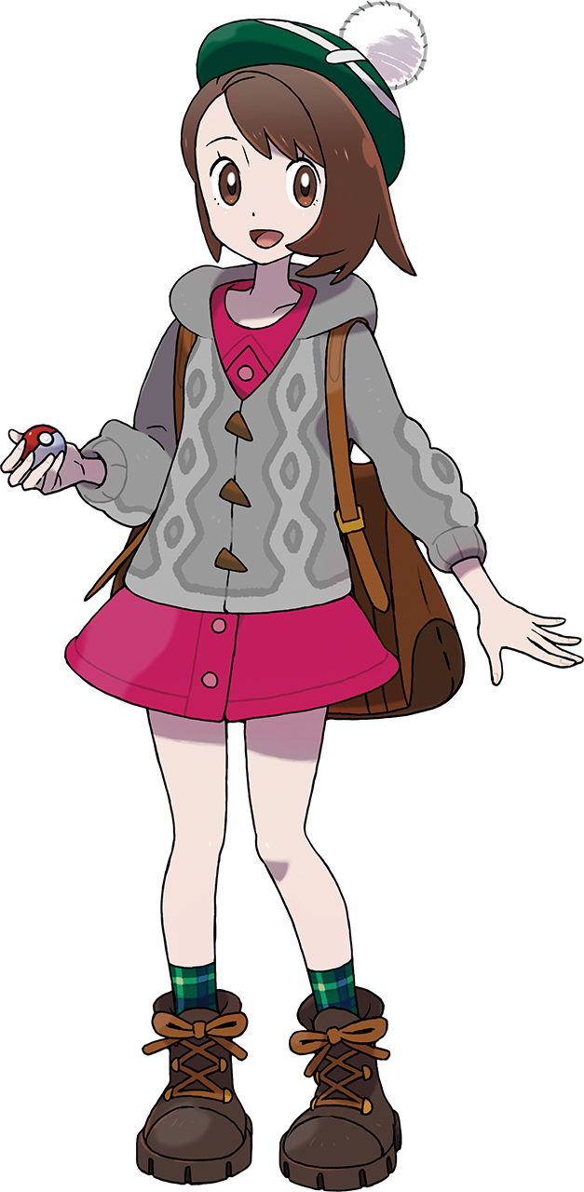
“Huh? Marnie!?” From Gloria’s point of view she had closed her eyes to make her wish, and when she had opened them? The star was glowing and her girlfriend was nowhere to be seen. She hadn’t been teleported back to their room like the other girl had been because she was still where she was supposed to be. In this new reality shaped by Jirachi, Marcie had run back to get the booze they’d forgotten while she’d remained on the beach. “Where’d you go!?”

Or, well, the woman she’d become had remained on the beach. The pair of them evidently would remain girlfriends, but it was Gloria’s wish to hurry things along that had changed her partner into an adult woman. For things to still make sense with their relationship then what had to happen now might as well have been painfully obvious, even if the Champion didn’t realize it.

She had to become an adult as well.

Unlike what was happening with her girlfriend back in their resort room, however, Gloria didn’t experience her growth first. Instead her earlier changes were a little more discreet and difficult to see since she didn’t know to look for them. The Champion’s eyes were a great example of this, with their usual reddish browns changing to an olive green as speckles of this new color ultimately overwhelmed the old.

“Where could she have even gone? She was right here a second ago…” In the meantime the transformee was still far too confused about her disappearing partner to show any introspection. Since it was the middle of the night and relatively dark out, even with her bangs swept lengthily to the left it didn’t occur to her that her bangs were lightening in color. It didn’t take long at all for them to become a platinum blonde and, even more bizarre, lengthen all of the way down her back. Her bangs had thinned and parted so that her forehead was ultimately exposed, too.

Even Gloria’s skin was aboard the color change train. Her pale skin darkened shade by shade towards a bronzer tone. This might have seemed like a fake tan considering she had been so pale before, but in truth? That was her biological skin coloration. That was her permanent skin tone as dictated by the melanin in her cells. Paired with her new hair and eye colors, she hardly resembled the girl she had been just moments ago.

She rocked back and forth. “I could… reaaaally use a drink!” This assertion, spoken in a way that felt a touch immature for Gloria’s typical demeanor, was spoken through lips that hardly appeared immature at all. In fact, much of her face looked older. Her lips had grown fuller, her gaze had narrowed, her cheeks were higher – all giving her the good looks of a mature young woman… on the body of a fourteen year old girl.

Based on what she was whining about though, it didn’t seem like that was an existence that was in the cards for long. And true to this assumption, the fit of the girl’s favorite outfit was promptly compromised. At first it was her top, with her button up dress and the yarn jacket thrown over it pushing forward because, well… Flesh was pushing forward beneath them. “Huh?”

Gloria’s voice had a sensual purr to it that hadn’t been there prior even as she made a noise of surprise. “Wait, was my chest always…?” That big? That was what she had noticed. A once teeny bosom had grown into a full pair of D-cups upon her chest – looking even larger since she hadn’t grown taller yet. Her top two buttons had flown off to show tanned cleavage, contributing to the idea that she might have just been a short, but fully grown adult.

But she hadn’t even noticed that swell hadn’t been isolated to her bosom alone. Since the Champion’s skirt was already fairly wide, hips extending an extra three inches apart were only really noted because her knees had buckled a little more because of it. That growth was needed for her ass to swell into a perky heart shape while thighs thickened until her skin was pulled taut and shiny around them.

“HIC! Is my buzz wearing off? Laaame.” The taste of alcohol could be noted in the back of her mouth, but it wasn’t nearly as strong as it had been for Marcie. She wasn’t nearly as intoxicated, but at the same time she was still oddly accepting of her changing body. Although it was more like she wasn’t completely noticing them? Just like she hadn’t realized her underwear had been replaced by a pink bikini that was tied behind her neck. There just hadn’t been enough clothing malfunction for it to be visible. Yet.

Tanned tootsies made direct contact with the beach sand beneath her even though she had come to the beach wearing shoes. But they were gone. They had to be, because her feet were two sizes larger now. But so was her entire body. Gloria grew vertically for her final change, limbs and torso alike stretching as she surpassed Marcie’s height and topped out at 5’7”. She liked being this tall because it meant her girlfriend was chest level.

And another moment later, her old outfit was taken away entirely.


“Mm… Why’s she takin’ so looooong?” The tanned woman on the beach was pacing back and forth with impatient now, biting her lower lip all the while. She could feel the alcohol she’d had earlier wearing off! She was sobering up, and that wasn’t very fun! But again… Being a Swimmer herself she probably should have been more cautious about swimming while drunk. But that was okay! This was the kind of fun adult stuff she’d wanted to do! Hadn’t she made a wish like that or something?

In Swimmer Georgia’s mind, all she had to do was have her Pokémon watch over them! If she went for a drunken dip with her girlfriend, Marcie, then her Wailmer would definitely help them out! But she didn’t even know if they’d hit the water yet. Hearing footsteps running at her from behind though, Georgia perked up and twirled around. “Baaabe!” Tanned arms were thrown out just in time to catch Marcie. “And you brought the booze!” She jingled her new bracelets excitedly in the process.

Marcie pushed up against her lover, their breasts rubbing against each other. “Mmn… Of course I did! Anything for you, sexy! And I mean anything.” That last sentence had been whispered in Georgia’s ear before nibbling on it, prompting the blonde woman to shudder sensually.

“Hey, booze first! Gimme some of that vodka and then we can have some fun! Why don’t we lose the suits and go skinny dipping?” Since it was so late at night neither of them assumed that someone would see them. And if they did, they didn’t care. They were so sexy that anyone seeing them would be lucky to, right? The two Swimmers shared a sensual, tongue filled kiss as the taste of vodka was transferred from one mouth to the other. When they finally broke that kiss? Marcie replied.

“OOOOH! Like totally! That sounds rad, baby!”

