THREAT REJECTION
COMMISSION STORY
BY CHALDEACHANGE
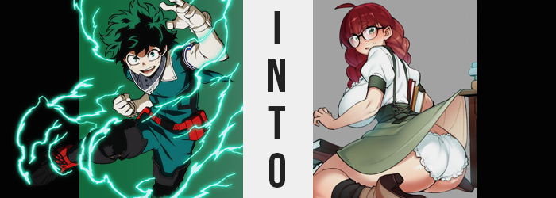

“RAAAAGH! STUPID DEKU!”

Bakugou Katsuki was in a foul mood, but really? When wasn’t this the case? Particularly when his ire was aimed at one Izuku Midoriya, a boy with whom he had a long history of typically one-sided friction. One-sided on his side, that is. Bakugou’s feelings about his fellow aspiring hero were complicated, but you probably wouldn’t realize as much considering how he’d scream in blind fits of rage over the topic.

Hands in his pockets, he was huffing to himself while returning to the dorms late one evening. The sun was already setting, and the world around him was painted in a dark orange. This was around the time most of the other students and faculty had already gone home, so there wasn’t anyone around that he knew of, really. “Where the hell does he get off!? Acting like he’s so cool!”

What had Izuku done in this particular case of the Bakugou Blues? Not a lot. He was just the center of attention as he often was, a place where Bakugou himself believed he should stand. Why the hell would anyone care about Deku when I’m right there!? That was more or less how he thought. Before he could reach his dorm though, a voice reached out to the boy from the shadows.

“What was that? You want someone to be less cool?”

Almost a full day had passed since the boy’s outburst, and Deku was waiting in the back of the library of all places as a letter requested. A letter from Bakugou. “It’s strange for Kacchan to ask me to meet him like this. I hope everything is okay…” ‘Strange’ didn’t even begin to describe it. The letter itself aside (because Bakugou was so direct he’d typically rather yell demands at Izuku in person) there was also the matter of the meeting place. The school library? Not somewhere where he could throw his Quirk around?

On the other hand, since the library technically lost its faculty at five and was student run until nine, maybe it was ideal for Bakugou to cause problems? After all, the student volunteer hadn’t been there when Deku had arrived. But neither was Bakugou himself, and it was looking like he was going to be fashionably late if he didn’t show up soon.

“I wonder what I did to make him mad this time? After everything with All Might behind us, I thought we were done with this.” There had been that clash between the two boys after All Might’s secret had been revealed and ever since Bakugou hadn’t taken things as personally. Or, well, that was the vibe Izuku had gotten (it was the wrong vibe).

The back of the library had no windows, and instead was overwhelmingly packed with tall shelves of books. Because of this, it was often the place where students would hide when they were up to no good, since you could not see it from the library’s front. In a way, it was the perfect place to launch an attack…

“Ow!?” Izuku had just been waiting idly with his back against a wall-mounted shelf when a sharp pain rang out from the nape of his neck, forcing him to slap the source because he thought it was a bug bite. “Huh?” Looking at his hand after the fact, it definitely looked like a mosquito or something. But he didn’t look close enough to realize that there was nothing biological about it. “I guess it is mosquito season.”

He'd been injected with something. The product of someone’s Quirk, which if left unchecked would completely turn the aspiring hero’s life on its head. And since not even Deku himself had realized that anything was awry just yet? Well, it was already too late. It had gone unchecked long enough between the time of impact and the two minutes that followed before its effects began to be seen… or felt.

It all began when a chill ran down the boy’s spine, causing him to shudder uncontrollably for a moment or two. “Darn, I hope I’m not getting sick.” Being the good-natured kid that he was, if anything Izuku was worried about having to miss class the next morning more than he was about actually getting sick. There was nothing wrong with being a good student!

But eventually the chills and shudders culminated in something weird. “Ahn!?” Standing there with his hands in his pockets, the sensual moan that was called forth from the boy’s lips certainly came across as uncanny. But it had been a sound made with good reason, and his hands patted the front of her pants with alarm. Because the sound had been summoned as a response to his dick wriggling about until it moved no longer. Because…

“It’s gone!?” The front of her pants was completely flat, and by probing more intimately Deku could feel fingers pressing into something through her uniform pants and boxers. Her scream of shock and awe was of a higher pitch than the girl had usually spoken with as a boy, which really spoke to the fact that her sex had been utterly, entirely altered. “Wait… Calm down! This must be someone’s Quirk? So I’m sure it can be changed back!” Being a girl wasn’t all that different from being a boy, right? Things felt a little weird between her legs, but!

Yet optimism could only carry her so far. Already the fit of her uniform was loosening in some places while tightening in others, which would undoubtedly cause problems down the road. The cause of this wardrobe malfunction was the fact that Deku’s body was readjusting to better suit her new sex, accentuating her features to lean into the feminine.

In some places it was as subtle as the softening of her skin, but there were a few key areas of importance. Her waistline, for one. Almost like someone had grabbed the sides of her torso and pushed inwards really hard, bones and muscle dipped inward to present a girlish arch to the shape of her figure. Shoulders narrowed along with them, and this left her shirt and uniform jacket hanging slightly loose.

If only for a moment. “I guess I should have expected this…” The new girl sighed as what could only be interpreted as a swollen feeling plagued the area around her chest. If she had a girl’s genitals, then it was only natural she’d acquire everything else as well, right? Her assumption ended up being correct, and as nipples dug into the fabric of her undershirt, a pair a B-cup breasts protruded to fill some of the space left by her lessened figure. “I have breasts.”

Not just breasts, but an ass as well. Pants tightened around her rear, and her waistband got caught on hips that widened in slight as a direct result. Her rump wasn’t huge or anything, but it was certainly more indicative of her newly bestowed sex, and that could be seen in how Izuku’s thighs had stretched to fill out her pantlegs as well.

Otherwise, there were more subtle altercations. Her fingers, still scarred, were now smaller and daintier with lengthened nails, and her feet bore a softer arch to match teeny toes. Likewise, her curly hair had fallen to her shoulders, and Deku’s face? It was certainly gentler, stealing away the last bastion of masculinity so that she looked like a biological girl in every sense of the word.

“I need to go get help, right?”, she asked herself aloud, but it suddenly dawned on her: Why am I asking myself that and not acting? How hard would it be to just run out of the library right this second and get help? But she couldn’t motivate herself to do it. What if she inconvenienced someone in the process? What if she made someone mad? “H-Huh? Since when did I care… about stuff like that…?”

Deku’s lower lip quivered. Where was all of this anxiety coming from all of a sudden? If anything, she should have been anxious about the fact that she’d been turned into a girl, right? But instead she was more worried about trying to convince someone that she hadn’t been a girl all along. Things only got worse from this point on.

The girl’s quivering lips turned into a pout, but not because she herself wanted to. The shape of her lips swelled abundantly with the lower lip growing thicker than the other one to create this resting expression. All in all though, this was just a small part of a bigger facial reconstruction project. Deku’s signature freckles? They evaporated until her complexion was completely clear, particularly cheeks that looked a little rounder. But she also looked older – perhaps around twenty?

Each step robbed her of something that made her the Deku that everyone knew and loved. Her nose rounded, stealing away another familiar feature, and those pretty, green eyes of her grew even wider, lashes dancing with new length. But at the same time?

“A-Ah!? I can’t see!? Why is everything blurry!?” Her cries were shrill for good reason: her vision had suddenly dipped from a perfect 20:20 to a point where she could hardly even make out the shapes of the world around her. This left her fumbling, worried that she might trip over something with every step.

This made it difficult for her to witness the changes that continued to steal away her old identity, but this wasn’t on her list of priorities anyways. The more time wore on, the less this all felt strange somehow? Her mind was now suffering the Quirk’s effects, memories placed in line with the reality that had been dictated for her before the insect had even bitten her.

Gone were her memories of combat and training, and with those memories went any associated boons from said life of battle. Deku’s muscle mass had been retained even after becoming a girl, but now her arms became a little flabby without any real strength to show at all, as did her legs and tummy. But this went even further, for all of the scars in her hands from her early days of using One For All? Bones corrected themselves and the scars evened out, leaving dainty fingers with only a few papercuts.

Considering her Quirk was book-based, that tended to happen.

Huh? Her Quirk was for fighting? Since when!?

Her curly, green hair was promptly overwhelmed by a new color. A red that, if she could properly see it, she could identify for her aunt had the very same color. This auburn spread throughout every hair on her body, from that atop her head, to her brows, to the hairs that would grow above her presently shaved pussy. But with color also came a new style.

No longer were her locks curly – they straightened with purpose, growing longer, and weaving amongst each other into a pair of impressively thick braids that made her look just as dorky as she was starting to act. Her bangs hung down to just above her eyes, masking the fact that her eyebrows were incredibly thick themselves, while an ahoge perked up from her head’s dead center.

“Still can’t see… Still can’t see…!” Preoccupied by her lack of vision, hands were held outward in the library’s corner so that she didn’t bump into anything. “Urp!? Were my clothes always this tight!?” She was forced to multitask her woes though, thanks to an outfit-wide malfunction brought about by a figure that was unknowingly expanding. She attributed it to her clothes being too small for some reason, but in reality?

The seams of her pants and boxers alike were forced to begin fraying, as her once meager showing of a womanly rear came back for seconds, and with the vengeance at that. Her ass grew so suddenly and with such intensity that Izuku’s uniform pants ripped right down the center seams, and the waistband snapped thanks to how hips widened as a result. The peaks of her ass poked up and over the waistline, while her thighs were revealed as flesh attempted to escape torn pant legs; their own mass growing thicker than her head was wide.

Deku squeaked and squirmed, the discomfort more than she could bare. Yet she didn’t question why she felt this way, not even once. She was already far too far gone, and the reality she knew was more in line with what was being enforced upon her. That was why she didn’t even bat an eyelash when the front of her jacket and the dress shirt beneath burst forward thanks to her breasts finding a weight to rival her rear. “Ah!?”

The flesh of her tits, now exposed for the buttons of her top had been ripped right off, flopped around as they grew and grew. It wouldn’t be wrong to liken them to inflating balloons with how round and full they seemed, her skin tightening around the fat that saw them jiggle and bounce. Her nipples might as well have been full teats when all was said and done, and the H-cup sizing of her bosom almost sent her flying face first into a bookshelf through weight alone.

Before she could even react to her sudden exposure, her clothes just suddenly fit again. It was the strangest thing. The woman’s clothes just instantaneously shifted from the tatters of U.A. male student’s unform, to a white blouse with a green skirt held up by suspenders. Beneath she had a plain, white bra and an even plainer pair of panties, while black socks and tanned, heeled boots contained her tootsies.

More than shocked, she was just relieved she could see again! Thanks to the black-rimmed glasses she pushed up against the bridge of her nose as if she’d done so a million times in the past. The lenses on these glasses were thick, no doubt because the woman’s vision was so poor.
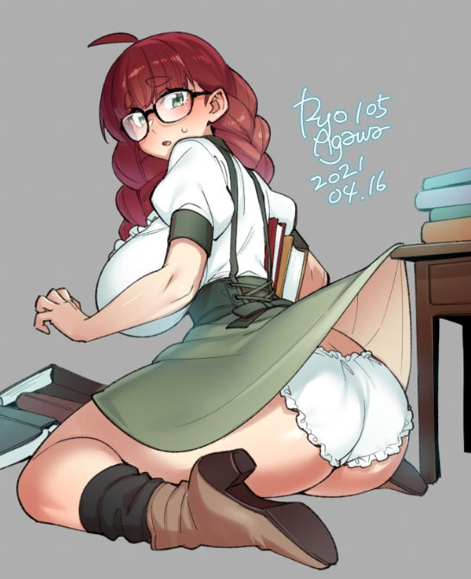
“Oh no!” Unsurprisingly flustered and alarmed as she was, one Miss Izumi Midoriya was caught unaware of the fact that her green skirt had gotten caught on one of the bookshelf corners, and the snag lifted her skirt up behind her to reveal her white, frilled panties along with her big ass. Her face burned crimson, and she struggled to pull fabric free before her large breasts pulled her off balance, forcing her to fall forward and onto her knees. “Uuu…”

Feeling defeated, the girl readjusted the glasses upon her face. While she looked rather youthful, she was actually a young adult volunteer at U.A.’s library – that was why she was allowed to wear whatever she liked. At only twenty years of age, Izumi found it incredibly embarrassing that she was always getting into accidents like these! She was supposed to be a role model to the students, right? Even if she weren’t a hero, and had no aspirations of being one, that didn’t mean that she couldn’t inspire them in different ways!

Despite how she felt now, something was still nagging at her. “Did I… forget something?” It was highly likely that she was only tired from a busy day, but there was a lingering sense of confusion. Had she really wanted to be a hero at some point in time? No, not even when she was a child! Which was fine, her mother preferred she work a more peaceful job like this.

Her Quirk really lent herself to it, you know? The ability to memorize a book’s contents just by touching it had no combat practicality, but for a pursuer of knowledge like Izumi was? It was enough! She wouldn’t trade it in for anything else in the world!

…Meanwhile, Bakugou had been hiding behind a bookshelf the entire time. That bug Deku had slapped away was something a strange looking girl had concocted for him using her Quirk. She claimed she could change the nature of anyone her insects injected with their venom to her own specifications, and then had asked him what he’d like to see happen to Deku. But he hadn’t actually expected it to work! He was practically in tears laughing!

At least until…

BZZZZZZZZZZ!

“OW!?”

A sharp pain could be felt in the nape of his own neck. Little did he know that the girl didn’t want him blabbing about her Quirk’s true nature, so she’d arranged to have him given a new life as well…

