LITTLE DEMON ACADEMIA
CHAPTER 5: MECH HEART
BY CHALDEACHANGE
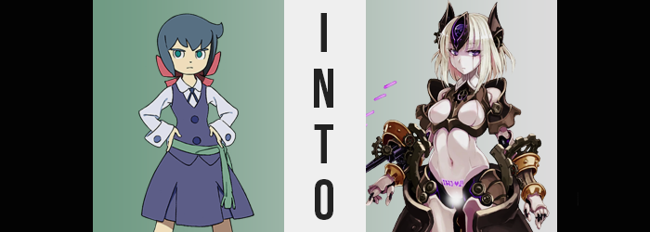

It had been a very, very late night for (inhales) Constanze Amalie von Braunschbank-Albrechtsberger. Noticing that there was some evident wear showing on the Stanbot she carried around with her, she had decided to do her routine maintenance check on it a little sooner than she normally did. As the Stanbot was a Magic-Mechanical device of her own creation, she was rightfully the only person talented enough to maintain it and see to its upkeep.

The issue? While it came as second nature to the extremely quiet witch, it was still a time-consuming process. If she rushed in her efforts to maintain it, then there was always the risk she would accidentally do damage to her own creation – and she would never be able to forgive herself if she had harmed any of her babies, unintentionally or not.

As she always did, she was working in the personal, underground workshop that was hidden even from the school’s faculty beneath her dorm. The only people that knew about it were her roommates and Akko, incidentally enough. The lattermost individual would come to be her own undoing now that she had been transformed into Cthulu-chan, however.

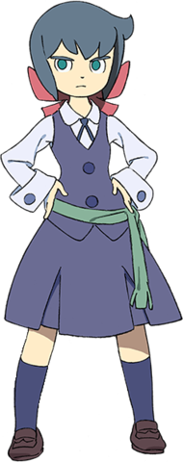
In fact, she was in Constanze’s workshop even now. With all of the amazing powers she now possessed, it was child’s play for her to hide her presence (she had learned from her encounter with Amanda that staying hidden was for the best). Admittedly, she didn’t even need to be close to her targets to transform them, but? Ever since she had been corrupted, there was just something pleasing about watching them transform in person that appealed to her more carnal sensibilities.

Or had it become a fetish to her?

Akko had the free will to choose any form she liked for them. She could peer into an infinite number of worlds, pick a form for someone, and copy and paste it over the existence of someone in her world. It was just fun selecting forms for them! Sometimes she’d give them forms that made sense for them, others she’d give them forms that contradicted their old ones. But never men. She was too gay for that.

Even now she had already picked what she considered to be the ideal form for Constanze, but the girl was so busy with both her hands and mind at work that she hadn’t even noticed the presence of the power getting to work.

It had already begun to affect her body in strange ways. One needn’t look any farther than her hair to see that much. Beginning with several strands, an amiss creamy blonde that bordered snow white had set in. These strands appeared to be slightly longer than the blue Constanze saw in the mirror every morning on the sides, but much shorter in the back, and while they began being few and far between, it didn’t take long for the trend to catch flame and spread throughout the entirety of her mane.

The cowlick to the right of the girl’s head flattened, but so did the full body of her hair as the creamy blonde inevitably became the constant, all blue overwhelmed entirely so that the lightened locks could dangle loosely around the sides of her head. It was certainly a more effeminate hairstyle than she was used to, but Constanze was far too distracted by her work to pay it any mind.

Eventually her work reached a point where she needed to get up to fetch a part from a nearby shelf though, and after wandering a little from her workbench, the quiet girl eventually did realize that something was very, very wrong. Because she was presented with a change that affected the fit of her uniform. “…?”

The body of Constanze’s outfit was split into two halves. The skirt that dangled to her knees, and a blue vest that buttoned up over a white blouse beneath – typically tucked into the skirt below. Not only had the shirt been untucked from her skirt however, but it was lifting higher and higher to reveal some of her tummy. Were her clothes shrinking? Feeling her sleeves pull higher towards her elbows, it was certainly a possibility that crossed the witch’s mind, but… No. Her point of view reached a higher shelf than it once had. She was growing?

Not even this realization was enough to coax a word from her mouth though. She merely held her hands out to her sides and looked down at herself, marveling as her flesh expanded to make it almost look like she was wearing children’s clothing by contrast. While only five feet tall normally, by the time her limbs and torso had stretched, she was a solid five-foot-five. “…”

Constanze hardly knew what to make of this. Magic? Was it the result of some sort of technological tool? No, she wanted to rule both of these possibilities out. There was also the question of ‘purpose’. What would someone have to gain by making her taller? Or, uh…

Better endowed? The top buttons of her vest and blouse had taken her by surprise, for they popped off and flew into the nearby shelf as a direct result of the mass beneath them expanding. Her A-cup breasts, something she had never thought nor cared about, had bloated and pushed her clothes forward as they developed into hefty Ds. And yet, she still didn’t speak, nor even bother to touch them as her cleavage became apparent with her top parted down the center.

There might have been a slight grunt on her part thanks to a discomfort created by the parting of her hips pressing up against the band of her skirt. There wasn’t enough room to accommodate them, and so the waistband did eventually snap so that her skirt fell to the ground. Because Constanze knew she was alone (she wasn’t), she didn’t panic about it – but thickening thighs and a swelling ass caused further complications for her plain, blue underwear. It was being ground right into her crack and loins!

Loins that were now, strangely, completely free of any hair. Rather, some strange, purple characters had begun to etch themselves right above her pussy. Runes that made the girl’s posture lock up without any notice. “…!?”

Hands held at her side, back completely straight, Constanze found herself to be whole incapable of removing herself from nearby the shelf of cogs and gears she kept for spare parts. She had been paralyzed before thanks to one of Sucy’s mushroom experiments, but this didn’t feel quite like that. Rather, it felt like much of her body had just suddenly grown stiff. It was something she couldn’t really confirm, because her chin was locked in a forward position so that she could only look ahead.

This kept her from piecing together the cause of her body’s immobility, but there were so many moving pieces to that puzzle that maybe it wouldn’t have been all that apparent even if she could see. Her skin, for example.

Most, if not all of it, had taken on a pure white color as if her body had been bleached. And yet? The skin on her lengthened limbs, torso, and even her face, were just as easily robbed of their lifelike glow. It was almost as if all of her skin had simply hardened into a very durable material, leaving the (now) young woman looking like a mannequin of sorts.

To those ends, her nipples disappeared into the white of her breasts, which remained squishy if not now artificially so, while vertical lines ran down their centers. These lines similarly ran down her face, crossing eyes that appeared to glow the same purple as the runes above her shaved pussy which, mind you, was still fully functional. In fact, it almost ached.

Constanze still couldn’t make heads or tails of her situation, even as her mouth dried – for saliva was not something her body could now create – and the taste of plastic and steel filled it. Her sense of touch had apparently dulled, making it difficult for her to sense anything short of arousal and pressure – and pressure was certainly something that wasn’t in short supply.

You see, while her body had taken on this cold, white exterior, the interior was changing at the same time. Flesh and blood had been replaced by mechanical counterparts, something that would have been a dream for Constanze if not for the horrors of this situation. Before long the whirring of steam mechanisms within her white plating built up, and that pressure she felt released.

For her body essentially ‘exhaled’, steam escaping through a plethora of regions where the white plates were blown off, exposing the inner workings of her transforming body while burning away any remnants of her Luna Nova uniform. Whether it was the joints of her fingers rupturing so that they resembled the hands of a doll, or the plating around her hips and shoulders exploding to reveal copper clasps and extensions beneath them, or her kneecaps blowing off to reveal black, gear joints above feet that… had ejected the ‘feet’ portions so that her legs now only stood up on a pair of white stubs? It was all carefully crafted to expose Constanze’s body for what it now was.

An automated, mechanical lifeform of some sort. One with tits and a pussy, for some reason. “I… I am.. I… I… I-I-I-I-I…” Strangely, the woman felt compelled to speak, her voice carrying a mechanical tone that lined up with her very mechanical looking body. But as if there was a glitch in the back of her mind, she couldn’t muster a sentence. Or much of anything, really. Trying to think was difficult, in no small part because her mind was being digitized. A body like these did not possess a normal brain, of course. Instead? A purple gem began to shine upon her forehead, and a copper shield wrapped vertically around it while two matching horns sprung up on either side. In a way it looked like a headpiece, but these horns had been fashioned in place of her ears.

Constanze’s chest plate blew open not long after, exposing a gear indentation just below her neck, while further plating erupted around her tits as a sort of frame, making the breasts themselves stand out even more. The indentation was where her new energy core existed, and as it whirred to life it created a magnetic field that pulled every piece of metal, such as all the gears of various sizes on the nearby shelf, against and into her body.

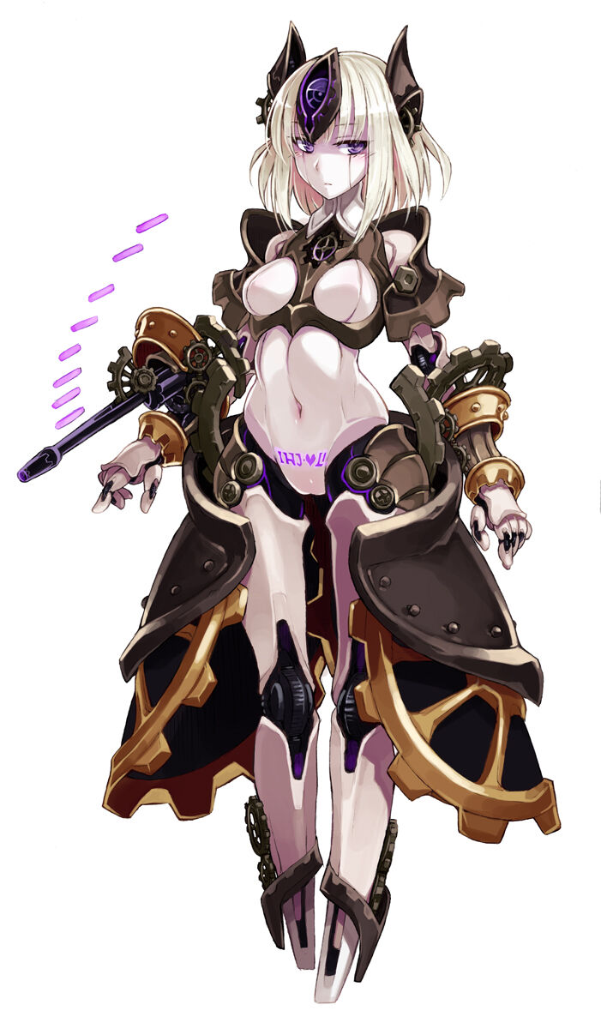
The result? It created a strange set of armor. Gauntlets with gears just below her elbows, a skirt made of two giant gears and metal plates, and shoulder guards that left the pale of her joints exposed within. Spiked blades had even found their way onto the bases of her legs, gears on either side permitting these blades to retract and expand on command from the mental core sitting on her forehead.

“I-I-I-I-IA-A-A-A-AW-AW-”

“Awaiting orders.” The beautiful machine girl, the gynoid-type Automaton that Constanze had become, stood completely still once her transformation had completed. Her free will had been completely robbed from her, which was different from her transformed peers that still possessed free will – just that it was the free will of another personality. Instead it was more like any, and all personality had been erased from Constanze altogether. “Master? Awaiting orders from my Master.”

At the very least she could recognize who that master was. The great, all-powerful Cthulu-chan. An extremely small part of her that was still Constanze questioned who that was, but was soon shocked to see a very tentacle-y Akko appear from nothingness before her. Not only that, but she dipped a finger into the Automaton’s exposed pussy, making her shudder. “You want orders from me, huh?”

Akko rolled that finger around inside the gynoid’s artificial loins, and the machine appeared to twitch from the stimulation. “A-Affirmative, master. I will do whatever you ask of me.”

“Hmm! Okay! Since I was kind of curious when I transformed you, how about we fuck? I’ve been getting pretty horny watching everyone else change!”

“Affirmative.”

