FATE / REINCARNATED
CH6: SPOILED BRAT
BY CHALDEACHANGE
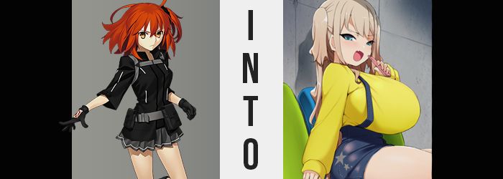

“Huh? That’s weird. Gudao hasn’t done the daily summons in a while.”

It felt like a fairly normal comment to make, especially within Chaldea of all places. The daily summons were a task that either the male Master of Chaldea, Gudao, or his sister, Gudako, were expected to do every day. Perhaps at times there would be a day or two were it would go forgotten, but usually only because something much more serious had taken place. Like, for example? The emergence of a new Singularity or their arrival at a Lostbelt.

But what made this so strange was that neither of these things had taken place for months now, which meant that the sister was skeptical about her brother’s inaction. Looking through the summoning terminal, Gudako could only raise an eyebrow at the fact that it hadn’t been used in five days. Come to think of it she hadn’t seen him in a while too, but it also wasn’t odd for the pair to go days without encountering each other seeing as how they were so busy.

She shrugged. She could ask da Vinci-chan about it later, Gudako supposed. If he was in any danger then someone surely would have noticed by this point, right? So it wasn’t worth worrying over, not when she seemingly had to pick up his slack in the summoning area. “Man, and it was going to be my day off, too…” Not that the daily summoning was even that much effort. She was just being incredibly dramatic.

With an undeserved sigh she stepped inside the summoning area, making the final preparations on the terminal to activate the summoning procedure. It was annoying that a Master was required to activate it, else anyone in Chaldea could do so. But it had all fallen on the shoulders of the siblings in the end. “Oh well! Let’s just get it over with!” Gudako really was coming off as a little selfish, but it was just because she was tired.

The next she realized she was sitting down, anyways.

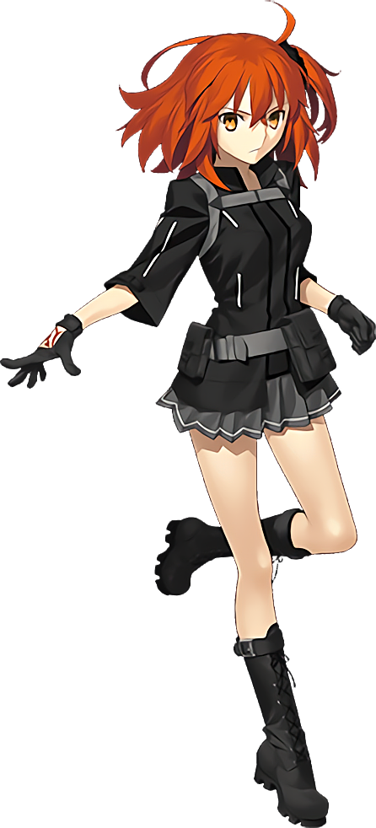
“…Huh?” What had just happened? The summoning process had started and the lights had lit up, but shortly after there had been something like a tugging sensation that had pulled her. Pulled her… into the summoning device? And now not only was she not in Chaldea, but she also looked to be… Where was she? It was noisy, that much was obvious. “Wait, did I get rayshifted?” Through a summoning circle? That couldn’t have been the case, could it?

Nonetheless there was little point in her denying what was obvious. That she was somewhere else entirely. She stood from the seat and looked back at it. Was this some kind of waiting room? The chairs were covered in a felt fabric, and they rotated between blue and green when it came to their color. There was a door nearby, and peering out of it revealed the answer she was looking for. “An arcade?”

That absolutely was what it was. Arcade cabinets were lined up inside, and there were plenty of people playing them – leaning more into a younger demographic. As soon as she checked though, she pulled back into the room she’d appeared in. It must have been one of the rest and waiting rooms that some arcades had. A quiet space for when people weren’t feeling well, or if they wanted to meet up with friends before venturing onto the floor proper.

“Okay, so why was I teleported to an arcade?” She really didn’t have an answer, and although she knew she shouldn’t? Gudako couldn’t deny the new feeling she had. That she wanted to go play them. Not out of curiosity, mind you, but because she felt as if that was the reason she had come here in the first place. It really didn’t make a lick of sense, but the worst part? The woman wasn’t really questioning it as much as she likely should have been.

Of course, she had fallen victim to the very same phenomenon that her brother unknowingly had – although the results of her own situation would vary quite significantly from what had befallen him. Gudao had been transported to a fantasy world, after all. This? It was a world similar to the one that Gudako knew and loved. If not the exact same one.

As she wrestled between going out into the arcade and remaining within the confines of the waiting room, the physical changes began to flare up. They began with the erasure of something key, for the red Command Seals on the back of her right hand ultimately faded away into nothingness, all while the complexion of her skin appeared to soften. Naturally in one sense, but it also saw to it that all of the muscles she had accumulated throughout her journeys were weakened as well. All of the muscles except those in her back for some reason.

“Should I go play something while I wait?” Wait? Wait for whom? She couldn’t have possibly been here to meet someone, because she had never planned on coming here in the first place. Yet something deep, deep down was telling her the contrary. And that something only grew stronger and stronger as time wore on.

In the meantime, the bright orange hair that she’d possessed since birth found a new color dancing among its locks. A platinum blonde that, at first, appeared more like dyed streaks, soon stuck out. But while it began appearing like an intentional, stylistic dye job, that notion was dismissed as within moments, most of her hair had lit up with that same color. By the time it had all turned platinum blonde, the hair was also softer and more voluminous. Longer to boot, falling down to her waist when it had once rested at her shoulders. This hair somehow appeared more youthful, and if to drive that idea home? A strawberry scent wafted from it, indicative of a more childish choice in shampoo.

“Nnnn…” Gudako’s eyes kept peering towards to the door with her foot tapping against the floor, an impatience building within that was getting harder and harder to resist. She didn’t want to sit around in this room anymore, but if she went ahead then the others might get mad at her. With these uncharacteristic thoughts and feelings swirling about, her eyes suddenly turned from amber in color to a steel blue. What’s more, they became bigger and more expressive.

There was more to the changes of her face than just her eyes, though. Her cheeks rounded, becoming somewhat chubby compared to their usual, lean looks. Which was odd, because over? The length of her face had become just a tad longer. This in turn made her nose look smaller – but on the other hand it had actually shrunk. Contrary to the shrinking of her nose? Her lips actually appeared larger, and once again strawberries returned, this time in the form of a flavored gloss that gave her lips an unnatural sheen.

It’s not fair! Why am I the one waiting when I invited them? Those losers. Gudako didn’t give a voice to her thoughts at this juncture, but it was evident that her mind was growing less empathetic and more self-centered; not to mention rude. Her attitude was worsening by the second, and she was beginning to feel as if it was completely justified for her to act this way. Why?

For her to been so misguidedly confident, there must have been something about her new life to make her feel that way. And there was, with indicators already beginning to show in the young woman’s figure. Stealing a glance at her hips, for example? You could see them widening a few inches, compromising the fit of her skirt.

But it was actually more substantial than even that, because her upper legs – specifically her thighs – soon engorged themselves with a soft yet appealing weight that saw them thicken to enticing degree. Skin stretched as thighs continued to bulge, almost meeting in the center despite her widened hips. They became so thick that no conventional pants would be able to contain them. Or at least not without their full outline being shown.

And her ass? Well, while perhaps not to the same degree as her thighs, it too swelled up into a peach shape, which in turn forced her panties to wedge slightly between her cheeks. It wasn’t comfortable, but Gudako didn’t really seem to react all that much to it. Which wasn’t perhaps as shocking as what she didn’t react to a little higher up on her body.

She had her fingers laced behind her back, not at all aware that they had not only shrunk, but lengthened nails now had a cute, pink gloss on them. This posture just made it easier to see what was happening to her torso – and that phenomenon readily justified why the muscles of her back hadn’t weakened despite the rest of her body getting weaker.

It was her chest. It had began to grow, nipples standing at attention as fat surged into them to bolster their weight. While she had a modest bust size to begin with, it quickly became clear – when paired with her thick thighs – that modesty was not on the menu when it came to her new life. Breasts grew and grew, not only forcing the zipper of her jacket down but completely snapping the strap that was drawn across it at the same time.

“Huh? What the hell’s up with my clothes?” She cried out with a much shriller voice than normal, evidently able to realize her outfit was amiss despite the measures meant to prevent her from noticing. “Why would I wear something so ugly?” Never mind. The truth of the matter though, was that her breasts had grown even larger than her head, with the naughty bits just barely hidden by her bra.

And while her transformation was not complete yet, her outfit reshaped before the final change swept across her. That is to say that her entire outfit changed, covering up her body with a loose, green sweater and blue shorts that highlighted her thighs. This was necessary to prevent any unnecessary exposure that came about as her body began to shrink.

And shrink… And shrink…

Her new clothing shrunk along with her, but when all was said and done she only stood at about 4’9”. The youthfulness she had exhibited before, evidently, had been a herring of what was to come. Because she was clearly no longer an adult woman, but had instead become a girl in her early teens.

“Woooow, those idiots are gonna take all day at this point! Why should I wait for them? I’m the one who’s paying, after all!” While she was clearly young, perhaps no older than thirteen, there was an accompanying immaturity to how the young lady sitting in the blue seat acted. Which stood as a fairly stark contrast to the maturity her body showed off, with breasts, butt, and thighs for days – far more abundant than any adult might ever grow in their lives.

But Hina Akemi loved how well-endowed and how mature she was! All of the other girls in her school were totally jealous of her! And if she played up to the right person? She could get whatever she wanted from them. Of course, the fact that she was incredibly wealthy also helped matters in that area!

The end result was a thirteen year old who was so arrogant and bratty that she didn’t actually have a lot of friends. Hina was abrasive to those around her, electing to mock other girls for not being as developed as her, and preying upon the boys her age only to tease them for being so gullible. She was, in many ways, like a very well-endowed imp. Not that she would ever show anyone her body, or do anything actually indecent. She still knew better than that!

“Hmph! Fine then! I’m going on ahead! I’ll have waaaaaay more fun by myself!” Take this arcade outing, for example? She’d had to bribe some of the other girls her age to come, and in the end? None of them had shown up! They had just taken her money and not appeared! But Hina didn’t care! Or at least she pretended not to care. Because she had way more money they could ever dream! “Hup!” Abundant as her body was, it took a lot of strength to push herself up onto her feet – and in turn her body bounced and jiggled as a result.

She then skipped off into the arcade, forgetting about anything else.

“Who needs those losers, anyways? I’ll make ‘em pay at school tomorrow!”

