STAYCARE DELIGHTS
CH7: SPOOKY CUTE
BY CHALDEACHANGE
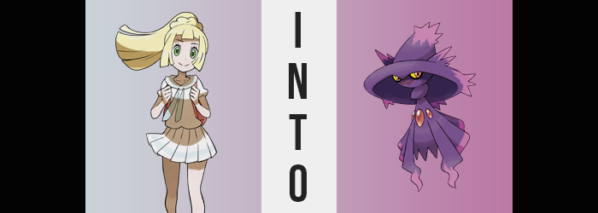

While she came from the Alola region, Lillie was not presently staying there.

It wasn’t all that long ago that a number of core-shaking truths had come to light. That her mother had fallen into madness at the behest of an Ultra Beast, that all of her actions had been because of its influence, and that she needed professional help. That was why she had travelled to the Kanto region with her mother. Despite what she had done, the bond between parent and child could be fixed if both parties wished it – and in this case they did.

Kanto was where the experts that could help with her mother’s condition could be found, and it had been almost a year since they had arrived at this point. On a positive note it seemed like a lot of progress had been made thus far in restoring Lusamine to her natural mental state. On a less positive note, the daughter found herself becoming increasingly busy.

Her mother could not work, and even with Gladion sending them money here and there it was hard for them to procure food and shelter without Lillie making an effort to work. She’d gotten fairly good at battling by this point, but that only helped a little. She was also too young to have a stable job, so in the end she resorted to helping out with the locals here and there. This meant that when not with her mother or training with her Pokémon, Lillie was working.

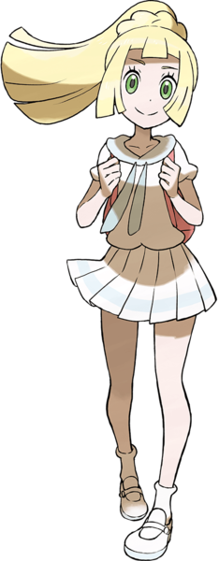
This eventually led to problems. She couldn’t always give her monster friends the attention they deserved, particularly new catches. And this meant that it was hard to raise them all by herself as well. So eventually? The girl turned her attention to the local Pokémon Daycare. A new one had been constructed on the outskirts of town recently, and since Lillie wasn’t a local she just assumed it was a branch of the one that already existed in the Kanto region. Not to mention she hadn’t caught wind of any rumors about it. Or at least the disappearances that seemed to be linked to it.

“Mhm! Just the Jigglypuff! Do I want to see where she’s staying? Oh, sure!” Lillie had intended on just dropping off the Jigglypuff she had recently caught and carrying on with her day, but upon receiving an invitation to see the center’s interior? Well, the part of her that was familiar with how the Aether Foundation had taken care of Pokémon had been a bit curious about what techniques a small business like a Daycare might have employed.

She was sort of like her mother in that sense.

But what had begun as a normal tour quickly followed a path that had been laid for so many victims of Team Galactic’s machinations thus far. Before she realized what was going on she was trapped in a room of white with a pedestal in the center. The color scheme of the room reminded her of the Aether Foundation. No… Even the pedestal? It looked like things she had seen in the Foundation’s lab prior to her mother’s ‘retirement’. “D-Did you steal this stuff from the—!?”

Lillie didn’t quite manage to finish choking out her question before the pedestal in the room’s center began to glow purple. She became paralyzed with her back to the door, but she could still move her mouth. She had just been so surprised by the suddenness of it that she’d cut herself off. “What’s happening to me!?”

Because she had never been in on the Aether Foundation’s inner secrets, she hadn’t known that Lusamine had put money into research on how to change people into Pokémon. But that project had naturally been abandoned after what had transpired in Alola. Team Galactic had seized that technology and gotten it to work, thus the current worldwide dilemma.

All Lillie could tell with her body immobilized was that she felt strangely light. That was the best way she could explain it mentally at least, but there weren’t any visual queues with her body that revealed why that was just yet. But that didn’t mean there was nothing to be seen at all. She had the same bright blonde hair as her mother typically, and yet…

A dark purple had infiltrated that blonde. It began at her roots and spread to her tips, but there was something even more off about it. Any hairs that were dyed were bound together and the barriers between them were erased. This hair was all becoming a single ‘piece’, including a ponytail that was raised straight into the air above her. This ponytail shortened downwards, the tip a lighter purple than the rest of what had become of the girl’s hair, and ultimately? With this lighter purple looking more like tufts, it almost gave the impression that her hair better resembled a hat?

If the resemblance was thin at first, that changed fairly promptly. Two more tufts puffed up on either side of the large point in the center, and the ‘hair’ around the base of her scalp began to grow and fan out in 180 degrees around her. “Huh!? Am Magi wearing a hat?” What had she just said instead of ‘I’? It somehow wasn’t as important as what she could observe with her eyes – the brim of a purple hat fanning out above her head. But while she thought a hat had been placed on her, in actuality it was part of her body with a trio of additional light purple tufts in the back to boot.

But why would someone put a hat on her? She would have liked to adjust it or take it off with her hands, yet they were still frozen at her sides. Or at least that was what Lillie believed. But those upper limbs of hers had begun to fade. Like, they were becoming transparent, everything from her shoulders right down to her fingertips. The seconds ticked on, each one bringing with it a more difficult time to perceive those arms until, finally, her sleeves dangled loosely at her sides.

Because shoulders, arms, and hands? They had disappeared.

“W-Wait a Magius! Magi can’t feel Mismagi floor!” The girl’s difficulty speaking, at least with the human tongue, was already becoming more severe. But even so, Lillie hadn’t once considered the reality that was befalling her. Rather she was fixed on the fact that she could no longer feel the sensation of her feet upon the ground which, honestly, was rightfully alarming. If she wasn’t standing, how had she not fallen over?

She had actually been bestowed the power of levitation, a trait inherent to the Pokémon that was her intended outcome. She just hovered in place, but that wasn’t why her feet weren’t touching the ground either. Her legs had slowly been shortened, feet lifted out of shoes and socks that were left on the ground below her. While simultaneously? Feet flattened and thinned, skin adopting a light purple color while the same darker purple from her hat stretched to the rest of her equally thinned and shortened legs. The tips that were once her feet were wavy, but all in all?

Legs had become little more than ribbons mounted to the front of her pelvis. They were only about a foot long, but her floating form gradually changed so that this length didn’t feel as short. The lower half of the girl’s torso (everything beneath her chest) was shortening, but it seemed to fan out in shape as the bottom hollowed inward. The same dark purple manifested across her skin as her belly button, ass, and related girl parts were absorbed into flesh that looked more like fabric than anything.

Everything below the chest looked like her body was wearing some sort of, but this was part of Lillie’s body. Even the trio of elliptical, red spheres that emerged beneath her bosom were born from her ‘flesh’, or at the very least were part of her own biology. But speaking of her chest…

“Mismagius!? Is Magi Mismagi Pokémon!?” It was far too late, but it seemed as if the truth of the matter had finally been made apparent to her. She was becoming a Pokémon!? And it was certainly worsening, for both sides of her chest, once painted purple and robbed of their nipples, collapsed in towards each other and expanded from back to front in the shape of what looked like a thorax. Her neck thinned with dark purple soon after, and ultimately? Her dress fell from her small, clothing-like body, leaving her ‘naked’. This meant that her face was the only part of her body that demonstrated her humanity.

But rather than frown, scowl, or even sport an angry expression at her now understood fate? Lillie could feel her lips pulling into a smile. A W-shaped smile that looked more like a line drawn upon her face with red pen, yet it opened so that she could speak and show how toothless her mouth was. “Mismagius!? Mismagius!”

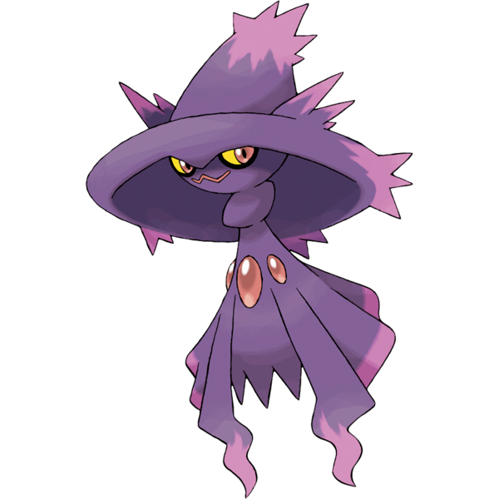
Lillie’s nose was pulled into her face until no nostrils were even evident, yet the girl could still smell somehow. The shape of said face stretched horizontally, making it shorter and similarly shaped to her new thorax just below the ‘hat’ that was her head. While she wanted to cry, she couldn’t. Yet being on the verge of doing so highlighted eyes that were lengthened sideways, irises turning red and sclera yellow. There was something unnerving about this appearance of hers. Spooky, almost.

It was hard to describe, but Lillie had just grown used to floating by the time her transformation had completed. The Mismagius circled about in the air like it was a completely natural thing to do, even though Lillie’s sense as a human was still largely intact. “Magi!? Mismagius!?” She flew in circles almost like she was chasing an invisible tail, but in actuality it was how her body was dealing with the pent-up energy that had built over the course of her changes.

She was a Pokémon!? A Ghost-type!? But Ghost or not, her body was still ‘solid’ as long as she willed it. She couldn’t stop herself from muttering in her monster tongue about nothing in particular too, as this was something that Mismagius were known for. Like a witch casting a spell, this trait often put off trainers that were unfamiliar with their natures. But didn’t this mean she was also pretty powerful? Couldn’t she break out of here? The thought crossed Lillie’s mind, but before she could make a dash for the door with the intention of phasing through it a force not quite unlike her own took hold of her. “Magius!?” Struggle as she might, she couldn’t break free of the big, purple hands.

The hands Haunter in the mood to breed.

