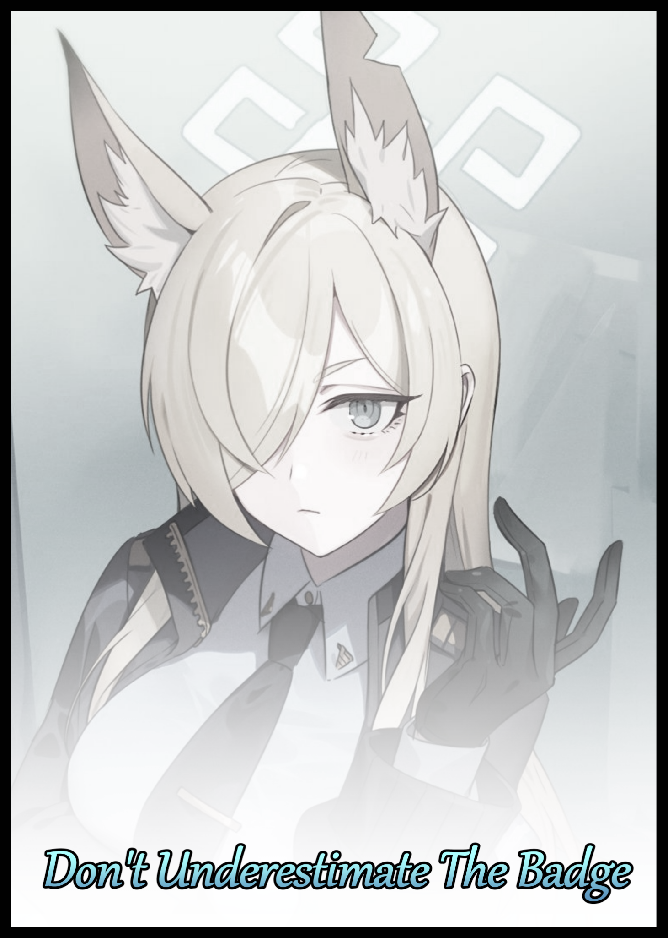

When Olga had signed on to join the force, the idea of swapping life experiences and other miscellaneous tales with the person who was arguably the most respectable soul in town had never once crossed her mind. She had been expecting to be assigned on mundane patrols, tagging along on uneventful shakedowns, having lunch breaks with her superiors before booking it back to dispatch with a baddie or two in the back and her skill set broadened by field experience…the usual rookie police officer routine.

So to see her role model wasted after going through what must've been her fifthteenth bottle of Japanese sake up close and personal only a month into her career had been enough to leave Olga dumbstruck. Stunned to silence by the fact that a newbie like herself was being given front row seats to the tipsy, lackadaisical face of Commissioner Rachel she kept on the down low. Until now, Olga and the rest of the public had thought of the head of police as a steely eyed heroine of justice. A paragon for good who had single handedly toppled the criminal empire that once held sway over the town with an iron fist after being subject to cruel methods that had left her with trademark equine features that made her all the more recognizable…and she wasn't sure if she should be counting her blessings for witnessing this vulnerable side to her role model or try to stop her from reaching out for another bottle. Ultimately deciding on the latter despite her own uncertainty telling her that there was no way in heck she was going to be able to restrain the freedom fighting police woman who still did her rounds with her underlings despite holding a lofty position up top. And that was what she liked about the commissioner; her ironclad sense of duty…not like that sentence could apply right now to the giggly blonde popping the cork off of her sixteenth drink.
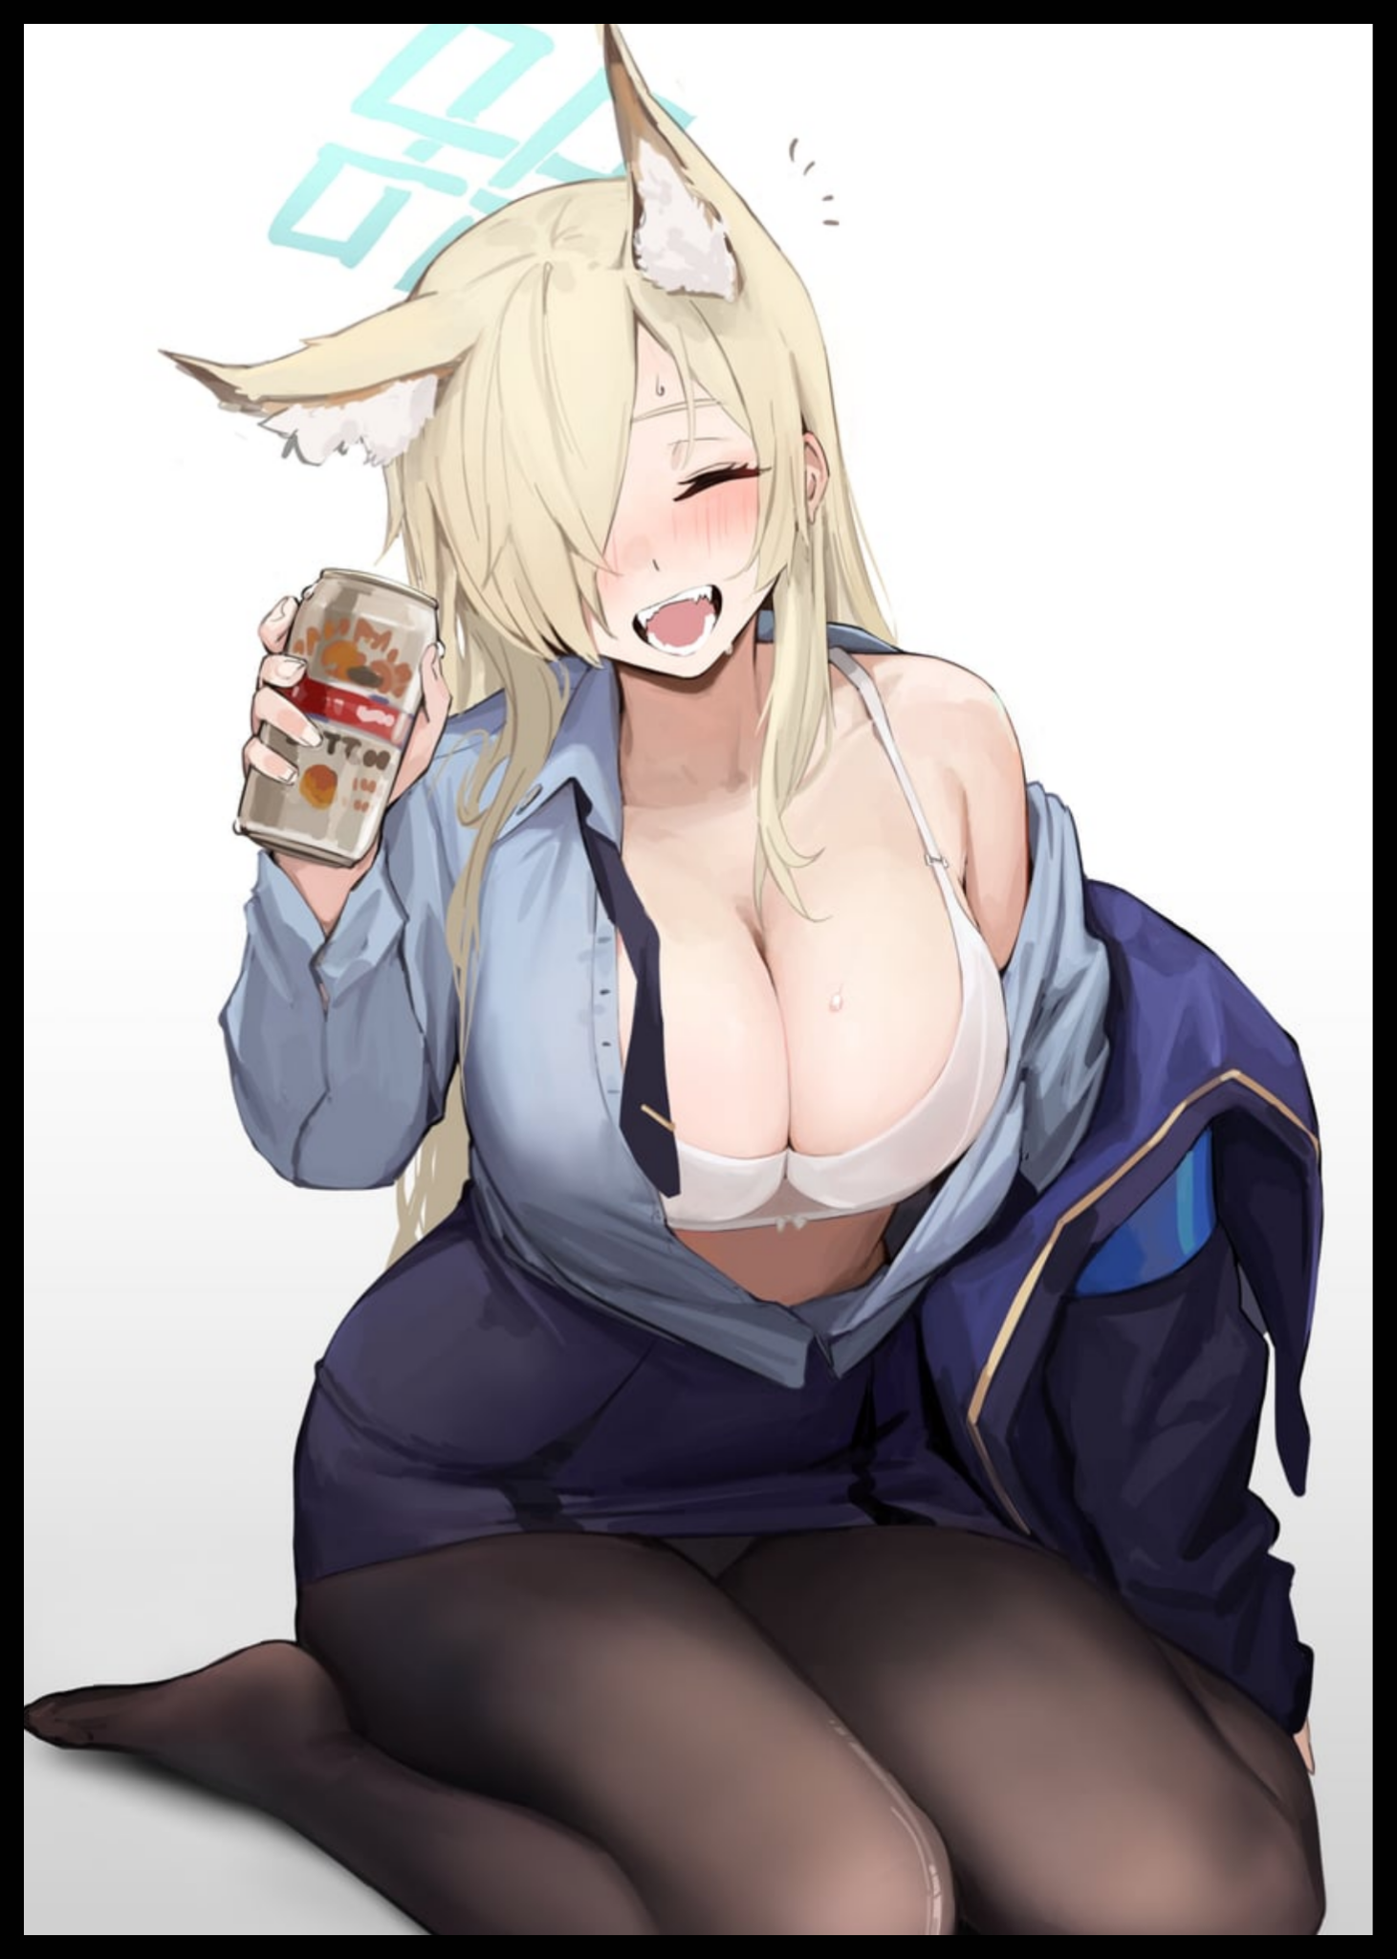
But with no one else around to supervise now that all the weathered veterans including Olga's mentor had all either left to go home for the night or were off getting more food and drink to resume their merry making in the commissioner's home, the rookie had seen fit to do what was right; reaching out with an uncertain hand aimed at her boss' shapely wrist…

"U-Umm…Commissioner? Don't you think that's enou-ooh god! I'm so sorry!" In her haste to remove the bottle from Rachel's grip, Olga hadn't accounted for the swiftness of the commissioner's response despite her system being flooded with alcohol. Turning with such vigor and energy that Olga didn't have time to course correct until it was too late as a closing hand wraps around the commissioner's collar, leaving kinetic energy and gravity to do the rest as the sound of a button coming loose and fabric being tortured resounds for a brief moment before Olga's panicked cries follow after realizing what she had done. Glancing between the black button in her grip and the jaw dropping sight of her boss’ partially exposed assets as a result of her accidental disrobing. A pair of majestic heifers that had the rookie struck by a sense of inferiority the longer she stared at the twin melons, held up by a simple yet titillating bra of satin make that demonstrates their weight from the way the straps sink gently into the supple flesh framing Rachel’s streamlined shoulders. It’s snow white color blending in nicely with the natural paleness of the commissioner’s skin as if the two were one and the same…which made it even harder for Olga to stomach the sight of a subtle dark spot beneath the bra. Feeling shame and embarrassment well up from within after catching on to the realization that those weren’t just ordinary mounds once they began to stir… ‘I-Inverted?!’

Expecting those salacious thoughts to be her last before a thorough shaking down for her callousness, Olga winces in fear. Expecting her ears to go numb and her bones to rattle if the rumors that spoke of the equine woman’s fearsome baritone were true, regretting her hasty decision to accept her supervisor's invitation to the casual drinking night over at Rachel's home. But the reckoning she anticipated would not arrive. Instead, the curious rattle of ice cubes being thrown around would break the silence, leaving Olga guessing before a freezing cold touch to her cheek snaps her out of her paralyzed state with a “Yeek!” and a nonchalant laugh from Rachal, whose warm smile conveyed no sign of the anger the rookie had expected to be faced with…a smile that aids in the deconstruction of the notion within Olga’s mind that the Mare of Justice, a title colloquially decided upon by her inner circle and shortly afterward; a dedicated fanbase, was a chivalrous heroine with her eyes dead set on a future free of crime.

“S-Sorry…I didn’t notice y’were there the whole time…*Hic*...go on…y’wanted to have a drink yeah? Take it, it’s the last*Hic*ugh…last one in the bucket…sake’s mine…and y’can’t have it~”

“But that’s not what I! You don’t have to say…I’ll…I’ll take it…”

Try as she might to explain herself without success, Olga would quickly acquiesce to the can of beer in Rachel’s hand. Taking it sheepishly in both hands before turning her gaze away from the still beaming face of her boss. Expecting that brief exchange of stuttered words and misconceptions to be the end of their conversation. “Where’re y’from by the by? I don’t think I’ve seen your cute lil’ face around the station before…”

Blindsided by the sudden question from her idol suddenly taking an interest in her, Olga would simply turn her head on a swivel, locking eyes with the lax commissioner before an excited brain finishes processing what she had said. “H-Huh?! O-Oh…I’m Olga...I just got assigned to the main HQ a month ago, graduated from the academy and all that…it’s…it’s an honor to meet you ma’am!”

“Drop the*Hic*pleasantries would ya? I’m not big on all that fluff outside the station…and the same goes for me too; nice to meetcha Rook~”

Popping open the beer in hand to quell the ecstatic fangirl bursting to life within her gut, Olga's only response would be a shaky nod of the head. Allowing for silence to creep back into the living room once again as the flustered rookie takes a step back into the crevices of her mind to think while taking a tiny sip of the strong alcoholic beverage, noting how Rachel didn't seem to be bothered by the fact that her modesty had been intruded upon and laid somewhat bare for the world to see. "A-Aren't you gonna do something with your clothes?"

A simple shrug that told Olga nothing would be all the rookie would get in response to her question, watching with raised brows at her boss' apparent lack of shame…or maybe it was the alcohol talking? Either way, all the speculation was beginning to disturb the crusty depths of Olga's mind. A place in the back of her head for mundane rumors, bewildering theories and baseless accusations to fester and fade, recalling a strange tale she had overheard back in the academy where they had drilled everything she knew about policing into her. A conversation she had just so happened to overhear while marching by a pair of officers. And what they had to say about Rachel was…wild to say the least. Wild enough for Rachel to pick up on it and put the drink down.

"Something eating you*Hic*up inside? Spill it, frown’s not something a girl like you’s supposed to wear on her face.” Put on the spot and unable to think up a suitable excuse, Olga sighs before turning to face her unwitting drinking partner with a slightly less serious look on her face. “Back at the academy…I heard things. Some bigwigs from HQ i think…they said you…weren’t like this before? That you were someone completely different from who you are now…that’s just…I’m sorry, it’s probably just nonsense I was hearing-gyah! D-Did I…say something wrong ma’am?”A loud thump and a clatter of utensils interrupts Olga mid-sentence, turning toward the commotion to see the officer with a firm hand outstretched, hand wrapped tight around the bottle she had brought down on the table with enough force to put a dent in the birch. Doing so more out of reflex than anger or shock before she too, let’s loose a long winded sigh accompanied by a lethargic flop from her coiled up tail. “Nah, what ya heard back then is mostly true…and I told ya to drop the ma’am right? Sorry…getting all winded right now…I’m guessing those ‘bigwigs’ are…did one of em have silver hair? A silly hat with stones in em? Really tight figure?”

“Now that you mention it…yeah…one of em had silver hair…can’t say much else about her looks though…”

“Yeap…it’s Aurelia then…girl’s a loudmouth who doesn’t know when to zip it…welp, no helping it I guess. Since you’re all clued, I guess I might as well admit it now; Yeah, I was a beat cop way back when…real bottom of the ladder goon the old force used to throw around back then when the gangbangers and their scum sucking daddies were calling the shots…I sure caught your attention with that huh? Lookin' at me all bug eyed like that…”

A quick series of nods from Olga and a glimmer of excitement in her eyes had told Rachel all she needed to know about her junior's burning interest in her past before her ascension to de facto keeper of the peace. Taking one final swig to empty the sixteenth before slumping backward onto an arm for support, bracing herself to recount the tales of a distant past she was equal parts proud and disdainful of. It's demons long since quelled by the time she had come to meet the sparkly eyed officer sipping on beer, eager to hear her story now that the rising conversation and unabated excitement of the fangirl within had overcome her previous doubts about being able to talk to the commissioner one-on-one without breaking into a fit.

And with her attention steeled so as to block out the sight of her idol's disheveled appearance and the slight tingle of alcohol in her system, Olga was like a sponge, ready to soak in Rachel's words as they began to flow. Demonstrating a remarkable control over her vices to wash away the brief but treasured sight of a bubbly alcoholic, leaving a stern woman with her face frozen in a subtle scowl and a tense aura about her. Freed of hiccups and slurring to begin her tale proper, speaking with a slightly more serious tone freed of her usual truncations and brusque verbiage…mostly

-
Law enforcement was a joke back then. The force only ever existed to help the scum of the Earth and not the average folk like you or me. It was like a dead thing; rotten all over, festering shit and sour pus to feed the flies with. And underneath all that…you had the little bits of glue trying to hold it all together, people like us. Even if having a badge meant nothing at that point, we all kept holding on, making up for our weaknesses and filling in where others couldn't.

But I think you know not everything lasts forever, and that includes what little good we had to go around in the force. Y’might think of us in high regard but…if you serve long enough, maybe you’ll come to see what I mean; losing the drive, breaking down inside from all the stuff you really get to see from society’s worst…and the inevitable turning when all moral quandaries fall apart and they go wild. Like that saying? If y’can’t beat em, join em? Yeah…stupid thing that…but you get the point.

Day in, Day out. It was the same nonsense again and again. And as long as the bigwigs up top were in control, none of it was ever going to change…'why didn't anyone try and stop it?'...heh, it's nice to think of it like that today, but back then? Without the power to back what you say? All you'd be doing with dangerous words like that is putting yourself out there with a big red target in the middle of your head. There was no one to put your trust in, no one to confide in…didn't mean it stopped people from trying though. Idiots…all of them…not ashamed to say I kept my head down, it's shit, I know. But you've gotta know when to get yourself out there and when to stick your ass down in the trenches, y'get me?

So there I was; just some low life grunt driving around town with his annoying partner waiting for dispatch calls or whatever else to come my way. That's when I get a…what? A mistake? Nah, you'll see why in a bit.

So yeah, dispatch rings us up and we go to investigate some seedy old warehouse near the old industrial center. We were expecting the same old routine as always; go in, use the good ol' big boy voice and a little bit of gun waving to get the gangers all under control, then we call it in and either way for a pickup to bag em all…or let em loose right then and there depending on which one's got to lick the bosses boots. Except we had no idea those thugs had gotten their hands on some new tech the world wasn't ready for, including the slimy hands in control of it. Sure, they might have understood how to use it. But the malfunctions? I don't think they even knew what the heck they were playing around with; like monkeys banging on a bomb with sticks…back on track though; the warehouse. We parked out back where no one could see us, just needed a little bit of walking until we were right up in there. Ready to dance…and that's when they hit us with their new toy.

I don't really know what that thing was. Even when I got to play around with it for a bit, all I could see was some strange device, looks a little like a TV remote, except it was real smooth, 'ganic and instead of TV's, the thing could put a leash around anyone they pointed it at. And just like that, they had us trapped with no way out.

At first, I thought it had to be some sick joke; thugs running around with superpowers and stuff. They didn't make it obvious so I assumed they had some sort of sway over us with their voice. Y'know, like hypnotism? So while they marched us deeper inside their secret little lair, my partner, little man goes by the Tanner, swapped a little plan around. And when your guards were two bit thugs and druggies too high to focus on anything, chatting wasn't too hard.

The plan had been a straightforward one; a focused strike on the guy barking orders once we were right outside where they wanted us to go. A real big fellow with his ass hanging out the front. Knock him out cold once his guard was down, then we could do the same for his underlings without that cheap move of his. Yeah, it's the stuff they teach ya in basic training right? Keep your eyes and ears open for anything to take advantage of, and when you're in danger, the tiniest iota of information could prove beneficial in the long run…or so they say, cuz there's just some things in the world you won't ever know about until it comes to bite you in the ass…True, we picked up early on the fact that there was a brief delay between expired 'orders' and new ones where we could move again. But we didn't know about the device their leader had sneakily handed off to his number two loitering behind us, or the extra functions it had besides making us go along with what they said. And Tanner ended up being the one to take the fall for it…yeah I know, the guy was a prick, and he wasn't the best cop…but I can't help but wonder about what else I could've done back then y'know? Or maybe it was fate that he'd be the one to land the hit? Ehh, it doesn't matter now…not after what they did to him.

Before I could join Tanner in beating up the rest of em, I found myself just…stuck there, not able to move an inch. It wasn't because those a-holes turned the device on me but rather, what I saw happening to Tanner. I thought it was just a trick of the light, something in the eyes. But when his usually oily head of hair started to grow right in front of me with a disgusting streak of yellow coming out of those roots. I knew then that the gangers had something else up their sleeves. A trump card they'd played us like fools with. They hadn't been fooling around cuz they were lax idiots who had no clue how to handle prisoners with live firearms, it was because they had no need to be so on guard…well, at least not to a point where their leader ended up taking a good hit to the chin.

By the time I noticed their little arrangement, the goon with the device had already made sure to put me on ice again. Made me stand there and watch as they put Tanner through their idea of a punishment.

He'd been reaching out to me, about ready to send himself swinging toward the next thug the moment he ensured I was up and running too. So that meant I got a pretty good look at what happens to someone when they change. His skin just starts bubbling like boiling water, same with the flesh. It was strangely…what's the word for it…entrancing? Yeah, that…entrancing. I couldn't look away, not even blink. When you've known the human form all your life, the structure of how a man should look like, it's like you can't help but feel all wrong inside when it starts to shift and sway. Changing into something else entirely, and the longer it went on, uniform unmaking itself into thread and cotton, athletic arms left looking slender and frail, that ugly dirty hair moving on their own like flaky snakes to take on a new girly hairstyle to fit a face that wasn't Tanner's…I started to get a clear picture of what it was they were doing to my partner. Hey, don't look at me like that alright? I'm just telling it as is, it's not my fault the gang got a hold of some body bending, mind control device alright?
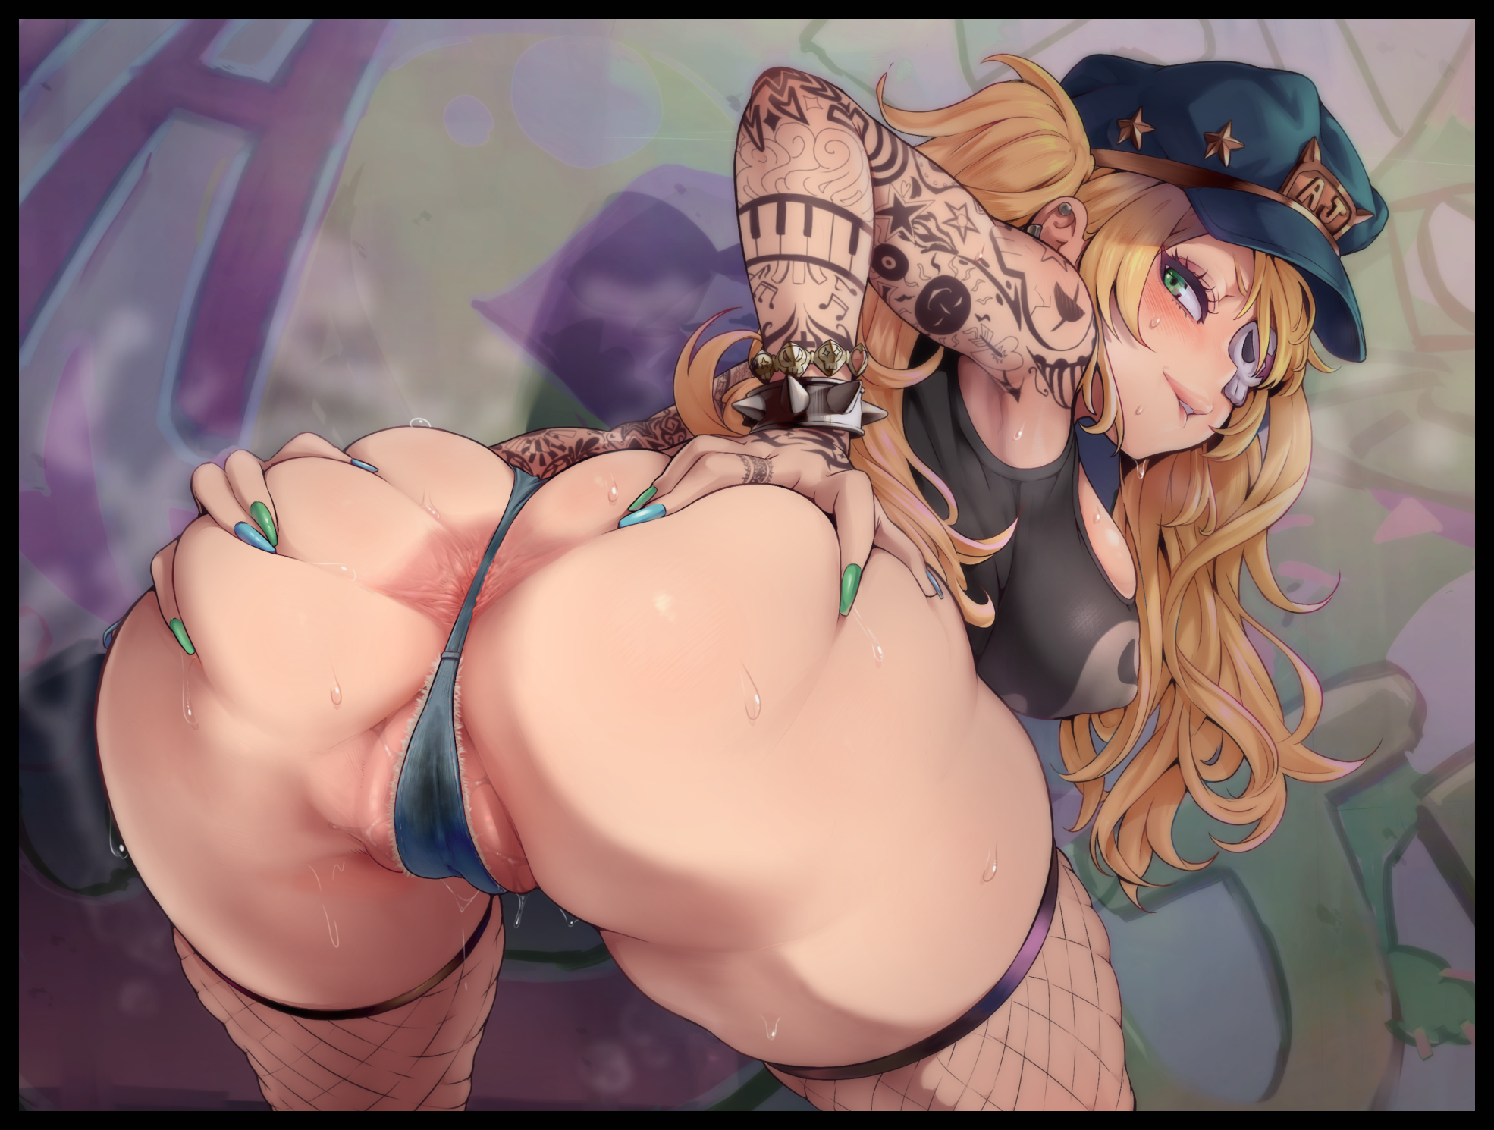
Tanner wasn't the burliest man for an officer of the 'law', but what he lacked in size and strength, he made up for in speed and reflex. So to see all that washed away by the perversions of some horny men who hadn't busted one in ages was just…infuriating.

But I couldn't be sure then, held back by bonds I couldn't see or feel, all I could do was watch my partner change. Losing what made him Tanner once whatever it was the thugs were doing overwrote it all. No matter how much I yelled, I don't think he could hear him. Not when those animals were jeering louder than I ever could. Hoping to turn Tanner back from something he and I had no control over…

By the time I saw his pecs bubble up into a fake pair of balloons barely clothed by what little remains of the uniform, I had to accept the fact that he wasn't in there anymore. Not after hearing him make that sound as if someone were jamming it up his ass while the pants he never took care of finished winding themselves up a gravure model's fishnet wrapped legs before slapping tight around hips that had been snapped outward. Handlebars, for the man rich enough to buy the services of the dirty slut that had taken my partner's place in the world…sorry if the harsh wording there rustled your nerves Olga…best you hear about this sort of thing now rather than later anyways. Our home might be better than it was back then, but that doesn't mean all the dirt and grime's gonna vanish by itself right? Atta girl…

When it was over, Tanner was gone. A policeman rewritten into a pervert's wet dream in the span of a minute with the only thing to remember her by being the crumpled hat sitting atop her curly head of hair, but even that had not been spared, its empty symbol replaced by the gang's insignia. Even though I didn't want to believe it, from where I stood, I'd be an idiot to deny the sight of a manicured hand sporting a spiked bracelet and plastered in tattoos and gang emblems I recognized to be the one they used to denote 'property' extending my way with neon green nails off of dainty fingers. That, and the not so subtle sight of moist, puffy lips pressed down by the leathery strap of shredded daisy dukes were all glaring signs of femininity at its worst; vulgar and debauched to form the twin tailed blonde bimbo staring me down with unfeeling spite in cyan blue eyes. Distancing herself from me as if I were trash before sauntering over to the man she had beaten down not too long ago with an expressive sway to her hips and a jiggle to her bum, demonstrating how small and powerless that thugs had left her as their leader lays into her, squeezing a breast in his hand with enough force to squeeze a driblet of milk out of them. As if to tell me not to try anything funny if I didn't want to end up the same way…like the giggling canary pressing her needy body into him as if her life depended on it…

I looked away then, not when Tanner…or whoever she was now, had been peeled away by a detachment of henchmen to be played with while the goon with the device leads me through the waiting door and into a makeshift torture cubby. Lined with shoddy soundproofing, tables with a select number of tools tossed messily across their length and a single chair, to which they quickly bound me to. Consigning me to a horrid end deep in the heart of enemy territory and down one officer once the heavy metal door slides shut, locked in with the hulking ringleader one other flunkey of his. Dreading what they had in mind for me while the horrid sounds from behind the door…what? Y'want me to stop? But I haven't even gotten to the good part yet!

-
“W-Wait…this is all too sudden. So you’re saying the gang had some sort of ‘device’ with them? Something that can change people into whatever else the user wants? And they used it to change you into…a girl?"

“Uh huh, contrary to what the papers might've put out there about my circumstances. Not even the best surgeon in the world can stick a pair of horse ears and a friggin' tail on my ass onto someone and make it work…don’t forget that stupid thing buzzing on my head. As neat as the benefits are…*Hic*...it's a bother to keep dust out of it all the time, like cleaning my hair…stupid gangsters and their shitty pastimes…just had to base y’fantasies on some*Hic*video game girl…"

Falling back into her drunken stupor now Olga had year enough of the commissioner's tale, the addled woman turns her attention to scouring the messy table, looking for anything that still had a lick of alcohol left inside. Finding success in Olga's forgotten beer, too busy processing the bewildering story Rachel had told her. Uncertain as to how much of it had escaped unblemished by exaggeration and hazy memory.

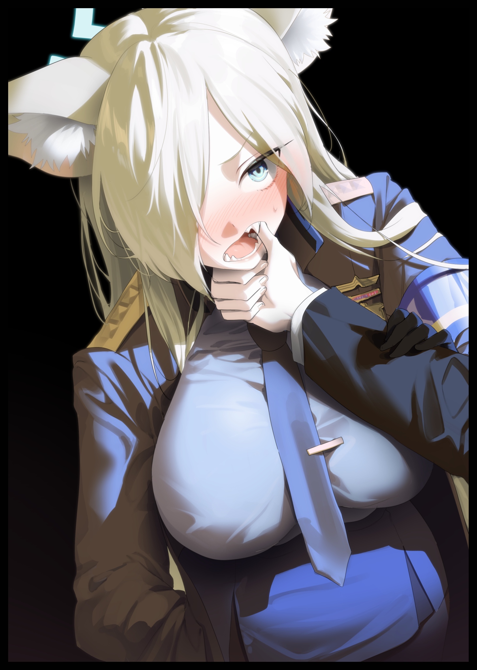
While some bits of it lined up with what Olga knew about Rachel's mysterious past, some oddities stuck out like glaring red flags to her. Like the abandoned warehouse for instance, said to have been somewhere in the town when the only ones she knew of were all the way out on the outskirts close to the ocean where a port handled all incoming and outgoing parcels. Or the part about the device for that matter… "But if this is all true…then why didn't they just use it to gain power instead of cutting deals with the police? A-And how are you so okay with all this?"

"Y'know? I could've told you if y'let me finish the story but…whatever…remember the little malfunction I mentioned earlier? It happened right after they…changed me. Didn't want to do it right away like they had with Tanner so…the boss and his goons wanted me to be 'there'. As myself, while I felt them change me…thought that by giving me melon tits and taking away my manhood…they'd make me beg…"

"Did you?"

"Whaddya think? Of course not, I held my own in there…even if it felt…really good…but that's besides the point! I made it out of there, and those idiots paid the price for it. They thought I'd end up like Tanner; a moaning waif for them to do with as they pleased…and I almost did. Y'don't know what it's like Rook…and I hope y'never find out. Fingers raking over your brain, digging in, making you say dirty words you don't wanna…making you love things you never did before…but I said screw em, and did the only thing I could do, even when I felt myself slipping. I rammed the bastard's head when he got careless, thought he'd won so he came close, hoping to cop a feel for his prize."

"And then? What happened next?"

"I bit the fucker's thumb, pain did the rest before I smacked him in the head with my own. Hurt like hell but, whatever I did managed to send the device falling from his grip and down onto my lap. But my arms were bound and time was not on my side. I had to act fast before they recovered their magnum opus, so I did what I had to do: destroy the damned thing…"

"So that's why you never turned back…but what about the gangsters? You were still trapped inside of there weren't you?"
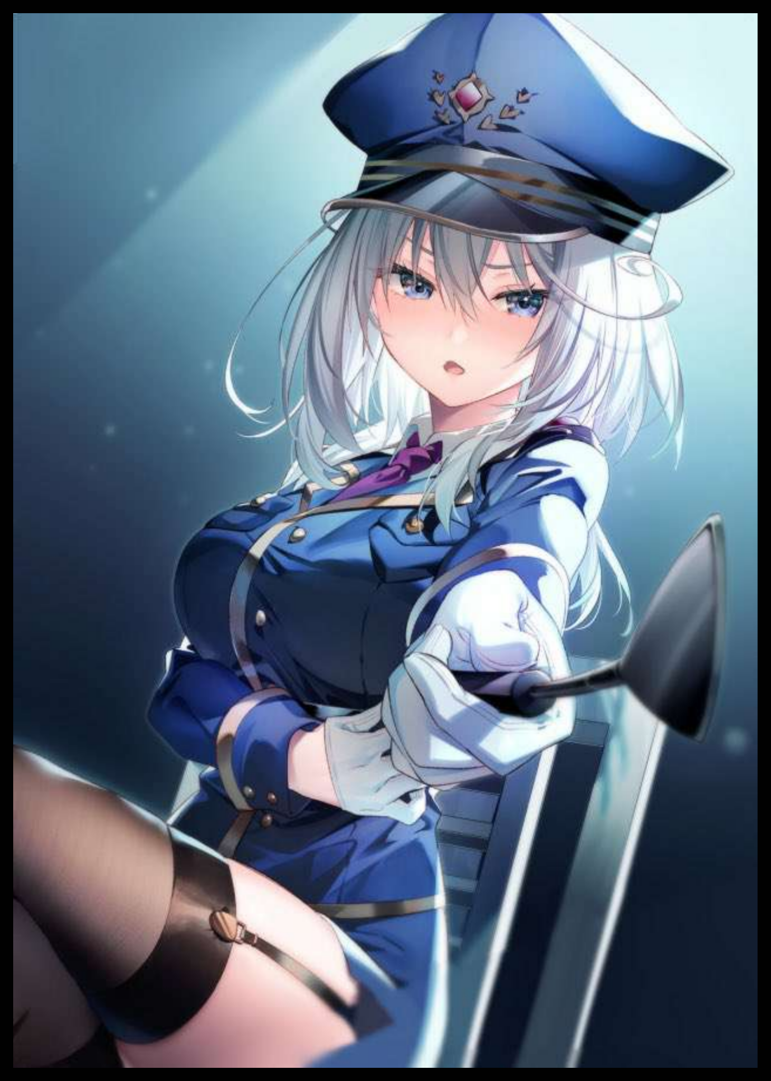
Amused by the suggestion, the first real laugh of the evening escapes Rachel as she leans backward to catch her breath. Bringing up the condensation soaked can to finish up the last bits of alcohol inside before setting it gently down to the table, sharp eyes remained locked to the ceiling while her silken mane of gold tumbles down her back and over the smooth curvature of her chest. An admittedly beautiful sight that had Olga shifting a little where she sat, swallowing a ball of saliva she hadn't realized was lodged in her throat until now.

"True that…but if I hadn't done so, what would've happened to the town? The future would've been messed up…and with that level of power in their hands, our town wouldn't have been enough. They'd spread like pestilence, taking everything while turning those who resist into their mindless slaves…just like what they did with Tanner…"

"Speaking of…did Tanner…what happened to her?"

"That…that I don't know. The last time I saw her was when they separated us. When I finally got them to untie me, she was gone…either those thugs took her away and put the skank to work, or she ended up like all the other gangbangers. They all ended up paying in some way or another, even if they don't remember what exactly their servin' time for~ As for Tanner…well…who knows? Maybe she ended up as one of those new coppers the device popped out for me…"

"W-Wait, but I thought you said-"

"-that I smashed it? True, gave it a good squish with my thighs, not even a chip was left…but that's why I said those fools had no idea what they were messing with. Cuz the moment I smashed the things, it was like a chain reaction began shooting through the room. And whatever it touched, man or otherwise, just started to change faster than what had been done to Tanner and I…the graffiti on the walls? They became notices and simple decor. The patchwork floorboards became brand new slip proof tiles…and the best part? I got to watch the big guy turn into Aurelia~ Unwinding dreadlocks into silver grace. A face any man would swoon over to replace a blistered shell and a tight, womanly figure that I just…uhh…can't get over…yeah…sorry…"

"Uh…huh…so what you're saying is…the warehouse was turned into another building altogether? But if Miss Aurelia's one of them…then the HQ…all the officers…were they all criminals once?”

“Not all of em, no. Especially after all these years for new recruits to fill the ranks…but there was enough for me to realize something back then; that I had the power to change things around the town. Especially when they all started to look to me for direction, like I was their leader instead of the helpless prisoner they had dead to rights or worse. The commissioner back then was a lazy scumbag, same went for the rest of those no good freeloaders leeching off the backs of the common people while throwing my fellow officers to the grinder. For every ill disciplined, untrained wannabe gangsters, I got a competent constable armed with her service pistol and dressed in accordance to their new duty…and once we got to work…Rook, y’should’ve seen the look on all their faces once they realized what we were up to.”

Rising up to her feet, Rachel shrugs off her coat and the ruined undershirt much to Olga’s bewilderment, disrobing herself until the commissioner stands before the rookie, barren and proud with only the simplest of underwear to clothe her modesty and transparent leggings to encase her alluring legs with. Masking the shimmering traces of sweat beading fair skin, especially prominent around the sensual region down beneath a toned navel…

“M-Miss Rachel?! What’re you-”

“Rachel…just Rachel will do…what do you think of me?”

“Excuse me?”

“After hearing my story…what do you think of me? A freak? Some pervert in a woman’s body? A fool who needed some device to set the world straight?”

She was severely drunk, it was clear for Olga to see. But the tone of her voice was ‘real’. Heavy, tinged with hints of spite and desperation. Almost as if the answer she gave would be the deciding factor behind something Olga knew little about but was steadily beginning to grow aware of as she dwells on the question, thinking for a few more seconds until finally opening her mouth to give a response fueled by all she had seen and heard, including her experiences up till now.

“I think you’re one of the best officers in the world…I think you deserve to be called a hero…and I don’t think someone like you should fret about the mistakes of the past…sure, you might’ve been a coward once…and you couldn’t protect everyone. But it doesn’t detract from all the other things you’ve done. You led the toppling of the corrupt force, coordinated the arrests and strikes that all but eradicated the crime lord's presence in town! And if you hadn’t? Who knows where I’d be right now…I’ve looked up to you ever since my Dad told me about you, and I don’t think who you were matters in the here and now. Man or woman…you’re still you right?”

“I’m still…me huh? Right…of course I am…”

Silence falls over the living room once again as the two women stay deadly still with a turning of the tables displayed in the way Olga's unwavering gaze never lifts even for a second away from Rachel, who had turned her head skyward like she had done so earlier, except this time there was a frown on her face formed from doubt more than frustration as the rookie’s words flow within her head in a repetitious loop…

“I get where you’re coming from…but y’know that’s not gonna cut it right? I know sugar coated words when I hear em, trust me, I’ve been mouthing em off longer than you have. But…thanks for trying anyway…you’re the first ever, normal person I’ve talked to about this…Aurelia and the rest…they're just work buddies who'll nod their heads without a second thought. But you Rook? You're the real deal…”

“I dunno…you just called me disingenuous and now you're thanking me? If you’re gonna be like that…then why not step back a little? Let me show you I mean it!" A soft chuckle would break the suffocating stiffness of the air in the living room as the partially naked woman bends over to pick up her discarded clothes, hooking them under one arm before turning to face Olga with a warm smile beneath tired eyes. "Looks like someone's getting cocky…keep it up Rook. You'll do great things out there."

"Where are you going?"

"I've got an itch to take care of…once the others are back, could you ask Aurelia to come to my room? If you're curious…you could tag along later~ I’ve seen the way you look at me Olga…I do mean it when I say you’ve got spunk…and I can’t wait for you to show it to me."

By the time the salacious implications behind Rachel’s invitation became known to Olga, the sly commissioner was already halfway down the corridor leading back to her bedroom, walking slowly with a jovial swing to her tail and a twitch to her ears, masking a serene smile with her back turned after leaving Olga alone in the living room, musing over the brief yet informative conversation she had conducted with such an unlikely character, deafened to the muffled voices of women approaching the front door alongside the clatter of dangling keys. ‘Hard to think the commissioner was ever a man to begin with…wait, did she just call me by name?!’
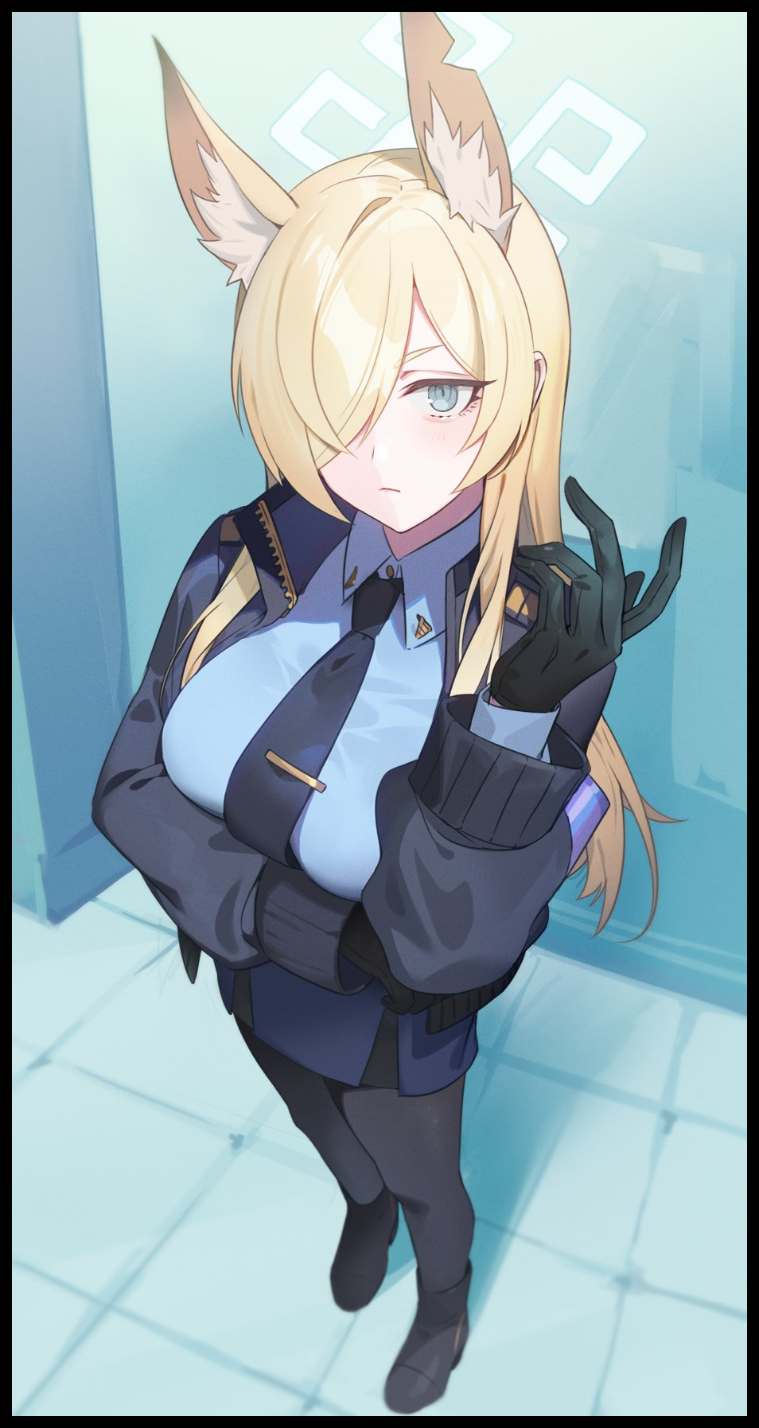
Following the return of her supervisor and the others with drink laden bags in each arm and primal panic consuming her very being, Olga would struggle to help her fellow officers in laying out their bounty before settling back down in a steamy mess, only to be set upon by the white haired lady Rachel had assigned her a message to pass on to, feeling a switch click inside of her hesitant mind upon the reminder of that extra bit the commissioner had teased her with... "Heya deary~ Whatever happened to Rachel? Don't tell me she's passed out now, we were just getting started!"

"O-Oh…Miss Rachel said she'll be in her room…if you don't mind, could I accompany you?"

A few days after the end of that fateful encounter between two unlikely individuals, rumors had begun to spread about the Mare of Justice possibly having picked up on a disciple of sorts. Speculation wrought by sightings of Commissioner Rachel breaking her stern demeanor on occasion, only to glance at a recruit whenever she thought no one was looking or said individual was in a crowd. With the target of the commissioner’s interest veiled in secrecy, the force would see a renewed flurry of gossip amongst the ranks. The men and women in blue wondering just who had caught the eye of their beloved ice queen heroine. Remaining none the wiser to just how far along their rumored ‘relationship’ had already progressed behind the scenes…

Rachel had tried to distance herself from a past deemed too cowardly and slothful to ever call her own. Working all her life since the sudden turn of events that had left her trapped in the body of a woman, never to return to her old one ever again, perhaps as a karmic act of retribution for her hesitation to act, or as she liked to call it; knowing when to stick one’s head up above the trenches. Serving her town and its people as the hand of a law she didn’t really believe in…until now that is.

But with Olga doing her best for both the force and its leader whom she had never expected to get tangled up with so soon into her policing career, the weathered commissioner would steadily begin to step back from her overbearing presence on the field. Taking to watching the actions and ideals of her biggest fan…alongside the occasional private in a place they could call their own…

THE END

Image 1 by Chela : https://www.pixiv.net/en/artworks/105438811

Image 2 by Dashi Namashi : https://www.pixiv.net/en/users/83605079

Image 3 by Yampa : https://www.pixiv.net/en/users/8045536

Image 4 by Riichu : https://twitter.com/rityulate

Image 5 by Yuura : https://twitter.com/82yura

