SUCCING DEVIL
BIWEEKLY STORY #117
BY CHALDEACHANGE
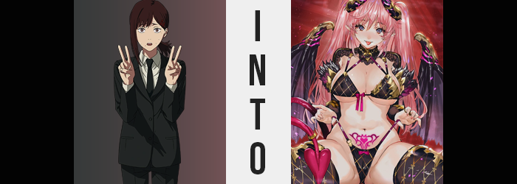

“S-So I’m just supposed to live like this… forever?”

Truthfully, Kobeni Higashiyama didn’t know if that was exactly the case. This and that had happened and not only had she been pulled away from the life she had known thus far, but she had learned that she would likely have to spend the rest of her life in hiding. For what reason could such a thing have happened? Well… It was honestly better off left unsaid in the end. Both for her safety and for yours, considering what she had learned.

The twenty year old woman was pacing around the room that had been given to her in the underground safehouse she had been evacuated to suddenly. It had all happened so quickly that, being the anxious mess of a person that she was, she was having difficulties keeping everything straight in her head. “I w-won’t be able to contact my parents anymore…” That sounded like it might have been a difficult ask, but admittedly Kobeni was happy about that.

Not everyone got on well with their parents.

“A-And I n-need to live with Denji for now?” Not that she didn’t know the boy in question well enough. She had worked with him during her tenure as a Devil Hunter. He was the Chainsaw Man and he wasn’t a bad kid. He was however a fairly blatant pervert. But then again weren’t all boys around his age like that? She could only imagine since she hadn’t exactly been close to many back when she had been a student.

Little did she know that he was off in his own bunker room mulling over similar things. He was lamenting his current circumstances not because of everything he had been through, but because, well… Seeing as how he was hidden away from everyone in this bunker? “No way I’m gonna meet any girls willing to have their way with me down here!” That probably shouldn’t have been his primary concern, and yet it was.

And something had been listening to those desires.

Well if he’s trapped in here with that woman then I suppose she’ll have to do! With a little bit of modification, I mean.

Kobeni couldn’t have possibly been aware of the entity that had been observing the two of the safehouse guests, a Devil with the power to create new Devils so long as it was both granting a human’s desire and had another body upon which to build it. She also didn’t know that Denji was off being horny in the next room even though she definitely probably could have assumed as much.

But she began to suspect that something might have been wrong when, out of nowhere, she began to feel a little horny. “U-Um…?” Not that she never felt arousal, but what about this situation was her body finding arousing exactly? Was she some kind of weird pervert that liked being trapped underground? “Maybe… Maybe I’m just too wound up!” Because she was so nervous about what was happening to her? Yeah! That made some sense, right? …Right?

No amount of excitement or anxiety could explain what happened next though. Kobeni had been lounging around in casual clothing seeing as she’d been taken to the safehouse so suddenly, but then she was wearing… nothing? “EE—!?” But then she was dressed again? “EEEEE!?” What she had been left wearing hadn’t exactly made the young woman feel any better, however.

She was wearing a bikini!? A black one with criss-crossing golden stitching, The bikini bottom had a little hot pink bow on it, and she was even wearing matching thigh high boots! Not to mention the choker the bikini top was adjoined to and the cloth that hugged her shoulders and connected to otherwise detached sleeves. It was an outright lewd costume that was seemingly not even the woman’s size. The cups of the bikini were loose, and the bottom wasn’t hugging her hips with the tightness one would have expected.

“Wh-What am I wearing!?” How was she wearing it!? Had a Devil of some sort found her!? But then what purpose did changing her clothing serve!? Mind you, because she was distracted by her outfit Kobeni wasn’t necessarily paying due attention to other aspects of her situation – namely the body that was clad in the outfit.

Her hair was one such area, with streaks of a playful bubblegum pink evidently surfacing midst her mane. It spread like a fun-colored wildfire from one strand to the next, but peculiarly once a strand was dyed with this pink its length elongated. Shoulder length locks spilled far past her shoulders, all of the way down to the middle point of her ass; bangs now no longer parted and somewhat messy in inconsistent length.

Kobeni blinked several times once those pink bangs tickled the tops of her eyes, although those eyes themselves were different. A steely blue color that was decorated by lashes that had grown longer and fuller by design. She didn’t look less Japanese, but there was no denying that her eyes seemed bigger and more captivating because of these changes. “Ith thomething wrong with my— Pffth!?”

Because of how long her bangs dangled she had taken notice of her hair, but trying to vocalize her surprise had made her aware of a different issue. Her lips weren’t cooperating. They were smacking against each other clumsily, heavily. Were they swollen? They were, but they also had a resting O-shape because of how swollen they were. Bringing a hand up to touch them revealed not only that this was true, but her fingernails were longer and painted dark pink. “I didn’t put that on~!?”

The sound of her own voice startled her and both hands covered her bee-stung lips. Her voice was higher, but there was a more playful quality to its sound too. Flirty. It felt more suitable for a promiscuous teenager, but looking at her face? Perhaps that wasn’t too far off the mark. While not substantially so she definitely looked younger, but certainly no more than a year or two.

“Mmn…” Kobeni definitely hadn’t meant to, but a moan escaped her lips as fingers began to pull at her loose bikini. Had her skin always been this sensitive? Maybe it was just a side effect of her growing horniness, but her nipples were extremely erect beneath the bikini top. They were actually larger than they should have been. This was foreshadowing.

Her posture shifted forward without her meaning to. “Whoa! Are my titties bigger!?” That wasn’t the word she normally would have used to describe her breasts, but regardless of the chosen word she wasn’t wrong. The bikini top had been loose with room to spare, but now it was tightening around contents that became significantly weightier. One, two, three, four cup sizes ultimately ballooned and jiggled, and Kobeni couldn’t seem to stop herself from touching them – slipping fingers underneath the cloth to twerk her larger nipples. “MMN~!”

It felt great, but she couldn’t help but feel like it’d be even better if someone else was touching her.

“N-No! I’m not like that… I…” She didn’t care about things like sex, but little by little it was all she could think about! Wrapping her full lips and sucking on a big cock, or licking the juices for a woman’s pussy… These thoughts burned in her chest and pussy. She was aching. It was more than a craving. It was a hunger. And one that for some reason seemed to stretch her ears into demonic points… as well as prompt black horns to painlessly curl up from the top of her head while her long, pink hair was pulled into twin tails.

The changes to her figure weren’t even done just yet. Her bikini bottom and thigh high boots still sat too loosely on her lower half, but once a hot pink crotch tattoo began to glow over her womb that began to change. Her thighs and her ass bloated, extra weight seeing a softness bleed into her belly beneath her big tits as hips slid wider an inch at a time. That gait was a necessity for the growth of her thickened thighs and perkier, heart-shaped ass. The bikini not only flossed into the deepened crack of her rear, but cameltoed around a pussy that was now puffier and worn from repeated sexual encounters.

Sex was all Kobeni could think about. She wanted to fuck. She wanted to feed. And the more intense these desires became, the brighter her new womb tattoo glowed. Bellowing out an intense moan she suddenly arched her back out behind her, slender fingers slipping between her bikini bottom to masturbate while standing. It seemed like she might fall over, but a pair of bat-like wings and a dark pink, forked, demonic tail erupted from beneath her shoulder blades and the base of her tailbone respectively.

It didn’t take much to make herself cum from there. Yet as fluids spilled down between her dense, plush thighs she couldn’t help but think she didn’t feel satisfied in the least. She did at least understand her own nature now. After all, all things considered she could only be…

“Heeheehee~! I get it now! I’m a Devil~!” The overwhelming confusion that had plagued her throughout her changes suddenly made complete and utter sense. Why else would she be so horny and unsatisfied even after masturbating? She was the Succing Devil! Well that wasn’t her official title, but it was one she had adopted thanks to the funny terms that humans liked to use on the internet. …Or at least one from the future, as the Devil who had ‘birthed’ her was one that could see the past, present, and future to draw its inspirations from.
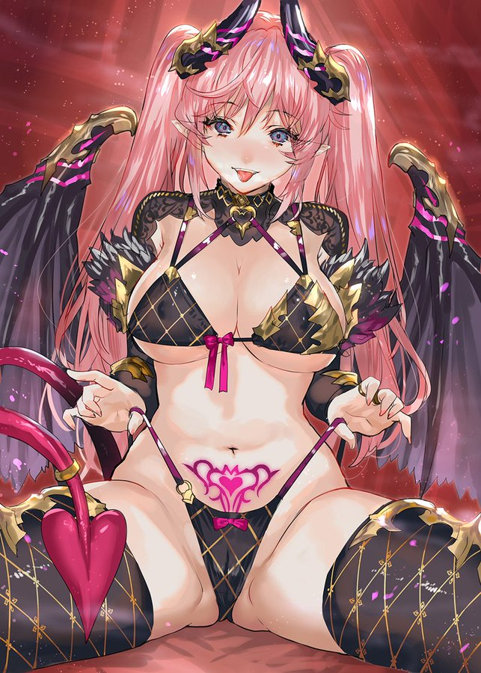
Physically? She was now a girl in her late teens. One that was incredibly beautiful and voluptuous. It was clear that her appearance had taken plenty of cues from popularized ‘succubus’ designs in Japanese media all of the way down to the glowing womb tattoo above her crotch. Of particular note were her round and plump lips, which were where she got her name from. She loved to succ. To suck men and women dry of their sexual juices; it was what kept her powers fully charged in fact.

“Mm… There’s a boy nearby~ I can smell him!” Each step she paced around the room carried a sexual stride. Wearing so little, it was easy to see her tits jiggle and ass bounce with each step. She was designed to be everyone’s wet dream (and the ability to charm people helped too) and she knew it. She was confident, maybe almost a little too much so, that she could seduce the boy she smelled on the other side of the wall. “Guess I’ll pay him a visit~!” But she didn’t even walk through the door to go find him, she simply teleported.

And some very curious Denji noises could be heard from the wall’s other side.

