LOYALTY WITH AGE
COMMISSION STORY
BY CHALDEACHANGE
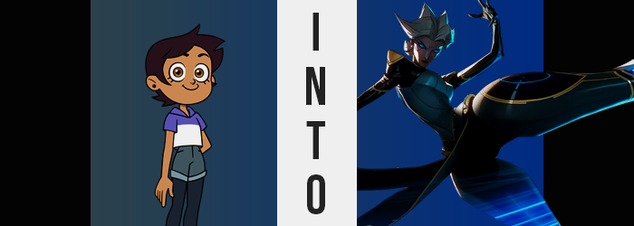

“I’ve seen enough. I need to do something about her.”

Odalia Blight fumed as she paced back and forth within the quarters that she shared with her husband within the Blight estate. It certainly wasn’t at all unusual to find her in a poor mood on most days in the first place, but today? Well, she seemed a little extra sour than she normally did. All because of one of her children – or one of the relationships that this child had decided to engage in at least.

You could use many words to describe Odalia Blight but ‘good mother’ was an adjective that would never pass the smell test. On her head she was the type of woman that loved to be in control, to make sure everything went how she wanted it to. Any little blemish in her plans was seen as a reflection of incompetence and unfortunately? This wasn’t an attitude that exactly meshed well with parenting.

For the longest time she had managed to keep her youngest daughter Amity under her thumb. That girl had a bright future so long as she did what her mother told her to, or at least that was the mentality that Odalia had embedded in her. But lately? Ever since she had begun to get close to that Luz girl, her sweet little Amity had changed. No longer was she a child that she could easily control and Odalia hated that.

In the end it had all come to a head when she had received the news that Amity and Luz were dating. Amity had even dyed her hair after! So enough was enough. If Luz wouldn’t leave her darling little princess alone so that she could follow the path her mother had set out for her? “I suppose there are way to get her to see things my way.”

“A… package? Is there a return address on there? Any idea who sent it?”

“How would I know, hoot!?”

“I just figured since you’re also the door that… Y’know what? Never mind!” After that almost nonsensical exchange with Hooty, Luz Noceada accepted the small, brown box from the mouth of the owl that formed the Owl House and ran upstairs with it between her hands. The young witch hadn’t been expecting a package, but it was addressed to her in such neat handwriting that she couldn’t have ever assumed that whoever sent it had done so with bad intentions! “Then again if Eda was here, she’d probably tell me to throw it out if I didn’t know where it came from.”

Considering how their little band of misfits had been clashing with the forces of Emperor Belos lately, well… It wasn’t like they didn’t know where to find the Eda Clawthorne if they really wanted to. This was all a very logical point of view! “Wait! If they were after Eda they wouldn’t send a package to me, right? Duh!” If not for that excuse, then Luz probably would have come up with something to convince herself that the package wouldn’t be a problem.

“I really hope there’s not like… homework or something in here though. Feels pretty light.” But why would someone send an empty box? That’d be a waste of shipping fees! Actually, did the Boiling Isles even charge shipping fees? Maybe that was a question she would ask Eda when she got back from shopping with King? “Alright! Time for the moment of truth!”

Luz slapped her knee repeatedly as a sort of ‘drumroll’ after placing the box on her bed. She was only fourteen years old, after all. When she was content that this ‘drum’ had been drummed enough she finally reached out to tear the tap off of the top. It took her a little longer than she would have liked but once she finally accomplished her task… “Aww…”

The worst case scenario ended up being the truth. “There’s seriously nothing inside? Then what was the point of sending me the box in the first place!?” Just to make absolutely sure, the human shoved her head into the box in order to make certain that she wasn’t missing something important. Not a toy, not something expensive, not even a note? Why would you even go to the trouble of sending such a lackluster package? No! Could a box with nothing inside of it even be considered a package!?

“Huh? Wait a second, what’s—?” With her head still buried in the cardboard she finally saw it. A small silver light glowing at the box’s bottom? No, it wasn’t a small light. It may have begun that way, but it was quick to expand and blast out of the box. “WAH!? MAGIC!?” The teenaged girl hadn’t even been aware that you could use magic in such a way! But at the same time? She had also just taken the spell head on. It sent her flying across her room. “Oof!?”

At least she was quick to pick herself up after landing, but she had no context about what that magic had been placed there for. Much less what it was supposed to do. All Luz knew was that she felt a little tingly all of a sudden. “That wasn’t magic that might have an effect on someone’s body, was it…?” She’d only suffered from that kind of effect a couple of times and her mind went to when she had swapped places with Eda.

Little did she know that she was about to receive a similar fate. Similar, but not exactly the same either.
“Should I tell Hooty? Maybe I should see what’s going to happen first…?” Luz had been around magic enough by this point that she knew well enough that the spell was affecting her body. Whatever it was doing, though? It was definitely slow acting. At least compared to other magics she had seen that had affected the bodies of others. The girl threw her hands out to the sides and looked down at herself for any signs that anything was awry.

She didn’t really need to wait long. “Huh? Woah! Wait a second! I’m definitely not dressed for this!” Because she was aware of magic and how it worked there was no shock addressed at the process, but she was certainly alarmed by the sighs, sensations, and implications of what she was presently experiencing. And that was… a jump in her height. A very significant one for a girl that had an average height of around 5’3” regularly.

Luz’s concern came from her clothes. Her limbs were definitely lengthening but she welcomed the idea of being given a fresh perspective. So her shirt lifting or her shorts yanking downwards to show off her tummy? These weren’t welcome changes – especially when it became clear to her that whatever the magic was doing? It didn’t appear to be showing any signs of stopping even after growing up to roughly 5’8”.

“No, seriously! I don’t really have any clothes for this!” Under no circumstance could the human actually have predicted just how tall she would become in the end, but simultaneously it was becoming clear that more was being affected than her height alone. It was extraordinarily apparent in the girl’s face as she peeked up over the 5’10” mark – and the sleeves of her top tore thanks to shoulders broadening.

Luz was also getting older. Facial features had certainly lost their roundness and matured a great deal while thinning. Her lips were slowly but surely getting fuller too, but… As her height rose over the six foot mark? This shift in her complexion began to suggest an even more egregious age range than just ‘young adult’ or even ‘adult’ outright. The quality of her skin was deteriorating more and more and even paling?

But her skin’s color wasn’t related to her age. Her melanin was being directly affect by the spell for a different reason. “H-Huh!? Am I white?” The Afro-Latina heritage had just been stripped from her body so not only was her skin white, but it was obvious in her face too. She was still getting older, height now over 6’5”, but it was clear that her increasingly jagged facial features were those of a Caucasian woman.

“I suppose I need to worry about my clothes too…” So many things were happening at once and so it was impossible for Luz to address everything. The deepness of her voice was a new one, but there was also the matter of what she was saying. She was passively using language and tone that was more befitting of a mature woman, too. That said? Concerns about her clothes were certainly warranted.

Her height had peaked at a substantial 6’8” and that had wreaked absolute havoc upon the outfit she had been wearing. Her shirt now barely covered her chest, much less past them, while her shorts? Hips had widened significantly as she’d grown taller, and so they’d torn at the sides and peeled off. They fell along with snapped panties, revealing thickened thighs and a fuller ass in the process. But there were signs of age weighing them all down.

And that wasn’t really surprising. “Wait… How old am I?” Because Luz had been in Eda’s body before… Well, it felt similar. Age certainly showed in every capacity but she still looked younger than she actually was. Because truthfully? She was eighty years old and this was promptly reflected in silvered hair too. Said hair grew out into a wildly pointed style, almost resembling horns in the back while bangs were styled into thick, side-shooting points themselves. She reached up to prod at her hair with purpose, her other hand resting on her hip with a posture that wasn’t her own.

But how did she look so young for her age? Wrinkles aside, of course.

It was, in fact, related to an eerie glow that her eyes began to admit. Their colors had been relatively untouched until that particular moment, but the second they began to glow they did so with a bright blue. But… eyes weren’t supposed to glow, right? Not unless there was some sort of magic behind them. Or some form of technology? In a sense both of those things ended up being true.

“Something else is happening…” Luz regarded her body with concern once more. So much had already happened to her, but now she had begun to feel oddly cold. It took a moment for her to clue in on things but she also felt hard? Sometimes feelings were difficult to put into words but she found the correct one. “Artificial?” Deep down in her subconscious she seemed to recognize what was happening. Or at least what her fate was.

Much of her body was hardening. Literally. Her skin was taking a supernatural sheen everywhere beneath her neck. It was clearly metallic in nature and any body hair was sapped away, but that previously whitened skin darkened again – this time into a dark bluish-green steel. It was at this point that parts of her hardening body began to expand. “Hm…” She regarded it with a subdued curiosity that contrasted Luz’s usual energetic reactions.

Her hips and thighs ‘benefited’ the most from the expansion. As they became more and more artificial they grew in girth, thighs creaking as they burgeoned with sheen and weight. They nearly tripled the size of the woman’s waist and had an almost bulbous shape to them and yet there were parts of them that lessened too. Because the joints connecting her legs to her hips were shaved into naught, granting those joints a doll or robot-like appearance.

“Oh! I understand…” An upwards jolt pushed her height even higher, applying an extra two inches so that the older woman’s final height was a whopping 6’10” – but the cause of this addition wasn’t because she had actually gotten taller per se. She had been forced to stand on her tiptoes which then thinned and sharpened along with the rest of her legs beneath her knees, turning them into blades she balanced on instead of feet. The joints of her knees flattened and thinned into metallic joints all their own.

Fortunately, aside from more and more of her flesh and blood being replaced with gears and steel until very little remained, her torso was essentially untouched. Her breasts grew beyond the confines of her shirt finally, but the dark turquoise plating that covered them concealed her nipples – if she even still had any. It was all needed to conceal the energy source that powered the rest of her body in its new form. At the very least she felt a great deal of overwhelming strength now. Of course it had been gained at the cost of much of her humanity.

“Such a strange fate has been thrust upon me.” And it was one that Camille had absolutely no context regarding. She could recognize that her body and identity had both changed. Her old name, Luz, could be recalled. But she couldn’t say it, nor did it feel correct for her to say it. In a way it was like she had been wired to accept this new name without complaint – and it was certainly the fault of that magic.
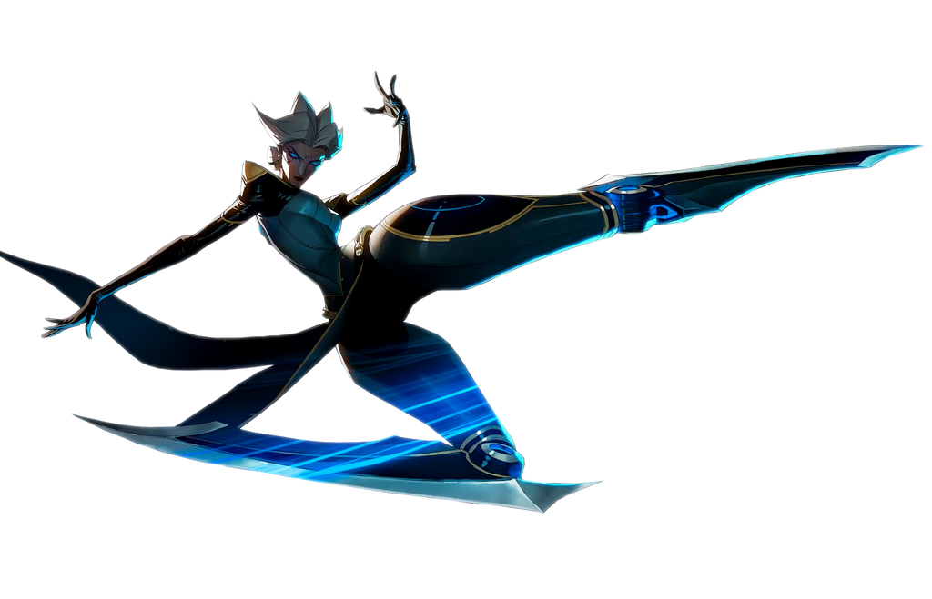
She could also recognize that her body was not fully natural. It was composed of parts that her memories recognized as ‘Hextech’. A form of technology that shouldn’t have existed within the Boiling Isles, and yet Odalia’s magic had made it so whether intentionally or not. It didn’t really matter so long as Luz had become an older, more mature woman like herself. Her logic being that ‘if Luz was an older woman like me then surely, she could understand my point of view’.

It had also been part of that plan to make the woman Luz became cold and ruthless. Camille was certainly both of these things, but… “But what of my allegiance to Amity? Surely nothing has changed in that regard. In fact, this new strength of mine…” Could it not be used to protect the people she cared about? Luz’s essence still existed deep down. She still remembered the things that were important to her. It was simply that her priorities and means had been shifted around by her new identity.

While the methods she might employ to protect those friends, and most of all Amity, might be far crueler now? Her loyalty to Amity herself had not wavered even in the slightest. Which meant the most fundamental piece of Odalia’s plan had failed. But the Blight woman did not yet know this. Nor had her plan entirely reached its conclusion. She had wanted to teach Luz a lesson and take her out of the picture, surely. But her daughter was in just as much of need of a ‘lesson’.

Of course, there was now a high chance that even that would go astray.

“I must seek Amity out now. Leave no trace of my presence here… And from thereon… I will decide on what needs to be done.”

