CharQuinda- A Disappointing date night

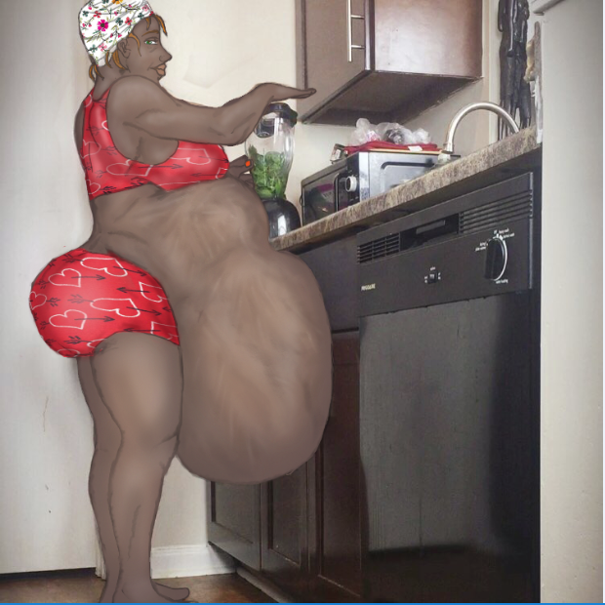

Last night was a major disappointment and you wake up this morning harboring the residual frustration. Despite what you assumed were positive signs from Toya, the lady you've been dating for the last three weekends, it turns out that she decided to stand you up. You're mostly annoyed at the rudeness of accepting your invitation for a bit of Netflix and chill at your apartment, and then after saying she's on the way cutting off all communication. Not a text, call and or even an email. Just letting her phone ring, and never picking up. But that's how dating is sometimes. Wouldn't be the first time this happened.

You shake your head and head to the bathroom to take a morning piss and shower. As you make breakfast, you decide to give Toya another call. Play it cool and relaxed. Not too clingy, you tell yourself. You dial the number, and butter some toast as you wait. Unsurprising , the line just rings and rings. But then the faint but distinct sound of Toya’s ringtone catches your ear. Moving quietly you follow the sound, your phone still plastered to the side of your face, until you realize the sound is coming from the hallway.

You peak out of your front door and immediately spot the familiar cell phone case, laying face down a few doors away on the hallway floor, ringing at full tilt. You hang up your own phone, perplexed noting the phone is sitting a short ways down the hall near your neighbor ChaQuinda’s door. You’ve had a bit of a crush on CharQuinda, but because she always seemed to be in various arbitrary stages of pregnancy whenever encountered, you’ve only conversed with her a few times, not wanting to be that weird guy hitting on the preggo bellied lady. You tip-toe out in you socks to get a closer look in case you’re mistaken about the phone case but picking up the now silent device proves you are not. You look around for any sign that Toya had visited last night, maybe after you already fell asleep and spot the apartment number 209 on your neighbor's door. You’re momentarily confused since 209 is your apartment number you move the loose digit swinging it upright turning 209 into 206.

After a moment you decide to knock and inquire if maybe CharQuinda had an unexpected visitor last night. You knock on the door and before you can knock again you hear a sweet yet sleepy voice call out that the door is open. You try the knob and it is so, and walk in. The sound of the intense humming of a blender fills the air. You feel a bit bad for interrupting her breakfast.

“Hey Neighbor. It’s me from 209, down the hall. I got a quick question if you don't mind.” you call out deciding to announce yourself as you enter the cluttered and somewhat unkempt apartment.

“Hey Hon. I’m In the kitc-**oOURAP!\***-Kitchen! Excuse me! Come’on over. “ CharQuinda calls out over the blinder, the unexpected guttural belch echoing easily over the sound of the obnoxious device.

Following the the sounds towards the kitchen You begin to ask if she knew her Apartment number was turned upside down. As you turn the corner into the kitchen you freeze in mid sentence as you see CharQuinda standing at the counter with her blender. Your eyes bulge wide and mouth drops open in a gaping O as you stare at your neighbor, sporting a snug red and white heart-shaped pajama short and top set, her head-scarf and of course the hugest most tightly swollen belly you had never imagined possible. Her distended bulge of belly flesh is pressed up against the counter and lower cabinet doors as she works the buttons of the blender, inconsiderate of the fact there is insufficient space between her thick hips and the cabinets as she purposely smashes the bloated mass against it, even grinding her hips a bit. You can see clear signs of weak movements of whatever is crammed inside her huge gut as it writhes about beneath the taut layer of stretched epidermis.

“Did I know what?” CharQuinda asks, snapping you from you’re shocked daze. You stutter as you pull yourself together, deciding to play it cool considering what you’re seeing.

“I-I-I was saying your door address says 209 i-instead of 206.”

“huh…(Yawn) Yeah that happens sometimes. Thanks for the head’s up… Is that all?” She says clearly disinterested as she pours her green goopy smoothie into a glass, turning to face you revealing the sheer hugeness of her shifting gut from the front. You notice her belly button was pushed out into a point, clearly from the compacted fullness of her stomach.

“I-I was expecting a girl over last night. T-toya. I t-think she came h-here instead of my apartement. She probably m-mixed up the numbers.”

“Hmm…*BWORP*” Scuse me, again. I had a really big dinner last night. Giving me hella (Hic). Hoping this ginger smoothie helps settle my stomach.” CharQuinda says, sipping her smoothie in consideration. Then she asks. “Did this girl have long black braids, brown eyes with a double ear piercing on her left ear?”

Yes! That’s her! Soooo... she stopped by here?” You ask with uneasy caution. You eyeball her stomach again. You know it’s a person inside her belly when you see a hand briefly push out against the tight surface of skin, and you understand what happened to your date.

“Nope sorry.” CharQuinda says with a grin. “Maybe you should ask T -aOURP*, ugh,..ask Tammy down the hall.

“Yea Right. I found **this** outside of your door.” You say holding up the phone like a prosecutor presenting evidence to a jury. You see Toya kick hard inside the cramped confines of CharQuinda’s belly, causing a volent protrusion.

*BEOOOWWWORRRRRUP!!* An equally violent belch burst from CharQuinda’s mouth sending a soggy sock flying from her throat right onto your shoulder. Brushing the smelly sock off you take a deep breath and decide to say it straight.

“CharQuinda, Did you eat my date last night?”

“Ugh...okay fine.” CharQuinda says annoyed any chance of deniability is up, with the phone and the soggy sock as proof. She Crosses her arms over her large breasts, resting them atop her Toya-filled belly. “Whateva’ I get it. you were looking to get some booty last night and now you want me to let her out. Well, don't bother asking, ‘cuz I’m not. Nope. She’s my dinner..uh...well, my breakfast now.”

“Com’on CharQuinda, that’s not fair. She wasn’t even supposed to come to this apartment.” You protest, a bit exasperated. You notice CharQuinda’s expression shift to a slight amused smirk as she looks you up and down. Suddenly, she places her hands on her lower back protruding her belly further out and quickly waddles forward shoving her bulbous swollen belly directly into you driving you back into a wall. Once she has you pinned, her huge belly full of your potential girlfriend pushed against your lower torso and hips, she begins to grind her huge belly into you. You feel apparently erect member get stiffer as she sandwiches her engorged stomach and it’s squirming occupant between her hips and you’re throbbing cock. You huff, breathing heavily as you gasp for air in pleasure and from being crushed.

“Hmm...It looks like you were looking for some booty....” CharQuinda whispers to you, taking your hands and putting them on her belly. You moan and rub the bulging mass as she grinds against you rubbing her breasts with her hands. “...I think maybe we can work out a neighborly deal.”

After a moment she backs off and you lean heavily against the wall wheezing to catch your breath, your cock rigid in your sweatpants like a tent rod. She leans close to you and kisses you deeply and invariably you kiss her back.

“How about this, neighbor. You let me keep my tasty meal right here…” She smacks her belly for emphasis, invoking a turbulent response from it’s prisoner before continuing, “... and I get to have THIS for desert.” She reaches inside your sweats and grabs you’re hard-on stroking it a bit. You nod silently yet vigorously, and with your hard-on in hand she leads you to her bedroom massaging you tenderly with her fingers. You follow behind her speechless, your eyes glued to her body, her big round booty tugging at the tight red shorts and belly swaying heavily side to side as she walks.

As you enter her bedroom she pushes you down onto the bed. As you sit up you’re face to face with her gravid churning stomach, full of a digesting woman turned meat. You rub the heaving gut with your hands, massaging and caressing it, and you hear the voracious woman moan in deep sigh. You make eye contact with CharQuinda and she smiles, licking her lips.You wonder if that is lust or hunger in her eyes and figure it’s probably both. You count yourself lucky it’s not the same hunger that would cram you in the gastric chamber alongside Toya.With great effort CharQuinda begins lowering herself heavily to her knees, resting her body atop her engorged belly like a squirming meat filled yoga ball.

*BLOOUUUUURRRRRRUAP* A Deep belch is discharged from her throat as as she settles, atop her full stomach. Not bothering to excuse herself anymore she begins tugging your sweatpants off and once you’re cock is fully revealed she parts her salivating lips and engulfs it whole. You’re toes curl as you’re member is is consumed, sliding deep into the moist depths of her esophagus, and slowly back out again. CharQuinda proceeds to give you the best blowjob of your life, her apparently non-existent gag reflex allowing her to repeatedly devour your whole shaft again and again, leaving you in a state of euphoria. After what must have been only moments of this epic enthusiastic deepthroating you feel yourself reaching climax. CharQuinda, apparently hungry for more, deepthroats you again, and with your cock squeezed in her tight muscular throat, she swallows repeatedly her peristalsis muscles massaging you over the edge. You gasp and your body tightens as you explode directly into the depths of CharQuinda’s maw. What feels like buckets of jizz pour into CharQuinda, your kids sacrificed along with countless other meals into the bottomless depths of her gullet.

Finally, completely spent, you flop back onto her bed as CharQuinda Dislodges your manhood from her throat, giving it another quick cleaning with her tongue.

“Hmm...Not b-oOOURAP* Not bad, Hon...” CharQuinda says, Heaving herself up off the floor and flopping on the bed beside you, her ponderous gut sinking the bed drawing you towards it. You don't resist with the post climax haze clouding your mind. ”...Normally I don’t suck on the *hic* first date but I guess you did give me a pretty damn good meal beforehand, so I’ll let it slide”

“Yea? For head like that i’d feed you all the time.” You mumble. It hit’s you a moment too late as you realize what you’d just potentially agreed to.

“Is that right?” CharQuinda replies, a twinkle in her eye. “Well, maybe i’ll keep you around after all.”

You get a sinking feeling in the pit of your stomach as you see Toya’s form shift within the corpulent swell of CharQuinda’s.