*A Chance to Win It All*

Urban legends; bewildering stories derived from rumor and the hot topic currently going on around social media to incite a variety of emotions from those who read or hear of them. They could be made to rile people up, lure simple minds into performing crazy stunts or making a complete fool out of someone gullible enough to fall for such tall tales. Since time immemorial, urban legends have existed in some form or another, almost always being based around folklore, superstitions or even incredulous ideas brought to life by a concept drifting by the minds of the people who wrote such things.

But a particular urban legend spreading rather slowly across the net wouldn't be based around some cryptic message or insidious otherworldly being with unknowable plots in mind, far from it in fact. All it was could be boiled down to a short simple message that sounded more like a scam than anything else;

[You Stand To Win It All Under The Light of The Moon]

***Like a line straight out of a romanticist's journal…***

What made that one sentence worthy enough to be recognised as an urban legend you ask? Word of mouth, gossip, rumor, idle chatter between friends. All of it because of an alleged few who had claimed to have actually gotten what they had desired from *'that place under the moon'*. But the way they had worded it sounded like the inoffensive beliefs of a new convert in some suspect religion; no evidence to base their claims and almost always ending in some plea for others to seek this place out…wherever or whatever 'this place' was however, not a lick of it was mentioned at all.

Many would begin their own search into That Place Under the Moon, a term the internet had collectively agreed on in all their great wisdom. All would meet with failure. Whether it was stalking out key areas with a past involving the moon or simply waiting out till the moon shone bright in the sky, nothing would ever happen, no such happening or mystical place for one to earn their fortunes in.

One of these seekers was a man simply known as Jeremy, despite his social life being left in shambles and his dead end career in some paper pushing position at a business firm being his only source of income, Jeremy was an avid fan of urban legends and the like, spending his free time browsing forums dedicated to the topic, doing research into ongoing mysteries and partaking in discussions whenever possible. So it wasn't too much of a surprise that he already knew plenty of the rumored phenomenon famed for its potential to grant anyone what they wanted most. Intrigued by that particular aspect of it over the supernatural.

Try as he might, however, nothing seemed to work. Even unorthodox methods like bringing along a portable tent with a moon pattern embedded into the fabric in a casino of all places bore no fruit…well, besides earning him a lifetime ban that is. But the point still stood; whatever this Place Under the Moon Was, it couldn't be replicated or 'summoned'. He had assumed it to be some sort of gambling machine of sorts after reading too far into the message so Jeremy's efforts were centered in or around such places, and while his hopes were high, not even that seemed to be enough to bring the thing into existence.

At his wits end with this particular endeavor, Jeremy was on his way back home after being escorted out of a seedy bar establishment when his eyes had caught the sudden glare of a bright light suddenly emanating from his right, turning to face an open garage door built into one of the derelict shophouses lining the dreary streets of the lower residential districts. A place no sensible man like himself should be unless he was asking for someone to rob him blind or a hooker to spend the night with.

But the dangers and pleasures of the slums were of no concern to Jeremy right now with his eyes glued to the lone crane machine planted in the middle of that concrete chamber, of a simple make without much decoration, it would've been easy to just pass it off as some elaborate setup by the local junkies.

If it wasn't for the very extravagant beginnings of what Jeremy was amazed to see painted on the walls and ceiling from where he stood, and with an excited jog into the mysterious garage, the weary man lets out an excited remark at the sight of the azure blue painting of an evening sky with a pale blue moon right above the crane machine.

That Place Under The Moon, he had found it at long last!

Stuck in his excitement, the man didn't care to notice the heavy steel sheet metal slamming shut behind him, tracing the control panel of the crane machine in awe while eyeing the contents through the thick glass; they looked like ordinary plastic capsules one could find in a gachapon machine.

***'But what was the price for entry?'*** Was the first thought that shot through Jeremy's mind after realizing there was no slot for a coin anywhere on the claw machine, instead realizing there was an extrusion of shiny glass reminiscent of a sci fi scanning device with a blinking outline of a hand flashing on it. Was that how he was supposed to trigger it?

Seeing no other plausible trigger to activate it, Jeremy willingly plants his hand firmly over the glass. If the tales were true, then he stood a chance to win everything he could ever want. And with his skill and technique in operating claw machines including the ones obviously rigged in the establishment’s favor, he was certain he could win.

But as the machine begins to rumble under his hands, an overwhelming heat suddenly takes hold of Jeremy as a stinging sensation akin to a needle spikes up the hand placed over the console, unable to pull away from an unknown force holding him in place despite the overwhelming discomfort he was feeling, only able to groan and cry out in fear as his clothes begin to grow heavy and baggy, with gaps in his jacket appearing where they once fit snugly over his portly body, a body that was rapidly losing all signs of its former obesity as layers of fat, thick muscle and body hair vanish one by one, leaving long bony limbs and a gaunt figure with a face that bore no resemblance to the former cratered face of a weathered Caucasian man…in fact, it wasn't the face of a man at all…and neither was it a woman's.

By the time the force had seen fit to free Jeremy from his restraints as the machine fully blinks to life with neon lights trailing the sides of it, the rest of his body had been warped into a similar state; being neither that of a man or woman with the bulge of his manhood against his underwear no longer present, tugging down in shock to reveal a smooth pale surface devoid of even a slit with his chest likewise bearing no nipples at all. It was as if a magical carpenter had shaved his sexual identity away with sandpaper. Just short, lean and slender enough to barely qualify for either gender, like an all purpose mannequin some clothes stores used to promote their goods.

About to drape himself back up once more, Jeremy was surprised yet again when his hands grope for clothes that were no longer there, realizing the jacket, singlet and baggy trousers he had kicked off him had all vanished, leaving him in only his underwear as he struggles to his feet, trying to draw breath and taking note of the fact that his voice had suffered a similar fate with airy breaths leaking from lips that were cured of their ulcers and cracked sores.

Cursing momentarily before reminding himself of what he stood to gain from this, Jeremy sucks in a heavy breath of air before beginning his work, wrapping bony fingers around the control lever while bracing his other hand over the controls, tapping rapidly as the claw begins to descend. Without a prize pool to guide him, Jeremy's first instinct was to go for the golden one he could see atop the pile, glittering a glamorous sheen with speckles of diamond dust scattered across its surface. Whatever it was, the deco was all he needed to know that it was a grand prize.

And with his innate talent with the controls, it didn't take long for Jeremy to get the capsule over the chute before releasing the claw, dropping it down with a satisfying clink as it's solid cover bounces down the metallic innards before pushing open the flap at its base and rolling to his feet, ready to collect.

Gently picking the wallet sized thing up in his hand before bouncing it up and down to watch it's shell sparkle and catch the light, Jeremy palms his other hand over the cap, heart heavy with anticipation before twisting sharply, triggering and explosive release of dark pink smoke that billows outward, consuming Jeremy like a tidal wave as he lets out a shrill scream.

Beneath the smokescreen, Jeremy's pale skin begins to dye itself a light cocoa brown all over, seemingly absorbing the purple smoke and gaining mass in turn, but instead of the muscle envisioned in his ideal body, lean flesh and supple fat pumps in to fill his featureless frame, granting curves, expanding hips, adding a gentle touch to his arms and plumping up his legs.

Not to be outdone, the man's former crew cut head of hair extends downward in a frilly bush of silky brown, gaining a dirty blonde tint to add some flair to it as a soft fringe blooms forth to greet his face before curling sideways, showing off a healthy amount of brow while lengthening down over his shoulder in a silky trail. By the time his new hairstyle had cemented itself stop his head while trailing down the nape of his neck and arched spine, Jeremy was beginning to look like a gaudy ditz of a teenage schoolgirl, complete with tanned skin, well kept hair and dainty fingers tipped with polished nails colored a fashionable sea blue. A far cry from the giant of a man and androgynous doll that came before.

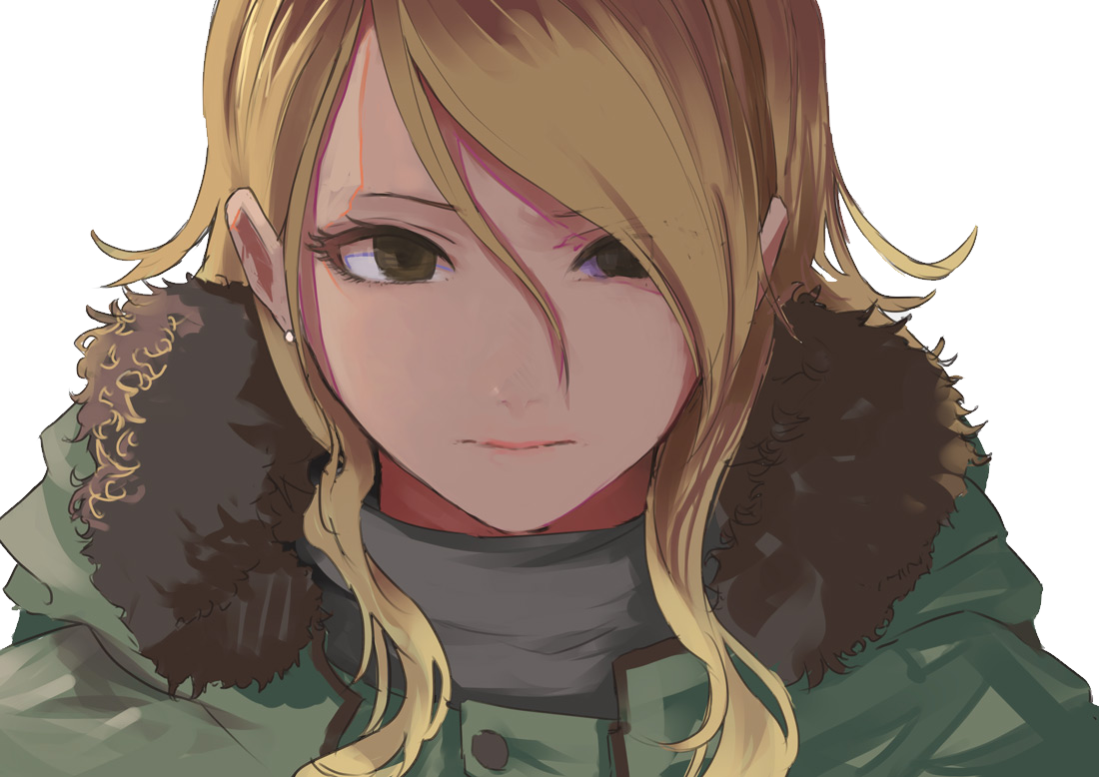

By the time the smoke had fully cleared, Jeremy was left stunned at the sight of his own body, pulling at the soft strands of hair trailing down his face, hesitantly tracing the contours of a smooth navel lined with firm bits of muscle that accentuated a disturbingly feminine appeal and the fact that he now seemed to be slightly shorter than before, putting his weight from one foot to the other while clicking his tongue at how soft and jiggly he felt. Had he picked wrong somehow? He was expecting the body of a jock, not the curvy frame of a waifish man with a slutty tan! Dreading the thought of how his face looked if his body was already this…mesmerizing.

Looking back at the sealed heavy frame however, he doubted he had a way out of this place even if he decided to call it quits now while he still could.

Shaking his head and left with no other choice but to attempt to win back his manhood, Jeremy lets loose a curse in an effeminate voice before placing his hands back on the controls of the crane, thinking harder now on which capsule to choose, ignoring any glimmering orbs while going for the rather ordinary ones that bore dark colors, associating them with something a man would choose.

***Oh Jeremy you sweet summer child…***

Just like before, the crane deposits yet another capsule down the chute, spitting out a dark blue one this time as it rolls to his feet, bending down much more easily now thanks to his reduced height to pick the tiny thing up. Despite its reduced size and less than grand appearance, it was a loss Jeremy was willing to take since he had no clue what actually laid within these accursed balls.

Holding it away this time, the cautious man twists as an audible crack fills the air, dropping the capsule as yet another plume of purple smoke escapes alongside a voluminous mass that drops to the floor, coming to life as a serpentine cloud that begins to entwine around his hand, slithering down the length of it and leaving behind a radiant sheen to his skin, as if he'd just applied some moisturizer to it. But that would soon prove to be the least of his concerns as the living mass shrouds his chest before sending a tingling warmth radiating from where his nipples would've been before they were erased, watching in a mix of embarrassment and pleasure as said nipples return as light pink nubs, leading the charge as fat and nerves begin to build up beneath them, piling together to form a pert pair of breasts that were beginning to grow bigger with every second in contrast to the cloud that just like before, seemed to seep into the jiggling mounds.

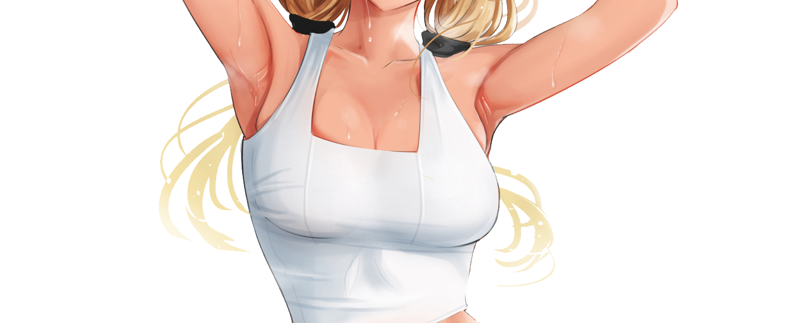

With yet another cloud absorbed, Jeremy was free to topple over onto a much former ass in an ecstatic haze, panting heavily while trying to ignore the heaving mammaries rising and falling atop his chest with beads of sweat sliding down the smoothened skin of his body glimmering with a red hue in certain places to show just how flush he was beginning to feel. As much as he hated to admit it, the pleasure gained by this strange form of feminisation was out of this world.

Moving his eyes away from his chest toward the extra item that had dropped from the capsule, Jeremy lifts an exploratory hand hefting a firm breast away from his privates and toward the pale white article of clothing on the floor, realizing it to be a form fitting black undershirt made out of cotton with long sleeves and exposed cutouts along the shoulders. Sighing in the airy voice of a young girl, Jeremy proceeds to wear the thing without much issue, slipping it over his porcelain smooth Toro before wincing a little as the rough cotton rubs at the erect nipples of his tits, muttering expletives while tugging at the hem of it that was only long enough to cover the top of his tummy with a suspicious cutout below and above his chest, exposing plentiful amounts of cleavage for a certain someone to see.

It was starting to feel monotonous to Jeremy at this point; rising to his shaky feet that had more girth thanks to a widened set of child birthing hips and a tantalizing thigh gap between them before leaning over the controls with a new weight pulling him down, the changeling could barely qualify for a man at this point because if anyone were to wander in from behind, they'd be wondering what a half naked, tanned babe was doing playing with a claw machine all on her lonesome.

Repeating the process a third time with a less than hopeful look on his face, Jeremy sighs as a pink orb rolls out of the machine, wondering if he really was in his right mind for choosing such a blatantly wrong choice if his end goal was masculinity. He'd tried going big, only to be rewarded big in a way he never expected. He'd tried choosing a color associated with men and earned himself a pair of tits and womanly clothes…so what if he tried something so obviously girly?

*'This is better than nothing I guess…if anything, beats being some overweight guy, sheesh look at me talking shit about myself…'*

Slapping himself on the face lightly, the undecided man gives up on even trying to find a safe way to open up the capsule, choosing to instead raise a curvy leg high in the air before stomping down on it, wincing at the sharp pain stabbing through the sole of his feet.

But the pain would be nothing compared to the pleasure soon to rock Jeremy's mind as an energetic blob of purple smoke wastes no time in leaving it's cramped spherical prison, spiking upward in less than a second as the guttural moan of a voluptuous beauty in heat fills the room alongside a soft thus as Jeremy once again, lands on his blubbery rear, tossing his legs wildly while bucking his hips all while screaming at the alien sensations assaulting his mind, pawing wildly at the floor as the smoke does its work, drilling away between his legs at the smooth crevasse in an effort to widen the moist lip already taking shape down below to connect the warm incubation chamber already lying in wait below Jeremy's pulsing belly, pumping him full of hormones and other chemicals a woman would need for her future as a loving wife to the man of her dreams.



And with a fresh spray of lubricant that wastes no time in soaking Jeremy's legs, the mystery sleuth's transition to the other side was finalized. Complete with a dramatic throw of her hair in tune to her slim beck twisting back at the insane orgasm rocking her body to the moon, gazing upward in a look of cocklust as her wide eyes slant to the side, earning a cute button of a nose while her lips plump further into a natural pout making for a perfectly kissable mouth, complete with a serpentine tongue lolling in the air, letting loose a sonorous melody of love for all to hear without shame before ending off with a happy sigh as her slim shoulders slump downward before collapsing in a heap on the floor, unable to stay awake for much longer thanks in part to the combined weight of exhaustion from her earlier search and the draining experience that was the female climax.

Whatever had drawn Jeremy here in the first place however, had no intent on letting her rest for even a second as she sharply comes to in an all encompassing void of white, no longer feeling overly horny and stuck between a mirror casting the reflection of her former self back at her; a weathered man that was the Jeremy of old and a door right behind her. A choice of some sort? Choose to return to a dead end life that ensured her manhood or exit to a life of unknowns as a beautiful youth?

It didn't take much contemplating to realize which one benefitted Jeremy the most as she spins on her heel, moving slowly towards the door before placing her hands over the cool metal knob, turning it gently to open it up, revealing the spacious interior of a room from that Japanese themed resort she could remember reading about in the news. Taking one step inside before turning around slowly, realizing her old self was no longer there in the mirror, staring back at her alluring new body with a worried look plastered over her mesmerizing visage; a sign that she had made her choice and that there was no coming back, swallowing any last regrets before slipping fully though the door and shutting it behind her, leaving Jeremy alone once more to ponder her next steps moving forward.

**"Getting dressed is probably a good idea…can't go around with my ass on show now can I?"**

Taking a quick scan of her surroundings, it didn't take long for Jeremy to find a fresh one piece dress hanging on the wall that seemed to patch the black innerwear she still had on her person alongside an array of accessories from bangles to necklaces and a silk pair of see through stockings with the added bonus of soft lace panties with salacious rose patterns intricately sewn in. Swallowing her nervousness, the newly transformed gal gets to work, sliding the comfortable underwear up her legs with an ingrained finesse built into her body before gently sitting herself down on a chair to finish off her outfit, slapping the elastic threads of her stockings over the firm meat on her thighs, enamored by the thin layer of pudge squeezed up tight before clasping a corset like belt over her shapely waistline, doing a spin in front of the full body mirror leaning up against the corner of the room. Whistling at the ten out of ten gyaru staring right back at her with a sparkle in her eyes, feeling a little miffed at her long unkempt hair. For as lustrous as it was despite the gaudy coloration, it didn't sit right with her to leave it unattended while in this posh attire.

Thankfully for Jeremy however, she still had the last few trinkets hanging on the hook to put on, and amongst the glimmering necklaces and earrings, there was a fluffy hair tie ready for use.

Only after putting it all on did she really feel complete, flashing one last pose before turning for the balcony, heading outside to take a seat on the soft velvety chair over on the balcony with an elbow to balance her head on the wooden railing to stare out over the city far below her, fanning outwards from neon lit streets to dim suburban homes and the dark expanse of the lower district where she had been only minutes ago, not way up here in the VIP suite of a newly opened resort as a glamorous young lady with chocolate brown skin and a cute face with slight oriental traces to it. Sighing in a despondent tone while stretching out her slender arm before her, blinking once, twice, as if expecting to come to her senses at any moment.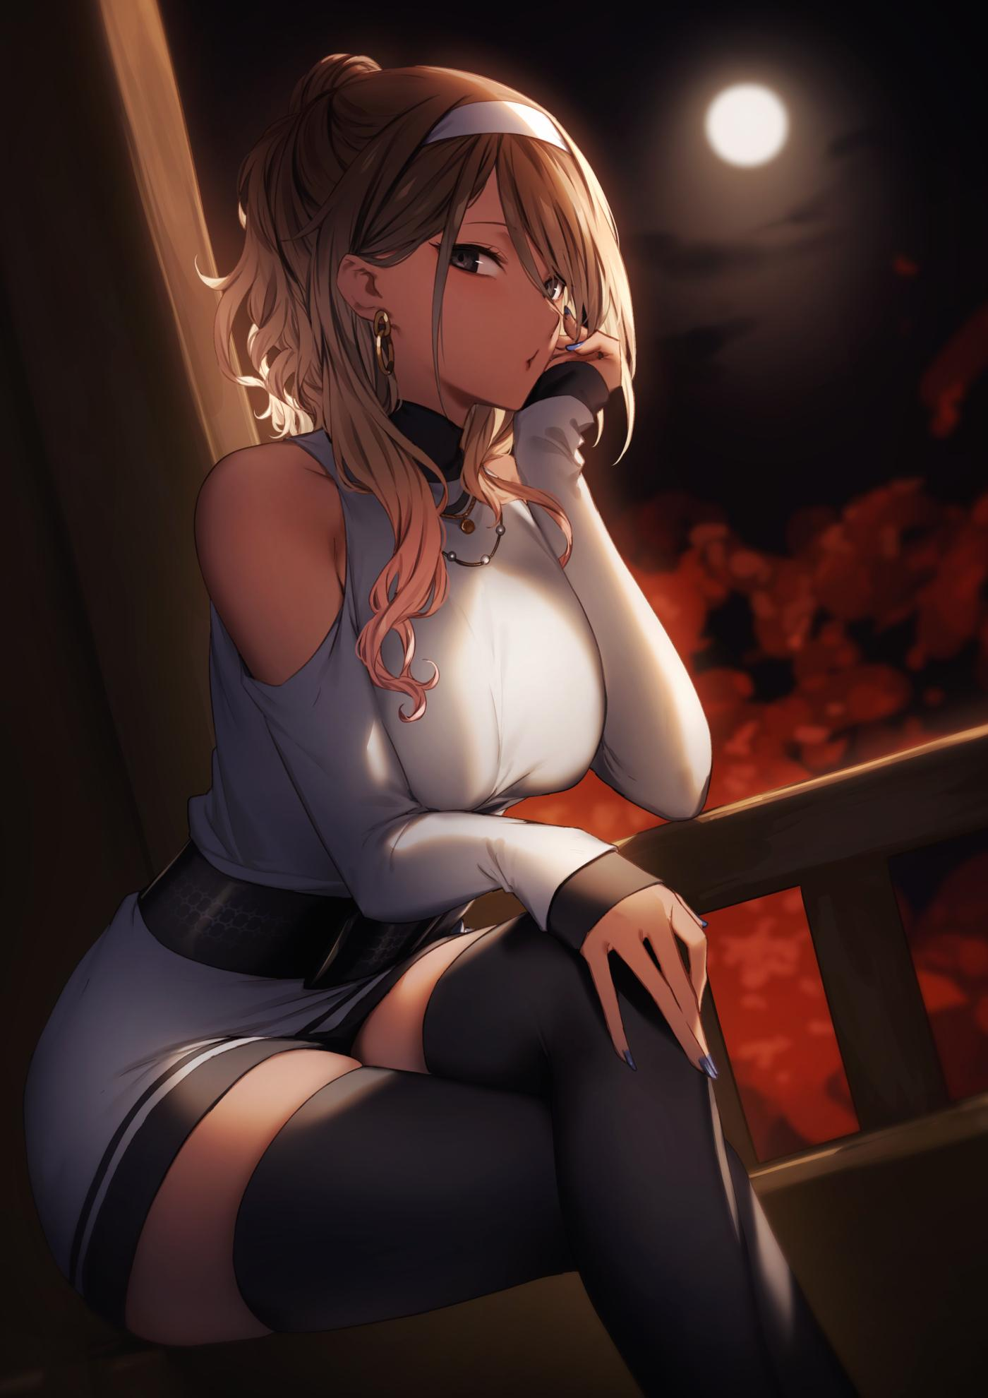

But the dream she had expected to awaken from never faded for even a second. The cool air caressing her sensitive skin, the chaffing of her underclothes against her puffy breasts and throbbing thighs, the boisterous energy of youth flowing in a body free of disease, the void between her legs with a slight throb emanating from her earlier experience. This really was who she had become, a fresh restart to life. A once in a blue moon opportunity.

And with the moon itself far up in the skies above her reflecting clearly in her deep brown irises as she raises her head up in time to notice one last wisp of purple smoke passing her by, curling around her head in a mimicry of an angel's halo before vanishing altogether, leaving Jeremy stunned right as the door to the room opens, turning her attention to the newcomer who had slipped inside without permission…a stunning newcomer with a manly visage that sent her heart fluttering with something she hadn't felt in a long time since she was in highschool.

***Affection; the heart of someone in a romantic tryst with their significant other.***

Folding her legs across each other in a way she would never have thought to do before while twirling a loose lock of hair around a fidgety finger as if to busy herself, Jeremy tries her best to turn her attention back towards the cityscape outside, desperately willing her mind to ignore the growing presence of the man in the room as her steamy ears twitch at the sounds of his belt unbuckling and his clothes coming off, she had no idea why she seemed to be acting so flustered and shy but the moment her eyes had met his steely gaze, her mind was ensnared by it.

*'Of course! It's got to be that stupid smoke again!'*

But as her tongue clicks noisily in anger, a gentle hand nudges at her shoulder, stimulating her loins with a subtle flame upon feeling the man's tough hide rubbing against her, spinning her head around sharply with a furious blush on her face, staring wide eyed into the concerned look the man was giving her, opening his mouth to grace her ears with a concerned query.

*'Oh my god, his voice…it's…so fucking hot…'*

Nodding slowly before struggling to get herself a safe distance away from the young stud before her, Jeremy's dainty feet trip over the man's burly legs, catching her off guard with her face set to plant itself into the floor before a quick thinking response saves her from a world of hurt, catching ahold of her wrist before a large warm arm hooks her womanly hips in its embrace, pulling a stunned Jeremy in close with no way out, feeling herself melt into a tiny puddle against the stranger's massive frame, quelling her fears as a sense of peace and safety sets in, soothing her panicked breaths and spurring the feelings of love burning strong in her heart. She had no idea who this was supposed to be, but her body was telling her that it was alright, that he was the man for her.

Questions could come later, this life she now led? It could all be figured out in time. But this moment before her needed to be snatched up quickly before it was gone. Something she had learned to take to heart upon flashes of her old life flickering to mind.

And so, with her hands held tightly around the man's broad shoulders, the lucky lady brings her face in close, accepting her partner's unwitting invitation while providing no resistance, loving the feel of his tongue forcing its way down her eager throat, letting her approval be known with gentle sighs and appreciative moans before things begin to escalate with her lengthy legs twitching in response to the adventurous hand that had ventured down below, hiking up the hem of her dress before peeling apart her soaking wet panties like the skin of a fruit to get at her juicy lips coating his fingers in slick precum.

On this night, Jeremy would soon experience everything he had missed out on in life; from the joys of a woman finally giving herself to her boyfriend or the fact that she even had someone who loved her just as much as she loved him. And it made the anticipation to figure out who she was now all the more stronger.

Although that might be a task best saved for later when both partners finally finish destroying the poor futon below them, splashing down upon the soaked sheets in each other's arms with their clothes left abandoned and soaked in their collective juices.

As if pleased with its work, the full moon shining high in the sky above them begins to fade behind the arrival of a thick patch of clouds akin to an eye closing above the somber streets of a man-made jungle of concrete, just in time for the break of dawn over the horizon as the fiery red of the sun crests the rooftops far off in the distance…

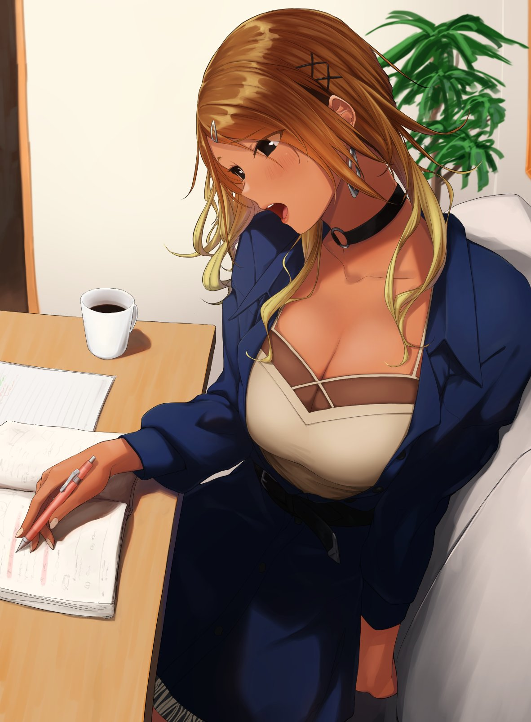

**"You've got something wrong again Rich, you're supposed to subtract this number over here, not the sum of the other equation. Here, give it a go again!"**

Slapping her boyfriend on the shoulder playfully before watching him redo his mock exam with her helping him through, Reina's eyes stare off into the distance as if her mind was heavy with burgeoning thoughts of her own. And indeed they were.

While tutoring Richard on his studies, the despondent young woman's mind was embroiled in thoughts and memories, recalling the events of the past 2 years she had spent living as herself…or more specifically, as the individual that had seemingly taken Jeremy's spot in life.

She had been surprised to figure out her mother and father still remained the same, as did her extended family tree which she realized had some descendants from Japan stemming from her father's side of things, which helped to explain her Asian appearance. And unlike her previous self, her parents loved her dearly, with her father especially holding a place in her heart after recalling memories of a younger Reina being coddled since birth as Daddy's Little Girl.

Even more shocking was the fact that her boyfriend was Richard, and she didn't need the aid of her new memories to remember who he was. In Jeremy's timeline, the man was a total creep and outright terrible individual, bullying, extortion and even sexual assault were things he wouldnt even think twice about before committing them wholeheartedly. Reaping joy from the depraved act itself and not the rewards in the form of stolen lunch money.

But in this new world, Reina was the beauty to the beast that had been Richard, reforming him by being the one individual who stood up to his antics in high school, before one thing led to another as the pair ultimately ended up together. It was a stark contrast really, with the gaudy gal being the smarts and the tall handsome man being a dumb brute with a polished heart of gold. Although both their parents were initially wary, neither side could stop them when they eventually eloped on a temporary trip to a newly opened resort on the day of their graduation ceremony from high school with the intent of giving themselves to each other. The memories of which, still burned bright in her mind, the passion, the love, oh how it made her heart ache, sighing wistfully with a wry smile on her face.

The events of the next few days however, were the main focus of her reverie. Soon after settling in back home after a heartfelt apology and reunion with her parents whom she had been surprised to see, Reina had got to work immediately, familiarizing herself with the drastic new life she had expected to find, only to realize it was a carbon copy of Jeremy's, except if he had been born a girl, took heavily after his father and had a thing for the gyaru aesthetic.

And the more she dug, the more memories of her alternative existence seemed to pop into mind. While she still remembered her time as Jeremy, Reina had to take awhile to acclimate herself to visions of her first period, hanging with the most popular girls at high school and the fact she was a studious gal, making it into the schools top five list of students in comparison to Jeremy being an average Joe scoring decently enough to graduate without much applause.

From there, time would begin to pass her by, and with it, a commitment to live this new life of hers to its fullest. Working out to maintain her health and figure, going on dates with Richard whose lecherous side ensured they had weekly nights together and the reason why her cup size had been boosted from a generous C to a hefty D. After all the attention her puppies received from Richard, she would've been dismayed if they hadn't grown at all.

But while she attempted to secure a spot at a college with her boyfriend in tow, Reina had also been doing searches into anything new regarding That Place Under the Moon, finding the garage that had changed her life forever as nothing more than a derelict storefront. The painting and claw machine were gone and the website she had used to frequent contained more posts praising the event without proof and everything she had done to 'contribute' wiped clean from the forums as if she'd never existed there. But before she cleared out that one last bit of her old self forever, an inkling temptation had motivated her to quickly setup a dummy account before typing out her own heartfelt thanks, urging others to seek out that fabled place before logging off and removing the site from her history forever, moving on to more urgent things in life.

**"Hmm? Oh, sorry there Rich…was just thinking about old stuff…what did you need help with?"**

Snapping out of her thoughts from a gentle nudge on her shoulders, Reina bows her head in apology before getting back to helping Richard out with his studies, spending that lovely Saturday evening with her beloved, egging him on about his 'reward' with more than purposeful nudges of her boobs against his arms.

For as wrong as it was, her body certainly was an excellent motivator to get her dear Rich eager to absorb knowledge if it meant a night with her. Then again it was a weekend so whether he learned a thing or not, Reina wasn't about to let his ass go tonight.

*THE END*