Cyprus Photography Holiday

**Daily Schedule – Group 1 (23hrs shoot time)**

**ARRIVAL DAY** (27th September): Collection from Paphos airport, check in at the villa and welcome drinks and nibbles. Free time to explore Aphrodite Hills resort and restaurants for those arriving early.

**Day 1** (28th September): “Chilla de Villa “

Morning shoot at villa and pool area- solo to nude (1:1) (3hrs)

|  |  |  |
| --- | --- | --- |
| Photographer | Anna | Ashley |
| A | 8.00-9.30 | 9.30-11.00 |
| B | 9.30-11.00 | 11.00-12.30 |
| C | 11.00-12.30 | 8.00-9.30 |

**BREAK**: 12.30-13.00 **LUNCH**- 13.00-14.00

*Salad Nicoise – breads – olives – fruit*

Afternoon shoot at villa and pool area- duo to nude (1:2) (1hr40)

|  |  |  |
| --- | --- | --- |
| Photographer | Anna | Ashley |
| A | 14.00-14.50 | 14.50-15.40 |
| C | 14.50-15.40 | 15-40-16.30 |
| B | 15.40-16.30 | 14.00-14.50 |

**BREAK 16.30**

Pack for pebble beach-Leave for pebble beach at 17.15

Evening shoot at Pebble beach (Golden hour: sun set 18.42)

Shoot specifics: *swimwear/beachwear up to nude*

Model to photographer Ratio: (1.1) and (2:1) -times are approximate (1hr)

|  |  |  |
| --- | --- | --- |
| *Time* | *Anna* | *Ashley* |
| *30 minutes* | *C & Zeus* | *B & A* |
| *30 minutes* | *B & A* | *C & Zeus* |

**Evening Meal** : Aphrodite hills – *Greek cuisine - Pithari taverna*

*Approx shoot time 5 hrs.*

**Day 2** (29th September): “Aphrodite Delight” (1:1) and (2:1)

Morning shoot- Sunrise at Aphrodite beach (6.43)– to nude-times are approximate. (1hr)

|  |  |  |
| --- | --- | --- |
| *Time* | *Anna* | *Ashley* |
| *30 minutes* | *B & Zeus* | *B & A* |
| *30 minutes* | *B & A* | *C & Zeus* |

**Breakfast**: 8.00 – 9.00 - *Full English breakfast*

**Break and independent time**: 9.00-10.00

Mid morning /Afternoon shoot- to nude- 10.00-13.00- Shaded shoots around villa/indoors (1:1)(2hr)

|  |  |  |
| --- | --- | --- |
| Photographer | Anna | Ashley |
| A | 12.00-13.00 | 10.00-11.00 |
| B | 11.00-12.00 | 12.00-13.00 |
| C | 10.00-11.00 | 11.00-12.00 |

**LUNCH: 13.00- 14.00**

*Greek salad, cheeses and dips -bread- fruit- sandwiches*

Late Afternoon shoot: villa and low light -Aphrodite hills (1:1)-14.00-17.00-solo to nude(1hr)

|  |  |
| --- | --- |
| Photographer | Duo Anna and Ashley |
| A | 14.00-15.00 |
| B | 15.00-16.00 |
| C | 17.00-18.00 |

**Evening shoot** (Golden hour) Aphrodite beach- Sunset (18.43)

Sunset shoot – Aphrodite beach 17.15 – leave for beach (2:1 & 1:1)- to nude-times are approximate.

|  |  |  |
| --- | --- | --- |
| *Time* | *Anna* | *Ashley* |
| *30 minutes* | *C & Zeus* | *B & A* |
| *30 minutes* | *B & A* | *C & Zeus* |

**Evening meal** : *Aphrodite hills , Italian or Indian*

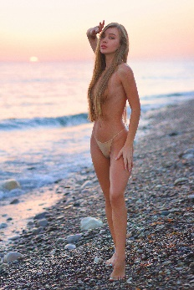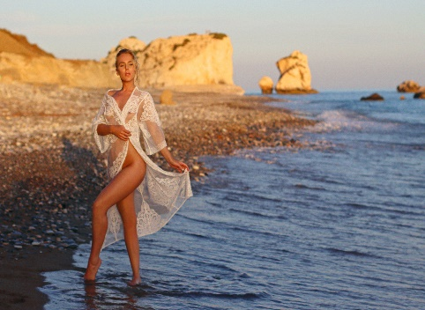

*Approx shoot time: 5hrs.*

**Day 3** (30th September): “Ancient Kourion”

**Lazy morning**

**Breakfast**: 9.00 – 10.00– *English breakfast, fruits and cereals*

Morning shoot – Kourion Archaeological site- (11.00-14.00) - (2:1)- fashion & lifestyles (3hrs)

|  |  |  |
| --- | --- | --- |
| Photographer | Anna | Ashley |
| A&C | 11.00-12.30 | 12.30-14.00 |
| B&Zeus | 12.30-14.00 | 11.00-12.30 |

**Big Lunch** - 14.00- 16.00- Kourion Beach

**Break**- 16.00-17.00

Evening shoot: Kourion Beach-(sunset at 18.43)-golden hour – 17.00-19.00 swimwear/fashion/implied (2:1)- times are approximate. (2hrs)

|  |  |  |
| --- | --- | --- |
| *Time* | *Anna* | *Ashley* |
| *17.00-18.00* | *C & Zeus* | *B & A* |
| *18.00- 19.00* | *B & A* | *C & Zeus* |

**Evening meal:** Relaxed evening at villa with snacks, beer and wine

*Approx. shoot time: 5hrs*

**Day 4** (1st October) : Lively Limassol

5.30 start- leave for Limassol (sunrise 6.44)

Sunrise shoots at white Stones Limassol – to nude (2:1) – to nude (1hr)

|  |  |  |
| --- | --- | --- |
| *Models* | *30 mins* | *30mins* |
| *Anna* | *A & Zeus* | *C & B* |
| *Ashley* | *C & B* | *A & Zeus* |

**Breakfast** in Limassol – *Columbia Beach Bar and restaurant* (9.00-10.00)

Mid-morning shoot – (10.00 – 13.00) Old town Limassol /harbours– Fashion and implied (2:1) (3hrs)

|  |  |  |
| --- | --- | --- |
| Models | 10.00-11.30 | 11.30-13.00 |
| Anna | A & B | C & Zeus |
| Ashley | C & Zeus | A & B |

**Light Lunch** in Limassol (13.30-14.30) – *Limassol Marina*

Late afternoon shoot- Villa and pool – Open shoots –1hr of your choice (1:1) plus 1 final duo (2:1) (2hrs)

|  |  |  |  |
| --- | --- | --- | --- |
| Model | 16.00-17.00 | 17.00-18.00 | 18.00 to 19.00 |
| Anna | ? | ? | DUO C&B |
| Ashley | ? | ? | DUO A&Zeus |

**Evening meal**:

*Farewell barbeque, music and drinks*

**CHECK OUT (2nd October): breakfast, check out and drop off at Paphos airport.**

Approx shoot time: 6hrs.