FE: SCHOOL HOUSE
CH8: TOTES PREZ
BY CHALDEACHANGE
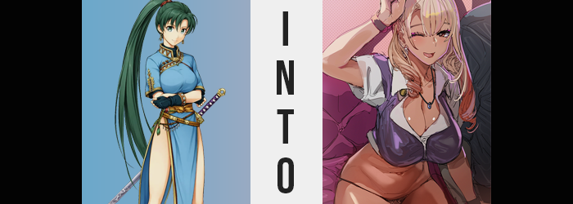

Lyn wasn’t sure if she had done the right thing, but in the end she hadn’t had much of a choice. She had sensed that something was amiss in Askr early in the morning, yet she’d had no means of identifying what the issue was. In the end she had attempted to plea to some of her remaining allies that they should abort the city for the time being, but they were insistent that they remain in case there truly was trouble seeing as most of the men were away.

But the feeling had been too much for her to ignore, and the woman had retreated away to a nearby village regardless. It might have seemed strange that Lyn of all people would be so avid about retreating rather than defending, but as of late she had been plagued with nightmares about something happening. Every time she woke up she felt panicked… and really horny, which in a way made it all the worse from her perspective.

“Is this… truly the right place?” She had returned the next day though, and when she did? The city she knew was gone, and in its place was a rather lavished school campus. Whether it was the big building in the center that was clearly an educational establishment, or the many dorm buildings, shops, and restaurants scattered around the rest of the grounds. Lyn could barely tell what these things were though, because they were so dramatically different in design from what she was used to.

Because they were modern.

Not to mention all of the people walking around? They weren’t the demographic of Askr’s capital at all. They were all largely teenagers and children, with the odd adult manning one of the local businesses or helping the younger generation along. Not to mention all of the city’s racial diversity had been eliminated because they were all Japanese (not that Lyn knew this term).

It had reached the point that Lyn couldn’t help but slip into the academy town to get a better look at what was going on. Had all of her friends been locked up somewhere so that these strangers couple populate her home? It sounded farfetched, but how else could she properly explain just what was going on?

The people that now occupied the town didn’t seem all that attentive, so even though she looked and dressed differently, Lyn still managed to slip into the big school building without being seen. It was still early in the day, so everyone was coming in for class. “But what am I looking for exactly?” She had acted on impulse without a lead, after all.

Accidentally slipping into a bathroom though? She let out an embarrassed shriek and jumped straight back into the hall. Because on the ground in the room had been an eighteen year old girl with tanned skin and blonde hair servicing a boy of the same age sexually. Neither of them had even batted an eyelash when the swordswoman had run out.

“Wh-Wh-What were they doing!?” Evidently not having been exposed much, if at all, to that kind of behavior, Lyn had run all of the way back into one of the unoccupied classrooms, her cheeks burning red and her heart beating quickly. She hadn’t noticed that she was only wearing a pair of black panties around her waist now, nor that her top was now a short-sleeved uniform top.

Indicating that even if someone hadn’t been turned, if they stepped foot on campus they would be.

Lyn was still so flustered from what she had seen, her back against the classroom door with her rear end hovering just off the wooden entrance. But given a moment? Her ass actually had begun to press into the wood, and not because she had leaned back at all or anything of the like. Rather it almost seemed like her cheeks had somehow been forced up against the wood on their own? Which was only possible, really, if they had grown.

Which was exactly what had happened. The myrmidon hadn’t exactly fit into the black, translucent panties around her loins, but with her ass jiggling to attention and pushing out the back? Not only did they fit a little more snugly in general, but the swell of her rear likewise seemed to adjust her hips so that they grew wider. This growth came at a cost though, and it could be observed throughout the warrior’s body.

Because it was looking less and less like a warrior’s body with each passing moment. “Why do I feel so totes tired?” She pressed her ass up against the door more as fatigue hit her like a truck, the cause an erosion of muscle strength that contributed to the growing softness her body was showing off. In her thighs, this translated into them swelling to better match her engorged rump. They made quick work of the gap between them even with hips widened, and before long even the peaks of her thighs were pressing into the wooden door.

It escaped Lyn’s notice, but her posture against the door actually slid a touch because her own body had shed a few inches of height, lauding her ass and thighs as even more bombastic by design. Still, with her tummy and pecs now robbed of the tightness that came with being a warrior, attention was soon fixated on the bosom nearby. For a woman in her late teens she already had a fairly abundant bosom.

But there was always room for improvement, right? “Pff… Hah! Like what was that!?” The young woman’s fixation to the door almost came undone with her body lurching forward, surprising her for a moment before she pushed her shoulder blades back into the wood again. It had felt like some sort of pressure had just released, like her upper body had given a sigh of relief. But Lyn herself couldn’t see what had caused it.

Realistically speaking it was obvious as hell to anyone else, though. As she had exhaled, her D-cup breasts had escalated in size, burgeoning out with additional weight so they not only fit in the school top she was wearing, but forced the top two buttons to pop off so that her cleavage was entirely exposed. Her G-cup cleavage. The woman did look down at her rack, but rather than question them? Good thing I cleaned them off after giving that BJ.

Something was definitely off with her mental state.

The embarrassment she had felt from seeing the other two students hadn’t disappeared, but it had transformed. Her mind kept wandering back to it, and an arousal of her own grew where it hadn’t existed before. Idly she began to bite her lower lip, not noting how much fuller that lip actually felt. Because both of her lips had swollen outward, a small piece of the bigger puzzle that was her facial features transforming.

Other than the swell of her lips (which came with a soft pink gloss to accent it), her nose rounded and her face shortened overall. What resulted was a face that seemed a little more squished together vertically, which also saw her cheeks become a touch fuller. Yet there was still something beautiful about it all, especially when mascara lengthened her lashes and purple eyelines highlighted eyes that were, for all intents and purposes, pinching in at the corners so that they had a noticeably Japanese look to them.

“Mmn… Really could go for a round two though…” Filthy thoughts continued to dominate the eighteen year old’s mind, her eyes changing in color to brown in the meantime. On the other hand? Streaks of a platinum blonde found their way into Lyn’s hair, eventually overtaking it entirely while the length of it all regressed to the point where it was merely halfway down her back compared to it reaching the back of her knees before.

While the platinum blonde had dyed the hair that grew from her scalp, though? Blackened brows told a different story. That this hair color was fake, and beneath it her natural color had changed to black. What’s more, the tips of it all had curled stylishly. But on the whole? Lyn did look much more stylish. To those ends, earrings pierced her ears and a necklace adorned her neck, the ring latched onto it almost swallowed by the depths of cleavage.

The young lady licked her lips as thoughts of sex grew even harder to resist, and as she contemplated how to act on these feelings? Despite not looking a single thing like Lyn any longer, there was still a change that had to take place. Splotches of bronze had begun to appear across her pale complexion like someone had flicked a paintbrush at her. And continued to do so, over and over, until the young woman was completely covered with the fakest tan imaginable.

But now? She had all of the hallmarks of a sexy, stylish gyaru.

“Like OH EM GEE! How could I forget my skirt in the bathroom? I’m so super silly!” As vapid as she was blonde and painted in a fake tan, Risako Kaneko bopped herself on the head with a curled up fist and stuck out her tongue, even though she had no audience. That was just how playful of a person Risako was, even though she had the burden of being the student council president. But then again this wasn’t exactly a conventional school in the first place.

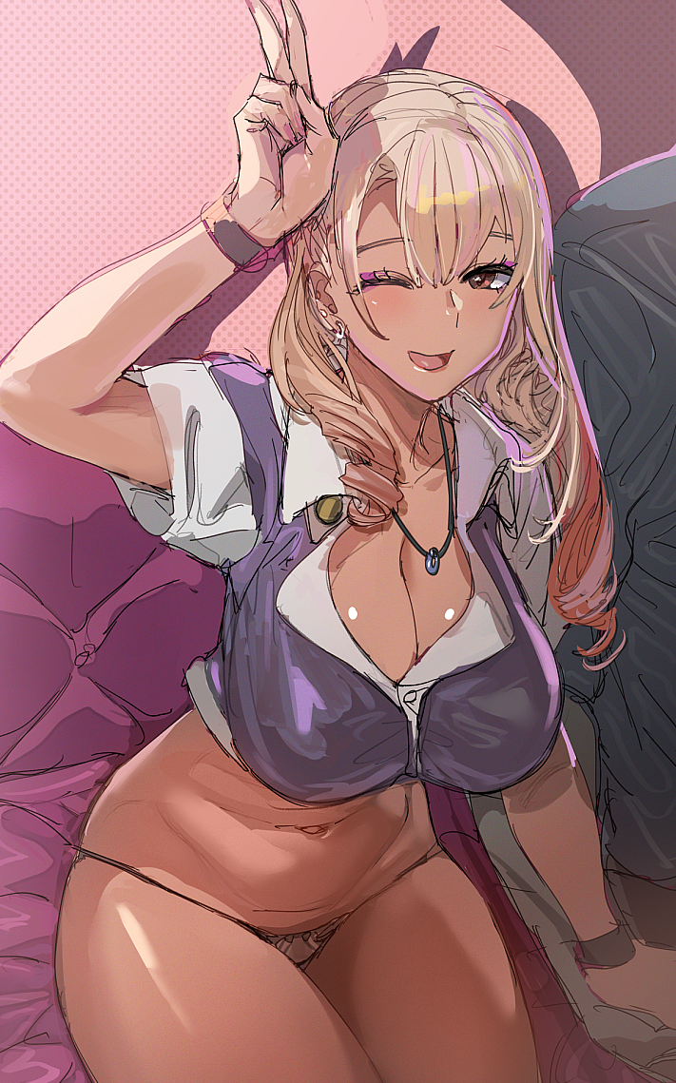
Things like the students, or at least the ones that of the age, walking around half naked or engaging in sexual activity in the college / late-highschool wing wasn’t uncommon at all. So a student council president like Risako? Who even now had begun to scoot down the hallway still without anything other than panties below the waist? Was not that shocking of a sight. People would stare at her a moment, think of how hot she was, and carry on with their lives.

“Heeey~ Has anyone seen a skirt laying arou- Oh!” Truthfully, the president had forgotten her skirt because she had been fucking in the bathroom earlier in the morning to begin with – after she’d met with the rest of the council. But now there were two more going at it, and seeing it? It spoke to just how horny of a young woman that Risako was.

“Would you two mind… if I like totally joined in?”

She was already scooting her panties down past her thighs.

