MOMMY ISSUES
COMMISSION STORY
BY CHALDEACHANGE
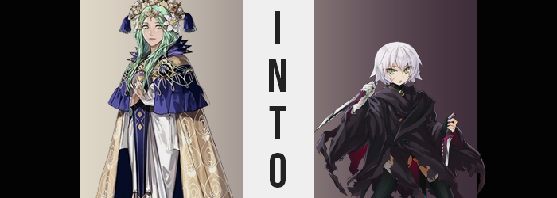

There was no denying that the Archbishop of the Church of Seiros had some mother issues to work out, and despite that it was difficult to completely blame her for this. The tragedy that was weaved throughout Fodlan’s history, from the dragons to the goddess herself, was one that most humans did not know the full story of. The love and loss, the fear and regret, the victories and desires for revenge – it all painted a canvas that ensured tragedy would continue to plague the continent for years to come.

It was a tragedy that had completely blinded the Archbishop, Rhea, herself. She had committed atrocities and ruined the lives of many for the sake of completing her goal. Her goal of reviving her mother, Sothis, and restoring what she believed to be proper order to the world. It was a selfish goal that cared very little for what lives it trampled over or who was sacrificed. Even if she had to create life just to sacrifice it, as had been the case such as the vessel Sitri that was meant to house Sothis’ soul.

Her obsession with seeing this goal to completion also carried over to Sitri’s child, Byleth. Seeing no other option, Rhea had placed all of her expectations on the child of the vessel and Jeralt, but had lost hope when the father had taken the infant away. In what she considered to be a stroke of good luck, Jeralt would return with the child again as an adult, and Byleth would begin teaching at Garreg Mach. All she had to do was bide her time and wait. Soon she could revive her mother for sure.

Or so that was the thought she had staked all of her hopes upon. But in reality, things had taken a very different turn. Byleth had awaken to her mother’s power, but her mother did not appear to return and had potentially disappeared altogether. Upon learning of this, the archbishop had managed to keep a level head. At least level enough to return to her quarters. But no sooner than she was in private, she broke down.

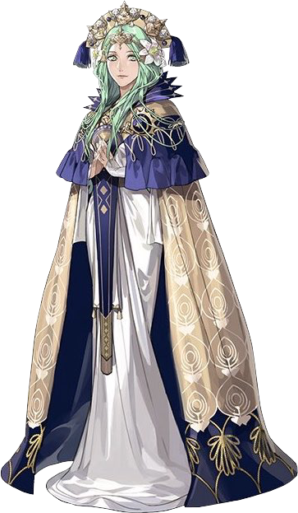
How long had she stewed in tears and depression that night? Long enough that she had never quite fallen asleep, that much was certain. Curled into a ball in only her nightgown at the foot of her bed, the green-haired bombshell of a holy figure lamented another failed opportunity as dawn’s first light filtered through her window. “There needs to be a way… I will return my mother to my side!”

For as messed up as her goals were, one certainly had to admire her conviction, nonetheless. How many times could you fall down only to get up again? Well, there were certainly points to be questioned about how sane Rhea’s pursuits were by this junction, so maybe it was not all that admirable to begin with?

There were certainly entities among the Church that were aware of Rhea’s plans and believed this to be true. In fact, the Archbishop was imperiling the continent and it looked as if war would be on the horizon if things did not change. That was why they had decided to take things into their own hands – they had just needed Rhea to be vulnerable enough to lower her guard. Which was a state she was more definitely in at that very moment.

And so? They struck. Not that Rhea noticed they had done anything at all, but a spell had been cast and directed at her. Not one that would kill the dragon in human form, but one that would see to it that she would never be fit to lead the Church for completely different reasons altogether. “Hm?” She wondered for a moment if something felt a little off, uncurling from the ball she had jumbled herself into. But she quickly dismissed it as just feeling a little cold from her moment of emotional insecurity, at best.

There was a physical indication of this cold, in fact. Or at least that’s how it might have looked to anyone observing. The archbishop has a naturally healthy complexion gifted to her by long life, after all. Even when she got sick under normal circumstances, she hardly ever appeared sickly. And yet there was no denying that under the light of the rising sun, the color of her skin appeared to be growing paler and paler still.

‘Sickly’ really was the best word to describe her complexion once the phenomenon had come to a halt, and yet it only seemed to do so because her skin could not plausibly become any paler than it already was. But that didn’t exactly mean that her skin stopped undergoing alterations altogether. Rhea’s skin, once completely void of any blemish whatsoever because it would infringe upon the image of perfection that she attempted to present herself with, soon found itself scarred.

And not just one scar, but a full bounty of them. The most notable of them all etched themselves into her face, with one slicing down vertically across her left eye, and a thicker one rising up towards her right eye from the same-sided cheek. But Rhea herself did not notice their appearance, not did she feel any pain from their etching – not even when they appeared in the tens across her right arm, to the point that it would have been better to wrap it up and spare anyone the horror of setting their eyes upon it.

Truthfully, Rhea was plenty far gone. Torn between fatigue and misery, it was her own depression keeping her awake despite how absolutely tired she was. There was no attention paid to her own body, which had its condition altering more quickly and more dramatically as time continued to tick on. In fact, it would only take a few minutes for the intended outcome of the spell that had been cast to reach fruition, and it had been designed to make sure that the one affected would not bat an eyelash.

If the archbishop got up and started screaming, it was likely that Seteth would be alerted. And that would cause problems for the ones who had organized this mutiny.

So even as the coveted emerald hue of her hair began to wane, the dragon in human form paid it no mind. A silvery white had seized her roots and was slowly working its way up towards the tips of her long locks, and at that pace it would have taken roughly a minute to fully convert the color proper. So it was fortunate for the coloring process that it received a little help in a change that saw the style of her hair shift.

Or, well… shorten. It almost seemed like everything beneath the peak of her neck had been chopped off, or at least it would have come across that way if not for the very obvious sight of its length being slurped up like a string pasta until it was no longer its original length. These locks, now fully painted white, did quite look healthy either. They were riddled with specks of dirt and grime, its healthy sheen lost to the kind of muck you might find in any commoner’s hair. Rhea was not a commoner, though. Or at least she wasn’t supposed to be.

The emerald in her eyes seemed to darken in slight, and at the same time? Those eyes almost appeared to become misshapen in a sense. They appeared to be bigger and rounder – much more akin to those of a child than a woman who was physically around the age of thirty or so. But much like with everything else, Rhea paid it no mind. Her eyes might have twitched as they changed, but they had already been reddened from the tears she’d shed leading up to this point, so she didn’t really think much of something she could easily explain through more rational means.

MOM. MOMMY. MOTHER. MOM. MOTHER. MOMMY. MOM.

“E-Eh?” And yet, her complete ignorance had to come to an end at some point. As the spell began to attack her mental faculties, she become overwhelmed with thoughts. It was like her desire to see Sothis had been amplified in a way that it echoed throughout her ego with many, many voices. Confused and disoriented, she had little choice but to unfurl from her fetal position pose and grip her head with her hands. “What’s happening? Who are you!?”

Because from the archbishop’s point of view she could recognize that those voices were not her own. They sounded like the cries of children. Many, many children. It was incredibly unsettling in a multitude of ways. Like her most private place, her inner thoughts, had been invaded by foreign adversaries. Her rounded eyes went wide as they grew louder and louder. All clamoring for a mother, or some variation of that word.

“No! Go away! You’re not me! You’re not us!” There was a less than subtle shift in Rhea’s vernacular, for she began to refer to herself in the plural as if it was the most natural thing in the world. Was there more than one of her? Was she accounting for the voices inside of her head? It was largely unclear, and the woman herself had thought nothing of it. She was too caught up in trying to stave off the voices, because she felt that if she didn’t?

She may lose herself.

This mental battle wore on, but not without any sacrifices on the physical front. The woman was far too distracted by what was happening internally to really notice, but her tall and voluptuous body? It was rapidly degrading. Within her white nightgown her frame unraveled, height shrinking quickly and without any regard for what her age should have been.

It didn’t take long at all for her height to dip beneath five feet, and in the process some of her proudest physical traits were being lost with the same speed. Her proud and bouncy bosom, for one? With her height sliding into a realm that was much better suited to the point of view of a child, it was is if her body was being rewound through puberty all the same. Like all of the fat was being slurped out of them, the cups of her night gown grew emptier and emptier with breasts ultimately ending up as barely notable growths upon her chest. Mere mosquito bites compared to what they had once been.

All the meanwhile, her feet were pulled closer and closer to her while seated on the bed, their change in position provoked by the fact that her legs were, of course, shrinking as well. Knee caps became petite, and tinier toes wriggled about. Yet while her thighs and bum naturally collapsed in kind, what remained was much more notable than what had been seen in her chest.

Her thighs seemed to be strangely pronounced for a girl that had dipped down to about 4’4” and had yet to hit puberty, while her bum was quite perky to boot. Were she permitted to mature once more by time, it was undoubtably true that she would become a woman that was extremely bottom heavy if she was showing these signs of maturity at an age so young and a size so small.

“We are.. We… are…?” Rhea’s green eyes almost seemed to be vacant as she rocked back and forth on the bed, once again now clutching tiny knees. It was like something inside her mind had just broken, and she was internally in the process of picking up the pieces. Who was she? What was she doing? How old was she? What was her purpose? Even as she pieced it all together, she could hardly say that it made much sense. Her immature, childish mind wouldn’t have been able to grasp it even if she could make sense of it.

The child, curled up in an oversized nightgown, felt like she was at a loss. It felt as if a million voices were swirling around inside her head, making it difficult to think – and one of those was very much Rhea’s voice, although it had been infantized to be just as hopelessly childish as all of the rest. Her tiny head was throbbing and her scarred body was quivering. Why did she feel so overwhelmed? Why did they feel so overwhelmed? It was difficult to think of herself as a singular individual, even.

It took Jack a moment, but she crawled off of the bed and allowed her small feet the patter against the stone floor at the bed’s foot. She felt strangely curious about where she was and why she was dressed in an adult’s outfit, even if the place did seem strangely familiar to her. Before long she tore at the skirt’s dress crudely so that the tatters hung at her thighs. The risk of tripping over that long skirt was just far too high.

Standing on tippy toes, she peered out the pane-less window. “Where are we…?” Was it her room? She felt like it was, but also at the same time she felt like she would get in trouble if she were caught there. Was this room off limits? Was someone important supposed to be there? Someone she should kill? It sounded like a dark thought for a child to be having, but Jack could recall killing plenty. Plenty of ladies that she wanted to be her mother. That she wanted to crawl into their womb. Disturbing stuff, but was it really worse than what Rhea had done?

“Jack? What are you doing in here? I thought we left you with the orphanage and you said you’d behave?” The child had been so distracted by her strange surroundings that she hadn’t even heard the door open and a woman in nun’s robes walk in with a warm but stern expression upon her face. In truth, this was the woman who had cursed Rhea into this form, but she had no way of understanding that. Instead, memories of the Church of Seiros taking her in despite all of her sins flooded her mind.

“We are…? Um, we are the Church!” Jack, evidently, still had some lingering awareness of who she had once been, even if she communicated it strangely. But coming from the mouth of a child, it essentially sounded like fiction and the girl herself felt like she was lying. Was she lying? She must have been lying to get out of trouble, right? “Uwah!?”

The nun grabbed her hand and began to tug her gently towards the door. “You’re obviously not the Church, sweetie. A little girl can’t be a whole Church!” On one hand, something within Jack loathed being talked down to like this. But the many, many other voices seemed to find it comforting. Having a woman like this in their lives. A woman that could be a good mommy to them.

And so she didn’t resist and allowed herself to be brought outside. The moment she stepped out of the room, the feeling that she had belonged in there waned, and she found herself overwhelmed by how pretty Garreg Mach looked while lit up by morning’s first light. It made her want to try and do better! That was why she had been taken in. They wanted to help her despite all the people she had murdered. And she was going to try and be better because of it.

Of course, there was the little matter of where the Archbishop had suddenly disappeared to, but the politics of that were much too complicated for Jack to understand now.

