EYE OF THE SPIDER
JANUARY 2022 REQUEST STORY
BY CHALDEACHANGE
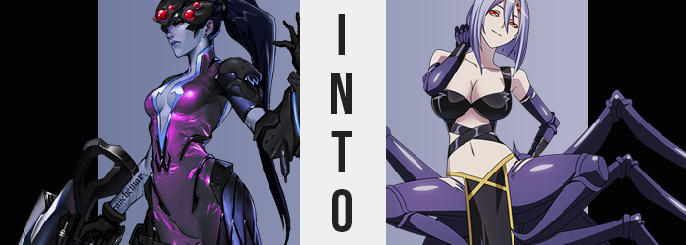

In another world at another time, it might have been the beginning of a superhero’s tale. But that was just a dreary world featuring a dreary woman as the main character. While her real name was Amélie, it was a name she had abandoned long ago so that she could become Widowmaker, a professional assassin in the employ of the shadowy organization, Talon.

On a mission as she often was, her newest orders had brought the silent killer to a manor out in the middle of an unfamiliar forest in Europe. There were supposedly experiments taking place in secret here that would be of use to Talon if they could get their hands on them, which meant that a covert option was needed. Her objectives? Kill the scientist responsible and obtain the data relevant to genetic modification.

Infiltration itself had been an easy enough task. Widowmaker was well-versed in the art of slipping into spaces she wasn’t supposed to be in. It was a skill that came in great handy against their greatest adversary, and fortunately there were no signs that Overwatch had gotten there before her. “Too easy.”

The woman, skin dyed blue from a brush with permanent death once upon a time, had already found the lab of which this manor had been crafted to conceal. Supposedly it was funded by a local government that sought to sew chaos of their own – but they had turned down offers to work with Talon. Taking their research was merely a consequence of their refusal – it was what the deserved.

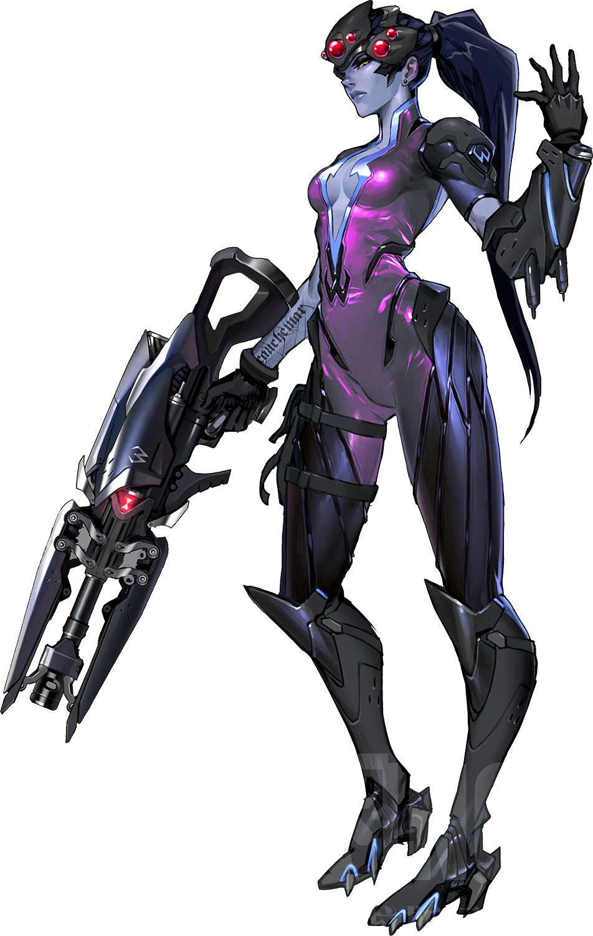
Among the lab was a plethora of tubes containing various critters. Insects, small mammals, spiders. It all made even her skin crawl, but she was not there to bring home samples. She needed computer data, and with Sombra not on the mission with her that meant using one of that woman’s special keys, which required she insert it into the USB of a computer. There only seemed to be one such device in the room, and so she approached it.

Ultimately unaware of the tiny creature that was dangling down towards her neck from the ceiling. A spider, and certainly not an ordinary one. It was one of the very tiny guards put in place to keep the lab’s secrets away from invaders. And with a sharp bite to the back of the cold woman’s neck before climbing back up to the ceiling with an astounding speed, it accomplished just that. “Tch!?”

Not one for many words, Widowmaker immediately slapped at the back of her neck, believing some random insect had taken a chunk of her neck while she reached down for the computer tower. If only it had been that mundane of an incident.

It didn’t take the woman all that long to realize that what had transpired wasn’t simply a regular bug bite (and in fact it hadn’t technically been an insect at all). The first indication was not one that most people would find odd, but considering the disposition of Widowmaker’s flesh, it certainly stood out to her. Her body felt warm. Not unusually so, but the normal amount of warm for a living human body, which was exactly the issue.

On the day she’d had her brush with death and Amélie had become nothing more than a memory, she’d been giving a new start in a body that carried some of death’s characteristics. Her skin was a purplish blue because her body’s circulation was practically nonexistent, which naturally lead to her body temperature being much lower than would be expected of someone – or at least someone that was alive.

That heat was returning though, and with it? Well, looking at the skin exposed around her right arm, left elbow, and the cleavage left open by her bodysuit, she could see it. A healthy pink color was returning to her body along with life’s warmth. A medical reversal that she had not asked for, and quite honestly hadn’t even been sure was possible. “What!? This cannot be!” Her French accent came off thicker than it normally did because she was panicked and she dropped her rifle at her side.

Truthfully though, there were things transpiring that could not be explained by assuming her body had somehow been returned to its previous state. After all, even after becoming Widowmaker the color of her hair hadn’t really changed all that much, yet… Streaks of a pastel purple had emerge amidst her long pony tail. The pony tail actually appeared to be growing shorter as time went on, until it hung no lower than her shoulders, but the change in color was much more blatant. By the time locks had completely shortened, the violet was not only the dominant but sole color present.

And this was also true of her eyebrows and pubic hair.

“Ngh… What was that bug!? Some kind of experimental weapon!?” It hadn’t struck the woman until much too late that she might have been bitten by something that had been created in this very laboratory, and that meant that she could not fully grasp what it was capable of. For all she knew it had simply returned the humanity to her body because she was incapable of seeing hair that was pulled back, and yet… Eyes that now glowed crimson certainly couldn’t be considered the traits of a regular human.

It took Widowmaker a moment to think anything of it, but… “Hm?” Peering down at her cleavage window once more, she could have sworn that it felt a little tighter than it did under normal circumstances. This was, of course, an accurate assumption – for the size of her now pink cleavage appeared to be greater than she recalled. “Augh! Why!?” She was powerless to do anything other than bemoan what she could witness with her own two eyes, which was the utter expansion of her own tits.

Back when she once cared about her figure she was better known for her lower half. There had been a time when she had first joined Talon when some of the members had made comments about it, but she had long stopped them with a little murder. Attention was never fixed on her bosom because it wasn’t all that impressive in scale. Or at least that was how it was supposed to be.

And yet the folds of glossy purple that made up the peak of her catsuit were pushed out to the sides to the extent that her bare, pink nipples eventually poked out, engorged tits just as perky as they looked hefty, perhaps defying the laws of physics. Perplexed and, for the first time in years, oddly aroused, she could not keep gloved hands away from them, prodding and squeezing those DDs until she’d had her fill. “This is preposterous! And yet…” What was this that she felt? Acceptance?

Indeed, and that feeling was growing. It had to, because everything she had endured thus far? Well, it was rather mundane compared to what was to come. Take the woman’s ass, for example. It was clearly straining the back of her latex outfit, and yet it didn’t quite look right. If her ass was simple growing bigger then it undoubtedly would have retained its rounded shape. But that shape wasn’t round. In fact, where her crack was supposed to be it almost appeared to be pointed.

RIIIIIIIIIIIIIIIIIIIIIIIIIIIIP

“What NOW!?” Widowmaker only yelled because what had transpired had been uncomfortable, and as a result her head turned over her shoulder to get a good look at what was behind her. What she saw should have shocked her, and yet there was only the littlest amount of surprise present. Her ass… Well, it didn’t really look much like an ass anymore, really.

Still growing outwards from where an ass should have been was what looked like a brand new growth upon her body. In a rich purple color, the skin didn’t quite look like skin either, but something harder and more durable. It was attached to where her ass had been, but as it grew longer and wider it didn’t at all resemble a butt. Rather, it was something the woman had seen on insects and arachnids. “My abdomen…? Why am I staring at it?” Was she supposed to have that jutting out of her torso? Something deep down told her yes.

At the very tip of the abdomen, now bigger than her body was tall, was where webbing could be released from spinnerets. And the inside of this abdomen felt fuller and fuller so that she could weave webs if she truly wanted to. In many ways this transformation was taking her moniker as Widowmaker a little too literally. But it was heavy, and without anything to properly support its weight it was sagging against the stone floor behind her.

“Why can’t I move?” The woman’s voice hissed, and in doing so she revealed teeth that had warped into verifiable fangs for injecting venom. Her gloves tore, for the skin beneath them hardened into an armored purple that was not unlike the material that had forged her arachnid abdomen, and this also presented her with some undeniable claws.

But the burden of her rear was soon lessened, and not because she had just magically found the strength to lift it. With what sounded like bones cracking (but was actually new material being forged from her flesh), eight long legs of solid purple unfolded from underneath the abdomen. Legs triple-jointed and sharp enough to piece a fleshy body at each tip, as they came down upon the floor her body was just lifted naturally – her front legs included. But their time as legs was a little bit limited to begin with.

Just dangling there loosely, heels pulled in towards Widowmaker’s raised underside while the feet themselves hardened and bent back into what seem to be purple hooks. Retaining their regular jointing, skin became enveloped in the same purple chitin that the rest of her arachnid features had, and once shortened appeared to be akin to a pair of mandibles around her exposed pussy.

“Mm… That’s better! I can move freely! As by my master’s design, of course.” Despite having just received her spider proportions she found that moving about was just as easy as walking on two legs. Perhaps even easier? She felt reassured, and that reassurance went back to a new individual within her memory. This… ‘Master’. Who was he? Widowmaker felt like she’d never had someone like that in her life before. But then again? What kind of name was Widowmaker?

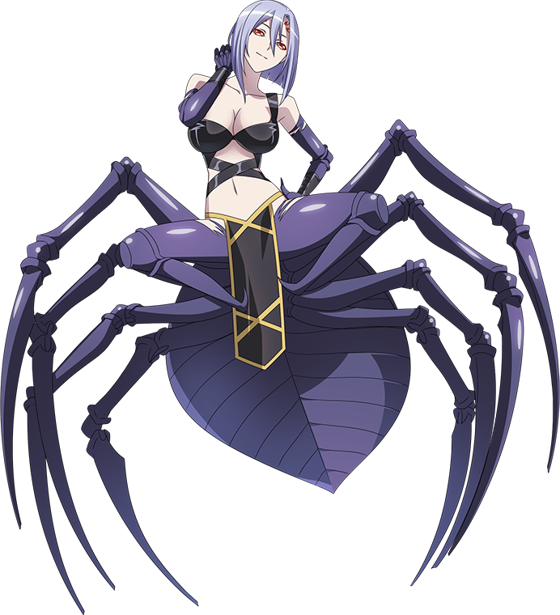
While pondering the fragile nature of her existence, the woman’s face gained four new features – all similar in nature. In fact it was two more pairs of crimson eyes, overall adding to her whole ‘monster spider’ look that was utterly undeniable by this juncture. But she didn’t seem to mind; not one iota. Not even as she, by choice, pulled off her headgear and allowed her hair to fall freely.

The six crimson eyes of the newly birthed Arachne glowed dimly within the realm of the lab, absorbing her surroundings carefully. The scraps of the bodysuit, not to mention the gear and the gun on the ground – those had been hers? She had a vague recollection of this and of another life altogether, but Rachnera could only fixate on who she was now. “Interesting. So I was created thanks to the experiments here, was I?” A product of the very same genetic modification techniques she had arrived to steal in the first place.

An acceptance of this had been programmed into her, as had a loyalty to the man that ran this establishment. There was nothing the Arachne could do to fight it, and even if there was she had no desire to do just that. She just knew that she loathed all of the humans that weren’t her master, and even now she had a burning desire to be by his side. Not to mention a burning in her loins, which was at the front of her thick spider body.

“Maaaaaster! Come hooooooome!”

Until then she would just have to protect the lab as she always did.

