A TAO TAIL
JUNE 2021 REQUEST STORY
BY CHALDEACHANGE
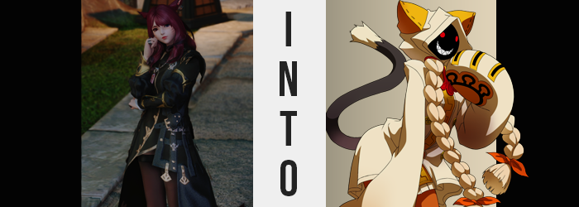

“I’m glad I sunk all of that Gil into this crate. There have been some real treasures mixed inside.”

Silvia Kuroi, thus far, had experienced an awfully long and exciting day, and it appeared that it wasn’t even close to ending. It had opened with a visit from her friend S’aiya tipping her off on the fact that one of her connections in Ul’dah’s black market was getting in a shipment of artifacts that had been collected from various undersea ruins between Eorzea and Doma. That had set things in motion.

She’d then quickly gotten ready and shipped out to the market in question. S’aiya’s intel had been good, and it had allowed her an opportunity to put in a pretty substantial bid for one of the crates they’d received. She’d walked off with an entire box of goodies! …With a little lifting help from S’aiya, that is.

But her friend had long left, leaving the scholar alone with her purchases in the inn room she was renting from The Quicksand. Gemstones, artifacts, and even weapons had blessed her hand as she had sorted through them, and after hours of analysis she’d only pulled out roughly half of the box’s contents.

“Oh, this is interesting. A cat idol?” Most of the items she had found within the crate hadn’t really featured any animal traits thus far, which had struck her as a little odd. Most ancient civilizations tended to focus their reverence on an animal or two and said animal would show up quite prominently on the items discovered in their ruins. But this was the first, and with such a common animal? “Maybe I’m being presumptuous? It might not be a common cat.”

Silvia carried the palm-sized, gold idol over to the desk where she’d laid out her tools. Ascertaining its authenticity came first, and from there she could try and eyeball its value – both monetary and from a scholar’s point of view. Yet before she could even make it that far? “Huh? Where did it…?” The ruby-haired Miqo’te had not been looking at it, but the idol’s weight just suddenly disappeared, leaving her hand completely empty. The idol was actually still there, but…

It had become one with her body.

“Hm. Did Silvia drop it? Silvia doesn’t see it…” Fixing her attention on the floor of the inn room, eyes skimmed it in search of the cat idol, onto find nothing. But wait a second… “Wait, why is Silvia talking like this? Silvia can’t stop!?” It had taken her a hot second, but it finally occurred to her that she was speaking in the third person, a very unconventional manner of speech that didn’t suit an adult woman. Try as she might though, she just couldn’t seem to correct it.

Suddenly, the missing idol became less of a concern – or was it actually more of one? Were the missing item and this sudden verbal tic somehow related? Absolutely, but Silvia was an intellectual. She required evidence before she could say for sure. However she was making one fatal mistake, she wasn’t considering the possibility that she was receiving more than an unusual manner of speech.

Even without that folly she would have been incapable of halting the inevitable though, not as the tip of her ruby red cat tail dimmed in color, shifting through pink all the way to a creamy color that wasn’t consistent with what became the rest of the length. Everything else darkened to black, the fur on the whole thinning so that her feline appendage was no longer fluffy. It was still fuzzy mind you; it just wasn’t as incredibly soft as it had once been.

Like clockwork, a paranormal glow then possessed the Miqo’te’s eyes, bringing them to passively glow a mysterious red. “Let Silvia think! The idol disappeared from Silvia’s hands, and then Silvia started talking like this. They have to be related!” As she attempted to map everything out, the woman had been waving her arms around wildly like some sort of maniac. It hadn’t even occurred to her that this was out of character, but those hands quite quickly found themselves mounted.

…upon her bosom, either hand grasping a breast.

“HM!?” They’d been guided there by an almost cartoonish popping sensation, one that both pushed out the front of her tunic and dislodged the brassiere she was wearing underneath. Her breasts had suddenly grown? Not a lot, but it was certainly noticeable enough to her. “Why did Silvia’s chest suddenly go BYOM!?” It was hard to resist fondling them – they certainly felt a lot more sensitive than they had before!

Not to be outdone though, a similar feeling suddenly forced the woman to swing her hips to the side. They’d promptly parted wider, forcibly forging a favorable gap between the woman’s thighs while inadvertently stretching the sides of her dark-colored tunic to the peak of their capacity. “Silvkaka is getting really squishy!” Her verbiage was deteriorating further it seemed, not only in terms of how she referred to herself, but in the simplicity and childishness of the words she used. It was all almost innocent somehow.

What wasn’t innocent was how her hands had moved down to fondle a growing tooshie. Much like how her tits had inflated a little, her ass was keen to follow that similar pattern. Thanks to her parted hips, there was even more room to work with as a result. Those cheeks, quite simply, blew up. They became big, round, and bouncy, and would certainly be quite comfortable to rest upon. But they were misleading in their weightiness, for while the exterior was quite soft? The muscles beneath had been enhanced to become undeniable powerhouses.

This was true of every single muscle on her body, though disguised by her clothing quite conveniently. Arms, legs, and tummy alike had erupted with this same strength, firming up her body and greatly boosting her physical power and, especially, her agility. This meant the muscles in her legs were far stronger than the rest, though much like the bounty in her booty, they too were disguised by an overpowering softness.

Her fingers groped these too, Silvia unable to stifle a giggling fit in response to just how much it tickled. “Haahaahaahaa!” The pitch of her voice had certainly risen, making her sound even more like a child despite how shapely her body had become. Thighs included, for they were tender and taut; very appeasing to the naked eye, even if they surged over the peaks of her thigh high boots for a time.

Silvia – er, Silvkaka? – was so caught up in her own amusement that little else was really registering. Squeezing the sponge flesh of her thighs, her body rocked back and forth on her heels, paying no mind to how the skin she was grasping was darkening in color. The tan that bled in from head to toe was very dark and rich, the complete opposite of her typically tanned visage, but before one could even admire how it had tickled her face?

“Whoa!?” Her hood was promptly yanked over her head, casting a shadow across her entire head that entirely concealed her face short of the two glowing red eyes. Giggling as she returned to doing, however? It was long before her teeth could be seen too, beaming into a bright and jagged smile that stretched from one cheek to the next. Each tooth in her mouth had become razor sharp, as if it belonged to a shark.

From this point on, there was a dramatic shift in the woman’s attire. The darker colors paled into a creamy tone, while a thick, gold zipper ran down the tunic’s front. Her sleeves lengthened and wrapped around her hands before dangling even farther past her knees, the ends balling up to resemble the shape of a pair of gigantic cat’s paws. Each hand was complete with a trio of slits on the ends were it looked like claws might erupt, while cloth paw paws done up in pink were on the undersides.

Silvia’s thigh high boots? They dwindled in height, allowing her thighs total room to breathe as they fell below even her knees. Tanned legs would have been wholly on display if not for the cream, knee-high boots that were reconstructed from her original pair – complete with steel bottoms that lifted her up several inches higher.

“WAH!? Silvkaka can’t stand properly! What’s up with Silvkaka’s clothes!?” It had really taken her by surprise, and she was struggling to adjust to how muffled everything sounded with her hood perpetually strewn over her head. Said hood has taken on the same cream color as the rest. It had a rather triangular design, and on either side a big, orange cat ear of felt had blown up. They were both much bigger than her actual ears… at first. But concealed as they were, it was impossible to see how either ear grew to fit into their respective ear slot.

The colors of these ears had likewise lightened from a ruby red to a sandy blonde, with this color sweeping through the hair atop her head not long after. It had been lengthening at a quickened pace, but all of that length was funneled through one of two, new holes at the base of her hood’s front. As said hair lengthened, it wound into a set of long, thick braids that fell as far as her knees, ends bound by orange ribbons and bristled wide.

The cat was less bothered by what had been happening to her body now than she had been from the onset though. Rather, a loud rumble from her stomach had completely distracted her, and drool fell from her lips within the darkness of her hood. “So hungry…” Arms flailed around the inn room again, this time at the expense of an energy that was on the verge of dwindling thanks to her sudden hunger. Considering how built her new body was, it likely wasn’t surprising to hear that it burned calories at a much faster rate than most.

But there was one area left to change, and it was attached to those flailing arms. Beneath her sealed cat sleeves, her tanned hands were bloating. Almost like she was having an allergic reaction, these hands puffed up. Heftier and heftier they became, and before long her pinky fingers and thumbs had merged inward so that she only had three digits per massive… paw? And paws they certainly were, coated by a black fur that had previously been seen on her tail.

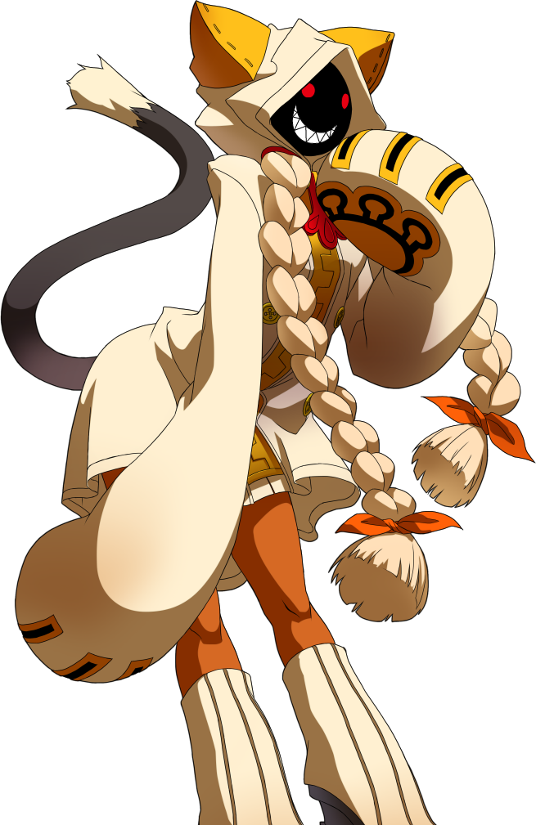
“Hmm… Tao isn’t sure what she was doing, but she sure is hungry!” The Kaka, Taokaka, looked around the inn room curiously. Her movements clumsy, she practically danced around to stare at the various objects of interest strewn about: the artifacts Silvia had unpacked previously. “Oooooh, shiny!” The cat crouched down before an ornate sword propped up beside the desk, paws on the floor with her tail swishing back and forth behind her. It was so shiny she could see her beady, red eyes and big, toothy grin reflecting in its blade.

But with her attention span so short now, it only took her seconds to jump back up, bumping into the desk and knocking some of the precious items off in the process. They fell to the ground and shattered; priceless pieces of history lost forever. Were she still Silvia, it would have broken her heart! But Taokaka?

She didn’t even realize.

“Tao’s gotta eat! Gotta go!” Another rumbly in her tumbly had reminded her of the fact that she was starving again, and so she took a prompt exit. Not out the inn door, but the window. Even though they were on the second floor.

Well, she was going to be someone else’s problem soon enough. Likely S’aiya’s, since her old memories had translated to her instincts in a way that would prevent her from getting lost in this world.

