HEAVY PODS
COMMISSION STORY
BY CHALDEACHANGE
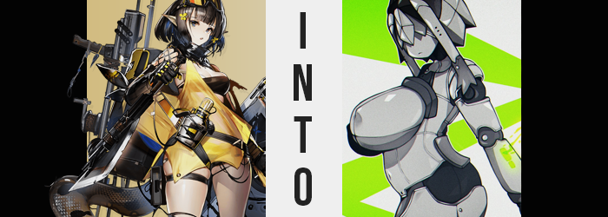

Among the Operators of Rhodes Island, it was inevitable that varied relationships would form between those that came from all walks of life. They all worked together, saw each other in the hallways, were deployed together, and sometimes they even spent their free time together. Those that would have had no business meeting otherwise became friends, while in some cases potential relationships were strained by disputes that arose over their backgrounds.

That was all completely natural. It was human nature to interact and form bonds.

But that didn’t mean that every one of these relationships made sense. Some of them were just downright bizarre, and perhaps none were as bizarre as the relationship between Eunectes and Lancet-2. Lancet-2 was, by all definitions, just a robot. A machine. A mechanical medic that bore a personality that was relatively human-like, but it did not change that she was not a human and those emotions were restricted.

Nonetheless, the Pythian girl, Eunectes, was smitten with her. Not in a romantic way, mind you, but in a more familial sense. The snake woman was obsessed with machines in general, so it was only natural that she would lose her collective mind over one that could both communicate with her and express itself, even if its sour personality was not a hit with most of Rhodes Island.

It had evolved to the point where Eunectes saw her as something of a sister figure, and referred to her as such. This was naturally eliciting raised eyebrows from her peers, and Lancet-2 herself hardly understood the meaning. …Which was something that would, eventually, lead to tragedy of a sort.

You see, curious about what sort of relationship being a ‘sister’ would entail, Lancet-2 had been doing some research of her own. What she had determined was that a living being could not be her sister, because relationships of that nature occurred between two that shared blood. Robots? They didn’t have blood. But being a machine? She could see that it was an issue that could be corrected, for what she assumed would be Eunectes’ benefit.

“Oh Lancet-2~!? I’m here as requested!” Eunectes felt like she had just jumped over the moon with how happy she was. After incessantly pushing the Medic Robot to accept her as a sister, or at least a friend, she had received an invitation to meet her in the robotics lab late that night! Some might have questioned the logic behind this meeting place in particular, especially since Lancet-2 received her maintenance in her own room.

But from the Pythian’s perspective? Why wouldn’t you meet a robot in a robotics lab? Perhaps this was a little disingenuous though, because every time she’d tried to get in here in the past she’d been thrown out. She’d really wanted to see what was inside so that she could use it for inspiration! And a chance to see had just landed on her lap!

The door had been unlocked when she had arrived, but the lab itself was mostly dark – signs that there were no staff present. Lancet-2 had left her some pretty specific instructions for what to do when she arrived, saying that she would arrive a little after Eunectes had. “Go to the pod in the back room? This is it, isn’t it?” A large piece of steel equipment could be found in the lab’s rear. It was certainly very pod-like, with what looked like a sliding glass door installed in the front. A door that was open.

There was also a red X on the floor right in front of it. “Huh? Am I supposed to stand here?” This trap was so obvious that nine out of ten people probably wouldn’t fall for it. Unfortunately, while Eunectes was a genius, she also fell under the one of ten that would be gullible enough to end up the victim of something this blatant. And it was only blatant because Lancet-2 wasn’t exactly capable of tact when it came to scenarios like these.

Lo and behold - no sooner than the woman had stepped on the X did it light up, and a mechanical arm from behind shoved her into the pod. At which point the glass door slid shut and locked. “Huh!?” Perhaps what was most surprising was that she was somehow surprised that this had been a trap.

The sound of machinery whirring to life filled her pointed ears, and the woman’s view through the glass panel slowly diminished as the pod filled with a strange smoke; strange in that it was a shimmering silver color. It certainly didn’t look safe to inhale, and the woman brought a gloved hand to her nose and mouth to shield them. But it was already too late.

“What is this stuff? I don’t feel drowsy or poisoned…” She was surprisingly qualified to identify poor side effects, because not only did Eunectes grow up in a tribe that tended to wield poisons in combat, but her inventions sometimes applied undesirable effects. And sometimes she accidentally applied them to herself. Such were the risks of being as talented as she was! But despite the fact that the Pythian didn’t immediately catch on to what it was doing, that didn’t mean that nothing was transpiring in the first place.

If anything, she almost felt a little… heavy? But not in the way that would imply her muscles were relaxing or that her body was undergoing any sort of malfunction. It wasn’t even as widespread as affecting her entire body, rather than remaining isolated to a number of key areas. It just so happened that those key areas were rather important ones, to say the least.

It took Eunectes almost twenty seconds of staring to even reach the conclusion that she could believe her eyes, because much of that heaviness? The feeling had gathered predominantly around her chest. “Um…” Since her chest was only covered by a single black stretch of cloth that essentially functioned as a cloth, in the beginning she was comparing its fit to the size of her chest. Maybe she was just seeing things and the black cloth was getting smaller? That seemed more plausible than the opposite possibility, with the cloth digging into her chest.

But it totally was the opposite possibility, wasn’t it? “Is my chest… growing?” Sporting a C-cup rack that was bouncy in its own right, the snake woman had never really had any major complaints about her figure. Sure she was a lot more bottom heavy than she was top heavy, but she had also assumed that having bigger breasts would just get in the way of her tinkering work. So to see them growing when she didn’t want them to? It didn’t exactly inspire joy.

Concern, more like.

“H-Hello!? What are you doing!? Don’t get bigger!” Maybe it was strange for a woman to yell at her own chest, but this was a girl that knowingly spoke to machines that had no means of understanding or responding to her. They had already swelled to the point that the black cloth appeared to be pushed beyond its possible limits, with engorged nipples practically being throttled by fabric that looked thinner and thinner the flesh beneath them expanded. “GAH!?”

Perhaps it was inevitable that this fabric would eventually snap, and breasts that were already in the E-cup range bounced free. They were already so heavy that the woman was passively leaning forward, the extra mass making it difficult to stay upright, but even without the bindings they continued to swell. “Wait, when I get out of here what am I going to even cover up with?” Keeping her dignity in mind, she tried to cast an arm across these tits. But she couldn’t. They were just way too big.

Before long they weren’t only bigger than her head, but protruded forward in a strangely oval shape as well. Her nipples had fared similarly, with areola stretching and the nips themselves poking out several inches farther than normal. “These are huge… I feel like I’m gonna fall over!”

It was, perhaps, lucky then that the gas’ influence sought to even her out, so to speak. The translucent yellow material of her strangely designed coat appeared to stretch out around her hips, but so too did the band of the black bikini bottom that she wore as the sole piece of clothing around her crotch. Those hips of hers had popped wider. “Wah!?” And once again, she had almost fallen inside the pod because of the temporary instability that had delivered to her.

That heavy feeling returned, but this time it was more focused in the areas around her hips. Her stomach, for example? It actually broadened, her gut thickening and sticking forward not in a way that made her look obese, but it just made her look big boned. It was a trend that saw her legs (and later arms) broaden as well, though those legs did get a little something extra to boot. Her thighs thickened, and thickened, and thickened, making good use of the ample gap that parted hips had allowed. Each thigh almost as thick as her torso, her ass bloated so that it was big and bulbous as well. So big, in fact, that her bikini strap snapped and fell to the ground.

Thicc was likely the best word to describe her now, and that applied to her limbs as well.

“Why is this gas making my body so big?” Eunectes had tried breaking through the glass to no avail, and so she went back to observing and analyzing what had happened to her flesh. Did bodies ever become like this? It all felt a little artificial somehow. “Pfft! Pfft! Pffffffft!” Before long, she wasn’t even able to freely observe (and fondle) her body because of her hair, which had strangely lengthened in the front. Bangs covered her eyes, and at the direct sides it hung down to her shoulders.

But there were signs of difference that Eunectes hadn’t even noticed, caught up in the growth of her figure as she had been. Her ears rounding and disappearing beneath her lengthened hairline was one of them, and the other? The Pythian’s tail… it had retracted back into her body so that she looked human.

Although… Not for long.

“Eh!? What’s up with…? Is there an electromagnetic field throwing through the gas!?” The mechanic had fidgeted with so much technology in her lifetime that she could sense the presence of a strange electrical energy basically immediately. It made her skin tingle, but more than that? It made her a little dizzy. “Getting… hard to see…?” Not only see, but think. Almost like her mind was being shrouded in a strange darkness. Seeing as how brains worked based on electrical signals, maybe that wasn’t all too surprising. The energy passing through the gas managed to completely incinerate any scraps of clothing that were left inside, too.

“What…?” The next the woman spoke, something was off about her voice. It sounded empty, hollow, mechanical. Eunectes’ body? It was beginning to feel stiff, and the burdens of the weight of her fatty tissue felt less and less imposing – not that there was any more ease in processing what did or didn’t inconvenience her by this juncture. She couldn’t tell what was happening to her body, but it was definitely obvious to an onlooker.

All of the Pythian’s pink skin was darkening. Not towards black, but varying shades of grey. Blemishes were erased, and this skin grew smooth, shiny, cold, unnatural – ultimately cooling the blood within as well. As vertical grooves formed in this flesh, it became clear that what was being looked at wasn’t skin. In fact, with her body growing heavier still, it could only be steel.

The woman’s legs eventually gave out, and so she fell against the back wall of the pod where her big ass slid down onto the floor with several metallic CLINKs. She could no longer croak out words from a mouth that had been utterly robbed of not only moisture, but of her tongue. The taste of metal was the only thing that lingered, and just as dry?

Were her eyes. The hair covering them bound together into silver plates of steel of their own, while irises were gradually replaced by small but sensitive cameras. While she did not have ‘eyelids’ any longer, she was still just as blind as she was mute. It was as if her mind had completely shut down. And it had, but only so that the data could be transferred over to a new piece of technology,

As the steel settled into her breasts, protrusions were still left in the shape of her huge nipples. These would act as buttons meant to open tits that had since become a pair of heavy pods that contained miniature missiles for combat.

Where most of this steel was silver, there was a black steel that ultimately settled in around her joints. Neck, shoulders, elbows, hips, knees, ankles, wrists, fingers, toes – all of these areas were indented and had this black, and were clearly modelled after the joints of a doll so that they could move about once powered by a motor.

Her heartbeat stilled, but in its place something else sounded a squeak. The woman’s heart had been replaced by a piece of technology just as her brain had. The only spots of color that lit up were on her arms – a bright green that evidently suggested bars of battery power – as well as a matching color that glowed upon a pair of antennae that erupted from her head.

The sound of the pod’s machinery finally quieted, leaving a stillness to linger in the air for but a brief moment. In its place, however? Something else whirred to life. The energy core within the chest of the robot woman that stood slouched against the back of the pod’s wall in all of her inactivity. A warmth flowed from this core, carried by the special fluid that ran through her limbs and the supercomputer she had in the place of a brain. So, in many ways, the woman of silver wasn’t all that different from a human.

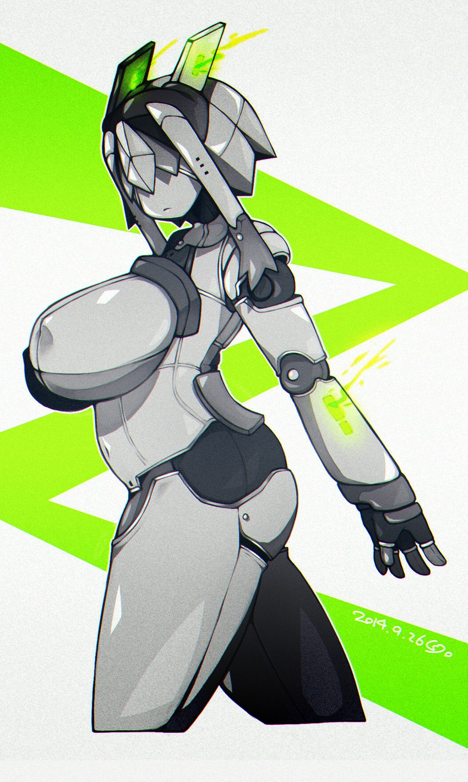
“B O O T I N G . . . B O O T I N G . . .” The hollow voice produced by the voice box housed in her ‘throat’ served as ample reminder that she wasn’t, indeed, a human not long after, though. Metallic lips opened and closed, but there was no real movement to the lips themselves. Her mouth was empty, only serving to carry the sound of her voice so that she could communicate with the humans that would give her orders.

With her systems coming back online, the robot could remember her past life. That was stored as data within her memory banks, and yet conversely it almost felt like a far off dream. She did no longer go by the designation of ‘Eunectes’, but instead Lancet-3. In terms of purpose, she had become a Combat Robot meant to compliment her medical-inclined sibling, Lancet-2.

Lancet-3’s cameras eventually booted, and she stepped forward with no shortage of creaking from her steel doll joints. With her head fashioned as it was, the steel that resembled hair covered her eye cameras – but they were advanced enough that she could see through the steel. It took her a moment to adjust, but she did eventually manage to get herself out of the pod. And who would be waiting for her on the other side other than her sister, Lancet-2.

“O N E E – S A M A . . . ?”

