MY DAILY SOLDIER LIFE AS A MONSTER GIRL
CHAPTER 5: WYVELIHOOD
BY CHALDEACHANGE
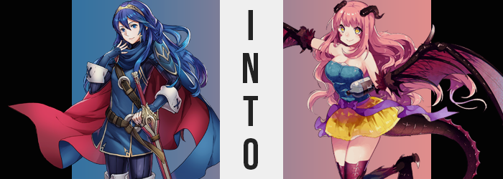

Lucina had just watched something indescribable. From start to finish, she’d watched her own father (and naked at that), be transformed into a monster. No, not merely a monster, but a monster woman. The chain of events that had led her to this point had left the woman feeling broken and unsure of what to do. Or maybe there wasn’t even anything she could do at this point?

It had all begun with some early morning training with her father, Chrom. She had gone off to fetch some water, but once he’d returned, she’d found him following after some strange girl with a single eye as if in a trance. Naturally, she had attempted to subdue the monster and free her father before they could escape… only to fall victim to its hypnosis herself.

The next she’d realized, she had been in that room with her father, naked, and the one-eyed girl. It had fed him some kind of candy and erected a mirrored cage that could be seen through from the outside, and his flesh and personality were reshaped into what the one-eyed girl called a ‘Hel’. Her father hadn’t seemed like himself at all…

Yet before he could even see her, Lucina had been whisked away in the room next door by courtesy of the Backbeard’s hypnosis, and before she realized it, she was both naked and perplexed by the taste of spice against her tongue, arms clamped to the wall behind her. “Gods! I didn’t!?” Evidently, she had fallen for the girl’s hypnosis once more.

Even worse, however? The taste of spicy sweetness atop her tongue could only be one thing based on what she had witnessed in regard to her father’s own transformation. She had been slipped one of those candies!? That meant that her time as herself, surely, was limited. Would she become a beast as well? One completely incapable of recognizing anyone she’d cared for in the past?

A burning at the bottom of her gut said yes.

The princess squirmed against the steel shackles that bound her just below her shoulders to no avail. Complaints about being captured aside, she couldn’t fathom why she’d been secured there and not by her wrists. “SOMEONE LET ME OUT! PLEASE!” Regardless, all she could do was cry out with desperation in hopes that someone might hear and help her – as much of an unlikelihood as that was.

Rather, instead of help arriving, her thrashing had seemed to hasten the effects of the candy within her gut. She could feel its burn intensify, so much that the breath that was coming up from the bottom of her throat carried an intense heat. An intense heat, and… was that the taste of alcohol? “Wait, was that… Is that why I feel so dizzy?” She’d attributed it to the shock of it all, but it seemed like this wasn’t exactly the case. Had she been forced to drink alcohol while in her trance as well, or had the candy been alcoholic? “Hic!?” Either way, drunkenness hit her like a truck, and she hiccupped to the point that raw flames shot from her mouth. “EH!?”

Humans didn’t shoot fire from their mouths, and certainly not without burning their tongues, but the insides of Lucina’s mouth had shifted without notice. A special coating had made her innards fireproof, and her canine teeth had lengthened into tiny fangs that she could hardly keep housed within her lips. It became a little easier with time though, for those lips became much more abundant with a few passing moments.

Lucina was a naturally pretty young woman, but there had always been a plainness to that beauty. Her features were fair, and nothing about them was necessarily sexy. But as lips engorged and became naturally glossy, steps were being taken in the right direction to turn her into a proper bombshell. Her complexion improved, her eyes widened, and her cheeks rounded until her face sported an undeniably sexy cuteness.

A sexy cuteness that began to seem monstrous. “Hey! I can see things all better and stuff now!” Evidently, the intoxication of the alcoholic properties had made quick work of the maiden’s ability to speak and make sense of things, and despite the direness of her situation she was now giggling gleefully to herself. But she wasn’t exactly wrong to point this out, either. Her vision had certainly improved, perhaps tenfold. But as a result, her irises had glossed over with a supernatural gold that almost seemed to glow in the dimly lit castle room.

The skin beneath either eye appeared to harden quickly in segments not long after, with color darkening to a dark red, segments rising into a series of durable scales that seemed to extend from roughly where her ears were beneath her blue hair. “Ehehe… I feel nice! Warm and nice! Didn’t I shoot fire just now…? How’d I do that!?” Lucina was far too far-gone to really take note of anything now – at least in a way that might alarm her.

Case in point? As she thrashed around wistfully now, there was an obvious indifference to the fact that the young woman’s curved were growing and swelling. Her breasts were a key area of note in regard to this phenomenon, with their A-cup sizing swelling significantly. Rather, Lucina seemed to like the feeling, and she rocked back and forth against her chains trying to get them to bounce. “Bouncy~! Bouncy~!” And bounce they did, each shake seeing another cup size applied until her erect nipples jutted several out atop a pair of DD-cup orbs that retained their jiggliness even after her shaking came to a halt from self-imposed boredom.

“Oops! Now my butt!?” The princess’ voice had jumped several octaves, sounding much more childish even though her changing body suggested she might be a little older than she should have been. This comment on the other hand, was made regarding the feeling of her booty pressing up against the cold, brick wall behind her. Her cheeks truly were wedged upon it with juicy goodness, pale buns now just as bouncing as her breasts had become. The excess, on the other hand, had made its way into her thighs, and they were bolstered with a delight that was felt by Lucina as well, as she bounced up and down a little to try and feel the jiggle southward as well. “This feels so good! Why was I upset about this again?”

She could almost go for another drink, honestly.

But now that her sexual features had been honed though, it was time for the remnants of what would make her a monster to bleed in. The blue hairs above her pussy were the start of it, taking on a rosy red that found its way into the roots of the hair atop her head not long after. As her entire mane became awash with a color so untypical of her bloodline, this hair grew softer, thicker, and even a little curlier, until it all looked like a much better fit for her overall visage. After all, the blue had clashed greatly with the red of her facial scales.

And it would have clashed even more with the abundance of scales that came soon after. They began to sprout, a little more purplish in color, around the base of her thighs, and quickly made their way down to her feet as her regular human skin was replaced in their wake. Once her Lucina’s knees had been coated though, tufts of red and brown fur seemed to erupt from them, softening her joints before continuing their adventures downward.

The bones beneath her knees painlessly crunched, not that Lucina could see them past her immense bosom even if pain had been involved. The reality of it was that these lower legs were thinning, but it was hardly as shocking as what occurred with her feet. Her big toe, middle toe, and pinkie toe all stretched forward, darkening until the looked like they were made of long bone themselves, complete with sharp claws that protruded from their tips, while the toes in between receded inwards into non-existence. A single claw, on the other hand, emerged from the back of either heel, and the end result?

Her legs looked like they belonged to some kind of weird lizard, the length and flatness of her toes entirely bizarre when looking at the rest of her body. Lucina’s arms, on the other hand, were about to say, ‘hold my beer’. Then again, maybe not? Because her hands wouldn’t be able to hold a beer by the time their transformations were complete.

Crimson fur erupting around her elbows was intended to veil the similar colored scales that erupted beneath and began to move towards her hand. Unusually though, as the scales crept down her forearms, it quickly became evident that there was simply more forearm to cover. Her bones were both thinning and stretching, pulling longer while her hands contorted.

Lucina’s thumbs were forced upwards and hardened into a pair of claws, but the other fingers both popped and stretched downward, index fingers becoming extensions of her arm while the other three appeared to form the foundation for a layer of scaly, red skin that webbed between them. “Wings! I wanna fly! I wanna… Whoa, dizzy!” Almost like a reptilian Harpy, her arms had become a pair of scaly wings that were twice her height in width, born of crimson and purple scale and bone alike.

Golden eyes clenched shut as a pressure built above them, and before long a pair of black, rigid protrusions sprouted, bending backwards as they grew. A perfectly pleasant pair of horns, selling her new, monstrous visage even more. But not as much as the long tail that wriggled out from above her thick ass. Thick at its base, it thinned gradually until reaching a spade-shaped tip. The coloring was a dead match for the rest of the lizard-like features upon her body.

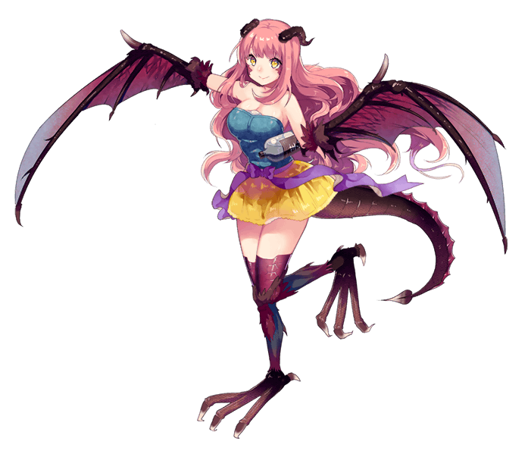
But, burping an alcoholic burp, another spout of flames erupted from the woman’s mouth with a giggle. She was no mere lizard. Lizards didn’t breathe fire.

Fere, as she now knew herself to be named, stumbled as the strength of her powerful Wyvern wings freed her arms from the chains that had bound them. “Kyaha! Woahsies! Did I have a little too much to drink? Standing feels all weird!” Both chipper and intoxicated, she struggled to stand on her large, reptilian feet for a few moments before she found her balance, wings folding in to help steady herself. She was entirely naked, and it didn’t seem that would be rectified. But drunk as she was? She didn’t seem to mind all that much.

Alcohol had clearly been laced within the candy she’d ingested, but now she just wanted more. She was a lizard of the drink, one who loved herself a good glass of sake or wine if available. Even as she walked forward, catching sight of a Backbeard and an attractive looking Hel, it was clear that she wouldn’t be able to properly walk, much less fly until she was sober again.

The Backbeard merely let out a sigh and shook her head at the sight, but the Hel? She giggled to herself. Why did the taller woman look so familiar to Fere? Was she important for some reason? Even entertaining this idea led to a dead end, and the Wyvern sloppily shrugged as she approached. “Who’s she!?”

“Your partner for this evening. I see you’ve already taken the liberty of dressing down for the occasion. Fufu!” The Hel bowed courteously, before raising Fere’s chin with her finger. “Shall we get a drink together first from the dining hall?”

The Wyvern wasn’t sure about what she meant by ‘partner’, but she did know what ‘get a drink’ meant.

“Oh boy! Sure thing!”

