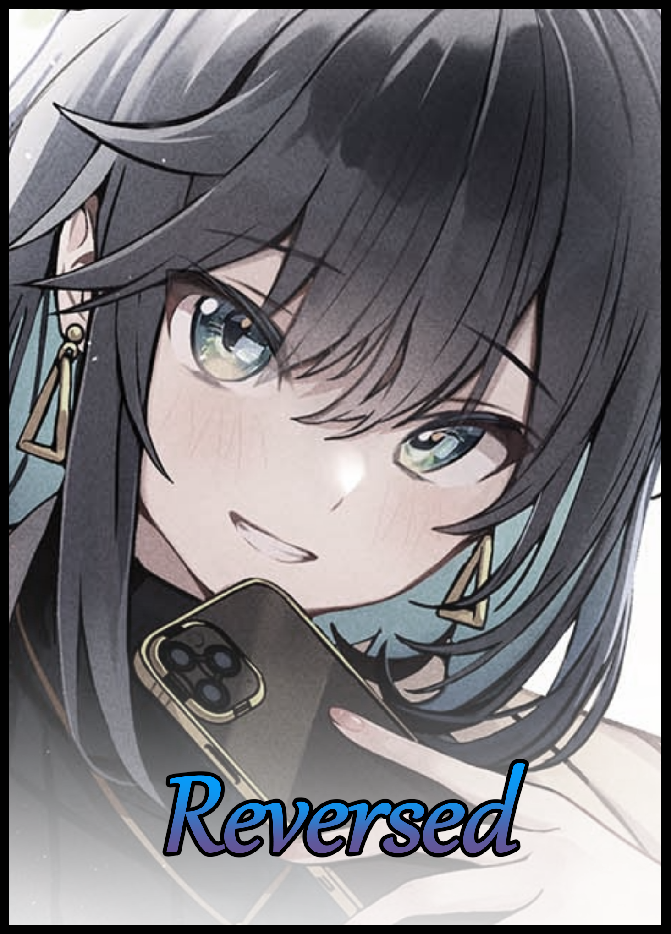

Sitting on a swivel chair with a pensive look on her face, a blonde haired youth busies herself with her phone, scrolling past contacts, entertaining messages with swift replies before sighing in frustration as another alert pops up to replace the one she had just tended to, rapping the floor with the soles of her feet as they shake up and down to the rhythm of her heartbeat.

"C'mon Suzie…what's with the long face? It's not like it's the end of the world right?"

"Not for you maybe…and close your legs when you sit!"

"Ehh~ Such a buzzkill…"

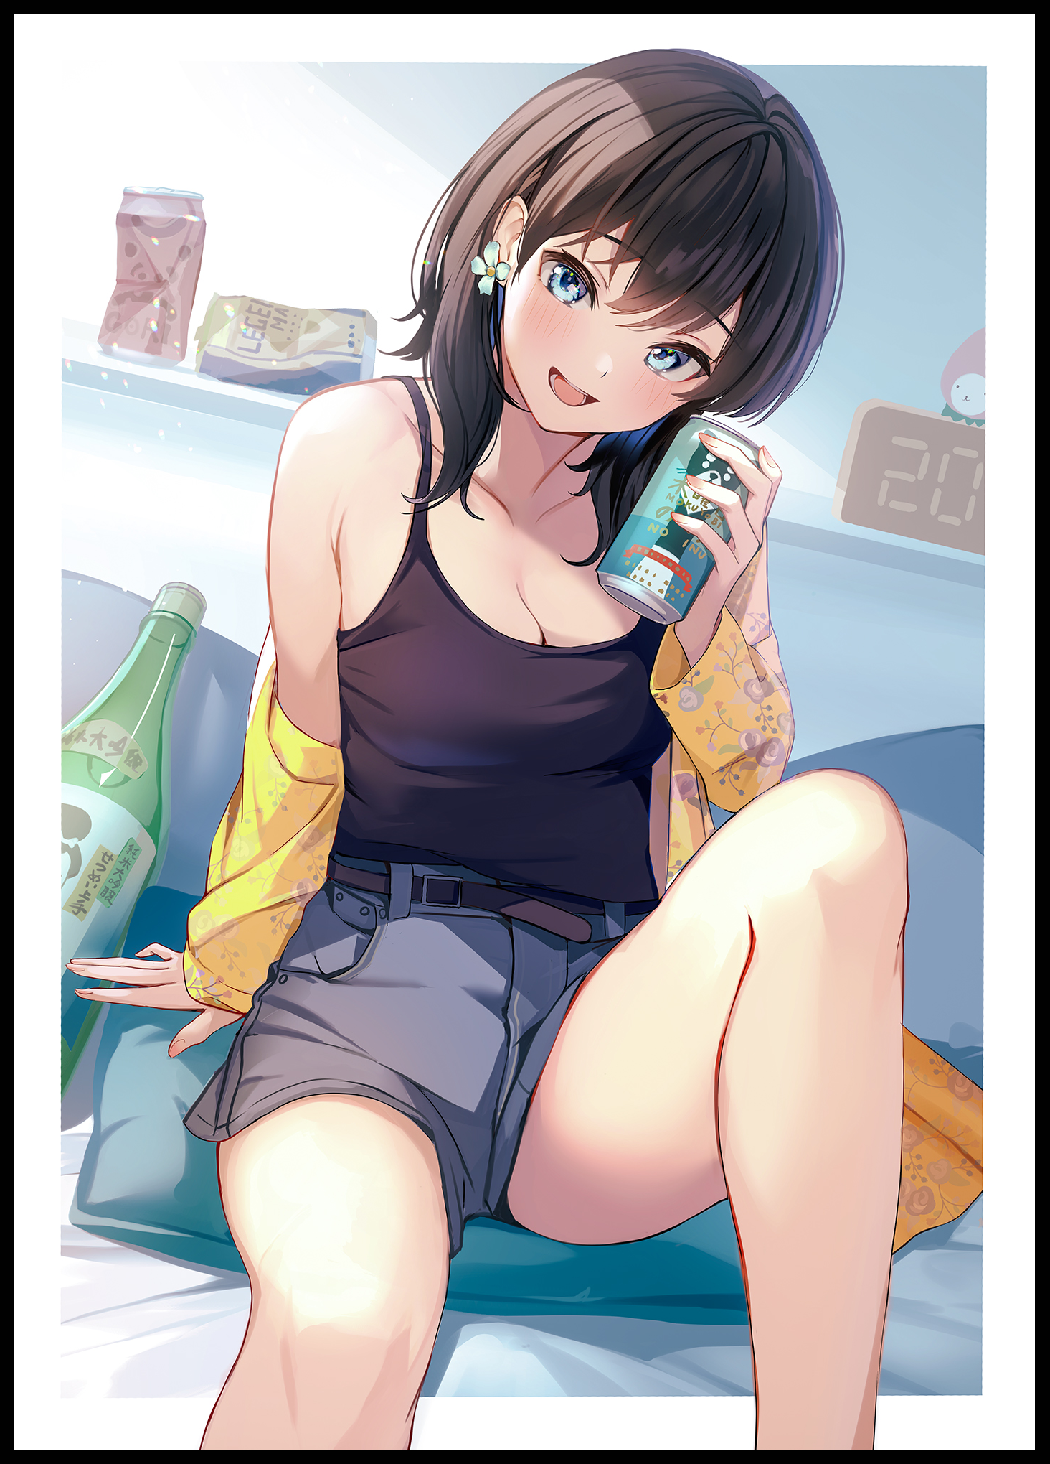
Sighing with a noticeable increase in exasperation, the blonde returns to her phone with a worried eye locked onto her companion; a sloppily dressed gal who looked like she was way too deep into the drink to be awake as she tips her head back with a tipsy giggle to empty the last remaining drops of alcoholic beverage into her gaping maw, showing no restraint as dainty hands reached out for a larger, unopened bottle of Japanese branded drink lying by her side, already having gone through a hearty supply of drink as noted by the array of empty cans lying all around her. All while totally disregarding her friends concerns for decency as she continued to keep a leg up, offering a dangerous view as the hot shorts slung around her slim hips do little to cover her privates, slipping off around milky thighs as they squish and fold to every subtle movement.

Although her staring seemed to have caught the attention of the subject as the promiscuous girl coos under her breath, drawing her friend's attention up to a pretty face beaming with a big warm smile, shaking the empty can by her side while parting her legs just a tiny bit more, just enough to reveal the beginnings of perky buttocks pressed up tight against a flattened pillow.

"What's wrong? Ya want some~?"

And as if her friend's teasing wasn't enough, another message on her phone makes Susan groan in exasperation upon reading the unpleasant news contained within, slumping over where she sat with a defeated look on her face.

'Goddamnit…how am I supposed to fix this on my own?!'

Things hadn't always been this way. In fact, Susan didn't even have a female roommate until that same morning had arrived and she awoke to the familiar scent of magic hanging heavy in the air, only needing to take a look around the compact dorm room to instantly spot an oddity that had her worried, then furious upon the realization of what happened.

Living a double life as a witch in-training and a normal, everyday university student meant that Susan never had a chance to kick back and relax, always having to study for test after test ranging from mundane math to mind boggling reality weaving formulae. Juggling two lives that demanded great things from her while never giving her the chance to enjoy it as she went, all because she had the 'fortune' of being born into a notable family, one of the greats that just needed to flex their intellectual muscles by owning businesses in the modern world while pioneering magical marvels in a lesser known world inhabited by wizards, witches and all sorts of fantasy creatures across the globe. A world Susan would scoff and sigh at in comparison to the awe and marvel most others would display if they knew such a place existed.

So while other girls got to fool around with their dolls, go to school, experience the thrills of a highschool romance. Susan was stuck under textbooks, scrolls, training schedules, revisions and so much more related to two lifetime's worth of studies. All to ensure she remain a fitting heiress for a renowned bloodline.

But a family with that level of fame was sure to attract attention, and in Susan's case; it came in the form of a coupling with someone from another renowned family the girl was initially hesitant to engage in. Thinking the man would simply be another uncaring leech who saw her in a superficial light, attempting to woo her just because she was someone with immense potential, and in the world of magic, genes mattered greatly when it came to seeding a powerful family tree. And after a few weeks of getting to know her would-be suitor, Susan had been relieved to know that the man, a dashing gentleman by the name of Tristan, seemed to be the exact opposite of what she had dreaded him to be in her mind.

Kind, compassionate and with an open mindedness to aid in her work without worrying about stupid traditions like keeping family magics secret. To her, it was like getting a match made in heaven struck overnight; paired with someone who saw her for who she was and treated her like an equal with unwavering faith that she hoped to kindle further as their relationship grew.

But Susan had been naive. Fooled by the intricacies of romance after taking that one semblance of normalcy for granted. For it wouldn't take Tristan long to show his true colors after realizing his girlfriend had a roommate…a male roommate.

Incensed by the idea of another man being so close to Susan, Tristan had begun plotting to remove what he saw as an obstacle, preparing a spell that would permanently remove his rival's ability to compete while serving the dual purpose of inflicting a punishment that, in his warped perception, was deserved and just. Except the brazen use of that spell would only serve to show just how he viewed his girlfriend in turn as an unintentional side effect. As for what the effects of the spell was, well…one need only look at the current state of Susan's roommate to figure out the surface level details.

In addition to turning it's victims into fully functioning women whose appearance was dictated by the caster, it's perverse nature as a transformative hex over a simple spell meant that it's twisted abilities imparted more changes beyond the physical; corrupting morals and warping memories in an effort to invert the victim's very soul until none could recognize them. Manipulating reality itself so any proof of wrongdoing couldn't be used to trace the caster. And only a few could resist that particularly nasty bit, hardy and powerful individuals like Susan for instance.

Which was why she could almost instantly sense the moment when the spell had gone off, awakening to a complete stranger lying in the bed opposite to hers in a compromising position, pinning the blame on Tristan after putting two and two together. But the real hard part, was undoing what her ex had done to her roommate after tracking down and reporting the illegal breach of ethics Tristan had resorted to in his paranoia fueled bid to keep Susan all to himself, only managing to make her despise him after beating him to a pulp while hearing him spew excuse after pitiful excuse out of his broken mouth.

The wool had been pulled over Susan's eyes, and she had almost given her unconditional love to a man who saw her as less than himself, a shameful predicament that had earned her the expected reaction from her father who would dump the responsibility of fixing this whole mess onto her lap, hence the dismayed reaction after receiving the speech like text she hadn't bothered to read all the way through, learning to navigate her overbearing father's words by filtering out the insults just to read; it's all on you…but it wasn't as if all was lost. After all, she did manage to reverse most of the mental edits that had befallen her roommate alongside the associated changes in reality, salvaging whatever she could with the power she had at her command.

But at the end of the day, Susan was still a fledgling witch. So despite her best efforts, the newborn Diana was stuck with her feminized form for the foreseeable future alongside some lingering remnants of the life Tristan had intended for her to live had his deed gone unnoticed. And when the behavioral tics and traits of a loose girl who didn't care that much about her public image and an innate love for drink mixes with the childish innocence of a meek young man who had more to say about his hardworking roommate than his passive appearance would suggest, you got the fun loving, hard-to-deal-with bundle of lackadaisical energy that was the raven haired girl offering Susan a drink…and in her exhausted state, she could only find herself nodding her head in acceptance despite the fact that the two of them were due for afternoon lessons in about an hours time.

“Sure…but make it…nevermind, just fill up a mug or something…”

“Ooo~ Daring aren’t we? Hold on a sec…will your drinking glass work?”

Waving her arm in careless dismissal, Diana hops off the bed before sashaying over to the desk, pouring the cool contents of the freshly popped bottle inside with a peppy tune slipping free of her bubbly shell. All while Susan continues to observe her roommate with eyes furrowed into an expression of frustrated anger; worries about the extent of the hex’s effects hogging up the mind while self blame and insecurity gnaws away at her heart, wondering if this was all truly her fault, thinking about the what-if’s, wondering if Diana, or rather David, hated her beneath the vapid mask she was currently forced to wear…

“Heey~ Earth to Suzie? Drink up!”

“H-Huh?! Oh…t-thanks…”

Taking the surprisingly large mug from Diana’s hands, Susan gives the fizzy liquid within a good shake, watching a small whirlpool form in the middle of the pale yellow slosh, lapping against the walls of the interior, forming a foamy froth similar to sea foam on the shore. Hazy eyes tracking the slow spinning spiral within as a drifting mind struggles to recall the brief few moments of interaction she had with David. Compared to how she was now, David had been a ghost, easy to miss out on many occasions thanks to his tendency to either remain rooted in the study chair or tucked away under the sheets, noticeable only when he made his presence known through movement and sound.

Most in her class made fun of the poor man behind his back, thinking him to be nothing more than a cowardly nerd who only ever piped up when it came to presentations and the like. A soft spoken wimp who many considered lucky to be sharing board with a girl like Susan. But he never once showed any reaction to those statements, preferring to keep to himself or, when the time came to work on group projects, toil away on his share of the workload, proving a capable member to Sarah after she had been paired with him once or twice, even managing to show her a trick or two she didn't know about to hasten her work process. Other than that however, Susan didn't really know anything else about David. Simply remembering him as the effeminate gentlemen with an impressive ability to remain hidden in plain sight.

'But to think all that knowledge could be lost overnight with the intervention of a jackass…oh David…what have I done…'

Looking at her own reflection in the drink, Susan knew she couldn't just step down and back away now. Sure, there was an easy way out of this with the intervention of magic practitioners under the employ of the state who could simply cast a memory wiping spell and make it so that Susan never studied in that university in the first place, carrying on with a clean slate elsewhere while Diana would never know of the drastic change that bad befallen her, living blissfully as the careless girl everyone now knew her to be as a result of the dampened hex. But that was against her personal creed to aid the helpless and an indirect admittance to Tristan that his holier-than-thou view of the world was correct and that she was as weak as he had assumed her to be.

'But does David…does Diana even want my help? Does she even realize what's happened I wonder…'

Taking a quick swig from the mug with a bitter wince on her face from how 'sharp' the liquor was on her tongue, Susan turns her attention toward her roommate, almost unfazed by the sight of her drinking directly from the bottle itself after all the cans she had burned through in her personal stash, taking deep, lengthy gulps that must've been knocking her head senseless from the sheer volume of alcohol being dumped into her system alongside the intoxicating amount already flowing within her veins.

"H-Hey…Diana? Do you…have a sec? I wanna ask you something…it's about this morning…you remember what I told you about it right?"

"If you're gonna *hic* ask someone if they gotta moment for a questioning…then start it anyway without waiting…you might as well *hic* ask right away!"

Jumping a little in her seat from the sudden outburst of emotion displayed by Diana as she swings the bottle in a haphazard strike that ends with a cringe inducing bang after striking the wall, Susan shifts uncomfortably in her seat before taking another swig, forcing herself to swallow alongside Diana as the atmosphere in the room begins to turn heavy and tense around the two women as they stay crestfallen and quiet until the unstable brunette sighs, breaking the silence as she sets the bottle down on the floor.

"That stuff about your boyfriend being some sociopathic freak who turned me into a girl overnight? Yeah…I remember…what about it?"

"W-What about it…Diana. You're a girl now! Surely you've got something you wanna ask…like-"

"-when I can go back to being a man again? Isn't that just pestering at that point? You told me about the *hic* circumstances surrounding my 'condition' so I figured *hic* I'd let you work on your own time…besides…you've got other things to worry about right? Being a witch and all?"

Stunned to silence, Susan can only gape in response to Diana’s surprisingly insightful statement. So she was listening when she had initially dropped the bomb as to why she had woken up with breasts hanging off her dress and new ‘thoughts’ rolling around insider her head, assuming it had been the latter that had influenced her to immediately start burning through her supply of sugary drinks before busting out the alcohol. Only to realize that it might’ve been a coping mechanism the mental changes had inserted into her roommate’s psyche…she’d jumped the gun on her assumptions…

“S-Sorry…I just thought that…maybe I hadn’t done enough to undo the hex…and that you might be some…well…brain dead bimbo for the rest of the semester…you’re just so…different now.”

Diana’s demeanor shifts upon Susan’s mention of the hex and its original effects, pursing her knees together before pulling them tight against her chest with arms clasped tightly around in a display that made her look meek despite the lean frown on her face, another expression she had begun to show after her recent metamorphosis.

“Harsh to put it like that but…I thought so too…it was like being told what to do by some pervert…and the more I resisted…the more it just…crept inside me…making me like it, not able to do a thing but laugh and smile as it turned my head inside out…until you stopped it…what’s there to be sorry about? If anything, you’re my hero Suzie *hic* I mean it…”

Being praised for the first time so earnestly by someone else would leave Susan incredibly flustered as her gaze immediately falls away from Diana and onto her drink, taking a big gulp to calm her nerves, deciding to steer the conversation elsewhere before another heaping of praise could implode her mind.

But before she could do so, Diana pipes up with a question of her own, staring directly at Susan with intelligent eyes peering out through half lidded eyes and a warm blush on her cheeks from all the alcohol she had imbibed.

"Instead of worrying about *hic* me…shouldn't you be more worried about yourself?"

"W-What do you mean?"

"Well…you just found out your boyfriend's *hic* a total creep…your dad wants you to fix everything yourself…and you…we've got midterms coming up soon…plus, with that magic stuff…do you have school for that too?"

A meek nod of the head from the fledgling witch earns her a silent whistle from Diana as she picks up the bottle from the floor before waddling over to refill Susan's near empty mug with another round. Accepting the act of goodwill without a word as she watches the clumsily dressed girl walk on over back to the bed, finding something strangely admirable about her drunken poise.

"No wonder you always look so *hic* stressed out…I'd lose my mind if I had to study for two entirely different courses at the same time…you really are incredible Suzie!"

"I-It's nothing…really…but what you said…I thought I was doing a good job of hiding that away…"

"There's many things I've noticed about you Suzie…I just…didn't have the mind to say it back then I guess. But now…after the change…it's like I can just..say whatever I want y'know? Like a great *hic* big ball of confidence making me say what's on my mind…I hated it at first but…after we got to talking like actual roommates…I think it might not be so bad after all."

"And…what about being a girl? Do you think that's 'not so bad' too? You did tell me to call you Diana after all, does that mean anything or was it the magic talking?"

Doing a quick once over with curious eyes lingering over her exposed cleavage for a moment, Diana sighs while flexing her slender arms as the mild interest in her eyes turns into despondent exhaustion. As if she had settled on a disappointing outcome and now needed to voice it to her friend.

"I mean…I never really thought much about my appearance before I became…Diana…boy or girl, I didn't think my life could get any different, still not changed on that view. But now that your boyfriend tried to curse me…it's like there's so many things I wanna do right now; buy clothes…mani pedis…it's all mild right now but they're just there, like an afterthought. Better than what I was thinking, back when I was asleep…but we don't need to talk about that…you stopped it, I'm clean, done."

"Not all of it though…you're still a girl…and with how thorough that particular hex is, your manhood might not ever be recoverable…is that alright with you? I…This wouldn't've happened if I wasn't your roommate…"

"Just…stop with the apologies alright? You always take things too seriously Suzie…and it's a lil frustrating to be honest…taking accountability is one thing, but blaming yourself for stuff that's totally out of your control isn't right…that scumbag was wrong for looking down on you and your dad doesn't dictate who you are…you helped me Suzie…take pride in that at least…besides…you are going to help me right? So let's make it a deal; you help me, and I help you!"

"...what could you possibly do Diana…you're just a normal person…"

"I could be your friend for one…from the looks of it, you're in a pretty bad state…and having a shoulder to lean on can't be all that bad right? Especially ones like mine~?"

Groaning with a weary eye cast at her roommate's subtle flirtation and an outstretched hand, Susan's mind retreats a little, considering the options left to her at this point on the road ahead. And in a way, she knew Diana was right. Tristan had shattered her hopes in a workable relationship, leaving her alone after revealing his despicable nature. Her father had left her to 'fix' Diana on her own and without a word from her mother, she was most likely in agreement with that sentiment…not to mention her ongoing studies that saw no pity to halt for her plight, and she truly was in a really bad spot right now, feeling as if the weight of the world might just crush her into dust right then and there.

But if Diana was offering her aid…maybe it wouldn't be so bad…right? Because underneath that mischievous minxy surface, David was still in there despite the tampering done to both her body and mind, and from her past experience, she found herself drawn to place her trust in a distant roommate than some smart Alec who would use wits and dashing looks to mask an obscene side from her…

"Alright then…I'll…accept your help…whatever that means…"

"It means; we're friends from now on…and friends do everything they can for each other…now c'mon, let's uhh...prep for class…barely got half an hour left to go! "

With her mind made up and a temporary settlement to her inner conflicts made, the witch reaches out to take Diana's hand in her own, rising off her chair to get ready for lessons, starting with cleansing her body of the alcohol running rampant within. Maybe it was a spur of the moment decision influenced by the drink, but a part of Susan couldn't help but tingle with excitement at the prospect of a friend despite the hellish schedule ahead…but if she kept her word, then maybe it wouldn't hurt so much? They were roommates after all.

And sure enough, over the following months, their uncertain relationship would nurture into a steady friendship as Susan took the time out of her schedule to 'help' Diana adjust to her new life and disposition as a red blooded girl, tempering her bad habits alongside learning the in's and out's of her biological functions. With Tristan's meddling mostly undone, that left only the vaguest of knowledge behind, most of which was unnecessary and forgettable, leaving Susan to show her how to walk the walk. Using the loo right, taking care of her hair, preparing for her menstrual cycle, etcetera etcetera…

As for Susan, her life would begin to lean ever so slightly into the normal one she could only dream of in the past, letting loose thanks to Diana's sprightly disposition and nonchalant attitude, being the only one in her life so far who had managed to rip her away from the toil of studies she so desperately thought she needed to embroil herself in just to excel. Like maintenance being performed on a worn out machine. Her parents remained distant, and last she heard, Tristan had been taken into custody by the authorities, shaming his family after many more crimes began to unravel under his name once investigation into his recent misuse of magic began. And with a hefty sentence in a supermax prison, it was safe to say that Susan and Diana were safe and free from his influence. But that wasn't enough to stop the cautious witch from casting protective spells over their temporary abode in the university dorm, going so far as to mask charms and spells in gifts she had begun giving to her best friend as their friendship blossomed over the months.
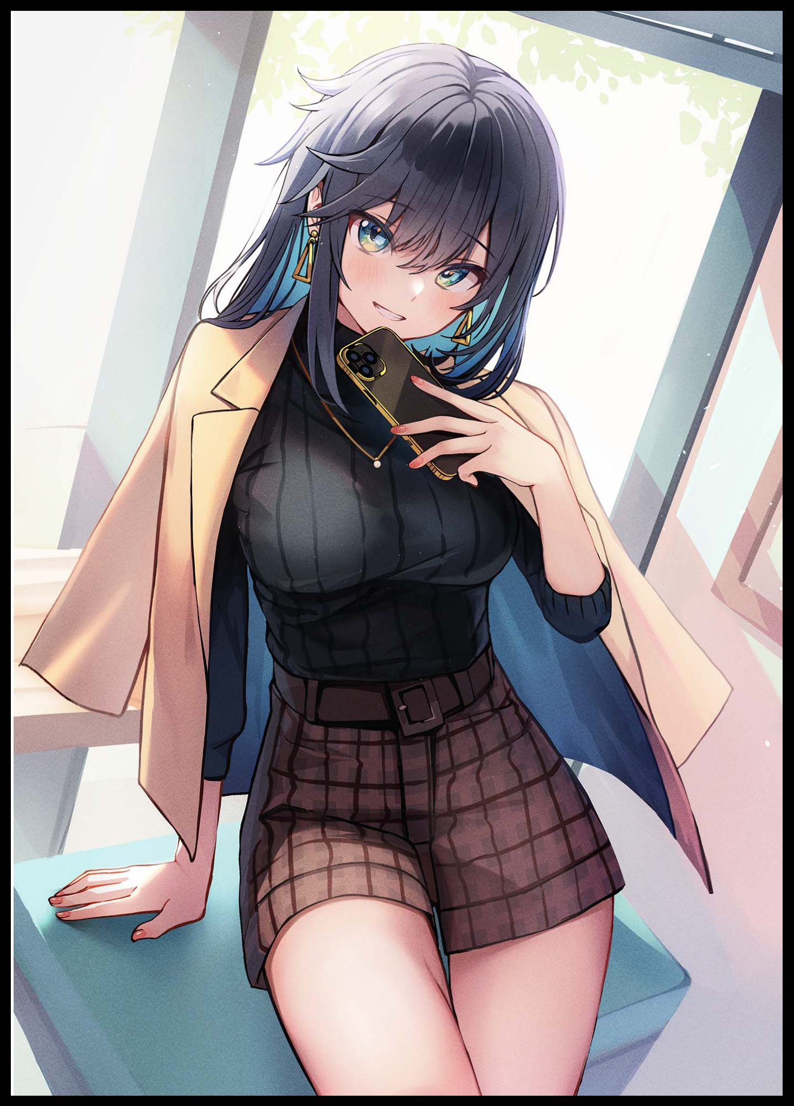
From studying to project work, they did everything together with a familial touch this time that made what should've been a chore enjoyable, much more than her time with Tristan where it felt like a play, too good to be true.

And as she steps into an empty classroom in the current day, Susan knew her decisions so far had been right, gazing upon the sight of a new and improved Diana dressed in clothes that still retained a modicum of her formerly overbearing self and promiscuous habits but painted over with an additional layer of feminine modesty and appeal that made her look beautiful in a good way, even more so when her eyes trace the delicate features of her visage framed by a head of raven black she had let grow out into a matte polished mane featuring a slightly boyish flavor with how her side swept fringe stuck out in spiky tufts…and on her ears hung the charms she had made for her alongside a pretty necklace slung around the collar of a turtleneck top, smiling warmly in greeting while closing the distance between them. Causing Susan to purse her lips in anticipation with the news she had to deliver to her friend regarding the status of the now permanent hex and any lingering effects it might have over her.

Despite doing her utmost, all traces of magic in Diana's body had long since left her system about a month ago. Leaving her life irrevocably altered, although it didn't seem like she would mind that much at this point now that she had already settled down nicely. Her family's perception of her had remained thankfully untouched, she had new friends, her social life both in the real world and digital one was booming…and by her side; she had someone that meant the world to her.

"Heya girl~ I've been waiting all afternoon for you! How did things go with your…'family meeting'?"

"Hahh…dad's still miffed about the spell's effects being permanent…mum doesn't seem to mind, in fact I think she's relieved to hear the hex doesn't have an active hold over you anymore. That means you're stuck and technically discharged from any extensive monitoring…but…"

"But~? C'mon Suzie, don't keep me waiting! What did they say about the other thing?"

"Well…they weren't too pleased…especially my dad…but mum…she seemed a bit…intrigued…saying you might just be perfect for a procedure that'll help our…y'know what? Nevermind…it's too risky…I don't wanna put you at risk again."

"Aww sweetheart~ No need to worry too much about me…I'd be more inclined to go along with your mom to be honest…so what's this 'procedure' about?"

"Umm…y'know how…two girls…can't really…uhh…make a baby together?"

It only took a few seconds for Diana to decipher what problem this procedure was going to address as a wry grin splits her face, tucking a tuft of hair behind her ears before regressing into her pervy persona with delight, not a care given to the mention of her femininity being permanent now;

"I think we should really give this thing a try…you could be the father…after all, I've already had my chance…and I wouldn't mind being your sweet, little-"

"Diana! You're being lewd again!"

Amused by her girlfriend's adorable protests, Diana would take the opportunity to swoop in low, landing a warm peck on Susan's forehead before backing away with a lean smile that makes the golden haired witch flush red and her heart skip a beat.

"Seriously Susan…if it's what I think it is…you really should consider taking that role…and I honestly wouldn't mind you taking my first~"

Whatever decision Susan would make regarding her mother’s offer of ‘physiological addons’ to aid in their lesbian relationship…would remain a mystery, for Diana would have the pleasure of escorting her girlfriend’s ragdoll back to their dorm with a modicum of satisfaction bouncing around in her mind. What was certain, was that from this point on, their intertwined fates were destined to continue on long into the future, one Diana was determined to make memorable and exciting for her significant other…

THE END
Image Sources

Image 1 and 2 by Kagawa Ichigo : https://www.pixiv.net/en/users/43467

