

It was just a stupid meeting where Steve Donovan, the general manager, gathered workers to hear reports about this year's work, as well as set the goals for the next year. He sat quietly on the wooden folding chair listening to endless reports on the completion of work tasks, listened to plans and suggestions about future work, answered the most irrelevant and stupid questions. Everything went fine and as planned until the loud rumble was heard. He started to lose his patience, clapping loudly with his hand to call all these speakers and it took him only one look and the room got silent. He looked at the crowded room with his employees.
"So what's this now? What is that noise?! Mark, useless piece of shit, it's in your shop again! Why the hell didn't you clean up the machines last night!? And Mabel! Goddamnit! Where are you? Move your stupid ass so I can see you and listen! You'll-" he suddenly interrupted by a something appeared inside his mouth and a sweet taste of something sour in his mouth - long, thick, curved, soft object that's moving and massaging his cheeks from the inside and his tongue touching as if continuing to move his lips around the object in his mouth. His head moving forward and back automatically and he became wet between the thighs.
"Yeah, doll, keep that up," some male voice shouted above his head and Steve opened his eyes, seeing before his eyes a fat male stomach covered with a shirt. His hands now were holding a male's leg and a male member filled his mouth.
"Umph!!! UMPH!" he tried to speak, but his lips were only massaging the object when he tried to say something. 'What the fuck is going on?!' he thought, trying to pull away, but can't only feeling how much his scalp began to hurt from this movement, as if he had long hair which pulled on his skull. And it's looked like this because he felt something falling on his shoulders and something brushing his face. "UMPHHH!" he screamed through his lips. His knees rubbed against something rough and he can see in front of himself a stone floor, as if he was kneeling down at one of his workshops.
But he still continued his attempts to break free with all his power. 'Ugh, this is disgusting!' Steve thought, his stomach churning with nausea. He tried to scream, but all that came out was a muffled moan. The taste of sweat and something salty filled his mouth. 'Fuck, I've got to stop this.' he told himself. "Ugh! Umph!".

Suddenly, a voice boomed from somewhere in the room. "Cut! Cut! Goddammit, Lola, what the fuck is your problem?" The grip on his hair loosened, and Steve felt himself being yanked backward. The thick, fleshy object slipped out of his mouth with a wet pop, and he collapsed back, gasping for air and coughing.
"What the fuck?!" Steve sputtered, spitting onto the dirty concrete floor. He looked down at his body and gasped in horror. "Shit! I’m a fuckin’ chick?!". He stared at his new breasts lying heavily on chest covered in a tight-fitting top, his full hips and shapely thighs barely concealed by the tiny mini skirt and barely-there thong he was wearing, along with the blood-red stiletto pumps that seemed glued to his feet. "No fuckin’ way! This ain’t real!"
"Lola! What the fuck is wrong with you?" he yelled, grabbing Steve by the arm and yanking him to his feet. "You know we don't have time for your bullshit!"
Steve blinked, barely trying to balance himself on the high heels he was wearing, staring back and forth at the unknown man standing near video camera, who laughing. Steve tried to pull away, but the director's grip was firm. "Get your filthy fuckin' hands off me!" he snapped, his voice coming out strangely pitched and high.
"Don’t you, like, fucking talk to me like that, Lola," the director snarled, his face inches from Steve's. "I’m so sick of your diva shit. You think just because you’re hot, you can do whatever you want? Think again, babe."
I ain’t fuckin’ Lola, you dumbass!" Steve snapped. "I got no clue what the hell's goin’ on!"
The producer laughed, a mocking sound that sent a chill down Steve’s spine. "Not Lola? Who the fuck do you think you are then, huh?" He stepped closer, his eyes narrowing as he leaned in, his breath hot and foul against Steve's cheek. "And what the fuck is this about, huh? Pulling away like some prude? You’re supposed to be a professional!"
"I'm fuckin’ Steve!" He shook his head slowly. "Steve Donovan! Not Lola, alright?! I’m a big-ass dude, not some skank!"
Before he could finish, the director leaned in, his hand moving to Steve’s rear, giving it a hard squeeze. Steve jumped, a strange sensation shooting through his new body, one that made his stomach twist in disgust and confusion. "Look at you, Lola," the director continued, his voice dripping with contempt. He reached out and squeezed Steve's breast roughly, making Steve gasp and recoil in disgust. "You think you're too good for this? You’re just a piece of ass. My piece of ass. And you’re gonna do what I say, or you’re gonna, like, regret it."
Steve’s face flushed with a mix of rage and humiliation. "Get your fuckin’ hands off me, asshole!" Jane shouted, trying to shove the director away. But her new body was weak, and her movements were clumsy. "I swear, you touch me one more fuckin’ time—ughhhh"
His eyes grew wide as, as the man's large and wet tongue invaded his mouth. It tasted horrible, his mouth filling with the taste of old chewing tobacco. Man's hand, grabbing his breast through the top and squeezing it harshly while another one forcefully pushed his fingers under his skirt.
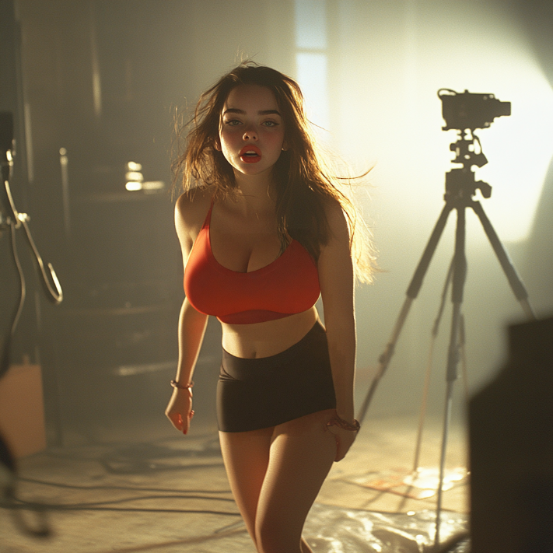
"Umphp!" Steve exclaimed in shock while trying to free himself while, for some reason, his body reacted differently from what he was thinking – his knees weakened, his nipples hardened through the thin material of his outfit, and he felt a growing warmth between his thighs. "Ugh, umhp, what the fuck, dude—" he exclaimed when the man finally freed his lips to only a grabbed his chin tightly and forced him to meet his gaze.
"Listen, bitch," the director hissed, his eyes narrowed and his jaw clenched tightly. "You don't get to talk back to me, understand? I've dealt with bitches like you, and they always learn their lesson one way or another." He stroked Steve's cheek almost lovingly, then he twisted Steve's nipple roughly.
Steve’s eyes widened in shock as the director twisted his nipple roughly, sending a jolt of pain through his body. He gritted his teeth, biting his lower lip, the mixture of agony and arousal threatening to overwhelm him. But just as quickly as the assault began, it stopped. The director’s face broke into a wide grin, and he let go of Steve, who stumbled backward, almost falling over, but the director grabbed him by the arm, helped him regain his balance, and chuckled.
“Alright, folks, let’s take five!” the director announced, his voice loud and commanding. “I need a goddamn break from this diva shit.” He gave Steve a patronizing pat on the cheek and, winking, slapping him hard on the ass as added motivation, causing Steve to yelp involuntarily. “Go powder your nose or whatever the fuck it is you do.”
Steve clenched his fists, glaring daggers at the director as he walked away, but his glare went unnoticed while his nipples hardened, pressing against the tight fabric of his skimpy top, and a warm, unwelcome sensation began to pool between his thighs. 'God, I can’t… I can’t like this,’ he thought, his stomach churning with disgust at himself. He had to get out of here, and fast.
Stumbling slightly on the unfamiliar high heels, Steve adjusted his miniskirt, then reached up, trying to fix the long hair that kept getting in his face, only to feel the silky strands slip through his fingers. With every step, the tight thong dug into his ass uncomfortably, and his breasts bounced and swayed. "Fucking idiot!" he whispered through gritted teeth as he walked toward the exit door. He didn’t know where he was going, but any place would have been better than here.
As he approached the door, a sharp female voice called out, "Where do you think you're going, Lola?!"
Steve turned, irritation flashing across his face as he saw another woman from the set, a tall blonde with a sneer plastered on her face. She wore same miniskirt and tight top, but her figure was much more curvy and her breasts seemed about to burst out her tiny top.

“Ain’t none of your fuckin’ business, blondie!” Steve snapped, shivering when he heard his own words and a voice reminded him a accountant from his factory which if she was angry she always sounded exactly like this, and that usually caused Steve to laugh. "I don’t gotta fuckin’ explain shit to you, got it?" he finished more calmly.
The woman raised an eyebrow, clearly unimpressed. "Oh, really? You gonna run off and leave us all hanging? Not very professional, even for a cheap slut like you."
"Listen, bitch," Steve hissed, glaring at the woman. "I’m not in the mood for your shit, so fuck off!" and with this words he walked to the door and pulled it with both arms. But door opened with such force that Steve staggered backward, his high heels twisting under him. The blonde giggled, shaking her head.
"Alright, alright," She waved her hand dismissively. "go ahead, princess. But don't come crying to me when they kick your ass out for good." as she finished Steve finally opened the door and stepped forward.
'Fuck her. I’ve got bigger problems,' he thought, glaring at the ground as he tried to figure out where the hell he was going.
He managed to find his way to the main office of the plant, his mind racing with the only logical explanation he could come up with. 'If I’m in this girl’s body, then she must be in mine, right?'

As Steve stumbled down the plant corridor in his tight mini skirt and high heels, he could feel the eyes of the workers on him. The clicking of his stiletto heels echoed against the concrete floor, drawing attention from every direction. He cursed under his breath as he tried to walk normally, but it was impossible.
“Hey, sweetheart! Where ya goin’ in such a hurry?” a burly man in a stained overalls called out, laughing.
Steve shot him a glare, gritting his teeth. "Ain’t none of your fuckin’ business, asshole!" he shouted in annoyance.
Another worker, this one younger and wearing a baseball cap, whistled as Steve passed by. "Damn, look at those legs! You workin' the floor today or what?"
"Fuck off, creep!" Steve shouted, feeling how his cheeks flushing with warmth, while his nipples were stiff, erect, and visible through the top, his heart was racing, and there was a strange, unwelcome warmth pooling between his shaking, bruised thighs. 'What the hell is wrong with me?' he thought, trying to ignore the tingling sensation that spread through his body with each catcall.
As Steve neared the entrance of the main building, he spotted a familiar face standing at the security desk: Bob, the guard who had been at the plant for years. Bob was a big guy, usually friendly and always ready to share stories about his kids and fishing trips.
Bob's eyes widened as he saw scantily clad woman stomping toward him with an aggressive stride. His gaze traveled up and down, lingering on hard nipples poking through a tight top. She tried to open checkpoint door with two hands and again. "Whoa there, missy! Where you going in a rush?" he asked, standing up as she approached, blocking her path.
"Hey, Bob! Fuck off, man! I gotta get the hell inside" Steve demanded, rolling his eyes as he tried to push past him. Bob only stepped in front of him and, hands on his hips, looked stern.
"Just what do you think you're doing here dressed like that? This is private property. How the hell did you even get in here? And how do you know my name?" Steve raised his hands and take a couple of steps back, crossing his arms on his chest and tapping one stiletto heel like a nervous girl.
'Great,' Steve thought, annoyed. 'This guy's even dumber than I remember.' But he didn't have time for this. He needed to get in, find his body, and fix this whole mess. "Course I know your name, dipshit. Everyone does. You’re always hangin’ around, ain’t ya?"Everyone knows you. You’re, like, always here, and stuff."
Steve clenched his fists, feeling the unfamiliar sensation of his manicured nails digging into his palms. 'Think, Steve, think,' he told himself, trying to come up with a plan to get past Bob. He knew he couldn't just tell the truth - it would sound insane.

"Look, Bob, I’m from, uh, some special department, yeah?" Steve started, his voice faltering slightly as he tried to come up with something convincing. "We’re checkin’ the plant for safety shit or whatever, so just let me in, okay?"
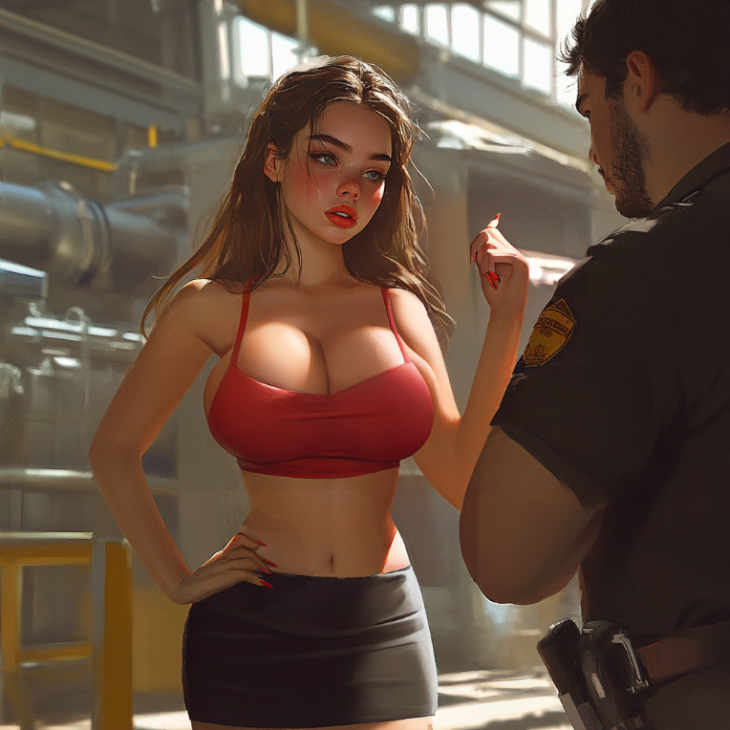
Bob raised an eyebrow, clearly unimpressed. "Special department, huh?" He crossed his arms, his massive frame blocking the door completely. "Yeah, right, lady. You think I'm going to buy that?"
Steve rolled his eyes dramatically, tapping his stiletto-clad foot impatiently. "Oh my fuckin’ God, you don’t even know, alright? I’m supposed to meet Mr. Donovan, yeah? I’m super fuckin’ important, so if you don’t let me through, he’s gonna lose his shit, and then you’re in deep, got it?"
Bob squinted at him, clearly unconvinced. "Super important, huh? Dressed like that? And why would Mr. Donovan meet with someone like you? No offense, lady, but you look more like a slut than an official from an inspecting department." He laughed at his little joke. "You ain't fooling me, missy. I think I better call the police and let them figure out what the hell is going on here."
Panic surged through Steve. 'God, this guy’s more stubborn than a mule!' he thought, desperately trying to think of another lie. "Wait, hold up!" he exclaimed, raising his hands in a placating gesture. "Fine, fine, you got me. I ain’t from no special department, alright? I’m fuckin’ Steve Donovan!"
Bob blinked, staring at Steve with a mixture of disbelief and amusement. "Steve Donovan - the big boss Steve Donovan who's currently in a meeting over in the main office?" He chuckled, shaking his head. "Yeah, right. And I'm the Queen of England. Nice try, lady."
Steve’s frustration boiled over. "No, for real! Swear to God! I’m fuckin’ Steve Donovan! Some weird shit happened, and I, like, swapped bodies with this chick, alright?!"
Bob’s laughter echoed through the hall as he doubled over, clutching his belly. He wiped a tear from his eye, still smiling and shaking his head. "Ha ha ha! Are you high or something, lady? Oh man, I haven't had a laugh like that since the last time I came in early and found Johnny Walker snortin' blow off the toilet in the men's room. Priceless!"
Steve clenched his jaw, feeling his anger rising. "Hey, don’t fuckin’ laugh at me, okay? I’m dead serious!" He stomped his foot, the stiletto heel clicking loudly against the floor. "I gotta get back to my body, and you’re fuckin’ blockin’ me, Bob!"
Steve bit his lip, trying to come up with another lie. But in his panic, he blurted out the truth, "There was some explosion or some shit, and then I in that damn porn studio that’s here today! In this fucked-up body! But that ain’t the point, okay? I gotta get back to my real body!"
Bob’s laughter stopped abruptly, his expression shifting to one of confusion and disgust. "A porn studio? Here? You gotta be kidding me." He turned to his desk, rummaging through a pile of papers. "Let’s see… Oh, for crying out loud, there is a permit here. What the hell is the world coming to?"
"Finally!" Steve said triumphantly, then in a lower voice, "Listen, just forget all this shit, alright? No one saw nothin’, no one heard nothin’, got it, Bob? Just get me past this fuckin’ checkpoint."
Bob frowned, glaring at Steve. "So you're telling me you’re part of some... some smut operation right here in the plant? And you think you’re walk around the factory grounds dressed like that? Not on my watch, lady."
Before Steve could respond, Bob reached for the phone on his desk. "I think it’s time I had a chat with your director. This is just too much." He started dialing a number, his eyes never leaving Steve.
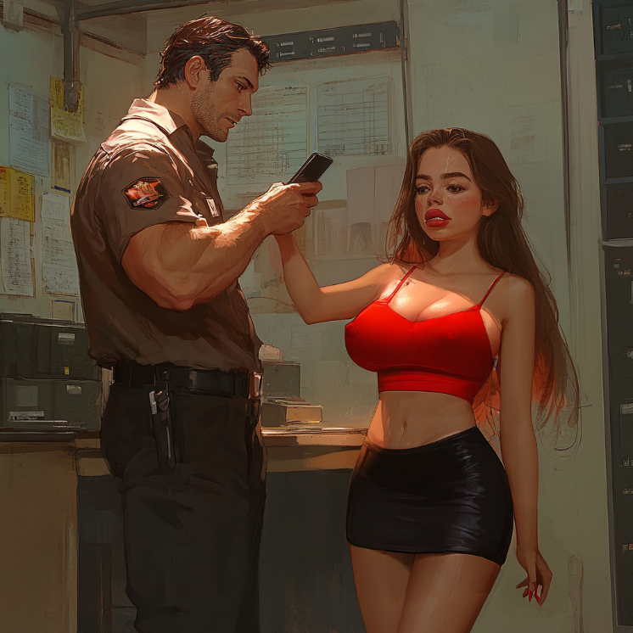
"Wait, no! Bob, please!" Steve stammered, remembering Lola's angry director, stepping forward and trying to grab the phone, but Bob pushed him back effortlessly. "You don’t gotta do this, man! Shit, I’m sorry, alright? You got me! I ain’t Steve" He rambled on, his voice becoming shrill with panic. "I’m fuckin' Lola, alright?! The chick from the studio! Please, don’t call the damn director!"
Bob leaned back, eyeing Steve with suspicion. He took a moment to consider the situation, his eyes trailing over Steve's scantily clad body, the tight skirt clinging to his new curves. Bob finally gave a low chuckle, shaking his head. "You know, Lola, or whoever you are, you’ve got some nerve walking in here dressed like that and spinning all kinds of crazy tales. But I’m a reasonable guy." His grin widened, and he leaned closer, his eyes narrowing. "So, what's it gonna be, little lady?"
Steve felt his stomach drop. 'What the hell is this dumbass talking about?' he thought, his heart pounding in his chest. "What the fuck you mean, Bob?" he asked, forcing himself to sound calm, though his hands were shaking as he clutched the hem of his miniskirt.
Bob leaned in closer, a sly grin spreading across his face. "Simple. You give me a little... something in return, and I’ll forget I ever saw you. How’s that sound, sweetheart?"
Steve’s eyes widened in shock. "W-wait, what?" he stammered, not quite believing his ears. 'No fucking way,' he thought, horrified. 'Is he seriously asking me to…?'
Bob's grin widened, his eyes gleaming with a mix of lust and amusement. "Come on, Lola. Don't play dumb. You know what I mean. You give me a little taste of what you do best, and I’ll pretend I didn’t see anything. A quickie in the utility room, and you’re good to go."
Steve stared at him in disbelief, his mouth dropping open. "You fuckin' kiddin' me, Bob? You just called me a slut, and now you wanna screw me?" he demanded, his voice rising with a mix of anger and disgust.
Bob shrugged, his grin never wavering. "Yeah, I did. And yeah, I do. What can I say? You got me all riled up, Lola. And it’s not like it’s a big deal for you, right? I mean, it’s not like I’m asking you to do anything you haven’t done a million times before, am I right?"
Steve felt his face flush with humiliation, his anger bubbling over. 'This fucking idiot,' he thought, clenching his fists at his sides. 'This moron thinks he can just... just do whatever he wants because he’s a damn security guard?' "Hell no, Bob! No fuckin' way!" he snapped, taking a step forward, his fists clenched at his sides. "You think I’m just gonna let you do that? You’re fuckin' nuts!" His heart pounded in his chest, and he could feel the warmth between his legs again as he thought about it. 'Damn, again?! This is ridiculous!'
Bob just laughed, clearly amused by Steve's outburst. "Oh, come on, Lola," he said, his tone mocking. "Don’t be like that. You scratch my back, I’ll scratch yours. And let’s be honest, sweetheart—you’re not in a position to be picky right now."
Steve glared at him, his mind racing as he tried to come up with a way out of this mess. 'Goddamn it,' he thought, his teeth gritting in frustration. 'I can't believe I'm even considering this.' He needed to get inside, and Bob wasn’t going to let him through unless… unless he did this.
But as Bob stepped closer, his hand reaching out to brush against Steve’s cheek, Steve felt a shiver run through his new body, a sudden wave of unwanted pleasure that made his knees weaken and his breath hitch. "Fuck, no!" he spat, slapping Bob’s hand away. "Get your dirty fuckin' hands off me!"
Bob raised an eyebrow, a smirk playing at the corners of his mouth. "Really, Lola? You sure about that? It doesn’t look to me like you really, uh, mean that. Especially if you want tha-"
"Alright, fine!" Steve cut him off, a frustrated blush coloring his cheeks. "I’ll do it, but only if you let me through after. No bullshit!"
Bob's grin widened, and he stepped to the side, motioning for Steve to follow him. "Deal," he said simply, his voice dripping with satisfaction. "Let's take this to the utility room. More private." He turned and started walking, leaving Steve standing there, his mind reeling with a mix of fury and confusion.
Steve hesitated for a moment, every instinct screaming at him to turn and run, but he knew he didn't have much choice. 'I need to get to my body,' he reminded himself, swallowing hard as he reluctantly followed Bob down the corridor. His legs trembled beneath the high heels, but his pussy was wet and it annoyed him. 'But what exactly does he want?!' suddenly went through Steve's head.
"Hey, what exactly am I supposed to do?" he called out to the guard, who just chuckled in response.
"Nothing that you wouldn't do, sweetheart." he said, glancing over his shoulder. "My wife is such a prude when it comes to anal sex..." his words trailing off.
"Oh, fuckin' hell..." Steve murmured, trying to sound casual. 'Great, fucking great...' Steve thought, clenching his jaw. He had never done anal in any of his girlfriends, preferring pussy and of course never ever though he would have to do that in man's body.
'God, what the fuck am I doing?' he thought, following behind Bob into the darkened utility room. 'I need to get my body back... but this... this is fucking insane.'
Bob, standing in the doorway, grinned as Steve reluctantly stepped into the dimly lit room. The smell of bleach and dust filled the air, and the flickering fluorescent light overhead did little to calm Steve's nerves.
"Alright, sweetheart," Bob said, stepping forward. "Turn around and go to that table over there." He motioned to a rusted metal table next to a line of washing machines.
Steve shot him an irritated glare, trying to suppress the unwelcome rush of arousal he was feeling at the mere thought of doing and walking slowly over to the table. "Fine, whatever..." he grumbled when stopped next to the table and suddenly felt the guard's hand on his shoulders, squeezing lightly and sending a goosebumps all over her new body.
Steve crossed his arms over his chest, turning his delicate face at Bob. "Just get it over with, alright?" he snapped, but Bob sharply turned his head back.

"Face forward," he ordered, and then took Steve's tender little hands and forced them down so that Steve's chest was not covered by them, causing Steven to stumble and gasp as he tried to stay upright.
"What the fuck, Bob?!" Steve hissed angrily, feeling how Bob's hands slowly moved down along his slender body down to Steve's hips, squeezing them roughly through the fabric of the skirt.
"Stay still, Lola. You've got one hell of a body." he mumbled while breathing hotly down the back of her neck. His hands moved to grab a handful of Steve's breasts. "Goddamn, these tits are so fuckin' perfect."
Steve bit his lip, struggling to keep his balance with Bob's rough groping. He was beginning to regret his decision as the big, hairy security guard leaned his bodyweight forward, pressing him harder against the cold, metallic surface of the metal table. He instinctively placed his hands on the cold table to lean on them, seeing the long nails of his girlish hands. 'Goddammit. This is not happening!' Steve bit his lip, a rush of anger and fear mixing with his arousal.
"That's it, Lola," Bob whispered, his hands sliding down to Steve’s waist, slowly lifting his miniskirt to reveal Steve's soft white ass, covered by a barely-there red lace thong. 'Fuck, I can't believe this is happening,' he thought, squeezing his eyes shut as Bob's fingers hooked into the waistband of his thong and pulled it down, exposing his bare ass to the cold air.
"Look at that," Bob said with a low chuckle, his hand sliding over Steve's smooth skin, squeezing his cheeks. "Nice and tight, just how I like it." Steve swallowed hard, his face burning with shame. But his body were already ready and his thoughts began to blur and lose their meaning. "I like you, doll." the guard added and pulled Steve's hips up, pressing his crotch against him, so he felt Bob's dick through his clothes.
"Oh shit," Steve whimpered, shivering with a rush of unfamiliar sensations. A strange warmth was radiating through his body, pooling in his thighs, and he struggled to stay upright as Bob started to unbutton quickly his belt. 'Jesus Christ... He's not serious, is he? He's not really going to fuck me, is he?'
"Say it," Bob commanded. "Say you want it, Lola."
Bob's fingers paused at Steve's entrance, his touch light and teasing. "Tell me, Lola," he whispered, leaning over Steve's back, his lips brushing against Steve's ear. "Tell me you want it."
Steve's eyes snapped open, his face flushing with anger and humiliation. "Go fuck yourself," he spat, his voice trembling with a mix of rage and disgust.
Bob chuckled, his fingers pressing a little harder against Steve's entrance. "Come on, Lola," he coaxed, his tone patronizing. "I know you like it. Just say it. Say you're a dirty little slut, and you want it."

Steve's stomach churned, his mind screaming at him to resist, to fight back. But another part of his mind whispered traitorously, telling him it would be easier, better. "No, no... fuck, no..." he groaned as Bob's finger slipped inside him. 'Oh, shit, that's not supposed to... not supposed to... not like that...' He gasped, a wave of unwanted pleasure washing over him as Bob pressed his finger deeper. "Fuck, no... stop... I don’t want this shit..." Steve pleaded, his legs buckling under him.
"Say it, Lola," Bob repeated, his voice firmer this time. "Or maybe I'll just leave you here, all wet and needy, with no one to fuck that little dirty slut hole of yours. Is that what you want?"

'Leave me? No!' thoughts were confused in his sweet head and it was already impossible to distinguish them, but he definitely felt that it was what Bob said.
“Say it, Lola. Say you’re a dirty little slut who wants it,” Bob’s voice was insistent, his breath hot against Steve’s ear. Steve couldn't think, couldn't breathe "and then you will get everything, or I'll leave you here," he whispered again, squeezing Steven's breast with his free hand. Steve moaned helplessly, his hands slipping across the metal surface of the table, as his knees buckled with his pleasure.
"Alright, alright! I’m a dirty little slut, a dirty fuckin' whore..." he hissed through gritted teeth, closing his eyes tightly.
"Good girl," Bob chuckled, his fingers sliding deeper inside Steve, making him gasp. "Now tell me you want it. Tell me you want my cock inside you."
"I... I want it," he murmured, his voice thick with shame.
"What was that?" Bob teased, his fingers moving more insistently, pressing against a spot inside Steve that made his knees buckle. "I didn't hear you."
"I fuckin' want it!" Steve gasped, his voice louder this time, desperate to make it stop, even as he felt his body aching for more. "I want your cock inside me, just do it!"
Bob grinned, pulling his fingers out of Steve. "That's more like it," he said, positioning himself behind Steve. He pulled Steve's hips up higher, forcing him to arch his back, and then, without warning, he thrust into Steve's tight entrance, making him moan loudly.
"That's it," Bob grunted, grabbing Steve's hips and pulling him back onto his cock with each thrust. "Tell me how much you love it. Tell me what a dirty slut you are."
Steve's moans filled the air, his mind now filled only with lust as he rocked back, matching each of Bob's thrusts with his own. "Yes, I... I l-love it," he whimpered, his eyes rolling back in his head. "God, I’m so fuckin’ dirty! Fuck me! Fuck me, Bob! God, I’m your dirty little slut!"
"Beg for it, Lola," Bob commanded, pulling his cock out of Steve and slapping it across Steve's ass. "Beg me for more."
Steve let out a sob of pure desire, his body shaking with need. "No, please, don’t fuckin' tease," he whined, struggling to maintain his balance, his knees buckling. "Please, Bob, I want it! I’m begging you, I want your cock back inside me. Fill your dirty slut with it! Please, just fuck me already!"
With a snort Bob bent over and pushed inside him again. "That's a good little slut, Lola. Moan for me. Beg for my cock, Lola!" he snapped as he thrust into her. "Beg me!"

Just as Steve thought he couldn't take any more, there was a loud knock on the utility room door, followed by a familiar voice. "Hey, what the fuck's going on in there?"
Steve's eyes flew open, his body tensing as he recognized the voice. 'No, it can't be!' he thought, his heart pounding in his chest. 'Not now!'
Before he could react, the door burst open, and Steve now definitely recognized his own former voice. "What the fuck is going on here?" Steve's former self shouted, glaring at the scene before him.
Bob quickly pulled out his cock, causing Steve to gasp involuntarily as it slid out, and quickly began stuffing it back into his pants, all the while eyeing his boss nervously. "M-Mr. Donovan! What a pleasant surprise," Bob stammered, obviously caught off-guard.
Steve, still standing bent over the table with his panties and skirt down at his ankles, looked over his shoulder, shocked by the sudden intrusion. It was him, his body, which was now looking at his bare ass with an angry expression on its face. "Uh, hi... uh, me" he stammered, tugging frantically at his skirt in a vain attempt to cover his nudity.
His former self, now standing in the doorway with an expression of pure anger and disgust, glared at Steve, who tried to awkwardly put on a skirt while the thong was still below the knees and his vagina was literally leaking juice.
"What the fuck is this?!" Steve's former body, now inhabited by Lola, shouted. Her - no, his - voice, strong and commanding, filled the small utility room. "Who the hell are you, and what the fuck are you doing in here, slut?"
Steve felt his cheeks burn with humiliation and rage. 'God, I hate hearing my voice like that,' he thought, biting his lip as he tried to steady himself. His body still quaked with need, and his clit was still painfully hard and thong only irritated it. "I’m fuckin' Steve, alright?" he stammered, his voice shaky, still trying to gather his thoughts. "You’re the one who’s full of shit! You’re not me, you’re that fuckin’ chick!"
Lola, narrowed its eyes at Steve. "What the fuck are you talking about? You must be high off your ass. I'm Steve Donovan, the boss of this damn factory. And you..." he gestured at Steve's current body with a wave of his hand, "...are my filthy whore."
Steve, still shaking from the aftereffects of the rough encounter with Bob, tried to steady his breath and gather his thoughts. His lips trembled, and he could barely get the words out. “No, you don’t fuckin’ get it!” he stammered. “I’m the real Steve! This slutty body ain’t me! You’re in my fuckin’ body, you idiot!”

Before Steve could finish, Bob interrupted, trying to defuse the situation. “Hey, hey, Mr. Donovan, this is just a misunderstanding, alright? Don’t tell my wife about this. She’s just some crazy chick from the studio or something. Probably high as a kite. Just… don’t pay her any mind, okay?”
Lola eyed Bob and Steve suspiciously. He took a step closer, his arms crossed over his chest, and a scowl forming on his face. "I don’t care who the hell she is," Lola growled, his voice dripping with contempt. "Get her the fuck out of here. And Bob, if I ever catch you doing something like this again, I swear to God I’ll have your ass fired on the spot."
Steve, still reeling from the shock of seeing his own body acting like a jerk, stumbled back a step, his eyes wide. "Wait, you don't fuckin' get it! You're in my goddamn body! This is fuckin' nuts! This is just totally insane!" he pleaded with hightened pitch "I’m the real Steve Donovan, not some fuckin' slut! I’m you!"
Lola rolled his eyes and waved a hand dismissively. "You expect me to believe that bullshit story, coming from a tramp like you? You sound like a total nutcase." he spat, looking Steve up and down, a sneer forming on his face. "Enough of this bullshit. Bob, get her out of here. I’ve got better things to do than deal with some crazy whore who thinks she’s me."
Bob, clearly not wanting to push his luck any further, nodded quickly and grabbed Steve by the arm. "Alright, alright, come on, sweetheart," he muttered, dragging Steve toward the door. "Let’s get you out of here before you cause any more trouble."
"No! Wait!" Steve yelled, struggling against Bob’s grip. "I ain’t leaving till you listen! I can prove I’m the real Steve! I know shit only Steve would know!"
Lola in Steve's body stopped in his tracks, narrowing his eyes suspiciously at Steve. "You talk like some trashy street girl, even if i were you i definitely wouldn't use that stupid manner of speech." Lola's voice sounded irritated. "But still, go ahead. Prove it to me, I'm curious to hear your story."
Bob looked at Steve with a mix of pity and disbelief, his eyes narrowing slightly. "You sure you’re not high, miss? Maybe you hit your-"
"Shut up, Bob!" both Stve and Lola interrupted, looking at him with disdain. Bob backed off, raising his hands defensively. "Fine, fine," he grumbled, then stepped back, giving them space.
"I ain’t fuckin' high, alright? I don’t know why I sound like some dumb street slut, probably ’cause I’m stuck in this fuckin’ body with all these damn sensations that... fuck! Whatever, it doesn’t matter." Steve paused, shaking his head. "And the truth, yeah, the truth about me, fuck, fine, I’ll say somethin’ only I’d know! What about when I cheated on taxes? With that offshore account in the Cayman Islands? Nobody knows about that except Steve! I’m tellin’ you, I’m really fuckin' Steven!" Steve exclaimed, his eyes pleading for recognition.


Lola hesitated for a moment, a flicker of doubt passing through his eyes. But then he shook his head, the scowl returning to his face. "You're full of shit," he growled. "I don’t know how you found out about that, but it doesn’t matter. Get your little ass out of here before I have you arrested for trespassing and prostitution!"
Steve's heart sank as he realized that nothing he said would convince Lola. "But—"
"No more, slut," Lola interrupted, his tone icy. "Bob, call the damn cops."

--------------
5th District Police Station
At the police station, Steve sat, shivering with disgust and anger. He cringed at the memory of what he had done in that utility room, how he had screamed and begged to be called a whore, how he had pleaded for more, how he had come harder than he ever had. 'God, that was worse than when I found myself in this damn body!' he thought, his face flushing with shame.
His body, however, reacted differently. Even now, sitting on a cold, hard bench in the holding area, he could feel a strange, unwanted warmth pooling between his thighs when he remembered the events that had taken place earlier. 'Goddamn it, not now!' he thought, squeezing his legs together in an attempt to quell the sensation.
The policemen in the station eyed him with a mixture of curiosity and amusement, their gazes lingering on his scantily clad body. Steve tugged down his miniskirt, which kept creeping up his thighs, and crossed his arms over his breasts, which still felt foreign and unfamiliar to him.
Eventually, a burly officer approached him, holding a clipboard and a stern expression. “Name?” officer asked, his eyes fixed on Steve's exposed cleavage - Steve's crossed hands on his chest only served to make them look even bigger, especially from officer's viewpoint.
"Uh, Steve Donovan" Steve muttered, shifting nervously in his seat.
The officer looked at him with a raised eyebrow, clearly unimpressed. "Is that so? You don’t look like any Steven Donovan I’ve ever seen," he said, his voice laced with skepticism. "Let’s try this again, sweetheart. Name?"
Steve bit his lip, feeling the sweat start to bead on his forehead. 'Goddammit,' he thought, trying to figure out a way to explain the situation without sounding completely insane. "I already told you! I’m Steve Donovan, alright? Some weird shit happened, and now I’m stuck in this body, but I’m still Steve!"
The officer stared at him for a moment, then shook his head, his patience clearly wearing thin. "Alright, enough with the bullshit," he snapped, flipping a page on his clipboard. "You keep talking crazy like that, I’ll have no choice but to get you evaluated by the psych ward. So, I’ll ask you one last time: What’s your name?"
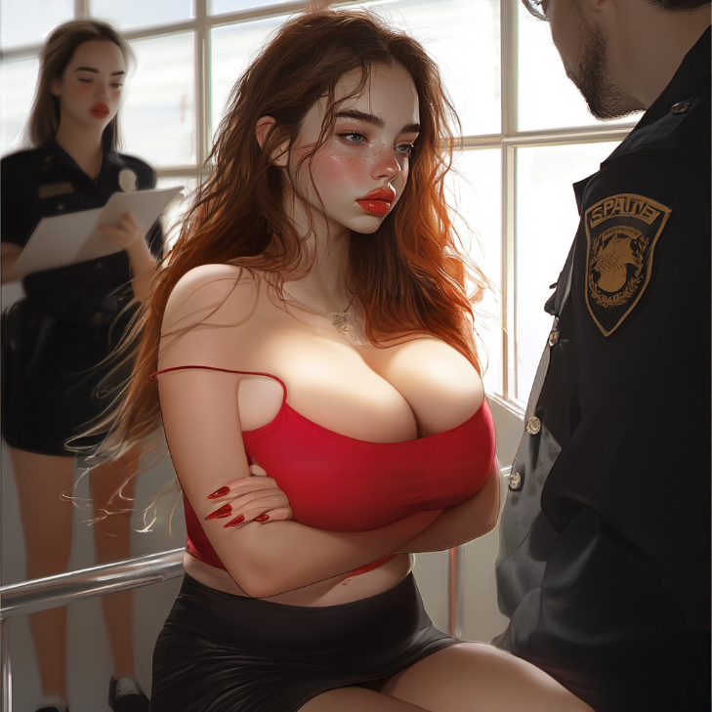
Steve's heart pounded in his chest, the panic rising as he realized the officer was dead serious. He couldn’t afford to be locked up in a mental hospital; he needed to get out of here and figure out how to get his life back. He needed to play along.
"Alright, fine," he stammered, raising his hands in a gesture of surrender. "I’m sorry, officer. My name’s… Lola. Yeah, Lola" he muttered, cringing at the sound of that name on his lips.
The officer sighed, rolling his eyes as he began to scribble on his clipboard. "Figures. Just another crazy whore," he muttered under his breath, shaking his head. "Alright, Lola, I'm gonna need to take your fingerprints. Let's get this over with."
Steve gritted his teeth, resisting the urge to snap back. 'Goddammit, this is fucking humiliating,' he thought, his hands with manicured fingernails shaking as the officer guided his fingers onto the ink pad and then pressed them onto the fingerprint card. The cold, slick ink on his fingertips felt strange, sending a shiver down his spine. 'How the hell did I end up here?'
After finishing the fingerprints, the officer turned back to Steve with a look of mild annoyance. "Alright, sit tight," he said, his tone dismissive. "We’re gonna run these through the system, see if we can't figure out who you really are."
A few minutes later, the officer returned, holding a printout in his hand and looking rather smug. "Well, well, looks like we've got ourselves a match," he said, waving the paper in front of Steve. "Jane Turner. Age 27. Born in Las Vegas, Nevada. Ring any bells, sweetheart?"
Steve’s heart sank as he heard the name, his face flushing with humiliation. 'Jane Turner? Goddamn it, that’s her real name?' he thought, biting his lip.
The officer continued, reading off the sheet. "Let's see here... Dropped out of high school at 16, got arrested for shoplifting at 18. Started working as a stripper, then moved into prostitution. Quite the resume you've got here, Jane." He glanced up at Steve, smirking. "Or should I say Lola Lustful? That’s your stage name, right?"
"You’re wrong," Steve snapped, his voice high-pitched and laced with anger. "I’m not her—I’m someone else, okay? I ain’t no cheap slut who gets arrested for—" He stopped mid-sentence, realizing that he was only digging himself in deeper.
The officer raised an eyebrow, clearly not buying any of it. "Sure you’re not, sweetheart," he said, dripping with sarcasm. "But your fingerprints don’t lie, and this little printout here says otherwise. So, why don’t you save us both some time and tell me why you were trespassing at the factory? And while you're at it, you can also explain why you were prostituting yourself there. Mr. Donovan, the plant manager, seems pretty convinced that's what you were up to."
Steve’s face burned with anger and humiliation. 'That fucking asshole,' he thought, gritting his teeth. 'Lying son of a bitch.' But he knew there was no way he could tell the truth without sounding completely insane.
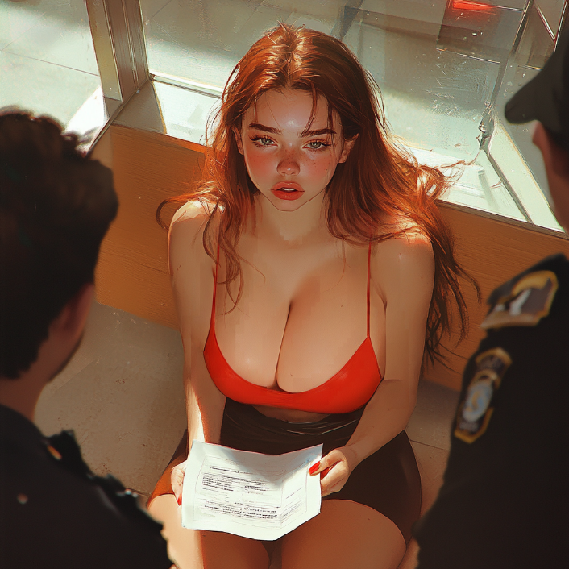
"Look, it’s all a big misunderstanding, okay?" Steve said, forcing himself to sound calm. "I wasn’t prostituting or anything. It was a work thing, and then everything went to shit, and now I’m here. I swear I wasn’t doing anything illegal!" His voice trembled slightly as he finished, knowing full well how lame the excuse sounded.
The officer stared at him for a moment, his eyes looked appraisingly at Steve's outfit, then snorted, clearly unimpressed. "Right. A work thing. Sure," he said flatly, flipping the page on his clipboard. "And what kind of 'work' would that be, exactly? Dressing up like a hooker and showing up at an industrial park?"
Steve swallowed hard, his mind racing. "Look, it’s not what you think... I ain’t no prostitute. I was just trying to, you know..."
The officer chuckled, shaking his head. "Sure thing, doll," he said, clearly not convinced. "But until we get this all sorted out, you’re staying right here. And if I find out you’re lying, well, let’s just say things are going to get a lot worse for you. So I’d start telling the truth if I were you."
At that moment, the door to the holding area creaked open, and a tall, broad-shouldered man in a leather jacket stepped in. His slicked-back hair and dark sunglasses gave him an air of arrogant confidence that immediately set Steve’s teeth on edge. The officer looked up and raised an eyebrow in recognition.
"Well, well, look who’s here," the officer muttered, crossing his arms over his chest. "Mr. Randy Steele himself. What brings you down here, Randy?"
The man removed his sunglasses and smirked, his cold blue eyes sweeping over Steve’s scantily clad form with a look of casual disdain. "Came to pick up my girl," he said coolly, jerking his thumb in Steve’s direction. "Heard she got herself into a bit of trouble."
Steve’s stomach dropped as he recognized the man—Randy Steele, the same asshole director who had been at the porn shoot earlier. 'Goddamn it, not this guy again,' Steve thought, gritting his teeth in frustration.
Randy chuckled, shaking his head. "Nothing major. Just a little misunderstanding, you know how it is." He waved his hand dismissively. "She was supposed to be on set, but she got a little carried away with... whatever. You know how these girls can be." He shot Steve a pointed look, his lips curling into a smirk.
Steve narrowed his eyes at Randy, struggling to suppress his growing anger. 'Fuck this guy. He thinks he's so fucking cool, talking about me like I'm not even here.' He crossed his arms over his chest, glaring at Randy defiantly.
The officer sighed, clearly not entirely convinced, but seemingly content to let it slide. "Alright, Randy," he said, shaking his head. "But you better keep a close eye on her. If I see her around here again, there’s gonna be hell to pay."
Randy nodded, his smirk never faltering. "Don’t worry, officer. I’ll take good care of her." He turned to Steve, his eyes narrowing. "Come on, Lola. Let’s get out of here."

Steve gritted his teeth, but said nothing. He was out of options. Steve forced himself to stand, his legs trembling slightly as he followed Randy out of the police station and into the parking lot. 'Goddammit, look at me,' he thought, clenching his fists at his sides. I look like some cheap whore following this douchebag around,'
Randy opened the passenger door of a sleek black sports car and motioned for Steve to get in. "Come on, Lola, my princess," he said with obvious sarcasm while Steve standing and not moving, thinking that he definitely was not getting in this jerk's car. "Get in the car. We've got a lot to talk about." Randy added in a more commanding tone, slapping Steve's ass, causing him to stumble into the passenger seat with a loud gasp and the sound of high heels clicking.
The door slammed shut with a loud thud, he barely managed to remove his legs so as not to hit the car door and now found himself sitting on a plush leather seat in this jerk's car. Randy climbed into the driver’s seat, slamming the keys into the ignition.
The car roared to life, and for a few moments, there was an uncomfortable silence as he pulled out of the parking lot. Steve stared out the window, his thoughts racing as he tried to process everything that had happened. 'How the fuck did this happen?' he thought, turned his gaze down to his slender thighs, to his miniskirt that barely covered his pussy and to his high-heeled boots, he felt like scratching between his ass cheeks because of this damn thong. His breasts are swaying softly from side to side with every movement of the car as Randy drove.
Finally, Randy broke the silence, his voice cold and dripping with contempt. "What the fuck were you thinking, Lola?" he spat, glancing at Steve out of the corner of his eye. "You think you can just leave the set, have a fucking sex marathon with some factory employees, and then get yourself arrested like some dumb whore? What the hell is wrong with you?"
“Leaving the set like that? I got a call from Donovan, and he said you were off having some kind of sex marathon with the employees or something. And now you’re at the fucking police station? Are you trying to get us both in deep shit?”
Steve turned to glare at Randy, his anger bubbling over. “Listen, asshole,” he spat, his voice high-pitched and full of fury. “I ain’t fuckin' Lola, got it? And I damn sure wasn’t screwin’ around with anyone! I’m Steve, for fuck’s sake! Call me that again, and—”
Randy laughed, cutting him off with a dismissive wave of his hand. “Oh, come on, Lola. Don’t be like that. I know your real name is Jane, but you’re always gonna be Lola to me." he grinned. "It suits you."
"Shut the fuck up! I told you, I ain’t Lola! That name’s dumb as hell!" Steve protested, but Randy only rolled his eyes, as his hand suddenly squeezed Steve's thigh tightly. Steve squealed softly, surprised and disgusted at the man's touch, but felt again this warmth between his legs and a blush on his cheeks. 'Jesus fucking Christ. Again?' he thought, trying to ignore the sensation.

Randy smirked, keeping his hand on Steve's thigh as he continued to drive. "Alright, alright, I get it, Jane, or whatever the hell you want to be called," he said in a mocking tone. "Let's just calm down, okay? I'm sorry for yelling at you back there, but you gotta understand the position you put me in. I had to come all the way down to the police station to bail you out. Do you know how embarrassing that is for me?"
Steve turned his head away, staring out the window and crossing his arms over his chest in a huff. "Whatever, okay? I didn’t ask for your help. I could’ve figured shit out on my own" he muttered, refusing to admit that he didn't know how he would've gotten out of the police station without Randy's help.
Randy let out a sarcastic laugh. "Yeah, right, but you know what?" Randy continued, his voice low and menacing. "You’re gonna start showing me a little more respect, too. You think I don’t know what you’re doing? Trying to pull that ‘I’m not Lola’ crap? You think that’s gonna fly with me? I’ve had enough of your diva shit. You’re lucky I’m even putting up with you at this point."
Steve opened his mouth to retort, but Randy's grip on his thigh tightened, silencing him. "Look, Jane, you need to thank your boyfriend, you can say your savior for today. The least you could do is show a little gratitude."
Steve gritted his teeth, his anger bubbling beneath the surface. "Gratitude?" he scoffed, his voice dripping with sarcasm. "For what? For treatin’ me like some piece of meat? For bein’ a total fuckin’ jerk? And I ain’t Jane, okay? I’m a man!"
Randy’s eyes flashed with anger as he shot a quick glance at Steve. "Oh, really?" he sneered. "You think so? Look down, doll face." Randy grabbed Steve's slim, delicate hand and pulled it to his own groin area. "If you are a man, then you know how good it is when such a soft, feminine palm is squeezing your cock."
"Hey! Stop it!" Steve tried to jerk his hand back, but Randy squeezed tighter and didn't let him escape. "I ain’t doin’ that! You’re outta your fuckin' mind!" he protested, despite his nipples, already painfully hard, and his vagina leaking. 'Goddammit, my damn body...'
Randy laughed, clearly amused by his reaction. "You've really changed... or maybe you're still playing dumb?" he teased. "But it doesn't matter. You still need to learn to do what you're told. So here's the deal, Lola. You're gonna do what I say, when I say it. And in return, I won't send you back to prison. How does that sound, hmm?"
"You can’t be serious!" Steve cried out, his eyes widening in horror. "You can’t be serious! I ain’t your whore! I’m Steve Don-"
"Yes, yes, we know already that you're Steve," Randy cut him off. "But I'm serious, sweetie. If you don't wanna end up back at the station, you'll do whatever I say, when I say it. You saw today what connections I have, even if you really aren't Jane. Got it?"
Steve opened his mouth to respond, but nothing came out. 'He's really got me here,' he thought, relaxing his hand and stopping the fight against Randy's grip.

"Good girl," Randy smirked. "See, this isn't so hard, is it?"
Steve blushed furiously, his hand slipping to Randy's belt as he slowly started to unzip his fly. 'Goddammit,' he cursed to himself. 'I can't believe I'm actually doing this. Again?!'
Randy watched with satisfaction as Steve fumbled with his fly, his fingers finally managing to pull down Randy's zipper with difficulty due to his long, manicured nails. "That's my girl," he murmured, squeezing Steve's soft, smooth cheek gently.
Without noticing, Steve smiled a little at this praise, then blinked, feeling disgusted with himself and his wet cunt, and looked at Randy's face. "Like, don't touch me, asshole! This is, like, totally gross."
"Don’t lie to me," he growled. "I saw you smile at it, and that's only a good sign." Randy put a finger to his cheek, stroking Steve's soft, delicate skin gently, then slid his finger down along his plump lips, causing Steve's mouth to part involuntarily with a soft moan and allowing Randy's finger to slip inside. "Mmm... See, you're loving it," he chuckled, slipping his finger in and out of Steve's mouth slowly and teasingly, while his hand already squeezed Randy's dick. "You are the same bitch as before," Randy said.
"Sphuhpt phup," Steve snapped, as if he suddenly woke up, his eyes widening at this, realizing what exactly he was doing. His lips closed tightly around Randy's finger as he tried to pull it out of his mouth without much success. "Mpfh!"
"Ah ah, don't bite," Randy warned in low and teasing voice as he felt Steve’s teeth lightly graze his finger. Steve's mouth tasted like salty sweat and something metallic, and he couldn't help but feel a mixture of disgust and confusion as Randy’s finger moved in and out, grazing his tongue. 'Fuck, why does this feel so... weirdly good?' he thought, trying to resist the urge to suck harder.
'Goddamn it,' he thought, feeling the heat pooling between his thighs. Randy's hand was no longer holding his tender wrist, so he could easily remove his small palm from the cock, but instead, he squeezed it harder and stroked it faster.
"Easy, tiger," Randy cooed, as Steve continued to suck on his finger, his hand gripping his dick tightly. "It's not a race, sweetie."
"Mpfh... Phup yhuph, 'assuh," Steve mumbled, trying to protest his own behavior. 'Fuck, what the hell am I doing?' he thought, disgusted with himself but unable to stop. His delicate palm loosened the grip on the cock slightly, moving at a less hurried pace, but still enough to send jolts of pleasure through his own body.

"That's better, Keep it up, Lola. You’re making me proud." Steve wanted to shout at him, to curse him out, but all that came out was a moan around Randy’s finger. The car's interior was filled with the wet sounds of Steve’s mouth working on Randy’s finger and the slick slide of his hand stroking Randy’s cock.
As the car sped through the city streets, the tension inside the vehicle grew thicker. Steve's mind was a whirlwind of anger, humiliation, and unwanted arousal. 'Goddammit, why won't he just cum already?' he thought bitterly, hating every minute of this and in same time enjoying the feelings that flowed through him. 'I can't believe I'm actually—'
But just as he was about to lose himself in the rhythm, Randy pulled his finger out of Steve's mouth, as he instinctively leaned forward, his lips seeking out Randy’s finger again, but he froze mid-motion, horrified by his own reaction, while his cum leaked onto Steve's delicate fingers. He immediately straightened his back, pulled his hand from Randy's cock and squealed.
“I… I didn’t fuckin’ want this! This is all your fault!” Steve shouted high-pitched and in anger, quickly wiped his hand on the seat, disgusted by his own actions, by this hot sticky liquid. 'Why am I so fuckin' horny? What the fuck is wrong with me?' he thought, biting his lip as he tried to regain control of his thoughts.
Randy just chuckled, a smug grin plastered across his face as he zipped up his pants. "Sure, sure, whatever you say, Lola. But you know what? You were pretty damn eager for someone who ‘didn’t want it.’" He shot her a knowing look pulling the car over to the curb.
Steve glared at him, crossing his arms over his chest. “Fuck off, Randy! I told you, I ain’t fuckin’ Lola, alright? I don't give a fuck how many times you say that dumb-ass name!" he snapped, his voice trembling with rage and shame. He hated the way Randy looked at him, like he was just some cheap piece of ass.
Randy sighed, shaking his head. “Whatever you say, Jane. But we’re here now, so you better get out and go home. I ain’t got all day to deal with your crazy ass.”
Steve blinked, looking around for the first time since they’d pulled over. He realized he didn’t recognize the neighborhood at all. Tall, run-down buildings loomed overhead, graffiti covering the walls. The street was empty, save for a few scattered trash bins and the occasional rat scurrying across the pavement. “Wait… where the hell are we?” he muttered, more to himself than to Randy.

Randy shot him a puzzled look. “You serious, Lola? This is your place. You don’t remember?” He raised an eyebrow, clearly skeptical. “Guess you must’ve hit your head or something. Anyway, your apartment’s up there, second floor. Better get going."
Steve frowned, looking up at the apartment building with a mix of confusion and frustration. ‘What the fuck? This dump? No way I live in a shithole like this!'
Randy watched him for a moment, his expression unreadable. “You know, Jane,” he said slowly, his voice taking on a more serious tone, “if you’re not her, like you keep saying… you might want to figure out who you are real quick. Cause this ain’t the kind of place where you want to get lost. Got it?"
Randy’s words hung in the air while Steve, or rather Jane, hesitated for a moment, looking around. He shifted uncomfortably in his seat, the wetness between his thighs reminding him of what he'd just done.
Randy gave him a final smirk before nodding towards the apartment building. “Alright, Lola. Go on. But remember what I said—don’t fuck with me, or you’ll regret it. Tomorrow at 5 o'clock" He spat this out with sarcasm and, after a moment's hesitation, added "Studio 9 of the MGM Grand. West Grand Boulevard between Jefferson and Warren"
Steve rolled his eyes and got out of the car with a loud sigh. His gaze fell involuntarily on Randy before he slammed the car door, he still felt of Randy's hands on him, the taste of his finger still lingering in his mouth, and thoughts of being fucked by him flashed through his mind, which only increased his rage.
“Fuck you, Randy,” he muttered under his breath, tugging his miniskirt down instinctively, though it did little to cover his ass, while car tires squealed and Randy sped away into the night, leaving Steve standing alone on the sidewalk.
'Goddammit, this is so fucked up,' Steve thought, wrapping his arms around himself, trying to ignore the way his breasts pressed together with the motion. He glanced around, hoping no one was watching. The street was mostly empty, save for a few people lurking in the shadows. 'What if… what if I'm actually... Fuck, what are you thinking?! Steve, pull yourself together!'
He hurried towards the entrance of the building, his hips swaying awkwardly with each step, his heels clicking loudly against the pavement. 'Fuck this body, fuck everything!' he thought, feeling the thong dig into his skin with every movement. He could feel the eyes of the men around him watching as he passed by. He tugged his skirt down as best as he could ‘Fucking creeps,’ he thought, his skin crawling as he quickened his pace.
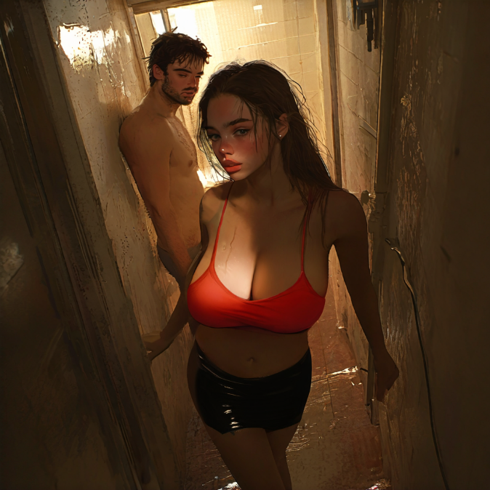
Just as he reached the entrance, the door to the neighboring apartment swung open, and a heavyset man with greasy hair and a stained wife-beater stepped out, holding a beer can. His eyes widened when he saw Steve, and a slow grin spread across his face. “Hey, Lola baby!" the man drawled, his gaze lingering on Steve’s cleavage. “Ain't you a sight for sore eyes? Looking mighty fine this evening, honey."
Steve scowled and brushed past him, trying not to make eye contact. 'Jesus, this guy reeks of booze and cheap cigarettes. Fucking disgusting.'
The man chuckled, his eyes roaming over Steve’s body. “Whoa, easy there, girlie. Just makin' conversation. You don’t gotta be so uptight. But I guess you had a rough day, huh? Must be tough workin' the streets.”
Steve felt a wave of disgust wash over him, his cheeks flushing with anger. 'Goddamn perv. If I were in my body, then...' he clenched his hands into fists, trying to open the heavy door, but man's hand suddenly appeared above his palm and easily opened it for Steve "You are welcome," man's voice sounded a little too close, his heavy, beery breath almost touching Steve's neck.
"Fuck you," Steve spat out, stepping through the doorway into a dark, narrow hallway. ‘Christ, what a dump,’ he thought, looking around at the cracked walls and peeling paint. He made his way up the creaky stairs, the sound echoing in the empty hallway. ‘Second floor, he said,’ Steve reminded himself, glancing at the faded numbers on the apartment doors.
'Fuck, which one is it?' he wondered, glancing around for any sign of familiarity. But then he saw it: a door with a faded, peeling number 23. Something about it felt right, and he stepped forward, reaching for the doorknob. Something told him to look under the rug and he bent over, feeling how his boobs hung down, while he leaned on the wall with one hand for balance, his skirt sliding up his thighs, exposing his ass a little. Steve groaned as he saw the spare key taped under the doormat and stood.

Taking a deep breath, he unlocked the door and pushed it open, stepping inside the small apartment. It was small and cramped, with peeling wallpaper and walls were adorned with posters of half-naked men and women in various states of undress, and there was a large, framed photo of “Lola” hanging above the torn—a bed that was unmade, the sheets tangled and stained with who-knows-what.. A tiny kitchenette was tucked into one corner, and a sagging couch sat against the opposite wall, its cushions torn and frayed. ‘Jesus, what a dump,’ he thought, wrinkling his nose in disgust.
“Holy shit,” Steve muttered under his breath, feeling a knot form in his stomach. ‘This place is a fuckin’ nightmare,’ he thought, his mind reeling as he tried to process what he was seeing. ‘No wonder this chick ended up doing porn…’
His eyes wandered to a small table in the corner, cluttered with makeup, jewelry, and an assortment of brightly colored sex toys. Steve's gaze lingered on the array of toys, a mix of disgust and intrigue washing over him. 'Jesus, look at all this crap…' He bit his lip, his eyes narrowing as he quickly looked away. He could feel the warmth between his legs intensify, his thighs pressing together involuntarily as he fought to keep control. ‘No, fuck that, I ain’t doin’ this shit,’ he told himself, clenching his fists.
Forcing himself to look away, Steve abruptly kicked off the ridiculous heels he was wearing, wincing as his feet hit the cold, dirty floor. “Goddamn stupid shoes,” he muttered, wiggling his toes. The sudden relief was almost euphoric. His eyes caught his reflection in a cracked, dirty mirror hanging on the wall. He stared at the image for a moment, his breath catching in his throat as he took in the sight of the woman staring back at him.
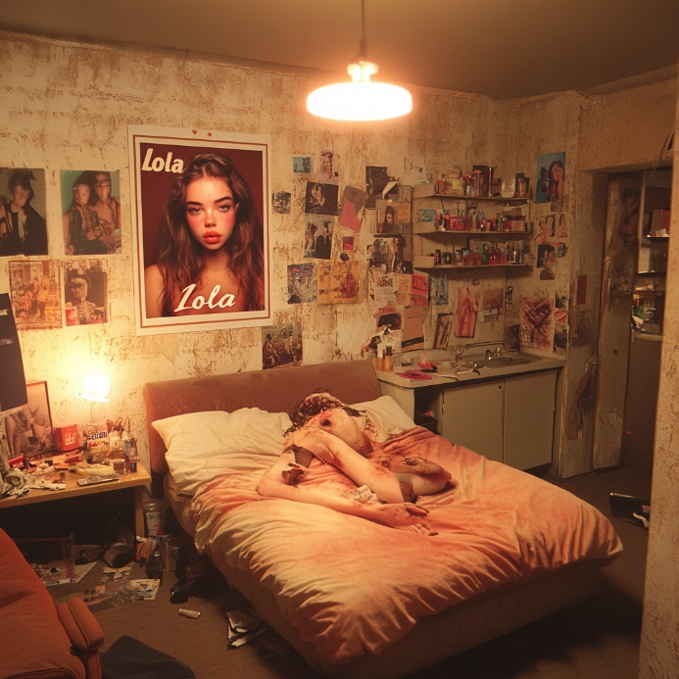
The woman in the mirror looked back with wide, fearful eyes, her lips full and pouty, slightly parted in shock. Long, tousled auburn hair framed a delicate face that was beautiful but unfamiliar and with a ton of cosmetics. The tight mini-skirt clung to her shapely hips and round ass, and the top barely contained her breasts, which still heaved from his hurried breath.
“Jesus Christ,” Steve muttered, stepping closer to the mirror, his voice barely a whisper as he reached out to touch the mirror, his fingers trembling slightly as they brushed against the glass then moved to touch his face. The delicate fingers, adorned with long, manicured nails, felt foreign as they brushed against his skin. 'What the fuck have I become?'
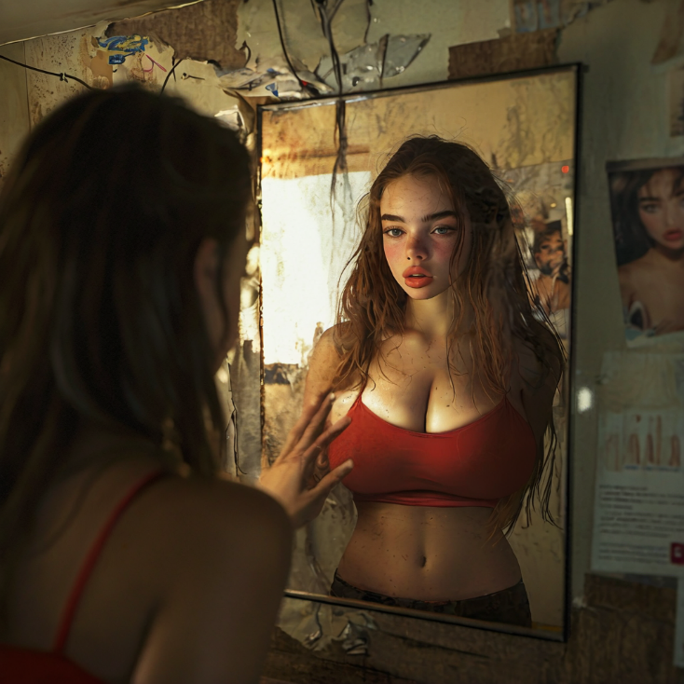
Steve tore his gaze away from the mirror, trying to push down the panic that was threatening to overwhelm him. 'Alright, focus, Steve. You need to get in touch with someone who can help you fix this mess.' His mind immediately went to his old friend, Marcus Reed. Marcus was the CEO of a big tech firm and just as much of a prick as Steve had been. They’d known each other for years, and if anyone could help him, it was Marcus. 'But where the fuck is the phone in this dump?'
“Gotta find a phone,” Steve muttered, scanning the cluttered apartment. With a plan in mind, Steve began searching the apartment for a phone, his eyes darting around the cluttered space as he tried to ignore the lingering heat in his body. ‘Gotta find a phone, gotta find a phone…’ he repeated to himself, his frustration growing as he rummaged through drawers and cabinets, his long, manicured nails catching on the edges as he frantically searched.
His eyes kept darting back to the sex toys all the time. Steve tried not to think about it, but the urge grew stronger and stronger. Gotta find a phone, gotta find a phone…’ he repeated to himself. He paused for a moment, deciding to fix his top, his fingers slipping over his hard nipples accidentally, causing him to hiss a little and his breathing to become heavier as the warmth grew inside him. "God-dammiiit..." he muttered, biting his lower lip and shaking his head as he tried to focus on his search.
Finally, he found a phone buried under a pile of clothes on the bed. “About fuckin’ time,” he muttered, grabbing the pink and covered in rhinestones phone and turning it on.
As the phone lit up, his eyes drifted back to the table, to the bright, colorful toys that seemed to be calling to him, their shapes and sizes sending a jolt of heat through his body. A sudden, intense wave of need washed over him, and he felt his knees go weak. ‘No, don’t even think about it, Steve,’ he told himself, trying to tear his gaze away. But his body was already exhausted, and the aching need between his legs was becoming unbearable.
The throbbing between his legs was almost unbearable now, his mind clouded with lust that wasn’t his own. Without even realizing it, he was moving back toward the bed, the phone slipping from his grasp as he reached out for the dildo. His hands, delicate and trembling, picked up the toy, feeling the soft, smooth silicone against his skin. ‘What the fuck am I doin’…’ he thought, but it was too late.
“No, no, no, this is fuckin’ insane,” he muttered, while his fingers fumbled with the buttons on the toy. He could feel his heart racing, his skin tingling with anticipation as he slowly spread his legs, his fingers trembling as he reached up under the short skirt, pulling the thong to one side. A small whimper escaped his lips, his breath catching in his throat as his fingers made contact with his slick, swollen pussy, sending jolts of pleasure through his body.
“Goddamn it,” he whispered, his voice barely a breath as he positioned the vibrator between his legs, his body trembling with a mix of fear and excitement. He could feel the cool, smooth surface of the toy against his skin, the sensation sending a shiver down his spine as he slowly pushed it inside, his eyes fluttering closed as a moan escaped his lips.
As he began to work the dildo in and out of his slick entrance, his head tilted back, lips parted in a silent moan. “Oh fuck, oh fuck,” he groaned, his body arching off the bed as the vibrator slid deeper inside him, he feel his pussy tightening around it. In his thoughs flashed all what had happened in this body today, but most of all, the scenes of being used like a sex toy, like a fuck doll, being humiliated, called whore and being fucked and used over and over again.
Everything around him was spinning when he opened his eyes for moments and looked around the apartment and to the photo, the one hanging above the couch with the name 'Lola'. Out of the corner of his eye he saw another toy lying next to him on the messy sheets. Without even thinking about what he was doing, he grabbed the second dildo, which looked like an actual, realistic penis, with the large bulge of the scrotum and with a suction cup and placed it vertically on the wooden armrest of the sofa.
As the vibrator kept pleasuring him with a rhythm without hand control, Steve, with shaking hands, quickly pulled his hair into a ponytail and folded it into one hand, then with his free hand he shoved the vibrator further in. Finally leaning that hand on the couch, he pulled his hair sharply with his other hand and slowly lowered his head and opened his lips. "Oof, yes..." Steve hissed, his plumb, full lips trembling as the tip of the realistic-looking penis slowly disappeared into his mouth. His tongue, slightly parted his lips and began to massage the silicon penis with his warm tongue. "Mm... Mphm..."

Taste of rubber filled his mouth, which felt strange at first, but after a few seconds Steve couldn't care less, his tongue caressed and stroked the head of the dildo, while he moved his head up and down.
"Fuck... Ooh, yess," he gasped, feeling how his juices were trickling down his inner thighs as he felt how the vibrator began to fill his insides. "Goddammit, what is happenin' to me... Oh shit... Nnnnh," Steve groaned as he pushed himself up a bit higher pulling too hard his own hair, causing his eyes to fill with tears of pleasure "Yeah! Yeah! Fucking hell... Fuck yes, harder! Ooohhh!" he pulled the fake penis off the armrest and leaned back, shoving it into his mouth, moving it back and forth, while other hand grabbed his breasts squeezing them.
And then it hit him, a wave of pure, unadulterated ecstasy that washed over him like a tidal wave. His body convulsed, his back arching off the bed as his pussy tightened around the vibrator, he felt his muscles contracting rhythmically, his mind blanked for a moment as pleasure flooded every cell in his body and finally his body went limp.
Steve, now sweaty, exhausted, but also very relaxed and satisfied, take away from his pussy vibrator and threw it somewhere and dropped his hands onto the sheets. His body was still trembling slightly, while realization of what had happened came over him. His eyes widened in shock and confusion as he slowly sat up, in his mouth still was this rubber penis and saliva was trickling down his over his chin.
With a frustrated grunt, he yanked the dildo out of his mouth, a wet, popping sound echoing through the empty apartment, wiping his mouth with the back of his hand. “Fuck!” he shouted, throwing the dildo across the room, where it landed with a dull thud.
'Jesus, I was just… I… Fuck!' He ran a shaky hand through his tousled hair, feeling the sweat cooling on his skin. His body still buzzed from the aftermath, but his mind was spinning with disgust and regret. His eyes fell on the phone, lying forgotten on the bed. 'Fuck, I need to call Marcus,' he thought, panic rising in his chest again. But the sensation of the fake cock between his lips, the taste of rubber still lingering, was enough to make him gag. He shook his head, trying to clear his thoughts. ‘Jesus, get it together, Steve,’ he told himself. ‘You’re losing it.’
He pushed himself off the bed, his legs still shaky, and made his way to the bathroom, which wasn't hard to find as the tiny studio apartment barely had any doors except the bathroom and entrance. 'I need a fucking shower,' he thought, his mind reeling from the mix of shame, disgust, and unwanted arousal that still clung to his body like a second skin.
Steve entered the bathroom, flipping on the light switch, and was greeted by the dim, flickering bulb overhead. 'I'm not surprised anymore' he thought looking at the moldy grout around the bathtub, to the rusty pipe, forming a puddle on the dirty linoleum floor. His gaze shifted to his own reflection in the grimy mirror - makeup smudged, hair tousled and lips swollen from latest activities.
"Fuckin’ Christ," he muttered, running a hand through his messy hair. The tight skirt was bunched up around her hips, the thong barely covering anything, exposing the curve of her ass and the top of her thighs. Her top was askew, one strap hanging off her shoulder, her breasts threatening to spill out at any moment. 'Look at me. I look like some two-bit slut.' He grimaced at the reflection, ignore the soft curves of his body and delicate features of his face. "This ain’t me," he said aloud, as if trying to convince himself. "I’m Steve Donovan, not some chick named Jane."
'Fuck this,' he thought angrily, gripping the hem of the tight top that clung to his chest. The fabric was stretched across his breasts, the neckline dipping low enough to expose the creamy skin of his cleavage. With a frustrated grunt, he yanked the top up and over his head, his breasts bouncing slightly as they were freed from the constricting fabric.

His breasts, now free, hung heavily on his chest. He looked down at them, feeling how them gently swaying and touching his ribs. 'How the hell am I supposed to deal with these things?' he thought, then shook his head. 'Hey! I'm not going to stay with this!' he thought, reaching up to cup one of his breasts with his hand. The soft, warm flesh filled his palm, and he felt a strange, tingling sensation ripple through his body. He quickly pulled his hand away, his eyes wide with horror. 'No! No more! This is just too much!' he thought. 'I gotta get this body back to normal before it drives me fucking crazy.'
He turned his back to the mirror and reached for the waistband of his miniskirt, tugging it down over his hips. As he bent over to remove the skirt, his breasts hung down, swaying slightly with the movement. "Damn," he muttered, then thumbs into the waistband of the thong, pulling it down and stepping out of it with a wince. Cold air rushed against his exposed skin, sending goosebumps up his spine, as he looked back at himself in the mirror.
He caught a glimpse of himself in the mirror again, completely naked this time. His reflection was that of a stunning woman, with soft curves and flawless skin. Long legs, full hips, and a slim waist. He reached up, brushing a strand of hair behind his ear, and watched as the woman in the mirror mimicked his movements.
'Fuck, I don’t even feel anything looking at this chick,' he thought, his brow furrowing in confusion. 'What the hell is wrong with me?' He had always been a red-blooded heterosexual man, never having a problem getting turned on by a good-looking woman. But now, standing here in this body, he felt... nothing. Just a strange emptiness that made him uncomfortable and more confused.

"Shower!" he said loudly, his voice echoing in the tiny bathroom. 'I just need to clear my head,' he told himself. He reached out to turn on the faucet, wincing when nothing happened. 'What the hell? No shower, really?' he thought, frustrated. "Fuckin' cheap apartment!!!" He shouted and banged on the wall with his hand and at this moment cold water sputtered out from the showerhead.
"AAA!" He jumped in place with a surprised scream. "God fucking dammit!!" Steve screamed and jumped back away from the stream of icy water, his hands moving instinctively to cover himself, squeezing his soft, round breasts in an effort to cover them, his long legs rubbing together, then quickly running out of the shower.
Gradually, the water began to warm up, steam rising in the cramped bathroom. Steve gingerly stepped back under the now-lukewarm spray, letting out a sigh of relief as the water cascaded over his new body. 'Jesus, this feels good,' he thought, feeling the tension slowly leave his body.
As he ran his hands over his body, he couldn’t help but notice how different everything felt. His skin was soft and smooth, his breasts heavy and sensitive, and his hips flared out in a way that was completely foreign to him. He tried to focus on washing himself, but his mind kept drifting back to the mirror, to the woman staring back at him with his eyes. 'Fuck, why didn't I feel anything when I looked in the mirror?' he thought, his hands lingering on his breasts for a moment as he tried to sort through his muddled thoughts.

He reached for the soap, lathering it in his hands and running it over his body. The sensation of his hands sliding over the smooth curves of his breasts and down his stomach sent an unexpected jolt of pleasure through him, and he bit back a moan, gritting his teeth. 'Fuck, not again,' he thought, quickly scrubbing the soap over his skin, trying to ignore the way his body reacted to his touch. His hands moved lower, down to his thighs, and he hesitated for a moment before finally washing between his legs. His fingers slid easily over his smooth skin, and he felt the telltale signs of arousal rising in him. 'Dammit, stop it! I can't handle this,' he thought desperately, his breathing shallow and uneven.
His fingers slipped between his folds, finding the sensitive nub of his clit, and he gasped, his knees buckling slightly and soap slipping from his hand. "Oh, fuck," he moaned, his fingers moving in slow, deliberate circles over his clit. His body trembled under the spray of the shower, his breath coming in ragged gasps as he felt the pleasure building inside him once again. "Oh God... fuck, this feels..." his voice trailed off as his mind clouded with pleasure, he couldn’t stop himself. His hips bucked against his hand, his fingers moving faster, sending jolts of pleasure through every nerve in his body.
Suddenly, the water turned ice-cold, shocking him out of his trance. "Shit!" he yelped, jumping back from the spray and fumbling with the faucet. "Dammit, what the hell?!" he muttered, cursing at himself under his breath as he shut the water off and stepped out of the shower, feeling cold and disoriented.
He grabbed a nearby towel and dried himself off quickly, avoiding his reflection in the mirror. He didn’t want to see that woman staring back at him again, didn’t want to be reminded of what he had become. He tossed the towel aside and stepped back into the living room, his bare feet slapping against the cool wooden floor, long wet strands of hair hanging loosely around his face, exsposed breasts, that still hanging heavily with water droplets, were swaying softly with his movements.
He searched the cluttered room for something, anything, that he could use to cover himself. He rummaged through the pile of clothes on the floor, looking for something to wear. 'Jesus, this chick's got nothin' but fuckin' lingerie and stripper outfits,' he thought, holding up a pair of fishnet stockings and a skimpy red bra. 'What the hell am I supposed to wear?'
He dug deeper into the pile, finding a few more items: a tiny black dress that looked more like a long shirt, a pair of crotchless panties, and a leather corset that seemed way too small. Most of the outfits were tiny, skimpy dresses, short skirts, and barely-there tops that left little to the imagination. "Fuckin' hell, does this chick ever wear normal clothes?" he muttered, tossing the items aside in frustration. 'I can't walk around naked in this body… not in this place.' He kept digging, hoping to find something more suitable, but it was no use.
He finally settled white yoga pants that looked more suitable than anything else. He grabbed them and stood up, taking a moment to study them. He'd seen a guy wear this stuff once at the gym, so he decided that he would try them on. He lowered himself, lifting his left leg, his knee touching his hanging chest and then putting his foot inside, repeating the same movement with the right foot. 'Damn, how does anyone get into these things?' he wondered as he pulled the elastic material over his smooth legs.

The fabric hugged his ass as he adjusted it over his hips and felt like second skin. He glanced at the mirror and saw how his ass and curves were even more visible in the yoga pants, while pussy lips could be easily seen. Some kind of inscription was visible on his buttocks through the fabric and Steve turned his ass to the mirror.
"Jesus fuckin' Christ," he muttered, reading the word 'Juicy' on his left cheek, and the other one - 'Slut' on his right. "This bitch is fuckin' crazy!".
He glanced at the phone lying on the bed, his thoughts turning to Marcus. 'I need to call that prick and figure out what the fuck to do,' he thought, reaching for the phone. But just as his fingers brushed the device, a loud knock echoed through the apartment, making him jump.
"Hey, Jane! Open up! I know you're in there, you noisy bitch!" an angry voice called out from the hallway.
Steve froze, his heart skipping a beat. 'Shit, who the fuck is that?' he thought, glancing toward the door. Another knock, louder this time, rattled the door on its hinges. "I said open up, Jane! I’m sick of your fuckin' moanin' and groanin' all night! Some of us gotta work in the mornin'!"
'Fuckin' great, just what I need,' Steve thought, grabbing the closest item of clothing - a translucent pink baby doll lingerie - and pulled it over his head.
Steve’s gaze immediately went to the mirror to see himself. “What the fuckin’ hell…” he muttered, staring at his reflection. The translucent pink babydoll lingerie barely covered anything ending just above his belly button, thin straps over his shoulders holding it in place, his breasts clearly visible through the thin material. Steve groaned as he turned to the door, last time glanced in the mirror where was reflected a round ass with words "Slut" and "Juicy" through the fabric. 'Fuck my life,' he thought. 'This can't get any fuckin' worse.'
“Goddamn it!” he hissed, pulling at the hem of the lingerie, trying in vain to cover his exposed midriff. The door rattled again as the pounding from the hallway grew more insistent. “Jane! I swear to God, if you don’t open this fuckin’ door right now, I’m callin’ the cops!”
"I'm comin', hold your fuckin' horses," he said, walking to the door, his hips swayed with a natural, feminine grace that felt completely foreign to him. The tight yoga pants clung to his ass with each step, breasts gently bounced with his movements as he finally opened the door, the lock clicking as it slid free.
"Finally! It's about ti- Holy fuckin' shit, what the fuck is this, Jane?" The angry neighbor's voice faltered when he caught sight of Steve's outfit. His eyes raked over Steve's exposed body, a lascivious grin spreading across his face. "Jesus Christ, I ain't ever seen you this dressed up for me, sweetie."

Steve narrowed his eyes, feeling a flush rising in his cheeks. He crossed his arms over his chest in an attempt to shield himself from his neighbor's prying gaze. "What the hell do you want?"
The neighbor smirked, his gaze lingering on Steve's breasts before finally looking at his face. "You got some nerve, Jane!" he hissed, poking him in the chest with his fat finger, sending jolts of electricity through his body. "You got some nerve, Jane! All night long, it’s the same thing—moanin’ and groanin’, like you’re in some goddamn porno! Some of us are tryin’ to sleep, you tramp!"
Steve clenched his jaw, squeezing his arms tighter across his chest, caused breasts pushed together and exposed more of his cleavage. "Listen, asshole, I ain’t Jane, alright? And I sure as hell don’t care about your beauty sleep! So why don’t you fuck off back to your hole and leave me the fuck alone?!”
"You little whore!" he spat, jabbing a finger toward Steve’s chest. "You think you can just bring all those guys back here, makin' all that noise, and no one's gonna say anything? You're a fuckin' disgrace to this building!"
"Listen, asshole," Steve growled, his voice filled with irritation as he took a step closer to the neighbor, pressing his chest against the man's outstretched finger, "I told you, I ain't Jane, and I-"
But before Steve could finish his sentence, neighbor's finger pressed firmly against his lips. "Shhh, bitch! Don’t wake up even more!" neighbor hissed. Steve’s eyes widened in shock, his mouth opening in a reflexive gasp, and before he could process what was happening, the neighbor’s thick, greasy finger slipped between his lips.
"What the—?" the neighbor started, his eyes widening in shock as he felt Steve’s mouth around his finger.
The taste was salty and unwashed, a sharp tang of sweat and grime. Steve’s initial reaction was one of disgust, his stomach churning at the intrusion. “Mmmph!” his lips tightened around the neighbor’s finger, his tongue running along the length of it, tasting the salt and grime. A strange, unwanted warmth spread through his body, pooling between his thighs. ‘No, no, no! Not again!'
The neighbor pulled his finger back abruptly, his face contorted in a mixture of confusion and anger. “What the hell, Jane? Are you fuckin’ high?” he barked, wiping his hand on his shirt. “You tryin’ to give me herpes or somethin'?!"

Steve blinked, shaking his head as if waking from a daze. “I—shit, no! I didn’t mean to—” He stopped, feeling the heat rise to his cheeks again.
The neighbor glared at him, his face red with anger. “You wanna play games, huh? You think you can just suck on my finger like that and I’ll forget about all the noise you make, bitch?” He stepped forward, forcing Steve back into his apartment. The smell of alcohol on his breath was overpowering as he leaned closer, his face inches from Steve's. "You think that shit'll make me go away, Jane? You sucked my damn finger off!"
Steve stumbled backward, his heart racing as he tried to gather his thoughts. “You got some nerve, asshole!” he spat, though his voice came out shakier than he intended. “Think you can just come in here and—”
The neighbor didn’t give him a chance to finish. He shoved Steve against the wall, his hands roughly grabbing Steve’s breasts through the thin fabric of the baby doll lingerie. “Shut up, bitch,” he growled, squeezing Steve's already hard nipples between his thick fingers, causing Steve to moan in surprise. The warmth between Steve's legs intensified, the feeling of his neighbor's hands on him sending waves of pleasure through his body.
Steve’s breath hitched as the neighbor’s rough hands groped him, the sensation sending conflicting signals to his brain. ‘Goddamn it, I’m not gonna let this fucking creep—’ But his body had other ideas. “Fuck… you…” he managed to mutter, though even he could hear the weakness in his voice.
Before Steve could react, the neighbor's lips crashed down on his, his tongue forcing its way into Steve's mouth. Steve's eyes widened in shock, his body tensing as the neighbor kissed him roughly, his hands roaming over Steve's body, squeezing his breasts and gripping his ass through the tight yoga pants.
Steve’s mind screamed at him to fight back, to shove the disgusting man away, but his body was betraying him. Despite the roughness of the neighbor’s grip, despite the taste of stale beer and cigarettes on his lips, Steve’s body responded with a wave of unexpected arousal. His lips, still swollen from his earlier activities, parted to let the neighbor’s tongue in, and he found himself kissing back with a fervor that shocked even him.
‘What the fuck is happening to me?!’ Steve thought, his mind clouded with confusion and lust. ‘Why the hell am I… oh, God, why does this feel so good?’
As the neighbor’s hands roamed over his body, squeezing his breasts and pulling at his nipples through the thin fabric of the babydoll lingerie, Steve moaned into the kiss, his hips grinding involuntarily against the neighbor’s thick thigh. ‘Jesus, I can’t… I can’t control this,’ he thought, feeling the wetness between his legs growing, soaking the fabric of his yoga pants.
The neighbor broke the kiss, his eyes wide with surprise and a flicker of anger. “Fuck, I came over here to give you a piece of my mind, not get my dick sucked by some crazy bitch!”
Steve looked at him with lust clouded eyes, his lips still swollen from their rough kissing and breathing heavily. “Shut… the fuck up… asshole… I ain’t Jane… I ain’t no fucking slut—ugh!” Steve groaned as the neighbor squeezed his ass tightly through his yoga pants.
"No? So why you dressed up like this before the door then, hmmm?" the neighbor taunted, his voice low and mocking. “Cause you’re actin' like wanna seduce me or somethin'. I mean, hell, if that ain’t the case, why you givin' me so much shit? I know a desperate slut when I see one, girl." He smirked, running his rough hand over Steve's bare skin.
Steve’s body shivered at the words, his pussy clenching around nothing as his arousal spiked. ‘No, no, no, I’m not supposed to want this,’ he thought frantically, but his body was already moving on its own. He dropped to his knees in front of the neighbor, his hands trembling as they reached for the waistband of his jeans. 'Fuck it! I can't resist this... I need more!' she thought desperately.
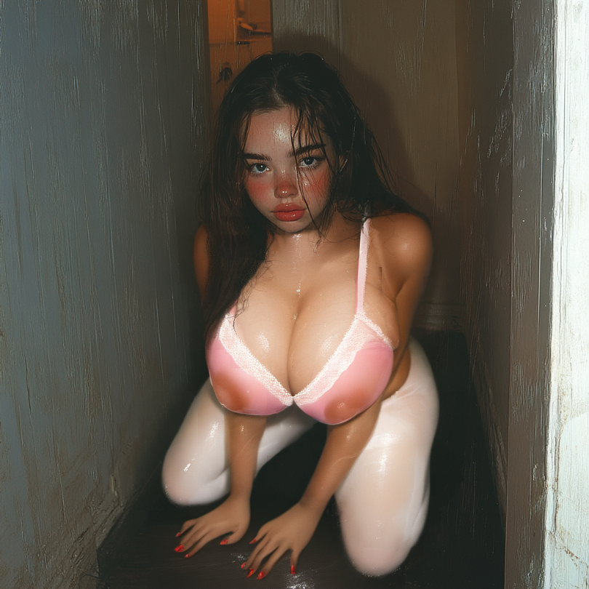
“Fuck, what are you doing?” the neighbor grunted, looking down at Steve with a mixture of confusion and anticipation.
Steve glared up at him, her eyes blazing with defiance even as her hands fumbled to undo the neighbor’s belt. “What do you think, asshole?! I thought you wanted your cock sucked by a desperate slut?" she growled, yanking the neighbor’s jeans down and pulling out his hard cock.
Steve paused for a moment, looking up at the neighbor, whose eyes widened in shock, his cock throbbing in anticipation. Steve licked his lips, feeling the warmth of his own saliva as he parted his lips, running his tongue over the thick, mushroom-shaped head, tasting the man's precum as he moaned softly, closing his eyes and letting the warmth spread throughout her body as the pleasure intensified.
Steve gagged slightly as the neighbor’s cock filled his mouth, the salty taste making his stomach churn. ‘God, I hate this, I fucking hate this! I don't know why I'm doing it. But, on the other hand, I want... No, no, no! This isn't me, this isn't me!' she thought, but his tongue swirled around the neighbor’s shaft, as his head bobbed up and down, sucking the cock deeper into his mouth with each movement. His hands gripped the neighbor’s hips tightly, pulling him closer as he took him all the way in, the tip of the cock brushing against the back of his throat.
The neighbor groaned, his hands gripping Steve’s hair tightly as he thrust into his mouth. “Fuck, Jane, you’re a real pro at this,” he grunted, his voice filled with a mix of surprise and pleasure. “Didn’t know you had it in you, slut.”
Steve’s face flushed with a mix of humiliation and arousal at the words, his pussy clenching around nothing as he sucked the neighbor’s cock with renewed vigor. ‘God, I can’t believe I’m doing this,’ he thought, but the feeling of the cock in his mouth, the taste of sweat and salt on his tongue, was making his body burn with need.
He could feel the neighbor’s cock twitching in his mouth, a sign that he was close to cumming, and a part of Steve wanted to pull away, to end this humiliating act before it went any further. But another part of him, the part that was slowly taking over, wanted to see it through, to feel the neighbor’s cum filling his mouth and sliding down his throat. ‘God, I’m so fucked up,’ he thought, his hands tightening around the neighbor’s hips as he sucked harder, his head bobbing faster as he took the cock deeper into his throat.
The neighbor let out a loud groan, his hands yanking Steve’s hair hard as he came, his cum spilling into Steve’s mouth in hot, thick spurts. Steve gagged at the sudden onslaught, his eyes watering as he struggled to swallow it all, the salty, bitter taste filling his mouth and dripping down his chin. ‘Fuck, this is so fucking disgusting,’ he thought, but his body shuddered with an unexpected wave of pleasure as he swallowed the neighbor’s cum, his tongue licking up every last drop.
As he swallowed the last drop, the neighbor pushed Steve off and looked at him with a mix of disgust and satisfaction. He tucked his dick back in his pants and stepped back. "Fuckin' bitch, what the fuck was that all about?" he snarled, spitting at the floor in front of Steve and then turned around to go out of the door without another word.
Steve slumped to the ground, his knees shaking, breathing heavily and still trembling all over, while he tried to collect his thoughts. He couldn’t believe what had just happened. 'What the fuck just happened?' he thought, his mind swirling with confusion and shame. 'Why did that feel so... so fucking good?'
His eyes drifted shut, and he let out a soft, defeated sigh. 'I can’t believe this... I can’t fucking believe this...' he thought as he slowly slid down to the floor, drifted off to sleep, his body still humming with the remnants of pleasure and his mind filled with conflicting emotions.


