A MODEL TRAINER
COMMISSION STORY
BY CHALDEACHANGE
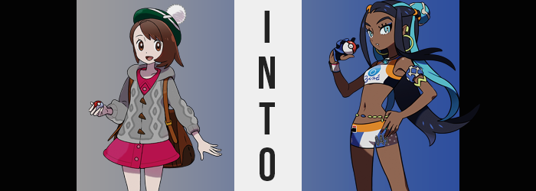

“Could you wait about ten minutes or so? I need to get changed first. Feel free to look around while I’m getting ready, though.”

The Champion of the Galar Region, Gloria, was beyond excited. The Gym Leader of Hulbury, Nessa, had invited her to spend a night out on the town – something she had honestly never been invited to do, considering she was a country girl through and through. Well, her age certainly came into play as well. She was only fourteen years old, so there weren’t exactly many places that would let her in unsupervised after a certain time, Champion or no.

But, after being invited to Nessa’s home to wait while she finished getting ready, Gloria was now free to explore at her leisure. Which was amazing seeing as she lived in what was essentially a mansion. It made a lot of sense all things considered. Not only was she Hulbury’s Gym Leader, but she was a world-famous model as well. She was probably filthy rich.

Not that wealth altered Gloria’s opinion about a person, mind you! She honestly believed that one’s actions mattered more than their upbringing or lifestyle, so whether someone was rich or poor, loud, or quiet, it didn’t matter so long as they did good things. And Nessa did a lot of good things.

Actually, despite how big her home looked from the outside, the interior was rather minimalist? There was the odd decoration here and there, but the walls weren’t overcrowded and, more than anything, there were pictures from Nessa’s various photoshoots pinned to them. “Could it be that Nessa is a narcissist? Well, she is mighty pretty.” It was possible she hadn’t decorated the home herself, either. Maybe they were up in case people looking to hire her came by? It was bad to assume, either way.
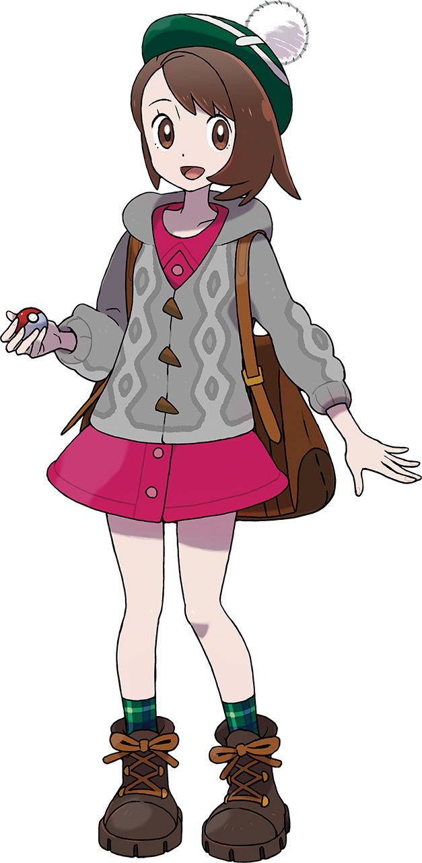
Walking along the halls, there was eventually something that stood out to her. Nessa did not have a lot of decorations like vases or plants strewn about, but in the center of the main hall there was something, and Gloria was quick to investigate. “A Water Stone? Weird thing t’have on display, I’d think?” The blue stone was absolutely placed with the intention of being the room’s centerpiece. The hall itself was crafted with white marble, so the stone really stood out upon its pedestal.

Now these was some history to this stone. A history that Nessa usually explained to her guests, yet hadn’t had the opportunity to do so with Gloria just yet. This Water Stone was a gift she’d been given by her mother after her first photo shoot, before she’d even hit the big time. Because of that, the Gym Leader valued it as a good luck charm. Before she left her home every morning, she gave it a little rub so that she might have a good day.

A rub similar to the one Gloria had begun to give it out of curiosity. “The top looks all worn out. Wonder if people touch it a lot?” If only she’d known. Only Nessa was allowed to touch it, but even the Water Stone’s owner knew not of the power that this stone possessed. After being stroked by her for so long, the evolution stone had stolen some of Nessa’s essence bit by bit. And now? With another human rubbing it? The stone began to glow, and that essence was released.

YOUR GLORIA IS EVOLVING…

The Champion yipped with surprise as she felt an energy flowing into her body from the point of contact with the stone. “What the…!?” It was a very weird feeling to experience, and the longer the light glowed, the stranger she felt. The issue with this? The Water Stone just simply didn’t stop glowing, and regardless of how far away she pulled herself, because she had established a connection with it, its effects just continued to flow into her.

A mental effect kicked in before anything else, disorienting the girl so that she wouldn’t make too much of a racket in regard to what was to come. Think of it as like an anesthesia, even if she still more or less had her wits about her. It was just much harder for her to make heads or tails of everything going on around her, from the light of the stone to her very body.

Gloria had taken in so much of Nessa’s built-up essence that it was simple enough to predict just what these changes to her body might entail, more or less. How the fabric of the world would be misshapen to accommodate these changes, on the other hand, was a topic worth pondering.

“Nn… Why do I feel all wonky?” The girl shook her head from side to side, taking the full force of the stone’s effects on her ego, rendered oblivious to what was happening, or at least beginning to happen. For example? If one were asked to show their work regarding any notions about Gloria’s body changing, they would certainly immediately point to the Champion’s height.

Little by little, her spine had begun to stretch, and with it her body’s proportions were temporarily rendered uneven. She sprung up from just under the five-foot mark, all of the way up to five foot six with the passage of just a few seconds, and while it hadn’t been consistent at first, things eventually evened out with her arms and legs keeping a match to her torso.

A direct physical benefit from this growth was one that saw the girl’s figure become leaner. Young as Gloria was, her belly was still a little round and there was a reminiscent, youthful plumpness to her frame before she had seen any height gain whatsoever. All of this was evened out once she’d grown though, leaving her belly lean and her limbs thin.

Of course, this left her outfit in a rather strange predicament. The pink, one piece dress she wore beneath her gray cardigan was hoisted cleanly off of her hips, what with it clinging to her body from her shoulders – shoulders that were now half a foot higher than they had once been. This left everything from the base of her belly and below wholly exposed, including the simple, black panties that were wrapped around her pelvis.

Meanwhile, her arms reached much farther out of her cardigan sleeves. They used to rest comfortably at her wrists, but there was now so much arm to her, well, arm that they only reached just past Gloria’s elbows. Not to go unnoted, a quick look at the girl’s hands would reveal that the length of each digit had certainly grown longer as she’d grown taller, and the lengthened nails at the tips bore a perfect manicure, much cleaner than anything she could do herself normally.

Because her skirt was lifted from her hips, any discomfort brought about by her hips swinging wider was limited to merely the sensation of the elastic of her panties stretching along with them. “I’m not feelin’ too hot either! What’s goin’ on here?” Try as she might to show the phenomenon affecting her any recognition, her mind was still too jumbled for her to wholly process it. Not even the tightness around broadened shoulders.

Now, Gloria was a girl that had traversed the Galar region both on foot and on bike. She was by no means unfit, but she wasn’t exactly an athlete either. Watching her body now though, you might not get that impression. Because an athlete’s strength, both raw and honed alike, wriggled its way into her muscles to leave her muscles toned and firm. The bulk of it lined her abs and legs, more suggestive of a talent for swimming more than anything else.

While her legs were left chiseled by this new strength, the swell of each muscle was ultimately obscured by a fattier offering that smoothed things out, particularly in her thighs which grew plumper with the apparent intent of filling in the thigh gap left by her widened hips – even though it hardly left a dent. Her ass bloated similarly, though there was still an ever-present firmness left by her newfound athleticism, and this wedged the black panties in between her peach-shaped cheeks.

“Was there something off in my protein shake? Ugh.” Gloria shook her head, wholly agitated, yet oblivious to a deepened voice and the peculiarity of the things she was saying. The Champ had never consumed a protein shake in her life, let alone one recent enough to blame for feeling so strangely. On the other hand, she could recall having one as recently as when she closed up the gym for the night.

Beneath the dress that sat uncomfortably upon her shoulders, her chest soon rose as well. Like pastries in the oven, the mess of her bosom lifted several cup sizes, pushing the training bra she was wearing around uncomfortably. They peaked at a fit B-cup sizing, but considering how aerodynamic her figure was, it wasn’t exactly a bad thing. Though between her breasts and her ass, she certainly appeared to be a little older… more adult, even.

That was because she was, actually, physically twenty-one now. Her face suggested this just as efficiently as her figure did, particularly with how her lips had swollen and the innocence that typically shone in her eyes diminished within more angular designs. In fact, the sleekness of her face overall betrayed the Caucasian heritage she was meant to have. But if the Water Stone’s effects were proving anything, it was that what was meant to be was not something that mattered any longer.

Case in point: almost like a flurry of freckles, a seemingly endless number of dark spots had begun to form themselves across her body. From her face to her hands, to the broadened tootsies that felt cramped within her footwear, they surfaced en masse. Each spot lingered for a moment before swelling larger, until the splotches ultimately connected with one another to present her with a consistent, dark skin tone – aside from her palms, which were slightly paler, and her nipples, which were browner.

Looking back at the glowing Water Stone, the light of her eyes permanently reflected the very same blue. “Seems like it’s clearing up a little now. Maybe I pushed myself too hard today?” Gloria gave an uncharacteristic flip of her brown hair with her darkened fingers, and the moment she did both the color and quality of her mane began to shift.

Brown hairs shifted predominantly to a black, and carried a sleeker, well-kept texture that suggested she used the highest of quality products for her personal beauty. The woman’s tam o’ shanter hat was pushed off the top of her head and fell to the ground behind her; a direct result of her short bob lengthening and falling far behind her back – past her ass and to the backs of her knees. Among the black, a dyed pair of lengths of watery blue fell down both the right and the left, while her bangs were swept back short of two lengths that hung down on either side of her face.

Physically, Gloria certainly didn’t resemble herself any longer. From head to toe, from her mannerisms to her attitude, she wholly matched the woman that owned this estate. Rather than remembering her humble beginnings, or the feat of becoming Champion, her desire to become Champion had once again been stoked with a fiery passion. But it was difficult to run a Gym, be a model, and aim for the Champion spot!

As the light of the stone waned, one final phenomenon saw the garments she was adorned with begin to glow the same blue as the Water Stone itself. For a brief second, almost a blink, the woman stood completely naked in what she perceived to be her own main hall. As quickly as that feeling came though, it left, and she was then dressed in a familiar Hulbury Gym Leader uniform.

YOUR GLORIA HAS EVOLVED INTO NESSA!
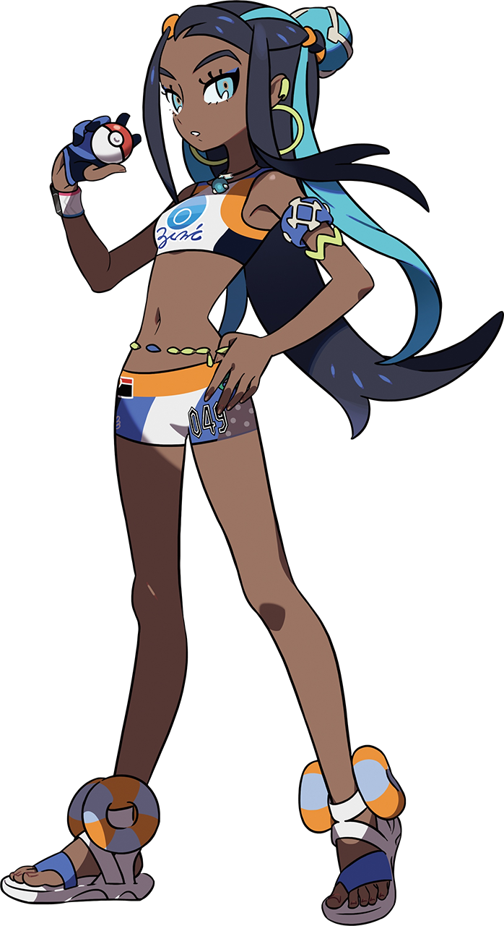
Not only Nessa in body and mind, but in fashion as well, this second Nessa stood in awe of herself after the Water Stone’s light finally faded. “Hm? I’ve never seen it glow that way before. There aren’t even any Pokémon out. What did it evolve?” It wasn’t like these things activated without eligible Pokémon nearby. Though, speaking of? The Pokémon in her Pokéballs had become a perfect match for Nessa’s party as well.

Either way, the one that the stone had evolved was herself. The issue now was that there were now two Nessas in the same manor, much less the same world. An issue that would soon come to fruition as… “Is this some sort of joke?” The real Nessa, now ready for the evening after changing into a striking, red dress, stood at the end of the main hall. Where was Gloria? Why was there a woman that looked exactly like her in her home? She certainly didn’t have any twin sisters of note! Her crimson heels clacked against the marble floor as she charged towards the equally shocked body double.

In both of their minds, they were the real deal. Even though it was only true for one of them. “A joke? That should be my line? You look far too similar to me for this to be a coincidence. Are you an imposter of some sort?” The fake’s retort came with the same tone that the original had conveyed, both women glaring daggers at the other. For a model, for someone else to steal their look was abhorrent! But both of them were thinking the same thing: Isn’t this copycat a little too realistic?

The original stepped past the Water Stone with the intention of removing the imposter by force, but as she passed it she gave it another rub for good luck. Much to the surprise of both Nessas, however? The stone shattered on contact, and one final burst of light blinded them both for a moment. “What!?”

Yet, when it faded? There was no longer any hostility in the air whatsoever. Almost like both women had forgotten that they were even mad in the first place. Which was more or less the truth of it all, seeing as their memories had both been subjected to a simple memory rewrite.

The imposter, the Nessa that had once been Gloria, now recognized herself to be Nessa’s twin sister. She even had a different name, Senna. Apparently their parents had though it would be cute to inverse the consonants in their names? Meanwhile, Nessa recognized Senna as a twin sister that had always been present. They were models together, Gym Leaders together, they had always just been together.

“Senna, are you just getting back? Hurry on and put on your dress so we can hit the town!” After the stun wore off, Nessa eventually blurted this out without delay. That’s right, the two of them were planning to experience Hulbury’s night life together as they often did. Though, it was strange.

Hadn’t she been planning on going with someone else?

