AI:SSIMILATION
COMMISSION STORY
BY CHALDEACHANGE
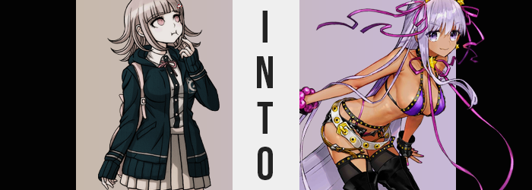

Chiaki Nanami was the happiest she’d ever been.

Maybe that was saying a lot for a girl that had lived an otherwise mundane life, but she truly felt that way. She was entertaining so many guests within the Neo World Program after a Virtual Summer Camp had been announced. Some of the faces she recognized from school, some of them were brand new. Either way she was surrounded by new friends, and despite their quirks most of them were as kind as could be.

All of this Neo World Program stuff was new to her, though. It was a strange concept. They were basically shoved into tubes to have their minds uploaded to a digital reality or something? It was a concept that sounded like something right out of a video game she would have played with Hinata, but come to life! And once they’d been uploaded into this Neo World? Everything just felt so real.

The food tasted like food. The air smelled like air. The water was as wet as water should be. If she hadn’t known better, she might have gotten it confused with reality. She couldn’t help but think it was a technology that could have terrible consequences in the wrong hands, however. Good thing that this was a good, safe world!

Day one of their digital trip had come and gone without consequence. Most of her peers had spent the entire day lounging around the beach, and while Nanami had joined them she hadn’t indulged fully. She was a little too nervous to put on a swimsuit – which made sense because she had never once shown off her body to anyone. She wasn’t confident in it either, even though she probably had one of the most bombastic bodies in the entire group.

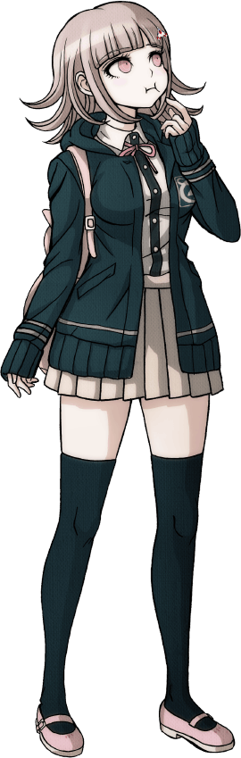
While everyone else had returned to their cabins for the night, the anxiety that came with the glee of such a big social gathering had been nibbling at Nanami and she found she couldn’t sleep. And so, dressed only in a white tee and a pair of short, dark green shorts with matching sandals, she had ventured out onto the beachside alone. Even then she couldn’t help but think how real the world was. There wasn’t a single indication that this space was digital.

“It’s pretty though. Even though it isn’t a real sky.” Standing at the water’s edge upon a sandy beach, her pink eyes were cast high upon the sky above. From the moon to the clouds, to the stars. It was just so picturesque, that… “…?” Nanami didn’t say anything about it, but there was confusion palpable upon her face. She was fairly certain she had just seen something wrong with the moon.

It happened again. A flicker that distorted the celestial body with what looked to be pixels. “What’s going on? Is that… normal?” Playing the devil’s advocate: even if it wasn’t, who was she going to tell exactly? They hadn’t entered the New World with any teachers, and everyone else here knew just as little as they did. Maybe the cute, pink bunny mascot they had met when they had first arrived? But where could she find her?

Just as she resolved to go ask someone though, the teen froze after taking a singular step. She felt weird. Like really, really weird. Her skin had grown tingly and her head fuzzy, and while she couldn’t really explain how such a thing might be possible, it almost felt like something had just passed through her. “That’s definitely not normal.”

Why couldn’t she move? No… It took her a moment, but she realized she was able to move everything. Everything except her legs, that was. Was this some sort of glitch in the program related to the pixelated moon? Because Nanami was the only one basking in its corrupted light, unfortunately for her she would become just as corrupted in the end.

“HELP! SOMEONE, HEL—!?” She thought, naturally, she might be able to at least call for some assistance considering she could still move her mouth, but fate had other plans. Nanami could still try and call out, but for some reason her vocal chords stopped producing anything other than a raspy noise that wasn’t coherent whatsoever. Whatever was happening to her, the source did not want her to make any contact with other people at the moment, clearly.

From the shock of her lost voice alone, Nanami brought a hand up to her lips even though she knew there was nothing she could do with it. This didn’t feel like the type of problem that massaging her neck would fix at all, but because she couldn’t think of what else to do it was more of an instinctual attempt at doing anything rather than doing nothing at all.

It was completely unintentional, but raising that hand revealed to her something she had not expected. “!?” Her fingernails, which she usually nibbled on until they were in a terrible state, were no long in that terrible state. Rather, they were an inch longer than she remembered, which was unfortunate. The girl hated having long fingernails – they were a pain in the butt while typing or gaming. Were that the extent of it though, perhaps she wouldn’t have been as surprised, but her eyes widened naturally at another sight. The sight of a purple polish painting across them, one by one, on both hands.

Her fingernails weren’t exactly alone in this department, either. She was wearing flip flops, so you could certainly see her toes, and her toenails had received the very same treatment. But her feet also grew a single size larger, and so the tips of those toes jutted out slightly over her flip flops’ ends. Replicated in her hands, even her fingers themselves were just the slightest bit longer.

What’s going on with my hands? My feet!?

She was shocked, naturally. If not for her feet being immobile, she probably would have kicked those flip flops off as soon as possible, but she was stuck with the discomfort of wearing footwear that did not properly fit her, unfortunately. If whatever was afflicting her could change her hands and feet like this, then what else could it—

Wait, what was that!? Nanami looked around a little frantically for a moment. It had been subtle, but it almost felt like for a very brief second, she had fallen? Which didn’t make a lick of sense considering her feet were firmly planted on the sands below to the point that she could not even lift them if she tried. It never really did click for her, but that’s because the only distinguishable factor was the fact that her white tee hung an inch farther against her shorts. Because the student herself had lost a single inch of height.

While she was still skeptical about whatever had happened there, that didn’t change the fact that the source of her woes were still… well, providing more woes for her to suffer through. A single glance at the young woman’s hair should have been enough to notice what was awry, for a purple washed through it all as if it was succumbing to some very vibrant hair dye. Except it wasn’t dye at all, but a very natural hair color that originated from the melanin in each strand. Strangely, however? That color changed again, this time lightening several shades to a more pastel purple.

Beyond Nanami’s notice, purple was becoming a very prevalent color in her defining features. The hair atop her head was one thing, but it colored her eyebrows and pubic hairs as well. It even tainted areas that had no hair whatsoever as her eyes eventually revealed – a glossy lilac permeating through once pink optics.

Because she didn’t really have anywhere to look, and the only changes she’d really noticed were her hands and feet, the maiden turned her attention back to her hands again. But upon doing so? She found herself squinting. Something didn’t really look right. Not about the hands themselves, but… her skin? Was it darker? Yes, it was. It was darkening, actually, and the color deepened before her very eyes.

It wasn’t isolated to her hands, though. She could see the very same anomaly in her exposed arms and the feet wiggling below her when she leaned forward. Her assumption then was that it was happening across the entirety of her body, and before long she had a very dark tan that was born from exposure to the sun if the thin tan lines straddling her hips, pelvis, and across the front of her breasts from her neck were any indication.

Now I’m ready for summer~ Senpai will— …Um, what am I thinking?

What was that she had just thought? It didn’t feel in-character for her usual self at all! Chiaki Nanami was a quiet girl, but that thought had been boisterous and peppy as could be! In some strange way it was almost… intoxicating. The level of energy that accompanied it just felt really good. So good, in fact, that despite all of the panic she had endured thus far, a little smirk began to play upon her lips.

It was a smirk that appeared to be more pronounced than it should have normally. Her lips were thicker, that’s why. The change was just one of many that plagued her facial features, and those changes ultimately preserved her Japanese background while wiping away any defining traits so that even if run a million times, a facial scan would never recognize her as Nanami again. This included a longer face, a more angular nose, and slightly raised cheekbones that gave her a very different aura.

Her smirk had widened as well.

Each fleeting moment only served to further Nanami’s building elation, and what was alarming at first was quickly becoming something that she wanted to embrace. Wasn’t her life just way too boring? Wasn’t she just way too lame? So what was the problem with being changed into something or someone just way cooler? This was the mental pollution skewing her interpretation of the events of course, but she didn’t exactly have a means of resisting that influence.

The victim’s hair almost seemed to grow longer and longer the further she fell into bliss, length already having cascaded halfway down her back. By the time her mind had been compromised in its entirety, pale purple locks would read all of the way to her heels in the back, while hanging even past her chest on the sides.

Although her chest was another area of note. Her entire figure was at this point, but her breasts were the most apparent. Now Nanami already sported a fairly hefty bosom, and she’d never thought much about what she’d do if her chest was bigger. She always thought they were a little too big as is, so if they were to grow she typically would have been a little upset. But Nanami wasn’t her typical self anymore, and so hard nipples forcing her shirt’s base to reveal a tanned tummy as the meat of her bosom below swelled garnered the opposite reaction.

That’s right! Get all big and bouncy! I love the attention they get me!

Nanami had never liked that type of attention before. Not only had they swollen two sizes, but the beauty mark on her breast had been erased. All of her beauty marks had been, actually. Her skin was flawless, and that’s how it’s supposed to be!

Just as her shirt had grown tighter, so did the shorts she had planned on wearing to bed. The girl hadn’t expected to bump into anyone while out, and so she wasn’t wearing panties beneath them just as she wasn’t wearing a bra beneath her shirt. Those dark green shorts were immediately overwhelmed by the swelling of her ass and thighs, a phenomenon that forced their waistband down slightly to show ass cleavage, and to suffocate her thighs so much that they looked like they were about to burst free of their cloth shackles.

Much to her delight, things didn’t reach that point. She was left momentarily naked in fact, clothes dispersing into beads of golden light that eventually recompiled themselves against her body. However when they were done, the outfit she was left wearing was totally different.

Beachwear done up in purple, with black trim bearing golden studs, was the overall theme. Nothing about it was very traditional though. Unless it was traditional to wear thigh-high boots, fingerless gloves with thick, purple bracelets, and a five-star tiara with matching earrings to the beach. Not to mention the huge, white belt that hung loosely against her exposed hips, and all of the purple ribbons. There was even one mounted to a star decoration upon her neck!

“BINGO! Much better! Now I look like the ultimate devilish kouhai!” Her voice finally returned, and now clad in the gaudiest of beach attire, it was simple enough to see the extent of the young woman’s sun-kissed tan. In fact there were no white lines exposed whatsoever, which likely implied that they were hidden beneath the thin straps and lackluster coverage of all the purple and black. While Nanami would have died from embarrassment wearing such a thing, as she was now that was hardly an issue. And what she was, was no longer herself.

Not that her new mannerisms and appearance didn’t make that entirely obvious. Her energetic demeanor and intentionally sexy sway as she paced about were not things her old self would indulge in. But her memories persisted even though her body and soul seemed to be different. She was still very much Chiaki Nanami. She just also… wasn’t. The teen went by a completely different name now: BB.

“Now what can I do to have some fun around here~? Now that I have these neat powers, I mean!” BB wasn’t even human. She was a super-advanced Artificial Intelligence that wielded unthinkable powers, particular as far as within a digital realm was concerned. The moon above had stabilized but only because it had completed its purpose of spreading the virus that had been injected into the Neo World Program into a host.

BB now embodied that virus in its entirety. She was a walking, talking, chaotic mess that would turn this digital realm upside down completely. Because her memories remained in tact though, she could recall a spicy little detail. The sheer number of individuals that had been brought into this world, as well as where each of them were staying. “You know! I’m in such a good mood that I should spread a little good cheer, shouldn’t I!?”

She spoke with implied good intentions, but that wasn’t at all what she had in mind. She was now wielding the very power that had corrupted her, after all, and she could use it in many different ways. Such as by transforming the other attendees of Virtual Summer Camp, perhaps? Only one question remained, though.

Could she wait until morning to get to work?

In the real world, a single peek into Nanami’s pod would have revealed what should have been impossible. While she was still clothed in the uniform she had worn to the getaway, everything else? From the purple hair to the pretty face, to the much more endowed figure – everything that had happened to her within the digital world had been copied over.

And that included her mind and abilities.

