The Waters
by Maryanne Peters and Joyce Melton

It was one of those hot Italian days that strike the Tuscan Apennines and the pine trees around "The Lake of Idols" offered no protection when standing at the ragged altar stone. Perhaps the heat kept any crowds away and that was why Mike stood alone on Mount Falerona, staring at the muddy pool.
Or at least he thought that he was alone. The trail up had been bare in front of him or behind, and it seemed the only access. But then a stranger stood beside him as if he had risen from out of the ground.
"A lake of mysteries," said the stranger, in perfect unaccented English.
"One of the most mysterious archaeological sites in Tuscany related to the Etruscan civilization," Mike read from the sweat-dampened brochure.
"They say that the future can be divined from these waters if you cast something of yours into it," said the stranger as if musing to himself. "Which is probably why this pond has yielded so much for historians to examine."
"I have a coin for the Trevi fountain," teased Mike. "I would throw it in if I knew how to learn anything from a muddy pool."
"I can read the waters for you," said the stranger, firmly. "Throw your coin."
Mike laughed. It was not something he had done regularly of late, but the situation was so odd that levity seemed necessary. He reached into his pocket. There was the coin, one Euro cent. It was of no real value. He threw it long and high, and it hit the water with a satisfying splosh.
"Great happiness awaits you, and it is very close by," said the stranger immediately. "Do you know the town of Bibbiena south of here?"
Startled, Mike stared at his companion. "I'm staying in Florence, but I have a car." Mike found himself suddenly more curious than doubting. It seemed that he was ready to follow directions from somebody he had never met to go to a place he had never been.
"There you will meet your life partner, this very day, at sunset, under the clock tower in Bibbiena," said the stranger. "But you will not be recognized looking the way that you do. Please allow me to see some small changes."
"What makes you think that I am looking for a life partner?" Mike asked. He intended to frown at the man but discovered he was smiling. The situation is so absurd, he thought to himself.
"I am just reading the waters. Is it true or not?" said the stranger.
"I suppose that it is," Mike admitted. "But I have not brought any other clothes." He looked down at his loose fitting shirt and his walking shorts and sandals.
"Take that bandana from around your neck," the stranger instructed. "Pull it up around the back of your neck and knot it on top of your head - now undo the man bun in your hair."
Mike followed instructions. He wanted to laugh but what came out sounded more like a giggle. "It's a rather girly look, I would think," he said.
"Like this you will be found, recognized," said the stranger. "And believe me, you will certainly look back and thank the Lake of Idols in your joy." He waved his hand in the direction of the pond and Mike's eyes followed it.
"Joy?" Mike asked. This mysterious site now looked small and dirty — the altar rock weathered and shapeless. Disappointed, he thought for a moment that the walk up had been wasted.
He turned but the stranger was gone. Not walked away, just gone. Just as he had appeared, he had disappeared. Mike felt strange in that moment. He shook his head, realizing he would have to leave now to be under the clock tower in Bibbiena at sunset. He didn't stop to think about why he wanted to keep that appointment.
For some reason, he felt a little uncertain in his footing on the way down, as if his legs had lost some strength. The descent took longer than he had planned. The sun was dropping towards the distant sea.
He didn’t know why, but he got into the car bottom first. His hands felt different on the wheel too. The drive to the town, some 30 kilometers away, was easy once he was clear of the winding valley. He arrived with little time to spare, the sun about to touch the horizon.
A large square took up the center of the town, with the ancient clock tower clearly visible. A small trattoria sat directly across the square, and an empty car park nearby — an apparent miracle in Tuscany.
He hurried toward the clock tower once he had parked under a laurel tree. Once there he wished that he had thought to check his appearance in the mirror. What would she think of him? But an unaccustomed assurance came to him. He thought that he might be sweaty and smelly, but he wasn't. Although he could not remember shaving that morning, his cheeks and chin felt incredibly clean and smooth. His roughly cut shoulder-length hair also felt clean, and surprisingly soft.
A man walked towards him. His first thought was that it might be the stranger by the lake, ready to laugh at his naivety, but as he got closer Mike saw that it was a different man — taller and remarkably handsome. Mike wasn't accustomed to thinking of men in quite that way. Not handsome in the classic sense, but just very attractive.
This man walked straight up to Mike and stopped. "I was told by someone to come here to meet the girl I will marry" said this new stranger, his voice a pleasant baritone. His English had a faint European flavor, not quite an accent. But he was speaking English.
Mike laughed. "That's certainly not me." As the words came out of his mouth they seemed squeaky, like a boy in just short of puberty. Mike felt suddenly felt something akin to panic.
But the stranger smiled. "Yet he described you perfectly, the man up at the lake yesterday. Blonde hair in a bandana, wearing shorts and a loose shirt knotted above the navel." He waved a hand at Mike, a casual gesture taking in Mike's appearance.

Blonde hair? Knotted shirt? Mike looked down at the knot and the bare midriff. Had he tied it like that? Blonde hair? He reached up and found himself coiling a lock around his finger in a motion that was unmistakably feminine.  "It is you," said the new stranger. His accent so clearly not American, but warm and friendly. "You are she. I think am already falling in love, mia adorabile. Call me Ariano, we are going to know each other so well. And what is your name, carissima?"  "M-m-mike," he stammered. What was going on? He was tingling all over, and this guy was looking at him with romance in his deep brown eyes. | 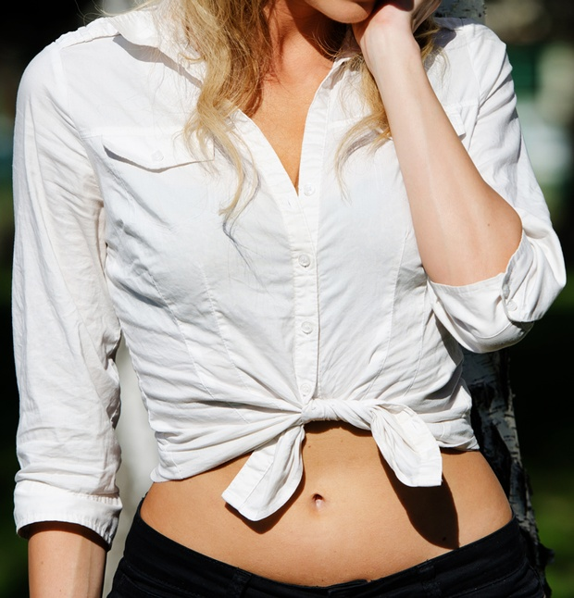
"You Americans, giving such a nickname to che bellezza." The stranger seemed delighted, those eyes sparkling.
"But, but, I'm a guy!" Mike squeaked.
The man with the beckoning eyes kept smiling. Reaching out, he took Mike's dainty hand in his and brought it to his lips, kissing the fingertips. "He did say you would be perfect for me."
The End

