I’ll use Emily saloon event as an example. You can see the code from all of my events inside the content.json file.

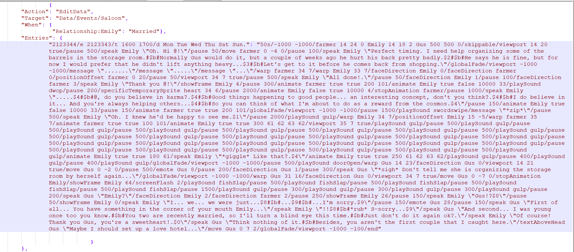

For a new event, first you have to decide where the event will happen. In this case, the location is the saloon.

Now we have to unpack the saloon map, so we can open it with tiled to see the coordinates.

For unpacking files, I use this tool: <https://github.com/LeonBlade/xnbcli/releases>

It’s pretty easy, you just put the file that you want extracted in the packed folder, you click the unpack.bat and the extracted file will appear in the unpacked folder.

The location of the maps files is this one:

Steam\steamapps\common\Stardew Valley\Content\Maps

If you’re going to use Stardew Valley Expanded maps (Ask for permission from the mod author first!) the location of the maps is this one:

\Steam\steamapps\common\Stardew Valley\Mods\Stardew Valley Expanded\[CP] Stardew Valley Expanded\assets\Maps\Locations

Put all files from those two folders into the packed folder and unpack them.

Once we have this, we open [Tiled](https://www.mapeditor.org/) and select “open,” under file tab. We go to the unpacked folder, and for this example we select Saloon.tbin

Now the map will open. We only need this value at the bottom left:

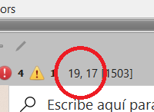

If you hover your mouse/cursor over the map, you’ll see that the coordinates change.

Now back to the code.



Let me explain what each part does:

**This part first:**

{

"Action": "EditData",

"When": {"Relationship:Emily": "Married"},

"Target": "data/events/Saloon",

"Entries": {

{ ->This is necessary, put it there for the event to work.

"Action": "EditData", ->This indicates that the event will edit data. Again, don’t think too much about this, just put it there and it will work.

"When": {"Relationship:Emily": "Married"}, -> Pretty self-explanatory, the event will happen when you’re married to Emily.

"Target": "data/events/Saloon", ->This indicates where the event will take place, it changes depending on the location, for example "Target": "data/events/town", if you want the event to take place in town.

"Entries": { ->Another part that you have to put there for it to work.

**Now, onto the preconditions for the event to trigger:**

"2123344/e 2123343/t 1600 1700/d Mon Tue Wed Thu Sat Sun.":

2123344-> This is the event ID, it’s a unique ID identifying that event, put a number there that no other event uses.

/e 2123343-> This indicates the previous event that you must see for this one to trigger

/f Sandy 1250 ->This indicates the hearts needed for the event to trigger. Each 250 points is a heart, so in this case: 1250/250=5 heart required with Sandy for the event to trigger.

/t 1600 1700 ->This indicates that the event will happen between 16:00 and 17:00 in game.

/d Mon Tue Wed Thu Sat Sun.-> The event WON’T trigger on Monday, Tuesday, Wednesday, Thursday, Saturday or Sunday. So in this case it only trigger on Friday.

Let’s look at another example of a more complicated event:

"371929/e 19931/f Abigail 3500 Sophia 3500 Leah 3500 Emily 3500/u 26/z summer/z spring/z winter/t 500 820"

371929-> ID

/e 19931->You need to have seen that event for this one to trigger.

/f Abigail 3500 Sophia 3500 Leah 3500 Emily 3500-> Abigail, Sophia, Leah and Emily need to be at 14 hearts for the event to trigger. Each 250 point represent a heart, so 3500/250 = 14

/u 26-> It’ll trigger on day 26 of the month.

/z summer/z spring/z winter ->It WON’T trigger in summer, spring or winter.

/t 500 820-> It’ll trigger between 5:00 and 8:20.

[Here](https://stardewcommunitywiki.com/Modding:Event_data) you have all the code that you can use under the EVENT PRECONDITIONS part.

**Now I’ll talk about the main part of the code:**

“50s/-1000 -1000/farmer 14 24 0 Emily 14 18 2 Gus 500 500 0/skippable/viewport 14 20 true/pause 500/speak Emily \"Oh. Hi @!\"/pause 50/move farmer 0 -4 0/pause 100/speak Emily \"Perfect timing. I need help organizing some of the barrels in the storage room.#$b#Normally Gus would do it, but a couple of weeks ago he hurt his back pretty badly.$2#$b#He says he is fine, but for now I would prefer that he didn't lift anything heavy...$3#$b#Let's get to it before he comes back from shopping.\"/globalFade/viewport -1000 -1000/message \".......\"/message \".....\"/message \"...\"/warp farmer 34 7/warp Emily 33 7/faceDirection Emily 0/faceDirection farmer 0/positionOffset farmer 0 20/pause 50/viewport 34 7 true/pause 500/speak Emily \"All done!.\"/pause 50/faceDirection Emily 1/pause 100/faceDirection farmer 3/speak Emily \"Thank you @!\"/showFrame Emily 4/pause 300/animate farmer true true 200 101/animate Emily true false 10000 33/playSound dwop/pause 200/specificTemporarySprite heart 34 6/pause 2000/animate Emily false true 10000 4/stopAnimation farmer/pause 1000/speak Emily \".....$4#$b#@, do you believe in karma?.$4#$b#Good things happening to good people... an interesting concept, don't you think?.$4#$b#I do believe in it... And you're always helping others...$4#$b#So you can think of what I'm about to do as a reward from the cosmos.$4\"/pause 150/animate Emily true false 10000 33/pause 150/animate farmer true true 200 101/globalFade/viewport -1000 -1000/pause 1500/playSound swordswipe/message \"*zip*\"/pause 500/speak Emily \"Oh. I knew he'd be happy to see me.$1\"/pause 2000/playSound gulp/warp Emily 34 7/positionOffset Emily 15 -5/warp farmer 35 7/animate farmer true true 100 101/animate Emily true true 300 61 62 63 62/viewport 35 7 true/playSound gulp/pause 500/playSound gulp/pause 500/playSound gulp/pause 500/playSound gulp/pause 500/playSound gulp/pause 500/playSound gulp/pause 500/playSound gulp/pause 500/playSound gulp/pause 500/playSound gulp/pause 500/playSound gulp/pause 500/playSound gulp/pause 500/playSound gulp/pause 500/playSound gulp/pause 500/playSound gulp/pause 500/playSound gulp/pause 500/playSound gulp/pause 500/playSound gulp/pause 500/playSound gulp/pause 500/playSound gulp/pause 500/playSound gulp/pause 500/playSound gulp/pause 500/playSound gulp/pause 500/playSound gulp/pause 500/playSound gulp/pause 500/playSound gulp/pause 500/playSound gulp/animate Emily true true 180 61/speak Emily \"*giggle* Like that?.$4\"/animate Emily true true 250 61 62 63 62/playSound gulp/pause 400/playSound gulp/pause 400/playSound gulp/globalFade/viewport -1000 -1000/pause 500/playSound doorOpen/warp Gus 14 23/faceDirection Gus 0/viewport 14 21 true/move Gus 0 -2 0/pause 500/emote Gus 8/pause 200/faceDirection Gus 1/pause 300/speak Gus \"*sigh* Don't tell me she is organizing the storage room by herself again...\"/globalFade/viewport -1000 -1000/warp Gus 31 16/faceDirection Gus 0/viewport 34 7 true/move Gus 0 -7 0/stopAnimation Emily/showFrame Emily 64/screenFlash 2/playSound fishSlap/pause 500/playSound fishSlap/pause 500/playSound fishSlap/pause 500/playSound fishSlap/pause 500/playSound fishSlap/pause 1500/playSound gulp/pause 300/playSound gulp/pause 300/playSound gulp/pause 300/playSound gulp/pause 200/speak Gus \"Emily?\"/faceDirection Emily 2/faceDirection farmer 2/pause 250/showFrame Emily 26/pause 150/speak Emily \"Gus!?$8\"/pause 50/showFrame Emily 0/speak Emily \"I... we... we were just...$8#$b#...$9#$b#...I'm sorry.$9\"/pause 150/emote Gus 28/pause 150/speak Gus \"First of all... You have something in the corner of your mouth Emily...\"/speak Emily \"!!$8#$b#*rub* S-sorry...$9\"/speak Gus \"And second... I was young once too you know.#$b#You two are recently married, so I'll turn a blind eye this time.#$b#Just don't do it again ok?.\"/speak Emily \"Of course! Thank you Gus, you're a sweetheart!.$0\"/speak Gus \"Think nothing of it.#$b#Besides, you aren't the first couple that I caught here.\"/textAboveHead Gus \"Maybe I should set up a love hotel...\"/move Gus 0 7 2/globalFade/viewport -1000 -100/end"

}

},

Again, let’s dissect it:

50s ->Here you put the music that will play at the start of the event. In this example the music that plays is “50s,” is the one I usually use for adult events. Another cool one is “sweet”. If you put Continue there, it indicates that the music that was playing before the event started will continue playing.

/-1000 -1000->This indicates where the camera will be at the start of the event, those coordinates are outside of the map, so a black screen will be seen at first.

/farmer 14 24 0 Emily 14 18 2 Gus 500 500 0/->Here you put the name of the characters that will be in the event, the coordinates, and the direction he or she is facing.

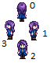

So for the previous example, the farmer will start in the coordinates 14 24 of the saloon map facing north(0), Emily will start at 14 18 2 facing south(2). And Gus will start at 500 500 facing north (0), outside of the normal map so you don’t see him for now.

/skippable -> This makes the event skippable.

/viewport 14 20 true -> This puts the camera at the coordinates 14 20, the true indicates that another command will play when this one finishes.

/pause 500 -> This pauses the event for 0,5 seconds.

/speak Emily \"Oh. Hi @!\" -> This show a dialogue window like this one:

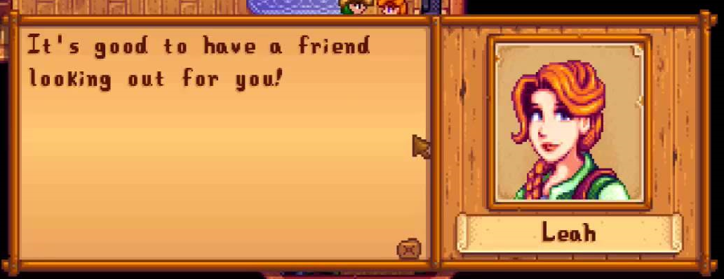

In the example the one who talks is Emily. The @ indicates the name of the farmer and will appear as the farmer’s name in game.

/pause 50 -> Explained already

/move farmer 0 -4 0 -> This command moves the farmer 0 coordinates right, -4 coordinates north, and he will end facing north(0). Use tiled to see the coordinates to see where to move the characters.

/pause 100-> Already explained.

/speak Emily \"Perfect timing. I need help organizing some of the barrels in the storage room.#$b#Normally Gus would do it, but a couple of weeks ago he hurt his back pretty badly.$2#$b#He says he is fine, but for now I would prefer that he didn't lift anything heavy...$3#$b#Let's get to it before he comes back from shopping.\" -> Now this is a dialogue command again, but this one has a few new things.

First, the #$b# symbol: this indicates a jump in the message to a new dialogue window.

And now the $2, $3, etc. This indicates the portrait that will appear for that dialogue.

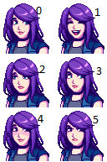

for example:

/speak Abigail \"Hi farmer.$0#$b#I like you$4\”

Will show first “Hi farmer”. With portrait 0, and then will jump to a new window with “I like you” with portrait four.

/globalFade/viewport -1000 -1000 ->Those two go together, it will fade the screen to black.

/message \".......\"/message \".....\"/message \"...\" ->Now those just show a message window without any person/character speaking.

/warp farmer 34 7/warp Emily 33 7/->This will warp/teleport the character to the indicated coordinates of the map, as we faded the screen to black.

/faceDirection Emily 0/faceDirection farmer 0/-> With those commands you select the direction that the character will be facing. It uses the same directions as the /move command.



/positionOffset farmer 0 20-> Now this is an important command for positioning. It moves the character, but at a shorter distance that the /move command. For example: /positionOffset farmer -1 0/ will move the farmer very slightly to the left, without changing where is he facing.

From now on I’ll only explain the new commands that appear on the event, as you should already have a basic understand on how the event is structured.

/showFrame Emily 4-> This shows the frame at position 4. Like the portraits, it starts at 0. So in this case it shows the last sprite from the first row. I usually use the /animate command instead of this one, as it can have the same functionality.

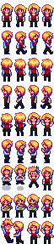

/animate farmer true true 200 101-> This command is how the character is animated. In this case, it only shows one sprite, so for now I’ll jump ahead and I’ll explain later this command with a better example on how it it’s used.

/playSound dwop->This plays a sound. In this case “dwop“ is the sound used for a kiss.

You can find a list of possible sounds here: <https://gist.github.com/dpchamps/46b1473415d412e220a21cb84dd9aad6>

/specificTemporarySprite heart 34 6->This command shows a small heart at the selected coordinates. Do not confuse this with the “/emote” command that’ll be explained later.

/stopAnimation farmer->This stops the animation that is playing for that character.

/animate Emily true true 300 61 62 63 62-> Now this is a better example for the “/animate” command. The first “true” indicates if the animation will be repeated, if you put false there it will only play one time. The second “true” indicate if the sprites will be reversed or not. For example this sprite:

 will appear like this  in the game if you have it at true.

The 300 indicates the millisecond that each frame of the animation will be shown.

And the other numbers indicate the frames that will be shown. Those are all frames for Emily.

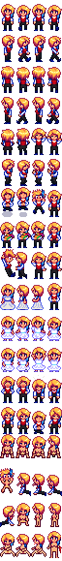

The first row has frames 0, 1, 2 and 3; the second row has 4, 5, 6, 7. Etc (4 per row)

So for this example: /animate Emily true true 300 61 62 63 62. It will animate Emily, the animation will be repeated, it will be reversed, and each frame (61,62,63,62) will stay for 300 milliseconds.

/playSound gulp/pause 500/playSound gulp/pause 500/playSound gulp/pause 500/playSound gulp/pause 500/playSound gulp/pause 500/playSound gulp-> Now I use this to give some sound to the scene, for blowjobs I usually use “gulp” sound, for sex “slimeHit” and for orgasm “fishSlap”

/screenFlash 2->This makes the screen flash for two seconds. I usually use this when a character cums.

/emote Gus 28->This show an emote from the next list above the head of the character named.

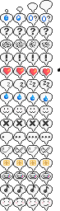

Again, the list starts at 0. For this case only put the first number of each row and it will animate the whole row. For example, if I use /emote farmer 32, it will show an animation on the head of the farmer with these four sprites: 

/textAboveHead Gus \"Maybe I should set up a love hotel...\”->Similar to the /speak command, but in this case, it shows the text above the character head, like the /emote command.

/end-> This ends the event.

Now, I really suggest that you start modifying some of my events and then play the event in the game to see how the changes affect the event.

Those are the basic commands, but there are a lot more.

On this page you have a list with all of them clearly explained:

<https://stardewvalleywiki.com/Modding:Event_data>

If you have any questions, there is a channel for modding on Discord where I can help.