TAKING AFTER MOTHER
COMMISSION STORY
BY CHALDEACHANGE
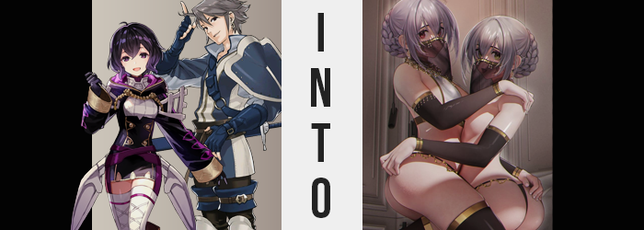

Was it difficult to be the children of a woman who was by far one of the most famous dancers in all the realm? This wasn’t a question that too often crossed the minds of the children of Olivia, Inigo and Morgan. Admittedly it wasn’t as if they had grown up under the light of that fame. They hailed from a timeline where Grima had succeeded in its plans and had ultimately killed their mother.

As a direct result a number of grown children from this lost future had traveled to the distant past, from before they had even been conceived much less born. It was here that they children had met with their parents when they were younger. Olivia was one of them when it came to Inigo and Morgan of course, but Robin was also their father. Things had certainly been confusing at first (and how could they not be?) but they had been accepted rather quickly.

But this also meant living in an era when Olivia the dancer was extremely popular. Never had her children been able to see her dance the way that she did in this era, back when she was young. The brother and sister were in awe of the sight and had been infatuation by just how skilled that their mother was, and while their career paths were undecided with the whole ‘saving the timeline’ thing, dancing had begun to look like a more appealing prospect.

“Oho! Are you interested in these? I have a very limited stock, you know? Once they’re gone, they’re gone!”

It wasn’t an unfamiliar sight to see Anna peddling her wares in a way meant to appeal to FOMO. ‘If you don’t buy this now you’ll never be able to obtain it!’ was a fairly standard merchant technique, but both Inigo and Morgan had been skeptical that day because it wasn’t the Anna they knew. Everyone in the Shepherds was aware of it at this point; that there were different Annas in different Outrealms. This one had come from abroad and was waving about a pair of Second Seals in her hands that had a subdued purple colors to them.

A vaguely questionable purchase to be making since they didn’t resemble the standard fare. But apparently that was because it could reclass those that used them into Dancers.


“Are you sure you want to use them here, Inigo? Would mother not be more excited if we did it in front of her?” The younger sister, Morgan, asked several hours later. Not only had they purchased those Second Seals despite their better judgment, but they had brought them back to Inigo’s tent to use them according to the brother’s own request. He hadn’t confided in his younger sibling about his reasoning for doing it privately, but he was concerned that the seals weren’t authentic.
Considering their off-color and the Anna that had sold them being unfamiliar, he had a vague feeling that something might go wrong. Not in a devastating way, but perhaps they wouldn’t work? He didn’t want to make such a blunder in front of his mother and he very much assumed the purple-haired Morgan was the same. “Mother will be happy regardless. Let’s just… use them here, alright?” Class changes were generally approved of by their father first as well, seeing as he was the tactician.

And Inigo was vaguely worried he wouldn’t approve of the use of such shady looking seals.

There was little to no fanfare when the teenaged boy brought the seals out of the pouch he’d brought shopping that morning. Second Seals were fairly common items and were used frequently by those that had to fight on the battlefield. “Here Morgan.” There was no rhyme or reason to which seal he handed to his little sister. They were both identical and would presumably do the same thing. Though while this perhaps sounded like irrelevant information at first, the one he had handed Morgan had been made before the one he kept for himself.

“Okay! And let’s go!” They both wanted to be dancers, but for Morgan her reasoning might have been a little more personal than she had confided in Inigo – even if he’d gleamed her reasons on his own. Because she still had a lot of amnesia about her life prior to coming to the past, she believed that by becoming a dancer she would in turn become closer to her mother, Olivia. Hopefully this would help inspire the recollection of additional memories, or so she had hoped!

The activation of the two seals went about as expected. To use a Second Seal you essentially had to ‘break’ it in your hands, and the energy stored within would change your combat attire and imbue you with the knowledge necessary to fill in the gaps between your old class and the new one. Inigo noted early on that the process appeared off somehow though. Upon breaking the seals light had begun to glow beneath them and that was normal.

But why was the light a pale purple?

He hesitated to comment. “Morgan, how do you feel?” The light was lingering and their clothes hadn’t showed any signs of changing. He also didn’t feel like he knew anything about dancing that he hadn’t already known before. Had the effects been delayed or had his hunch been right that they had been scammed? His sister didn’t reply immediately though, prompting him to look over to her. “Morgan?”

“Hm? What’s wrong, sister?” The younger sister did eventually respond, but there was something off about her. Her words sounded a little floaty. There was no infliction in what she was saying. It was all deadpan, like she was caught up in some manner of trance. Of course how she had said it wasn’t quite as bizarre as what she had said, at least to Inigo. Had he misheard her, or had she just referred to him as her sister?

The older brother naturally opened his mouth to rebuke this, or at least correct her while making sure she was okay, but what felt like a kick in the pants stopped him from doing so – instead forcing him to bellow out a groan. “Argh!?” He keeled forward like the force of a ball had just collided with his junk, and yet not even that dramatic gesture prompted a look of concern from his sister, who seemed to continue to stare off into space.

“What… was that!?” A sharp voice crack could be heard but Inigo didn’t really notice considering how much… pain… he was in? No, did it actually hurt? The force had shocked him but there was no lingering agony. In fact, while correcting his posture he couldn’t help but note that there wasn’t any pain whatsoever. And so he sent a hand down to pat the front of his pants. “That was certainly… certainly… EEK!?”

A girlish scream escaped her mouth once she finally realized. The front of her pants was completely flat, and pushing in upon them found nothing but the void. The moment Inigo had acknowledged her sex had changed was the moment her brain had ‘updated’. Even if she didn’t mean to from that point on, she would view herself in the feminine. “Where did it go!?”

Morgan continued to remain indifferent to her brother’s own struggles, the purple light beneath them persisting. She didn’t even look at him, but if she had? She might have pointed out that it wasn’t just his genitals that had changed, and were in the process of continuing to change. Inigo was shorted, her face pointedly a feminine version of its previous self, and her hair now shoulder lengthened. And that didn’t even include what was happening beneath her clothes.

Inigo soon found herself distracted by the sensation of her nipples rubbing up against the underside of her tunic. Had they always been that sensitive? No, nor had they been as big as they were. Those nips had essentially doubled in size, leading the charge as fat built beneath them so that she had a small, A-cup pair of breasts that were similar to her sister’s. Just as similar to her sister was her ass, which took on a bloated, rounded, bubbled appearance behind her. This forced her hips a little wider and her thighs a little plumper.

All in all? She was still easily identified as Inigo.

If not for her sex, that is.

“I’m… I’m a woman!? Morgan, why aren’t you saying anything!?” Her voice was even higher than Morgan’s as she now noted, but her mind was torn between two very different – but related – issues. The transformation affecting her own body was certainly a big one, but Morgan’s silence was another. Were the things she said to her even registering? You would think that if you watched your brother turn into your sister that you might have something to say?

She took a step forward to give her little sister a shake in hopes it would snap her out of it. But she didn’t manage to travel the entire distance before the light the Second Seals had created grew brighter, and a lighter feeling prompted Inigo to stop. But she realized what had happened by looking at Morgan before she realized the exact same thing had happened to her. “Your clothes!”

The youngest sibling’s robes had disappeared only to be replaced by a different outfit. That was what Second Seals were supposed to do on use, and while it was definitely the attire of a dancer it also wasn’t right. Morgan had a translucent, black veil with golden accents across her mouth and was wearing a white bikini top with gold trim that wrapped behind her back. There was a black, thong-like garment around her loins that had golden chains around it, and thigh high black leggings and sleeves that left her feet and hands exposed. But other than her hair being braided into a bun behind her?

She wasn’t wearing much of anything.

It wasn’t until she turned her gaze down slightly to see a similar veil across her nose that Inigo realized... “Wah!?” …that she was wearing the exact same thing. She’d been trying to put the fact that her sex had changed in the back of her mind, but it was impossible to do it with her body completely exposed. Come to think of it, had her body always been so… soft? These was a tone to her belly and arms still, but it wasn’t nearly as toned as she remembered it being.

Looking back up at Morgan, she blinked several times to make sure her mind wasn’t playing tricks on her. “Your hair…” Its dark purple coloration was lightening to a softer shade of mauve. It had started from the roots and swept through her braided bun and bangs. Inigo, on the other hand, was in no position to realize that her silver braided bun had been recolored in the exact same tone. In the case of either woman that was now their permanent and biological hair colors, and it permeated through their brows, pubes, and body hair with time.

She didn’t vocalize it, but it wasn’t just Morgan’s hair that changed color before her very eyes. Her purple gaze held a hint of red to it, and were the shapes of those eyes… different? “M-Madilynn!?” That was the wrong name and yet it didn’t even click with Inigo. Because her little sister looked more and more unfamiliar thanks to a wave of changes affecting her face.

Inigo was ignorant to the fact that the very same changes were affecting her own complexion. The eyes of both sisters widened and eyelashes fluttered longer. There was something notably alluring about them as their resting expressions appeared welcoming yet subdued. Their lips thickened, noses shrunk, and cheekbones narrowed. Yet Inigo’s eyes, now pale purple in color, couldn’t help think that there was something else.

Did Morgan look older?

Looking up at her— “…Up?” She was the taller sibling, wasn’t she? Why was she looking up? Fixated on Morgan’s face like she had been, she hadn’t being paying attention to her own stature. Inches had been shed while their faces had change, but solely from Inigo’s body. Morgan had actually grown two inches taller, and in the end she was 5’4” while Inigo was 5’1”. “Well she is my older sis…ter…? Wait, is that right? I thought I was…? Madilynn! I need you to snap out of it!”

This finally seemed to stir something in Morgan’s mind and she blinked. “Isabella?” The name that was uttered both stunned the now younger sister and seemingly awakened something inside of her. Isabella? Was that her name? Hadn’t it been something else? A boy’s name? But how could she possibly be a boy? “Oh dear. Why is your top so loose? What would you do without your big sister watching over you? What would our clients think if the cloth flapped around during our dances?”

Morgan was acting like a proper older sister looking over her younger sibling, which did make some sense since they were now three years apart. Morgan was 21 and Inigo was 18. “Our clients? Dancing…?” Did she know how to dance? Inigo felt like she’d known how to… she still did? But this dancing was… How to dance around a pole, how to weave her body with her sister’s, how to perform atop a client that wanted to get a little more intimate. She blushed, these skills locking her up and overwhelming her.

And so she didn’t note much else of their transformations. Not that it was as excessive on her part as it was Morgan’s at this point. Within her own bra, Morgan’s breasts soon jiggled to life. Her nipples ached and the young woman moaned in response, nips pushing her own garment forward while tits inflated to enticing D-cups. On the other hand? Inigo’s only swelled to B’s, but at least this meant her bra top was no longer so loose.

Farther down, the thong bottoms of both women dug into their flesh to differing degrees. It was once again Morgan who received much of this blessing, her ass cheeks tripling in size and even doing a hearty bounce from how quickly the weight piled on. Her ass was ultimately shaped like a heart and extended six inched past the arch of her back, whereas excess saw thighs thicken and hips widen. On the other hand, Inigo’s ass and thighs did bubble, but she didn’t meet the same standard that her older sister established.

Not that it mattered! What she lacked in curves, the younger dancer was more than confident that she could make up for it with technique. There were some things that only a smaller body could do both dancing and in the bedroom after all, and she had studied and practiced tirelessly so that she could do them. That was why they were so powerful as a duo and why they were sought after by so many. Not to mention why they had required an agent! With these memories of hers stabilizing, the younger sibling suddenly blinked and her exasperated expression subsided. She felt calm, quiet, and at peace.

The light of the Second Seals finally faded along with any memories of having used them in the first place.

“…Isabella? What’s the matter, my dear little sister?” Just as calm as she had been throughout her transformation, the older sibling that had once been the younger spoke up finally with a subtle tilt to her head. From what she could recall her sister had been freaking out about something, but she seemed much calmer now. Much more docile as they typically were. They had to be in their line of work, Madilynn knew this.

Isabella felt… uncertain. Had something been bothering her? Looking at her beautiful elder sister seemed to fill her with ease. Nothing had been wrong, had it? Surely it had just been all in her head? The closest thing she could recall to a concern was the idea that she had once been a man and she knew that couldn’t possibly be true. “...I’m sorry, Madilynn. Perhaps I need to sleep more going forward.” She’d had a number of late nights as of late, but that more the fault of their work than her own decision.

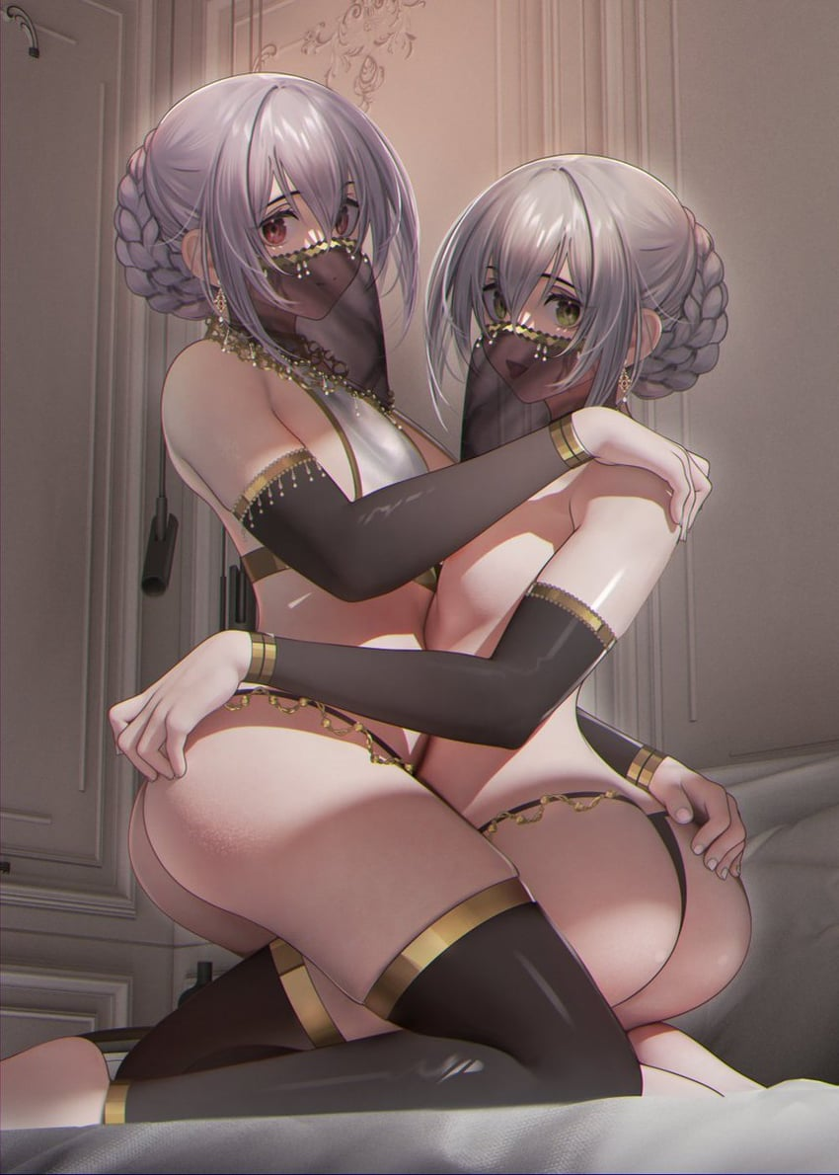
The two young women were certainly dancers, but not of the same sort as their mother. Their dances weren’t meant for the battlefield but for the private quarters of any noblemen or noblewomen willing to pay for their ‘services’ – which often included ‘aftercare’. Since the two sisters were talented, beautiful, and skilled in bed they were often requested. And come to think of it? “Should our manager not be picking us up around now?”

Anna was this manager. The one that had sold them those Second Seals in the first place. But the pair didn’t remember any of that, just that she was the one who booked them work. They were paid handsomely and she took a healthy cut of those funds, but there was no one as good at finding them places to dance as she was. “Of course I am! I was just waiting for you two to finish!”

This manager’s voice called out with as much energy as ever from outside of the tent. Once she dropped them off at their current job, she was thinking, she’d have to go and make some more seals now that she knew for certain that they worked. But why keep it isolated to dancers? What other things could she use them for? Some food for thought! Perhaps she could turn some nobles into maids?

As Madilynn and Isabella stepped out of the tent and into the night air, a single thought crossed their minds simultaneously. One that would vaguely haunt them for the rest of their lives, surely.

Mother wouldn’t like the kind of dancers we’ve become.

