TIDDY OF TIME II.
A LITTLE LESS TIDDY
DECEMBER 2021 REQUEST STORY
BY CHALDEACHANGE
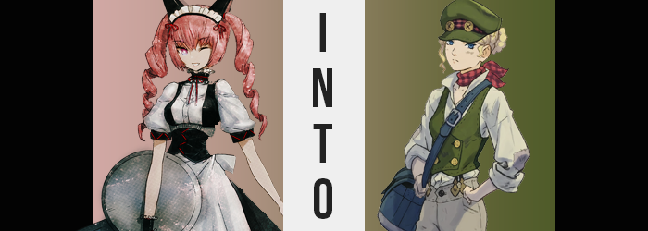

Rumiho Akiha, better known by those in Akihabara as Faris Nyannyan, was very perplexed by her current situation. The last she could recall she had visited Rintarou’s laboratory for a party organized by the girls. Everything had been going so well! There hadn’t been a single hitch in their plans, aside from Suzuha’s sudden disappearance. Considering Suzuha’s personality though, it wasn’t something that everyone hadn’t expected to transpire in some capacity.

Faris had planned on putting her talents as a maid to good use at the party, helping with drink and snack distribution, and so she had come dressed in her maid attire. She was more than accustomed to “normies” looking at her funny at this point in her life, so she’d even walked over fully dressed. What was the point in living if she couldn’t stay true to herself, right?

But the party had taken a very unusual turn. A flash of bright light had disturbed the peace, and the next she knew? Faris wasn’t at the party at all. She was standing in the middle of a street dimly lit by torch lanterns, her senses assaulted all at once by irregularities. It was extremely cold for one, and with the moon in the sky she imagined the time of day had something to do with it. “Guh!?” What was more overwhelming was the scent. Despite being outside, it was so pungent! Like garbage? No, something worse than garbage?

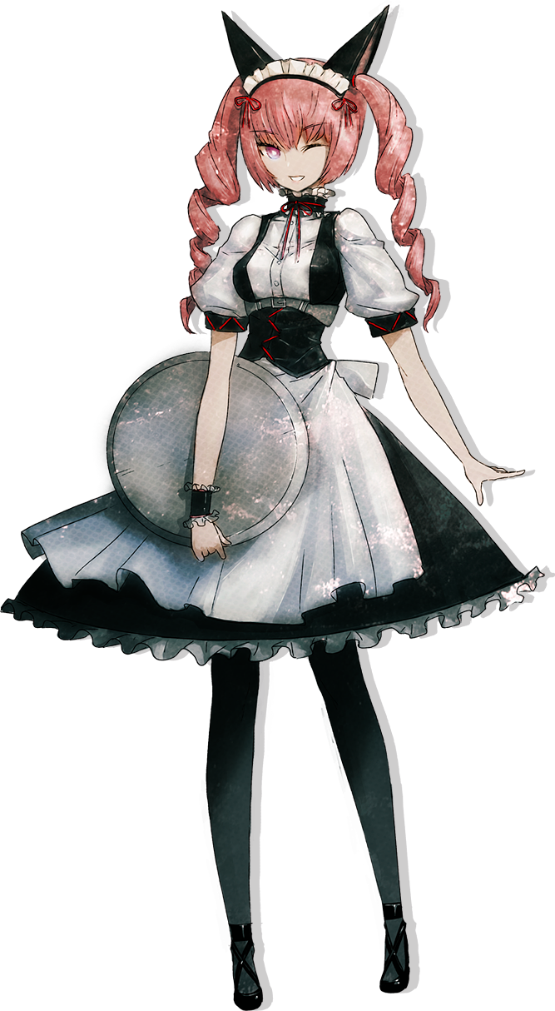
“Where… am I?” The oil lamps barely cast a glow on her surroundings, but from what she could make out there was little commonality between the architecture here and what she was used to. The road she stood on was cobblestone, and the multistoried buildings made of stone and brick didn’t seem like Japanese architecture. If she needed anymore proof towards the assumption that came to mind though, it landed in front of her: a newspaper carried by the wind. “English!?” It was written completely in the English language. She was fluent though, so after bending down to pick it up, she read the title. “The London Times? LONDON!?” How was she in London? But that wasn’t even the most shocking part. No, the most shocking part provoked her into dropping the paper. The year…

It was the late 1800s?

“No, no. That’s impossible! A different country? A different time? And… Ngh! Why am I so ITCHY!?” One of those concerns was far less serious than the others, or at least that was how it sounded. But for the past thirty seconds or so, her scalp had begun to tingle until it had blown into a full fledged itch. Said itch grew, and grew, and grew, until the maid could no longer resist bringing her fingernails to her scalp. “Ahh…” It brought momentary comfort. Until it occurred to Faris that something felt wrong. Her hair felt…

Gross. Fingers moved from satisfying her scalp to sliding against locks of hair that she always saw to with the finest shampoos and conditioners to make sure her pink locks were in tiptop shape. But they didn’t feel like that. The hairs themselves felt unhealthier, coarser, and grimier – and they appeared that way too. Fingers even worked their way down the curling twintails, but they stopped short because they weren’t as long as they were supposed to be. “WHAT!?”

“No way! What’s going on!? Why does my hair feel like this!?” It was growing shorter within her very fingers, in fact. But the length alone wasn’t the only thing at stake. At the very same time, her infamous pink was being sacrificed for a dirty blonde that visually made its reduced quality even more apparent. Speckles of dirt clung to a mane that reached only just above her shoulders, and the griminess was clearly a sign of a lack of bathing regularly, if at all.

Hard t’ take a wet one when yer livin’ on the streets.

Well, that would certainly make some sense, but… “Wot!? What was that thought? No, a memory? I don’t like this!” It was only natural that she didn’t, but the situation was actually much worse than she even realized. After all, the fact that she’d blurted out ‘Wot’ in English with a very thick accent before finish her sentence in Japanese had gone more or less disregarded – which was to be expected, considering the shock that wracked her now.

In tandem with her outburst, there had been a change in her eyes. Much like her hair, the uncanny pink that plagued them was washed away, but not by a blonde in this case. Rather, it was an ocean blue that was certainly more typical of Westerners, but then again the line of Faris’ racial background was rapidly becoming skewed. All it took was one look at the shape of those eyes, and the overall shape of her face, to reveal the truth.

Those baby blue eyes were widening, becoming rounder in design by the grace of her eyelids, while her lashes thinned to indicate that they were not in any way cared for. “I’ve really gotta figure out wot’s happenin’ here!” All the while, her Japanese was peppered with more and more heavily accented English, as a clear Caucasian lean was applied to all of her facial facets. Her cheeks became bonier for one, and those bones raised to give her sharpened chin an overall lengthier look. Her nose became more apparent, and her lips a little plumper, but this English-looking young woman would not be seen as ‘fair’ by society.

Not with how dirty she was becoming. The filth that had matted her hair had spread. Not only into her facial features, where days of dried dirt could be seen against her complexion, but across her entire body. Her maid costume remained untouched, but everything below showed at least some signs of a lackluster lifestyle. Whether it was the ample dirt beneath her fingertips or the scum between toes, she evidently was not the recipient of any modern healthcare.

“Eh? But is somethin’ really? Nah, I’m just… No! That’s not… I ain’t…?” Her English was fluent now, with not a single word of Japanese mixed in. This was reflected in her thoughts as well – she couldn’t speak a single word of the language if she tried. The memories of doing so no longer existed. In fact, things about this street she had found unbearable before were becoming more normal. The temperature and scent; it all felt like something she lived with daily.

If anything was unusual, it was her point of view. “I am feelin’ kind o’ meek though. Coulda sworn I wasn’t this puny…” Rather than finding her hair or how dirty she was strange any longer, she was fixated on her… height? She couldn’t remember being this short since she’d been a little lass, in fact. It wasn’t a feeling that lingered for an overly long period of time however, not before reality was adjusted so that it all ‘made sense’ again.

And so the maiden’s petite form began to stretch vertically. Her feet remained planted on the ground, obviously, but the peak of her head grew farther and farther away from the ground thanks to a combined elongation of her limbs and torso. Which, in turn, brought about mayhem as far as her maid costume was concerned. The black tights she wore beneath her skirt, for example, were pulled down off her hips so that the cool night air teased a rear that was naked short of her panties, and the skirt of the gown was lifted higher so that her pelvis was fully exposed, what with it all struggling to rest on a torso that was several inches taller.

In fact, it was a full eight inches that were ultimately applied to her overall stature, leaving the short sleeves of her dress pulled up to her slightly widened shoulders, and tights ultimately resting in the center of her thighs once the full height had reached fruition. While the growth appeared to be mostly vertical, there were a couple of areas that had grown: namely her hands and feet.

In the case of the form, Faris’ fingers all appeared longer and bonier, and the nails that already had dirt tucked underneath them were frayed and bitten. Her feet almost felt set to burst out of her shoes with how much more ample they had become. Calloused to boot, with a sharpened heel so hard that it was almost alarming. But such was the life one had to lead in this society if you didn’t have a single coin to your name.

“Now wot the ‘ell am I wearing ‘ere? A maid? I’d sooner take me own ‘ead than subject myself to that!” To someone not familiar with this accent, her English might have sounded nigh indistinguishable at this point. But she was understandably fretting over an outfit that didn’t fit her at all, not because of the fit but because of the social implications. Being a maid was certainly a fair way to make money in this world, but she sure wouldn’t subject herself to the subservience of another.

So distraught by her maid uniform, Faris didn’t even note that it was growing a little looser in some areas. The bosom was one, as her breast dwindled in size to become two cup sizes smaller, and her rear was the other. In fact, her hips narrowed several inches without those perky buns to justify their breadth. And in front, her now blonde pubes grew incredibly bushy. Overall these changes contributed to her leaner frame. Lean and very thin, because as she could now recall it was difficult to even obtain scraps of food on the daily. “Maybe I can sell this getup though… Hehe…”
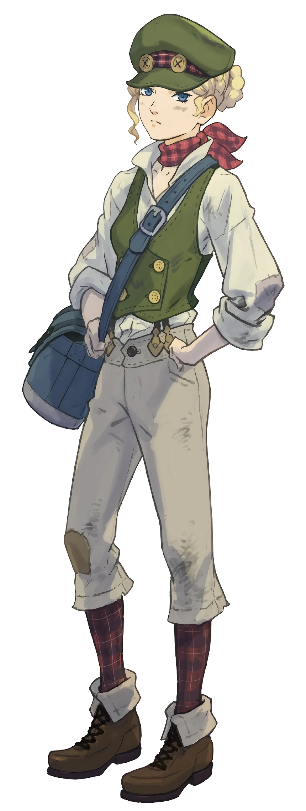
Unfortunately for her, any silver lining dissipated before her very eyes. Much to the girl’s surprising, the outfit seemed to soften into a moldable slime that tickled her body as it crawled about, spreading the cover her body from head to toe before it ultimately hardened. The end result was an entirely different ensemble in entirely different colors, but they were at least better suited for the nipping cold.

Said outfit consisted of a tanned, loose fitting shirt with a popped collar beneath a green vest, matching tanned pants with a button between her hips, and a green hat atop her head that found her hear weaved beneath it so that it wouldn’t tickle her neck nor shoulders. Paired with plaid socks and brown boots, these clothes were filthy and worn, with no shortage of patches applied where they had clearly torn in the past. A plaid scarf was wrapped around her neck too, just to keep it safe from the night chill.

But Gina Lestrade didn’t really care about that. Life was tough, and she was just doing her best to make sure she could survive. On that note, had she just wanted to sell something? She couldn’t really remember honestly, and that bothered her for all of ten seconds. Life was too short, especially if you lived on the street and worked as a pickpocket like she did. “Musta not been important if I forgot then.”

She was filthy, so what? Couldn’t do any better on the streets of London. Money didn’t come easy, shelter even less so. She couldn’t even dream of the idea that she had once lived in a fancy apartment with a lot of money to her name in the far away nation of Japan. Hell, that place had only become one of note to Britain in the past few decades. If you’d explained such a reality to her, Gina would’ve just smirked and robbed you blind.

Shrugging, the girl started down the road ‘again’. It was surely late, but that didn’t really matter all that much. Not like she had parents to give her a bedtime, right? “Maybe I can hit a carriage or two. I know a few of ‘em ‘ave some good hidin’ spaces under the seats and wotnot.”

But Gina didn’t know just how fateful that decision would be.

