NASHU NATION
COMMISSION STORY
BY CHALDEACHANGE
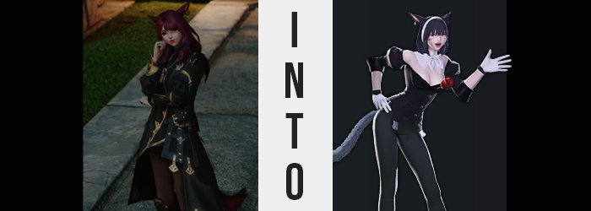

“This is the place, isn’t it?”

Silvia Kuroi paced back and forth in front of what looked to be an old storage shed in Kugane. This wasn’t her normal job – investigating things as mundane as someone’s personal storage that is. She was a scholar, a woman who focused on the past of this world and how the past could teach us things about the present so that we can walk confidently into the future. Whether it was going on expeditions to ruins or analyzing artifacts that had been sent her way, those were means through which she contributed to her profession.

So why was she checking on a storage shed that wasn’t her own? Silv probably would have called it a ‘favor’ and in a sense of the word it was. But realistically? She was repaying a debt to the keeper of the inn she was staying at after accidentally breaking the lamp in her room. A new discovery had gotten her a little too excited and, well, the rest was history. “The innkeeper said that a previous guest had been using it, right? Nashu… something.”

Specifically, his request had been to have her check out its contents. He had given her a key and asked her to open it up. The reason? Some local kids had mentioned hearing something rummaging around inside. They claimed it had been a monster, the innkeeper had been concerned it was a thief, but the ruby haired Miqo’te was fairly confident it was just a small animal. If the door was locked then what else could really get inside?

CLICK!

There wasn’t any fanfare when she unlocked the padlock and opened the door. Apparently it had been some months since the one renting had last come back, but she had also put down enough Gil to cover a year. So what was she keeping inside? “Are these explosives? Was the innkeeper aware of this?” The space didn’t amount to more than a small room – smaller than the room she was renting at least – but it was filled with shelves full of boxes. Boxes that contained various explosives. Some of them laid around the floor. Someone or something had definitely been rummaging around inside.

It didn’t take long to figure out what. A chipmunk dashed out from a nearby shelf and past Silvia’s ankles into the outside world. “That’s what I figured. Mystery solved I guess.” But should she mention the explosives? It did seem like something worth asking but it also wasn’t really her business. Her debt was paid with this. She placed a hand on her hip after stepping deeper in for a moment to make sure no animals were inside, but without any indication that it was about to happen?
BOOM!

A small explosive detonated on the shelf she had been staring at. Fortunately it wasn’t very powerful, but it was shocking enough to send her flying back onto her ass – after scattering a strange powder around. “What the heck was that!?” She sat there stunned a moment, listening out to make sure nothing else exploded. It didn’t seem to. But she also was quick to catch onto the fact that she hadn’t come out of the incident scot-free.

One might have expected that, having a small bomb go off in your face, such an incident might have damaged the hair of the one experiencing the blast. While slowly picking herself up though? No singed nor damaged strands of ruby red hair could be observed. Did that mean that nothing was wrong with them, however? Not quite. They weren’t burned but the tips of Silvia’s hair were black. The issue was that it wasn’t from heat damage. After all, if these strands really had been burned from a sudden explosion then would the color by slowly creeping inward?

“I really should report my explosives. They’re going to get… someone… killed… Hold up. Did I just call them mine?” That just wasn’t correct. She had been talking about how she planned on getting that ‘Nashu’ person in trouble, only to refer to her stash like it was— “Bugger! I did it again!” …Bugger?

The black in her hair crept closer and closer to her roots with around half of her mane darkened now. What became far more curious about this phenomenon in the meantime was how the effects didn’t seem to be isolated to color alone. The texture of the dyed portion seemed silkier somehow, but perhaps it was because these strands had been straightened wherever the new color had seeped in? Silvia’s mane typically reached her shoulder blades, but was it regressing? It only dangled just past her shoulders now, and the darker the color became the more like a regular bob the style seemed to become.

Of course, being a Miqo’te? The hair atop her head shared a coloring with the fur of her ears and tail. And the black didn’t leave them untouched, not by a long shot. When it came to her feline ears there wasn’t too dramatic of a shift beyond the color change and a very subtle shortening of length. Yet Silvia’s tail? The thick fur that clad it seemed to thin out until it was neatly groomed and trimmed, black eventually coating it entirely before long. It had the look of a tail that underwent a different grooming process with different grooming preferences.

If the fur is too think and I get caught up in an explosion then it’s way too difficult to clean after!

Had she thought about it that would have been the logic that would have come to mind. “This stash of explosives belongs to me. No, to me! Bollocks!” The scholar was unfortunately still too fixated on the problems with her speech for it to truly register the issues with her body. Try as she might, she couldn’t speak of the storage hut’s contents as if they were someone else’s, leaving her rather flustered. But what if she changed the way she worded it? “This stash of explosives belongs to I, Nashu!” Nope! And is if to make matters worse, her voice was sounding less and less familiar. It wasn’t usually so… raspy.

Silvia’s hair was entirely black by this juncture and her new bob had not only formed entirely, by a white hairband had appeared atop it between two different earrings in her ears – suggesting that whatever was happening to her wasn’t isolated to her body alone. But when it came to that body? The fact that things were changing had spread to other facets. You only needed to take her complexion for example. It was paling towards a white that only a Keeper of the Moon Miqo’te could ever really be born with, leaving nipples and her clit paler in color in the wake of it all.

“What is wrong with me?” Pushing aside the mental confusion, the sound of her voice had finally prompted the woman to examine herself in other ways. The pastier color of her skin was something she observed in her hands. “Am I getting ill? I smell a mystery…” Which was totally, 100% the sort of thing that Silvia would say (it wasn’t). “But this isn’t good, that much I know for suuuure!?”

The cause of her holding that last word for so long might have sounded meager on paper, but it was her live reaction to her height suddenly dipping. Two inches were shaved right off of her overall stature, compressing her figure so that she might have seemed a little thicker with her usual proportions if not for the tunic she was wearing. Yet that tunic, and the tights that she wore underneath, felt a touch too tight. Too pressed.

Well, it was more like they were doing all of the pressing. The Miqo’te’s paled breasts were warm, a side effect of weight pooling within them and seeing their shapes expand within the confines of her clothing. She curiously, and sillily, reached hands that were now wrapped in white gloves to give her own bust a little squeeze. “Speaking of explosions, these have certainly blown up!” Were they one cup size larger? Two? Either way, if Silv’s mind was in tact she wouldn’t have made such a stupid joke.

“Wait. Could it be? Is this what I look like?” It had clicked, though while referring to herself she had actually meant to utter the name of the woman who had rented this storage room – Nashu. On some level she saw herself as Nashu, so was it then the case that she was becoming her? Evidently Nashu was shorter and bustier than Silvia, but just as notable… she definitely had a bigger ass.

Her undergarments were struggling to contain the pasty cheeks of a butt that was expanding into a respectable heart shaped. It was the kind of perky, tight, round ass that would look great in a pair of tight pants. And this theory was soon proven, for her tunic’s design and coverage soon shifted to better suit her. Tights thickened and attached to its base around thickened thighs into a pair of black pants that were so tight that the indentation of her ass crack was plain, whereas the top shifted into a black suit top that sported a neckline so low that her ampler cleavage was utterly and entirely bare.

“What is with these clothes? Though I suppose they do scream business!” Did they, though? By the time a rose had appeared on one breast and an ascot had wrapped around her neck, when you accounted for the very puffy sleeves it almost looked like something you might find entertainment in the Gold Saucer wearing. It was clear by this juncture that her appearance had nearly entirely been changed, with only the slightest bit of her old self remaining on her face. “I should attempt to say my name again!”

Before she could even attempt to mouth it again the lips through which she’d do just that seemed to inflate as if they’d been stung by bees, nearly doubling in their plumpness as her pale face finally shifted. Her gaze narrowed beneath the long bangs of her new bob, any color within fading to be replaced by a grey. She could feel her vision worsening in tandem, which made it odd that a monocle appeared over her right eye as opposed to a full pair of glasses. With her face a little rounder and cuter overall, albeit arguably plainer, a singular, white bandage was plastered across her left cheek.

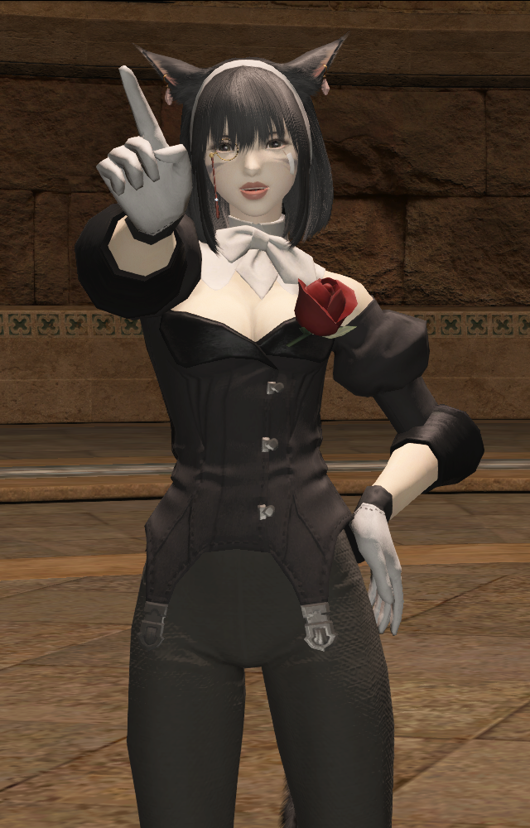
“Nashu! Nashu! My name is Nashu Mhakaracca! Oh bugger, I truly can’t stop!” It didn’t matter how many times the Miqo’te woman attempted to correct herself, she couldn’t speak her previous name. Something deep down was blocking her from doing so, no doubt related to the force that had changed her body and clothes – and had her acting in such a goofy, scatterbrained fashion. It wasn’t like her old personality at all to be so expressive as she spoke, but there she was waving her arms around like a maniac.

If there was any silver lining to this mysterious circumstance it was that she could still recall who had once been! “A befitting mystery if anything, but a cure must be sleuthed out! A cure for… for…” It was only briefly, but that scatterbrained personality had actively worked against this Nashu Mhakaracca. She had momentarily forgotten what the problem was in the first place. “No! How could I forget that? I need to remember it no matter what! That I’m, uh…” It happened again!

“Shoot! Am I on a time limit! I need to act fast! A mystery with a time limit! Ah, if only Inspector Hildebrand were here! He’d know what to do!” Her own words baffled her further. Who was Hildebrand? She wasn’t even certain and yet thinking of that name filled her with such warmth and admiration! No! She was getting off topic! She had to focus on the problem at hand lest it slip through her fingers!

But the fates themselves saw it fit to ruin her plans. Because a gentle hiss pulled her attention away from her thoughts and towards the explosives the chipmunk had tugged onto the ground in her storage shed. One of the fuses had been lit. “That’s… not good!” Rather than fleeing immediately her body broke out into a panicked little dance. And by the time she had managed to pull herself together and flee?

She’d forgotten entirely about the ‘mystery’ she’d wished to solve. But not all hope was lost. She’d remember in the future. In intermittent moments of clarity before she got distracted again at least.

