I-NOCENCE
COMMISSION STORY
BY CHALDEACHANGE
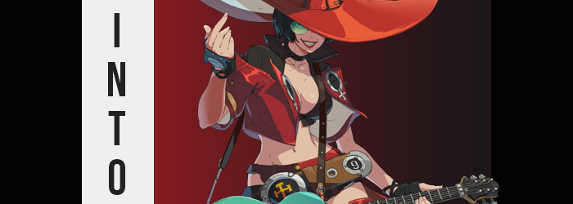

It went without saying that you were surprised to receive a package that day. After all, you were fairly certain that you hadn’t ordered anything, and for the package to arrive at the strike of midnight? There weren’t exactly any delivery companies that saw their packages reach their destinations at such an inconvenient time. The company in question would undoubtedly be liable if said package were to go missing when delivered in the dead of night!

Nonetheless, you had picked up the small box and taken it inside after responding to your doorbell. Whoever sent it was lucky that you were typically up this late, because if you had a much more normal sleep schedule then there was a good chance you would have slept right through, and then what? You wouldn’t have noticed such a small box while leaving the next morning, so it likely would have sat there until the next evening!

“Now what was so important that it had to be delivered at this ungodly hour?” You were the only one awake in the house at this time, but you didn’t really like the absolute silence and so you wondered the package’s origins aloud. All it took was a pair of scissors that you had grabbed from the kitchen to unseal the tape that bound the small box, and beneath the layers of bubble wrap? “Sunglasses?”

That certainly appeared to be what had been so mysteriously concealed within the package. With rounded lenses tinged green, you couldn’t imagine why you had received them. You weren’t in the habit of wearing shades, and these ones weren’t really your style even if you did. But with no return sender on the box there wasn’t really any method through which you could get answers.

At the same time, after picking the glasses up and holding them in your hand, didn’t they look a little familiar? Like you had seen glasses of this style somewhat recently? You raised a brow for but a moment before you finally stumbled upon the answer. “Guilty Gear? Oh, right, could it be I-No?” Whether it was through playing Strive or knowing about the character herself, you were able to put a name to what you felt.

Which simply brought you back to the question you’d had originally: why? Why did someone shove what you assumed were cosplay glasses into a box and send them to you? A prank? The lenses looked authentic, so it wouldn’t have been a very cheap prank if so. There was nothing stopping you from breaking them and then, as a result, that being that. Well, maybe you would have a friend showing up on your doorstep being very pissed that you broke their glasses or something?

It was late though, and now that you knew what was in the box, you decided to just leave it for the morning. You wanted to relax for the rest of the night and eventually fall asleep, and so worrying about an accessory wasn’t really worth it at the end of the day. At least that had been your intention, but when you took several steps towards the dining room exit?

Your vision was suddenly inhibited, and a weight upon your nose made it blatant that something was resting on your face. And considering the green tint that now plagued your vision? “…The glasses?” Your right hand reached up to feel the frame tucked behind the same ear. How had they gotten there? You had just left them on your dining room table! In the box that you had received them in! You couldn’t fathom how they might have possibly jumped from there without help, much less in a way that had them appear perfectly upon your face!

And, making matters worse, you couldn’t seem to pry them off! It was like they were glued to your face, and with some very strong glue. Mind you though, this was only the first of many, many problems you’d experience over the next few minutes. Maybe you wouldn’t seem them as so problematic after the fact, though? At the time you most certainly couldn’t expect you’d have such a big change of heart, but when it came to mysterious objects that force themselves upon your body against your will, well… They usually find a way.

“Why won’t they come off? Are they like, glued to my ear? But even if they were I didn’t put them on!” Were you dreaming? Was this whole thing a dream? If it had been then it certainly would have made sense of some of the many questions you’d had, such as the delivery of the box so late at night in the first place. “And why is my head so itchy? Have I ever dreamed about an itchy head before?” If you had, it wasn’t really a dream that you could remember having. It would certainly be strange if so.

The itch in question certainly had a good reason behind it, but it wasn’t something that could be described away by science in any capacity. No, much like the existence of the glasses and the fact that you could not remove them, the cause was something that defied reason. After all, the length of your hair was changing. Whether it was growing longer or shorter was really dependent on how long you kept your hair in the first place, but in the case of either possibility the length changed so that it was styled in a bob atop your head, the maximum length grazing the top of your neck and covering your ears, while bangs hung loosely.

What’s more, a change in color brought some degree of menace to the style. Because even if your hair was already dark, it darkened some more until it was a raven black so deep that any other colors would get lost within. “Huh? That’s odd. Was my hair always like…?” Because you had been scratching your head it went without saying that you’d notice, but even though you could tell the length and color of your hair were completely different? You had a hard time caring for some reason. You’d even accepted the glasses stuck to your face as an inevitability despite having been given no reason to think that.

On that point though, or at least the ‘stuck to your face’ part, it appeared that there was more transpiring than you could even process despite your uncharacteristic indifference. Your lips were sitting differently now, not because of a change in expression but because they had literally no other choice with how pronounced they had become in shape, and they really stood out with your chin having shrunk some. Then there was the matter of your nose, which had most certainly lost an inch of length.

What had happened to you eyes was a much more outstanding point though. Those eyelashes of yours had grown so large that they practically tickled the lenses of your new shades. Your irises? They flickered through several colors over a few seconds before settling on a green, but as you would eventually realize their colors were something you could bend according to your own will. Complimenting them was a single beauty mark that appeared above your left lip and below the same eye. All of it might have been very familiar if you’d had a mirror nearby.

After all, from the neck up you looked like the perfect match for those glasses.

Soon to be more than just from the neck up.

Whether your hands or your feet, the nubs that stretched out from them began to bend. Fingers became a little longer and daintier upon fair palms, and down south your socks felt a little looser thanks to smaller toes and a softer heel. They were undeniably feminine just as your face had become, but being where they were you didn’t really notice. Even if you had, the same indifference you’d felt towards your hair would have just resurfaced.

“OOF!?” Reddened lips let loose a pained gasp in a voice that didn’t quite sound like your own (sounding much more like a mature woman’s) at a sensation that certainly didn’t leave you indifferent, because it had hurt. “Bitch!?” And whether you were prone to swearing before or not, you couldn’t keep that expletive bottled within. The cause? The bones around your stomach had just crunched inwards without warning, giving your torso beneath your loose-fitting night shirt a dramatic sway that only took that appeal on more keenly with time.

You swore again as a result, but only because you’d almost fallen forward – which would have had your face smacking against a nearby table. It felt like your legs had temporarily broken and fixed themselves, but that wasn’t quite it. Your hips had widened with gusto, but in doing so they had temporarily popped loose from their sockets which naturally knocked you off balance. Fortunately they fell back into place in time for you to stop your fall, but it didn’t help with your growing agitation.

An agitation that was very unlike you.

It was just a general agitation though, and once the problem had corrected itself you held a more lethargic attitude towards the cause of your woes even if you felt easily wound up by other things. Among those things wasn’t what was happening with your legs, though. Fatty tissue, as if from nowhere, had begun to make good use of the space left between your legs. Your pajama pants weren’t exactly keen on it, what with its fabric tightening around bulging flesh, but you really were fortunate that you liked wearing loose-fitted clothes to bed.

This was doubly true about the back of your pants, what with them filling up with tissue of a similar quality to that of your thighs. Your ass protruded quite significantly out behind you, the curvature of your back into your cheeks quite prompted with a very sudden turn thanks to how pronounced they were. Thank God for the elastic waistband of your pants! With the width of your hips and all of this newfound mass, your lower half almost looked like it belonged to a stripper or a porn star. A woman.

Which was what you were now, it seemed. Much like the crunch of your waist, there was some discomfort accompanying the loss of what existed between your legs – if any such thing had existed there in the first place depending on your own situation. Regardless there was nothing there now but a slit, a clit, and a depth within your loins that was suggestive of the idea that you had fucked a lot over a very long time.

“Mm… Feels pretty damn good, whatever this is. But I must be becoming someone, right?” While biting your lower lip, you weren’t even talking like your old self anymore. There wasn’t a single iota of manners in how you spoke, and deep down? You had no desire to be polite. Wasn’t going against the grain of society much more fun? Creating problems was way better than constantly having to solve them!

With your motor already running so to speak, hands reached up to paw at your chest through your shirt. You could feel it there, a tingling that was indicative of one thing and one thing only: your chest was about to rise, and quite substantially at that. Lengthened nails dug into rising flesh whether you’d had anything there before or not, with some of them occasionally twerking nipples in the process. “Oh yeah!” It sure was lucky that your home was somewhat soundproof, else a friend or family member might have heard you fondling your own swelling tits.

And swell they did, lifting the bottom of your shirt higher and higher to reveal the fact that your belly had turned incredibly toned at some point throughout this entire process. But you didn’t really care about it, nor were you shocked by the growth of your own bosom. You just wanted to feel alive, and through arousal and pleasure you could feel that if even briefly. By the time both tits had risen to DD-cups you were bored with playing with them, though, and…

“Wait. The fuck? Did I turn into I-No?” You finally realized, and that realization pulled you free of your stupor. Well, not dressed like this I didn’t! With that thought you snapped your fingers, and your outfit was replaced by an ensemble of crimson that left very little to the imagination. Just what were you wearing around your crotch and how did it not fall off? Why wear a jacket over a black bikini top? What was with the big, skull witch hat? You didn’t really know.

It was just all to I-No’s tastes, really.

“Well, isn’t this nice? What? Am I supposed to applaud whoever did this? I don’t really give a fuck!” You’d found yourself in a strange position in the end. You were I-No from Guilty Gear now, but like, in the real world! Even stranger still, you could feel this villain’s power flowing through her veins. Those world-bending abilities that she had at her disposal were now yours to play with, and the power you felt as a result sure seemed pretty damn good. You felt pretty damn good!
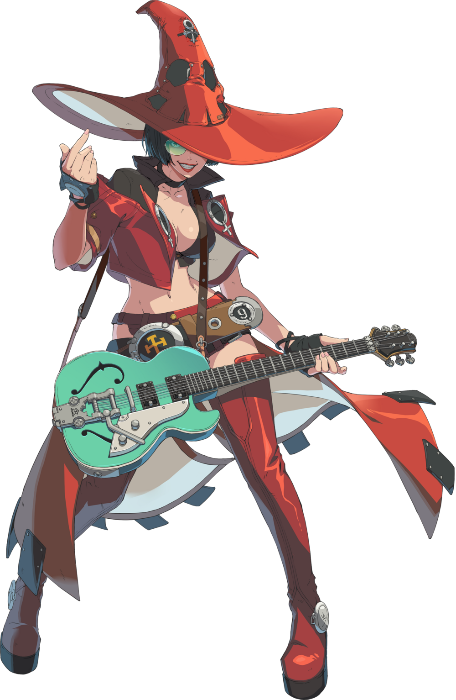
You had I-No’s looks, her powers, her personality – and while in sporadic chunks, even her memories. It seemed that whatever had transformed you had made a point to keep your previous sense of self intact, peppering your psyche with fragments of I-No’s knowledge so that you could function in this new form. This meant you knew how to wield her power, and your motivations fell more in line with hers despite knowing who you’d once been.

Perhaps that was why you felt very lethargic despite the rambunctious manner with which you spoke?

“So what’s the plan then? Cause some shit? Make some lives miserable? Guess I don’t have any pains in the ass to worry about in this world, do I?” With both the freedom to do whatever you wanted to, and the lack of adversaries that could plausibly keep you from doing them in the first place, it seemed clear enough that this was the perfect world for you, I-No. But at the same time that felt boring and uneventful. What were your searching for? What did you want to feel? “Tch.”

Without an answer, you simply expressed your distaste for the very question and created a portal with the snap of your long, slender fingers. Whether you had once cared for your old family or not, their lives now felt so inconsequential compared to your own. And so you had absolutely no issue with leaving them behind to venture forth into the unknown. Or the known? With your mind overflowing with information, there was seldom a thing you didn’t understand while stepping through that portal.

Except maybe your own heart.

But hey, you were a hot bitch now! Why not get fucked and see if that helps things?

