Turning The Tables

Throughout the annals of recorded history in a world where multiple sentient races struggled to maintain a firm grip over their own lands, conflict was an ever present staple. Cropping up constantly even during times of supposed peace and stability noted down in tomes penned by the hand of drones under the employ of state officials and royalty; writing the world as they saw it for all to read.

A distortion of the truth that only a few would ever see pass. 'Self professed scholars', 'lawless renegades', the downtrodden forbidden from speaking the truth.

But a certain incident…no, a massive conflict the likes of which no empire had seen repeated since then was impossible to hide or fabricate for the evidence was clear to see all around, especially in places where the rich and influential tended to gather or in more seedier circumstances like the mud ridden filth of the outer slums and decadent provinces almost every major population center sported, human or otherwise.

Fur covered hides, snouts and muzzles instead of slant noses and lips, tails that varied in length, hind legs and paws. The Beastkin were common sights to be seen everywhere, except they weren't treated as people, but rather, slaves to be used as their masters saw fit. After their crushing defeat at the hands of their neighbors; the normally peaceful Elves who lived like reclusive hermits in the great forests, the once proud race slowly had their history and culture erased from the memory of the world.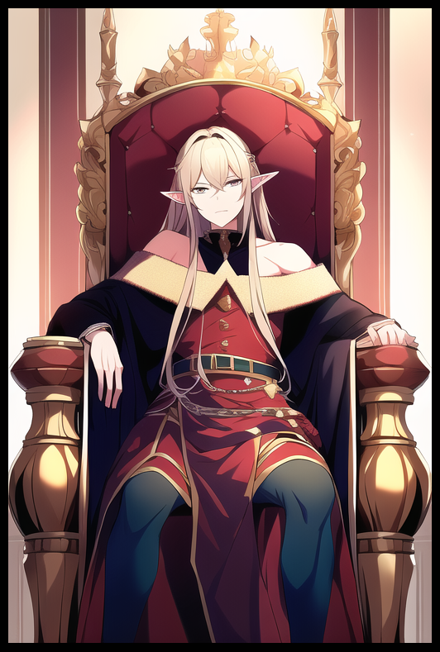

Their people became slaves, goods to be exported. Homes were razed and remade in the image of the Elves. Cultural sites critical to the Beastkin were desecrated and left corrupt. And in only a matter of weeks, the former home of the defeated was wiped clean off the face of the earth…

…all because of one man. A maniacal sociopath who stood apart from his peers with a preference for violence and brutality over peace and love…and worst of all; he was smart, with a cunning, the likes of which even the exceptional folk that made up the Elven Rangers couldn't hope to match.

The Beastkin's defeat wasn't mere circumstance. For a people blessed with an impressive physique and a tight knit attunement to an arcane force known only to them, tacticians to this day still ponder how the Elves had managed to devastate their forces so easily. And the answer, information known only to a few, laid in their ritual sites; burial grounds for fabled heroes, shrines to their deities.

Targeted strikes with foul magics and destructive implements of the Elven war machine rendered the Beastkin powerless, and without the blessings of the divine on their side, their soldiers were no match for the Elves' surgical lethality.

That conflict had served as a warning to all the lands who heard of it, telling their neighbors that the Elves were not to be trifled with…and excellent friends to be in bed with on the political front.

And so the world moved on, turning their eyes from the blazing mountains, an entire people whittling away in flame, until all that remained was a shadow of their former self. And as was to be expected of the slave trade, harsh living conditions and faltering souls meant that in a few years time, the eradication of the Beastkin would be definitive as their numbers dropped with every passing day.

But that was not the end of the Beastkin, for there remained one last glimmer of hope for the dying race, burning in an unlikely place; the very same opulent palace that housed the Elf responsible for igniting the war, the wicked being who desecrated two peoples in one night; the youngest king to sit the throne; *Ra'el*.

On the night of the conflict, only one in the king's council held love for the Beastkin, but without the ability to voice his concerns without losing his head, the elf had remained silent, unable to do anything but watch, nod his head in agreement to everything the new order said, weeping internally as his fellows were forever ruined by bloodshed and depravity. Even more so when he was presented with an unwanted prize, the spoils of war from their recent conquest.

She was hardly taller than his hip, but the young Beastkin knew enough to treat the elf with hostility, biting away the pain caused by the enchanted cuffs that held her down. Keeping her from running off to certain death or worse, unable to do a thing to help her family as they were torn apart.

It was hard, something both thought impossible. But gradually, the Beastkin and her Elven charge would begin to establish bonds, shaky strings that became firm rope, the foundations for a metaphorical bridge to be enforced with wood and twine in the form of shared experiences and bonding that made the two look like father and daughter rather than a spineless diplomat with a slave he could not reject. Behind the backs of Ra'el and his loyal cohort, the elf taught the girl everything he knew, from basic education to arcane knowledge extending to former Beastkin ritual sites.

Tanya had been a smart kid when she was younger, a fast learner with an intuition that aided her in seeing last the hate for what the elves had done to her people, accepting Fel'ain as her foster father once he'd done his best to make her life as comfortable as possible, keeping her safe in his study, swapping out her chains for plain ones that wouldn't stun her, making sure she ate three full meals every day, the sort of things a parent would do for their child.

So when the pair had been ambushed by a rogue contingent of guerillas formed by liberated Beastkin while they were out on their routine , they were shocked by the sight of Tanya defending Fel'ain with elven magic.

But that chance encounter would be the trigger, causing a cascading series of events that seemed hopeless to the guerilla as they ushered Tanya and Fel'ain into their camp neatly hidden away in the bogs just north of a neighboring human settlement. With a little bit of convincing and a hefty to of merry making however, the once hopeless plan soon became viable, accelerated by the arrival of an elven diplomat that had easy access to the same castle nestled in the heart of enemy territory they had been trying to infiltrate for years now ever since the attack had driven them this far.

All in an effort to trigger a magical trap of a scale never before seen or performed, something they couldn't just cast right then and there, not when their target was miles away under the comfort and protection of an army. It took years of backbreaking work and necessary sacrifice to gather the incantations, the unique ingredients and a bevy of exotic bobbles needed to complete the spell, but without the ability to deliver the payload, all seemed lost without a miracle.

With the presence of Tanya and Fel'ain however, those barriers were rendered obsolete and hope was now at an all time high. Although he was frail and cowardly, Fel'ain was one of the most knowledgeable folk to ever grace the ranks of elven royalty. So they kept him around purely because of his scholarly capabilities…the perfect person to help the guerilla in their endeavor to overturn the status quo…by ensuring it never happened in the first place. It was a spell that made Tanya and Fel'ain suddenly hesitant once they knew what it would do, especially the poor Beastkin girl once she realized what would become of her relationship with Fel'ain.

By resetting time with an additional hex specifically meant for the recipient of its wrath, the guerilla hoped to restore their former home and people by manipulating the world itself, playing with the weaves of reality to turn back the clock, ensuring the attack would never happen through what would assumedly neutralize Ra'el before he could ascend the throne. 'Snuffing the baby in its crib', so to speak.

But by wiping the slate clean, it meant that Tanya would never have met Fel'ain in the first place. And that wasn't what she wanted, not at all. To lose another family, no matter how small or foreign it was, made Tanya deny the aid she was shocked to hear Fel'ain persist in giving to the guerillas who by now were more than certain of the bond between the unlikely duo. At first, she was furious, thinking he was trying to get rid of her, that he had been treating her like a burden.

Instead, the man was more understanding than she had expected. Arguing with her once they had returned back to the comforts of their quarters once they had parted ways with the guerillas, their payload stowed safely away in Fel'ain's robes. For once in the few short years they'd spent together, the shriveled elf wore an indignant look on his face, the likes of which Tanya had never seen before. She thought he'd relent to her childishness, but the elf was insistent that they carry out the task handed to them, telling her the life she lived now wasn't meant for her, and that even though he cherished her like the daughter he never could have had, Fel'ain knew their circumstances mattered little when they were talking about the fate of an entire race.

But the pain was evident in the tears he couldn't hide from Tanya, to know the price of righting the wrongs of others was the time and memories he shared with his adopted daughter hurt him to no end. But he couldn't hesitate, not when there was a silver lining in the form of reuniting Tanya with her proper family, give her the chance to live as she should; in the arms of her kin, not a lonely elf like him who just so happened to be the one to be charged with her just because the rest of his corrupted ilk couldn't stand petite proportions as sickening as they were…

Come night, the pair couldn't sleep. Adrenaline and sorrow still running high all the way into the night as they swapped takes of the past decade or so they had spent together, falling into occasional silence as they mulled about the coming morn before continuing their recounts, voices growing hoarse and cracked once the tears ran dry and their throats, parched. They didn't even wait to freshen themselves up before setting foot outside with the rays of the morning sun gracing the windows for they both knew there was no need to, simply nodding before they left the confines of that dank, yet homely study for one last time.

But not before Fel'ain stops Tanya, perking up in an uncharacteristic moment of forgetfulness as he rushes back toward the wardrobes, eager to show his daughter something he'd been working on for quite some time now behind her back.

On that day, a strange sight would send an uproar so early in the morning through the elven palace. One of their own, prestigious noblemen walking hand in hand with a young Beastkin pup. Except she had no bindings on her person as was to be expected of a slave. Instead, she wore a fluffy dress, tailor made for her canine features. Both wore smiles on their faces as they made their way into the throne room, entering boldly before the Ra'el, whose leisurely demeanor soured instantly at the appalling sight before him as the pair ascended the steps leading up to the throne before the elf takes a knee, leaving the Beastkin girl sobbing by his side, arm still grabbing the little hem of his sleeve.

**“I ought to lop that inbred head of yours off myself…do you have any idea what you bring before your King right now Fel’ain?”**

Bravery the likes of which he'd never felt before until now flooded Fel'ain as he slipped a hand behind his back, producing the scroll before the king as he knelt. He didn't want to look to the side in fear of putting a face to the painful sounds of Tanya's sobbing. He'd done all he could, fulfilled a request of hers she'd muttered a long time ago in passing, probably because she knew she never could without being put down.

*A last goodbye that didn't mean words to be made known…*

**"I'm afraid I do your Majesty…far better than you might think…would you mind looking for a moment? I assure you, it's quite intriguing…"**

Pulling the knot that kept the parchment rolled up, Fel'ain's vision blurs as an immense fount of light shines forth, devouring the king before he could say another word before lashing out at everything else. The surroundings, the encroaching guards, the presence he could no longer remember by his side. All were washed away in the blink of an eye…

**"So? What is it you have to show me Fel'ain? Another one of your pathetic musings?"**

Before he knew it, Fel'ain was back inside the throne room, blinking away an odd tear drilling free off the edge of his heavy eyes. He felt like he hadn't slept in about a day, feeling exhausted in more ways than one as he kneels before the Queen, turning his gaze away from the arrogant ruler, ignoring her mocking trill as it reverberates down the hall.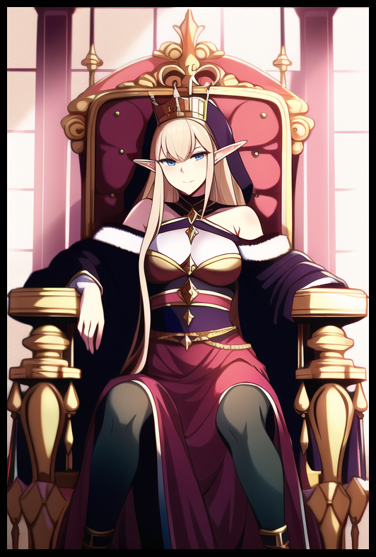

He could've sworn there was someone right next to him moments before, but besides the amused guards, he was alone…had he been imagining things?

**"I-I'm sorry your Majesty…I must've-"**

**"If you've nothing but jests I suggest you leave…cowardly oaf…"**

Barely able to maintain a proper stance as the guards shove him outside before slamming the grand doors behind him, Fel'ain couldn't help the strange feeling of euphoria that was starting to wax and wane, leaving nothing but an ache in his chest no amount of external stimuli seemed able to quench as he walks back down the corridor towards his study.

Even now as he pushes open the door, that weight only seemed to intensify even further, filling him with a profound sadness that had him confused. He couldn't recall any stressful tasks he'd undertaken in recent memory, and as far as he remembered, he wasn't in any financial trouble.

**"Gods…maybe I really do need to take a break from all this political nonsense…journeying to broaden my horizons doesn't sound like a bad idea…maybe the Beastkin mountains…for a start…"**

Flopping over onto his bed, it didn't take much more for the tired scholar to doze off, falling asleep just in time for another soul in the neighboring lands beyond to awaken from her cot with a start. Startling the familiar sight of her mother staring down at her from above, rousing excitement in her chest as she leaps off the sheets and into her parent's waiting arms.

**"Is everything alright dear? You were mumbling in your sleep!"**

**"It was a dream Ma! I had a dream!"**

**"How exciting! Come, you can tell us all about it over breakfast!"**

A scholar slept, a young girl fills the kitchen with her exciting recount of a prince escorting her through the halls of a palace, wayward souls returned to the lives that had been taken from them last night….in a time that had been rendered null and void with the drastic alterations caused by the powerful Beastkin magic Fel'ain could no longer remember unleashing against the former tyrant, transforming him into an incompetent empress whose days on the throne were numbered.

Although both Tanya and Fel'ain had their minds and bodies reset, on occasion, the two would feel a strange longing in their hearts that would point their gaze toward each other across the vast distance between them, never losing steam despite them never realizing what that familial sensation was as they went about their separate lives…*a faint remnant of an unbreakable bond to tie them together…*

THE END