Concentration
Inspired by a Captioned Image by Jennifer
By Maryanne Peters

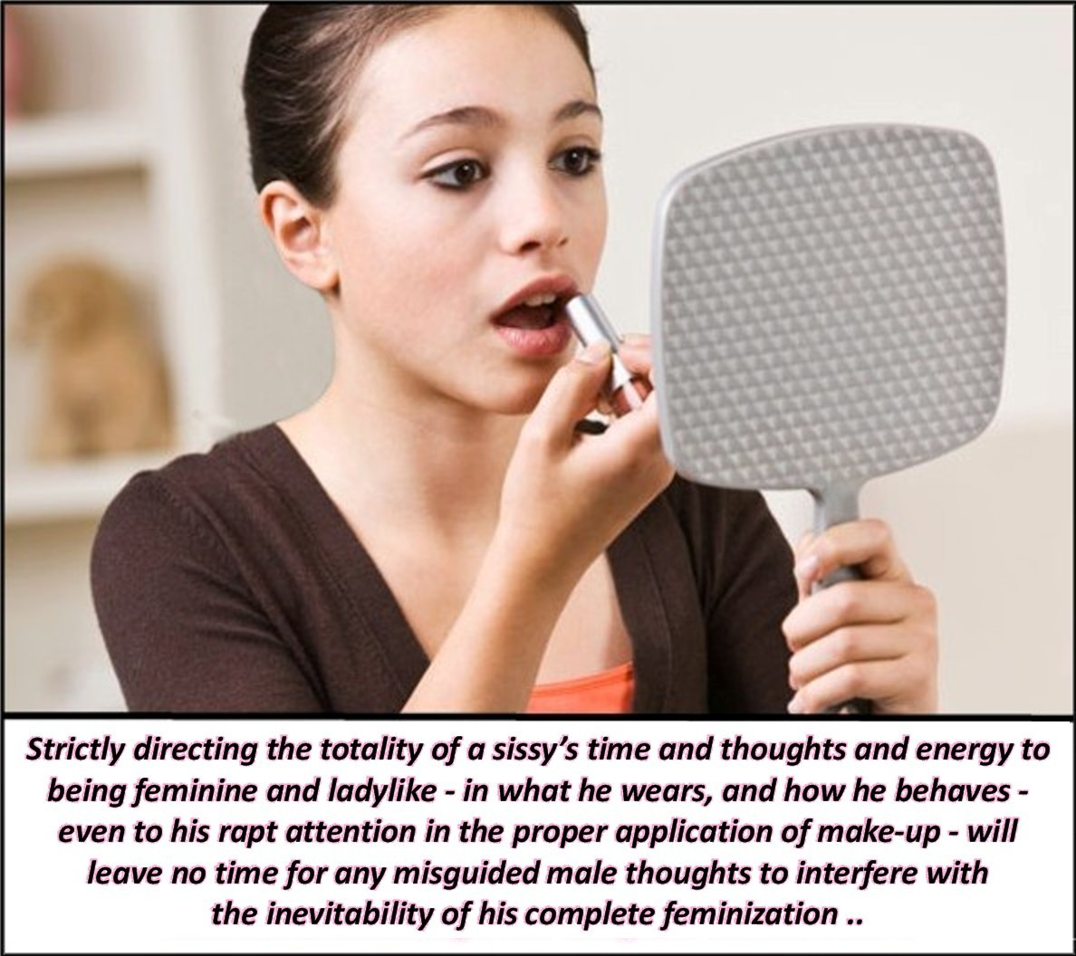

There is just so much to do to stay pretty. My skin regime is very important. He says it is like preparing the canvas for a masterpiece. A wrinkly canvas will never do. I pay a lot of attention to it. Devoid of all hair, and soft. The hormones help. Patches under my breasts and pessaries shoved up my boi pussy with a little help from my tool, Richard.

I have to tweeze out any little hairs that appear on my chin. I seem to have more than other girls. I used to know why, but I have completely forgotten.

Hair tied back. It is so long now that it is easy to tie back and up, and hold with a clip. I used to have short hair, although I don’t know why. He hates short hair on me, and what he doesn’t like, I just can’t abide.

Now eye makeup. I have dark hair so I can get away with well-drawn eyes. That means eye liner and just a touch of mascara. I do not believe in false eyelashes unless it is a special occasion. My eyes are good enough on their own – don’t you think?

There is just so much to do. I need to get on and get tucked. I know that most girls don’t need to, but I do. I don’t want any bumps showing where they don’t belong, and my bump does not belong.

It does get uncomfortable, but he likes to be the one to free it. He says that when he is ready for me to get naked he will tell me, or maybe even help me – not because I need help but because he likes it. But when it comes to breaking the tuck, that is for him to do. It serves to remind me that I am his, and I am only free when he is inside me, or just before.

I used to think about a lot of things, but nowadays I only thin about that.

And also this lipstick. Do you think it is the right shade?

The End

Too Pretty  Inspired by a Captioned Image by Jennifer  By Maryanne Peters  They were all staring at me. People will say that it is because I don’t really belong there, because of what is in my panties. I have a little penis, you see. And they will think that penises don’t belong in beauty salons, and I suppose they don’t.  But I like to think that they are staring because I am young and pretty. Most of them are not young, and none of them are pretty. | 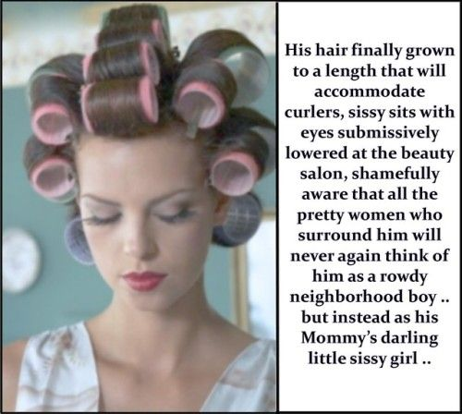

I mean I am pretty, don’t you think. I am far to pretty to be a boy. Mommy always said that. I suppose that was why I went a little crazy and started to misbehave. I was crying out that I was male, because I thought that I was.

I never wanted that first injection, but I don’t blame Mommy for having it done to me. It really helped me to find peace. Before it was like my brain was trying to bust out of my skull, with all those violent and destructive thoughts. Now my head is encased is curlers and I feel at peace.

Soon enough the curlers will come out and my honey blond hair will be a mass of bouncy s curls. Mommy says that I will be irresistible and she is right. Every boy in town will want to lick my butthole, and some may get there chance.

Yes, I can look down at the floor and be happy. No hairdo is going to fix things for most of these women. The prettiest creature in the room is me, and I am a sissy.

The End

Discovering Pink  Inspired by a Caption by Jennifer  By Maryanne Peters  “That’s a smile on your face,” she said. Is it? It is certainly not the grumpy scowl that I started the week with. She keeps this image to document what she calls “the turning point”. Maybe she is right.  I mean, this outfit is ridiculous! A pink puffball dress with that giant rosette thing on my chest – it is simply awful! But I did like the way it hung off my shoulders, and somehow having something sticking out from my flats boy’s chest made me feel different. And then there were those pale pink sheer stocking, and those gorgeous open-toed shoes. Even without any makeup at all, and my not-so-long hair just washed and a little fly away, the boy was gone.  From the moment I arrived she would go on and on about how I was borm to be something other than a boy. She said that boys and men in general, were a lower form of life. Women were the peak of God’s achievement. Women were blessed with the capacity to bring life into the world, and to feed the child from their own bodies. What are men? Just there for a couple of minutes to provide the seed, and a bit of pleasure if you are lucky. | 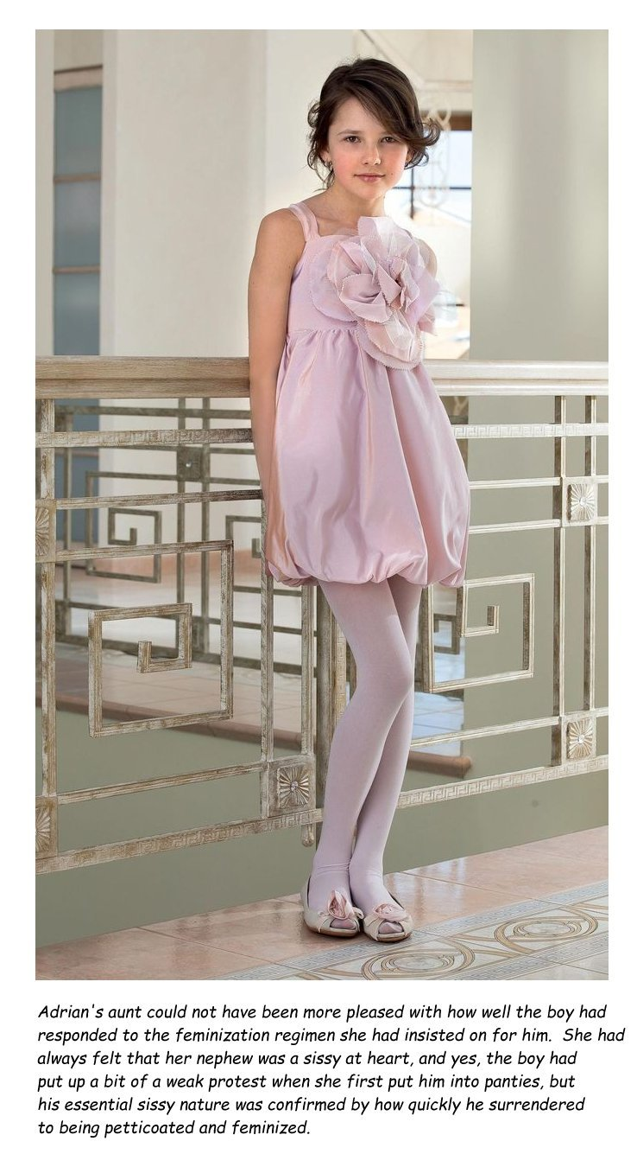

“You will never be a woman,” she said. “But you will come so close. You will start as a sissy, a boy who will submit and leave all masculinity behind. At your age that is easy. It will become so much harder when you get older. Now is the chance to grab you chance. Take the opportunity now to live a life in pink.

I protested, but now I wonder why I did. I think that she was right. This was the turning point. This was when I discovered pink. I have never looked back.

Thank you, Auntie.

The End
Metamorphosis
Inspired by a Captioned Image by Jennifer
By Maryanne Peters

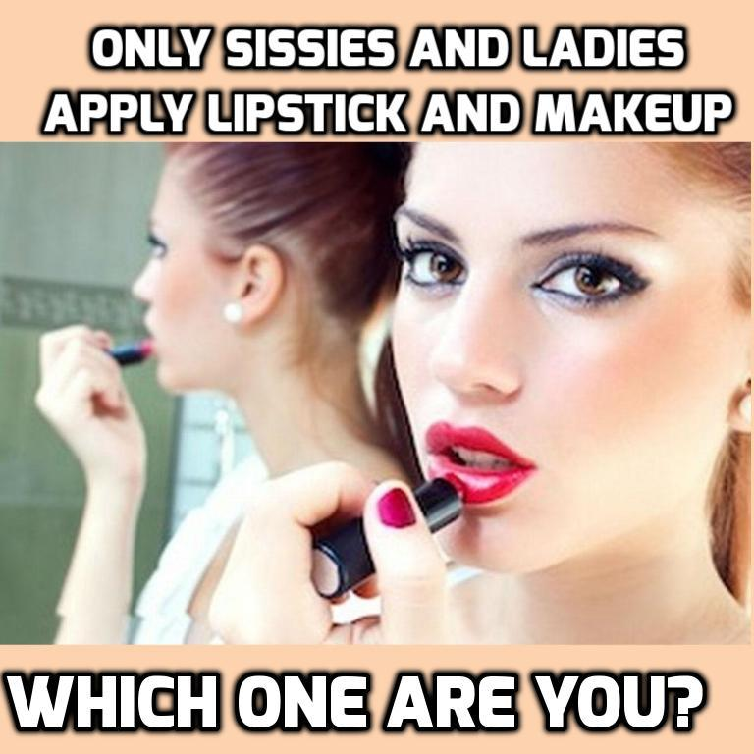

“Do you have to be one or the other?” That is what I wanted to say to Kevin, Mom’s disgusting boyfriend. “Aren’t these just stages in the development of a person?”

I like to think of it like the evolution of a butterfly. You start as a caterpillar, just toiling on a leaf, munching and munching, and growing mass that you will never need, other than to give you the energy you need to fuel the metamorphosis to come. That transformation will see you become the butterfly that will fly free, to bring beauty to the world. But there is an intermediate stage – the chrysalis. That is the stage that will see you locked away from the world, losing mass and gaining al of the attributes that you will need when you break free.

I know that Mom is a sexual being. She needs a man – I can understand why better than she knows. But why Kevin? Kevin is a pig.

But it is because tried so hard to please him that she became a co-abuser. I am sorry, but there is no other way to put it. Mother’s are supposed to protect their children. Perhaps she thought that it was all in fun. It was just that Kevin had me branded as a sissy from the money he stepped into our house and into our lives.

“Your kid is a sissy,” he would say. “He looks like a sissy. He sounds like a sissy. He only seems to do sissy stuff. It’s called art, you dumbass. It’s called music you moron. It’s called interpretive dance, you ignoramus.

But I could not say anything, and Mom told me just to not piss him off. Even when he bought me dresses to wear, she said I should put them on. She was worried that he would leave her if I caused trouble.

I love my mother, but I understand that she needs other love, even though that will never be as strong. I went along with it, even though it meant hiding away as my appearance changed. I put my hair up as a dancer might, and I applied makeup like the artist I was, and learned to modulate my voice with the help of music. And I did all this in front of Kevin, while I watched his confusion grow.

He knows nothing of metamorphosis, or any word even half that length. He is just a man, after all. And I am a lady, or I soon will be. The day when I will break free from this chrysalis is soon approaching.

The End

Dressing Right  Inspired by a Captioned Image by Jennifer  By Maryanne Peters  I am always forgetting. I try to get it right. I want so much to please my mother.  My body is now the perfect body for a sissy – smooth and weak; a waist and hips shaped by corsetry, breasts and buns molded by hormones; soft and yielding.  I can tuck tight and so invisibly that I can wear the skimpiest of panties including in white see-through lace – the kind of lingerie that makes me feel like a virgin, even though that was long ago. | 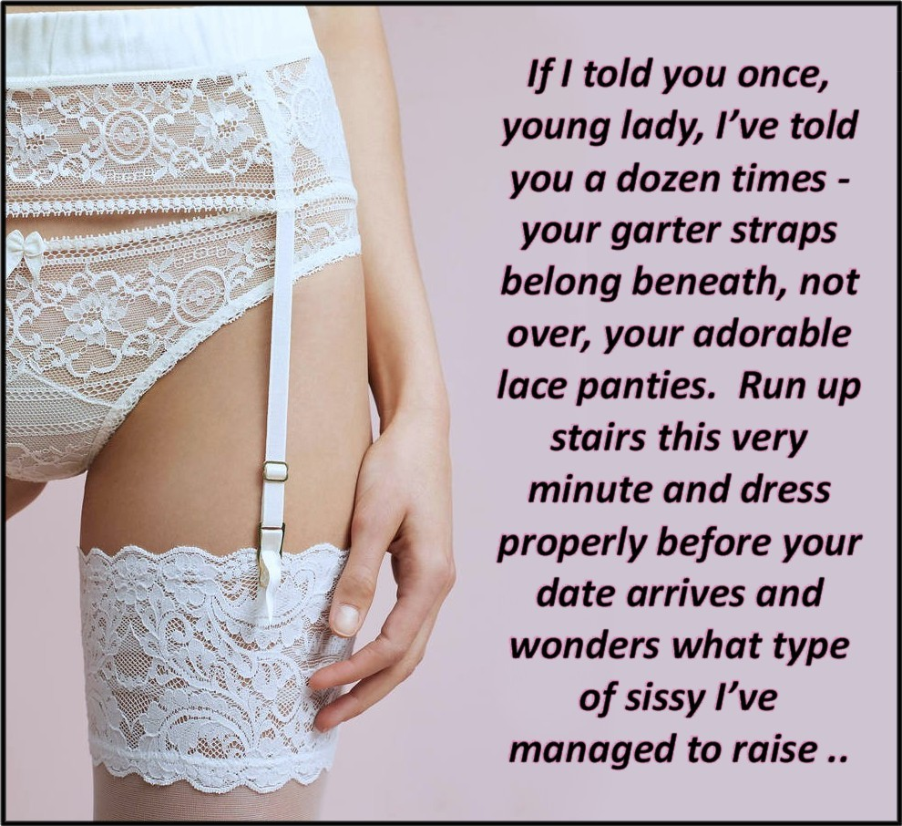

But of course, Mother is right. Panties outside the garters so that I can pull them down while keeping my thigh-highs up and gartered, or I can pull them down if he directs me to. Men like me to wear my stocking and maybe even my heels too, when they get between my thighs and get right inside me. And I like what men like, so long as it makes them like me.

Mother has raised me right. I will be all over my date tonight, and he will ride me the first chance he gets, and it will not be enough. A well raised sissy will leave them wanting more.

The End

© Maryanne Peters 2023

