MJF’s Reality Check
By Soul-Controller
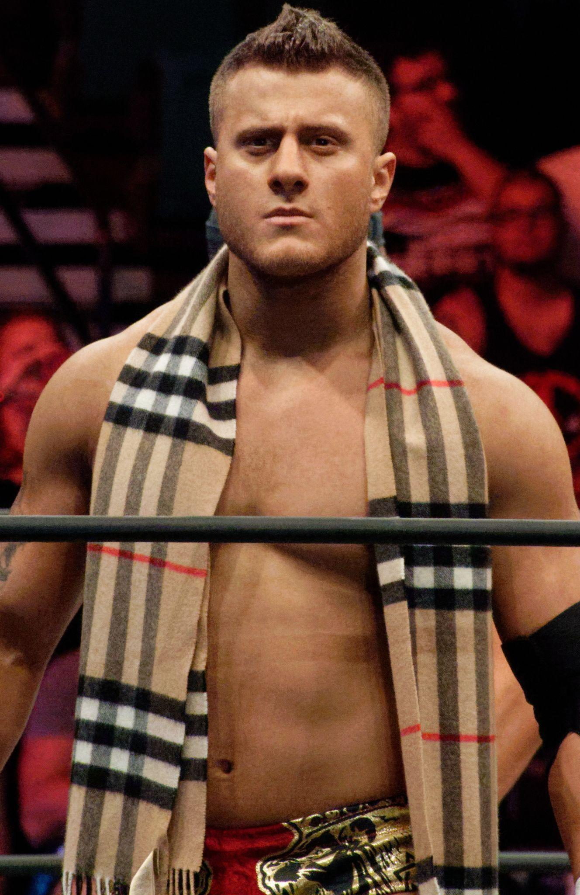
Outside of a dressing room, the various employees and wrestlers that were a part of AEW couldn’t help but stop and smirk at the petulant screaming occurring on the other side of the door.

“Are you fucking kidding me? This is how you’re going to treat the biggest superstar in your shitty little company? You’re really going to let those whiny little brats on Twitter dictate how you run your business?” a disembodied voice cried out, the words coming out slurred due to just how enraged the man seemed to be. “You better listen to me loud and clear. I’ll do your stupid little publicity stunt, but having me go and meet a bunch of these entitled fans that think that they know me and thus somehow deserve to be in my presence is not going to cause me to have some reality check. I’m a god amongst men and you’ll never be able to change my mind,” the voice further exclaimed, the increased volume of the speech causing the few low-level staff leaning against the door to quickly scurry away to prevent getting any vitriol directed towards them as well.

Just as the last person escaped the surrounding area, the sudden sound of a door opening and quickly slamming shut filled the quiet set. Stepping out was a clearly enraged wrestler by the name MJF, whose reddened face severely clashed with the patterned scarf wrapped around his neck and draping down over the front of his shirtless torso. MJF, whose real name was Maxwell Jacob Friedman, had just exited out of his dressing room after an impromptu meeting with the owner of the company. Apparently, some of MJF’s most recent comments on social media had portrayed AEW in a negative light after he just simply responded to a wrestling fan who was making comments about him on Twitter. It was annoying to Maxwell that the company even went through the effort to give him a warning and a stern talking to, but it was absolutely infuriating when it was revealed that he was going to have to do a free meet and greet with some wrestling fans before their show next week in Georgia to try and get back in the good graces of the fans and protect the company’s image.
Yet no matter how much he protested and threw a tantrum inside his dressing room, the owner refused to flinch and stated that it was mandatory if he wanted to continue performing in the ring. With no options available since he refuses to give up wrestling and enjoying the spotlight, Maxwell begrudgingly agreed to the concept before storming out of the building and returning back to his luxury hotel.

* * * * *
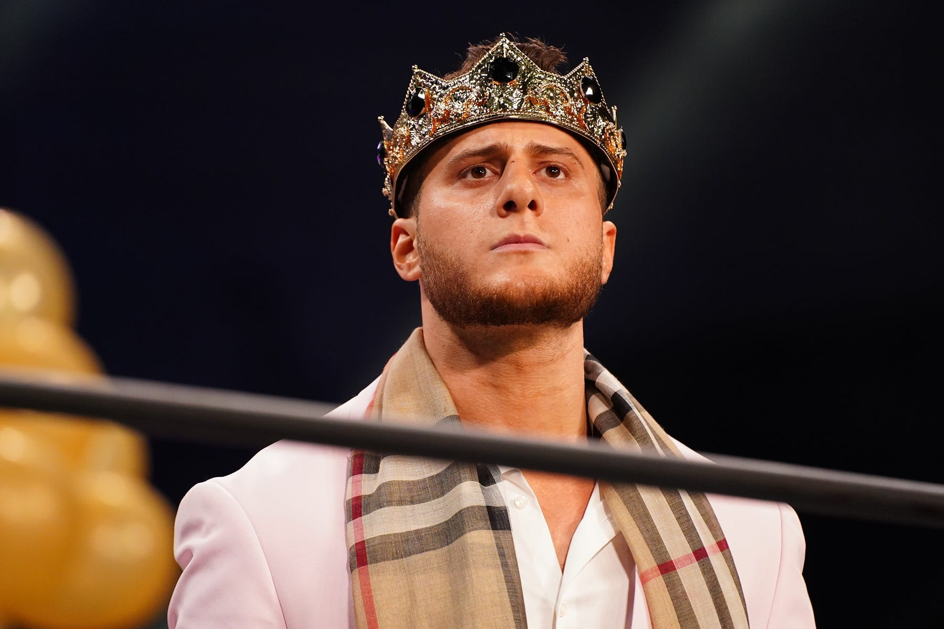
As the day of the Georgia match finally arrived, MJF was purposely dragging his feet upon being forced to arrive several hours early for the meet and greet. The man was a certified diva, so the combination of not getting enough beauty sleep along with the concept of having to spend hours of his precious time interacting and taking photos with all of these clammy-handed fans had severely dampened his mood.

So while the owner of the company had demanded for MJF to dress up for the event to get back into the fans’ good graces, he opted to add a special accessory to his look to boost his spirit - a shiny gold crown. Given just how ornate it was and how great it sat atop his head, MJF couldn’t help but feel overly confident in himself as the group of 25 fans were all led into the room in a single-file line. If his otherworldly persona wasn’t clear enough, the crown was the icing on top to showcase just how godly MJF both looked and felt!

For the next two hours, MJF was forced to deal with 24 fans who were either extremely anxious to meet him or incredibly clingy. Despite the fact that he usually liked clinginess when it came to female romantic partners who would swoon over his every move, the clingy fans in the meet and greet were almost entirely men who didn’t have nearly an inch of muscle on their body. While he certainly didn’t have a problem with gays or anything, the strange obsession that they had for him was quite peculiar and quite off-putting for the usually confident man. The women that were part of the meet and greet were all incredibly anxious to be in his presence, especially when he further tormented their horny minds by peeling off his dress shirt, pants, and scarf to reveal his nearly nude body clad only in his purple wrestling shorts. Understandably, the women were quite transfixed and stuttering over the reveal (which he completely understood and expected), but MJF wasn’t prepared by the double-edged sword of the countless men in between whose eyes couldn’t help but wander towards his shirtless torso or beefy thighs.

Throughout those 24 fans that he had interacted with, there was only one man who seemed normal enough to have a conversation with. Despite the fact that he was the only interesting fan that he had met, MJF couldn’t for the life of him think of the man’s name as they finished up their conversation and started to take some selfies. Although he could recall the brief conversation where the guy revealed that he had traveled from England for the meet and greet and was a big wrestling aficionado, he couldn’t figure out his name. He thought it might have started with an H, but he wasn’t 100% sure about that (and truly didn’t care enough to actually find out).

After that man giddily made his way away from the ring and was led backstage by security, MJF directed his attention to the one lone fan waiting for him. Staring in front of him was a huge blob of a man, decked out in some MJF merchandise that showcased a large image of the intimidating and nearly nude wrestler (which did not look great stretched out over the overweight man’s huge flabby chest and globe of a gut). As he watched the fan rapidly exhale and grunt as he forced himself up off of the ground and into the ring, MJF couldn’t hide his grimace as the man rolled into the middle of the ring and accidentally revealed his pale gut due to his shirt riding up. Luckily though, the fan was blissfully unaware of the judgmental look as he sat up and pulled himself onto his feet.

“Hey there, my name’s Floyd,” the man said in between labored breaths, causing Maxwell to immediately pick up on his incredibly southern drawl. “It’s a pleasure to meet ya Mr. MJF, I’m your biggest fan,” he continued.

Luckily for him, the man hadn’t asked for a handshake. Given how sweaty the man looked, Maxwell had no desire to make physical contact with the pudgy fan or his soft and pillowy hands. “Hi, it’s nice to meet you too,” he curtly responded, attempting to move past the pleasantries so he could just take the photo with the fan and be on his way. He had a big match coming up tonight, so the sooner he could head back and prepare for it the better!

But before he could move on to asking the man for the selfie, MJF’s attention suddenly returned to the man’s clothing as he watched a pudgy hand tug at the bottom of the shirt to pull it back down so it covered his entire gut. Looking at the photo on the shirt though, Maxwell quickly picked up on the fact that this wasn’t an official MJF merchandise item since he would never approve of such a tacky and discolored item. Despite trying to be on his best behavior, the audacity of a fan approaching him wearing unofficial merch of himself was too much for him to ignore. So instead, Maxwell began to speak once more, this time with a much more biting tone.

“Oh would you look at that, what a nice shirt you have there,” he cheerfully exclaimed, causing Floyd to smile back in response. However, that didn’t last long as Maxwell continued to speak. “Except, that’s not an official MJF shirt is it?”

As his cheeks reddened, Floyd could only tilt his head downwards and shake his head side to side.

“Hmm, so you got a meet and greet with the MJF and you decided that the best course of action was to just wear some unofficial shitty merch with my face on it? Like, that shirt isn’t even good, the colors are so fucked up that it looks like I’ve been sunbathing on the goddamn sun!” he exclaimed, his tone becoming more pointed and aggressive with each word that he spoke.

Finally forcing himself to respond, Floyd pushed aside any shame he felt and began to explain himself. “I mean, I’m sorry it’s not your official merch. I can’t afford all of that expensive stuff that you sell. I just found this online and thought it would be a fun way to show my appreciation for you for this event,” he responded, his voice beginning to trail off as the nerves quickly returned.

Not buying that response, Maxwell immediately crossed his arms and shifted his face into the intimidating glare that Floyd had seen countless times while watching MJF perform in the ring. “Well since you didn’t buy my official merch, I don’t think you have any appreciation for me whatsoever. I mean, it’s not my fault that you’re too poor that you can’t afford a reasonably priced quality t-shirt! If you’re not willing to pay for that quality and give away your cash to some leech making money off of my name and image, then that just means that you’re not as big of a fan as you say you are!”

For nearly a minute afterwards, the two men stood in silence while also having significantly varied expressions. While Floyd was clearly feeling ashamed and on the verge of tears, Maxwell had the cockiest grin possible on his face as he stared at the portly man. Despite knowing that the man had already felt shame, Maxwell decided to do one more final jab to get the point across.

“Also, if that shirt was so cheap, wouldn’t you at least pay the extra charge to get a 3 or 4X size so it could cover every inch of your pathetic and disgusting body?!” he chuckled, continuing his torment while not even paying attention to the sniffles leaving Floyd’s mouth and the tears that just started running down his face. As the fan tilted his head downwards to prevent his favorite wrestler from seeing him sob, he was unaware of MJF’s cocky stature changing as his hands moved away from his chest and down towards his hips. As he took on a more superheroic pose while watching Floyd continue sobbing, the wrestler puffed out his chest to just further showcase his apparent superiority over the man. But while he continued to do this, Maxwell was suddenly caught off-guard as the man stopped crying and said a simple statement.

“You deserve a much-needed reality check. You’re not the god you think you are,” Floyd stammered out, tilting his head back up towards the wrestler and quickly drying his eyes for one final time.

Clearly thrown off by suddenly having this man talk back to him, Maxwell stood silently for a second before responding. “Oh wow, so that’s the way you’re going to talk to your idol huh? Do you somehow think that you’ll be able to give me that reality check? Believe me, I don’t think you want to mess with this godly body,” he responded, punctuating the sentence by throwing his arms up into a flex that left his prominent biceps bulging in front of the shorter man’s eyes. “I don’t care if you’re a fan, if you want to go against me in this ring I’m not afraid to fuck you up.” Since he expected the fan to immediately cower back and apologize for his outburst, Maxwell was caught off-guard when the fan actually doubled down.

“Wanna bet then? I’m positive that I can teach you a lesson,” Floyd responded, feeling incredibly confident to the point where he extended a hand towards the man.

Despite being taken aback, MJF was more than willing to take the challenge. As he extended out a hand and began to grasp it, he began to talk once more. “Alright if you say so, don’t be upset when I-” he began, his words suddenly stopping as a dizzying sensation suddenly filled his head. As he tilted his head upwards, there was a moment of pure weightlessness that rivaled the sensation of rapidly going downhill on a rollercoaster. In that moment, the man lost consciousness for a second before returning back to his senses. “- kick your ass,” he continued, but the words suddenly felt different in his throat.

Tilting his head downwards away from the bright arena lights, Maxwell rapidly blinked his eyes a few times before gasping at what he saw. Instead of seeing the obese man looking up at him, he was instead looking directly at a shirtless torso. Confused and completely scared due to the impossible sight that he was seeing, the man slowly tilted his head upwards and screamed out in fear. Somehow, he was staring back at his own smirking face!

“Wha- what the fuck did you do to me you creep,” he angrily declared, one hand immediately going to his throat as he picked up on the deep southern accent coming from his mouth. “Oh no, oh no no no,” he said, beginning to hyperventilate as he looked down and found the usual sight of his feet blocked by a round sphere of flesh. While this was certainly enough for Maxwell to draw a conclusion, the peculiar sight of a warped image of himself stretched out against this blanket of a shirt made the truth apparent. He had somehow swapped bodies with Floyd!

“Aw, looks like someone didn’t think this bet through huh,” Maxwell’s all-too familiar voice said, causing the man to shiver in fear at how intimidating his own voice was to him now. “I told you that I could give you a reality check, but you didn’t believe me. I bet you didn’t think this would ever happen to you, losing everything from your career and body with just one simple handshake” the body-swapped fan retorted, grinning wide as he slowly walked around the confused and terrified wrestler. “Since you wanted to be so rude and make unnecessary comments about how terrible my body was, I figured it was only fitting for you to have it. I think it’s fitting, especially for that hideous ego of yours,” he maniacally chuckled, causing Maxwell’s booming voice to echo throughout the empty arena.

Although Maxwell was completely terrified and confused about what had happened to him, that paled in comparison to the intense rage that was coursing through his veins. This creep had the gall to steal his body and taunt him with it?! Eager to teach the man a lesson and punish him for stealing his body, Maxwell prepared to use this new weight he had been forced to adopt to his advantage by jumping on the man and pinning him down until he offered to swap them back. Not wanting to wait any longer, the man immediately pushed off of the floor and began to run as fast as he could towards the imposter. But just as he began to prepare to leap onto the man, Maxwell’s plan was suddenly foiled by a right-hook punch to the jaw that immediately sent him and his new obese body falling over and landing onto the ground in a loud thud.

As his body made an impact, Maxwell immediately grimaced as he felt the wave of motion reverberate through the wobby gut and chest that he now had. But as he heard his former body scream for security, the wrestler pushed that disgust and pain from the impact aside and began to scream at the man. “You goddamn pussy, give me back my fucking body so I can properly kick your ass,” he screamed at the top of his lungs, refusing to pay attention to that country accent that now coated his words.
After struggling momentarily, Maxwell was finally able to pull himself back up onto his feet. While doing this, the man immediately picked up on his now-labored breaths due to the exertion from having such a massive weight. Given how much time and hard work he had put in to give himself his incredibly muscular body, the concept of being stuck in an overweight man was a total nightmare! By the time he had finally gotten back up to his feet though, security was already rushing in to prevent the “crazed fan” from doing more damage.

“Get this fucking weirdo out of here! He tried to attack me for no reason,” the imposter MJF exclaimed, putting on his best performance as a shocked and enraged celebrity. Understandably, the security refused to question what the man said, especially as the new Floyd finally began to rush towards his former body once more. “You goddamn freak, I’ll fucking kill you! Give me my body back right now,” he exclaimed while continuing to run as fast as he could at his size. Unfortunately, his fastest wasn’t fast enough as two burly security guards each grabbed one shoulder and pulled him away from their star wrestler with ease.

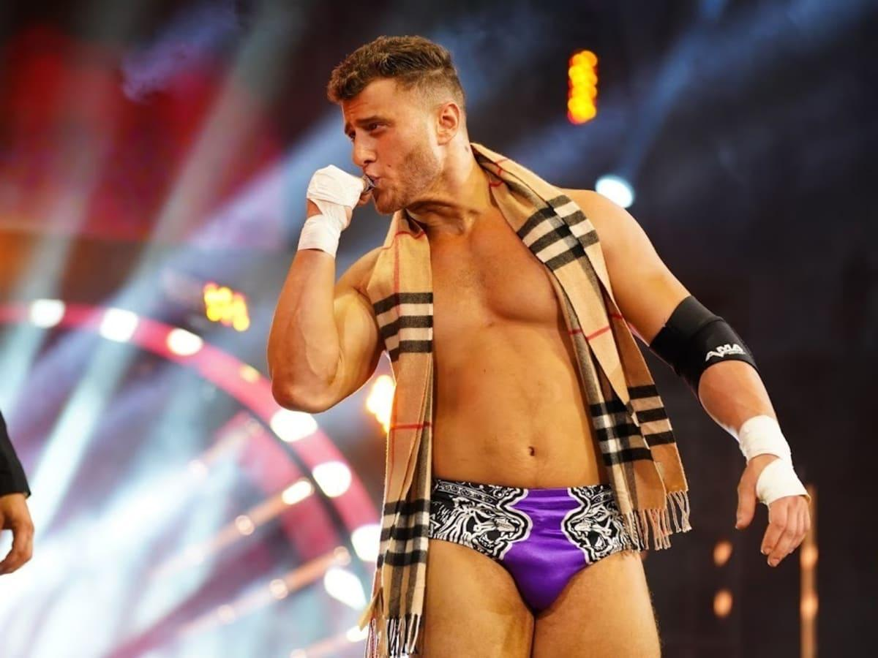
As he continued to flail and scream profanity while being pulled away from the wrestler, Maxwell finally began to take notice of the immense heft that he was dealing with. With each step that the bodyguards took while pulling him away, his gut wobbled and his chest jiggled wildly, which left him fully disgusted by the fact that Floyd had allowed his body to get in such horrific condition. Not only that, but there wasn’t a single inch of muscle definition in the man’s arms as Maxwell couldn’t use any strength to rip his arms away from the two men and also felt the security team’s fingers dig into the doughly flesh without meeting any resistance in the form of a tiny bump of a bicep.

To further add to Maxwell’s horror at the whole situation, the real Floyd was having a blast continuing to torment the man from afar. As he continued to cockily smirk towards the man, the brand new MJF brought up his right arm and kissed his fist to showcase how easily he had used his strength to disarm the real wrestler. But after that, Maxwell was treated to the horrific sight of watching the imposter flexing and feeling up his body in front of him. Not only was it terrifying to watch some man eagerly explore his body, it also angered Maxwell as he felt insane jealousy that he would seemingly never be able to have a body like that again!

Just as Maxwell was finally beginning to get dragged out of the arena, there was one last morsel of dialogue that he picked up on that chilled him to the bone. It was his voice talking clear as day to some AEW employee, but the most worrisome part was just how much Floyd was talking like Maxwell usually talked! “You see, this is why I hate meet and greets. Most of these people are total creeps,” he exclaimed, which caused the other man to begin profusely apologizing for forcing him to do that meet and greet. Just as Maxwell started to get out of earshot, he heard one last chilling remark. “I guess people just can’t handle meeting a god like me!”

* * * * *
Three Months Later

As Maxwell arrived home after another long 10 hour shift at work, the man couldn’t help but groan in annoyance as he pulled open the door of his trailer and found the same sad-looking residence awaiting him. It had been three months since the traumatic meet and greet that had forced the wrestler to adopt the name and life of rural Alabama native Floyd Smith, and to say that the man hadn’t adapted well would be an understatement!

Not only had Maxwell loathed the fact that he had ended in some yuppie redneck’s body, but he grimaced every time he looked down and saw the bulbous physique he now possessed. Clearly Floyd had never heard of a gym before, so now MJF was pissed to find himself living with the flabby consequences. It was humiliating to walk into a gym, a place where he used to be an absolute beast, and find that Floyd’s body could barely lift 10 pound dumbbells without causing Maxwell to break a sweat.

The various trips to the gym also further infuriated the man because each specific exercise that he did only caused him to feel new sensations of body parts jiggling from the rigorous movement. Although he knew that intense cardio would be great for losing weight, the sensation of feeling his beer gut violently bounce up and slam against his crotch had forced him to look for other weight loss alternatives. Yet no matter how hard he tried those alternatives and made progress in terms of losing weight, Floyd’s body had an insatiable appetite that left Maxwell’s intense gym routines practically worthless. As a result, he was unable to resist the temptation of stopping to get fast food, filling up his gut on greasy burgers and delectable desserts until it was satisfied and thus causing him to almost immediately gain back any of the weight he had lost.

Yet despite this humiliating and disappointing reality that he found himself in, Maxwell was still unable to shake off his own inflated ego and vicious cockiness after becoming Floyd Smith. As a result, this had completely ruined many important elements of Floyd’s life ranging from his simple entry-level job to his friends and family. Due to this unbridled cockiness, Floyd’s decades-long career in retail did not mesh well with Maxwell’s personality. The thought of constantly having to help pathetic individuals who were too dumb to locate their desired items or ask idiotic questions left him with an incredibly short temper. As a result, it wasn’t surprising that “Floyd” soon found himself fired from that job for snapping at a rude customer within the first month of the swap. Despite explaining to his manager the way that the customer was being abusive and calling him worthless and various names such as a “fatass” and “slob”, Maxwell soon found himself unemployed and in search of work.

This lack of income soon forced Maxwell to rely on unemployment to get by until he could figure out his next career move since he had no desire to ever return to retail. But given the fact that Floyd was a high school dropout, there wasn’t much available in his small town in terms of jobs besides retail. This new situation was the cause for the conflict between Floyd’s friends and family as they randomly showed up at his trailer one night to celebrate his 36th birthday. As they entered the trailer and found it a total mess with beer cans and fast food containers strewn about on the floor, Floyd’s close-knit circle tried their best to figure out what was going on.

Although Maxwell was certainly flustered and annoyed to find himself surprised by strangers, it was also annoying to realize that he was in a body that was 10 years older than he truly was. Not only that, but the scattered looks of judgment and disgust that were directed his way as he explained how he lost his job and had just been relying on unemployment to get by had caused him to reach a breaking point. Immediately, the man began to curse them all out and shame them for actually “failing him” as MJF’s ego left him unwilling to take the blame for anything that he had inherited after the swap.

In the time since that tragic birthday party, Maxwell had lost all of Floyd’s friends and severely strained the relationship between himself and his new family. But luckily, Floyd’s father was still willing to do his son a favor and get him a job at a family friend’s farm near Floyd’s trailer. Despite the disgust he felt about having to get dirty and sweat all day in the intense heat (the AC was actually one of the few good things he recognized about his former retail job), Maxwell agreed to the job and finally started his new career.

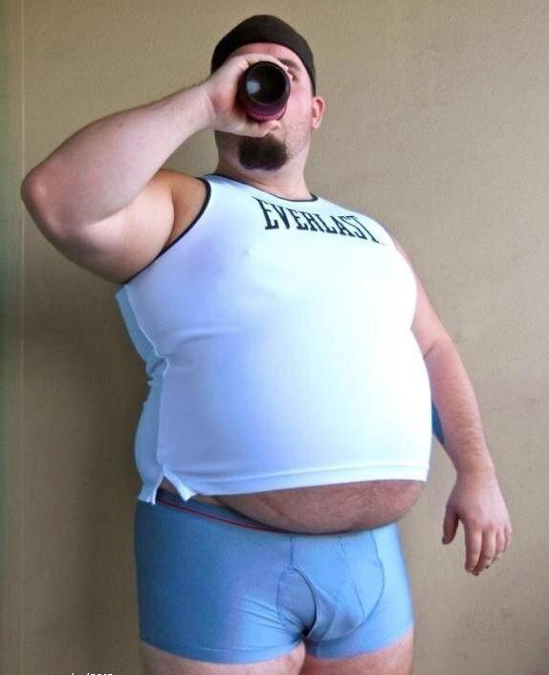
So as he arrived home after an intense day of caring for the farm animals and cleaning out their barns, Maxwell was desperate for a way to destress and just relax before he woke up early again the next morning for work. After quickly pulling off his mud-stained clothing, the man rummaged around in his closet before pulling on a pair of underwear and a workout tank-top that was now a bit too tight given the weight he had gained from his period of unemployment. After lumbering around and idly scratching his gut and tugging the ridden-up tank to cover it up as much as possible, Maxwell finally arrived at his fridge. Upon pulling the door open, the man groaned from back pain as he leaned down and grabbed a beer from the bottom drawer. As he shut the door and turned back towards the kitchen counter, Maxwell quickly removed the cap and began to take a swig of the alcohol.

After he waddled his way into the living room, the man grunted as he fell back into his recliner and instantly flipped back so the foot rest would spring forward. Turning towards the end table sitting next to the recliner, Maxwell quickly gripped onto the thick TV remote and pressed the power button. As it took a few seconds for the older model television to fire up, Maxwell couldn’t help but smile as he took another swig of his beer and began to flip through the channels. After finally reaching the desired channel number, a peculiar cocky smirk emerged onto Maxwell’s overweight and goatee’d face.

Playing on the screen was AEW Dynamite, which Maxwell had quickly found to be his new favorite pastime every Wednesday. Despite the obvious trauma that Maxwell felt about being taken away from his position at the company, wrestling was in his blood and he couldn’t help but root for the company that he had once been a part of (despite their shitty plans that had caused him to lose his body). As he watched several matches play out, Maxwell couldn’t help but yell aloud and taunt his former teammates and co-workers as they performed terribly and got their ass kicked. But when the next match started, the man instantly shut up as an all too familiar name was said aloud. “Please welcome MJF!”

Although he used to get a kick out of those resounding boos that filled the arena and came through onto the TV, this time Maxwell was joining them as he watched his former body finally make its appearance. To his annoyance, it seemed as though AEW had finally accepted months too late his request for an entrance where he was carried in on a throne while waving to his adoring subjects. So now Maxwell was annoyed not only at the real Floyd for getting to live out his fantasy and still be the wrestler that Maxwell had spent years training to be but also towards his company for finally giving him a time to shine once he was actually out of the picture. He wasn’t one for conspiracy theories, but he couldn’t help but wonder if the company was involved with Floyd and had purposely orchestrated the meet and greet to get a more manageable wrestler…

Despite the slight interest in pursuing that train of thought, the wrestler’s arrival at the edge of the ring caused Maxwell to quickly push aside the thought for the time being. Watching the TV, he rolled his eyes as Floyd dusted off his shoulders and fixed his suit jacket before looking around and smirking at the sea of boos that were still filling the crowded arena. “God, he’s such a fucking poser,” Maxwell said with a drunken chuckle, finding it hilarious how he was perfectly replicating all of MJF’s body language and movements since he didn’t have a strong enough personality to do something new with his stolen body.

Back on the screen, as the imposter wrestler turned his head to the left and right, he quickly motioned in each direction for someone to come over towards him. Immediately, Maxwell watched as a woman with a deep red dye job walked out and stared longingly at MJF. As he motioned towards his cheek and began to lean in, the man pursed his lips and smirked as she leaned in and gave his right cheek a gentle kiss. Playing the scene up for the camera, the imposter MJF exclaimed “oh yeah” before turning to his left and doing the same motion towards his other cheek. As a natural redhead then began to approach, the real Floyd suddenly turned his head and pulled the woman in for a passionate kiss that quickly evolved into a full-blown makeout session.

While this was going on, Maxwell immediately pulled himself out of his chair and began to yell at the television. “Are you fucking kidding me? Those sloppy kisses look horrible! He’s clearly never made out with someone before. He kisses like a goddamn pussy!” Stomping his feet down, the man continued to rage in place at how terrible Floyd was doing in Maxwell’s body. The crazed fan went through all of this effort to meet him and swap bodies and it didn’t even pay off with him becoming more confident. It was such a try-hard and unrealistic behavior that he totally was on the fans’ side this time with their near-constant booing!
As the two women quickly turned and left the ring, the new MJF quickly pulled a leg over the middle rope and leaned down to fully enter it. Upon doing so, he immediately pulled a microphone from the back of his pants and held it up to his face. While he slowly approached the camera and began to speak, Maxwell’s blood suddenly went cold at the words he was saying.

“This is my body and my ring! Me, nobody else’s, me! Right now and forever!”

Although Maxwell knew that most people just assumed that it was some cocky banter to make the crowd root against him, he knew the truth behind what he was saying. It was just a secret message directed to him and only him. Even after three months since the swap, the former wrestling fanboy was still finding a way to torment him through the television screen!

“You motherfucker, I hope he kicks your ass,” he loudly cried out, gripping the beer bottle once more and pouring the remaining contents into his mouth. Upon finishing it, the man figured he’d better replenish his drink before the match officially got started. So after grunting, the man pushed himself out of the recliner and quickly wobbled his way over to the fridge and grabbed another beer. As he popped the bottle cap once more and began to take a swig, he made his way back to the chair and began to merrily enjoy the match in hopes of watching the imposter MJF being defeated.

Yet no matter how hard he tried to put a positive spin on his new life, it was a rather sad ending for the fallen wrestler. It had been such a fall from grace that the man found himself living in a trailer, giving up his gym regime, working a low-paying job, and having his only fun pastime be watching his former body compete on television. Given how hard his damaged and still wildly-inflated ego hid the fact that he was a total loser now, Maxwell refused to learn any lesson from this situation. Instead, he would end up spending the rest of his life as a total outsider, a loner who would rather sit and watch life pass by rather than moving on and figuring out something more productive to do with his life just like he had always viewed his fans to be…

