HOOVES MAKE THE LADY
COMMISSION STORY
BY CHALDEACHANGE
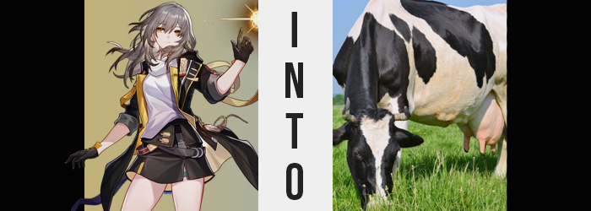

“Ugh… Just 1000 more minutes…”

The morning of the Trailblazer, Stelle, had begun more or less how it normally did. Very, very slowly. She was not a morning person and it definitely showed with how long it took her to pull herself out of her bed, housed within her own room in a passenger car aboard the Astral Express. Of course, there was no indication that it was even morning considering the Express was stationed just outside of Penacony, effectively sitting in space. But for spacefarers? Such a thing was more or less commonplace and essential to adjust to.

Either way, the woman whose body housed a Stellaron clearly wasn’t a morning person as she demonstrated by moaning and groaning while shuffling around her room and adjoined bathroom. It took a lot to get her going after a good sleep. A brushing of her teeth, a long and hot shower, and then her hair… Well, she didn’t really do much with her hair at all! This routine generally took her roughly half an hour to complete.

A half an hour spent away from the phone beside her bed.

“Huh? Clara?” By the time that routine had been wrapped up and she had returned to the phone in question, a missed text notification inevitably caught Stelle’s golden eyes. It had been sent by Clara, a young girl she had met on Jarilo-VI that had essentially been raised by machines. The girl had a tendency to refer to her as ‘big sister’, which she thought was cute. Clara also walked around shoeless, something that the Trailblazer had raised concerns about before in the past, which made the text she’d received a little strange.

It wasn’t a finished text. This was odd on its head but not necessarily that odd. Stelle herself was guilty of accidentally fat fingering the SEND button in the past. But it was a little odd that the text had been sent ten minutes ago and Clara had chosen not to send a follow-up nor a correction. “Something about being given shoes?” Based on what she could make out from the half of a sentence she had received (tragically without any cute emojis like she normally sent), it seemed Clara had been gifted footwear of some kind?

“I guess I should send something back… Maybe she didn’t realize it was half finished?” It was also possible that Clara could have accidentally highlighted and deleted half of the message, only to hit send without realizing. As reliable as the messaging application was, human error was still a common problem – and Clara herself was still a child. Of course, Stelle, being Stelle? All she had typed out was ‘????’ before hitting send. What? Clara would understand! At least she would have if she’d received the message. But it didn’t send at all. In actuality…

It was the sender who was sent to where Clara was.

Where Clara was presently in the process of becoming a ‘child’ no longer.


“Oh man, something reeks!” The first thing that occurred to Stelle when a bright blue sky opened high above her was that her surroundings stank. Like poop, more specifically the type of poop smell that you often associated with farms. Manure and grass clippings, namely. The Trailblazer actually noticed the scent before it even clicked to her that she was in a different location, however. “Wait… HUH!?” She had just been alone in her bedroom aboard the Astral Express! So why was she standing in the middle of a field!?

In the middle of a field on a planet called Earth, more specifically.

What had just happened? How had she been teleported off of the express, much less without any fanfare? And why a stinky field? “I guess farms always smell kind of like this, though…” And the location was obviously a farm. She could see a rickety old house in the distance, not to mention she seemed to be standing in a fenced off paddock that was attached to a nearby barn. Funnily enough? Clara was within that barn at that very moment, being transformed into a farm girl named ‘Clementine’.

Stelle didn’t know this, and even if she had? She probably couldn’t have fathomed why she had been brought along with the girl. The one who had given Clara those shoes hadn’t intended on anyone else being brought to the farm either. But the magic of those shoes had somehow been transmitted through Clara’s phone to the person she had been trying to text when the shoes had brought her to the farm in the first place. But this magic… it was supposed to transform any victims based on what was on their feet. Shoes, normally.

But Stelle’s shoes were her on. And she was more or less just standing with a single toe of her footwear in a pile of cow manure. The magic would default to that, then.

And what was ‘that’? Well, it certainly wasn’t the form of a person. People didn’t wear manure. But… “URP!? Ew… What the heck was that?” The woman burped rather loudly all of a sudden, and that burp carried a taste that could be described as ‘unusual’ at best. If she were to liken the taste to a smell? Perhaps she’d describe it as ‘natural’? Almost as if she had consumed the scent of a freshly mowed field. But grass clippings also weren’t exactly something that humans ate on a regular basis.

The burp wasn’t a gesture that had come unaccompanied, either. As was a common trend with gas, Stelle had come on with the sudden sensation of feeling bloated. “Don’t tell me I’m getting sick.” The last thing she wanted was to be stranded in an unfamiliar place and be sick there. But the bloating only became more and more intense, not only in her stomach but… below it? She idly reached a hand down against this pelvis, finding that there was an unusual pressure – one tied to how her skirt felt a little tight?

“Uh…? Am I putting on weight?” Could you put on weight down there? It was definitely below her tummy, but it was also pushing forward while her stomach’s usual shape was retained. She lifted her shirt and could make out the base of it sticking up and over her skirt’s waistline. “Pink?” The rising skin did look a lot pinker than her usual skin. And as it rubbed against her clothing? She could tell that it was very swollen. She looked around the field quickly to make sure no one was around to see.

Before sticking her hand down the front of her skirt. “WHOOOOOA!?” It was extremely soft to her touch, but the sensitivity of this distended flesh was so intense that it pushed her to bellow almost like an animal. “What is this!?” She could feel four nubs on the front of it, but… No, she didn’t have a choice, did she? Against her better judgment she threw her skirt and her panties down her legs, fully revealing something that she could now properly label now that Stelle could see it.

“An udder!?” It only protruded a few inches from her body for now, but with four teats that were being pulled longer that was the only thing she could think of. She could both see and feel it bloating, filling it with milk and stretching the pink sac so that slowly blew up like a balloon. Whether it had been a coincidence or not though, the moment she freed the udder the more quickly it began to swell. It was already ten inches larger, teats even bigger – big enough in general that veins emerged around its exterior. “So heavy…”

So that was milk filling it!? But the more that there was, the heavier it became. Her knees were already shaking from its mass, which also pushed her back to bend forward. “Wait, if I don’t moove to a more comfortable position soon— Ah!?” The Nameless was going to fall forward? It had ultimately been an inevitability, and with the udder expanding another two inches she finally fell forward onto her hands.

But not her knees.

“Eh?” Normally, if you fell forward, you’d instinctively let your knees hit the ground, right? But that instinct hadn’t kicked in for Stelle. She had instead kept her feet firmly planted behind her despite the differences in her arm and leg length, essentially leaving her standing like a tetrapod. But the discomfort from both sets being mismatched was quickly corrected. Arms and legs alike began to rise, lifting Stelle up higher and evening her out. “SHOOOOOOOOT!”

It was more than just a shift in length, though. Her bones became denser as the unnecessary fat around them thinned away. Elbows and knees inverted while thighbones flattened against the woman’s body to snap the band around her left thigh. But there was also the matter of the fuzz. Thin, white fur was sprouting up both of her arms and her legs, whereas her hands and feet disformed. They hardened, black chitin replacing flesh while fingers merged together into hefty, powerful hooves.

RIIIIIIIIIIP!

The clothing that the Trailblazer was wearing had begun to tear courtesy of her own body. Her legs were now bovine in both shape and function, and that bloating feeling she was experiencing had only intensified. Her udder had swelled even larger, but it was also now sensitive even without anything touching it. The bigger it became, the more pressure there was, and it began to ache. It needed to be milked, but she couldn’t exactly touch it with four hooves in the grass. “NOOOOOO!” All the while, her cries for help sounded more and more like the mooing of a cow.

Stelle’s udder jiggled and swung while the bulk of her body became, well, bulkier. Her stomach gargled excessively as it grew bigger and bigger, flesh and bone thickening rearranging while fur of white and black alike covered what tore through her clothes. Not even her original breasts were spared as they flattened and her human nipples disappeared, leaving her with a broad, muscular chest that pushed downwards as the woman’s body became more and more rectangular in its shape.

Words had turned into grunts and groans. Her transformation wasn’t painful, but it also wasn’t particularly comfortable either. This was nowhere near as obvious as it was with what happened at the rear of her body. Her asshole had inverted and puckered out for one, becoming black and leathery after swelling, while her female genitalia was nestled beneath it – always open and unprotected and unfathomably deep within a body that had bulked up so much now that it neared 1000 pounds in weight.

This region was unprotected for a brief moment, but a ropey tail eventually emerged and began to flicker from side to side to dissuade any of the flies that had begun to gather. With her insides in dismay, Stelle was forced to groan in embarrassment as the contents of her bowels were ejected without any input on her part, adding to the manure beneath her. A tuft of white hair emerged from the end of her tail just moments later to avoid being soiled.

A hefty hoof lifted and fell again. “MOOOO!” As big as her body had become, a great deal of that weight was now the muscle necessary for a cow to functionally carry that weight. She had to be almost five feet tall while standing on all four hooves, and it was a wonder how much of that 1000 pound weight could be attributed to her udder. But while almost all of her body was that of a cow now? Her head had retained much of its humanity, the moos only a side effect of any recollection of the human language fading away.

Still, the fur spread up a neck that broadened, thickening to match the bony, muscular bulk of the rest of her form. “Mmn—BLEH!?” For a moment Stelle almost choked, and the reason was obvious when her mouth opened and a thick, pink tongue spilled out. It was much too big for her head at first, but bones stretched, and black fur spread around skin that pulled into the shape of a thickened muzzle. Her nostrils flared and widened, whereas the teeth in her mouth flattened into the perfect set for an herbivore. Even her eyes changed as they were pushed to the sides of her head, left beady and black in a way that matched the bovine ears that shot up from her head’s sides.

In the end she couldn’t even recognize that she was standing in the tatters of her old clothes, nor strands of silver hair that had fallen from her head.

There wasn’t much she could think about, really.

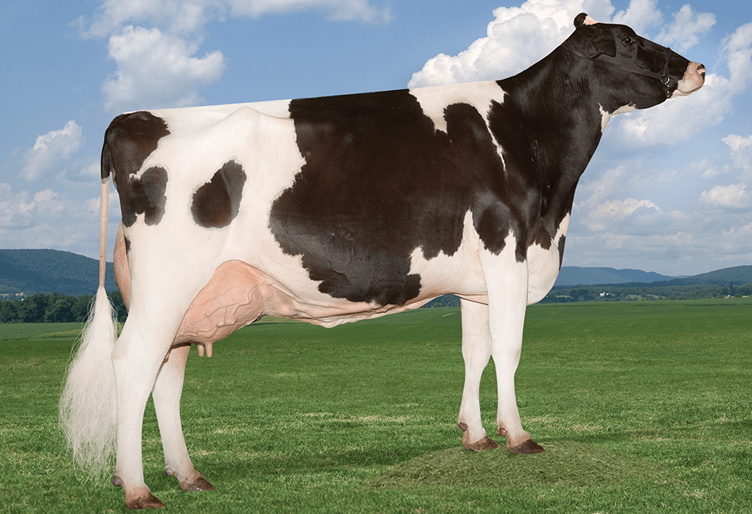
“MOOOOO!” While Stelle’s consciousness still existed vaguely within the mind of the grazing dairy cow, the awareness of her situation had more or less been stifled by the reality that cows were nowhere near as intellectual as a human being. It wasn’t that she couldn’t remember things, mind you, because cows actually have amazing memories. It was more a matter of what she could do with her mind. She couldn’t process complex thoughts like thinking about her time as a human.

There was just a subtle acknowledgement that she may have been one once upon a time, and now she was a creature guided almost solely by instinct. Even now? The pungent smell of manure upon the field was being enhanced by the load she dropped from her ass like it was the most normal thing in the world to her. Because it was. Dairy cows ate, shit, and slept; all in the service of creating the best possible milk. It was a simple life, and one that Stelle the cow had been simplified into accepting without protest.

The sound of approaching footsteps didn’t disturb the happily grazing cow. “Hey there, Stelle! Was wonderin’ where you were grazin’!” The cow instinctively recognized this voice. It was the voice of the human woman that cared for her, and it was because she cared for her that the cow had bonded with Clementine. She could tell the human was hovering around her rear end while her tail batted another few flies away from her butthole and vagina. “Gettin’ to be about that time, huh? Should probably look at gettin’ a bull…”

Because Stelle was an exceptional dairy cow as her huge, full udder demonstrated, there were risks and benefits to breeding her. Not that the cow cared either way. If a bull had been brought to her and mounted her, she wouldn’t resist. She’d simply nurse and raise whatever calves she was ultimately bestowed with. “But that ain’t why I’m here today! Well, I think you know why I’m here.” Clementine was basically just talking to herself, though.

Stelle couldn’t understand the human language anymore.

Nor was she disturbed by the sound of a bucket being place on the ground near her rear. “Yer teats are really swellin’ up again, huh? But they’ve been achin’. Here, lemme help ya!” The cow’s udder really had been a pain point during her transformation once her body had become too big, cumbersome, and misshaped to tend to it herself. But now it felt natural for it to be so full – at least she could deal with the aching.

But as the human’s hands began to pull her teats and she could both feel and hear her milk shooting out and into the bucket? “MOOOOOO!” Stelle couldn’t help but moo. Aside from being mounted by a bull, that was probably the greatest pleasure a dairy cow could experience!

