MAID OF NYAS
COMMISSION STORY
BY CHALDEACHANGE
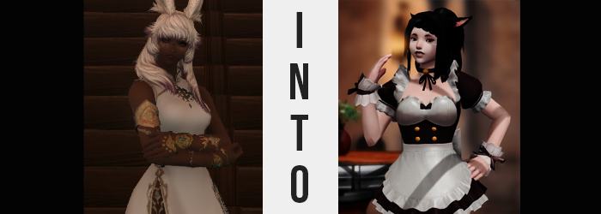

It wasn’t easy having attitude.

L’luna Winterbloom had learned that the hard way. She had plenty of experience with it, seeing as it had pretty much been her nature over the course of her entire life. She was standoffish not because she liked to be, but because the cruelties of the world had driven her to act that way. But it was not like she was a bad person either. That was what made things all the more difficult for her, seeing as she didn’t exactly mean to come off as intensely as she did.

If there was a term to best describe her personality, it was one that didn’t exactly exist on Etheirys. Tsundere. For as condescending and snappy as she came off, Luna only wished for the best for her friends. That fact just tragically got lost in translation time after time, which inadvertently caused some friction between her and her companions.

She had fallen asleep that night after one such episode. Her Highlander companion had gotten a touch upset with her after the white-haired Viera had insisted that she was the one pulling all of the weight when it came to finishing quests to earn their living money. The two had been renting an inn room in Ul’Dah for several weeks now you see, and a constant stream of Gil was naturally required to put up board.

The distribution of earnings hadn’t exactly been even though. It wasn’t either of their faults, but her friend had been making less. There had been no reason for Luna to bring it up, and she had realized it in retrospect, but… it had already been too late by that point. “What a terrible night’s sleep. I suppose I should apologize… Oh, their bed is empty.”

It was in the wee hours of the morning, but perhaps they had gone out to train? Luna herself had been so exhausted when she had gone to bed that she hadn’t even gotten changed – but she’d probably have to after visiting the public baths just down the road. It wasn’t until the Viera had gotten up, stretched, and then rubbed at her neck that she realized she was wearing an article that she hadn’t put on herself.
“What the…? A choker?” She couldn’t see it, but that’s what it felt like. One tied with a ribbon in the center. It certainly wasn’t the sort of accessory she would put on by herself, and it probably didn’t match the rest of her ensemble. As for how it had gotten on her on the first place… “Did they pull a prank on me and put this on while I was asleep? It isn’t a very good joke if so.” Unless it looked far sillier than she imagined, and to confirm that she tried to pull it off.

But she couldn’t.

Pull as she might on the ribbon, it just wouldn’t budge. She couldn’t use brute force to snap it off either. “What is this thing made of? Is there some sort of trick to removing it!?” Luna smirked a little, believing that she had been pranked a little more efficiently than she had first assumed. But she was still sorely underestimating the extent to which she would soon be bamboozled. After all, her dear friend had been subjected to quite enough snootiness as of late. Enough to bestow her company with a curse meant to embarrass her greatly.

Luna was a confident woman, but she wasn’t the kind of woman that liked to flaunt herself. She retained eighty-five percent coverage with her outfit for a reason after all. But it had struck her suddenly. A strange thought. This outfit is totally stuffy! Needless to say the Viera was immediately stunned by her own line of thought. …Since when? It wasn’t even all that warm in their inn room, it being Ul’Dah’s cooler season and all.

“I must still be groggy. I wouldn’t think like that…” It was much easier to blame the fact that she had just woken up more than anything, even though there were physical indicators that there was more than meets the eye here. In fact, it was very clear and obvious if you looked at her. The issue? The Viera didn’t have the liberty of seeing herself. There was no mirror in the room, and she had no reason to check in the first place.

She’d always had light markings beneath her eyes, but never in the woman’s life had she had white freckles, which was exactly what it looked like was developing across her face. …And her arms, and her chest, and her belly, and her legs. These patches of melanin-deprived coloration became oh so plentiful, coating her from head to toe. Once they reached the maximum number of possible spots, those spots then grew larger and combined until her skin tone was a very consistent pale – complete with pink nipples where they had once been brown.

The markings under Luna’s eyes faded, but to replace them some pure white streaks, almost resembling whisker patterns, barely stood out coming in towards her eyes from the sides of her face. Eyes that, mind you, had come to reflect a color that was different from her usual one themselves. A baby blue was what shone in their place, bright and pure. What wasn’t pure was the kind of thoughts that began to run through her head.

Thoughts of strangers ogling her body with their eyes. She’d never much liked being stared at before, so why was it that this was all she could think of now? She even idly licked her lips some, at least before catching herself. It’s not my fault that I’m hot and everyone knows it! No… She was confident and sometimes insufferable, but it never manifested like that. “Something’s… wrong.”

Much more wrong than she could even comprehend if the midnight black sweeping through her wild, white hair was any indicator. It was only a few strands that took this color at first, but it ultimately spread like wildfire and even seeped into the fur of her Viera ears and into her eyebrows. Dramatically farther south, within her loins, the black stained her pubes just as keenly – even seeing their trim buzzed into a cutesy heart shape above her pussy.

When it came to the hair atop her head, it was more than a mere color job though. Naturally fluffy as most Viera hair was, it thinned and lengthened just a couple of inches in the back, while that at her sides did the opposite. This completely altered the balance of its aesthetic while making it a little lighter.

Of course, there were other factors in play that lightened the load atop her head. With L’luna’s entire body now dyed in new colors, the choker’s curse began to fixate on remodeling other aspects of her being. And based on what was transpiring? That aspect appeared to be her race. Her long, rabbit-like ears were slowly absorbed into her head so that they shortened, reaching lengths that were less than half of what they had once been while also inheriting a pink inner plush. These ears twitched in response to every single sound, which was something she immediately found distracting.

“Like, what the heckie is going on with my—!?” Luna was assaulted by realizations stemming from multiple fronts. What had provoked her into speaking up in the first place was her ears, and so she had reached high to touch them – only to catch a glimpse of the skin color on her hands in the process. But then she’d blurted her shock out aloud, finding her vernacular littered with casual, unintelligent words communicated in a vapid manner. “This is so not good!”

Fingers, now sporting fake nails, jumped to the choker to try and rip it off again. Now that she was aware of it, she could feel it. A subtle warmth radiating from its material and into her skin. It was changing her, and not just her body! What she had originally thought was a grogginess was actually a case of her intellect sneakily dropping while a new personality was enforced upon her. That explained her sudden overconfidence in her physical appearance and why she felt keener on showing off!

Pull as she might though, the accessory was stuck. Trying to remove it was just wasted time, and because she was so fixated on it she hadn’t thought much about what was transpiring with the rest of her form. An extra appendage had actually appeared, pushing up the back flap of her white dress. Coated with fluffy fur the same color as her hair, this prehensile tail swished about unencumbered by her outfit. It wasn’t until it eventually slapped her thigh that she realized. “Is that…? That’s totes a tail!”

A Miqo’te tail at that. Which finally clicked everything into place for her. She needn’t touch her ears anymore to figure out what was amiss with them, because they must have resembled a Miqo’te’s as well. It was shocking, terrifying, and angering, and yet…

“HEEHEEHEE!”

L’luna wore an expression of defeat upon her face as it burst forth from within. The most airheaded of giggles escaping her lips, even though there had been nothing to laugh at in the first place. It was strange but… Giggling so freely felt kind of nice? Especially being done through lips that had swollen as she’d laughed, taking on a glossy tone painted with dark red. This made her mouth much more pronounced, and it took up more of her face than it had before.

This wasn’t helped by the fact that there was less of a face to cover though. Her head had shrunken subtly, and so her face must have as well. The end result was a shrinking of her facial features that put her more in line of what one would expect of a Miqo’te woman – from a smaller chin to a sharper nose. But her lips and big eyes were the attention grabbers.

However, speaking of shrinking. It was only brief, but the slightly smaller head looked unusual against her Viera stature – which meant one of those two things had to change, and it wasn’t the size of her head. Indeed, her head was quick to dramatically drop, and in the time it would take you to count to ten, she had collapsed down to five-foot-three. Rather than express any fear about it, though? “Wheeeeeee!” She just couldn’t help herself! She didn’t even care that the golden jewelry on her arms was just falling off!

A dress that was once so comfortable was now dragging its fabric against the floor, and thigh highed boots were riding up into her groin from how much height she had lost. “Wow is this not comfortable! Gods!” Taking a moment, she at least pried the boots off. And not a moment too late, for the final phase of assimilation had finally begun.

This phase focused on the woman’s figure, which was absolutely obvious looking at her ass and thighs. Both regions swelled in tandem with one another, forcing her hips to part dramatically several inches where thick and perky flesh strained the stretch of her skin around them. Undergarments were flossed in between the cheeks of an ass that overcame her head in combined size, while thighs needily rubbed against each other because, well…

This was pretty damn arousing!

The new Miqo’te’s dress was eventually lifted up slightly, but only because her breasts beneath had swollen. She did not wear a bra underneath, which made it all the easier for these mammaries to surpass even the impressive size that had been preserved from her old race. It was only a single cup size, but against a 5’3” frame? They looked huge.

Her senses overwhelmed, her body warmer than ever before, she swayed from side to side. “Ooooo. I bet I look so totally, super-duper amazing! I totes wish someone could see my hot ass right now!” The cursed collar did Luna one final deed and, with a blast of magical energy, saw to it that she was wearing something more comfortable for her. Or the new her, at least.

The end result was a simple maid uniform that left plenty of skin exposed. Her ample cleavage was clear as day, and her thighs were bare as could be. The skirt? It was so short that if she bent forward even a little she would totally show off her butt to some unsuspecting individual. And the idea of such an encounter? It excited her!

“Wowie! I feel so, totally, like… Oh gods!” The woman had felt it transpiring throughout the entirety of her transformation from a tall Viera woman to a short but stacked Miqo’te maid, but now that she could focus a little better L’luna realized just how she sounded. Vapid and childish, giggling unprompted at every opportunity. Her mind still felt a little fuzzy, but it was meant to be that way! It just felt nice!

It felt nice, and she hated it deep down. She couldn’t express as much with her words nor her expressions, but the part of her old self that remained in tact was very much suffering within a stew of desire to show off her luscious body and garner the affection of every poor soul that walked into the maid café she worked it.
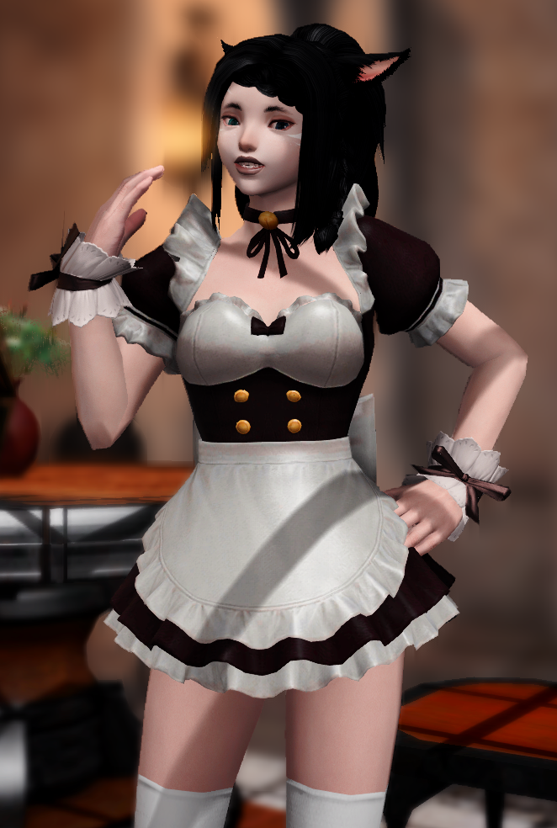
At the very least she now had perspective regarding what her friend’s intention had been. Her current position was a very demeaning one. One where she actively desired to flaunt herself sexually, where she would happily put herself into the service of another for moment, and where she was, well, dumb. Her loss of intellect wasn’t subtle. She couldn’t exactly wield a weapon any longer because she couldn’t remember how, and big words were a little too far out of reach for the bimbo maid.

“Ahh!? I’m totes gonna be waaay late for work if I don’t hurry up!” Luna hated how she sounded, but the anxiety she felt about being late for her shift was real, even if it was something she had only just learned about. From the kitty’s perspective, it was a job she could recall having gone to every day for the past little while. How else was she going to help provide for the mistress with whom she lived?

…Was that how she saw her friend now? Ugh.

And so the maid scurried out the door, running at such a speed that her honking E-cup tits bounced about painfully beneath her uniform’s top. Her skirt was so short that anyone she rushed past would get a good look at her fat rump, too. It was so, so embarrassing! The Viera within was so upset by it all, and yet the Miqo’te she presented as forcefully? She was elated! She wanted as many people to stare at her as possible. Because when you looked as good as she did, why not show it off?

Just down the street, it didn’t take Luna to burst through the door of the café to the sound of her boss calling her name. “Nyanko! You’re late!”, to which the Miqo’te giggled childishly. Wasn’t her name so funny? Nyanko! Because she was a cat! Wait… had that been her name? Wasn’t it something else?

“Ehehe! Sorry, nya! Just prettying up, nya!” And why was she making those cat noises!? She couldn’t stop! How demeaning! How HORRIBLE! She hated it all. But most of all, she hated that doing it made her happy. “Just show me to a customer and I’ll wiggle my ass at them, nya!” And to prove that point, she wiggled her ass towards the café’s owner. He simply director her to a customer in the corner of the room. But it was none other than…

“Like, Mistress!? Heeheehee! I’m sooooo happy to see you!”

And she honestly was.

