CHIKA DANCE
APRIL 2022 FIRST PERSON STORY
BY CHALDEACHANGE
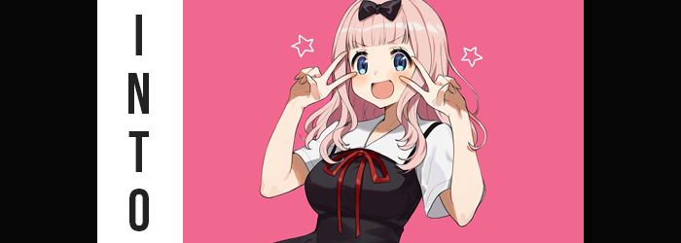

Sometimes it was a little hard to keep up with the internet, especially when it came to meme culture. It almost seemed like every day there was a new meme to keep up with, and whether or not you knew what it originated from, it was all over your social media. It could be something as mundane as a crudely drawn image without even a punchline but some hidden meaning, or perhaps a gif from a show that had aired. Again and again and again, these would be switched out for something new.

There was really nothing quite as topical as a good meme.

Just as quickly as they came, however? They would disappear. Replaced by the next big thing. But there were exceptions to this ‘rule’. Some had enough staying power to become timeless, while others? Well, memes could be revived. All that needed to happen was for them to become relevant again. Usually, at least when it came to media-based memes, that meant the show or game they came from getting a second wind of some sort.

A new anime season would most certainly qualify as a means of presenting an anime-based meme that second wind. “The Chika Dance again? Is that anime airing a new season?” Busy with work as I was, I hadn’t quite been capable of keeping up with all of the new anime releases each and every season. That was why I was surprised to see my Twitter feed overwhelmed by gifs of, and links to, the Chika Dance.

It was a meme ending sequence first showed off in season one of Kaguya-sama: Love is War, and featured the cute pink-haired student, Chika, doing a rather adorable dance. So, you know, exactly the kind of thing that would quickly be made a meme of. But that season had long ended, and a second had come and gone. Now it seemed the third was airing, and so this meme in particular was getting its third wind. For some reason. Well, I could at least admit that it was cute.

“Isn’t this a little excessive, even for a meme?” I was scrolling, scrolling, scrolling… yet the GIFs just kept coming, even from accounts I followed that typically wouldn’t tweet such things. Had everyone been hacked? Did I miss a memo? Was I enduring a fever dream of some sort? There was any number of possibilities. Admittedly some were much more plausible than others, but that didn’t mean that these possibilities didn’t exist!

Just as I’d been about to make a tweet asking why everyone was doing this, though? Something strange happened. My own account tweeted a GIF of the Chika Dance right before my very eyes. “What the-!? Was I actually hacked!?” Having seen it with my very eyes, that definitely appeared to be the case. And I frantically went to delete the tweet with the intention of changing my password right after.

Yet the second I hit the delete button? Well, the whole world spun around me.

“Woah!?” I’d been sitting at my computer, yet the feeling of falling for just a moment hit me before my bottom landed on what appeared to be a soft couch. In a room that most certainly wasn’t my room. That didn’t mean I’d never seen it before though. “Wait, isn’t this the student council office from that anime? I really must be dreaming.” There was no way I could actually be in the student council office of Shuchi’in Academy. That was a fictional place! In an anime!

Mind you, I hadn’t quite realized that I, too, had become 2D. And I wouldn’t because I was perceiving the world as three-dimensional, nonetheless. It would continue this way for now, but in the end I would see the place as it really was, whether I liked it or not. Either way, as a Western adult I didn’t fit into this location whatsoever. And the location itself? Well, it was seeking to change that.

It actually didn’t waste any time on that front, for change had begun the moment I had set foot in this arguably ‘sacred’ land. The fact that I was of Western descent was actually the issue that was addressed first, as my hair quickly darkened to black, and my facial features were quickly… not rearranged per se but were slightly altered to better suit a completely different genetic, racial background.

Whether it was my facial structure, which shortened some, or my eyes, which narrowed into shapes far more akin to almonds than their usual rounded shapes, it was clear that I had begun to look more Japanese. Even when it came to the tone of my skin, there was a tinge more yellow to it than there had been previously. And yet, especially when it came to my eyes? When seen through the two-dimensional lens, those eyes had become big and bright – as well as shimmering with a steely blue that my irises did not typically possess.

“So since I’ve established this has to be a dream or something, now what?” The part of me that believed in common sense over everything else could only rationalize my presence there as an impossibility. So a dream or something like it was all that could explain it. Had anything happened to me yet that might have been noticeable, I probably would have recognized it. But I was not even capable of noticing that my first language had shifted to Japanese – although English still lingered in my memories.

There was also something about my overall appearance that seemed slightly off, but again, it wasn’t the sort of thing that was at all easy to notice. You see, my height had peaked in my mid-teens, so provided I was still in that age range, even if my age were, to say, lessen, I wouldn’t have noticed myself unless I dipped to an age when I was shorter. One of those things had happened, but the other hadn’t.

I had gotten younger.

Not just a little bit, either. Based on the youthfulness of my face and the energy that had been returned to me, I probably looked to be around the age of seventeen or so. Mind you, this meant that my body type from those days had been returned as well, so I was a little trimmer than I was normally, but I always wore loose clothing, so it wasn’t all that noticeable even if I was thinner. And thinner. And thinner. “…Huh?” The excess weight just kept leaving my body to the point where there wasn’t any extra whatsoever, and by that point in time? There was no way I couldn’t notice.

Hands patted down the front of my tee, confused about where all of my pudge has gone. “Yeah, definitely a dream.” My reasoning was that no matter how real it felt, there was just no way to lose weight so suddenly. It was probably responding to my desire to get healthier, that’s all! While I had noticed I’d gotten thinner, evidently my newfound youth and the fact that I was now Japanese continued to elude me.

“EEP!?” A sensation of falling, just as sudden as my confused scream was loud, led to me almost falling over if not for catching myself on the back of the student council room couch. Even then, it felt like I was getting closer and closer to the couch in question. Probably because I was. “Now I’m shrinking!?” I sounded alarmed, but only because I was trying to avoid acknowledging my subconscious curiosity about what it might be like to be smaller. Even for a man I’d been quite tall, so plummeting down to around five foot two was a very significant drop.

Both my pants and my boxers slipped off my waist, while my shirt kept the bare essentials covered at least. I was left tugging at that shirt with hands that had shrunken in kind, but they were different in other ways too. Each finger almost looked more girlish, and that was helped by longer nails. Mirrored with my feet, there was no denying that a much more effeminate aura had begun to see my appearance, well… become cute.

“I… Huh!? My voice too!? No way! I sound like a girl!” I could hardly believe the sound of my own voice. “And my hands…?” So much so that I had raised one of my hands to my mouth, and in turn had caught sight of just how girlish they now appeared. They had only just briefly grazed my lips before I had noticed.

Lips that were puffier than usual, but only because the rest of my face had taken a turn towards the feminine as well. My Japanese features were even rounder than they’d been prior, with cheeks full to the point that they almost seemed to be childish. Through the 2D filter, facially I looked the part of an anime girl – and a very familiar one at that. This was ultimately solidified as locks of my hair grew wavy and spilled out to my shoulders with square bangs. It tickled my neck, having me pull some forward just in time to notice the color change. “Pink!?” A very pastel pink, actually, and one that was replicated with my brows and pubes.

Speaking of that general area, though… “Gyeh!?” While I definitely possessed the voice of a maiden, as I lurched forward in response to a sharp tug in the front of my crotch, I certainly didn’t make a very maidenly noise with it. Smaller hands immediately dug into my groin, where they found that, well… “I’m a girl!?” My mini-me was absent? Where had it gone!? I was too afraid to dig too deep and probe what I assumed was now a pussy between my legs.

Wait… A thought had suddenly struck me. I had been hacked with a Chika Dance GIF before I’d shown up in a set piece from the series in question. I had become a girl. One with pink hair. One who was much shorter than I was. There was no way it could be, right? There was no way that— “WHOA!?”

Before I could properly put that thought together, a wave of change saw several key aspects of my body swell, changing in slight the fit of the oversized tee that clad me. The most notable sent my body lurching forward, for a once flat chest erupted into a pair of soft, C-cup breasts that I accidentally groped when trying to regain my balance. I blushed fiercely at just how sensitive they were. I wasn’t exactly comfortable in a body that was increasingly not mine.

On the other hand, beneath a tummy that had arched inwards at the sides to see my hips pop just a little wider, I had been greeted by the feeling of my rump and thighs both growing fuller. Both facets swelled magnificently, and yet never with such abundance that they betrayed my more youthful age. My butt was tight and perky, and my thighs were tender and soft. There was little denying that I was wholly a teenage girl now.

Just as there was little denying that I was—

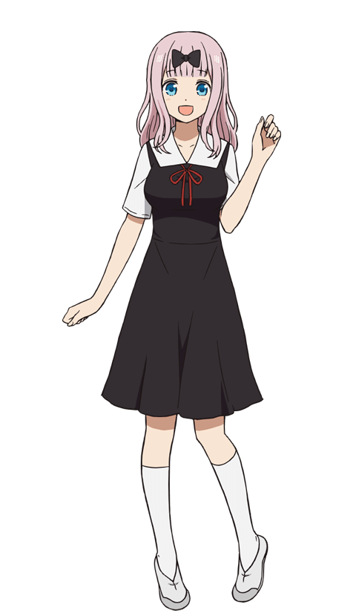
“Chika Chika~!” What… had just happened? The sound of music, barely audible, had sounded from all around me, and I had just as suddenly blurted it out. I couldn’t stop myself from beginning to move in a way that made my new curves wiggle and shake, while I could feel my clothing transform around me into a Shuchi’in Academy girls’ uniform, complete with a bow atop my head of pastel pink hair.

Wasn’t this the song from that meme? From the Chika Dance? I was utterly powerless to stop myself from dancing along to it, it seemed, and I gradually moved over to the student council room desk where I continued to play out the routine. But at the same time it was more than that. The more I played along against my will, the less it was against my will in the first place. It was more and more like I wanted to do it. Because it would be something cute to show off to my fellow student council members, right~?

Before long the dance had almost concluded, and any doubts or discomfort within my heart had more or less evaporated! Of course, it definitely helped that I couldn’t remember, um… Was there something that was distracting me? I mean I totally present myself as an airhead sometimes, but I’m not actually an idiot! How else am I supposed to get everyone else to open up to me if they don’t let their guards down, right?

As the one and only Chika Fujiwara, I had a duty to lift everyone’s spirits!

…And invasively investigate their love lives~!

