Into My Own Hands

Inspired by a cap by Becky

For John Number 51

By Maryanne Peters

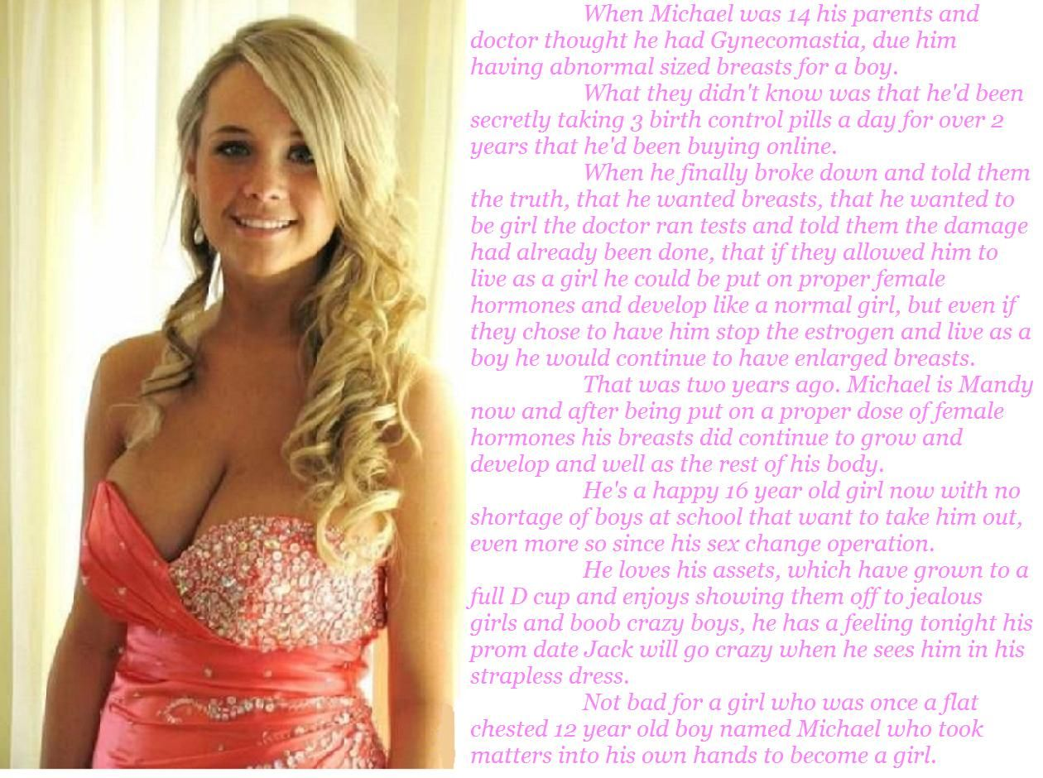

I suppose like most teenage boys, I had a fascination with tits. To me there is nothing like watching a pair of big jiggly tits bouncing around under a V-neck top. And at our school, when you talk tits you are talking Mandy Foster.

I mean Mandy was a knockout anyway, but those tits! What 16 year old girl has tits like that? Mandy Foster, that’s who. From the moment I arrived at that high school and saw those tits for the first time I just wanted to push my face in between them and maybe have the nipples touch my ears.

But one of the guys said: “There is one thing you should know about Mandy – she hasn’t always been Mandy. A few years ago she was a guy – a girl called Michael”.

Ok, so initially a turn-off, right? But the word was that she had been snipped, and she was one of the prettiest in school, girl or whatever … and those tits!

I just had to get my hands on those tits.

So I asked her out to the prom. I thought: ‘What the hell? I am not the only one who wants to stroke those pillows’.

“Of course you cab touch them,” she said. “But not here. Let’s go to your place.”

Like a dream come true.

“They are completely natural,” she said. “I grew them myself. I have always wanted breasts. I took things into my own hands. I took my mother’s estrogen for years. Do you like them?”

Do I what?

“Do you like my hair. I am a natural blonde. I have been growing it out. I like to curl it at the ends. Do you like it this way?”

Girls can prattle on. I could not drive fast enough to get home and get her naked.

“If you know about me, then you know that I once had a genital deformity,” she said. “But I want to let you know that has all been dealt with. The old growth is gone and I have a vagina just like all the other girls. Except it might be a bit tighter. Tighter than that other girls, I mean. Do you mind?”

What I mind is the fact that I am driving with a rock hard erection straining at my pants.

“But of course I can’t have children. But don’t think that means that we won’t be using protection. STDs are still an issue. Unless of course, you promise me that you have been checked out recently, and that you won’t play around.”

Fuck, fuck. I am going to come in my pants.

“You look like you are in a bit of discomfort there John. I can take it into my own hands. Just promise me that there will be something left for later.

The End

|  |  |
| --- | --- |
| Girls from the Group  For John Number 52  By Maryanne Peters  I’m no shrink, but I guess that I was attacking my little brother because my feelings were all fucked up. I shouldn’t call her my little brother – she is my little sister. There is nothing of Ben left in her.  It was just that as a family of two boys, there was no girly stuff around. I know guys who have had sisters all along, and they know about what they do. Maybe some of them peek at their sister getting dressed, pretending they walked in by mistake. Or is it just me.  There is stuff on the internet. There are pictures of guys growing their hair and growing their tits – “transitioning” they call it. I got to see just part of it happening in my own home. To find out the other stuff I had to go on line.  I mean, there is nothing wrong with looking at those trans-girls is there? I am not interested in their cocks, of course. That would make me a faggot.  I know Brianna is not a faggot. To be a fag you have to be a guy, and she isn’t that. And I know Jason. He is a pal of mine. He is not gay. He wants Brianna because she is a girl. He has told me that all he wants is for her to get her surgery so they can make love like any normal couple. He is even talking about them being together permanently.  I am not a fag either. I mean both Katie and Hannah are all over me, but they are girls - not male either of them. They are the girls Brianna introduced me to – the girls from the group. |  |

It is just that … I can’t seem to get it out my head that they have dicks. At least I think they do. They all have to wait until they get to a certain age – right? Just like Ben, I mean Brianna. They stay as sissy girls until they get the surgery – right?

Katies says she is not telling me. She says that if I ever get past first base I might find out. She says that won’t be easy as she is not that kind of girl. She is the prettiest thing. Nobody would guess that she was born a boy. I have to remind myself sometimes. Otherwise I would fall for her and then where would I be?

Hannah says that I don’t need to know. She says that all I need to know is that we can have sex when I am ready to get over it. Get over what. I have to say it, she is hot. She has had new implants. I would love to get my face between those puppies. But she is bigger than me. What would she make me do? I don’t want to have a cock in me. Hot but scary, that’s Hannah.

And then there is Keira. She ignores me. I think that she is afraid of guys, even though she was one. There is just something about her.

And then there are all those girls out there – real girls – born that way.

Why can I not stop thinking about the girls from the Group?

The End

|  |  |
| --- | --- |
| Chrissy the Sissy  Inspired by a cap by Becky  For John Number 53  By Maryanne Peters  Life can play funny tricks on a guy. You love who you love. That is just the way things are. I just happened to fall in love with Chrissy the Sissy.  Chris was the kind of wimpy guy that there must be in every school. I suppose that we all thought that he would turn out to be gay, but even then, he was different. He really was one of the girls.  Then on his last week at school he really did join them. He had decided to go to graduation dressed as a girl. We did not know it then, but from that day on he would never dress as a boy again.  It was Chrissy that went to college, not Chris – a different college from me, so I did not get to see the gradual change. Sometimes I wish I had. I think that it would have been nice to see the woman I fell in love with take on her shape before my very eyes: Her hair growing long, her titties growing like giants blooms, her face softening. But would I really have been interested?  Instead I met her again by chance when I was home just before graduation. She smiled at me with familiarity and I thought that I had lucked out big time.  “I am sorry, have we met already?” I asked.  “Chrissy,” she said. “Chrissy the Sissy”. |  |

I have to say it, my mind was thrown into the tumble washer. It was as if I had already made my mind up at first sight, that this was the woman for me, but then I saw something in those eyes that confirmed what she had just said. It was Chris, but so different.

Maybe there are other guys like me who have been through the same thing? I hope so. There is something that says “it’s a guy” and makes you want to back off. I guess that is what it is to be heterosexual. But then when you find your eyes wide open, and your mouth too, and you just cannot say what you want to say … well, sexuality becomes irrelevant.

“I have changed some,” she said, trying to break my trance.

I said: “You look great,” because she did.

“I am all woman now,” she said. “So, I guess I am no longer a sissy?”

“No”. That was all I could say. Struck dumb by her.

She came right up close to me – close enough for me to smell her. My cock was stirring. There was no argument now. This was no longer a sissy in front of me.

“I was young. I was immature,” I said. “Will you forgive me?”

“Take me to dinner and I will consider doing that,” she said.

And then a few weeks later she was my date to the graduation prom. And that very night I was inside her and she was mine, just as I had been hers from that very first meeting. I mean, the meeting that was not the first for her, but it was for me.

I think that she has forgiven me, although she has never said it. She still signs off her emails to me, and the occasional text, “CTS” – “Chrissy the Sissy”. I guess just her way of reminding the guy who adores her that a woman never forgets a slight.

The End

|  |  |
| --- | --- |
| Dancing  Inspired by a cap by Becky  For John Number 54  By Maryanne Peters  Johnny’s mother told mine, and when she told me, I could get the thought out of my head. Johnny Davis turned into a girl! Is that even possible? I thought: ‘If they can turn that prick into a limp wristed sissy then anything is possible.  Throughout those early years at High School he had been on my back. It was not that he was bigger than me, but he hung with a rough crowd who were pretty scary. For some reason he picked me out and was always trying to get me into a fight with one of those guys.  Now he was up-state at some academy for “transgender girls”.  But I have to say, it kept me awake, the thought of Johnny Davis as a girl. I was not sure why. It just seemed so strange.  Maybe I even had an image of him in my head, with a mop of blond curls and too much make up, wearing a pink ruffled dress with petticoats. It is not the kind of thing a young guy should be thinking about with his hand on his cock.  Then I heard that this academy was having a graduation prom, where guys were encouraged to dance with the newly qualified “girls”. Who would go to such a thing? Some had boyfriends, some had supportive brothers who would come along, or close family friends. That is what they told me when I asked.  “I’m not really a friend,” I explained. “We were at school together, but I would not call us friends. |  |

“We think it is important that they have young, robust, heterosexual men to mingle with,” the “tutor” told me. “I am sue Jenny would appreciate it.”

Jenny. Johnny was now Jenny. How could a guy like him have such a pretty name? What would she be like? More sleepless nights. More stick bed sheets in the morning.

So, really, I just had to go. I sent through a note. I smiled when I thought that he would read it. At last the guy he kept calling out would stand in front of him as a man, with him now a simpering sissy. It promised to be a real laugh. Some kind of justice, maybe.

I walked in expecting to see a bunch of teenage drag queens, I suppose. I was shocked that the room was full of beautiful young women. Surely Jenny would not look as good as them. And then the prettiest of them walked over to me. She was wearing a long blue dress with a textured bodice cut low to reveal two wonderful breasts. He long honey brown hair was pulled back from her pretty face, the makeup understated to show her perfect skin and large eyes. She was smiling at me as if she knew me. Because she did.

“Jenny?” I could not believe that I asked. Surely this was not him? This must be a real girl – a support person perhaps?

“I got your note, Matt,” she said in a voice that was so light and girlish that you wanted her to say your name. “Are you going to ask me to dance?”

Her hands were so soft. Her hair smelt of flowers, and I longed to bury my face in it. The skin from her forehead to the valley of her cleavage seemed to glow as if beneath the cool luminous outer layer, a fiery heat lay below it, the promise of excitement.

“What I really wanted was to be a girl – to be Jenny,” she said. There seemed no doubt that she had achieved that. “I picked on you all those years because I like you, Matt.”

Somehow that made sense. Johnny had wanted to see take on the other guys in his crew, maybe for her to watch. Maybe she could have imagined that I was fighting for her. She as attracted to me even then, but how could she express herself when she was in the body of a young man. Somehow that body seemed long gone.

Was she right? Did I feel the same way? Yes, and some, would be the correct response.

The End

|  |  |
| --- | --- |
| Having to Accept It  Inspired by a cap by Becky  For John Number 55  By Maryanne Peters  I still see my boy in her. She is tall and athletic, with the strong face that really did make him a very good-looking young man, so popular with the girls. It just now that the face is smooth and soft, and painted with a little makeup, and somehow after only two years her brown hair hangs all the way down her back and even in her sports bra, her breasts are obvious.  I never wanted this for him. He seemed to have the whole world in front of him, if only he were not so insistent that he was a girl inside. If he felt that made him miserable, I only saw more misery ahead of him, trying to pass as a girl being built the way he was.  And he was talking about a future without a family. Maybe you don’t think about it when you are a teenager, but when you get older you want to leave your mark on the world by leaving something of yourself behind. And it seemed to me he could be that person. He could have been a better man than me.  His mother felt that she needed to support him. We disagreed strongly about it. I am not saying that was the sole reason for the divorce, but it played a part. He said that he needed his mother more than me – she could help show him how to be a woman.  We never talked because he did not like to argue, but he sent me emails reassuring me that he loved me no matter what. I never really doubted it. The problem was me. Could I love “her” as much as I loved him, before all of this. |  |

Then came the letter that I dreaded. The request for my signature so that he could become she. My perfect boy would have his maleness cut out with a scalpel, and I was supposed to agree!

“I want you to come to the game,” the message said. “I know you enjoy watching me play football. But now I am on the cheer squad and I will be performing. And there is somebody I want you to meet.”

It had been my high school too. Hell, I went to school with Timmy’s football coach. I had been hard to leave my home town, and harder not to go back. But why not go? I did not have to tell anybody. I could watch from a distance. I could see what Tiffany looked like – what kind of girl my son had turned out to be. I could always walk away if it was too embarrassing.

And there she was. The biggest girl on the team, doing the lifts, but also so pretty, and clearly popular with all the other girls. That long hair floored me. She tossed it around as if there was nothing more natural – as if she had wanted hair like that all her life. I guess she had.

After the game I went down to the sideline, just to get a little closer. My old school had won, but the coach still found time to come over to me after his boys were hitting the showers. How weird was this going to be, as he reached out his hand to shake mine.”

“You must be so proud of Tiffany,” he said. “It took guts to come out the way she did. The boys are right behind her, and so are the girls.”

“Daddy, you came!” She had recognized me, and she came running over, taking me in a strong scented hug. “Daddy, there is somebody I want you to meet.”

One of the footballers was late into the showers. I recognized him as the captain of the team, and huge young man who seemed like a natural leader on the field.

“I am very pleased to meet you Sir,” he said. His grip was strong. His voice mellow, his eyes sparkled with intelligence and ambition. “Given my feelings for Tiffany I hope that we will become solid friends before anything else.”

The kind of son a man like me dreams of having, but maybe just not by this route.

The End

© Maryanne Peters 2020