*Ideal Idol*

*Siggy Commission for ProbablySomebody*

The path of an idol was a treacherous one. A small, rickety road fraught with unseen pitfalls and loose stones that could trip up anyone who let their guard down for even a second. With pressure from both their adoring fans and overbearing managers, being in the starlight was a tough job than most would ever realize, with their managers doing just as much to ensure their idols stayed on track while keeping the path behind them squeaky clean without even a crumb for the riff raff to pick up on.

But rarely would someone ever walk on both sides of the line. Quitting entirely either once they'd had enough or were ultimately let go of for new talent to fill the gaps they left behind.

One such individual was Haruto Togawa; once a famous idol himself, the man had led a successful career in his youth that had numbered well past the double digit mark, nearly placing himself amongst the most popular vocalist's to grace Japan's populace.

Until an accident that took the function of Haruto's legs away from him had left the idol unable to perform at all, rendered a bedridden vegetable while the world continued to move on around him. For many big name performers, this spelt the end of their career with barely anyone besides devout worshippers able to even remember who they were in the first place. And in Haruto's case, whose fame and influence only ever managed to reach around Japan, it was a quick and painless end, so to speak.

By the time he awoke from the coma, Haruto was already 10 years past his glory days, awakening into a new age of virtual avatars masking the voice behind the talent and an oversaturated market filled with dozens upon dozens of groups that numbered in the thousands. A far cry from the days of old where niche or overlapping talent was instantly sliced from the agency and let go off. It was like waking up to find out his entire world had been flipped upside down.

A world where no one except a handful of people and the ones closest to him knew his name anymore. It was a depressing fact that left him solemn and initially bitter.

Thankfully for the displaced man however, his original agency has managed to withstand the test of time, becoming a moderately successful company that had a robust lineup of idols to their name, deciding to take them up on their offer of continuing work as an advisor of sorts to guide some of their newer talent. In other words, a manager.

And with his experience, they were expecting things to go well with Haruto's new job posting raising the next generation of idols soon after he had finished rehabilitation and was discharged from the hospital he had spent the last decade or so wasting away in.

That was when things started to go off the rails, with new recruits dropping like flies, handing in their resignation papers or even going off to entirely different agencies altogether, calling the agency's new manager a *'stuffy old geezer'* even though Haruto was still a 40 something year old man, years below what one might call geezer worthy.

Losing talent was bad enough, losing a handful meant to fill in spots in the industry the agency hadn't filled yet was the equivalent to a deathblow.

Inevitably, Haruto would be called in for a review under the executive who had come to him with the offer in the first place. His old friend; Ishihara Megumi. A former hand on set who used to be his choreographer. Years ago they used to sit with each other and make idle chatter over the most menial of topics. But now?

Now they weren't conversing as equals but rather, an angry employee and his equally angry boss. But both men knew enough to let assumptions get the better of them, and so they sat in awkward silence within Megumi's posh office.

**"それで...君の頭の中はどうなってるんだ？”** (So...you wanna tell me what's going on in that head of yours?)

**“芝居はやめろよ 俺はお前に言われた通り、自分の仕事をしてるだけだ。富沢や石津が文句を言わないのなら、他の餓鬼も俺の言うとおりにすればいいじゃないか.”** (I think you can stop with the theatrics. I'm just doing my job, like you told me to. If Tomizawa and Ishizu aren't complaining then I don't see why those other brats can't just do as I tell them to.)

Sighing before rubbing his brow, Megumi takes off his glasses before staring Haruto in the eyes with a keen look

**“富澤と石津は、今朝辞表を出したばかりだ...君には内緒で...「あのオヤジを怒らせるリスクを冒したくない」と、彼らの言葉だ、僕じゃない.”** (Tomizawa and Ishizu just handed in their resignation papers this morning….without telling you…they didn't want to 'risk making that old man angry', their words, not mine.)

Haruto's face remained blank for a moment, blinking a few times as if processing the words he'd just heard before swallowing the ball of saliva in his throat, returning his gaze to Megumi's lime green eyes whose expression hadn't changed one bit.

**“それで、なぜここにいるのか、もうわかったか？君のやり方はダメだ。会社に損害を与えている。そして、私が個人的に君を推薦したから...”** (So do you see why you're here yet? Your methods aren't working, they're costing the company…and because I'm the one who personally vouched for you…)

**“責められているのか？”** (Are they blaming you?)

Shrugging his shoulders in a gesture that implied he more or less guessed right, Megumi sighs before straightening the glasses on the crook of his nose. Grabbing on to Haruto’s wrists in a pleading handshake with a noticeable increase in the volume of his voice.

**“自分が良いと思ったもので、この人達を判断しちゃダメだよ、春人！考え方が違うんだから、それを否定するんじゃなくて、育てるんだよ！？”** (You can't keep judging these people based on what you used to think was good, Haruto, different minds think differently, you're supposed to nurture them, not shut them down!)

Scoffing before forcefully freeing his hands and folding them up defensively, Haruto simply brushes off Megumi's words, looking unremorseful of his actions.

**“つまり、こんなインチキアイドルのお遊びに付き合えってこと？まったく恵さん、ここはアイドルの事務所じゃなかったの？”** (So you're saying I need to help these phony idol wannabes play pretend? Damnit Megumi, I thought this was supposed to be an idol agency?)

**“そしてそれは今も、これからも変わらない。お前がこんなに変わるとは思わなかった...お前がいつも俺に言っていた変化への情熱はまだ持っていると本当に思っていた.”** (And it still is, always will be. I didn't think you'd change this much Haruto…I really thought you'd still have that passion for change you always spoke to me about.)

**“さて、「旧友」を失望させて申し訳ないが、人は変わるものである.”** (Well, sorry to disappoint 'old friend', but people change.)

**"私はそうは思わない.”** (I don’t think so.)

Linking the fingers on both hands together, Megumi's posture straightens as his expression turns serious, no longer addressing the man before him as his friend.

**“まだ事故のことを根に持っているんだろう？10年間もベッドに寝たきりで、世間はあなた抜きで動いていたんですよ？あなたの名声はもう過去のもの？”** (You're still bitter about the accident aren't you? That you were stuck in bed for a decade while the world went on without you? Moved past your fame?)

Now that was enough to stoke the flames of ire in Haruto's eyes, gritting his teeth and balling his hands into fists in anger at the jab. And from the wry smile on Megumi's face, the man knew he'd hit the right spot to get at the former idol's ego.

**“次の言葉には気をつけた方がいいぜ、メグミ...昔は友達だったかもしれないが、今は俺とお前の関係は大きく変わってしまった...”** (You'd better watch your next words very carefully Megumi…we might've been friends long ago, but now things are very different between you and I…)

But the seemingly innocuous executive was unfazed, leaning further forward and leaving himself vulnerable to attack from the angry manager before him.

**“私があなただったら、そんなにすぐに怒らないわ。上の人たちは私を責めるけれど、問題を解決するために必要なことは何でも私に白紙委任してくれたわ。私たちはまだ第一にアイドル事務所だけれど、あなたがずっとそうだと思っていたような、純真な小さな企業グループとは違うの。私もそうだったけれど、役員になると、エンターテイメント業界の熾烈な世界について本当に目が覚めるわ."** (I wouldn't be so quick to anger if I were you, while the heads up above do blame me, they've given me carte blanche on whatever needs to be done to fix the issue…while we are still indeed an idol agency first and foremost, this isn't the same innocent little corporate group you've always assumed it to be….neither did I really, but becoming an Exec really opens your eyes to the cutthroat world of the entertainment industry.)

**“何言ってんだ 恵 なんか変なこと言ってる...”** (What're you even saying Megumi? You're starting to sound batshit crazy…)

Despite the brave front however, Haruto was beginning to feel creeped out by the cold look his friend was currently shooting him in the eyes with, unfazed and unimpressed by his crude insult with his face unmoving as he utters the next words with a sinister bite to his voice.

**“そこで選択肢を与えよう、春人、自ら進んで立ち上がるか、それとも、お前のために用意した...特別講習を受けさせられるかだ。モグラや悪党にしか使わない最新鋭の技術だから安心してね.”** (So I'll give you a choice, Haruto, either buck up on your own initiative, or be forced to undergo a…special training course…I've put together just for you. You'll be glad to know it's the state of the art tech we only ever use for moles and miscreants.)

That was the final snarky insult Haruto would take lying down, clicking his tongue as he lunges forward with his fists flying toward Megumi's smug face before something jerks his hand back and forces him back into his seat, gaping in shock at the matte black cuffs securing his arms to shifting leather seat as secret compartments open to reveal an array of organic pipes and mechanical claws much like the ones currently binding his ankles and wrists, leaving Haruto completely helpless to resist besides swinging his torso madly from side to side, but even that would soon cease to be an issue as a corset like contraption snaps itself shut around Haruto's waist with a matching collar to keep his neck painfully straight.

By the time the grating whirs came to a stop, the once ordinary leather sea had transformed into what looked like a stage prop straight out of a science fiction movie with an unfortunate Haruto bound and gagged midway through releasing a defiant tell as a long pipe takes the opportunity to jam itself in his open mouth.

**“そう言ってもらえると嬉しいですね。久々に使うので、たまに段差があっても気にしないでください.”** (Training course it is then, I was hoping you'd say that. It's been awhile since we last used it so do mind the bumps every now and then.)

Ignoring the man's panicked cries coming through his clogged mouth as a muffled roar, Megumi grabs a stack of papers after combing through a neatly cataloged shelf behind him, fishing out a single slip of paper from the stack before placing it straight down on the table before Haruto, with wide eyes gazing down to meet the image of a cute young lady with a hair color calling back to the afternoon sun setting over the horizon before looking over her name; Haru Tomioka.

It was her personal information, that of an unknown woman he'd never seen before. Was Haru his next trainee or something? But Megumi had mentioned something about training so…was she his teacher?

*“でも、本当に可愛いですね！独身なんでしょうか？” (She's really pretty though, wonder if she's single?)*

**“彼女はあなたの先生でもなければ、生徒でもないのです。でも、あなたは彼女に魅力を感じたんでしょう？彼女は...あなたのスイッチを入れますか？”** (In case you're wondering; no, she isn't your teacher, nor your student. But you found her attractive didn't you? Does she…flip your switch?)

**“妖艶な瞳...クリームのように柔らかい毛先カール...プリンのようにクリーミーな肌...一瞬で目を奪われるセクシーな姿...これらは、あなたがアイドルに求める資質でしょうか？”** (The sleek eyes of a vixen…hair as soft as cream and curled at the tips…skin that's as creamy as pudding…a sexy figure that instantly catches the eye…are these the qualities you look for in an idol?)

As Megumi's words flow around Haruto's ears, holograms of women that looked like they worked as beauticians flickered to life just out of sight behind the bound and gagged man, waiting patiently with their arms folded as Haruto finds himself nodding to Megumi's questioning, eager to get on with this strange 'training session' if it meant he could go free earlier and beat him to a pulp.

**“では、そうさせていただきます...お嬢様方、お運びください.”** (Then let it be so…ladies, take it away.)

But the instant he had agreed along with the executives approval, the digital women flanking him get to work, moving silently and surprisingly interacting with Haruto's corporeal form as if they were actual people, catching him off guard as untouchable hands harshly tear off his dapper suit before grasping ahold of his hair, pulling hard and causing him some level of distress as he watches wide eyed as they extend into long silky threads in the hands of the digital women, flickering as they smile down at him from their height vantage, combing the strands and gathering more hair to work with as they lose their age, regaining a lustrous sheen symbolic of vibrant youth as curling irons tend to the lengthening tips. Screaming out in protest as he watches one whip out a hair dye solution before thoroughly soaking his newly grown mop of hair in it, bringing down the drab black locks before raising them up in a fiery orange color. Giving him an. Idea of what Megumi had planned for him as a sour tasting fluid begins to run down his throat, instantly softening the cracked lips wrapped around the metal pipe with the skin surrounding it beginning to soften into rejuvenated layers of smooth, hairless hide just as a lengthened fringe falls over his face in time to conceal wide angular eyes slanting downward at the tips into slant slits.

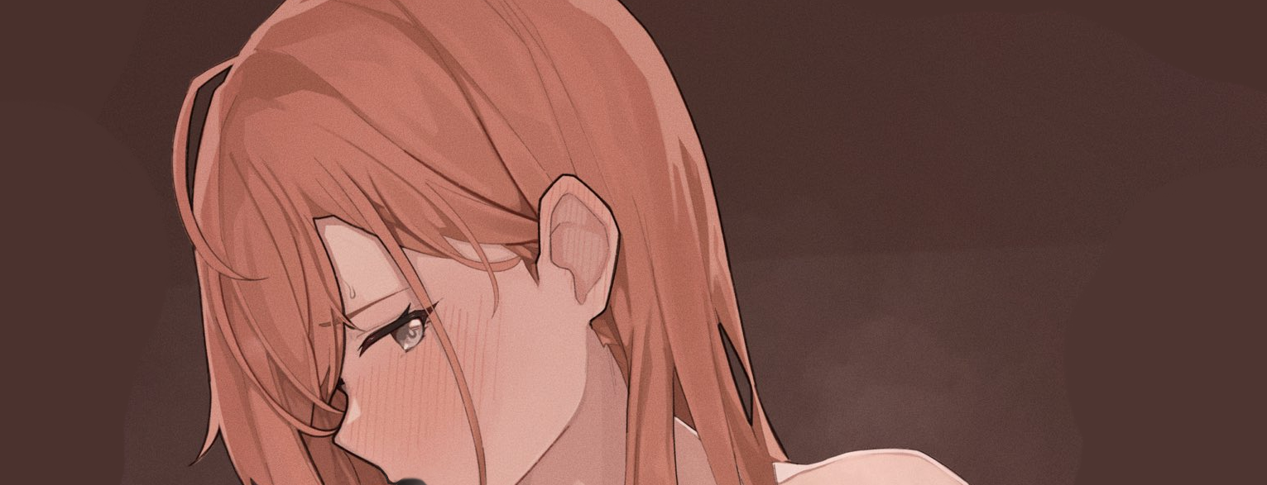

And as he feels his jawline begin to snap and quiver under the strange influence of whatever was flowing into his tummy with bone shifting like liquid into smaller configurations, Haruto lets loose a terrified yell for Megumi to stop as the mechanical beauticians move on to his arms, grabbing ahold and prying them free of their restraints with their superhuman strength, leaving his once broad biceps as nothing more than smooth shapely pearls covered in the same smooth skin adorning his face, feeling that alien tingle spread rapidly wherever the holograms graced him.

**“Mmppf!!!”**

**“落ち着け波瑠、変換中に肺を破裂させるようなことはするなよ。肉体が可鍛性である以上、技術の限界に挑戦するのは避けたい...”** (Easy there Haru, you don't want to rupture your lungs in the middle of conversion. As malleable as the flesh is, I wouldn't want to push the limits of the technology…)

Just a minute ago, Haruto had been an angsty retired idol disgruntled about his current place in a new world with drastically different standards placed on idols as a profession. But as he was now, you could barely tell the terrified androgynous figure lying with their feet strapped into a metal chair was supposed to be Haruto at all with the entirety of his weathered face and crop cut black hair replaced with the visage of a pretty damsel with a voluminous head of bright orange hair. The face of Haru Tomioka staring back at him with a smile on the desk.

But with the holograms finishing up with their slow methodical massage ironing out his wide callused hands into slender twigs tipped with carefully trimmed nails, it was clear that more than just his face would soon follow suit.

**"Mppf?! Gnoooomn!"**

Positioning itself directly behind Haruto, one of the holograms pushes itself into him, arching his back in one go as it's prickly surface engulfs it in its entirety, accompanied by an audible crack as the man's recently healed spine rids itself of any irregularities, leaving Haruto feeling strangely euphoric with his back permanently arched inward in a sexy S curve, placing emphasis on the twin peaks slowly being pressed into existence with the holograms transfiguration touch now focused on the managers flabby, hairy chest, squeezing, relaxing and pulling until all of it coalesces into a soft, creamy orb, tipped with erect nubs of dark strawberry being teased by the thumbs of an expert, clearly stimulating Haruto as his womanly pleas break and devolve into high pitched gasps and surprised moaning, as if he himself was stunned at the erotic sounds he was producing involuntarily from having his suddenly very sensitive and heavy chest tweaked like that.

And with the soft wet splat of fat slapping against fat, a heaving pair of small yet pert breasts were rising and falling with each heavy breath through Haruto's still plugged up mouth, sucking sensually on the pipe still lodged deep in his throat with trails of saliva running down a shapely chin before dripping down onto the plump valley below. Sitting right above the well trained navel that had spread out from the region of his belly where the sour sap he had been forced to consume pooled in, already having grown a new set of organs to serve in his new place in life as the second hologram strolls forward, kneeling before the dwindling pecker that is Haruto's manhood, not even hesitating as it takes the wimpy dick into its mouth, rocking Haruto with mind blowing pleasure as the tingling sensation that had transformed the rest of his body wraps itself around his retreating member like an electric fleshlight.

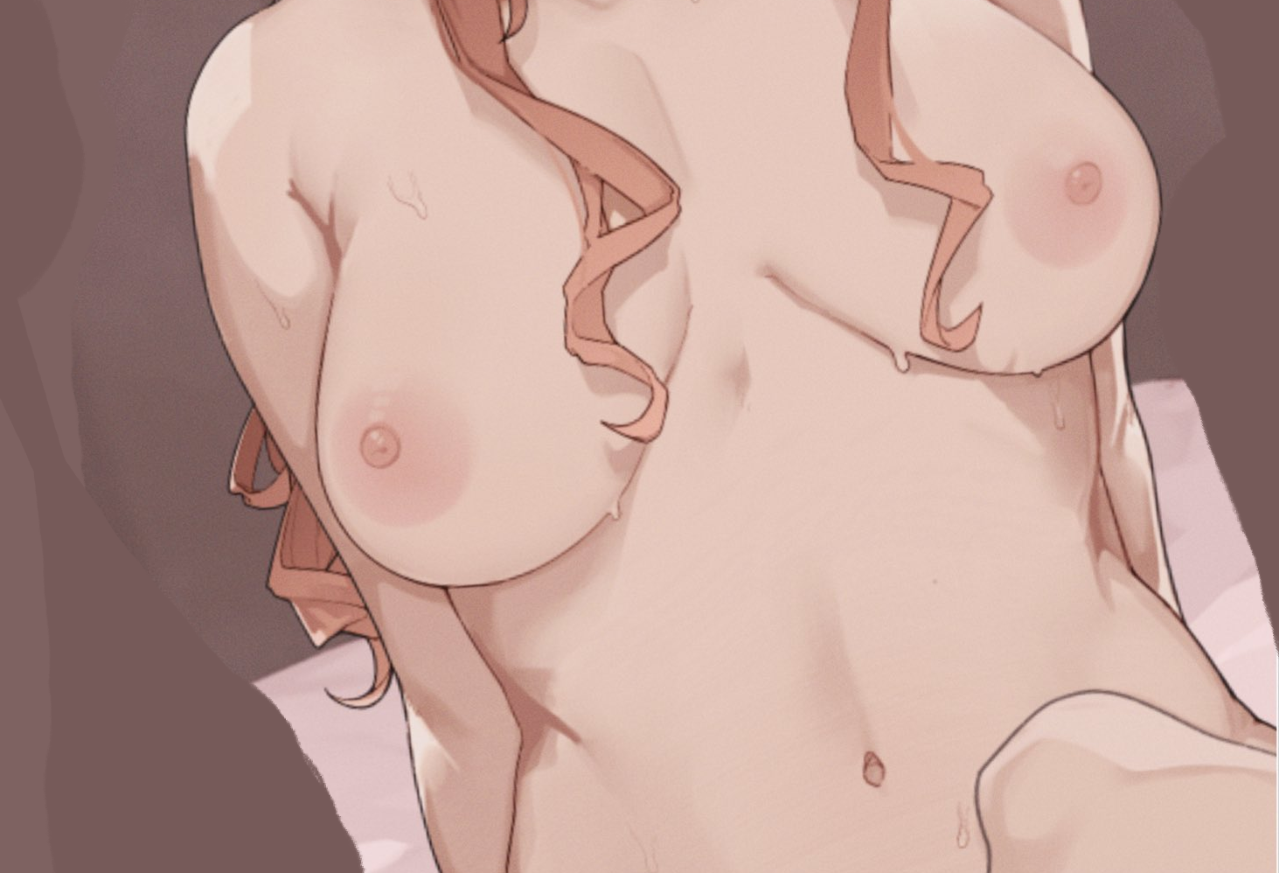

And with his blocky, hairy legs quickly being subverted by the pale, hairless skin that coated everything from his cocklusting face to the wobbling masses on his chest, Haruto Togawa loses the fight as the metal pipe in her mouth quickly withdraws along with the rest of her restraints alongside the holograms, leaving her free to trash around the her seat in the throes of a mind blowing female orgasm with a healthy spurt of vaginal fluids from between the puckered snatch between her legs, dripping with a tiny bit of precum sliding down her trembling legs. All while letting loose shrieks and screams in her sonorous new voice with the elimination of her deep nasally voice the instant she first tasted the liquid delivered directly into her belly where a nice warm womb sits waiting to be inseminated.

The bitter manager was gone, and in his place; Haru Tomioka; a peppy young lady looking to make it big on the idol stage (at least in her bio) sat twitching in all her nude glory, slick with sweat and barely able to comprehend Megumi's catcalls and slow claps, gazing weakly to stare at her friend in disbelief while clothes begin to materialize over her body, providing some measure of decency for the newborn female as a tight fitting top layers itself over her bosom alongside form fitting cotton panties slinging themselves around Haru’s shapely hips before a baggy singlet hangs down her torso, sticking to her moist skin and teasing the nubile young body beneath while her messy mane of flowing orange bundles itself up into a ponytail.

**“春ちゃんも、だいぶ良くなったんじゃない？これから先、君はマネージャーの私に報告することになる。有望な人材が脚光を浴びるチャンスを与えてくれるこの事務所で、一緒に働けることを嬉しく思う.”** (Much better don't you think Haru? From now on, you'll be reporting to me, your manager for your foreseeable future here at our agency where promising individuals are given their chance in the limelight…happy to be working with you.)

**“~~売り込みがうざい~~...俺の名前は "はると "じゃない、"はる "だ...待てよ...え？)** (~~F…Fuck off with the sales pitch~~…my name's not ~~Haru~~ Haruto, it's ~~Haruto~~ Haru…wait…what?)

Scoffing at the stupefied look on Haru's face, Megumi folds a leg over the other before returning to his former business as usual look, not a hint of amusement in his eyes as he focuses in on

**“プログラミングに抵抗する必要はない、ナナイトはあなたの脳と生理機能を徹底的に調査している。今までの自分を 否定できなくなり- 語彙力も低下する 自分を見てみろ...**” (Don't bother trying to fight the programming、 the nanites have thoroughly scoured your brain and physiology. Not being able to say a lick of who you were along with some kinder adjustments to your vocabulary is just the start. Take a look at yourself…)

Looking down in disbelief, Haru could tell nothing off with her body; gazing at cross legs bent at the knees, slender arms curled inward with a dexterous hand cupping her breasts and her smooth sloping shoulders rising and falling with each breath. This wasn't unusual at all? It was how a ~~man~~ woman was supposed to hide ~~himself~~ herself when ~~he~~ she was exposed like this in front of a man? Right?

No matter how much her brain seemed to correct itself though, Haru could sense something terribly off with the way her thoughts seemed to veer off course before she could utter the correct words, feeling a strange sense of being a passenger at certain points as words she definitely hadn't meant to say flowed out of her mouth.

**“わからないんだろう？精神的な変化は予想より早く効いてきそうですね.”** (You can't even tell can you? Looks like the mental changes will be taking effect sooner than expected.)

(S-So what? You're just going to keep me as your little idol slave?)

Laughing out loud with his shoulders jittering up and down, Megumi straightens his glasses before standing up and striding slowly over to Haru's side, taking a knee until he was level height with her.

(If you call repaying company debts slavery…then by all means, feel free to head to the police, but by then you'll have lost your job and credibility for causing hundreds of thousands of dollars in company damages. But…if you stay with us, work to fix what you've done, then you'll be given a clean slate. But I still see you as a troubled friend that needs help…and I think this might just be what you need to get back up on your feet Haruto.)

Haru herself felt conflicted as all hell, struggling with her new emotions of guilt and a sudden eagerness to right her previous transgressions she was beginning to see as petty sabotage instead of the self righteous vitriol she has been using to justify herself. Whether it was because she was now in the body of a young girl over 10 years the former Haruto's junior or something the nanites had done to her mind, she couldn't really tell.

More curiously however, was the strange tingle shooting through her heart before a warm sensation spreads out below her heated tummy.

(That jerk…sweet talking me after turning me into…making me a woman!)

Gritting her teeth and clenching a hand laid over her aching chest, Haru sighs before looking up hesitantly at Megumi, taking the hand he had held outstretched to her with a hesitant look, nodding silently before her new manager…

After that day, Haru Tomioka would officially begin her work as a full fledged idol, debuting with a short vocal performance that had many online wooing at the fierce gal with an equally fierce blush on her face doing a solo on stage. While some had pointed out the old timey feeling Haru gave off, they weren't quick to discount the quality of her mesmerizing voice and alluring body language, a rarity in the modern idol culture in Japan, with some geeks even going as far as to put credit on whoever was in charge of her choreography.

*‘指導している人も、波瑠と同じくらい評価されるべき！’ (The person who's mentoring her needs just as much credit as Haru gets!)*

From there, Haru's popularity would only begin to climb higher and higher, starring in music videos that would be posted online to streaming sites before eventually making her first physical debut, amazing both herself and the massive audience waiting for her in a small park. Her fans; excited to see her in the flesh, and Haru; driven to tears at the moving sight she hadn't seen in years. Stirring a bevy of emotions within her as she waved and greeted the people with heartfelt thanks that, besides the glasses wearing man hidden away backstage, no one was aware of.

Haruto's transformation into Haru had changed more than just her ability to think and act like her former brash self used to behave. With the mental inhibitions and alterations made, she no longer felt bitter and angry all the time in addition to a renewed eagerness to return to the stage, working hard to get acclimated to her new body and all its attachments. While Megumi was confident in the nanites, the man left nothing to chance as he personally oversaw Haru's training sessions and dance classes after her introduction as a newbie idol, returning to take on his role as a choreographer, just like the good old days as he critiques Haru on her form and posture, having to remind himself he couldn't just focus entirely on her all the time with a whole class to supervise now.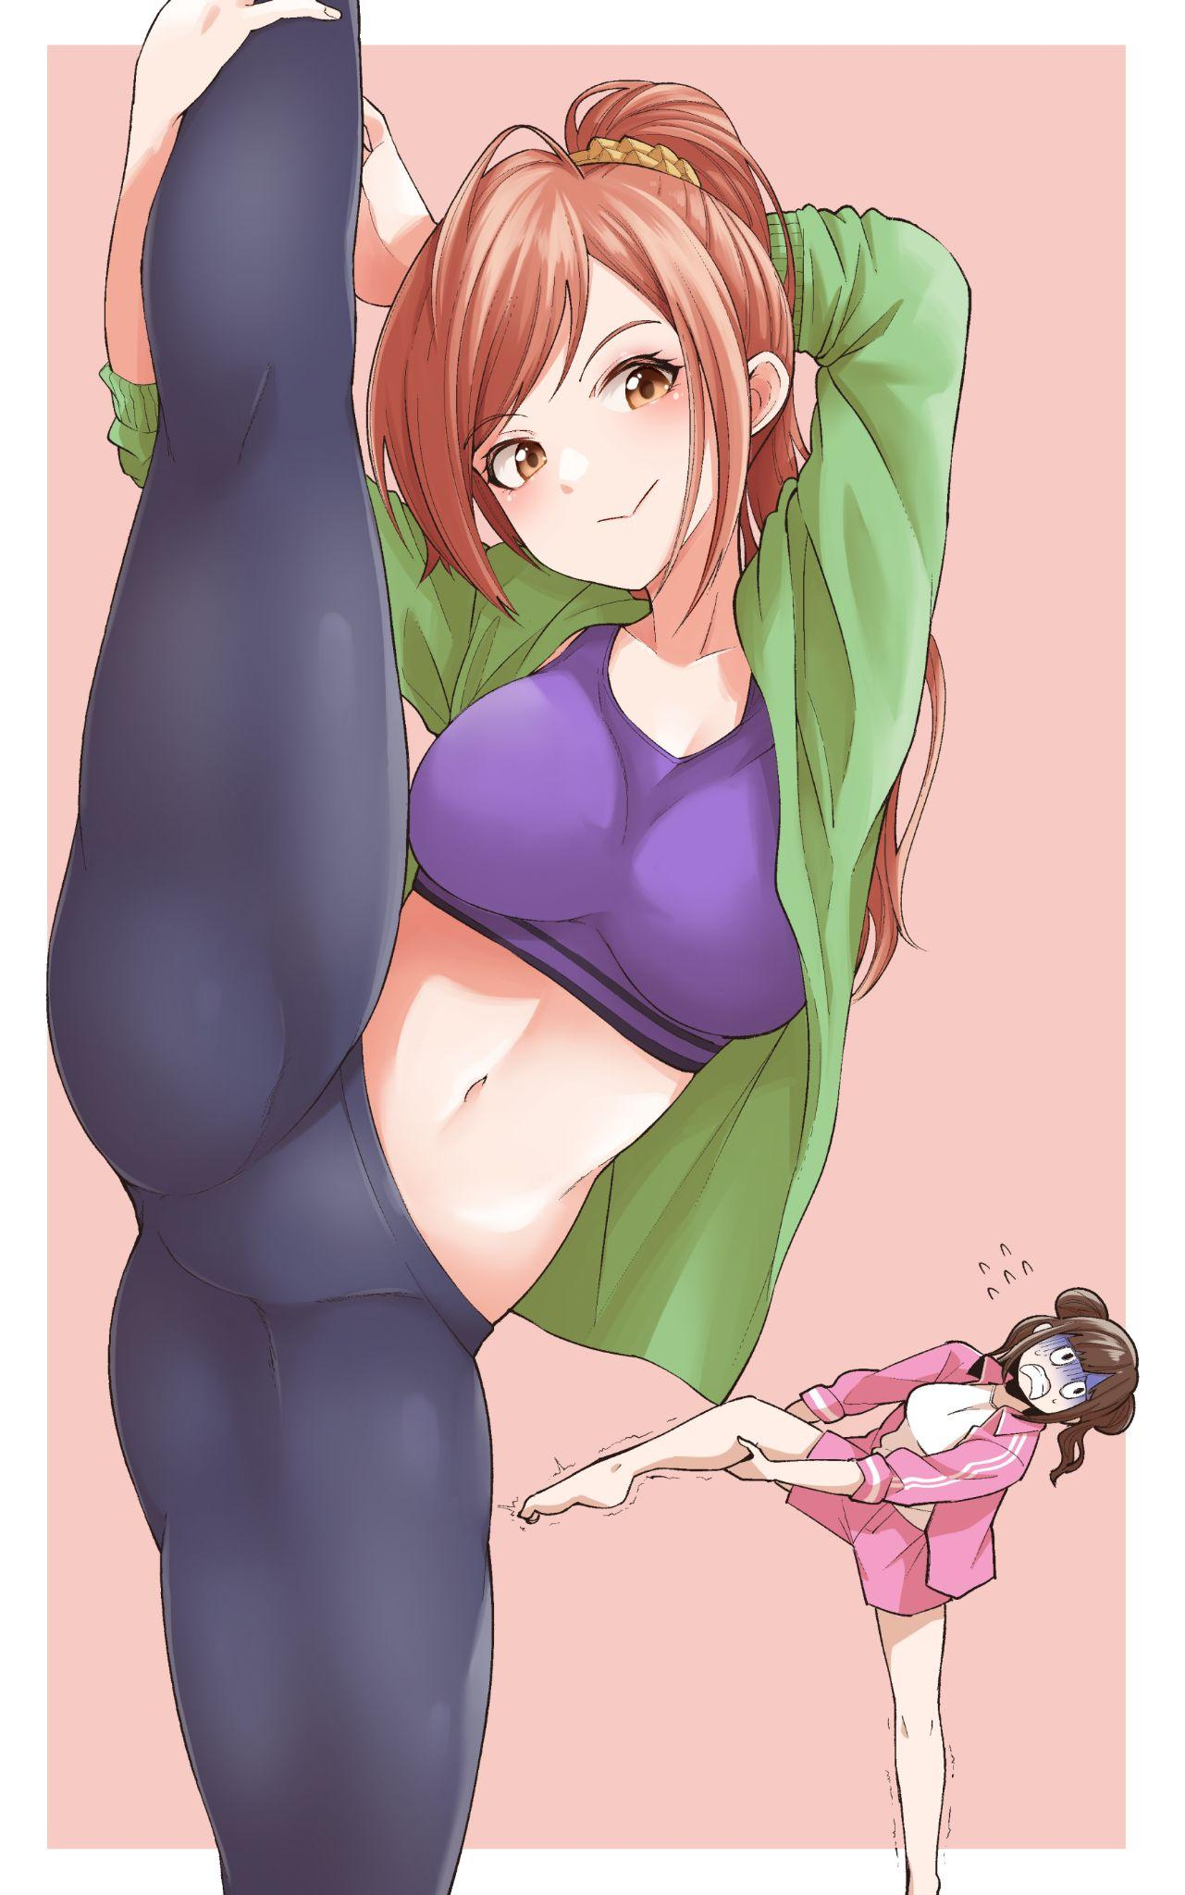

Only he was at least 10 years older now, and his friend had become a 20 something year old lady with an admittedly killer figure, and whenever Haru took yoga practice, Megumi had to avert his gaze from his friend's amazing body stretched tight against her workout attire.

After the amazing performance put on by Haru consisting of covers and ending off with the same original song she had made her debut with, the up and coming idol had all but cemented her place in the limelight as the next big hit in the industry with the already massive crowd almost doubling in size as bystanders caught wind of her melodic voice and energetic performance, drawn like a moth to the flame that was the orange haired woman standing confidently on stage.

With that successful first performance in front of an audience secured under her belt, Haru Tomioka would soon become a well known name as videos and snippets of her wonderful singing and energetic dancing began to circulate, and not just within Japan too, with talk of the rising star spreading out far into the west and elsewhere in Asia. It was a rare thing for Japan to produce talent such as Haru after the apparent decline in j-pop and the idol industry focusing more on numbers than talent and skill. With a womanly voice dripping with masculine undertones, a rockin bod and giving her all in dances that wasn't just mindless shaking and trashing, Haru's career was off to a banging start as contracts for performances and gravure shoots began to flow into the hands of her agency. Whose executives and board of directors were more than pleased to accept after Megumi's ridiculous proposal to use their hidden black market technology to 'bring our old ace back into play'. While it couldn't outright program new thoughts into someone, Haruto's pre-existing knowledge and experience in the field had certainly proved indispensable when combined with her altered physiology

By the time Haru had finally been signed on for a performance in a well known concert hall that had been the cornerstone in many an idol's career, the money she had earned for her employers was more than enough to pay back her debts and free herself of their employment. Only, she didn't seem to want to do so anymore, politely refusing Megumi when he dropped by after that momentous occasion that had left her wrung out and exhausted. Sleeping in the car ride back to the modest apartment unit she had rented out for herself after earning more than enough to live comfortably for the rest of her life.

With Haru reclined in a leather chair holding a novel in her hands, Megumi had brought the issue of her debt up to her while leaning against the wall, clearly on edge as Haru simply giggled at his words before hushing him midway through his words. It was amazing to see the stark contrast between the refined lady sitting before him and the angsty man said lady had been months before. Molded into her current self over the passage of time.

**“思い出してくれるのはありがたいのですが...たくさんの人の前で演奏する...本来のキャリアが降りてからずっと夢見ていたコンサートホールに立つ、そんな自分の人生を受け入れるようになりました、こんなこと言うと変ですが...”** (I appreciate the reminder but…I've grown to accept my life the way it is, performing in front of so many people…the concert hall I've dreamed of standing in ever since my original career got off, it sounds so weird saying this…)

**“じゃあ、春人はいいんだな？”** (So you're sure then Haruto?)

**“とても...それと恵さん...今は春と呼んでください...過去は忘れましょう あなたはもう、私のマネージャーよ！バカね”** (Very…and please Megumi…call me Haru now…its best we move on from the past. You're my manager now silly!)

Sighing as he pushes off from the wall, Megumi sheepishly moves forward before coming to a stop before a perplexed Haru, wondering what her boss was planning.

**“念のため、それだけなんだけど......ハル？”** (I was just making sure, that's all…say…Haru?)

**“な、な、なんだ？いきなり変なこと言うね...”** (W-What is it? You're talking funny all of a sudden…)

Taking to a knee much like he had the first, more antagonizing moment they had met in his office, Megumi bows before uttering the words Haru hadn't been expecting to hear.

**“男性と付き合うこと...恋人になること...どう思いますか？”** (What do you think about…going out with a man…becoming his girlfriend?)

**“メグミ...とでも言うのでしょうか？”** (Megumi…are you saying?)

One look was all she needed to know what her manager was implying, turning her stupefied look into a heartwarming smile before turning away and masking her face behind her book, clearly flustered at the impromptu proposal and the strange feelings of elation running wild in her body.

But after a second or so of silent contemplation, Haru sucks in a breath before putting the book down, cradling Megumi's chin in her smaller arms while trying her best to remain composed, staring into his violet eyes with her hesitant yet curious almond brown pearls.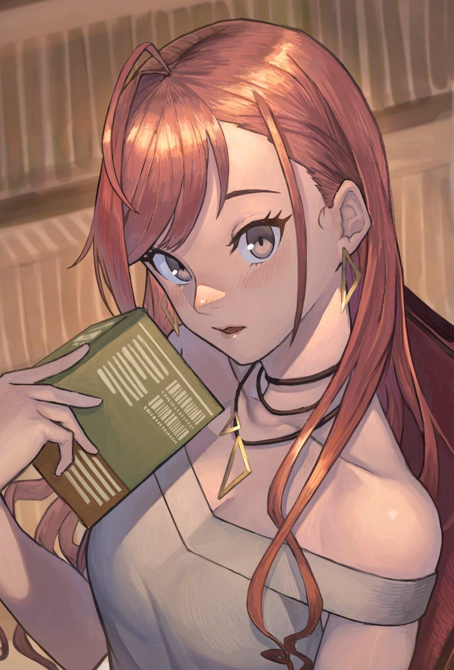

**“最初はデートとか、そういう小さいことからでいいと思うんだ.”** (I think we can…start off small…dates…that sort of thing…if you'll have me..I mean…then I-*mmpf*!)

With the small distance between them, it didn't take long for Megumi to take advantage of Haru's fluster, moving in to plant his lips over hers as he feels her hesitation and surprise melt away, slowly relaxing as her tongue acquiesces, letting his slide around her mouth in an erotic kiss before parting with a wet pop and a spout of steam between the two horny lovers. With a tent in Megumi's pants and a damp spot between the pudgy cameltoe straining the purple panties between Haru's legs.

Over the many months he'd spent together with Haru, the feelings for his friend had been slowly nurturing into a full blown romantic interest for her, wondering when was the right moment to talk to her about it or if it was even right to have feelings like these for a former man.

But after the climactic performance that was more than enough to convince him of Haru's change in perspective and identity alongside the refusal to return even if it wasn't possible since the procedure was a one way trip, it seemed his patience and hesitation had finally paid off with Haru in his arms.

As strange as it was, maybe this was all some strange twist of fate that landed them together after a decade apart…

*THE END*