Big Top
A Mercynaries Story from SinComics.com

Bradley kicked a stone as he shuffled down the dirt road. It had been a depressing summer for him. His hopes of being the next big thing in the digital world ended as the last of his savings dried up. He'd spent everything hiring the engineers to work on his databases, so when the time came to create the actual app, he was dry. Even if he could get some friends to help out or a programmer willing to defer payments until the app was released, he'd never be able to afford the marketing and support needed to reach enough people to make it profitable. The last few weeks were spent in a futile attempt to get some investors or venture capital that never materialized. Today marked the end of the project. He paid off the final contractors, talked to the manager he was leasing the office space from, and pulled the final plugs.

As Bradley started up the hill, he heard faint music. This area was nothing but farm land and farmers weren't the type to be out partying past sundown. At least he thought so. Bradley had no idea what the growing seasons were, but some general knowledge of farmers said they went to bed early. He listened in as he crested the hill, only to see an explosion of lights and colors in the fields. It was the fair! He'd been so wrapped up in his project for the past months that he forgot about the county fair. There had been a blurb on some local news sites about the county talking with a new distributor this year, but Bradley had passed that over as he scrolled to the business sections.

The cacophony of the circus filled Bradley with a warm sense of nostalgia as he looked down on the event. The county fair had been a part of every person's childhood in his town. It was exactly what he needed to close the book on this chapter of his life. Some fun and games or ungodly fried food to shut out the bad feelings before he got home to start sending out resumes. A quick pat of his pockets proved to be a reality check. At best, he had a quarter to his name, so forget the food and games, he'd never even be able to get into the place. As Bradley started to slink away, some old memories started to trickle up. It wasn't just going to the fair as a kid, there was a certain competition in his circle of friends where the only thing better than going was going for free. They had laughed and bragged about how many rides they could sneak onto, groups they could hide themselves in, or games they could play with found tokens. And it all started with the most important part of the ritual: getting in for free.

Bradley circled around the perimeter for the farm and it was exactly as he remembered it. They were smart enough to have a tall outer fence to keep freeloaders out, but they never trimmed back the trees that rose above it. Bradley found his footing as he slowly clambered up the branches. It had seemed a lot easier as a kid. When he was finally high enough to get over the fence, he moved out over the fence and dropped back to the ground. He landed with a thud on the hard-packed dirt. Definitely easier as a kid. Thankfully, the second part of the fence was easier. The farmers never came out this far on the property to mend the fences and fair organizers never paid enough attention to the rotting posts in the back corners. Bradley peeled one back and squeezed through the best he could before the post wouldn't bend any more and he was wedged into the makeshift entrance. There was no going back and over the outer fence, so he slammed the rotten post with his hand and it broke free with a loud snap, sending Bradley tumbling back to the ground as he popped through the hole.

"Hey! Who's there!?"
Bradley's heart sunk as he heard the shout come from behind the tent. He scrambled up as fast as he could, but the flap opened and out stepped a woman with a giant wooden mallet.
"What are you doing?!"
Bradley stammered and looked for a place to bolt to, but he was stuck between the fence and the tent. His eyes shot to the weapon in her hand and she looked back down at it.
"Calm down, this is just for the Whack-A... Wait, yeah! I'll totally hit you with this! You, uh, better come with me!"

The petite blonde woman threateningly waved her comical mallet at Bradley but then leaned in and grabbed him by the ear. Between yelps of pain of being dragged through the grounds, Bradley rambled and failed to convince the woman that this was all a misunderstanding.

Bradley was forced into a chair in a dark room. Suddenly, a flash of bright light burst on and stayed pointed at his face. He recoiled but he was being held down and couldn't escape. A figure moved between him and the light but it was so bright he couldn't make out any details. Bradley leaned forward as far as he could and passionately gestured at the figure.
"I-I'm really sorry! I know it was dumb. And wrong! And I totally shouldn't have tried to sneak in. I'm sorry, I'm sorry! Please don't call the cops!"

The figure chuckled and made a motion to the blonde holding Bradley's shoulder. The spotlight dimmed a little and he could finally see the woman he was presented to. She was tall and lithe, but held herself with a no-nonsense air. Her outfit was that of a ringmaster's with a long red overcoat, white dress shirt, pink bow tie, tight black pants, and thigh high boots. She leaned in close to look Bradley over and he stared into her intense, deep eyes.
"Don't worry on that front. The Circus and the Law have never seen eye-to-eye over our histories."
Bradley sighed deeply and slumped back in relief.
"That's why we've always taken care of issues ourselves," she grinned. He immediately went rigid in his chair.

"Ma'am, I'm sorry. I've just... I've been a fan of the summer fairs and circuses here since I was a kid. I'm in kind of a rough patch and I thought this would be some fun and... I'd offer to pay, but I don't have any money."

The ringmaster chuckled again and leaned back on her heels. "A patron of the arts, but a poor one. I can't just let you go, that would set a bad example. But what to do with you..."

"H-How about I work it off! Surely you need somebody on the business side. I can help clean up, then at the end of the night, help you file everything, and fill out whatever forms you have. Nobody likes forms, right?"

She smiled and pat him on the head. "No, I've been doing all that for years, it's second nature. But you could help me out there on the grounds. My crew could keep an eye on you out there and keep you on the straight and narrow. We wouldn't want another... lapse in judgement."

Bradley shrank back in the seat. "Could we not? I'm going to have to start looking for a job soon and interviewing and... If anybody out there recognizes me, this could make things a lot harder..."

The ringmaster twirled around and sauntered over to some cabinets. She pulled out a large kit and a handful of brushes. "You leave that to me, love."

Bradley sat frozen in the seat and the woman lathered layer after layer of paint and makeup onto him. She spread a cool, white goop over his face, leaving no space untouched. Once satisfied he was thoroughly encased, she dug out a few colored jars from her kit and reached for a large brush. The brush was coated with a bright purple dust and she turned back to Bradley. "Close your eyes, dear. You don't want any of this in the wrong places." Bradley dutifully clamped them shut and she went to work dabbing and painting him once more.

When she stepped back to look him over, Bradley spoke from the corner of his mouth. "All done?"

She chuckled and pulled out a case and thick red pen. "See, you already have the sense of humor for this."
She resumed her task and started drawing and coloring around his mouth. Bradley could taste it on his lips as he tried to clear the makeup from his mouth. It had an unnaturally sweet taste, but with a citric, almost acidic bite that left his face and lips tingling.

Finally content with her artistic skills, the ringmaster shuffled through some boxes stored on top of the cabinets. She clucked her tongue as she pushed several back aside but let out a gasp of happiness when she pulled out a giant red puff from one. She slipped behind Bradley and he could then feel a tacky liquid around his scalp.
"Just a hint of wig glue to keep everything in place."

"Glue? Wigs!? Lady, you have to-"
The ringmaster cut him off short and spun his chair to face the mirror. Gawking back at him was a painted visage of a clown. His skin was all white, save for the neon purple eyeshadow, giant red lips, and two bright pink hearts on his cheeks. She came down with the finale and plopped a red wig onto his head and puffed and styled it into place. It looked more like a beehive now and Bradley could feel it wobbling over him as he leaned in.

The ringmaster patted him hard on the shoulder. "Still got it! Well I haven't done this in ages. It's been so long since we had just a clown. And you don't have to worry about anybody recognizing you. Now, for the costume."
Bradley went to speak, but a sharp glare from her black eyes cowered him.
"I will not have a clown that looks like it works at a bank."
He dejectedly nodded and followed her pointing finger behind a screen.

Bradley hung up his jacket, shirt, and slacks as the ringmaster dug around racks of clothes and opened and closed closets around the tent. He finally heard a happy little clap and soon a bundle of clothing was tossed up onto the screen. Rather than waste his breath protesting, Bradley slipped his arms through the costume and wrapped it around himself. The costume was a monstrosity of ribbons and frills, ruffling and shaking with every slight movement he made. Giant, puffy shoulders breezed in and out of the corners of his eyes as he struggle to smooth out and press down the bouncing outfit. As he got it under some semblance of control, two white gloves and striped tights were slung over to him and Bradley obligingly suited up.

"And the final piece!" The ringmaster came behind the screen and motioned for Bradley to sit. She shoved on a pair of bright red platform shoes and latched them closed just under his knees.

"I can barely walk!" Bradley protested.

"It will help you stay in character! Clowns aren't graceful, they're bumbling and funny and wander all over." She spun him around and zipped the outfit closed with the thick metal slider hidden among the frills.
"Now, head over to the arcade. Grace can use your help running the games. And make sure you delight any guests you see on the way over."
Bradley grumbled in agreement and wobbled over towards the exit.
"And, dear, be good. We'll have our eyes on you."

Once he was out of the tent, Bradley searched around and when the coast was clear, he furiously searched through the ruffles for the zipper pull trapping him in this horror. He moved his fingers up and down and back and forth through the frills couldn't track the zipper or find where it started. Unable to find anything to grasp onto, Bradley yanked and pulled at the costume but it wouldn't give. Resigned, he headed over to the arcade.

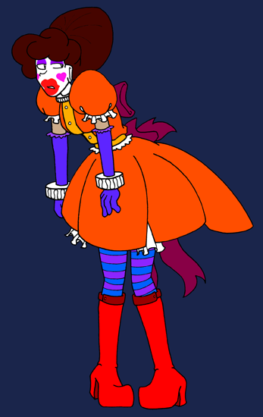

Along the way, people clapped and laughed as he walked by. Bradley tried to speed up, but that only made him wobble in the boots and the costume to bounce around more. The only thing hiding his bright red, embarrassed face from the cameras was the layers of makeup he was caked in.

When Bradley finally made his way over the alley, he saw the blonde woman leaning against a booth. She perked up and smoothed out her vest when she caught sight of him.
"Well, it's the thief!"

Bradley scowled. "I'm not a thief."

The petite woman laughed and gently punched him in the shoulder. "Ah, I'm just messing with you. C'mon, the boss says you're going to help me out!" She waved Bradley over behind the curtain.

He looked around at the bare, wooden guts propping up the booth's front and the rows of stuffed animals and prizes. "What do you need me to do, ma'am?"

"It's Grace, love. Oooh, we need to think of a fun clown name for you! Howzabout... Handsy! Because you tried to steal."
Bradley glared at her, but she either couldn't see it past the makeup or she just didn't care.
"Climb on in. I need you to run the game while I'm up front."

Grace pulled back a lower curtain and pointed Bradley to a wooden tunnel leading up to the front of the game.
"When you get through, we'll move to the next step. And watch the hair, dear!"
Bradley got down on his knees and crawled through the curtain. It was a short journey, but he made slow progress and frequently had to tug at his costume to un-wedge it. At the end of the track, there was a circular hole. Bradley lifted it up and looked through.
"Grace?"
All he could see was the darkened booth hidden behind a curtain. He felt something soft press against his neck and he pulled back in reflex. Instead of moving back, Bradley just stretched his neck and stayed in place. From behind the hole, his hands searched around and grasped at the padding that was now holding his head in place. He fidgeted and squirmed but couldn't move the padding back to its previous position.

Suddenly, music started playing from the tent and he could just barely make out Grace's voice shouting to the crowds. The curtains were yanked to the side and Bradley was staring out at a line of kids holding water guns aimed at his end of the booth. He looked to the side in a panic and saw several plastic clown heads with open mouths and balloons over them. The crowd laughed and pointed, but when a bell rang, the laughter changed to cheers as the water guns squirted to life and the fair-goers commenced the game. Bradley squinted against the errant splashes of water. As it ran down the back of the booth, Bradley could see it wasn't actually water. It was some kind of blue goo... He peered at but was shaken back to reality when he received a face full of the goop. Bradley stared down the booth to see a laughing little girl with her water gun pointed directly towards his face. She giggled as the gun shook again and another stream of the blue liquid went directly into his mouth. Bradley sputtered but another stream hit him again. It continued to flow and Bradley was stuck spitting it out when he could but gulping it down to grab breaths between the shots. He could just barely make out the cheers from the crowd over the sprays of water, the looping music, and Grace's shouts of encouragement.

Bradley struggled against his position in the booth as he continued to swallow the liquid forced down his mouth. It felt like the booth was shrinking behind him. He shook his backside as the tunnel pressed against his hips and legs. The game seemed to continue for an eternity as the crowd happily filled him with the goop. Bradley's stomach churned and he was sure there was no way he could swallow any more, but he continued to guzzle it down. Finally, Bradley heard a loud pop off to his side and a bell rang above him. The crown cheered and Bradley gasped as the stream finally fizzled out. Grace walked back, grabbed a stuffed bear from off to the side, and presented it to a cheering young boy at one of the guns.

With the crowd dispersed, Grace closed the curtain and walked back to the groggy and wet clown. She kicked the back wall and the piece around Bradley's neck slid back into place and the door swung open to free him.

Bradly sputtered and rubbed his face. "What was- That stuff- Why..."

Grace started to clean up and reset the game. "Don't worry about that. Real water doesn't really show up well at the distance or have a satisfying splash. The balloon burst looks way better when this stuff splats!" She tossed him a towel and took out another one to wipe down the backboard. "It's natural stuff, so you're good. I tried it once. Kinda tastes like strawberries, amirite?!"

Bradley whimpered into the towel and wiped his face clean. Grace helped him to his wobbly feet but clucked her tongue. "You... are not cut out for this work if you're that fidgety and shaken up after just one round. Look, I won't tell the boss, but you have to go help somebody else. I'll call ahead to Serena and she'll put you to use." She slapped him on the back, pointed towards the tents in the distance, and shoved him on his way.

The walk over was even more uncomfortable. Bradley felt like his costume had shrunk and was clinging to him tightly after getting wet. The outfit seemed to jiggle and shake even more and the ruffles and fringe never stopped bouncing. He pulled at the costume but still couldn't find the zipper or get a good hold to tear it. As he patted himself down, Bradley realized why the damned thing was so unwieldy, it must have had some kind of padding to it.

He passed through the crowds and stopped to catch his breath outside a tent advertising itself as a hall of mirrors. Save for a few thin streaks, the water from the game had washed away most of his face paint. The white foundation and the pink hearts were all but gone, while the purple eye shadow and lipstick remained. Bradly scoured his face with his arm, but while the last of the white paint rubbed off, the makeup remained. He leaned in closer to the mirror, but somebody grabbed his arm and pulled him back.

"You must be the new helper! Come on, come on, the show is about to start!" A woman with stunningly long black hair pulled at Bradley and gestured him towards a tent lit up with sparkling lights. She wore a costume right out of a cartoon with a tight unitard, tuxedo jacket, long white silk gloves, and a top hat cocked on the side of her head. "I'm Serena!"

The magician pulled Bradley onto stage and he was shocked to see a crowd already seated and waiting. He went rigid and tried to back away but Serena grabbed him around the waist, pulled him in close, and whispered, "Just follow me. I'll do all the work."
She then spun him around and motioned to the crowd. "My lovely assistant!"

Laughs went up from the audience and Bradley was mortified. Serena soon returned to center stage carting out what appeared to be a closet on wheels. She popped the door open and motioned for Bradley to step inside. He cautiously approached it, looking over the walls, when Serena bumped him with her hips, sending him flopping into the box to the laughter of the crowd. Bradley barely had time to spin around when she slammed the door shut and he heard a click. There was barely any room to move but he tried pushing on the door with his shoulder and knees but it was locked shut.

The box was pitch black and Bradley could just barely make out the laughter of the crowd and some whoops from the audience. Something brushed against his cheek and Bradley panicked, shaking. He felt like a fool when he realized it was just the puffy shoulder of his costume. His sigh of relief was cut short when it brushed against him again, but harder, like it was pushing against him now. He moved his head back what little he could but the costume quickly took up the space and started to push back. Bradly shouted but it couldn't be heard outside the box.

The puffs filled the top of the box and prevented him from moving his head. He struggled and fidgeted but soon felt a tightness around his chest and a force pushed him against the back of the box. It grew tighter and Bradly had trouble breathing. He muttered in disbelief and denial as he soon felt the pressure around his hips as well. He was pinned inside the box and the things around him continued to inflate.

Suddenly, the door swung open and Bradley was bounced out of the box. The inflated outfit around him bounced and jiggled, giving him the appearance of having an enormous and cartoonish hourglass figure. Cheers erupted from the audience and wolf whistles rang through the tent as he struggled to control the outfit. Bradley could just barely see around the balloons on his shoulders and over the ones on his chest as Serena reached into her hat and pulled out a pin that glinted under the spotlight.

Bradley couldn't manage more than a waddling shuffle with the weight around him and barely made it a few paces before Serena slid over and stuck the pin in his inflated backside. The costume burst with a rush of air and a loose draping skirt fluttered down around his hips. He stared in disbelief at the rounded, plump curves that now made up his lower half.

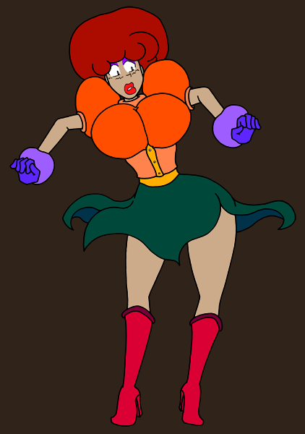

A swell of applause rose from the crowd once more and Serena deftly popped each inflated section of the outfit, revealing a spangly, shimmering dress underneath. Serena teased the audience, leaving the giant balloons on his chest for last and even stuck the pin into his wig before them. It burst out and wavy red hair curled down from his head until it bobbed and rested on his shoulders. With one final dramatic flourish and calls not to from the audience, she burst the beach balls on Bradley's chest to reveal two perky globes nestled in a shimmering bodice. The audience went wild with whistles and cheers. Serena took her bow, motioned to Bradley for another round of hoots and hollers, and thanked the audience before shuffling her assistant off stage.

Serena wiped a bead of sweat from her brow and settled as the curtain dropped.
"Whew! Rowdy crowd tonight, eh?" Bradley couldn't say anything in return. He looked down at himself and threw his hands over his feminine curves. Serena grinned and rubbed his back.
"You did great! What do you say, one more show?"

This was enough to snap Bradley back to his shattered reality. He shoved her aside and practically fell over himself as he ran to the exit. He skidded as his new heels hit the mat out front and he had to grab onto a pole to steady himself. The sudden motion attracted the attention of the passing customers and phones rose into the air and camera flashes sparkled around him. Bradley angrily tried to wave them off before realizing that the only thing he could do was try to escape and get away from everybody.

He stumbled and wobbled his way around the tents, ducking away whenever he saw a crowd look his way. One group was coming up from the side while another was attracted by the commotion of Bradley's panicked run. He had nowhere to go but to fall through the flap on the tent behind him. He stumbled into the tent, his heels clacking on the now hard surface, and he looked around the dim space.

The tent was calm. The lighting was subdued and the only decorations were some shimmering drapes and fake candle lights flickering around the area he was on. Bradley looked around and realized the tent contained a stage. He moved towards the stairs but heard the faint sound of music coming from above and it stopped him in his tracks. The tent flaps opened and two lines of people started to walk in and take seats in the audience. Bradley's heart raced but when he heard the music again, he felt relaxed. So relaxed that he couldn't help but sway his hips to the song.

Bradley closed his eyes and moved to the beat of the music. Dancing gracefully across the stage, he moved to one of the silk drapes and plucked it from the wall. He wrapped it around his arm and twirled, never stopping his hips from swaying side to side. He leapt into the air, the silk fluttering gracefully down and around him before spinning again and wrapping himself in.

He was lost in the music, alone in his mind and completely oblivious to the audience paying rapt attention. Bradley was never one for crowds or dancing or gymnastics, but everything about the moment just felt right. He lost track of time and could have been dancing for hours or just minutes but didn't know or care.

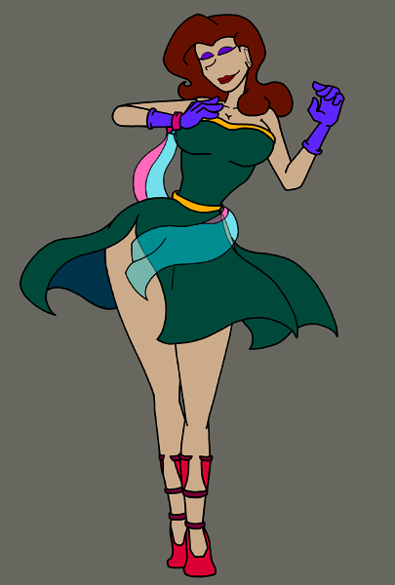

The music eventually stopped and Bradley became aware of himself again. He was on his knees, bowing to the audience, panting slightly, and he could feel the heft of his new shape once more. The audience was on its feet, clapping and whistling, but it felt different than at Serena's show. Bradley felt their respect this time. The crowd calmly filed out and the lights dimmed once more. He picked himself up and placed the silk back on the wall before noticing a woman still standing in the crowd. She clapped softly and started towards him.
"Wonderful, love!"

Bradley backed away from the ringmaster. Had she been there the whole time... She strode quickly to his side but so gracefully that he hardly saw her move.
"That was a beautiful dance, dear."

He wasn't sure how to respond, so he just gently nodded. The ringmaster slipped arm behind Bradley and pulled him in.
"This could be a new field of work for you. You're quite good at it. Let's talk in your trailer."

The ringmaster gently led Bradley down the stairs and out of the tent. They passed a sign announcing that the Divine Brandy's show was closed for the night and headed for the row of living quarters at the back of the circus.

***********************************************************************************
Read more Mercynaries comics and stories at: http://www.sincomics.com/ddg.php

