ELECTRO SPARKS FLY
COMMISSION STORY
BY CHALDEACHANGE
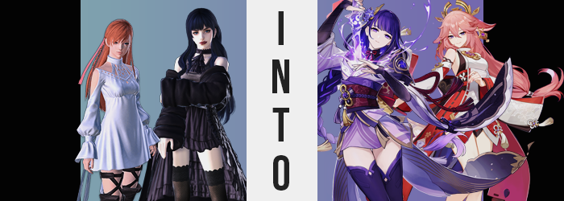

“That visit went well I think!”

“It would have gone better if we’d gone to the coffee place that I suggested…”

Listening to the two seventeen year old girls now, you wouldn’t have known that both Ryne and Gaia had been on their best behavior up until that very moment. The day had actually started on a very positive note after all! The Warrior of Light had visited them from the Source. Now, it wasn’t exactly the sort of visit that they could ever plan for, but it was certainly one that was appreciated. Ryne knew all of the Scions of the Seventh dawn and had essentially been raised by them. She was always eager to receive an update about how they were faring.

Gaia, Ryne’s girlfriend, was more or less just along for the ride. She had met Thancred, Urianger, and of course the Warrior of Light themselves but… She only had any real attachment to Ryne. She cherished the rest like one’s girlfriend normally would – based on how much joy they brought the one the girl who brought her joy. But Gaia did appreciate the jewelry the Warrior of Light had gifted them. Both Ryne and herself had been given one half of a set of matching necklaces; each bearing a purple crystal.

Apparently, the Warrior of Light believed it would aid them in their endeavors within the Empty.

But when it came to the plans that the three were to do as a group? That was where Gaia’s attitude had come from. Both teens had wanted to go to a coffee shop so that they could have coffee biscuits together, but they had stumbled into a disagreement about which shop to visit. Ryne’s had been chosen but somehow Gaia had gotten it in her head that the Warrior of Light had been dissatisfied with the food and had kept making vague remarks that had been getting under the Oracle of Light’s skin. And in the end?

“Gaia, why are you starting a fight about this? I just wish that you would communicate with me better sometimes!”

“Well maybe if you were better are reading my mood, then—”

Both girls were immediately bewildered as, after this exchange, the matching necklaces they were wearing began to glow. “W-Wait, what’s—!?” But Ryne’s wasn’t even able to get her question out in its entirety before the two of them disappeared not only from view, but from the First altogether.

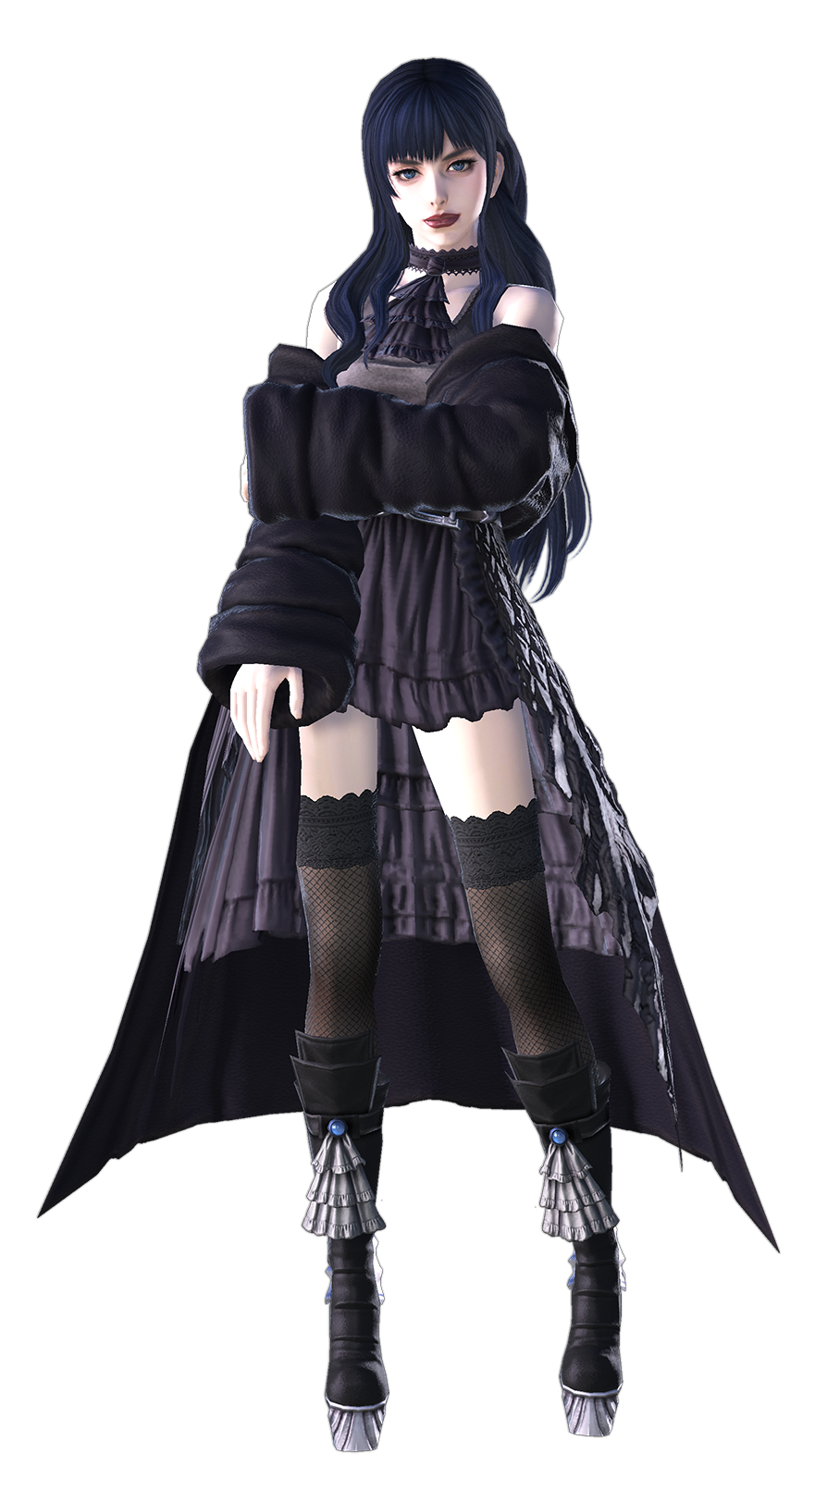
“Ryne!? Ryne!?” When Gaia became aware of her situation again, she was in a different location altogether. From what she could tell she was standing beneath a shrine atop a mountain? But it wasn’t Mt. Gulg and the land it overlooked was not anything she had ever seen before. Had the necklaces done this? “It’s gone!?” The teen soon realized that she wasn’t even wearing it anymore. It had vanished without so much as a trace. “Damnit… I shouldn’t have started that stupid fight.”

Even though it was hardly a fight in the first place, all she could think about was the possibility that she would never see her girlfriend again. Sure, both necklaces had been glowing but that didn’t guarantee that Ryne had warped as well. Even if she had, there was no way to know if the girl was even nearby. “She’s right, I should be better at communicating. Not that it’d do me any good now…”

Of course, she didn’t have the context that she had been brought into this world to help rectify the couple’s relationship woes. It just wasn’t going to be handled in a conventional way, if the whole world hopping aspect of it all wasn’t already indicative of that. Before long, Gaia turned to look at the big tree overlooking the shrine. “It’s strange though. I’ve certainly never been here before, but there’s something oddly nostalgic about it all.”

She slowly approached it with this thought in mind, almost as if her mind was in some manner of haze. Enough of a haze at least that she didn’t seem to quite notice something off about the color of the bangs from her hair that occasionally danced at the peak of her gaze. They weren’t black like they were supposed to be. They were a soft, almost cotton candy pink. And that color had begun to permeate through all of the hair on her body.

“But where have I seen this tree before…?” It was a question that she had posed to no one but herself, but strangely enough? She received a reply. Do I not see this tree every day? Did she? That would certainly explain why she felt the way she did about it, but… “No, what am I thinking?” That really couldn’t be true, could it? The moment that thought had crossed her mind, though? Not only did the colors of her eyes brighten to a soft purple, but their shapes narrowed into almond-like designs that felt closer to the eyes of the people of Kugane back home.

This wasn’t the end of the troubles that Gaia wasn’t even aware were occurring. They were just smaller parts of a greater aesthetic shift that would become more and more dramatic as the moments passed. For example, the hair atop her head that had pinkened had begun to lengthen too. Not dramatically so, only a few inches, but something about it felt choppier? The strands were thinner but softer, and her bangs became fluffier than ever.

The teenager remained ignorant of it all even as the strides she took towards the tree seemed to lengthen – a feat that was generally only possible if her body was longer. But it was. Her legs rose a slight way out of her thigh high stockings while the boots themselves became a little cramped. The skirt of her dress lifted upwards, and detached sleeves appeared to creep downward on her arms. None of this was extremely substantial but, in the end, it all pointed to a singular possibility.

Gaia had grown taller.

“Yes, this tree…” She spoke with a voice that had lost its more youthful qualities. There was an allure to her tone that hadn’t quite been there before either, all falling in line with her four inch height increase. It was reflected in her face, too. A maturity that hadn’t been there before; signs that the girl was no longer a girl but instead a woman. “I certainly know this tree.”

A vaguely longer tongue emerged to lick at lips that were a touch thinner than they had been, but that tongue didn’t catch on any black lipstick because it had been erased from their presence. Her jaw did widen a bit and her nose lengthened. When you considered how her eyes changed prior it was clear enough that her very racial profile had changed. And that aside, it also communicated an enhanced level of maturity. Not like a teen, but perhaps a woman closer to thirty. But that was actually wildly underrepresenting what her body’s true age was shifting to match. Hundreds of years.

The woman shook her head. “I have to say, this is a view I’d like to see more with Ei. …Ei? No, I meant to say… her?” Who was she thinking of? Her girlfriend? Her romantic partner? That had to be Ei, right? So how could she be confused about her girlfriend’s identity? If anything, this conundrum served as the perfect cover for some additional and pronounced physical alterations though.

Gaia’s dress was already having some difficulty with fitting thanks to her height jumping up, but while reaching out to touch the tree as if doing so might bring her some clarity, things began to feel even more uncomfortable courtesy of some additional weight in some regions where most women would certainly appreciate it. Had the woman herself been aware then she probably would have liked it herself if not for the… other aspects of her transformations.

She promptly felt possessed to pick at her own black lace underwear. It just didn’t fit her ass and pelvis right – and for good reason. The flesh that the undergarments surrounded had become more abundant. Her cheeks had expanded, skin tightening around them and forcing panties to slide in between her cheeks. Not only did this provide her with a wedgie in the back, but it was flossed into the lips of her loins in the front. Hips wedging wider probably didn’t help either.

“Hm?” Gaia did notice it subconsciously, just as she noticed a thickness in her thighs rubbing against each other, or how her breasts felt to swell a single cup size within the dress itself. This all made for a very uncomfortable experience in her current outfit… which made it fortunate that the clothing was swapped out to a red and white shrine maiden-like outfit with plenty of exposed skin and a golden headdress.

But her changes weren’t complete until her own ears poked out of the top of her head. Not in their original shapes, mind you, but as a pair of long, furred (and fluffily so) fox ears.

The fox ears of the pink-haired kitsune twitched in the night air. “Hmm~? Now what was I doing out here again? And with Ei so heavily in my thoughts.” Perhaps it wasn’t all that strange for Yae Miko to be doing such a thing. She was the beloved partner of the Archon of Inazuma, Raiden Ei. The two shared a romantic relationship that wasn’t known to the public, but neither of them particularly minded this arrangement.

Of the two? Miko was the most romantic and the most, shall we say, promiscuous. She had loyal awaited her god and lover’s return for 500 years and now that they were reunited? Her thoughts often turned to Ei and what she would say to and do with her the next they met. Miko was exceptionally good at communicating after all. Which made her life a suitable fate for Gaia, who had been accused of struggling with such things.

“I wonder if she’d come by the Grand Narukami Shrine for a ‘recreational visit’ sometime soon if I asked her?”

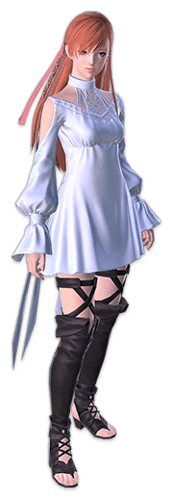
Elsewhere in Inazuma, Ryne had found herself in a predicament not unlike Gaia’s. Her necklace was missing, and she was in an unfamiliar location – but where she found herself was not a place as open and free as an outdoor shrine. She had appeared atop what she could only liken to a crown overseeing an open room within which she had to assume was so large in order to accommodate a large number of people simultaneously.

“I— What do I do? I don’t see Gaia anywhere…” She clutched a hand to her chest anxiously. Regardless of how large the room was there was no one but herself inside. She stood from the throne and began to pace around. Considering the circumstances, she was a little worried that someone would find her and seem her an intruder. But which way should she run? Without knowing how she had even gotten inside it was highly possible that she would bump into a guard or something of that nature. What guard would dare challenge me? …Was a thought that she had definitely had for some reason.

In the first place Ryne didn’t even consider herself to be that strong. Her small body didn’t make it very easy when it came to intimidating others, that much was certain. Or at least that was how things were supposed to be. But times were changing – and so was Ryne. She had begun to rise out of her own boots, the skirt of her dress no longer barely reaching the center of her thighs but instead lifting up until the base of her white panties were exposed.

Furthermore? The thin cloth of her dress that bound her sleeves to it tore in part because her arms were longer, but also in part because her shoulders were wider. “Ah!?” Cloth tearing certainly caught her attention but no sooner than she reacted did her awareness of the change slip through the cracks. She was about 5’9” before all was said and done, and the woman featured a body that was body taller and wider. Her thighs flaring out had lifted the base of her skirt even more so you could basically make out the entirety of her underwear.

“I… suppose I could be stronger?” Had her voice always been so deep? Ryne felt somewhat certain that it hadn’t and yet… had it? Just like her height, she couldn’t seem to properly process things. Even the room around her had begun to look more and more familiar as the surroundings were reflected in her eyes. Eyes that began to glow purple and shifted in their shapes to resemble the same racial profile that Gaia’s had gained. Namely to say that they resembled an Inazuman’s eyes.

Her height change had come with some additional implications, mind you. There was a maturity to her face that certainly hadn’t been there before, and it was enhanced by her face further inheriting traits of the people she was changing to resemble. Her lips bloated until they were thick and juicy atop a jaw that widened somewhat. Cheekbones raised and her brows furrowed. All coming together to make it look like she was around the age of thirty or so herself.

Ryne quietly looked around again. She had things she wanted to say, but she didn’t feel as keen about speaking aloud as she normally did even without an audience. Stranger still? There was something akin to a voice in the back of her head that wasn’t her own. Her personality was being warped by the power that changed her, sure, but that other voice wasn’t it. It was a voice belonging to a different existence altogether. Its presence was distracting.

Distracting enough that a swelling of her bosom was of little consequence from her perspective even with how little room existed in her dress. It had a tight fit already, but with mounds doubling – no, tripling in size? The neckline had no choice but to rip down the middle so that the woman’s ‘girls’ could breathe. Odd. Was my dress always this uncomfortable? That was the strongest reaction she made to her now D-cup tits, and it wasn’t even directed at the actual problem.

In a similar vein? She internally targeted her panties as the problem once they began to not only dig into her hips, but into her pussy and ass as well. The actual issue was visible enough since her dress had been yanked up so high. Whether it was her thighs or her ass, these regions all swelled with additional glorious mass. Skin was pulled taut around plush thighs, while has rump pushed into a thickened, round cake. There was something extremely sexy about this new body of hers.

But it wasn’t a mortal body. It certainly resembled one but at its core? The body wasn’t flesh and blood. It was a puppet. A puppet possessed by a god.

There was a sudden and dramatic shift in her outfit that covered up any potential issues with the previous one’s fit. A stylized, purple kimono with long sleeves was the more prominent article of clothing. It was short enough to show off her thighs, but thigh high boots came to additionally highly their girth. An obi was pulled tightly around her stomach and fingerless gloves reached up into her sleeves. A regal looking headpiece was placed on the right side of her head, in hair that, at least so far, had retained its style and color.

That was no longer the case. It was all that remained of Ryne and that just wouldn’t do. Strands darkened to a rich purple while that hair lengthened dramatically. It cascaded past her shoulders, all the way down to the backs of her knees. Oddly, the purple lightened closer to the tips of her hair while bangs took a straighter cut above her eyes. It suited her new sense of style much more keenly. That is to say the same style she now recalled having for thousands of years.

The Raiden Shogun whose true name was Ei stopped pacing around her chambers. It was so late at night that it was only natural that she was alone. Most of the remaining guards were either patrolling outside or had retired for the night depending on their shift. But their presence was also an unnecessary one. The Shogun was the most powerful being in all the land. Not even a Fatui Harbinger had any chance of assassinating her.

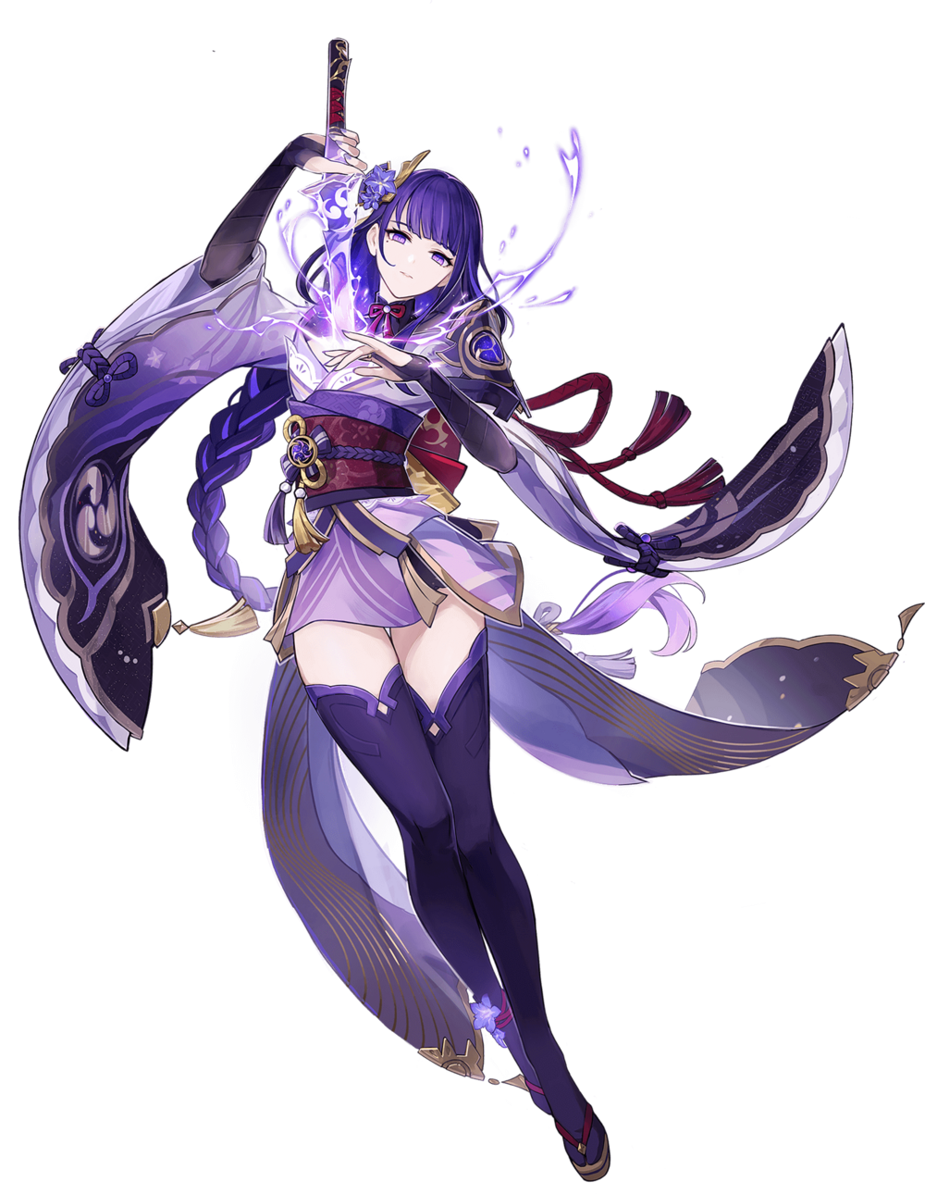
Still, on nights like these? Ei may have been the reclusive type but even she yearned for companionship once in a while. “I wonder how Miko is doing. Shall I have someone fetch her for tomorrow night? Hm…” She had no doubt that the kitsune was yearning to see her as well. Because while the Shogun was bad at expressing her own feelings? She had an exceptionally sharp sense when it came to understanding others. Which was exactly the sort of trait that Gaia had wanted from Ryne when it came to understanding her feelings.

So perhaps it was ironic that the two women now practically had inversed personalities otherwise. Had that been the intention of the necklaces that had brought them to this land? In the end it didn’t really matter. Neither Ei nor Miko could recall their past lives nor transforming into who they were now in the first place. From their perspectives Inazuma had always been their home, warts and all.

After nodding to herself the Archon spoke to herself once again. “I believe that I will. I’m certain that she’ll ask me to make the trip up there instead, but it would be far too suspicious.” If the Raiden Shogun left, then the people would know. They didn’t need any unnecessary rumors about their relationship spreading.

But the fact that this even crossed her mind? It confirmed just how much she knew her partner’s heart.

