SOMETHING BORROWED
COMMISSION STORY
BY CHALDEACHANGE
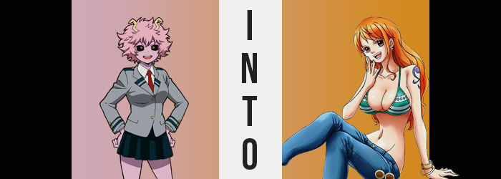

“OCHACO-CHAN IS THAT REALLY YOU!?”

That was the scream that had started it all. Well, no, wasn’t it the scream that had sounded at the end of it all? Mina Ashido was pacing back and forth outside of her own room in the U.A. dorms while biting at her thumb nail. It was evident that something was bothering her. She was frantically trying to think of a solution to something. And it was something that she was trying to keep a secret for the time being because what would other people say if they realized what had happened?

So what had happened? From Mina’s point of view? She wasn’t really sure. Ochaco Uraraka had come to her asking her for help. Apparently things hadn’t been going well with Deku which, obviously? Mina had teased Uraraka plenty about this in the past. She just was not good at expressing any romantic intent. Could the pink-skinned girl really judge her for that? Well, no. Try as she might, she hadn’t had a boyfriend or girlfriend yet either. But that was beside the point!

As part of her plan to try and help her friend get Izuku’s attention she had whipped out a special invention that Mei Hatsume had made for her. A special pen that allowed you to instantly dye one’s hair. She’d used it to dye a little of Ochaco’s hair orange before having to leave the room to take a call. Admittedly she didn’t know how it worked, but when all was said and done?

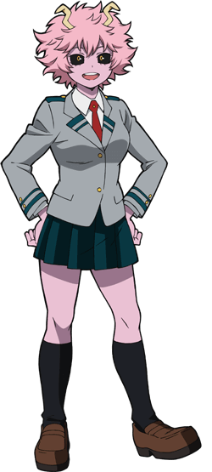
“It had to be the pen, right? Should I ask Hatsume-chan about it?” The only thing that could have caused the present debacle was that pen, right? Mina spared a glance to the door of her room. She had foolishly left her phone inside, and she could hear Uraraka talking to herself inside. Well, no, was that really Ochaco Uraraka? Before her call had finished, Uraraka had stuck her head out of the room to ask her if she had a second. Mind you, Mina had been outside the door the entire time and they were on the third floor. There was no way for someone to normally get into her room without her notice, especially with the window locked – which it had been.

And so who was Maki Gamou, the girl who had appeared in her room where Uraraka had been? According to Maki herself she was Uraraka. Even despite her assertion that she didn’t want to be called nor treated like Uraraka. She was Maki now, so her old life didn’t matter? Mina really wanted to assume this was all some crazy practical joke. And yet Maki’s orange hair was the same color as the dye she had placed in with the pen.

Maki herself even corroborated that the pen was the cause.

No, rather than ask Hatsume about the pen… “I need to tell her. This could be dangerous.” If that pen really had the power to change someone’s appearance, personality, and identity then it couldn’t fall into the wrong hands. Bringing the pen back to Hatsume was also the only likely way to reverse engineer the effect. Maki couldn’t stay that way, right? They had to change her back into Uraraka! …Even though she didn’t know at the time that doing as much would have been impossible.

“Okay!” With a plan in mind, Mina reached for her room’s doorknob. She was going to go inside, grab the pen and her phone, ask Maki to stay inside, and then march down to Mei Hatsume’s lab to figure out just what the heck was going on! She stepped inside. “Gamou-chan, was it? Look, I’m going to— ACK!?” The girl had been on the cusp of explaining to the victim just what her plan entailed. Only to get sneak attacked by the tomboy who, on sight, pointed the pen at her and pressed a button.

Launching some of the orange dye into her own hair. “Hahaha! So you can shoot with it! That’s pretty funny!” Maki seemed to be having a grand old time, not thinking much about what she had just done. Mina reached up to touch her own hair, noting that some of her bangs were now orange. Maki might not have thought about it, but she certainly did. “I’m heading out for a bit! Don’t worry, I won’t get into any trouble!” Making matters worse, Maki practically ran out the door before she could stop her, closing it behind her.

“Wait! But my hair…?” The teen who was left behind had a bad feeling about this. Not only had Maki run off with the pen, but her own hair had been splashed with it? If the running theory was correct and it was the pen’s dye that had changed Uraraka, then didn’t that mean…? “Crap!” She turned to the door again. She had to reach Mei before anything… before anything… Actually, do I have anything of value in my room?

What?

Did she not have more important things to worry about than how much her stuff costed in that specific moment? Glancing at her mirror, in fact, she could see the orange dye working its way through the rest of her hair rather quickly. No, it wasn’t just dyeing her hair a different color, was it? Her short and curly locks, once as pink as her skin, were unwinding. What was once curly and a little frizzy was both straightening and flattening, pressing against her head and dangling to her shoulders. But it didn’t just stop there either, and before long it was inching past her shoulders and quite a ways down her neck. It didn’t look like her hair.

It looked like hair that belonged to another girl altogether which, considering the whole Uraraka to Maki pipeline, wasn’t exactly surprising. But it was alarming to Mina because she absolutely did not want to become a different person. “Come on! Stop…!” It was too bad that she didn’t get a say in the matter and the dye practically tried to tell her as much. Because by the time she had run directly in front of her mirror she was forced to watch her irises turn an orangey-brown, and her sclera shift from black to white. Like a normal pair of eyes.

Mina Ashido’s unusual physical features had been a side effect of the acidic Quirk that her body contained – and that included the two, curved hook-like horns jutting out of her head. Perhaps it was a scathing indication of just how deep these changes ran that they snapped off of her head on their own and fell to the ground, then. “Ah!?” But once they had snapped off? The girl could do nothing as she watched the pink pigmentation of her skin pale until it was a completely normal skin color.

Oddly though? Her Quirk wasn’t gone. Whatever had happened had simply staved off the side effects that she suffered from.

“So I’m becoming another person? What kind of person is she?” It took her a moment to recompose herself, oblivious to any realization in the meantime that a detailed, blue tattoo had been engraved into her left shoulder beneath her uniform. She’d calmed herself. So she was becoming another women, and? Maki still remembered who she was, so she probably would too, right? That meant she could undo it! But I’m going to be so sexy that I won’t want to go back!

Mina’s brown eyes blinked, their shapes widening in her reflection until they didn’t look like the eyes of a Japanese girl at all. More like the eyes of a Caucasian girl. But that didn’t click with her. She was hung up on what she had just thought. “Sexy? Am I going to become sexy?” That had never really been a priority for her. The girl liked being cute, but being sexy wasn’t important, right? She just dressed the way she wanted to! If she ended up coming across as a little sexier because of it then that was fine. But she was also a teenager still, there was a limit to how ‘sexy’ she could be.

“Maybe that wouldn’t be so bad. Think of how easy it’d be to steal…” The teen looked up thoughtfully, although those thoughts were brought right back down to Earth as a realization struck her. While still staring at the ceiling she tilted her head to the side. Was the ceiling closer? No, her face was getting closer to the ceiling, right? And she could feel her uniform jacket and top lifting to reveal her tummy even though she wasn’t stretching. And was her skirt only covering… “WAH!?”

She craned her neck back down to find that all of these things were true. “I’m taller!?” Was the new deepness of her voice a side effect of that? She definitely was taller though; about five inches more, enough to show her midriff and her thighs almost in their entirety. Brown eyes darted back to the mirror not long after. “Wait…” It wasn’t just that she was taller. She could hardly recognize her own reflection!

Perceived age was a part of that. As she’d grown taller Mina had also grown up. Looking at her face in the mirror it was clear that those features had matured into young adulthood. But more significantly? Those features weren’t hers. Like her hair they belonged to an entirely different person now – and it was only now she noticed any trace of her Japanese heritage had been erased. Instead? Her eyes were much larger, her lips were much fuller, and her facial structure was leaner. She was beautiful, though. Mina felt an excess of pride in just how beautiful she was.

“Hmm…” She was confused. Why had she been panicking about all of this? She didn’t care at all anymore that her waistline was pinching in until it was almost freakishly narrow, nor that her hips were expanding to the point that her skirt now revealed the base of her underwear. “Hehe. Think of how much I could get away with looking like this?” The breadth of that only expanded as her proportions, well, expanded.

Mina’s outfit was already having difficulties, and adding more to her body’s mass didn’t really help her much in that regard. “Oh!?” But the woman herself seemed to be elated at the sight of her uniform top gripping her chest more keenly, fatty tissue swelling at the base of her breasts to fill them beyond capacity. They grew, and grew, and grew until she was afforded no option other than to unbutton everything so that the depths of her new cleavage could spill out energetically. Expanding to J-cups as they did, she practically had the whole front of her outfit unbuttoned so that they could hang out without showing her nipples. “Whew!”

That said, her skirt suffered similar comfort issues. Perhaps not as much as her panties though, as a swelling of her ass saw them tightening and digging into the supple flesh of her expanding rump. Unfortunately the design of the human ass meant that, if enough tug was applied, anything worn would slide into the crevice – and so a wedgie had been guaranteed as soon as her butt began to balloon. Mina made an odd noise when that happened, but she was used to wearing thongs! It wasn’t that big of a deal!

Even though Mina had absolutely no experience with wearing thongs in her life. Much like Maki, new memories had mixed with her old ones. It made it easier for the woman to adjust to her new body and personality, and that new personality of hers might have been even more flamboyant than her body. It was the personality of a rascal. One who took no issues with exploiting her own attractiveness for personal gain.

And there was a lot for her to personally gain if she put her mind to it.

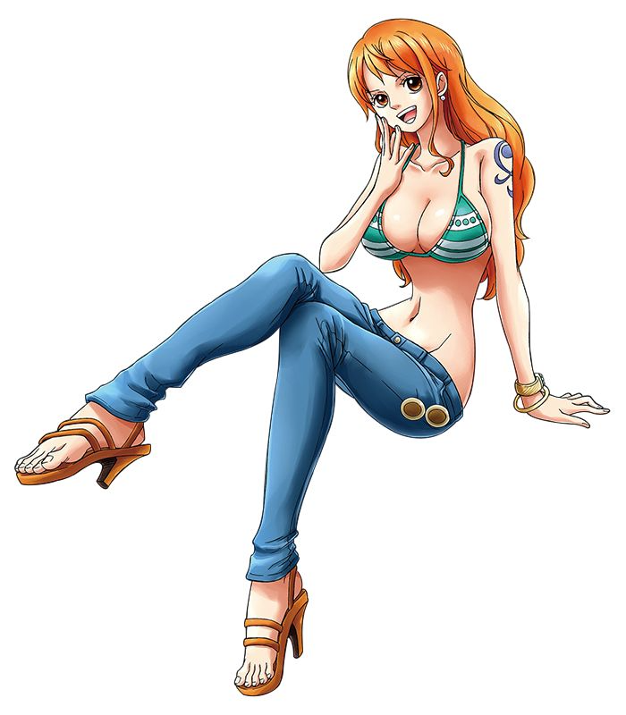
“Well this is weird.” The older, orange haired woman could definitely understand where Maki had been coming from now. Her brain was in the exact same state. It was easy to identify what was different about herself. She was a little taller, she was substantially curvier and pretty, and her personality, while still as extroverted as before, placed a lot more value on things like personal profits and thievery. These were behaviors that were a little more villainous in nature, but Nami was no villain.

Unless you considered all pirates to be villains, anyways.

Nami tugged at some of her orange hair. “So the pen did all this, huh? Interesting that my name is just my old name rearranged, but that must have been a coincidence?” She was talking just to hear herself talk. She addressed the clothing situation next. With her clothes the way they were now, her skirt was too short and her top didn’t even cover her tummy. Finding a pair of scissors? She cut her top even shorter so that her entire midriff was bare. The short skirt didn’t bother her either, she was actually more comfortable revealing her skin.

“And my Quirk is still present? But my skin color is normal. Huh.” This probably should have been more alarming to her than she acted, but she felt comfortable. This was her body, and despite knowing it had changed she felt like she had lived in this skin her whole life. But wasn’t she a little old to be a U.A. student? She was in her twenties! “Yeah, that’s probably going to be a problem if I get caught.” And so she’d simply have to avoid getting caught, right? She’d slip out of the school, and—

What happened to reporting the pen to Hatsume? As Nami now saw it, it wasn’t really her problem, right? Maki had the pen and was probably squirting others with it while she lingered. Someone would realize sooner or later, and if she hung around for too long she’d probably end up getting arrested or something. She didn’t want to do that. And realistically? The pen wasn’t dangerous. It wouldn’t hurt anyone. So she didn’t really care if other people were transformed. “Maybe it’ll be better for them? If they end up like Maki and I then they’ll probably like their new lives better anyways!”

That was the excuse she used to justify not taking accountability anyways.

Nami unlocked the window of her room and pulled it up high enough that her slender body could slip through. She might have been on the second floor but with her new skills it wasn’t all that daunting. She grabbed a nearby vertical pipe and just slid down to the ground… where she broke into a sprint off the school property. She’d succeed in her escape and it had ultimately been a good idea for her to take as much stuff from her old room as possible to pawn off for money. “See ya!”

Wait, when had she had time to do that!?

A cat burglar indeed.

