WET CELTICS
COMMISSION STORY
BY CHALDEACHANGE
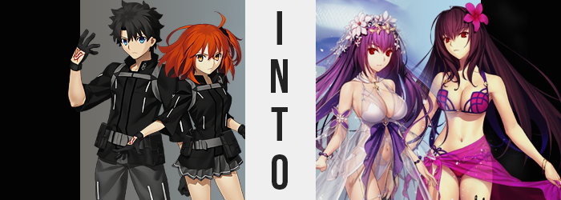

“SENPAI! SENPAI! ARE YOU OKAY!?”

It was cold. And that voice was very loud. These were the two thoughts that popped into the head of the Master of Chaldea, Gudao, first the moment his consciousness finally returned. Vision blurry, he couldn’t remember what had even happened for him to fall unconscious in the first place. It wasn’t like he had gone to sleep, and groggy as he was he couldn’t possibly imagine his lack of consciousness had been from sleeping.

Picking himself up, though, he realized why he had been so cold. Vision clearing, there was nothing but a sea of white spread out before him. He was standing in an open land of ice and snow, one with a giant and crystal palace spread out behind him. Wait. He knew where this was. He had been here relatively recently in fact, but that Singularity should have already collapsed.

It was the icy, summer wonderland that Scathach-Skadi had created.

Albeit it didn’t appear to be fully formed. The castle and surrounding area stood, but he couldn’t see the other attractions off in the distance. But everything made sense now. His sister and himself had been about to use the simulator for the dailies, but when they had activated it Skadi had called out about something. Apparently da Vinci had asked her to enhanced the machine with some Rune Magic, and the process hadn’t been ready yet.

And well, after a flash of light? He was here. “Mashu? I’m okay. This is a simulation, right? So just try and get us out.” Mashu had been projecting herself into the simulator from outside, the Demi-Servant undoubtedly hoping to make sure that the two siblings were alright. And seeing that the brother was alright, an audible and visual sigh of relief could be observed.
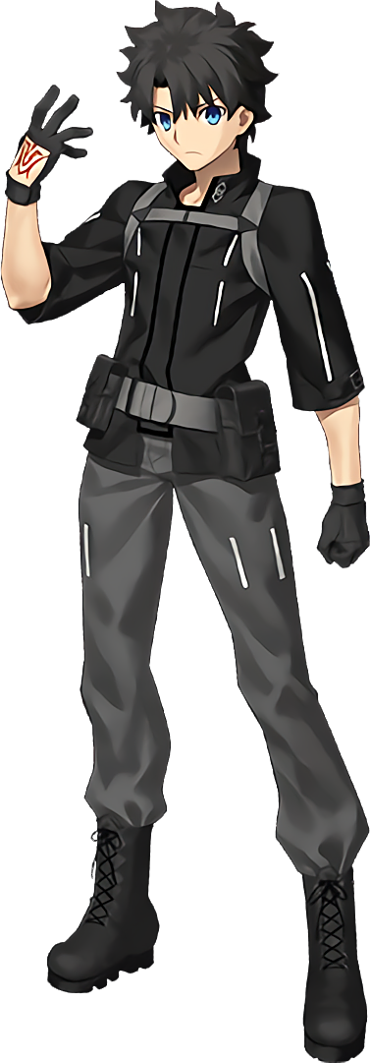
“Okay, senpai! Skadi gave me something to try, but I’m going to make sure your sister is— Hey, Skadi! Not yet!” And then the call cut out, evoking a smile from the brother. It seemed like he was in good hands, even if those hands were the things that had gotten them stuck in this mess in the first place. Yet no one involved realized that the Runes that had been placed on the simulator were untested, and while Skadi believed they were harmless, they would interact with anyone trapped inside in unusual ways.

It was cold, but Gudao recalled that despite being made out of ice, the castle interior was warm. So he made his way up those icy steps and inside, taking shelter until Mashu and Skadi could get him out of the simulation. It sounded like the normal method of doing so couldn’t be used for some reason. “Oh, is the process starting?” But it didn’t really seem to take all that long at all. He could feel the tug on his mind and body that he normally felt before ‘logging out’.

Yet it didn’t take him all that long to realize something was wrong, too. Logging out should have only taken a few seconds, yet he still lingered there along with the feeling of doing so. “Did something interrupt it…?” If there were any problems he assumed Mashu would have informed him, but the boy also didn’t know that his kouhai was dealing with issues of her own in the physical world.

Gudao’s confusion only built as a distortion flickered throughout the surrounding castle of ice, seeing pixels fluctuate before the phenomenon converged on himself. It brought him to recoil with a confused groan, not because it was painful but because it had taken him off guard. “What’s going on!?” The ripple of corruption had forced his eyes shut when he’d winced, and while everything had otherwise appeared normal when he’d done so?

When those eyes opened, his irises were instead a crimson red.

He shook his head once the phenomenon had appeared to have subsided, looking around to make sure nothing dangerous had happened to the castle he was taking shelter in while still holding out hope he would be logged out at any moment. “Phew.” Fortunately, he didn’t see anything worth losing his head over. Albeit he didn’t realize he was ascertaining that with a level of sharpness to his vision that should have been unheard of.

But because he could only see what could be perceived with his own eyes, that made it rather difficult for him to take note of things that his vision couldn’t see. At least not with a reflective surface and the knowledge that he should have been examining himself. Alas, the red of his eyes escaped his notice for now because he didn’t have any of this awareness.

As did the fact that their shapes, as well as the rest of his face, appeared to be changing towards the unrecognizable. Beginning with the eyes of red, the lashes that protruded from his eyelids appeared not just a touch longer, but almost triple their usual length. It created a budding air of femininity, and one that was soon followed up by the shapes of those eyes themselves. They ultimately appeared bigger and rounder, far more expressive by design. But so too did the corners round and thin so that there was something else unmistakable about Gudao. That he was no longer Japanese. Those were, undoubtedly, the eyes of a Caucasian individual. A Caucasian woman.

Something that the rest of his face had begun to demonstrate. Such as in how his jaw narrowed and his cheekbones raised. Paired with those bigger, brighter eyes and a smaller nose, the defining feature in the end was a pink plumpness that beset his lips. They appeared full and kissable, and hid a smaller tongue beneath them. But at the same time, while this face appeared womanly and beautiful, it also appeared older. Like that of a woman in her early thirties, if not older.

“I… Hm. Maybe the cold isn’t as terrible as I first… My voice?” It had taken some time for him to notice that anything was happening to him in the first place, yet while locks lengthened and fanned out behind him, taking a purplish hue as they did so, it was the quirkiness of his own voice that had taken Gudao by surprise. Soft and feminine, it held an air of elegance when he also considered he was speaking strangely. His choice of words felt stiffer than normal, any hint of his more casual manner of speech absent.

What had even provoked him to speak up was the fact the cold wasn’t bothering him as much as it had been before. In fact, he had almost forgotten it was cold until he placed a hand on a nearby wall to steady his balance – something that had only come about because a pair of inches had been shaved from his height, seeing his overall size not only dip in terms of height, but likewise all of the muscle on his body appeared to melt away in favor of flesh that was softer and spongier.

Glancing at the hand that was on the ice wall, crimson eyes went wide as he realized something else was wrong. His fingers were thinner, longer, and sported delicate, manicured nails. Taking his free hand, he then pulled locks of long purple in front of him. “Ah, so that’s what is happening.” He should have been shocked, because he understood what was occurring now – and it was alarming. But there was a sense of calm and acceptance that he just couldn’t shake.

Even as he felt his waistline tug inward beneath his jacket, and his hips flare out so that his pants clung so tightly, there was no expression of shock. Just a mature calmness across feminine features. And they were, evidently, growing more feminine by the moment. His jacket and undershirt soon found themselves struggling to grapple with a new growth; the growth of his chest which had once been so flat.

Beginning with his nipples, which had turned erect and swelled several coin sizes larger, the phenomenon eventually spread to the tissue around them. Softer and softer it became, for a gentle layer of fat presented them with the beginnings of some volume. But once that layer had been established they quickly ballooned towards a breathtaking size. …Maybe they were just breathtaking because his jacket was compressing these E-cup beauties against his lungs, however?

“Enough!” His clothes showed no signs of ripping, which meant the weight of his tits crushing his chest was not an issue that would be solved on its own. So, without thinking? A snap of his fingers solved the problem, for his entire outfit transformed into something that hugged his body a little more effectively. An elegant, white bikini top now covered his new breasts, allowing them to breath. While a matching bikini bottom sat on wider hips.

Yet the key remnant of his masculinity had been sticking out of the bikini bottom’s top at first. Not that it was visible long, for with thighs swelling plumper that dick gradually disappeared into the bikini, revealing a couple of purple pubes for but a second before the bikini ultimately rested flat upon her pelvis. A soft and meaty swell of her ass finally signaled the end of her transformation, all while more translucent white adorned her in terms of clothes and a garden of flowers bloomed in her hair.

From Scathach-Skadi’s perspective, it was odd. She could still recall being a young man named Gudao, and his memories were still even present amidst her ego. But her sense of self was very much ‘Skadi’, from what ideas took priority, to the mannerisms her body communicated with, to the way she spoke. “I presume this isn’t what the other me meant to do, but I’m not pressed to take offense.” Speaking of the Skadi in the other world, she couldn’t help but identify them as one in the same. Nor could she find anything wrong with who she was now.

She was a beautiful goddess. What complaints could she have? Well, perhaps along the lines of how she was still unmarried, but that concern was neither here nor there at the present. Especially when she finally felt it in the air. The proper feeling of being pulled into the real world.

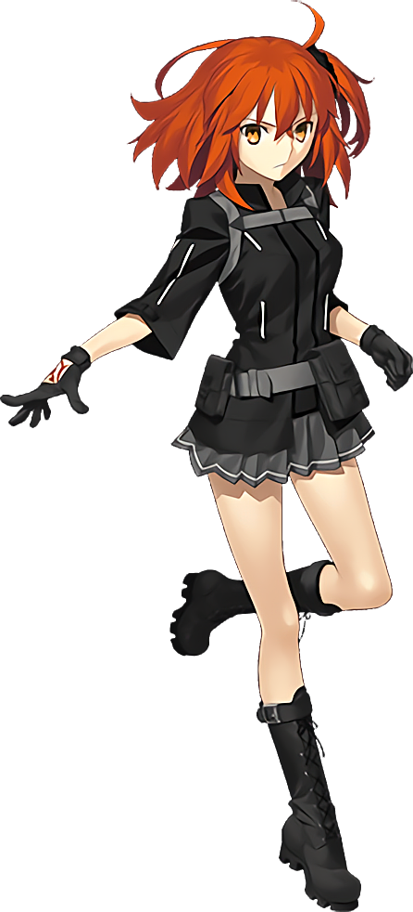
Unlike her brother, Gudako was not at all bothered by the cold. She had actually awoken on a deserted island. One that she recalled perhaps visiting many, many years ago. Back when she and her brother had first joined Chaldea and Goetia’s plans had first been put into motion. If anything, dressed in all black she found the tropical temperature to be a little too much. “I hope Mashu gets us out of here soon…”

Hiding in the shade of some nearby palm trees, it had been a good few minutes since Mashu had managed to get into contact with her. At least she had brought good tidings about her brother – something she had been concerned about. Though seeing as this was all a digital simulation regardless, the girl had never thought herself to be in very much danger.

“Oh!” And there it was! The feeling of being ‘logged out’. That hadn’t taken very much time at all! Which was good, honestly, because the shade of the palm trees had been steadily disappearing as the minutes passed, thanks to the movement of the sun in the sky. Except the escape she was looking for? It didn’t come immediately. In fact it even appeared to have some stipulations attached.

Gudako immediately became aware of those stipulations due to a building tightness within the depths of her jacket. Blush played upon her cheeks as she stared downwards, unsure of whether or not she should take care to check. But once she ascertained with her eyes what she could feel, that somehow her bosom was getting larger, she was prompt in undoing her jacket. “WHAT THE?”

No sooner than she’d undone the buckle and pulled the zipper down enough did the contents spill out, stretching her black tank top in the process. “There’s no way this is real…” Her breasts were notably larger. Perhaps DD-cups if anything, with grown and erect nipples visible in terms of their greater shapes through the thin cloth of the top she’s been wearing underneath. It almost made her glad she tended not to wear a bra with this outfit, seeing as she almost never took off the jacket.

“But why make me… big— WAH!?” She’d been on the verge of questioning the cause behind this change when she suddenly almost fell forward, just catching herself as knees buckled in towards each other and her skirt ultimately rested a little higher on her thighs. “What now!?” Something had happened to her lower body, yet with her breasts significantly larger in size it was much, much harder for her to see past them.

Using hands to explore instead (and not noticing how her fingers were a touch longer now), they rubbed across the sides of her skirt to find that her hips were a few inches wider than normal. This had led to her tummy becoming broader, but not in a way that was unappealing. But for all of the shock Gudako had felt before, she didn’t feel quite as concerned now. “Hm…” A deepened voice even indicated that she was now more prominently focused on identifying the cause of the changes, rather than being alarmed by them as she had once been.

These fingers reached a little lower, and one hand eventually gripped around her thigh. Not for no good reason, but because she could feel it fattening up beneath her grasp. This led her other hand to her ass, for cheeks were doing the same. Bit after bit they bloated, creamy skin stretching around a rump that saw her black panties wedge in between the cheeks with no shortage of discomfort. Yet the girl did not groan. Instead, instinctively, she snapped her fingers.

“That’s better.” Still spoken with a huskier voice, even while alone she couldn’t help but give a nod to the relief that she immediately felt once those fingers had snapped. It was of no surprise, because gone was her Chaldea uniform, only to be replaced by something a little more appropriate for the sandy beach she was standing on. A familiar, purple bikini with a dark trim and a series of bracelets had found her, fitting her curves much more snugly.

Yet while the intended outcome of her appearance was obvious, she still looked like herself. Like a Gudako that had really blown up in terms of curves and was now wearing the swimsuit of a certain Servant. But what was inconsistent was quickly rectified. She wobbled in place a moment, for her height gradually rose. Bones lengthened until she peaked at 5’6”, which in turn made her breasts and ass appear a little less ridiculous, all things considered.

All the while, the same red that had found Gudao’s eyes had found his sister’s. In fact, the very same shape of it all was reminiscent – almost identical – of that of the woman he had become. From eyes that were plainly Western, to the same jaw and nose shape; the only notable difference was that her cheeks were a touch thinner. Well, that and the fact that Gudako’s hair, as it fell down past her ass, inherited a much darker purple than that of Skadi.

Rather than be bothered that she was changing at this point, she felt more bothered by her physique. Why did she feel so weak? And why did that even bother her? It hardly mattered for long, for all at once all of the muscles in her body suddenly tensed up. With so much of her skin bare now it could be easily seen, and it was even plainer once that tension slowly released. Because as it did? The size of her muscles could been seen swelling, arms, legs, and tummy all rippling with notable physical power that gave her body an imposing yet wildly attractive glow.
It was very much the same for the new Scathach, the one clad in a swimsuit, as it was the swimsuit-clad Skadi that was being logged out elsewhere. She both accepted herself as who she was now, while acknowledging her roots as well. Gudako was part of her, but she was not literally Gudako. They had become something greater, perhaps. And she didn’t hate it, because she felt strong. She felt experienced. And she wanted to pass that knowledge on to others.

“…Oh.” Not one to offer much in the way of dialogue, she hardly batted an eyelash as she felt the logout procedure finally fully take hold, and the next she realized? She was standing in Chaldea’s simulation room. Beside her was a Skadi dressed in a swimsuit. Considering her own circumstances, she could only assume that she had been Gudao.

Then there was the original Skadi, who appeared to have the look of a woman in defeat. Considering all that had happened, perhaps that wasn’t all that surprising. Scathach doubted that she had intended to turn them into swimsuit Scathach-faces even if the pair of them were okay with it. But there was one other. A fourth individual that probably shouldn’t have been there.

“…Who is this?” Sounding a little unsure, it was the summer Skadi that had spoken up – waving a wand towards them. It was a second Scathach. Albeit it one dressed in a bunny costume. “H-How indecent, showing my face dressed like that!”

It took a moment, but the original Skadi eventually answered with no shortage of reluctance in her voice. “Erm… That’s Mashu.” An awkward silence hung in the air, because evidently this meant the ill effects had plagued anyone that had interacted with the machine in order to get them out. Mashu had made a sacrifice, but if she was concerned by it, it wasn’t shown on her cold facial features. Rather, she greeted the two instead.

“Welcome back, pyon.”

…Pyon?

