A VERY JK HOLIDAY
2020 HOLIDAY STORY
BY CHALDEACHANGE


It just really didn’t feel like the holidays yet.

Maybe because there was so much going on in the world? Between the pandemic, political strife, and a whole slew of random bad news that had been what amounted to essentially an emotional barrage over the course of the year, nothing about the past three hundred-some days had felt very conventional. So why would the winter holidays be any different? Well, I’d also taken on a lot of work so that certainly didn’t help me feel up to the task festivity wise.

The thought was really just a random one I’d had while writing at the computer that day. ‘It’s basically Christmas already, and not once has it felt like the holidays’. Sure, I’d indulged in some movies and some in-game events – and as always, gachas were the real killer – but it just didn’t feel the same? It wasn’t as if I was young anymore. I wasn’t a kid, or even a teen. Maybe Christmas just didn’t have that same zing that made me enthusiastic?

WASN’T THE FIRST PERSON PADORU STORY ENOUGH? HOW FESTIVE DO I NEED TO MAKE YOU, YOU GRINCH!?

“Uh…” The moment I’d turned on my computer that morning, I hadn’t been greeted by the usual login screen but by a less than cryptic message. I was getting déjà vu. Not because this had happened to me before, but because I had just written a Patreon request story with a terribly similar setup, where I was transformed into Christmas Nero. The culprit behind that? My own original character. “…Hisa?” It had just been a story though. Hisa wasn’t real, so this shouldn’t have been real. Did someone hack my computer after reading it?

YOU’VE BEEN DOWNLOADING A LOT OF ART OF SANTA SUZUKA I SEE, SO LET’S SEE IF SHE PUTS YOU IN THE CHRISTMAS SPIRIT!

Before I could properly react, my screen began to glow in flashing Christmas colors. That in itself wasn’t intimidating or alarming, but the second I felt something CLICK in the back of my mind? That was when I finally found the words I was looking for. “Wait! Totes don’t do that!” …Those hadn’t exactly been the words I’d intended to use. I was in my late 20s, I didn’t talk with slang like that. “Totes? Did I just totes say totes?” I ended up doing it again.

So, wait. Was my OC real? And turning me into a gyaru Christmas Servant? I really must have been dreaming this time, right? Honestly, even if I wasn’t, it wasn’t necessarily a bad thing. Who didn’t want to be a cute girl with fox ears at the end of the day? But that kind of thing was impossible, right? Totally impossible!

As much as I was trying to convince myself of the fact that original characters couldn’t come to life and turn you into holiday Fate Servants, denying that reality didn’t alter the outcome any. Since I had just gotten up, I was dressed only in my dark blue pajama pants and an oversized, gray tee – both even bigger on me than normal because I’d lost a little bit of weight. But while they were already spacious, their looseness was soon amplified substantially.

It was fortunate that I hadn’t gotten up from my desk chair, for I absolutely would have lost my pants due to a thinning waistline. I certainly had always wanted to be a little thinner naturally, but never in a million years did I think all of the excess weight might just pour off my body like a deflating balloon. Tummy, arms, thighs, butt – it was so significant of a change that I naturally sunk in my seat with so much less of me to actually affix there. “I’m so thin… Thin like…” Suzuka. I didn’t want to admit it, but it looked like what I originally assumed was happening, as outlandish as it was, was indeed actually happening.

Patting my body through my clothes just confirmed what I had already assumed, while revealing even more than that. My tummy was thin, yes, but it was also very tight. Forget just being a healthy weight, did I have abs now? As tempted as I was to lift my shirt and check and abstained for the time being. Although had I made the effort to do so I would have noticed something a little earlier. The spread of an unusual coloration across my skin.

Well, the definition of ‘unusual’ was a little loose in that regard. The light bronze that was tickling my chest and belly while working out towards my head and limbs wouldn’t appear all that unusual to anyone who had ever been to a tanning booth. It certainly wasn’t ‘unusual’ from a technical standpoint but considering I had been cursed with a pasty white complexion there had never been a single spot of tan against my flesh. Then again, norms were being shattered left and right. At least the skin itself was becoming unbelievably soft, accompanied by the scent of gentle soaps and skin lotion.

“Pfft! PFFFFFT! Get out of my eyes! This is totally not hype!” No, I was far too busy grappling with a new nemesis to notice my changing skin. I made a point to always keep my hair short in order to avoid the inconvenience of hair tickling my ears, neck, and to escape bangs dangling down and into my eyes. But now? All three of these dislikes had bloomed inconveniently, with the most noticeable being the bleach blonde hairs that hung down before my eyes. I stopped struggling against it after a little while though, because I became unusually mesmerized by their color. “Well, I guess that color is kinda un-freak-ing believably cute!”

It was becoming difficult to deny the growing pitter-patter of my heart, the beating excitement that was contributing to an enthusiasm not only for my transformation but the day of good cheer that was up and coming. Any attempt to resist the teenaged slang that was spewing from my mouth was waning, and once I began to slide back in the years it became even harder.

Six? Seven? Eight? How many inches did I lose in total? Regardless of the amount, I had practically slid into the back of my chair and my oversized clothing hung off my body like a tent. The shirt dangled from one of my shoulders, leaving the other completely bare and exposing the tan – but I still hadn’t noticed that. More evidently was a shift in my facial structure that supported I had actually regressed in age, while adding to both my more androgynous visage and laying the groundwork for everything else to come.

My jaw narrowed, my teeth shrunk (except for my canines, which became unusually sharp by contrast), my tongue became far more flexible – okay, that was a weird thing to note, but it was true! Nostrils flared before shrinking, and my lips plumped to a perky thickness that looked ripe for kissing and sat in an idle pout. I certainly appeared more like a girl than a boy, but…?

Not a Caucasian boy. The narrowed shape of my eyes suggested a more Eastern descent and considering Suzuka Gozen’s name had been invoked that meant I had likely become Japanese. A golden glow had applied itself to my optics and they shone with the light of the computer screen reflecting against them, the eyes themselves somehow rounder and brighter than ever even though the shapes of my lids had changed. The same blonde of my hair had even seeped into my brows, seeing their shapes plucked and trimmed against a now completely tanned complexion.

“I’m like so fabulous! But I can’t let Hisa get away with this!” My phrasing was becoming about as gaudy as my appearance was, and by this point in time my mind was going back and forth on whether I should just let things happen. Unbelievable as the transformation had been at first, it didn’t feel bad. Quite the opposite! My heart was racing with anticipation, and the hype of the holidays was singing a song of excitement in the back of my head. Why would I resist this? Well, totes because that wasn’t who I was!

If my nekomata OC was changing me through the computer, then there must have been, like, a way to stop it through the computer, right? That was the final, last-ditch idea I had, and I stretched out my fingers to try and communicate with her by typing but, my plump lips hung agape once I got a look at my keyboard.

I didn’t understand the lettering. What were these characters?

No, this was… English, wasn’t it? The second I realized, it all made sense again, but that didn’t really explain the strange lapse of confusion. What did explain it was the fact that, unbeknownst to myself, I had been both thinking and speaking in fluent Japanese for a short time now. Servants could auto-translate, but the lapse had been from that feature kicking in. “Okay, so now I totally need to…” The pitch of my voice had become so high and floaty that I could easily be mistaken for a young woman when it was paired with my effeminate frame, but as I brought fingers to the keyboard, I ended up fixated on a completely different sound.

CLACKCLACKCLACKCLACKCLACK!

“Huh!?” Not only did my fingers feel weird as they typed frantically, but the noise it was making was totally way too loud! Needless to say it was the result of my fingers themselves and not the keys, for now they were decorated with festively colored acrylic counterparts that extended several inches off the tips of my fingers. Likewise, was my skin tan now? Was that weird? I felt like it hadn’t been before…? Oh well! “Oh, I guess I can’t type like this. I totes don’t want to chip these…” And so my only plan of action folded to the whims of a strange desire to preserve my super pretty nails. Well, nails were totally important, right!? They were a girl’s pride! Maybe not as much as—

“Mm… Now what…?” With much of my body changed now, if I truly was becoming a super cute girl then I was missing a pair of key features. And it felt like they were finally coming to fruition, for a warmth built both in my loins and upon my chest. “Oh! Tits, of course!” With an anticipation I likely shouldn’t have felt, I pushed myself back on my rolling computer chair enthusiastically to prevent my chest from inevitably pressing against the keyboard, for I could feel a pressure building beneath my nipples.

The nipples themselves poked into the back of my shirt as they rose to the occasion, arousal seeing them harden and protrude with more abundance than a man’s nipples certainly ever did. But that was just a taste of what was to become because a building pressure and the sensation of something slithering beneath the skin of my chest saw a bosom begin to push forth, breasts building in mass and shape as the round protrusions took on a notable heft. Tanned skin was pulled taut around the feminine fat that saw them grow and flourish, all of the way to a pair of impressive D-cups, and with my shirt hanging off one shoulder I could see the perky shapeliness of the opposite breast just dangling out. “Big! Well, I guess that’s to be expected, ‘cuz Suzuka is pretty big!”

It honestly took all of my willpower to refer to Suzuka by name, because thinking of or mentioning her was beginning to feel like I was talking and thinking in the third person. Suzuka’s identity was like melding with my own entirely.

Not to be outdone by my perky, gyaru tits, I found myself rising in the computer chair as a similar meatiness was applied to my ass and thighs. A bubble butt and thicc thighs can save lives, or so the story went! I was absolutely giddy to find my curves bleeding in so wonderfully! But could thicc thighs save Christmas? We’d have to find out! They certainly didn’t save my dick, but it had been doomed from the moment Hisa had cursed me. It was fortunate really, because my swollen thighs would have crushed it had it been fully sized, but it was already growing in the negatives, pushing inside of me as a pussy took shape beneath bleach blonde pubes cut in the shape of a Christmas tree.

“Whoa!? I’m so totally hot now! The cutest girl in the world!” My excitement finally reached a climax, and I jumped up and out of my chair. The action saw my trackpants finally fall to my ankles, but it was totally fine! After all, I wasn’t sure why I was wearing these men’s clothes, but my Santa costume had been put on underneath them!

That much was true, because with my trackpants gone you could see my short, Christmas skirt and the straps of the black thong I was wearing reaching up to hug the well-defined curves of my hips. I had boots with fuzzy rims on both of my tiny feet, and only on my left leg was there a fishnet thigh high with an equally fuzzy hemline.

“Hup!” The shirt I was wearing was waaaay too big, and so I pulled it up and over my hair, which spilled back over my shoulders in the exact same style. It left my tummy exposed, as well as the decorative heart that had been marked to the left of my navel in glittering Christmas beads, and that totally cute Santa bra that was a part of my costume hugged my titties nicely! Plus there were the red, detached sleeves with furred ends that hung large and loosely, the collar with a Christmas bell around my neck, and then my Santa hat… “Wait, like where’s my hat!?”

I couldn’t spread Christmas cheer without my Santa hat! Though… I totally wasn’t sure when I’d started caring about Christmas cheer and junk. I was a Santa though, right? That was pretty much my job, and Christmas was pretty fun! So regardless of the circumstances I wanted to spread good cheer!

“Aha! Gotcha!” My fingers slid around the pesky hat, which had been hiding on the chair I’d just leapt from moment before. The moment I placed it on my head? I felt complete! It actually made me complete, too, for a bushy, blonde fox tail ended up erupting from above my skirt, and I could feel the hat hook onto one of two complimentary vulpine ears that had sprung out from atop my head. “Perfect~! ❤ Santa Suzuka is ready to go! ★”

But like now that I was ready to go? I totes felt like I was forgetting something important! How did I end up in this dark and dingy apartment? Had I been kidnapped!? No, wasn’t this totally my room? My memories were a mess! Was I Suzuka? Was I someone else? Did it matter? Couldn’t I like just be both? “’kay, this is weird, but… Presents! I gotta deliver all those presents!”

So, it was like this: I couldn’t be all flustered and stuff about my identity, ‘cause I was Santa! So I was gonna make sure all of the presents were delivered before I worried about it! ‘course, I spent about an hour in the bathroom of that dingy bachelor pad making sure I looked as cute as I possibly could, and then another hour looking at cute clothes online…

Oh! I was being all scatter-brained and stuff, but I was totes surprised when I looked in the mirror too! Suzuka Gozen was all anime and stuff, right? Or I was supposed to be? But I totally looked like a real girl! Not that it was a bad thing, I was still cute and sexy! But it was kinda weird, right?

Oh well! Merry Christmas! Maybe when I’m like done with this Santa gig I can find a cute boyfriend or girlfriend! Wouldn’t being curled up with a cute Santa like me by the campfire on Christmas Day be totes the best!?

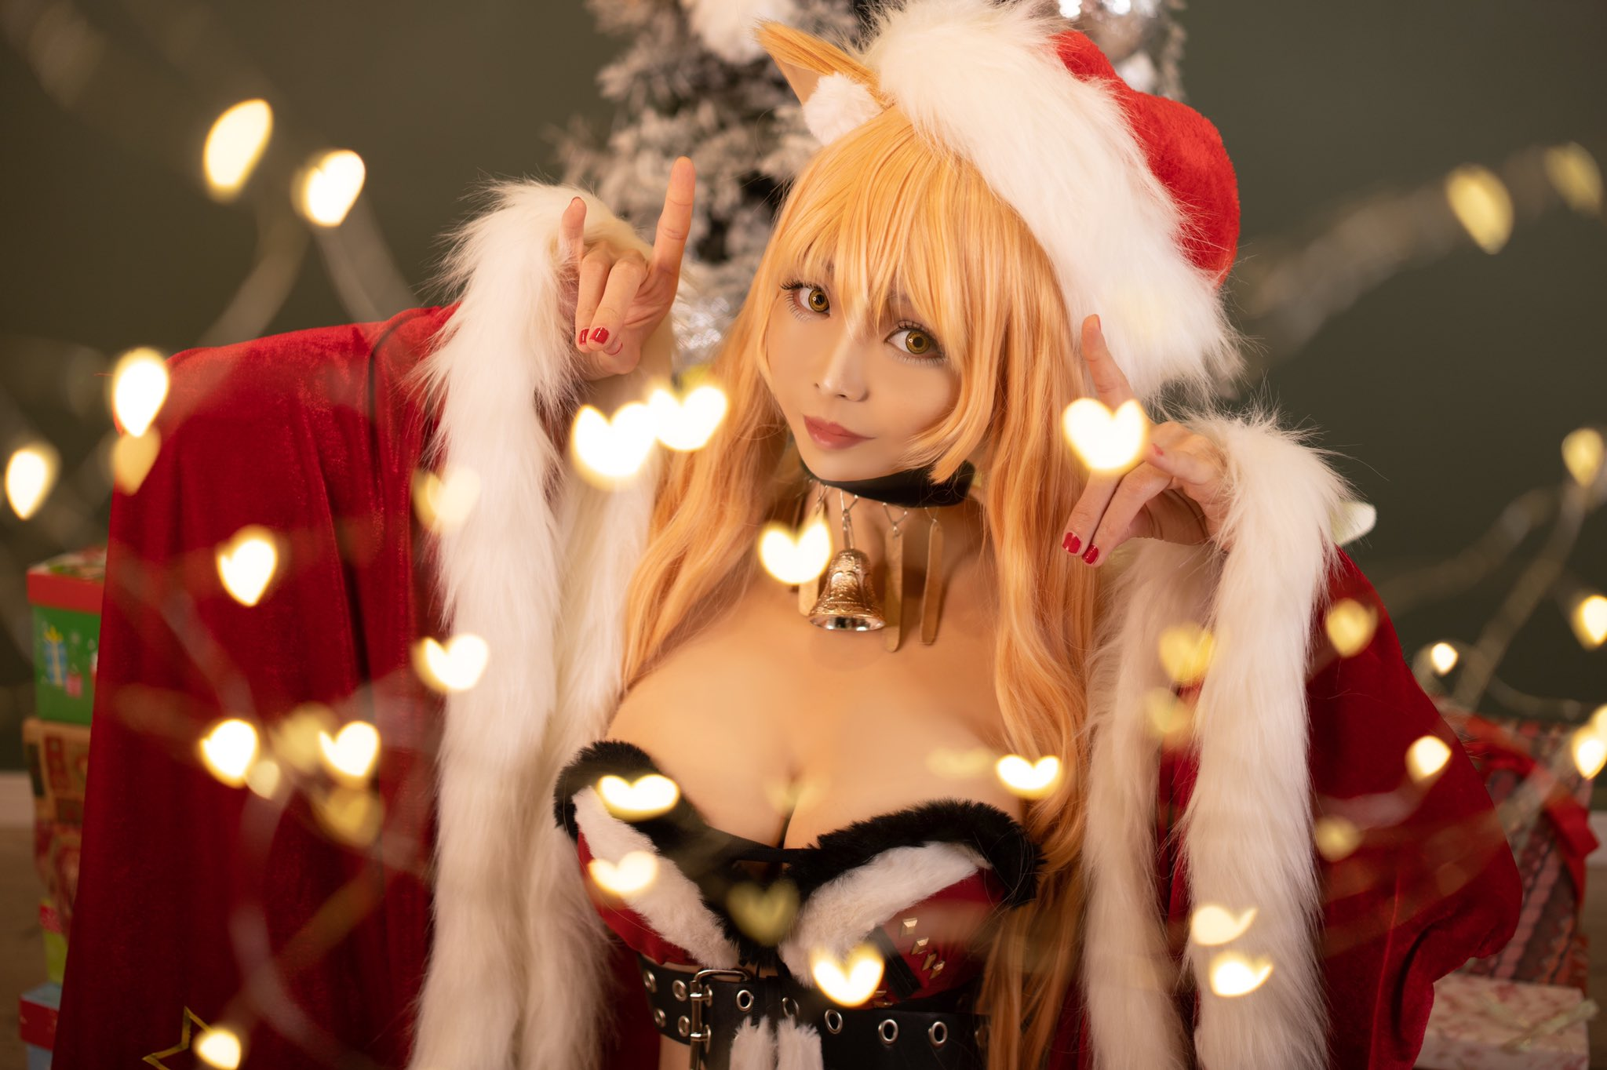

IMAGE SOURCE

