MAN THINGS BE DAMNED
COMMISSION STORY
BY CHALDEACHANGE
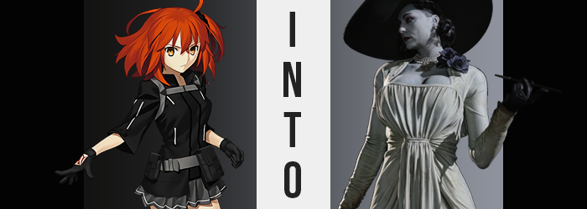

Every Friday, the Servants of Chaldea held a game night.

Whether it was board games, video games, or something else, they typically broke themselves up into groups for a little rest, relaxation, and bonding time with one another. It had been the Master, Ritsuka’s idea originally, looking for different ways to spend time with her Servants – while giving them all opportunities to interact with each other outside of combat and bumping into one another randomly at the cafeteria.

There were still complications, of course. Game Night had become such a popular affair, and over the years Chaldea had grown its number of Servants so significantly that the groups were in the tens, with anywhere from three to ten Servants in every group. Each of them hoped that Ritsuka would visit their group every Friday, but it had more or less become impossible for the girl to do just that.

And so, a schedule had been born! One that allowed a fair rotation where she spent every Friday with a different group. And in that night? The Friday night before Halloween? She would be joining the Walküre trio consisting of Ortlinde, Hildr, and Thrud for what they referred to as a ‘Spooky Gaming Session’ showcasing a number of scary games over the four-hour period.

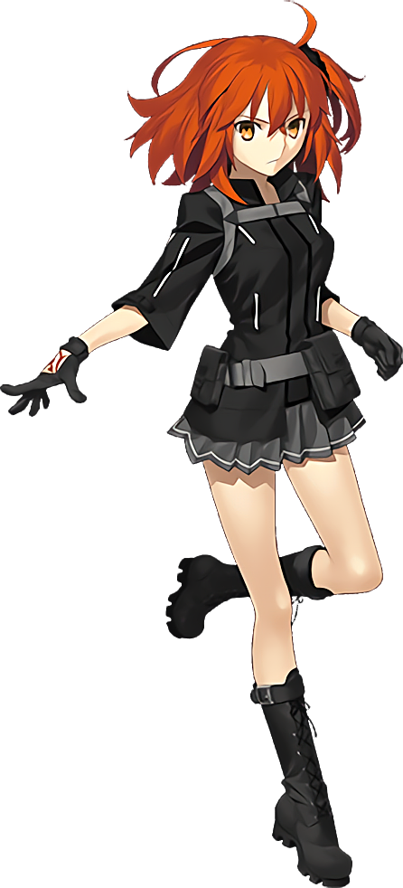
Two hours had already passed, and after playing Alan Wake they had been prepared to switch to another game, Resident Evil: Village. But it was the perfect time for a break, and so Ritsuka slipped out to both use the bathroom (something Servants never had to do) and grab some snacks for the group (after washing her hands). It wasn’t a trip that had taken her overly long, and ten minutes later she had returned with arms full of potato drinks and sodas.

The moment she stepped into the recreation room the group had been using, though, all of that ended up on the floor. Instead of the three Valkyries she had left there, in their stead were three young women dressed in black hoods with bloodstains around their mouths and unusual markings scrawled upon their foreheads. The scent of blood in the room was potent, but there were no bodies thankfully. Still, all three sets of eyes immediately fixated on her, and Ritsuka was certain she was about to be killed.

“MOTHER!” Instead, all three of the women cried out in unison (and was she crazy, or had she heard the buzzing of insects a moment in the process?) and lunged for the Master, arms outstretched before they landed atop her, sending the girl tumbling back to the floor beneath their combined weight. Had they just referred to her as ‘mother’!?

With such a close proximity it was even clearer that something wasn’t right with these three. The scent of blood was far more potent, and the light of the television was flickering strangely in the back. “Get… off of me! I’m not your mother! Where are the— OW!?”

“Hehehe… It’s okay, mother! You’ll remember in a moment. Just let us give you a moment while you get… changed.” Of the three women mounting her, the blonde whispered this into her ear and withdrew with the brunette, while the ginger had bitten into the side of her neck. It had certainly been painful, but with warm blood flowing from this wound she could feel the stranger lick it before withdrawing, all three of them retreating into the hallways while the girl laid on the floor in shock a moment.

Ritsuka didn’t even realize that her wound had already healed.

Despite how stunned she was, an uncomfortable throbbing throughout her body provoked the Master into climbing back up and onto her feet again. Her posture was wobbly, and she could hardly croak a single word out. The word she did manage to state was strangely fitting. “…What?” It was a strange phenomenon, like being devoid of energy but overflowing with too much energy at the exact same time. It was certainly difficult for the Master to make heads or tails of.

“Ack! COUGH, COUGH!” An uncomfortably dryness had beset her mouth and throat suddenly, forcing the young woman to cough wildly. She’d just been bitten on the neck, so she couldn’t fathom that any throat-related injuries weren’t related to it, but that reminded her. Where had the pain from that injury gone? A hand immediately went up to pap it, and while when her fingers returned they were very much covered in her blood, she hadn’t felt any pain nor touched any notable injury.

The scent of the blood on her fingers, though? There was just something about it. The concentration of iron? The color? She couldn’t take her eyes off of it, much less her mind. Until, dazed, she slid a blood-soaked finger into her mouth and pulled the blood right off of it with her lips and tongue, allowing the liquid to roll down the back of her throat with an elated expression upon her features. It wasn’t until the swallow had settled and she had removed the finger that the horror of what she just did struck her.

The dryness in her mouth was gone, and yet… “Did I… Did I just swallow my own blood!? Why was it so… so…” Tempting? Delicious? Both adjectives, unfortunately, were extremely applicable.

Ritsuka stumbled back, unable to force her hand back down to her side because the other fingers still had blood on them, and she just couldn’t look away. This fixation served as an ample distraction to keep her attention away from what was happening to her body. She had already grown an inch or two, and there were indications that her figure was slightly fuller than it had been before. But the cause wasn’t exactly what you might expect.

The telltale signs, because she was fully clothed aside from her gloves, were in the skin that was readily visible. While she was staring at blood-soaked fingers, for example, she did not notice her skin drying and cracking, nor that her fingertips shriveled and cracked. When it came to her slightly bloated proportion like her breast, if not for her bra or panties both her tits and ass would have sagged ever so slightly. And yet the greatest tell? The skin upon Ritsuka’s face appeared to sag and deform in slight, with crow’s feet appearing in the corners of her eyes and heavy dimples around her face.

She was growing older. Significantly so.

Forty? Fifty? Either way, she had aged up without losing any bit of herself in her appearance thus far. The moment she stopped being able to resist dipping another finger into her mouth to suck the crimson from it however, that all changed. The color of Ritsuka’s hair was the earliest offender, darkening to black while the hair itself grew thinner, flatter, and just the slightest bit longer. That thinness could not be understated though, for it was a clear sign as her new age.

As was the color of her skin… kind of. Slightly loose thanks to her newfound maturity, the color of it all paled. And grew paler. Until it turned to a ghoulish white. It didn’t simply afflict the skin of her face, or her breasts, or her arms – it was a consistent and unfortunate whitening that affected key areas of her body just the slightest bit differently. Her lips, nipples, pussy, and nails all blackened. In a strange way she almost looked like a character from a noire movie given life.

The taste of blood was rolled around in her mouth with a succulent slurping sound as she withdrew her finger once more, drool rolling down her chin in part because of her careless thirst, and in part because, well, her lips weren’t exactly the same size they had been when the finger had first been inserted. Already black, their surface area expanded due to her lips themselves plumping up. It was merely a small piece of an overall change in her facial structure.

And that change was quick to rob her of Japanese heritage. The almond shapes of her eye softened, narrow corners rounding until she appeared downright European, irises darkening from gold to grey and lashes thinning just as her eyebrows did. The overall weight of her face appeared to distribute itself better, for her cheekbones became better defined and her jaw slid down slightly to give it all a longer but fuller appearance. It was all brought together by her nose, which both shortened and spread its nostrils wider.

If anyone were to walk in at that moment, they certainly wouldn’t recognize the forty-four-year-old woman standing there as Ritsuka Fujimaru. Not only was she clearly a much older individual, but nothing about her screamed native Japanese. “Oh, I feel so…” The woman didn’t even finish her sentence before depositing the third of her four bloody fingers into her mouth, her slurping now much more violent than it had been before.

What was it about the essence of blood that made her want, nay, need it? It smelled so tempting, it tasted so flavorful, and it was such a beautiful color. Ritsuka’s mind was falling farther into the depravity, oblivious to the fact that she craved it because of a new personality running through hers that demanded it. Signs began to show though, because on some level she understood the reason. She needed to consume blood to preserve her ‘youth’.

With a fresh batch of crimson swallowed, it was Ritsuka’s MILF-like figure that began to change this time. Clearly the blood was the trigger, ultimately, and the fingers she had just licked – and was continuing to lick – clean was the most blood-soaked of the four.

A great deal of tension built throughout the entirety of the woman’s body. Whether it was around her hips, her chest, or even the general vertical fit; all of her clothes began to clamp around her figure uncomfortably… or at least that’s how it seemed at first. “Mm~” The woman herself? That pain stimulated her some, possibly a masochistic kink, but the cause? It wasn’t her clothing tightening around her body, but her body overfilling her clothing.

Her jacket was lifted high off of where it rested on her hips thanks to her torso lengthening, belly exposed to revealed that it was slightly overweight in its whiteness thanks to her increased age. Ritsuka’s sleeves were likewise pulled up far past her elbows, and her skirt lifted to reveal far too much of her thighs. Overall, her change in height was utterly, implausibly dramatic. Because her height peaked at an unbelievable 9’6”.

But the woman in question? The one that had experienced that growth and continued to experience further growth of a different kind? She not only paid it little attention, but she was still licking particles of blood from beneath the nail of the finger she’d shoved gluttonously into her mouth.

RIIIIIIIIIIIIP!

Not even the splitting of her undergarments and the snapping of her skirt’s waistband was enough to sway her from her fervor, even though the cause was something as dramatic as it was. Ritsuka’s hips had swung wide with a great deal of gravitas, ultimately rendering her naked from these swollen hips down in a way that revealed how her aged ass and thighs sagged ever so slightly, along with the black bush above her pussy.

“Mmh…” The next sound she made was one that implied a moment of ecstasy, for her thighs rubbed together with a seemingly unprompted bout of sensuality that saw loose skin tighten around contents that swelled wider than her own head was. Beauty marks and blemishes, all newly formed, were tugged snugly around the fat that saw her upper legs ripple in all of their height, and the excess eventually made its way into the vampiric MILF’s ass.

Her already wide hips were stretched even wider by the mass that composed her rear, cheeks growing perkier from their sadder, gravity-worn selves as the weight piled in with reckless abandon. The canyon that was her ass crack became incredibly deep, and before long her ass was so immense that there was no way she could sit properly in a normal chair without risking it grinding up between her cheeks.

The woman removed the third finger from her mouth and stared at the fourth, extending and retracting the black nail upon it without thinking anything about how strange that was – all while her bosom began to heave. The straps of her jacket didn’t simply come undone, but instead snapped entirely so that her gray tits would spill out in all of their progressively veiny glory, nipples inevitably extended to sizes that were larger than her eyes.

While the size of her bosom did not rival the immaculate shape and size of her ass, once they busted through her undershirt and forced her snapped bra out the front so that it fell to the ground, they were much perkier than they had been before. Each breast was just as large as her head, and they retained their shapes thanks to the same process that her big old butt did.

By consuming the flesh and blood of humans. There was something deep within her that granted the woman an eternity so long as she continued to do this.

She handily sucked away the blood on the fourth finger, but her body? Tall and full-figured, her transformation was complete. What instead happened as the blood was consumed was an alteration to her outfit. Scraps of black and gray that were both plastered to her new figure and gathered on the ground began to crawl up and across the woman’s thicc body, bending together while the material lightened to white. When all was said and done, she was wearing a form-fitting white gown, black leather gloves, white heels, and a gray sunhat.

Her hair was done up into two small buns, and two black roses in a corsage sat next to several pearl necklaces around her neck. Most surprisingly though, with her cleavage fully exposed and the definition of her huge ass more than obvious through the tight fit of her dress, it was clear that the woman was not wearing underwear.

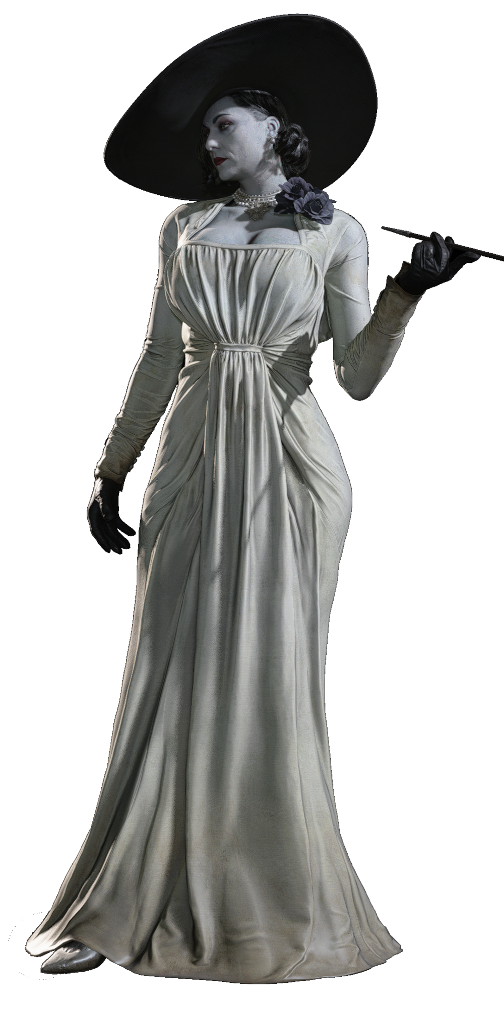
“Hm. Not terribly well suited for my figure, this ‘Chaldea’.” With the towering height of Alcina Dimitrescu, she hardly had a choice but to lean slightly forward within the confines of the recreation room, her amply sized hat brushing up against the ceiling. Mentally, it could be said that a tiny fragment of Ritsuka’s original self managed to persist, but tragically it was only enough for her to look on in horror as her thicc, milf body sauntered about with a craving for blood on the tip of her tongue.

Dimitrescu leaned forward so that she might slide through the door, slamming it open with ease and straightening properly once she found herself in the hallway. “Ah, much better! And even my dear daughters are here, I see.” Not only was the ceiling in the hall high enough for her to stand up straight, but the three women from before – women that she now recognized as her ‘children’ – had been standing against a nearby wall. They were quick to rush the tall woman, embracing her generous figure and calling her by her title.

Being called ‘mother’ now filled her with some degree of pride. But the scent of the blood that came off of them? It merely served to amplify her hunger pangs. “Now, now you three. Mother is hungry, and I’m sure you all are as well, are you not?” She had hardly noticed the trio of red marks on the back of her right hand, but perhaps that was for the best. “Go and find me something to eat. You can have any man things, but if there are any women…” She wanted those.

“Yes, mother!” The trio replied enthusiastically with their own bouts of personality before dispersing into swarms of insects that disappeared into nearby cracks and vents. Just when Dimitrescu believed she might have to exercise some patience to feed though, a voice called out from behind.

A sweet voice, belonging to a pretty, young girl. “Who are you!?” It was Mashu Kyrielight, woefully unprepared for the danger she now faced. For Dimitrescu’s ample body began to saunter towards her, long claws erupting from her fingertips. She looked tasty.

“Lady Dimitrescu, my dear. And I do believe… You’re just in time for dinner!”

