Bonding Time

A Short Story

By Maryanne Peters

Illustrated by Al

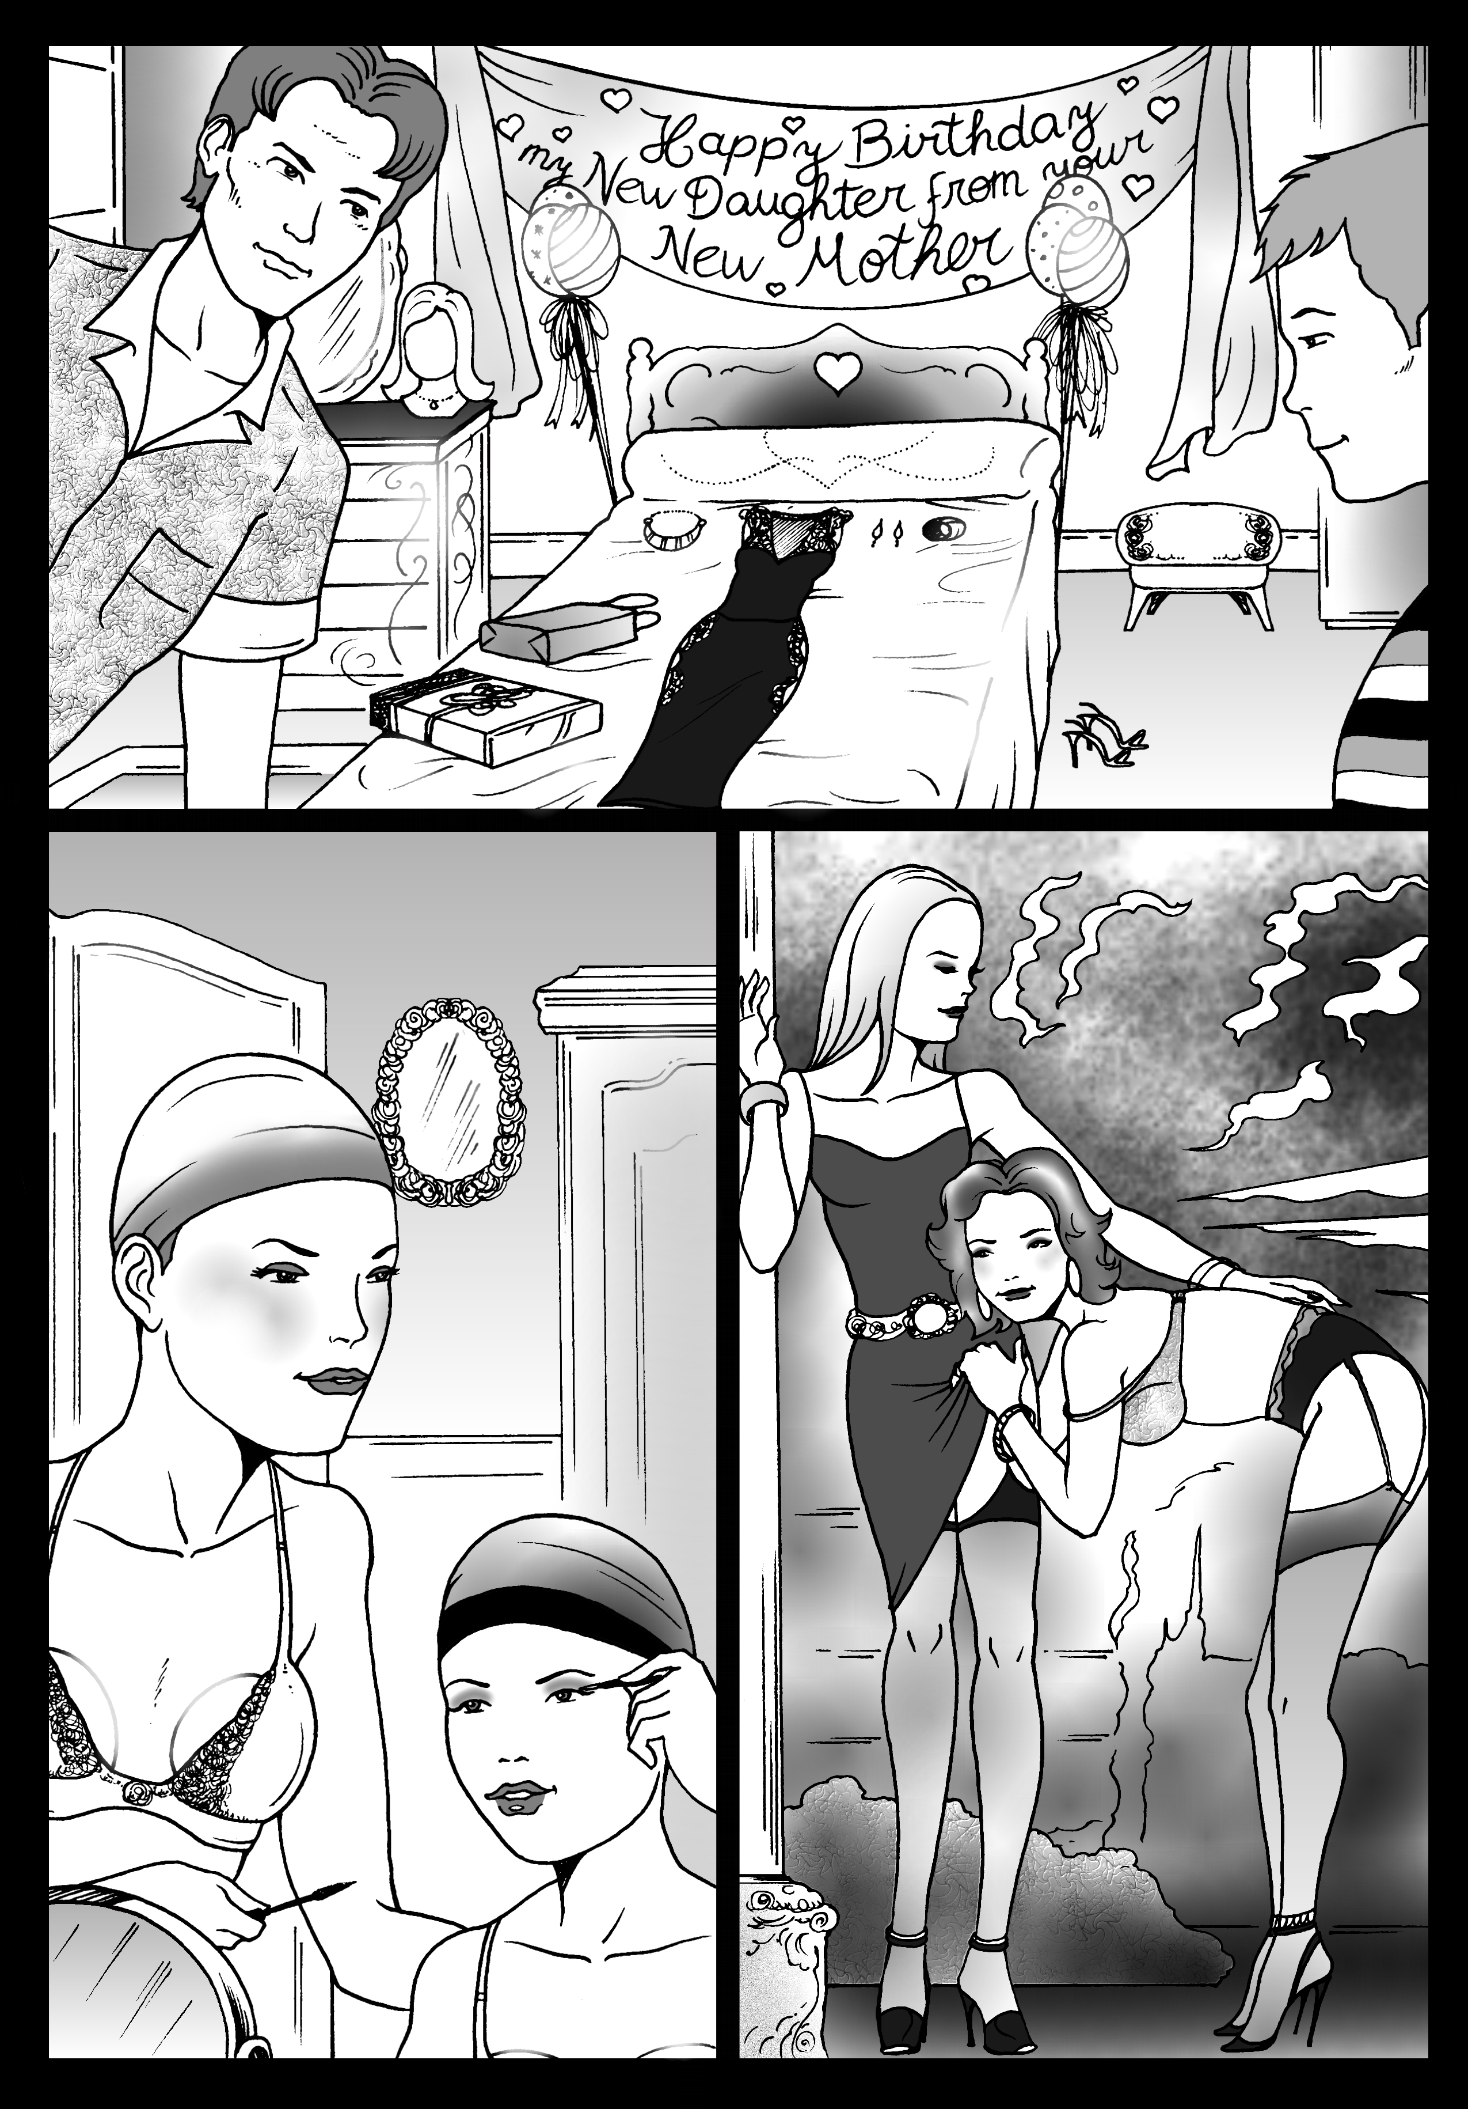

To think that I once loved that woman. How could somebody be so cruel? It is not as if she doesn’t understand. I did.

“Your son is just like you,” she said. “Not a real man at all. Even worse, he doesn’t even want to be a man. I am sending him across to you. He can spend his birthday with you well away from all of his perverted friends. Perhaps you can straighten him out. Perhaps you can show him how he can repress these weird thoughts of his.”

We had been separated for years and were time zones apart. Sure, I visit Chris when I could, and we stayed in touch by email, chat and telephone. I knew something of his problems. They were different from mine. There is a huge gulf between cross-dressing and gender dysphoria. “Straighten him out”? I don’t think so.

My circumstances had improved at the time. I had just bought the business where I had worked for years. I was free to be who I wanted to be, but who was that?

Being Hannah was just something I did to relieve the stresses of everyday life, but now there was less stress, why did I still feel the need to be her? Was I so different from Chris?

I decided that I would give him his birthday present the moment that he arrived. I redecorated his room and I laid out the gifts on the new pink bedspread. Instead of a card I put up a banner over the bed: “Happy Birthday my new Daughter from your New Mother”.

Chris was a little suspicious at first. He said: “Dad, what are you thinking?”

“It’s not Dad anymore,” I explained. “Call me Mom, or Hannah if you like. That I who I will be while you stay with me. And you can be Christine.”

“I prefer Crystal,” she said in a voice that I hardly recognized. “And Mom is Mom, so do you mind if I call you Hannah?”

“Not at all,” I replied in my femme voice. “But we both need to get changed first.”

“The black dress is beautiful,” Crystal said. “But it is not what I would wear around the house.”

“Quite so,” I said. “That is laid out because tonight we are going out.”

Her eyes were as wide as saucers. She said: “Really! Oh my! Thank you Dad … I mean Hannah. This is going to be great.”

|  |  |
| --- | --- |
| “Let’s make sure it is,” I said. “Now lets shave down and glue on our breasts, and get started on our makeup.  It is so much easier getting ready when there are tow of you. You have somebody to get to those hard to get spots, and somebody to check you out all over.  “But I can’t pluck your eyebrows,” said Crystal. “You have to go to work tomorrow?”  “Forget about that,” I said. “Tonight I want to be pretty so that I don’t embarrass you. I own the company now. I don’t care what they think. I want to go out with my daughter tonight.”  We hugged. I don’t think that a parent and child can be any closer than we were that night.  Crystal showed some real skills, all from avidly watching beauty tutorials on the web.  “I just haven’t had much chance to actually do it until now,” she said.  It was the same for me. I had years of experience but had never really had the chance to go all out. This was going to be a first for me too. We were both very excited. |  |

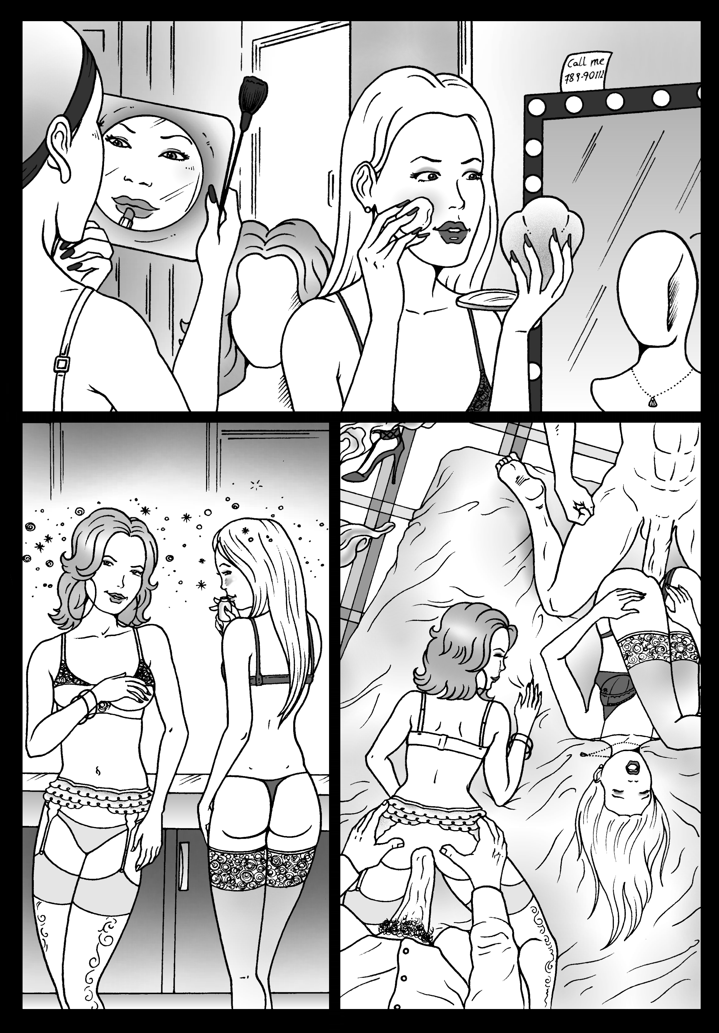

Crystal put on her blonde wig and added the finishing touches. I did my lips and put on my auburn wig.

|  |  |
| --- | --- |
|  | “I just need to check back here,” I explained. “There is one last little accessory for both of us, just in case.”  “Ooh,” she gasped. “You have put something in my butthole?”  “I am not encouraging promiscuity, my darling,” I told her. “It is just that I do not want to see my precious daughter getting hurt if things get hot.”  “What about you?” she asked, wiggling her butt to get used to the liberally lubricated plug I had just inserted.  “I am not that way,” I said, checking my earrings in the mirror.  “Tonight, you are,” she insisted. “We are both in this together, tonight – right?”  I had more than one, but they were only for her. Now I was trapped.  “Ok,” I said.  “I’ll put it in for you,” she said. “There you are.” |

It felt strange, but not unpleasant. It seemed to affect the way I walked, but then I was wearing stiletto heels. So was she.

We called a cab and went to “Loofah”, a trendy bar that was known to be frequented by ladies of all types. We trotted in arm and arm. Two luscious ladies – mother and daughter although you would not have guessed it. Thanks to quality makeup I must have looked 10 years younger, and thanks mainly to Crystal’s new-found confidence she could clearly have been 10 years older.

“We’re cousins,” I explained to the first two guys to buy us drinks. “With a slight age difference.”

“You must be the two most beautiful women in the room,” one of them said. But the way he said women, he must have known, or guessed, that we were not quite that.

“Run with it,” I said to Crystal. “Hormones will change everything in time. For now just be as female as you can be.

“Thank you, Hannah,” she said with a trace of tear in her eye. “This is the best birthday ever.”

But it got even better when Joe and Dave turned up.

The other guys had moved on, looking for something nowhere near as fabulous as us but anatomically correct. Joe would be in his thirties and Dave in his twenties – two engineers in town on business and staying in the hotel next door.

It was clear to both Crystal and I that both of them had no idea that we were not complete women. Somehow that seemed to make all our effort complete. After buying us a drink they offered to take us to dinner in the restaurant attached to their hotel.

“It’s on our accommodation budget,” said Joe. “Entertaining suppliers.”

“What are we expected to supply?” I said flirtatiously. Crystal giggled.

We talked, just as two girls talk to two guys. Somehow it just seemed so natural. It was not a performance. It was as if I had found another person deep inside me and she was doing the talking. I began to wonder if the male me was the performance, as if I had been playing a role all my life.

Crystal was clearly loving it. Dave put his arm around her and I could see her body respond to him. This was what she wanted. She was a woman in the embrace of a man. She smiled at me knowing that I understood. It was a wonderful moment. It was my gift to her. I grinned back across the table.

“I don’t want you to think that I am this kind of guy,” Joe began. “But we have a suite upstairs and …”

“I think that you guys should know that we are not everything we seem to be.” I needed to say it. These guys were nice. “We are women, but pre-op transwomen, if you know what that is?”

They looked at one another. It was a look of puzzlement rather than horror.

“You’re kidding right? You could just say no.” Joe stared at me. It seemed to me that there was a glint in his eye – like “a moment”. He was pleading me to take it back.

“I don’t want to say no,” the voice coming out of my mouth said. “I want to say yes. I want you to say yes. I don’t want to lie to you.”

“I can’t believe it. You’re so beautiful,” Joe said.

“You too?” said Dave, taking his arm away from Crystal and looking at her.

This was reality for my new daughter. The world can be hard for a girl like her. How would she handle this? Was she ready for this?

Her eyes were moist but the tears were not flowing. She looked him squarely in the face and she said: “Thanks Dave. Thank you for tonight.”

And she leaned across and kissed him tenderly on the lips.

And instead of pushing her away his hand went behind her head into those blonde locks and he pulled her head towards him and they kissed as if possessed.

I looked at Joe, and he said to me: “Let’s go upstairs then.

|  |  |
| --- | --- |
| We went into the bathroom of their suite together.  “Are you sure about this?” I asked Crystal.  “If you are with me, I am sure,” she said.  “I wanted you to experience womanhood as your birthday present, and I guess that can include to have a man do what a man does to a woman, but as for me … I have loved tonight, but I am not really into guys.”  “You could have fooled me,” she said. “But maybe we should go? It’s just that they do seem really nice. Dave has been so understanding. I real feel that he will be gentle with me. If I am going to lose my virginity to a guy, I want it to be somebody like him – one night stand or not.”  My daughter stood before me, in her sexy underwear just like me. I could not let her step into the room alone. I needed to be with her through this.  “Ok,” I said. “Lets do it. Remember, these guys are not gay so we just let them pull the thong to one side so they don’t see our junk.” |  |

|  |  |
| --- | --- |
|  | There was some slow dancing in the half light and some kissing and cuddling first. I don’t want to give the impression that they were immediately on us with their cocks buried deep inside us, but when you turn on a guy that hard, you can’t expect him to wait around. And our guys were rock hard.  It was the first time either of us had been entered by a man. For Crystal it simply confirmed who she thought she was, but for me it changed everything. At last I understood who I was. I am just like her – a woman on the inside, with a man inside me.  The End  © (text only) Maryanne Peters 2020 |