HONKAI STAR RAIL: TROPE CITY
CH3: CHILDISH WHIMSY
BY CHALDEACHANGE
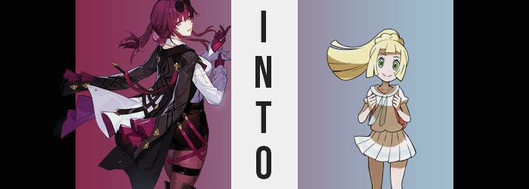

“Hm? Odd. She hasn’t left yet?”

Sitting in the control room of the Stellaron Hunters’ (current) spaceship, Kafka hadn’t actually been slacking. After leaving Blade’s side with the expectation that he would soon return, she’d followed Elio’s summons to speak with him about her next mission. One that was different from the one that Silver Wolf had been assigned and yet one that wasn’t exactly unconnected, either.

She had been sorting through the documents with very little urgency. There wasn’t much urgency because her orders involved setting out the next day. Silver Wolf’s mission was different. She should have left by now and yet there were no signs of the shuttle she was supposed to take having left. “Nor is she replying to my messages… I suppose I better check on her.”

This wasn’t really that unusual. Wolfie was only a teen after all, and at times teens required patience. While in harmless ways the girl had a tendency to rebel. Leaving late? This wasn’t the first time; whether intentional or not. There had been instances in the past when Silver Wolf had fallen asleep and had slept through her alarm, but there had also been moments when she’d been so caught up in a game that she’d forgotten. Kafka assumed it was one of these two things.

“I don’t think I’ll ever understand what it’s like to be so young…” Or so she mused as she went to exit the control room to check Silver Wolf’s quarters. She didn’t make it that far though. Not before a flash of light shone from her shorts pocket. From her phone. And then she was just gone. Like the girl she had gone to check on.

“Hm? What in the world?” And the world had changed. It was like it had shifted around her, and now she found herself standing upon a sandy beach overlooking the ocean, a setting sun basking the world in orange. There were no boats on the water, and turning her back to the sea revealed what looked like a resort off in the distance beyond… Well, that was a strange creature she had just seen? A very cartoonish crab. And a moving plant in the distance? “Monsters?” But they didn’t seem to be especially interested in her.

She supposed that making her way to the resort should have been her first plan of action, but… “My weapons are gone?” Even despite the fact that the rest of her outfit was intact. But this wasn’t the sort of world where guns and blades were used. They would have disturbed the peace if anyone had seen her. Well, at least if they saw her before the fate she was now destined to fall victim to. Unintentionally and courtesy of Silver Wolf, of course.

“I suppose if I need help I could check in at the Pokémon Center.” Which was a remark the woman speaking it didn’t even think to question, even though she definitely should have. Kafka shouldn’t have known what a Pokémon Center was, much less a Pokémon. Yet she had spoken of the location as if she was incredibly familiar with it. Which, naturally, she should not have been.

And yet there was plenty afoot at that time that shouldn’t have been. Taking a quick look at Kafka’s silhouette from the side. It was from that angle that you could best see the curvature of her body, right? And Kafka was a woman who certainly had a fair amount of curvature. She was quite abundant in it, in fact, despite not being someone from the Path of Abundance (to be fair there was no correlation between one’s path and their body anyways).

The issue was that this abundance was growing, well, less abundant. Kafka had only taken a few steps away from the water, yet that was enough for her side silhouette to thin in more ways than one. Tragically the curvature of her breasts was among them, and the mounds that pushed forward her button-up shirt had been shrinking, leaving the cloth that had tightly fit them to sag loosely. Before long the only shape to her bust wasn’t her breasts whatsoever. They had shrunk until they were practically nonexistent, and what remained was just the wiring of her bra against her chest.

Just as tragically was what occurred to the lower half of her silhouette, and yet there was no wiring down there to preserve the fit of her clothing in the first place. Her ass flattening was a fairly efficient sampling of what was occurring. It pressed in on itself, shape diminishing in roundness until both cheeks were barely a couple of inches off her back – which meant her shorts were much looser, and this wasn’t helped with her hips pressing closer in tandem.

But it was actually even more noticeable in the woman’s thighs. Her purple tights always did a great job of highlighting just how thick everything was above her knees. They were plush and tender, skin always pulled as tautly around them as her tights were – and the band around her right thigh pressing into it only dialed how hot they were up to 11. And yet? No more. Seemingly all of the weight bled from them until she was dry. There was no mature definition to her body at all, with the only indications being her height and face. Yet…

“Eh?” Kafka’s voice cracked and she gave a tilt of her head. Something seemed odd. Odd enough to stop herself just a few steps away from the edge of the beach. She couldn’t quite place what was wrong. Was she dizzy? It did feel a little akin to that but simultaneously not quite? The force transforming her had sealed her ability to acknowledge it, but it was visually extremely obvious.

Her tights bunched up, her boots began to press up into her pelvis, and her shirt untucked and began to hang off her like a dress. But her gloves also slid off her while feet slipped within boots that was gradually too big for her. By the time her sleeves had slurped up her hands, it was clear enough. Kafka had been shrinking and continued to shrink. As a rather tall woman, dropping down to around 4’10” was a pretty substantial dip.

It was impossible to progress with all of that cloth weighing her down. “H-Huh!? Why am I so heavy!?” She squeaked with a voice that was now permanently high and soft simultaneously. The tinier woman sounded much younger than she had been, yet it was pretty clear that this was physically the case too. Her face bore a newfound youthfulness to it. At first reminiscent of her older appearance, but with time her identity seemed to seep from what remained.

Kafka’s purple-pink eyes began to shine with an emerald green and her irises darkened to the usual black, but the shapes of those eyes slowly inched so that they were move ovular in shape rather than circular – vertically, at least. Her chin rounded and thinned lips soon thinned further. She definitely looked like a girl around eleven or twelve, but more than that she just didn’t look like Kafka.

The child struggled with the clothing that was still peeling off of her. “I… is it my clothes? What am I supposed to be wearing?” Why couldn’t she remember? Was it this outfit? But it was way too big for her, right? And the darker colors didn’t really suit her. This became truer once the changes finally came for the last part of her previous appearance: her hair.

Dark purple strands lightened to blonde from the roots, sweeping all of the way to the tips with time. The length changed a little and did grow a couple of inches longer. More than that, though? Her blonde hair thickened and fanned out, bangs framing her face with a chopping cut. But all of her hair had very straight-cut tips. Nothing about her appearance then suited the clothes she was wearing.

But with a blink any clothing woes she had were erased and replaced. With clothes as white and pure as her mind had become while she’d changed. A white, short-sleeved uniform top and a matching pleated skirt made up most of it, with both garments having a light blue accent in her tie or in a stripe around the skirt. Matching socks and loafers complimented this ensemble, and a pink backpack full of Pokéballs hung from her shoulders. Even her hair was styled differently, pulled up into a very high ponytail.
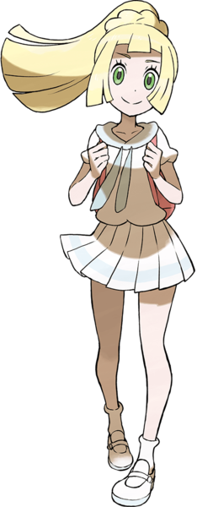
“Oh, it’s such a lovely evening! The ocean breeze is so nice!” Lillie had long since given up on returning to the resort town of Pasio and was now staring out at the sea once more. She could seldom believe the circumstances that had brought her to the island. A trainer of both Alola and Kanto, after everything her family had been through it was nice to have a chance to experience peace and relaxation. Even if villains did sometimes cause problems on purpose.

But the blonde-haired girl believed in the goodness of the hearts of others. If anything bad ever happened then she just knew the good trainers of the island would work together to prevent it. Herself included, of course. This was a very stark departure from once being a woman who was suspicious of everyone and everything – not that she could even remember a smidgen of her time of being such a suspicious person.

Giving a little stretch of her arm, the girl continued down the beach by her lonesome. “Once I get back I should recommend the view to mother and Gladio. Maybe I can get them both to come with me next time!” Or perhaps the special someone she had a cute little crush on! Just the cute little crush of a child, though.

Maybe Kafka shouldn’t have commented on not understanding children.

