*Maid(en) At Heart*

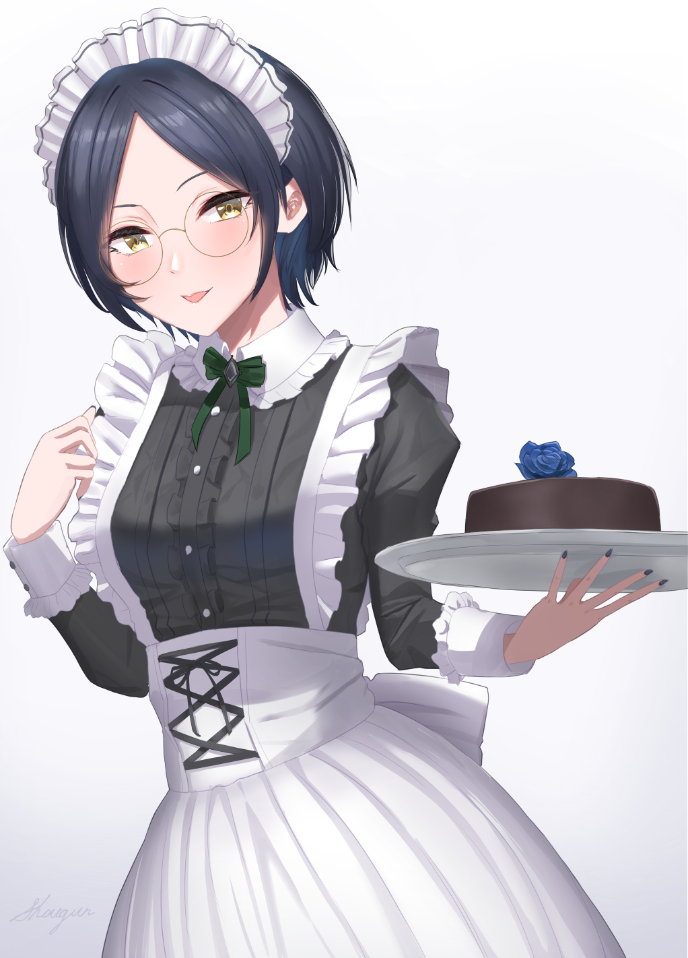

**“Wakey wakey Young Master….rise and shine~ It’s time for breakfast~”**

Groaning with the bright rays of the early morning sun searing him right in the face, a man with a neatly trimmed head of blonde hair tosses the sheets off of him before leaning up against the headdress with a weary look of disbelief on his face at the sight of a prim and proper maid sticking her tongue out at him with a teasing look.

But the man's attention was focused on the ticking clock on the wall rather than the pretty face in front of him, slumping back into bed upon realizing the sun had barely risen beyond the horizon to even shine through the veiled window…because it was still well past the dead of night when everyone besides the guards should be sleeping.

Which only made the man more frustrated after realizing the beam of supposed sunlight turned out to be the warm orange rays from the newly lit fireplace reflecting off the shiny metal tray held precariously in the maids dainty fingers, balancing what looked to be a frosted chocolate cake with an artificial blue rose in the middle.

As expected of all maids serving in households often under the strict supervision of their royalbred masters, the man's worries weren't warranted in the first place as she began to spin on her heels, expertly passing the tray from one hand to the other before laying it down on the table he used specifically for work in a display of her skill. Bowing curtly with a slim smile on her face, showing no signs of fatigue despite the wee hour of the night she had decided to intrude upon her master's privacy and rest. Everything from doing the laundry, cooking and even physical training was something a high class maid was expected to hone to their utmost in an effort to ensure they were as refined and elegant as the people they served. A quota enforced by a head maid that was in charge of coordinating their efforts and assessing the individuals under her.

But if it wasn't obvious enough from the way she had spoken to the man in such an informal manner unbefitting of a Master-Servant relationship and the rude awakening she had subjected him to without reprimand, she was no ordinary maid.

And he wasn't just her Master either.

**"Wh…What're you even doing here so late in the night Rickard? And…cake? Is something wrong? Did someone track you down?! Figure out your actual identity?"**

Chuckling with that serene voice of hers filling his ears, the oddly masculine named maid shakes her head to the negative, tucking a strand of raven blue hair behind her ears before taking off her glasses to wipe them down.

**"It's nothing like that Young Master…and please, call me Reena…it's better this way."**

Growing a little concerned, the blonde haired man bites his lower lip in frustration as he gazed upon the serene visage of his servant wiping down her glasses with her back arched straight and proper, a nubile young body wrapped in suffocating clothes that no doubt cinched and bit away at her skin with each movement. Thinking back to just a few months ago when the maid standing before him was just a simple nobleman and a dear friend.

*'How had it all come to this…'*

Deralius Alphonso, eldest son of the the Deralius family and the next in line to inherit the title as head of the household, had lived a life of normalcy as expected of one born into nobloehood; tutored in fine arts, trained in swordsmanship and thought to be an excellent scholar. Alphonso had all the traits his father had wanted of a worthy successor, appointing him the new head just before his passing to rejoin his wife in the next life.

But what many didn't know, was that the Deralius family was just one of many participants in a long running feud to topple the head of the snake that was the nation they lived in after decades of corruption and political deceit, all in an effort to fatten their pockets while ignoring the suffering of their own people. That and the fact that the Deralius family were also skilled mages, one of the rare few that could utilize the arcane arte's of magic. With Alphonso being tutored on spells ranging from novice level to highly advanced ones that included teleportation to transfiguration spells.

The fight against the royal family however, was led by the Zacharia royal family with a strong connection to the Deralius'. A connection that would prove indispensable in the forming of a strong bond between the two families' sons, with Alphonso meeting Zacharia Rikard one day while training in the fields just outside the family manor during a business meeting.

After being challenged to a duel that ended with a draw, the two would soon become fast friends, bonding over the strenuous life of being the child of a noble and the back breaking expectations placed on them as the next in line for their respective families.

But they also spoke a lot about what they could do if they weren't bogged down by such burdens; living the life of an adventurer slaying monsters out in the broad open world? Or maybe working the simple life of a farmer would've been more fun and peaceful than it sounded? The boys grew fond of moments such as these with not a care in the world to worry about.

With the years passing by and the friends growing mature with some level of insight however, they knew the importance of upholding their respective families missions. With Alphonso inheriting the family wine business while Rikard went on to take his place alongside his father in their mission to fight back against the state. But life as a mere rebel against all odds would soon lead to failure.

And a devastating failure it was when a knock against the Deralius estate doors one night would lead to Alphonso finding Rikard beaten and barely hanging in to life right outside the door when he'd left just a few hours ago healthy and strong…and accompanied by a crew that was led by his father…

It didn't take long for Alphonso to put the pieces together after ushering Rickard safely into his home; if his friend was alone and he came here instead of going back home, then that meant the mission was a failure and whoever they had tried to mess with knew enough to place the blame on the Zacharia's.

Which meant the rest of his family…all the servants, were probably dead.

Left with no other choice and with the knights probably headed here right now after the high chance of suspecting Alphonso's involvement, Rikard was not suspecting his friend to begin casting a transfiguration spell right then and there. Wrapping him up in a cocoon of light that was already beginning to alter his very being; removing the muscle that had been carefully grown after years of training while dropping Rikard’s height a head or two lower than Alphonso with the peculiar sight of his gaunt, blocky frame giving way to a mellow, petite body coated in unblemished skin as pale as the moon in the skies above. Keeping the spell powered despite the look on his friend's face that seemed to say; **"what the hell do you think you're doing?!"**

A face that was already losing its edge with sleek cat-like eyes widening into large almond shaped slits housing brilliant gold pearls beneath a slim furrowed brow with a small cute ridge of a nose between them. With the finishing touches removing some excess mass from Rikards chin, ending it off in a sharp point with a cute puckered set of pink cushions for a mouth set just above it.

But if he wanted his friend to live without the fear of being hunted for the rest of his life, then he'd need to disappear off the face of the earth, the authorities would need to know he was taken care of for good.

Being raised in a household composed almost entirely of maids mostly due to the peculiar tastes of his parents however, the first thing envisioned in Alphonso's unconscious mind when thinking of an inconspicuous servant for the end result of the transfiguration spell was of course; a maid. Not that he realized it at first

But the moment Rikards tattered, baggy clothes mend and reshape themselves into the signature frilly maids dress complete with an indigo brooch tying itself neatly around the former man's slim neckline, Alphonso knew he had messed up somewhere as he gawks with wide eyes amazement at the sight of a hefty pair of breasts blooming forth from his friends pecs, straining against the fabric and slouching her back before something beneath snaps itself around her chest harshly enough to arch her spine inwards, giving her a permanent curve to her stance that only served to place further emphasis on how large her breasts were despite the right hold her new bra held over them.

With the soft fluttering sound of a dress settling in around her waist to conceal the shapely pair of stocking clad legs that had since replaced Rikard's chiseled pillars of masculinity, the formerly beaten and disgraced nobleman had been replaced by an inconspicuous maid with a furious blush on her face, doing her best to stand as the final stage of the spell takes effect with a visible rumbling beneath the fabric concealing her groin from view, forcing stifled gasps and needy moans in the risque breathy voice of an alluring female that were a far cry from the deep baritones of Rikard's commanding tones.

But with the sounds of clanking chainmail and thundering hooves now drawing ever closer toward the manor, there was no time for the newly changed maid to protest as she stood deathly still by Alphonso's side, who had already turned to face the door.

And so when the knights eventually arrived and banged on the Deralius estate doors, Alphonso was there to immediately greet them personally with a humble servant by his side, bowing her head politely as expected of a maid at the passing of the knights as they spread out to question Alphonso, unaware of the lowly maid's flush cheeks and trembling feet hidden beneath her dress, biting her lower lip in an effort to keep herself calm and composed against the overwhelming pleasure emanating from her manhood inverting itself into a tight, virgin snatch. An excruciatingly slow process that left her feeling every tiny bit; from her flaccid member sliding itself into place as a sensitive clit to her testicles grazing her spasming innards until they took their place alongside a freshly grown woman, pumping strange chemicals throughout her body that soon left her vision hazy and cloudy.

But after a stressful bout of back and forth that eventually end with the knight captain convinced their target was never here in the first place, the manor falls into silence once more as the entourage of brutes ride off into the night, leaving Alphonso alone with Rikard, collapsing in a heap once they were sure the knights had moved on.

**"I can't believe…you turned me into…a girl…"**

Alphonso didn't know what to say other than a simple shrug of his shoulders, before offering his hand to the newly transformed Rikard. He wasn't familiar with women at all, and after hearing the passionate sounds of a feminized Rikard, the flustered man was at a complete loss at what to do next.

After a few moments of being left hanging however, Alphonso turns to realize his friend had silently slumped over onto the floor, breathing raggedly with sweat pouring profusely down her radiant skin glimmering in the moonlight peering through the windows above. Spurred into action at the sight, Alphonso scoops up the notably lighter and smaller Rikard in his hands before ferrying her to the guest room nearest to his own, surmising her incredible fever to be the result of his brash casting of the transfiguration spell that took a lot out of the subject so soon after she had returned from that failed mission that no doubt had drained her mentally and physically. Cursing himself as he laid her out on the bed before fetching some water and medicinal herbs from the storage rooms an entire floor away.

By the time he was sure Rikard's feverish state had stabilized, Alphonso had worked up a sweat rushing back and forth like a madman, falling to his rear by the frame of the bed where Rikard now slept soundly with her too half undone to allow her to cool down somewhat since Alphonso couldn't bring himself to undress the vulnerable maid. Even if she was his friend, the sight of her supple bosom beginning to slip free from its prison was enough to get him to back off.

Making sure Rikard wouldn't fall into another feverish fit with an aid spell to help ease her body's tense muscles and fatigue, Alphonso had returned to his room a wreck, tossing off his sweaty clothes before falling into a heap on the bed, drifting immediately into a deep slumber.

After that day, the duo had lain low at the estate while keeping their eyes and ears peeled for any useful information about the latest incident advertised in the papers as a 'massive blow against the rebels'. And with the authorities still on alert, Rikard seemed to agree to the notion that she should remain in her current form for now.

But as Alphonso had suspected, the Zacharia family had been rounded up and executed on the very same night of the failed mission, leaving Rikard the sole surviving member of the ill-fated family. Predictably shaken, Rikard had requested to be left alone despite Alphonso's worries.

**"I…I need time to think…to gather my thoughts on what to do next."** Was what she had told him before shutting the door to the guest room and locking it up tight. Even though he wanted to respect his friends wishes, the deadened look behind her distant golden eyes told him it was a bad idea to leave her to her own devices.

That was when the head maid and long time counselor to the family; Rachel, had stepped in, requesting she be given some time to work on mending Rikard's broken psyche. Being with the family for so long and acting as a mentor figure likened to a stern aunt by the two of them since they were kids, Alphonso readily agreed to Rachel's help. Even moreso when she chastised him for the use of the transfiguration spell before she shooed him away, assuring Alphonso that she would do her best to help his friend.

But whatever Rachel had in mind when she slipped into Rikard's room with lunch on a platter seemed to help alleviate some of the stress weighing down on his friend's shoulders, finding her already seated and nibbling on fresh toast with the head maid at her side when the time came for dinner. Nodding to him with downtrodden eyes in a gesture of greeting. It was a start, but at least she didn't look like she wanted to end it all in a fit of despair.

The most surprising turn of events however, came the following day, with Alphonso slowly opening the door to Rikard's room only to find no one inside, slipping into the dining hall to find similar results.

He was beginning to panic until he stepped out onto the fields just outside the manor, glimpsing the sight of Rachel teaching Rikard how to trim the hedges as she watched diligently, donning the same maids uniform he had seen her in that night after she had metamorphosed from man to woman.

Wondering what was up, Alphonso had tracked the two stealthily in the shadows, watching the head maid go over everything from dusting, mopping the floors, doing the beds and even cooking with Rikard, treating her like a freshly inducted maid as she practiced, tested and refined her moves all in the span of a single day. But to his surprise, the young woman seemed to be taking it in stride, smiling every so often when Rachel complimented her on a job well done. Until a sudden tap on his shoulder draws his attention to another maid; Tina, smiling up at him from her short height. Despite her status as an imp, the girl was as capable as any other.

**"Interested in the new servant Young Master? Madam Rachel's personally taken her under her wing, at the rate they've been goin' at it, I won't be surprised if she'll be a bona fide maid by the morrow…kinda makes you wonder what's up with that gal huh?"**

**"Yeah…it does…"**

**"Hmmm, from the sounds of it, you didn't really hire her, didja Young Master?"**

**"Not exactly Tina…not exactly…"**

Deciding to back away now that he had been found out, Alphonso waves goodbye to Tina before tearing his gaze away from the pair far off down the corridor, returning to his study to get the pile of paperwork on his desk cleared up. He still had a business to run after all.

But the events and excitement of the past few days had rendered him easily exhausted, leading to him slumping over on the desk out cold an hour or so before dinner time. A perfect opportunity for a certain someone when the master of the manor had failed to turn up for dinner with nervous murmurs and excited prodding coming from behind the door to the study before it slowly creaked open with steady footfalls of an approaching figure in the dark accompanied by the clatter and creaking of utensils.

**"Umm…Y…Y-Y-Young M-Master? I-It's d-din…I mean…y-your food…it's ready!"**

Awoken by sharp rugs to his sleeve, Alphonso had almost assumed he was still dreaming upon igniting the lamp on his table to illuminate the shapely figure of a raven haired maiden holding a plate full of food in her dainty arms, shaking so much it was beginning to sound like an earthquake was underway as he stared up into her nervous visage, biting her lip in embarrassment with a crimson flush over her radiant cheeks.

**"Damn it, I overslept, didn't I? Sorry to have to bother you…here, I'll take it from you…"**

**"O-Oh, right…here…"**

She seemed somewhat disappointed by Alphonso's flat response to having a pretty girl serve him dinner, but to the blonde haired man, this wasn't so much of an event for him since it was practically a daily occurrence for him. Which came as a surprise considering how terrible he was when it came to talking face to face with women without the Master/Servant relationship to mask his nervousness.

But before Alphonso could spoon the warm tomato stew into his mouth, he seemed to connect the dots that it wasn't just any maid that had served him dinner…

It was his best friend standing there with a mild look of anger and embarrassment on her face and her hands crossed under her chest.

**"Wait…Rikard?"**

**"Took you long enough huh?"**

After a brief standoff between the two that ended with the spoon in Alphonso's hand splashing back into the bowl, Rikard finally sighs before walking over and curtsying perfectly with her lithe legs crossed over each other.

**"A pleasure to make your acquaintance Y-Young Ma..Master! My name is R-Reena…m-my services are yours from now on! I…I hope you'll take g-g-good care of me! There I said it!"**

Huffing out of the room before slapping the door shut behind her with audible giggles coming from the other end, Alphonso's flabbergasted look is interrupted when Rachel's familiar laughter comes floating in from right behind him, spooking the noble as he leaps in his chair when her hand comes to rest on his shoulder.

**"R-Rachel?! When were you here?"**

**"Easy now Young Master, I've been here ever since you failed to turn up for dinner!"**

Moving over to settle in the chair facing the other side of the desk meant for visitors, Rachel sighs before her serene look turns into concern, directed right into his eyes.

**"Don't worry yourself alright? She's in good hands now…you've seen her yourself haven't you? Sir Rikard…or I guess it's just Reena now…she's a fast learner that one. I guess that's why you never could best her in a sword fight!"**

**"Speaking of that…why the sudden name change? A-And the whole maid thing? I know I…was sort of at fault back then but…why's Rikard acting like a servant?"**

**"It's Reena now…and it's not an act. After that talk I had with her in private, she seemed desperate about her family's situation and the whole confusion about what to do next…"**

Leaning forward in her seat to grasp ahold of Alphonso's hand, the head maid looks him directly in the eye with a pleading look.

**"So as strange and painful as it might be, please, know that whatever happens. Reena chose this for herself, as a way to help her move on, forget the past and take on a new identity. Would you rather she sit moping in isolation? Fearing her head might come loose at any moment at the mere mention of her name? This is the best path for her moving forward Alphonso dear; she gets to live a good life, and you'll be there for her won't you? Just like you've done for the other maids? Treat her fairly, that's all I'll say. Let her do as she wishes without the burden of family expectations holding her down!"**

This was news to Alphonso, who had already averted his gaze from Rachel's, frowning in indecision and a growing sense of guilt in his chest. Was it too late now to recast the transfiguration spell? Was this Rikard really talking or mental corruption stemming from his new body polluting his brain? But one question rang the loudest in his mind;

**"B-But why didn't she just come clean? Didn't tell me?"**

Shooting him a sly look, Rachel leans back into her chair, folding her arms in her lap with a cheeky grin on her face.

**"W-What?"**

**"This, Young Master, is why you haven't gotten yourself a spouse yet…you have to remember Reena's not used to this yet…and acting all 'maidenly' in front of her best friend? You have to see why she'd be hesitant to tell you face to face. She already has trouble even after my coaching, imagine if she never even came forward at all!"**

Sighing at the mention of his inability to read a woman's feelings, Alphonso palms his head in his hands before reaching for the stew, drinking it down to calm his nerves before clapping his cheeks.

**"I get you Rachel…just…promise me you'll take good care of Rikar-"**

***\*AHEM\****

**\*-Reena…take care of R-Reena for me will you?"**

Rising off her seat with a curtsey, Rachel soon takes her leave, leaving Alphonso alone to finish his food. Still unsure of letting his friend serve under him as a servant, even if it was her own decision to do so.

But from that day forward, the guest room would go unoccupied with Reena moving in to join her fellow workers in the maid's quarters, no longer moping around like she had for the first two days and instead, walking around the manor and doing her part in keeping it up and running; whether it was mopping the floors or dusting the rafters, Reena took her new profession as a maid seriously and without complaint.

And in the shadows was Alphonso, watching his best friend slowly change further, no longer stammering when delivering her greetings, behaving far more feminine than she ever had before and even befriending many of her fellow servants her past self would've attempted to flirt with in an instant. No longer any hint of depression left in the young woman's brilliant eyes.

Pretty soon, months had flown them by with the Zacharia incident soon becoming a distant memory to everyone besides Alphonso it seemed. Still torn up at the fact that his best friend had, in his mind, been reduced into a lower form she never would've wanted. Having nightmares of the original Rikard trapped in the body of Reena. In fact, he was beginning to feel like his best friend had simply degraded into becoming his servant, referencing the fact that their past conversations had faded away into simple grunts from Alphonso in response to Reena's "Good Morning Young Master!"'s.

Unbeknownst to him however, the keen lady had most definitely picked up on his slow mental degradation and hesitation to even speak with her. Finally having had enough after yet another "Mm…" after she had left dinner for him on his desk, mirroring her first day of maid duties at the Deralius manor.

Which led to the current state of events between the two; with Reena having made sure to lock the door to Alphonso's room in the dead of night with a cake of her own make lying on the table. It was just for fun, but feeding Alphonso wasn't why she had broken in and ruined his beauty sleep. Approaching him slowly after a period of inactivity from the blonde haired man who had a frown on his face, whipping out a pair of gold rimmed glasses she had bought from her allowance at a shop she now frequented in the town. Catching Alphonso’s attention again as she kneels before him with a gentle smile on her face, unbuttoning the clasps that held the front of her dress tightly shut with freshly learned lessons from the Head Maid fresh in her mind.

Her final lesson…

“W-What is it Rai-wait, what’re you?! Stop!”

Without a hint of concern for the man’s startled protests, Reena presses her hefty bosom into his lap while moving her dexterous hands to immediately pull down on his pants, revealing an engorged pecker that almost slaps her across the face as it shoots through the gap in her cleavage,raising her brow in amazement with a blush on her face, clearly not expecting it to be that big.

“R-Reena! Wait!”

Ignoring him once more, the maid begins to press her breasts together with her slender arms, massaging her tits with Alphonso’s erect dick in the middle, struggling to fight back against the immense pleasure of being sandwiched in the middle of Reena’s pillowy milkers with her dainty hands adding pressure to the mix as she massages the hefty weights with soft gentle breaths from her petite lips gracing the head of his dick every time it came up past her cleavage, angling her flexible neck downward to deliver precise licks and kisses that sent mind blowing waves of pleasure pounding through Alphonso’s waist, keeping him pinned as he recoiled everytime Reena’s lips made contact with his dick.

Under Reena’s sudden showing of her sexual expertise, Alphonso would soon surrender as his hips thrust upward, clenching hard on the sheets as he lets forth a mighty explosion of semen between Reena’s breasts.

By the time he was done orgasming, Alphonso could only crane his neck up weakly to meet Reena’s affectionate gaze as she sticks her fingers in between her stained bosom, extracting the cum soaked digits with a hesitant look on her face before her nose twitches at the scent, bringing the thick yellowy paste into her mouth before rolling her tongue over it, savouring the taste with the blush on her cheeks intensifying along with her eyes narrowing into slits in an erotic display of her devotion as she swallows it down her throat, spooning more of the sour batter into her mouth once she was done with the taste test.

**“Ahmmn…Hahh~ So salty…”**

Evidently the display had been a rousing success judging from the renewed vigor Alphonso’s pecker displayed as it reared up bigger than before after his first ever titjob. And despite his discomfort, he had to agree that it felt amazing.

**“W-Wait…Rikard! This isn’t you!”**

But she clearly had no intention of listening, straddling Alphonso with her dress already lying in a heap on the floor with her glasses topping the pile like cherry on a cake in the time he had taken to recover, planting her heart shaped derriere and flattening his dick between the dripping lips of her spasming snatch, planting her soft hands firmly on her master’s chest with a look of…sadness?

**“Then…let me prove it really is me…”**

**“W-What? A-Al-ghgh?!”**

Before he could say anything else, Reena had raised herself off of him just enough to allow his swollen pecker to rise up before slamming herself back down on his groin, forcing a drawn out ground from Alphonso and a sudden, surprised scream of pain from Reena before they give way to strangled moans and spasms all over her frail nude body, rubbing her hand over the bulge in her belly where Alphonso’s dick was now buried deep inside of her, pushing hard against the entrance to her womb with a trickle of blood running down her thighs.

**“R-Reena…is that?”**

**“M-Hngh-My virginity? Y-You can take delight…oh gods! In claiming it…”**

**“But don’t you hate me? I…I caused all this!”**

Hearing that, Reena breaks into a fit of laughter atop her partner, silenced only with a sudden forceful thrust from below as her chuckling breaks into a guttural moan at having her womb be teased once again.

**“H-Hey! That wasn’t funny!”**

**“Tit for tat…"**

With the room falling back into an awkward silence, Alphonse finally sighs before redirecting his gaze back to his bold and daring partner, fighting the urge to look away from Reena’s pretty face still staring him down.

**“Do you…I mean…are you really okay with this? Aren't you still…Rikard?"**

**"Of course it's still me silly…well..I've mellowed out abit as you can clearly see…but I'm still the same person who beat you all those years a-hahn!"**

Cut off mid word with another thrust from Alphonso with Reena's mocking giving way to happy giggling as she pressed her chest into his, lying over her friend's much larger frame as he gingerly accepts her embrace, taking a moment before he finally returns her hug, wrapping his large arms over Reena's nubile young body.

**"See? You can be a gentleman~"**

**"Don't make me do it again…"**

**"Go on~ you should know the same move starts to get boring once you reuse-oh!"**

With his arms tightening their grip, Alphonso rights himself off the bed, cradling Reena's tiny frame in his arms as she rises up with him, dislodging her partner's member from her innards with a wet pop as the pair come to a seated position as equals, staring wide eyed at each others faces and making direct eye contact for what must've been ages.

**"If we're going to do this…then…Reena?"**

**"W-What is it…Young Master?"**

Lifting her slightly higher with a raised leg and a gentle grip around her dainty waistline, Alphonso brings his friend right up to face level close enough to feel her labored breath against his cheeks with the faint scent of strawberry and semen wafting off her lips.

He needed to stop thinking of the past, with how easily Rikard, now Reena, had moved on with hers with the help of Rachel and the other maids, he needed to take his place alongside her when she was already so far ahead of him.

**"I'm sorry…for not noticing anything earlier…I should've tried to talk but…I just…wh…why're you laughing?!"**

**"Hehe…I'm sorry, it's just…I thought for a second there…and you looked so serious too…looks like I'll need to step up again…"**

Before a puzzled Alphonso can ask what the lovestruck girl meant, she leans in to connect their lips together, bridging that tiny gap between them in less than a second before jamming her tongue down his mouth in a passionate kiss that jolts the stunned man for a moment, before eventually acquiescing as his arms trace the smooth contours of Reena's tight frame, feeling her body twitch in delight at his touch before finally coming to settle upon her soft visage, cradling her face tenderly in his arms while repositioning himself further onto the bed until his back was pressed up against the headrest once more and Reena could comfortably rest herself on the sheets after realizing what she had meant by 'stepping up'.

He truly was a lucky man.

Parting lips with a puff of steam highlighting their exciting kiss, Reena's attention draws downward with the strange sensation of something prodding her tummy, blushing at the sight of Alphonso's raging member digging hard into her tiny belly button.

**"You're not saying this just to cheer me up Reena? You really do…you know…"**

**"Jeez…how many times do I have to send the message across; I love you, truly. Stop apologizing already, I’ve never despised you for that, and I never will, so let’s just move on…you, and me."**

**"That's...incredible really…to think a girl would confess her feelings after all this time…you've really changed a lot these past few months…"**

**"You have to thank Madam Rachel and the other girls really…they've been a big help in aiding me in adjusting to life on the other side of the fence. But I think…I should be thanking you for turning me that night."**

**"I-It was nothing, really. Magic was never my strong suit…and you turning into a maid…I honestly wanted to just disguise you as a servant, inverting your gender wasn't my intention at all."**

**"Surrounded by women since the day you were born, yet you couldn't get your conversational skills with women up to speed? That's why you never had any luck with the ladies."**

**"But…I've got you now don't I?"**

**"I'm not like the others mind you~"**

Sharing a happy moment together in the quiet stillness of the night, Alphonso let's himself lean further back as Reena begins to climb back over his legs, preparing to resume their romantic tryst together, exhaling upon feeling her lover's member push past the warm dripping folds of her snatch before stopping right at the part where it would feel good.

**"Reena?"**

**"What is it? Young Master?"**

As if the previous conversations were rehearsals, Reena's mind could no longer care about the fire burning in her womb as Alphonso's gentle arms pull down on her plump thighs, fully impaling her on his member before raising an arm to reach for her face, almost as if he was reassuring himself this all wasn't some mad dream he was having, instinctively fingering her lips and toying with her slick tongue, all with the soft sounds of sex emanating from his gentle thrusts slapping meat against meat.

**"I love you."**

**"I wub yew too!"**

With the new couple swearing their love for each other on the bed while trying and failing to keep their romance quiet. The satisfied Head Nurse leaning against the wall outside would slip away satisfied. Nodding her head at the affirmation that the friendship between the two kids she had raised as if they were her own had bloomed into something more.

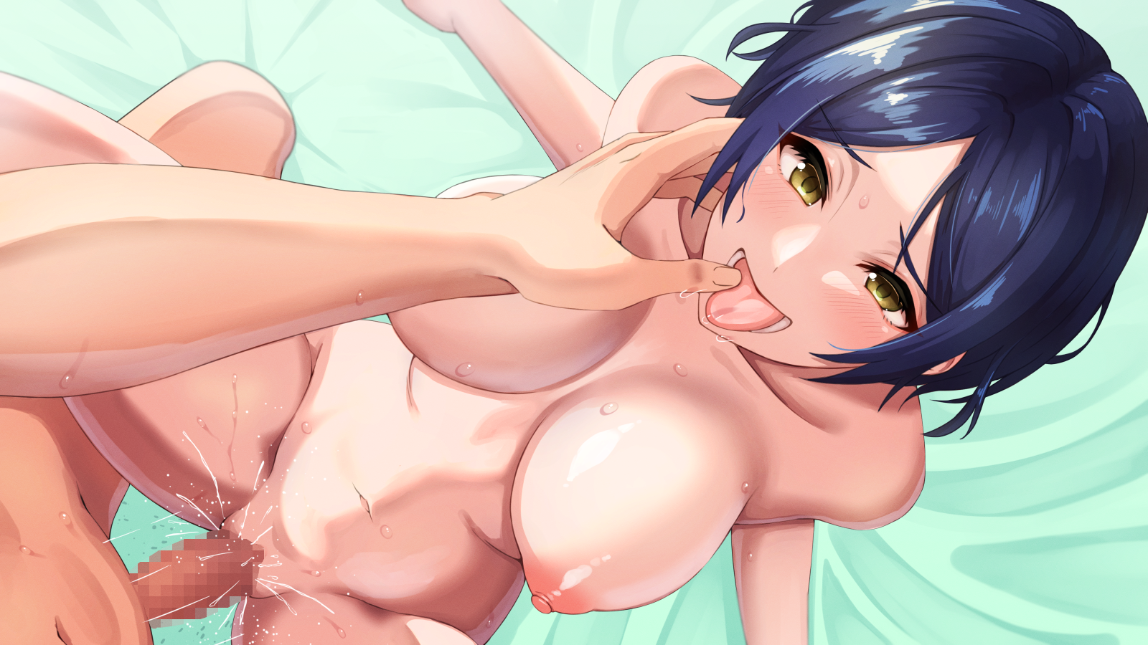

The only thing that would not endure the night however, was the chocolate cake Reena had made, slumping into a sad marsh of melted dessert by the time Reena's tired body had finally collapsed onto the bed alongside her soon to be husband, who had already dropped out a while ago with his rabid girlfriend milking him for all he was worth.

Epilogue

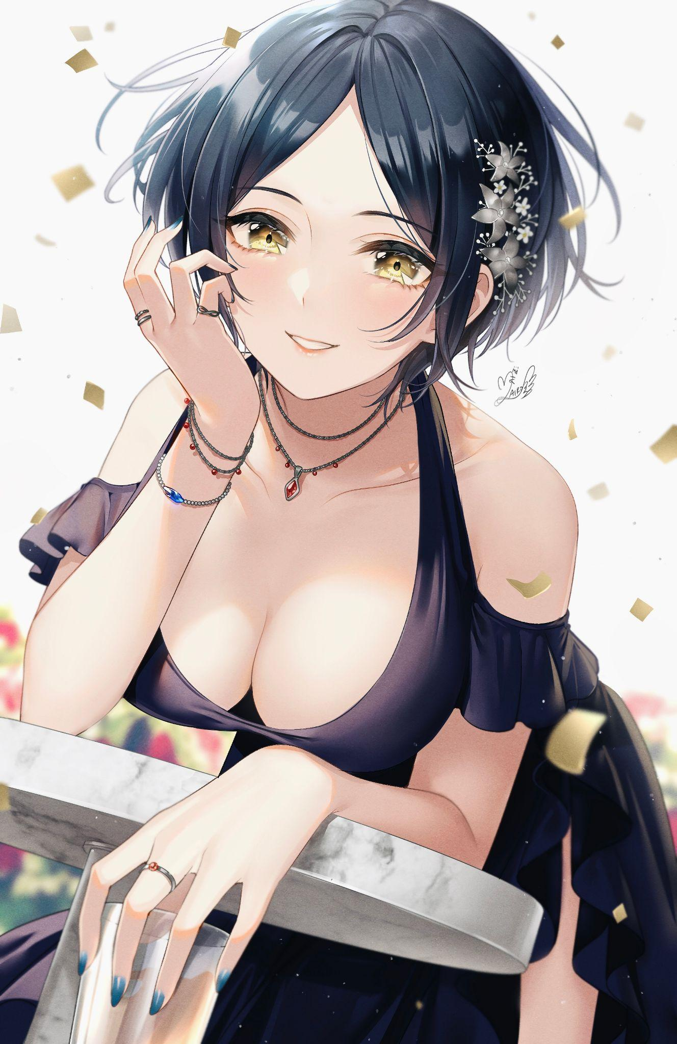

With news of the brutal execution of the Zacharia family making its rounds, the rebellion that had once been stewing away in the political backdrop of the kingdom had finally reached its boiling point with a number of other houses banding together to fight back against their corrupt rulers. Culminating in a full blown coup that ended with the royal family overthrown and a toast made by the victors commemorating their comrades that had been lost in the long fight to prune their kingdom of their diseased rulers.

Unbeknownst to them however, a little celebration was held in the Deralius manor. With both master and servant alike spending the quiet evening far away from the fighting together as they celebrated the fireworks that were launched to signal the end of the hostilities. While they never had a direct hand in the conflict, the Deralius’ had been critical in funding their efforts for supplies and weaponry. Continuing that aid even after the passing of the former head and his wife.

And as the man himself strolled outside to join Reena who seemed to be enjoying the solace of a peaceful evening dressed in an elegant black dress after the two had announced their intentions to wed to the entire household clear with the official ceremony held not long afterward. Despite no longer serving as a maid, Reena still did her part around the house, working alongside her fellow maids she had grown to treat like her own sisters. Alphonso leaned in to land a kiss on his wife’s lips. Already pregnant with a child, it was only a matter of time till the baby bulge in her belly would make itself obvious.

For the rest of their time together, Alphonso would make sure his wife would be the happiest woman in the world.

*THE END*