**BROWN MIRROR**

**EPISODE 1**

**Beep, beep, beep**

John was suddenly blinded by the light that shone down from the roof and the walls around him, it was so bright that his eyes watered as they adjusted. The lights dimmed to a soft gentle glow as he desperately looked around, trying to figure out where he was.

The room was small, the floor flat polished concrete, the walls bright white panels with light shining from the other side illuminating the room. John was seated at a table in the center of the room. It was plain, metal, nothing on top of it. Across from him was an empty chair. Behind that, a single door leading in and out of the room.

**“HELLO?”** John called out before trying to stand. Chains rattled as he was pulled back down to a seated position. Looking down he could see, he was handcuffed to the metal chair by his wrists and ankles.

**“HELLO? ANYBODY?”** John called out again before pulling on his handcuffs, seconds later the door opened and a pretty young woman walked in. She had bright red hair and was dressed professionally wearing a blouse and blazer with a short skirt ending at her knees. She had a manilla file in one hand that she placed on the table before closing the door and taking a seat across from him. John had no idea how, but he could tell she was law enforcement, maybe it was her confidence or the way she carried herself, but he could feel it deep down, like a sixth sense.

“Where am I?” John asked, she took her time taking her seat without bothering to respond. John’s head felt so heavy, it was pounding with pain but he couldn’t reach up to rub his skull. He could not remember a thing, his memory was a total blur. He barely knew his name.

“Now John, I know this must all seem very confusing, but you’ve been in an accident,” she said softly. He took a moment to examine the woman’s face, she was incredibly beautiful. Her green eyes were bright and looked as if she was studying him down to the soul. Her lips were plump and covered in a fresh layer of lipstick. She had incredible features which made it quite hard to concentrate

“An accident? I can’t remember a thing” John said while reaching up to rub his head, once again forgetting he was handcuffed to the chair.

“Well, you hit your head pretty hard, it’s amazing you're still standing,” she said with a smile.

“Why am I handcuffed, am I in trouble?” John asked…



“Well, that’s what we’re trying to figure out,” The woman said as she opened up the file before her.

“Is this familiar to you?” she asked while sliding a large full-page picture across the table. John looked down and it felt like his heart had been shocked with 1000 volts of electricity! His whole body seized up as he saw the picture of the Diamond. He began sweating buckets and hyperventilating as the detective watched his reaction.

“I’ll take that as a yes” she closed the file and looked him in the eyes.

“Tell me where it is John” she demanded with a tone of superiority.

“I don’t know! I can’t remember!!!” John cried!

“I can’t remember a thing, If you hadn’t called me John, I wouldn’t even be 100% sure that was my fucking name! John shouted in frustration, his heart was beating so fast, his body was telling him to run but there was nowhere to go. He watched as the detective slowly got up and left the room, returning a moment later with a machine in her hands. It looked like a laptop but it had a whole ton of wires and attachments hanging from the side USB slots. She set it down on the table between the two of them and then began untangling the wires.

“When can I leave?” John asked softly with a slight whimper.

“When we find The Pink Star, it’s worth over 70 million dollars” The Detective answered with no emotion. She took a few wires from the side of the fancy laptop and began attaching them to John’s fingers like he was in a hospital and she was measuring his heart rate.

“But, I don’t know where it is! I can’t remember anything!” John answered nervously as she continued hooking him up to the machine.

“That’s fine, we’re gonna take a look back, and see how exactly you’re involved. Then, when I have decided that you are innocent, you can go free” she answered as she placed two tiny stickers with wires attached to each side of his forehead just above his ears.

“Look back to where?” John asked nervously as he looked up and down his body, he had so many wires hanging from him.

“Inside your memory” she smiled and took her seat back across from him at the table.

“What?” John asked as his voice cracked

“This technology is still in its pre-trial stages for human use, but due to the value of the diamond, our employer has requested that we find it at any means necessary. We can jump back to any memory, anytime in your life, and you can relive the experience while I watch on this screen here!” she smiled and pointed to the fancy white laptop screen.

“Please! Let me go! I can’t remember a thing and I would never steal!” John almost began to cry as the detective began laughing.

“That’s hilarious, especially when it’s coming from the mouth of a professional diamond thief. You have made a career of stealing and taking what isn’t yours! For the past ten years, you have been a free man, but we will see how long that lasts! Hmmm, let’s start at 7 pm on the night the diamond was taken.” the detective said as she began typing something into the laptop.

“Are you ready? This may be a bit painful. Once you enter the memory, it will feel like you are there, but you won’t have control of your body, you will just be reliving the experience through your own eyes.” she said with a smile, clearly she didn’t care. John gripped the arms of the metal chair he was handcuffed too just as she hit the **ENTER** key.

John felt his entire body from head to toe freeze as a current of electricity ran through him. It felt like his eyes were going to explode as he let out a breathless scream. The last thing he could see was the red headed detective laughing, smiling as everything went black.

John began choking as he opened his eyes, it was cold and wet all around his head, he was standing in some sort of damp dingy basement with a large heavy object around his head and some plastic cloth over his face that he could barely see-through, it had a big hole over his mouth. He could feel a lever in his hand that he was gripping. He looked around trying to figure out what the bowl was, where the hell was he? suddenly the sound of high heels clicking on the tile floor could be heard, the sound came closer and closer until the area around his face filled with light. He had to squint to see the young woman standing above him. She was pretty with long brown hair and a tight black party dress on. She began raising the back of her dress and pulling down her black panties, her tiny ass was thick and bubbly. She bent and started to sit as her ass came closer and closer, settling down just over his face. John could smell the thick earthy stench of assholes as he realized. **HE WAS IN A TOILET BOWL! WHAT THE FUCK!**



She sat down, wiggling back and forth as John racked his brain, trying to figure out **WHY** he would be in this situation? How did he get trapped here? He would never do this willingly! The young woman began grunting and pushing as her anus flexed, winking at him. There was a soft hissing as the bowl filled with a foul stench, like rotten Chinese food! John could feel himself restraining his choking, trying not to let the woman know he was there! **WHAT THE FUCK**, why would he do this?

He watched as her asshole began opening, spreading just as her lips started to part and release a heavy thick stream of urine! It splashed down into his mouth, filling it with salty piss as a thick dark log inched towards him! His heart was racing, he could taste the foul piss, he was choking it down, willingly swallowing! The thick turd had pieces of corn and seeds in it, the sides were covered with undigested food. She continued to grunt and push as he choked down her piss, the brown turd slid out fast now, landing in the urine and hitting the back of his throat! John willingly began chewing, eating it!!!!!

He wanted to cry, he could taste it all, the filth, the grit, it was so bitter and horrible. He could taste everything she had eaten over the past twenty-four hours, there were hints of broccoli and asparagus, spicy patches of chili, his eyes watered as he chewed, swallowing quickly as her pussy dripped. His teeth were covered in her shit, it was so thick, he had to use his tongue to collect it and push the crap to the back of his throat.

**BBFRRTTTTT**

A short fart escaped her asshole blowing against his face as she laughed. John felt sick, his stomach was twisting, he was going to puke but he was holding it back! Why was he here? Why was he willingly eating this woman’s shit? What the fuck was going on!!!!!! John screamed at himself.

Her anus stretched open as another thick log began crackling out. It was wet and much hotter, also coming out much faster! John wanted to cry as the thick mushy sausage filled his mouth and coiled over his nose. It had literal steam rising from it as he inhaled the stench! John wanted to die as his body began chewing, he was sucking down her shit like his life depended on it. He felt the heat of the shit as his tongue slid through it, breaking it up and letting it slide down his throat. Above him, the young woman was wiping, cleaning her asshole, and dropping the paper in thick clumps on his face.



John chewed and swallowed, chewed, and swallowed. Suddenly the young woman flushed as a swirl of water came down from the sides of the bowl. Water washed all the shit and paper into John’s mouth, covering his nose and forcing him to take it all in. He was thankful for it though, the whole experience was terrible but the water was mostly fresh, cleansing the flavor of feces from his throat. He felt his lungs screaming for air as he choked down the liter of water, sucking it and chewing the paper. When he took his first breath and gasped loudly, the woman was gone. He was alone. John wanted to cry, this was torture. Suddenly his entire body filled with a terrible shock and he screamed. He was ripped from the memory and woke up back in the room across from the pretty detective.

“Well, that was interesting!” she said with a smile as John gasped and choked.

He could not believe how real it all felt, he could still taste the shit in his mouth, he could still feel the burning inside his lungs, and the odor in his nose. He leaned over and began spitting on the floor as he choked.

“Don’t do that, it’s disgusting” The detective commented.

“Why were you inside of a toilet?” she asked with a smile as John continued to choke, he wanted to puke but there was nothing in his empty stomach.

**“I DON’T KNOW!** Please!!!! Just let me go!” John begged, almost on the verge of crying.

“I can’t let you go, not until we find the Diamond, remember? Now let’s move a bit forward, let’s say, 8 Pm?” The detective asked as she began typing the information into the laptop.

“No, please. **NO DON’T!”** John begged as she laughed and hit the **ENTER** key.

John let out a deadly scream before he went breathless and froze! The pain was so great, it felt like his body was being torn apart as his soul was torn out! He woke up in the same place as before, the same familiar wet feeling, but the taste, the smell, it was **SO MUCH WORSE!**

John felt sick, it was like he had eaten the feces of over a hundred women! The toilet bowl around him was caked with shit, smears of yellow-brown and green down the sides! The plastic sheet over his face was painted in feces and weighed down heavily. The taste in his mouth was horrifying, so bitter, each breath made him gag. He felt a hot liquid rise in his throat that he forced himself to swallow, why was he here?!?!?!?!?!!?!?!?!?!

The door opened as a group of young women entered, he could hear them all talking amongst one another in posh British accents. They all sounded very spoiled and rich. The sounds of their footsteps came closer and closer until they were just above him. John wanted to scream out for help but he had no power over his body!

“Ugh, this toilet is disgusting!” one of them exclaimed.

“I can’t believe Amelia hosted a party with just one bathroom! If this was my party, you could be sure there would be no line for the toilet!” One of the other women said in a very haughty tone.

“Move! I’m about to piss myself!” one of the women said with a giggle as her ass hovered over the toilet bowl.



John could not see any of them through the shit covered plastic sheet hiding his face, but he could sense her over him, the shadow of her ass looming over the seat. Her urine came thick and strong in a powerful stream that filled his mouth in seconds. He took his first gulp, expecting it to be tangy and terrible, but was pleasantly surprised to find it tasted like a hot mellow tea. Her urine was diluted from the amount of alcohol she was taking in. John gulped over and over, suddenly freezing as the contents of his stomach tried to rise! If John was in control he would have lost it, but for some reason, he was fighting back. He was swallowing the hot shit in his throat as the woman above him continued to pee, her urine forming a pool over his mouth and nose. The flavor in his throat was atrocious, it was spicy and bitter, he could feel the thick sludge of shit working it’s way up as he struggled. He was losing the battle. He flexed his throat and swallowed again, forcing the shit down and choking down a few mouthfuls of urine. After drinking another, and another, and another, he got a breath of air, his first in over a minute!

John gasped but made sure to do it quietly, not letting the women know he was there, **WHY???** He could not figure out for the life of him why he would be in this position! Why would he be here? What the hell was going on? If he was in control he would have pulled his face from this toilet and thrown up for a fucking week! His stomach felt like it was going to explode!



Another ass loomed over the bowl, hovering for a moment before letting loose! John wanted to cry as her hot urine splashed into his mouth. Just like the previous woman, her piss was light and diluted, but his stomach was so incredibly full, each mouthful was filled with pain. The women laughed and gossiped to one another, completely unaware that he was below them, inhaling their waste! He could feel his stomach fighting to eject the contents sitting within it, but he fought back, sucking down her piss as if his life depended on it.

The stream ended and he got the last mouthful down. He could hear the women walking around the tiny bathroom, chatting and washing their hands as the sinks turned on and off.

“Are you coming Alena?” one of the women asked...

“You two go ahead, I’ll be right there!” she said as the two women left, he was now alone with Alena.

He could not see the woman above him with how thick the shit was covering the plastic covering hiding his face, but he could feel her hovering just an inch above the toilet bowl.



**BBBFRRTTTTTTT**

A thick dense fart left her puckered asshole filling the bowl with a foul beefy stink, he felt his stomach churning as shit began creeping up his throat. It was so hot but he fought it, swallowing and bracing himself. Suddenly screams could be heard outside, there was some sort of commotion.

**BBBBBFRTTTTTT**

Another fart left her asshole, this one much denser and way smellier. He felt his nose hairs curl inwards as he sucked in the terrible gas, he had no idea women could even produce such bad odors! There was a wet crackling as soft mush covered his nose and filled his mouth, his cheeks puffed outwards with how much shit was inside of them. Suddenly the bathroom door crashed open and the women above him screamed. Footsteps rushed in as the woman sat down heavily on the seat, no longer able to hover as her legs gave out.

**“AHHHH GET OUT!”** The woman above him screamed. John tried to listen and hear what was happening but it was hard with such hot mushy shit filling his mouth.

“One guest in the bathroom sir,” A man said followed by a crackle from a speaker or walkie-talkie. The woman above him was still freaking out in the stall, her asshole letting loose streams of shit that coiled over John’s mouth and nose.

“Affirmative” he answered.

“**WHAT’S GOING ON?”** The woman above him screamed from the stall.

“The Pink Star has gone missing, this party is now an active crime scene miss, please finish your business here so I can escort you back to the main party room, no one is leaving before they are thoroughly searched” he replied.

John felt soiled paper landing on his face over the pile of steaming shit! It tasted fouler than anything he could ever have imagined! He was eating it, sucking it down slowly, trying not to make any noise! Why??? Why??? He still had no idea why he was in a fucking toilet!!! John suffered as his body continued to eat the feces, slurping down the steaming mush. It had bits of corn inside that got stuck on his teeth causing him to gag lightly. He finally felt the paper over him, it was sticky and clung to his tongue. He pulled it into his mouth and the paper instantly stuck to the sides of his cheeks. The woman quickly walked away and washed her hands without flushing! John wanted to scream, he had been waiting for the water, praying for it! His mouth was completely covered, even breathing made him want to puke!

“This way Miss The officer said as both of them left, John was now alone.

“Please. Take me out, take me out, take me out!” He prayed and begged in the back of his mind, waiting for the detective to take him out and pull him back to reality. But she never came, he just waited, his mouth full of sticky shit. He could feel his throat flexing, fighting to eject all the shit inside of him. Wet shit was sitting at the bottom of his throat, trying to force its way up but he was keeping it down, forcing himself to contain it, why would he ever put himself in such a terrible position?

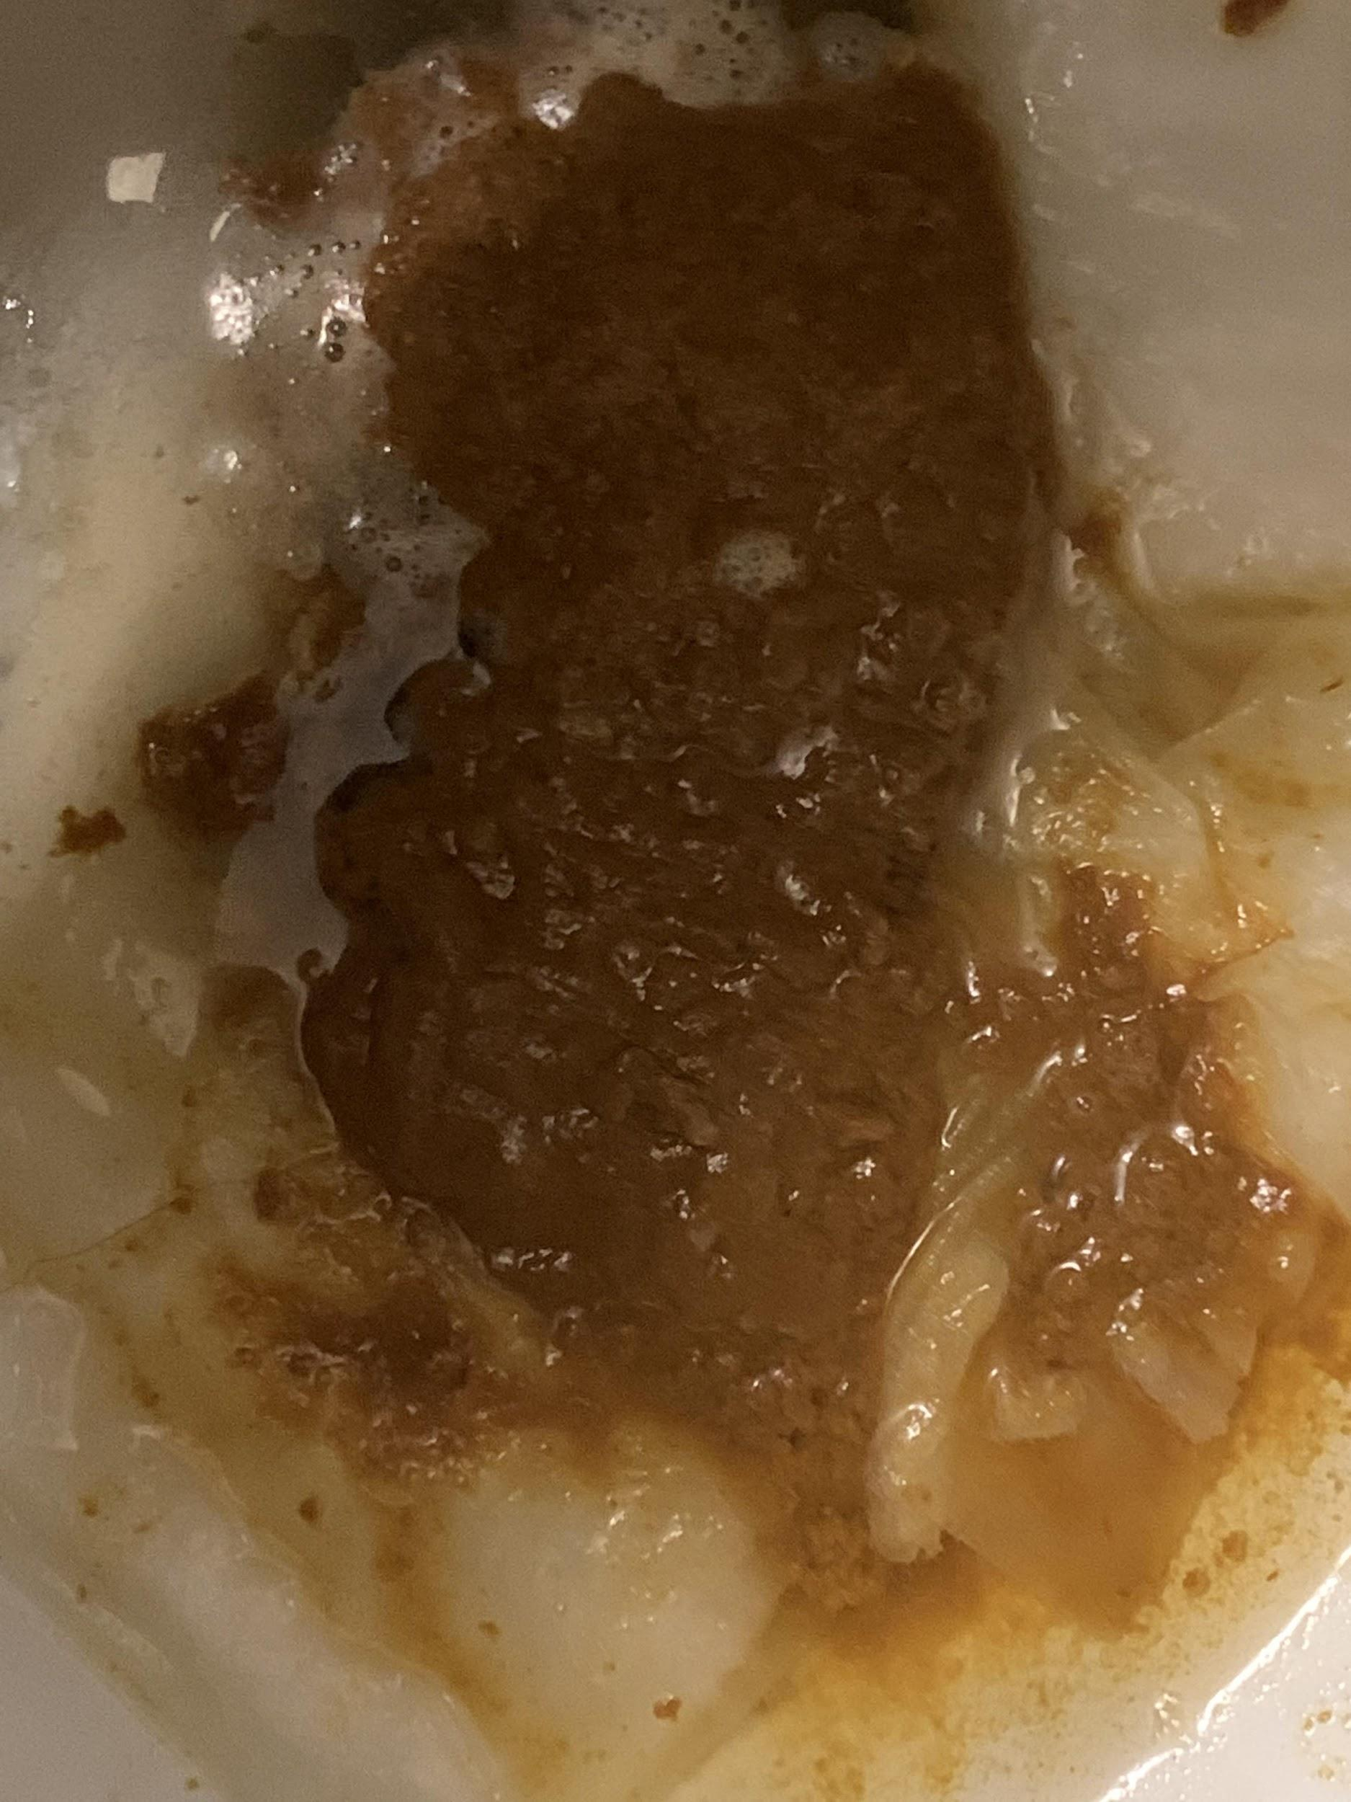

John prayed, begging for the detective to end the program as his throat buckled. Suddenly, it all came up, there was nothing he could do to fight back! The shit of god knows how many women rushed up, filling the bowl with terrifying speed! He could feel it all coming out, so hot, so thick, there were big hard chunks mixed into the milky soft shit. John began to cry as he choked and started to swallow, he was willingly drinking it, eating it, why, he could not for the life of him figure out why he would do such a thing! He could feel the hot shit moving down his throat as more tried to come up. His nose was completely covered, he could not breathe at all, he could only eat!

John kept eating as he heard screams coming from outside! Suddenly everything froze, the electricity surged through his body as he was pulled from the memory and back into his real body. He gasped and choked, gagging on his empty stomach as he hung from the chair crying. The detective looked down at him as she took a seat and then sipped a coffee cup.

“Sorry about that, I ran to go grab a coffee and got caught up with a coworker” she smiled and took another sip of her coffee while inspecting the screen.

“So did we learn anything?” she asked with a smile.

“Fuck you!” John spat at her between heavy gasps for air, he could still taste the feces inside of his mouth, the hot steamy feeling in his throat, the thick bulging of his stomach. It was all so real.

“Hmm, so rude, you know, if you’d like… I can set the program to re-run the hours of 7 pm to 830 Pm on a loop for a few days, have you remain in the memory for a week? Would you like that? Then we can continue the interrogation when you’ve learned some manners?” She asked with a slight grin.

**“PLEASE! DON’T!”** John gasped! Her finger was on the **ENTER** key as she smiled, pretending to push it a bit.



“Let’s move a bit further back, it’s entertaining watching you eat shit, but at the end of the day we have a job to do here, right?” she asked with a grin.

“I don’t know where the Diamond is!” John said with a slight whimper and cry.

“Let’s jump a month back, to the night of November 27th, Give your stomach a little break” she smiled and began typing into the laptop.

“Oh, thank god, thank you, thank you” John cried…

“Don’t thank me just yet!” she giggled and hit the **ENTER** key on the keyboard. John closed his eyes, preparing himself for the pain, but it still caught him off guard! He let out a breathless scream as he was torn from his body and placed into the memory from one month prior!

John screamed, his entire body was filled with a blinding pain! His arms were tied up above his head hanging from a chain attached to the ceiling. He could see down his body, it was covered in cuts and bruises, some of the cuts were dripping with blood, forming a puddle by his feet.

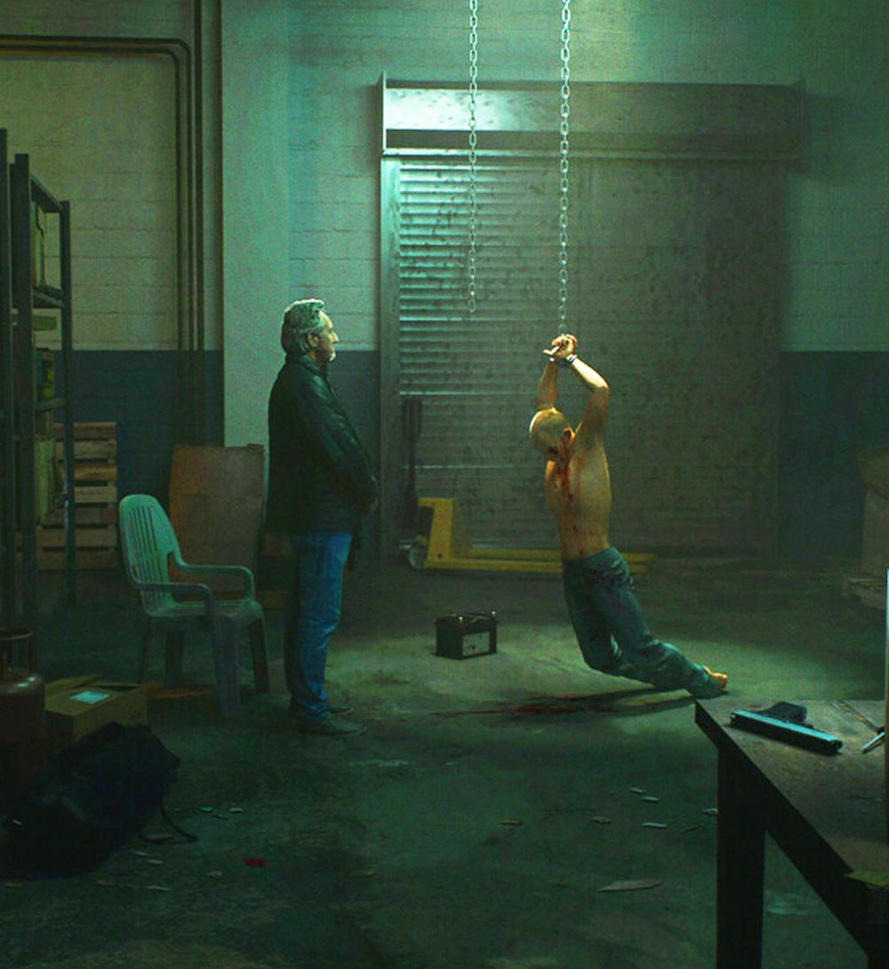

A sharp-dressed older man in a suit was standing before him with his arms behind his back. He had a plain unphased look on his face.

“Again,” he said softly with a Russian accent as another man approached from behind John and stabbed him in the side. The knife slid in and out as John let out a gasp and then cried in pain, he felt the blade pierce his insides as his body went limp, the chains the only thing keeping him up.

“Please! I don’t have the money! But I can get it!!!” John cried so hard he could barely speak…

“You failed one too many times, I don’t have time for failures,” The man said while stepping forward and grabbing the sides of John’s mouth with his thumb and forefinger. Squeezing tight and forcing his jaw open!

“Mppphhhmmlleeaseeee” John cried

“I can’t let you go, John, not with what you know!” The man said while taking a handgun from his pocket and pressing it to the center of his forehead.

**“MPPPH MPPNNOOO MPPNNOOO MNNOOO”** John cried!

Just as he was about to fire, the other man in the room behind John approached the old gangster.

“Подождите” He spoke in Russian and whispered something to the man as they both began laughing.

“That’s perfect,” the older Russian man said with a laugh.

“How would you like a second chance? Hmm?” he asked.

**“I’LL DO ANYTHING!”** John screamed out while trying to stay conscious and not pass out from the blinding pain.

“I thought so,” the other man said with a thick accent and a sly smile. He walked away and began rummaging through some files before returning with a picture, he held it up in front of John’s face. It was the same one the detective had shown him, The Pink Star.

“This is Pink Star, it’s worth 73.1 million, enough to pay off your debt, and some extra!” The Russian gangster said with a smile.

“I know what it is!” John gasped, still hanging from the chains as the blood left his arms making them numb.

“It was just purchased by a member of the English royal family, it’s going to be given to his new wife, Amelia, as a present next month.” The older man explained

“Right now, Diamond being fashioned into ring” The younger gangster explained in his thick broken Russian accent.

“They will give to her at big birthday party!” he explained

“We want you to steal it for us!” the older man said with a smile.

“That’s impossible! I could never get close enough, and I would need to be invited! And security? It’s the royal family? That’s an impossible job!” John shook his head…

“There is another thief, hired by our competition, she plans to steal the Pink Star and swallow it to make her escape and avoid security, so you do not need to Steal it from the royal family, you only need to steal it from her!” the older man explained.

John felt his body being pulled from the memory as he screamed in pain, it was terrible, something he would never get used to. When he opened his eyes the red headed detective was standing above him with her legs pinched together tightly.

“Sorry, I know that was important, but I have to run to the ladies’ room, let me quickly put you back into a random memory between 7 Pm and 8 Pm on the night of the crime, I’ll be right back and we can continue!” she said while quickly typing on the laptop.

**“WAIT NO, JUST LET ME WAIT! I’LL WAIT!**” John screamed as she hit **ENTER** and sent him back into the memory from the night the diamond was stolen.



John cried out in pain as he was forced back into the toilet bowl! He opened his eyes to see a random young woman’s ass approaching the bowl, he could just see her through the plastic sheet hiding his face. She settled down quick, wiggling back and forth to spread her cheeks and reveal her steamy asshole! The bowl was filled with the odor of shit but he could smell her anus through it all. She let out a groan as John gagged the taste in his mouth was beyond terrible. He could feel bits of shit and toilet paper covering the inside of his cheeks.

Music could be heard playing outside the bathroom as the woman grunted and pushed. Her anus began to spread as a soft chunky log started to creep out. John watched as it moved closer towards his mouth, dropping to hit his tongue. As the shit landed in his mouth her anus pinched closed and burst open letting a wave of diarrhea loose! John took one last breath before it covered him like a pool. It was so hot and sticky, filled with undigested food. There was a heavy splatter above him as more was let loose, he could feel it bursting through the surface.

Desperately John began drinking, he was slurping down her shit, using his teeth like a dam to catch the grit and random chunks. Every few seconds he would slide his tongue over his teeth clearing the blockage and continuing! He could feel the burn in his throat, it tasted sour, like cheese that had gone bad, like a liquid swiss-cheese milkshake

“Aw fuck, I’m never eating dairy again!” the young woman complained as John continued to eat.

With his mouth full of shit, he felt his body being torn out and back to reality! He let out a heavy gasp and fell over in his chair as the detective sat down and straightened her skirt.

“Sorry about that,” she said with a smile

“Now where were we” she looked over to John who was in tears and on the verge of passing out.

“Why would you do that? Why wouldn’t you just let me wait?” John cried.

“Well, where's the fun in that, plus, I couldn’t just leave you sitting here with such valuable evidence and other materials on this laptop, even though your handcuffed, it’s not a chance I can take, now let’s continue!” she adjusted the date on the computer back to one month prior and quickly hit **ENTER.**

**“NO”** John screamed as he was pulled back into the memory! He was back in the warehouses with the Russian gangsters now, his hands above him still chained and hanging from the ceiling.

“This is Plan” The younger guy began to explain in his thick accent.

“Party, start at 6 Pm. We will disrupt plumbing, make sure only one toilet is available. 630 Pm you will sneak in through maintenance and place yourself in the toilet from bottom.”

**“IN THE TOILET?”** John said in shock and disgust.

“Yes, in toilet, to eat shit” The Russian explained as both he and the older man began to laugh.

“You will remain there, eating shit, acting as toilet with covering over your face so no one sees you. Amelia will receive the Pink Star as gift, and other thief will steal and swallow. Then we create distraction outside, forcing guests to stay in party room, Theif will come to use toilet, and shit out Pink Star! Before she can reach down and retrieve it, you grab and run!” he explained

**“ARE YOU KIDDING ME! I CAN’T EAT SHIT!”** John screamed out!

The older man stepped forward and placed the gun to his head once more.

“You don’t have a choice! Now, I want the diamond, even if you lose your life in the process, we were going to kill you anyway, so two birds with one stone, right?” he smiled and pulled back the gun before laughing. As the two men laughed and John lamented his fate, he felt his body being pulled back and out of the memory, he gasped in pain as the detective smiled.

“So that was the plan? Eat shit until the thief had to expel the Diamond? Make sure only one toilet was available, that’s a sick plan, disgusting, but I must admit, quite creative, leave it to the Russians to go above and beyond” she laughed to herself.

“Now, let’s pop you back into the night of the party, and find out where the Pink Star went” she smiled and began typing as John begged.



**“PLEASE, DON’T! I DON’T WANT TO RELIVE IT, DON’T SEND ME BACK!”** John cried as she hit **ENTER.**

John was pulled back to the night of the party, he was back in the toilet, it was **A MESS!** There was shit all around the sides and completely covering his face and the opening for his mouth. He didn’t even need a covering anymore, no one would see his face under all the feces!

A woman walked in and took a seat on the toilet above him. He could see the shadow of her ass through the layers of shit over his eyes and nose. The smell was foul but through all the shit in the bowl, it was impossible to make out if any came from her. She began grunting, pushing, bearing down, and trying to expel the shit inside of her.

**BBBBFRRpppppfprtttttvvvvvvvvfrtttttttt**

A messy fart sounded out from above him and John cried! His stomach was so full it felt like he was about to burst! He now knew why he was here, he was forced by threat of death, to repay his debt to dangerous gangsters, but how much longer would he need to wait until the thief came in the bathroom to shit? A thick soft log began coiling over his mouth, entering his lips, that was when he felt it, the big hard rock, the cool metal, **IT WAS THE RING!**

John felt himself move, his body now in action. His left hand squeezed the handle he was clenching and his face was released from the bottom of the toilet bowl! Shit and piss poured out around his shoulders covering his body as he began to run through the lower maintenance area.

**“HEY WAIT!”** he could hear the female thief scream as he rushed through the dark inner passages behind the walls. Shit and piss were dripping down his face as he held the shit covered 70 Million dollar diamond in his hand! He tried to move fast, as fast as he could but his stomach was so full, he was so sick, for the first time in hours he was free and all he wanted to do was puke! Barely fifty feet from the bathroom he bent over and began puking wildly, shit coming up and piling on the ground in the darkness before him. He couldn’t control it, his body expelling the waste as John cried, the shit from god knows how many women were coming up and he could taste it all! Thousands of flavors, every ethnicity, so many women had used him, filled him with shit, now it was all coming out!

**“FREEZE! STOP RIGHT THERE!”** John heard the voice of a police officer as he vomited uncontrollably! The Diamond dropped from his hand just as the taser hit him sending a deadly shock of electricity through his body! The pain was unbearable.

He was pulled back to reality, gasping and choking as the detective smiled at him. John leaned over in his chair, the handcuffs pulling on his wrists as he cried. He was broken, he started to weep as snot ran down his face.

“See! I… I don’t have… The Diamond! The police! They got it!” John cried!

“I know they did!” she smiled.

“You can come in now if you’re ready!” The detective said with a smile as the door behind her opened. A beautiful young woman walked in. she had on a tight pair of jeans and a knit sweater. She smiled at John who was weeping, his body shaking and trembling from the pain and trauma he had gone through. She raised her hand to show him The Pink Star.

“You’re… You’re Amelia?” John whimpered…

“You thought you could steal from me?” she asked with a spoiled smile…

“I’m sorry! I was… forced too, I would never”

**“SHUT UP”** she screamed and interrupted him.

John’s chair began leaning back, mechanically it lowered until he was flat on the floor, his wrists still handcuffed to the arms of the chair now laying flat. The room opened and a clear plastic toilet bowl began lowering. John watched in horror as it reached the floor and covered his entire head with a thick rubber seal around his neck. Amelia walked over and looked down at him through the opening at the top. She was gorgeous but terrifying from this view.

“I hope you’re hungry!” She smiled and began undoing her jeans, turning around and pulling them down to reveal two thick pale ass cheeks, each one with smooth soft skin. She sat down quickly, her fat ass spreading and falling over the sides of the seat.

John looked up at her dirty asshole. It was hairy and covered in pieces of shit from her last visit to the restroom. Her anus had a thick sour smell that made his eyes water heavily! He could see it puckering and winking at him, getting ready to let loose.

**BBBFBRTTPPPPRFppfprtttttttttttt**

Her asshole let loose a foul wet fart that leaked liquid feces down to the tip of John’s nose! He started to gag and choke as Both women laughed.

“When would you like me to restart the program Miss?” The redhead asked politely as she began packing up the laptop. Amelia grunted above John as her anus puckered.

“We’re just about to begin dinner, and I will need to go again before bed, let’s start it again at 9 Pm and I will be ready by 11 to use him again” she smiled.

John listened to their conversation as Anelia let loose. Her anus spread wide as a thick serving of mushy feces began piling down over his face! The bottom of the toilet where his head was sitting gave him no room to move his head left or right so the waste was forced to pile over him. He could feel the hot shit leaking down his nose, forcing its way between his lips. He could not breathe and his lungs were begging him to open his mouth, he fought the urge, fought it as long as he could!

Eventually, John opened his mouth, just as Anelia let more shit loose! It filled his mouth and covered his nose and eyes! He could see nothing, all he could taste was her bitter sour shit! With his entire face covered and his mouth full, John slowly went unconscious.

**Beep, beep, beep**

John was suddenly blinded by the light that shone down from the roof and the walls around him, it was so bright that his eyes watered as they adjusted. The lights dimmed to a soft gentle glow as he desperately looked around, trying to figure out where he was.

The room was small, the floor flat polished concrete, the walls bright white panels with light shining from the other side illuminating the room. John was seated at a table in the center of the room. It was plain, metal, nothing on top of it. Across from him was an empty chair. Behind that, a single door leading in and out of the room.

**“HELLO?”** John called out before trying to stand. Chains rattled as he was pulled back down to a seated position. Looking down he could see, he was handcuffed to the metal chair by his wrists and ankles.

**“HELLO? ANYBODY?”** John called out again before pulling on his handcuffs, seconds later the door opened and a pretty young woman walked in. She had bright red hair and was dressed professionally wearing a blouse and blazer with a short skirt ending at her knees. She had a manilla file in one hand that she placed on the table before closing the door and taking a seat across from him. John had no idea how, but he could tell she was law enforcement, maybe it was her confidence or the way she carried herself, but he could feel it deep down, like a sixth sense.

“Where am I?” John asked, she took her time taking her seat without bothering to respond. John’s head felt so heavy, it was pounding with pain but he couldn’t reach up to rub his skull. He could not remember a thing, his memory was a total blur. He barely knew his name.

“Now John, I know this must all seem very confusing, but you’ve been in an accident,” she said softly with a smile.

“Damn I love this job,” She thought to herself.

**THE END**