*Big Things Come In Small Packages*

*Siggy Commission for Nep*

**"Barkeep! Another round fer our table if you'd please!"**

**"Rondine! T'was five minutes ago when we ordered ours! Where's d'hooch?!"**

Noisy banter and boisterous laughter could be heard far down the mud strewn streets of a homely little village bordering a certain empire's vast domain. With many industrious companies and lucrative businesses having a personal stake in the seemingly innocuous settlement for a multitude of reasons. Whether it was aiding in expansion efforts or profiting off the exclusive distribution of material and resources found only within certain locations far out in the wilderness kept safe within the minds of their leaders, these entrepreneurs had come together to form their own little haven, attracting many others to flock there with the intent to start businesses of their own with some even setting up fine real estate.

And this far out in the countryside? Kinder folk tended to gather alongside the strong, both humans and demihumans from all walks of life had joined hands to form the village, whose inhabitants had come to lovingly call Menagerie, thanks in part to the varied populace and the many businesses that operated there. Corporate guilds, adventuring hubs in charge of putting together orders for the many men and women under their banner, if you could think of it, Menagerie had it.

But the heart of the village arguably lay in the only bar to be found in Menagerie, drawing adventurers, miners, lumberjacks, stressed out paper pushers and taxed scholars fussing about an unsolvable solution, and they came in many different flavors. Although they did employ eye catching waitresses, the strict security and brutal enforcers made sure everyone stayed in line during their stay at Tilly's Pint House; named after its owner whose family held a closely guarded formula for some of the best mead across the land. Even amongst the dwarves, Tilly's family brew stood out for its rich flavor and soothing texture. And best of all? One would need many pints running down their gullets to even begin to feel woozy, making it an excellent drink to have with friends and colleagues. But Tilly's Pint House had the benefit of starting off young alongside Menagerie's growth, before it even earned its name. That meant everyone who frequented the bar treated each other like family; a collection of brothers and sisters bonded not in blood, but trust and friendship, with the bouncers being akin to wiser kin who put their feet down when the time came for it.

The real trouble came when outsiders from elsewhere came visiting, picking fights, insulting the mixed population, even rough handling the waitresses. These were just a few of the common triggers that started fights in Tilly's much to her chagrin, it had become a common thing for her to witness. Although they did earn themselves a handful of loyal patrons from the few scuffles the bar had seen more so than disdain.

On this particular evening though, Tilly wasn't too particularly eager to have this new face around town become a repeat customer. In fact, not many outside of people looking for disposable heads wanted him in any of their businesses.

Gregor was his name, a portly brute with no finesse, although the term brute only ever applied to his mouth. Foul in temper and terrible with weaponry, the man had started off his career as a wannabe adventurer who went nowhere, plying his trade wherever he could with mixed results. Sometimes he'd get lucky and catch his bounty off guard or maybe a wayward sword strike would coincidentally hit a critical spot, earning him enough pay for the next week or so, but most of the time, he would return banged up with nothing to show for it. If he took the time to learn, analyze his mistakes, then maybe Gregor would've been famous by now. But instead of doing that, the thick skulled idiot preferred to blame it all on everything else around him, drowning in hooch and sin to drive away reality.

Some wondered how the bumbling idiot even managed to stay alive for this long when others much more deserving of a well lived life led far shorter careers on the path of an adventurer. Some said it was luck, others saying he had a nasty fate in the works, a fate the pantheon of the gods were simply waiting to place in Gregor's path.

He'd laughed at that, calling them jealous fools and crazy hermits. Deluding himself into thinking he was worth far more, that his minute deeds were on a level worthy of fame and recognition everywhere he went.

Although as he soon arrived at Menagerie with that cocksure attitude, none but Tilly would be aware of how close Gregor would draw to his end. She didn't have plans to kill him per se, a nasty thing to do that would technically be a much more merciful end than what he had subjected others to in his drunken bouts of rage and 'stress venting' elsewhere across the land.

With his 4th visit to her establishment, she had told the rowdier men to expect a pleasant surprise tonight, alongside orders to her elder brother to keep the rest of the bouncers away. Enough warnings were given, this drink would be his last…unless of course, he managed to beat her at her own game. Shaking a bottle of powder gleaned from months of experimentation with possible formulas to improve her brews while uttering some silent thanks to the unfortunate miner exposed to a whiff of the stuff after some excess runoff on her clothes had gotten into his eyes.

Getting up off her bed to prepare for yet another busy night, Tily sets aside the bottle on the countertop while greeting the new batch of regulars fresh in from yet another hunt, just waiting for that old grump to come bumbling in through the front doors for one final time…

**“Friggin numbwads, swears they be eyeballin’ me…”**

Gurgling through a mouthful of delicious stew, the dark eyed goon of a man sitting by his lonesome in the usual spot he had come to claim over his 4 day stay here stares out amongst the rowdy patrons of the well lit bar, disgusted at the sight of demihumans while leering at the girls from a distance. He'd learned his lesson after the first day there when the itchy hand that attempted to grope one of those sweet bums had been snapped sideways by a powerful kick from the Ram waitress, followed up with a stern warning from the bouncers not to pull that trick again after gingerly nursing him back up.

*‘I don't know where yer from chum, but Tilly's place ain't some harlot's house. Try that again, and a broken arm will be the least'a ya worries.’*

Needless to say, he got the message loud and clear, irritating him to no end that a mere dwarf would talk to him like that. From there, Gregor would relegate his 'troublemaking' to drunken bouts after getting wasted on the bar's specialty brew. He didn't care about the damages caused or the people he put at risk, because getting thrown out on his bum meant he didn't have to pay, and for some strange reason, they never once demanded he did so.

*'Damn right they wouldn't…with all d'gold they fleece from these dunderheads, what's me gold worth to em? Serves these pussies right!'*

Just before the man's rotten mind can get busy formulating another insult, the same waitress who had broken his arm that day trots up to him with a wide smile, planting a fresh fill on the table before curtsying politely the same way they all greeted the other customers.

**"A freebie, from the gentleman by the corner~"**

But before he could stop her, the waitress had vanished back into the busy crowd, leaving Gregor momentarily stunned, glancing back and forth between the freshly poured mug of fluffy cool drink and the location the peppy demihuman had pointed to, finding it impossible to peer through the crowd.

**"Stupid bitch, I ain't got eyes like them freaks…won't say no to free hootch though…"**

Bringing the cool tankard up to his bearded mouth unaware of the smug look cast towards him from the deliverer of the gift herself, Gregor empties the contents down his parched throat in one gulp, savoring the cool creep of Tilly's brew spreading throughout his body with a long, drawn out belch that momentarily silences the jovial mood before the crowd continues on as per usual.

Unbeknownst to Gregor however, the mead currently bubbling away inside his gut was spiked with the luminescent powder from Tilly's workshop upstairs, working literal magic throughout the human's body signaled by a low rumble that doubles Gregor over in no time. Cursing as a shaky hand goes from holding a spoon to pressing down hard on his portly belly, collapsing with a solid thump on the hardwood table, lacking the strength to even right his posture while threatening to slide right off his seat and onto the floor.

But even a pig headed man like Gregor would've known by now that his drink had been drugged, spitting vitriol as he struggles to maintain what little strength left that hadn't been sapped away by what he had assumed to be poison…except no poison would begin to shrink it's victim down to size much like what was happening beneath the greasy armor, thick chainmail and suffocating leather tunic, with sweat slick skin pulsating like a beating heart in tune to the magic coursing through him. Vaporizing thick body hair, purging impurities, removing the wear and tear of time and misuse. An agonizingly slow process that left the afflicted Gregor weak and feeble. Mind running wild with thoughts of vengeance and fear.

*'Friggin…she-goat…poisoned me!'*

With her prey locked up tight, another waitress, far taller and with the wicked horn of an Oni approaches Gregor, clicking her tongue in disgust while tugging at the hem of his collar, feeling a mix of his sweat, bile and other unmentionables stain her skin while she hauls her catch into the backroom, catching more than a few stares directed at the child wearing an ill fitting suit of dirty armor trailing behind her.

**"Oi Umi! Who ya got there?"**

**"Hahh? It's just Delilah's brat that's all…found some toys he shouldn't be playing with so I'm taking him out back for some lesson time…"**

**"Well…best be careful then…and take it easy on 'im will ye? He's still a young boy after all!"**

**"Yeah, yeah…s'not like I'm gonna kill em or anything…even if I really wanted to…can't believe this fucker tried touching Rondine…"**

Cussing for one final time before tossing Gregor into the backroom behind the counter manned by Tilly's brother with loose pieces of failing armor clattering into the dark as Umi slams the door shut, leaving the scumbag to his fate as his boots fall loose onto the floor, filled with empty leggings and worn bandages with dainty feet wiggling just out of sight beneath the baggy openings of a loose pair of pants. Feet that were coated in skin as healthy and pure as a babe.

Gregor wanted to punch the oversized waitress for manhandling him like that, but alongside the physical transformation leaving him unable to lift a finger, something else was interfering with his ability to do so (not as if he even stood a chance against Oni women in the first place), taking ahold of his mind, making the rapidly shrinking human feel extremely light headed akin to a severe case of drunken lethargy, mumbling incoherent words that were a mix of expletives and nonsensical phrases, spoken in a voice that was rapidly losing its gruffness in exchange for a buttery smooth one with an occasional hiccup and vapid giggle breaking up the monotony of it all.

By the time Gregor fully collapses onto the floor with his helmet coming off to a blossoming head of fluffy blonde hair, Tilly emerges from the shadows, easily and unintentionally crushing the dented, rusty thing her thorn in the side had used as armor, whistling at the sight of Gregor's luscious new mane while circling a wide berth around him, inspecting the effects of ingesting the magic powder for herself with a look of curiosity and delight.

**\*Interesting…remarkably slower than inhalation or physical contact…maybe its because of the dilution with the brew…"**

**"Yew…yew-ahyuck-did dish? Me head feels all…tingly!"**

**"...and severe mental degradation…I've got myself a potent mix. Let's see what we have here…"**

Moving to unbutton the baggy mess Gregor's shrinking face vanishes into, Tilly gags a little at the combined stench of body odor, blood, rusted metal and other waste material before marvelling at the sight of what had become of the pompous brute that had terrorized her establishment and Menagerie for the past 4 days; stripped of over ¾ his original size and seemingly purified with nary a hint of the ulgy bulk she had come to know him for. Removing her gloves to prod and poke at soft, porcelain smooth skin painted a natural cocoa brown, lifting slender arms tipped with the tiny hands of a maiden, spreading plump thighs connected to rotund hips and an equally rounded ass to inspect the rapidly dwindling manhood between them, noting the surge of movement from below a strip of blonde pubes up into a tight, toned navel, upon which rests a growing pair of teats that were not the bestial lumps of blubber Gregor once sported, but actual breasts, large udders complete with faded brown nipples leaking a clear white substance that Tilly wastes no time in bottling a sample of, lifting the diminutive human easily in one hand…

**"Eyyy….put me down you shtewpid she-giant! I'm not some…what’re…oh gods…y-yer hands! They squeezin' me good~"**

…while the other gently grabs ahold of an engorged tit before squeezing hard, sending a hearty spray of sweet mother's milk into Tilly's test tube, forcing womanly squeals of pleasure out of Gregor's barely recognisable visage; no longer that of a man-pig but a mischievous pretty gal. Stripped clean of unwanted facial hair and sagging fat, the man's face was left pristine for all to view wide curious eyes, thin brows, the cute slant of a button nose and lips that were just as soft as the skin around it and equally lustrous as the hair that framed it all, pooling down and around Gregor's completely feminized and shrunken form. With Tilly letting go of the newly formed Fae just as her useless pecker rids itself off its last load of semen, staining the floor beneath her with a jovial cry of lust as it slides back up inside the thick lips of a puffy labia that wastes no time in drooling all over her legs.

With the emergence of a bright yellow set of butterfly wings behind her arched spine and her ears lengthening into spiked tips, there was no mistaking Tilly's assumption of what had become of Gregor, especially since she had already seen the end result once a few days ago.

Cousins to the Fairies, Fae were similar in appearance; small enough to hold in one's hand but with a penchant for acts of debauchery, making them much harder to tame and form pacts with, unlike Fairies.

But also unlike Fairies, Fae were not a natural occurrence, rather, they were the result of a curse begun by a mage desperate to replicate the great powers held by the Fairies. Only ever managing to succeed in two things; perverting their power and becoming the first ever Fae in existence. Thankfully however, the specifics behind the curse were never truly realized, but every now and then, an alchemist (or even an illustrious brewer of mead like Tilly) would accidentally happen upon its creation, turning either themselves or others into more Fae. Thankfully however, Tilly never did come into contact with the cursed powder, having quickly created a counter spell alongside the town's top alchemists and mages after she had accidentally transformed a dwarven miner into one of the lust stricken midgets.

Staring into the face of Gregor the Fae however, she felt no remorse nor a will to turn him back, scoffing a little at the state she had ended up in. Although Gregor was an ill fitting name for a Fae like her…

**"Oi! Gina! Get yer ass up and change, will you? It's almost time for yer shift! Umi's been doin' good work overtime so I expect ye to do the same."**

**"Mm…Ma name-tee her-ain't Gina…right?"**

Massive libidos and an unquenchable thirst for sex wasn't just what the Fae were known for however, with incredibly short attention spans and an intelligence lower than a rock, the cursed species were incredibly easy to trick with simple word play. No doubt Gregor's human brain was too far gone by now, and that made her incredibly open to suggestions. Suggestions like her name always having been Gina, a pleasant one to speak and hear of.

**"But of course it is, you've been Gina for as far as we can all remember! And speaking of, don't ye remember what it is yer supposed to do?"**

**"B-But I…wasn't I called…I was huge too! Not tiny…right?"**

**"If by huge, ya meant those big fat titties of yer’s? Definitely Gina dear~"**

**"He heh~ My boobs really are big aren't they…wait, you're tricking me!"**

Despite the resistance clear in her hazy red eyes, Tilly could tell whatever was left of that horrible man was beginning to wane within that tiny little brain of hers. No doubt struggling to hold on while her words continued to rattle her around. It was like trying to climb a rumbling mountain, with each reverberation representing Tilly's manipulative words and each lost grip further cementing Gina's growing presence in Gregor's mind.

Trying to think of anything past the events of a few minutes ago brought about a dull ache, discouraging further attempts while relaxing brought pleasure. A most vindictive workflow for the curse to whittle away at its targets will. Combined with the reduced cognitive function wrought about by their brains being forcibly compacted into that of a Fae, their resistance would give way sooner or later.

And for a person like Gregor who wasn't the brightest tool in the shed to begin with? It was little wonder when the name Gina and the belief that she had always been a salacious Fae willingly devoting her entire being to the pursuit of pleasure soon cements itself within her mind as the cold hard truth, firing off synapses and chemical reactions that soothes the airheaded demihuman into her new role in life, letting loose a vapid giggle with a cockeyed look of wanton greed on her face. Memories of failed adventures and false promises give way to a scenic overhead view of Tilly's Pint House, watching the many patrons and her fellow co-workers bumble about below her with a tray atop her head. Painful aches and sores earned from pathetic defeats melt away under a soothing tide of perverted up close scenes of men, more specifically, their members, pressed up against her face with the salty taste of spunk fresh on her tongue, followed up by the searing lights of an overhead lamp along with the equally fierce sensation of something probing away at her snatch, perfectly able to recall her favorite moment in the bar when some of the men had spirited her away into a private corner after getting her drunk, passing her amongst each other while they played with her, uncaring of the miniature clothes lying nearby, fondling her pillowy teats while drinking directly from the source, fingering her dripping pussy with giant fingers and kissing her rosy face oh so lovingly with tender lips.

*'This…This is who I am? Gosh darn am I friggin' hawt~'*

By the time Gina had felt the warmth of her uniform consisting of a woolen top with cutouts for her bosom and a shredded pair of leggings that left plenty of skin exposed specifically tailor made to fit her bumbling proportions and miniscule size, the newborn Fae was well and truly convinced of her identity, showing nary a hint of hesitation in her crimson eyes burning with a passion to do her job like she had always done, rising to her feet with an air of confidence and her clothes in hand, raising a curvy legs before freezing with a stupefied look on her face…

**"Speakin' of…what was I s'pposed to be doin' again ma'am?"**

Sighing dramatically while struggling to hide the look of satisfaction on her face, Tilly pockets the vial of Fae breast milk before moving to rid her backroom of the discarded pieces of shattered scrap, addressing Gina with a dismissive tone.

**"Sometimes I forget how dimwitted ye are…entertain the guests, serve em their drinks, and make sure ye fellow colleagues aren't hurt. Did ye get all that?"**

And as expected, Gina's focus was already drifting elsewhere, directing her attention to a propped up shard of broken steel still polished enough to cast her reflection back at her, adjusting her pants till the flesh of her supple thighs and ginormous butt were squeezed up right, loosening her top as much as possible so she could be as mobile as possible while pulling off that underboob look she loved so much before tying her wild mane of dirty blonde hair into a striking ponytail with the provided hair tie fashioned after bright green leaves.

Scooping the little Fae right off the floor with a short bout of protesting before they fall silent under Tilly's expert application of makeup and eyeliner over Gina's spunky visage, the newest, and not so new, addition to the bar's roster of waitresses was ready to hit the floor. Grunting a little as her employer gently nudges at her forehead with a pinky finger, as much as she hates being treated like a pet to be coddled, Gina couldn't deny that it felt good to be rubbed this way, filling her perverted mind with strange thoughts of affectionate love…before losing track of that train entirely as she pulls free of her employers grip, taking to the air with a strong beat of her wings.

**"Do yer best out there Gina! And remember; no-"**

**"-drinkin' on duty, yeah I got it…totally do~"**

**"Hm! Ye actually remembered…but I'll be watching yer ass out there!"**

Giggling flirtatiously before flitting out of the backroom in the blink of an eye, Gina quickly puts herself to work picking up trays of idle orders with their recipients marked clearly on small wooden tiles, combined with her birds eye view of the homely establishment, it wasn't long till the backlog had been cleared, leaving the waitresses free to converse with one another and their customers, giving a hearty cheer for the tiny Fae whizzing by their heads as a golden blur.

But as the night carries on and the people grow more restless and inebriated, Gina's perversions had hit their peak, deciding on the burly man drowning himself in the corner as her first lay of the night as she swoops down unnoticed below the table, slinking stealthily up into his pants before finally catching his attention with movement in his jimmies, snapping out of his drunken stupor in a mild state of panic until he spots the mischievous face of Gina peeking out at him from between his popped pants, motioning for him to remain silent before shooting him a lewd gesture with a shake of her hand a bulge against her cheeks as she motions with her salivating tongue, retreating back into the darkness of the man's pants like a mole returning into its lair…

Unnoticed by all except the towering Oni waitress watching from the shadows, clicking her tongue in disgust at the sight of the weary adventurer and his incognito companion having fun in the corner, tearing her eyes away from it to address a satisfied Tilly enjoying a shot of her own mead.

**"Well…it's as you said…that thing really is putting in her weight around here, figuratively speakin'...are these thing really that frisky?"**

**"Calm down now Umi, ya might be surprised but whether they be Fae or Fairy, once they're under your beck and call, they do mighty fine work…compared to the alternative, bein' frisky with an active love life's much more preferable…speakin' of, how are things with Rondine?"**

**"Mmm…she's doing fine…haven't seen a smile as wide as that when I broke the news to her…I think the girls might like it if Gina stuck around, from what I heard, she's been getting along fine…you really sure you wanna turn her back into that ugly sack of shit again?"**

Rubbing her chin thoughtfully, Tilly raises the flask up to her lips, emptying the rest of the mead while considering the idea. She'd heard of Gregor and what he was like from word of mouth, seen it all first hand in these past 4 days. Turning him into a ditzy Fae who had no idea she was once a human male seemed cruel at face value, but after so many years of getting away scot free with no repercussions for his misdeeds, this seemed like an appropriate lesson in humility for the racist bum. Doing her best to serve men and women from all walks of life.

**"I dunno really…maybe we'll see but for now…I guess Gina's here to stay…"**

Maybe she would change her back someday, but until then, the opportunist within Tilly had plenty of things in mind involving experiments to run with Gina, if her curse could be utilized without the negative effects, then maybe her dreams of inventing the next big thing to make her mark in the family tree wasn't so distant after all…

And as Gina leaves her first man of the night spent and wasted with a belly full of cum, the horny Fae settles atop another drunkards table, making sure her attire was presentable before leaning over seductively with her chest sagging downward, twin tears bobbing and jiggling as the miniature minx poses before the stunned man's shot glass with a sly wink, letting loose the voice of an enchanting siren to inspire less than noble thoughts within the mind of her second catch.

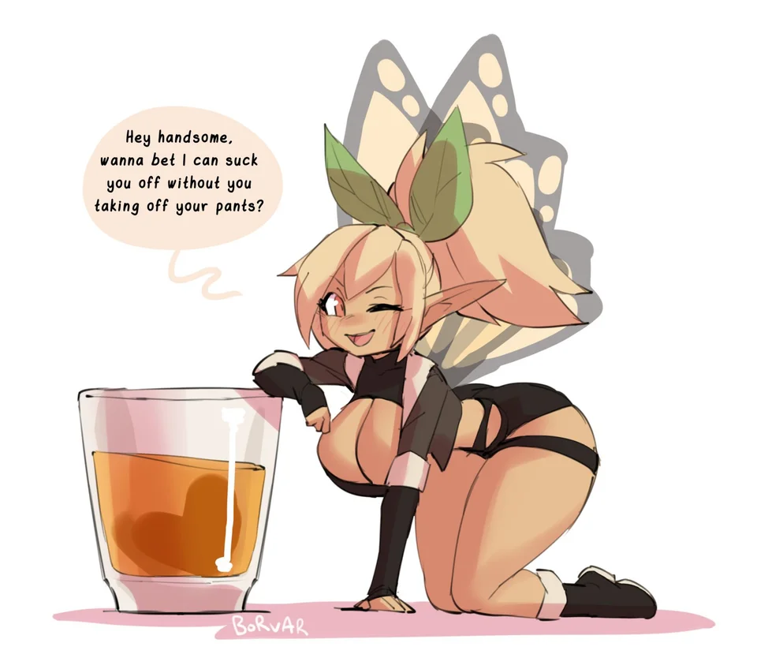

**"Hey handsome~ wanna bet I can suck you off without you taking off your pants?"**

**"B-But the catch…t-this can't be real! A tiny thing like you solicitin' me for sexual deeds? You's nothing more than a specter of me mind!"**

Crawling over the table in the blink of an eye towards a trembling hand, Gina presses her voluminous bosom against the stunned man's warm digits, feeling her tiny heart beating strong with excitement, her lustful visage flushed brilliant crimson as she runs a dripping wet tongue over a finger, liking the taste of the stud before her eyes as her loins spasm in need.

**"Do I feel real enough for you? Because I feel you…taste you…and you, big boy? Are . just . my . type~"**

Years would pass the town of Menagerie by, and rumors of Gregor's passing would fade just as quickly as they'd emerged with little care being given to the debased human. Because with Gina spreading cheer and joy within that little love nest of hers with occasional bouts of unpredictable hype and energy wrought about by her employer letting her sample the first of what would be her newest mead recipe, few if not none had the focus to care.

And Gina herself, still the same clueless Fae that had joined Menagerie's residents 4 days after Gregor's disappearance, loved her life. Doing her part in Tilly's bar to earn her keep in mead and sex…

*THE END*